Title Page
Module name:
Games Architecture and Mechanics (ACCB5017)
Assignment Title:
Assignment 2
Student Name & Number:
Adam Williams (2008159)

Table of Contents
Contents
Title Page 1
Table of Contents 1
Report 2
General Code 2
Function “pTopDistance” 4
Function “pTopDistanceSqaured” 4
Function “getRadiusTotal” 4
Testing 5
Video Link 6
Appendix 7
“Sphere.h” 7
“Sphere.cpp” 7
“Vector.h” 7
“Vector.cpp” 8
“Source.cpp” 10

Report
In this report I will write explanation of my code, and an explain of the functions used within the code.

General Code
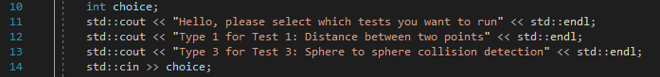The code starts off with declaring the integer variable choice and getting the user’s input and putting that into the recently declared integer. This will be used to run different tests depending on which number the user inputs.
If choice one is chosen, the code runs the test for calculating the distance between the two vectors.
Two vectors are then declared as v1 and v2, we then get the users in put to enter the value of x within the v1 vector, the same is then repeated for the y and z, and also repeated for x, y and z of v2. 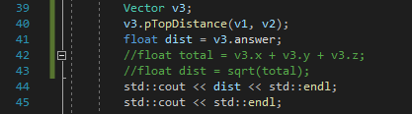
The code then declares v3 to store our answer into. It uses the “pTopdistance” function to calculate the distance between v1, and v2, and store it into v3. We then take the variable answer from v3 and store it into dist and display it to the user.
The next step in the code does a similar process as shown above but uses the “pTopDistancesquared” function instead as we want the answer squared.

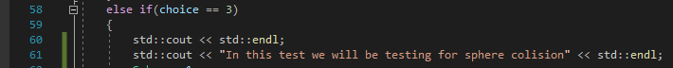If choice 3 was chosen in the beginning, then the code starts the sphere collision test. 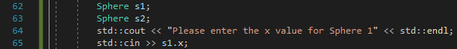The code starts with declaring Spheres s1, and s2. Then gets the user input for the x, y, z and radius for sphere 1 and 2.
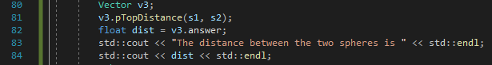The code declares vector v3 to store the answer for the distance into. The code gets the answer from putting s1, and s2 into the “pTopDistance” function. This answer is then put into the float “dist” and displayed to the user. 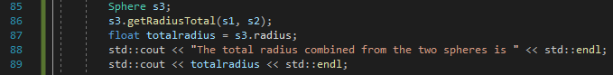The code decalres sphere s3 to store the answer from the getRadiusTotal into. It then uses the function “getRadiusTotal” to combine the radius of both spheres. This answer is then stored into the variable totalradius and displayed to the user. 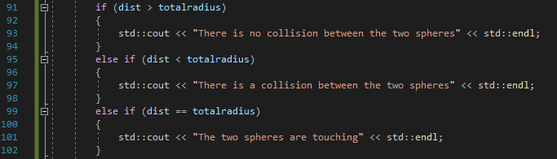Then the code has 3 “if’s” to determine if the spheres are colliding, touchhing or not colliding. If the distance between the coordinates of the sphere larger than both the radius’ of sphere 1 and 2 combined then there is no possible collision. If they are the distance is less than the combined radius’ then a collision is happening, and if they are equal the spheres are touching.

Function “pTopDistance”
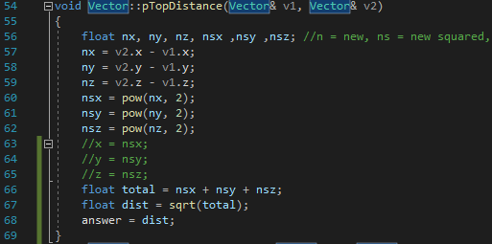
The purpose of this function is to use the formula for calculating the distance between two vectors. The function starts off with declaring all the variables being used. Then moves onto subtracting the x of v2 by the x of v1, and repeating this process for the y and z. The results of the previous stage are then squared. The results of them being squared are then added together, then square rooted for the final answer to be stored in the vector’s variable answer.

Function “pTopDistanceSqaured”
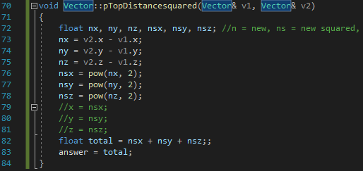
The purpose of this function is the same as “pTopDistance” but to leave the squared answer. This means it follows the same steps as “pTopDistance” until it comes to the square rooting step as it misses this step out to keep the answer squared and returns that answer to the vector’s variable answer.

Function “getRadiusTotal”
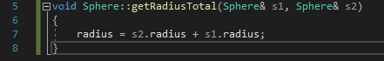
This function combines the radius’ of sphere 1 and 2, and stores it into the new sphere’s radius.

Testing
Below are my tests to check if the code is functioning as intended and giving out correct results.
Test Number | Description | Expected Result | Actual Result | Pass or fail
1 | If choice “1” is selected it takes the user to Test 1 | Displays first line of Test 1’s code | Displayed first line of Test 1’s code | Pass
2 | If Choice “3” is selected it takes the user to Test 3 | Displays first line of Test 3’s code | Displayed first line of Test 3’s code | Pass
3 | Test if the correct answer is given within Test 1 if the user inputs Vector 1 is equal to (4, 6, 3) and Vector 2 is equal to (2, -1, 4) it should give the correct answer for the distance between the two vectors. | 7.348469 | 7.34847 | Pass (Same answer just rounded up)
4 | Test if the correct answer is given within Test 1 if the user inputs Vector 1 is equal to (4, 6, 3) and Vector 2 is equal to (2, -1, 4) it should give the correct answer for the distance between the two vectors. | 54 | 54 | Pass
5 | Test if the correct answer is given within Test 3 if the user inputs Sphere 1 coordinates to be (1, 2, 3) and Sphere 2’s to be (3, -1, 0) with the radius of sphere 1 being 2, and the radius of sphere 2 being 2 it should give the correct answer for the correct sphere collision status. | No collision detected | No collision detected | Pass
6 | Test if the correct answer is given within Test 3 if the user inputs Sphere 1 coordinates to be (1, 2, 3) and Sphere 2’s to be (3, -1, 0) with the radius of sphere 1 being 2, and the radius of sphere 2 being 4 it should give the correct answer for the correct sphere collision status. | Collision detected | Collision detected | Pass
7 | Test if the correct answer is given within Test 3 if the user inputs Sphere 1 coordinates to be (0, 2, 0) and Sphere 2’s to be (0, -1, 0) with the radius of sphere 1 being 1.5, and the radius of sphere 2 being 1.5 it should give the correct answer for the correct sphere collision status. | Spheres are touching | Spheres are touching | Pass

Video Link
Below is the link to the video where I display the code working in all my test scenarios.
https://www.youtube.com/watch?v=mpxbP3eOQv0

Appendix

“Sphere.h”
#include "Vector.h"

class Sphere : public Vector
{
public:
float radius;
void getRadiusTotal(Sphere& s1, Sphere& s2);
};

“Sphere.cpp”
#include "Sphere.h"

//Sphere::Sphere(void) { x = 0; y = 0; z = 0; radius = 0; };

void Sphere::getRadiusTotal(Sphere& s1, Sphere& s2)
{
radius = s2.radius + s1.radius;
}

“Vector.h”
//File: Vector.h:

//*****(note x,y,z are not private–should they be?)
#ifndef VECTOR_H
#define VECTOR_H

class Vector

{
public:

//construct
Vector(float x, float y, float z);
Vector(void);
void Scale(float s);
void pointsToVector(Vector& v1, Vector& v2);
void Add(Vector& v1);
void Add(Vector& v1, Vector& v2);
void Cross(Vector& v1);
void pTopDistance(Vector& v1, Vector& v2);
void pTopDistancesquared(Vector& v1, Vector& v2);
Vector getVector(void);
//private: //these are currently public – should they be private?
float x;
float y;
float z;
float answer;
};
#endif

“Vector.cpp”
//File: Vector.cpp:

#include "vector.h"
#include <cmath>
//construct
Vector::Vector(void) { x = 0; y = 0; z = 0; answer = 0; };
Vector::Vector(float myx, float myy, float myz)
{
x = myx;
y = myy;
z = myz;
}
void Vector::pointsToVector(Vector& v1, Vector& v2)
{
v2.Scale(-1);
v1.Add(v2);
x = v1.x;
y = v1.y;
z = v1.z;
}
void Vector::Scale(float s)
{
x = s * x;
y = s * y;
z = s * z;
}
void Vector::Add(Vector& v1, Vector& v2)
{
v1.x = v2.x + v1.x;
v1.y = v2.y + v1.y;
v1.z = v2.z + v1.z;
}

Vector Vector::getVector(void)
{
return Vector(x, y, z);
}
void Vector::Add(Vector& v1)
{
x = x + v1.x;
y = y + v1.y;
z = z + v1.z;
}
void Vector::Cross(Vector& v1)
{
float tx, ty, tz;
tx = y * v1.z - z * v1.y;
ty = z*v1.x - x*v1.z;
tz = x*v1.y - y*v1.x;
x = tx;
y = ty;
z = tz;
}
void Vector::pTopDistance(Vector& v1, Vector& v2)
{
float nx, ny, nz, nsx ,nsy ,nsz; //n = new, ns = new squared, r = squarerooted
nx = v2.x - v1.x;
ny = v2.y - v1.y;
nz = v2.z - v1.z;
nsx = pow(nx, 2);
nsy = pow(ny, 2);
nsz = pow(nz, 2);
//x = nsx;
//y = nsy;
//z = nsz;
float total = nsx + nsy + nsz;
float dist = sqrt(total);
answer = dist;
}
void Vector::pTopDistancesquared(Vector& v1, Vector& v2)
{
float nx, ny, nz, nsx, nsy, nsz; //n = new, ns = new squared, r = squarerooted
nx = v2.x - v1.x;
ny = v2.y - v1.y;
nz = v2.z - v1.z;
nsx = pow(nx, 2);
nsy = pow(ny, 2);
nsz = pow(nz, 2);
//x = nsx;
//y = nsy;
//z = nsz;
float total = nsx + nsy + nsz;;
answer = total;
}

“Source.cpp”
#include "Vector.h"
#include "Sphere.h"
#include <string>
#include <iostream> //for cin, cout
#include <sstream>
#include <cmath>

int main(void) {
int choice;
std::cout << "Hello, please select which tests you want to run" << std::endl;
std::cout << "Type 1 for Test 1: Distance between two points" << std::endl;
std::cout << "Type 3 for Test 3: Sphere to sphere collision detection" << std::endl;
std::cin >> choice;

if (choice == 1)
{
std::cout << std::endl;
std::cout << "In this test we will be getting the distance between 2 vectors, and getting the distance between two vectors squared" << std::endl;
std::cout << "Firstly we will show getting the distance between 2 vectors " << std::endl;
//std::cout << "Vector 1 will be (4, 6, 3) " << std::endl;
//std::cout << "Vector 2 will be (2, -1, 4)" << std::endl;
//Vector v1(4, 6, 3);
//Vector v2(2, -1, 4);
Vector v1;
Vector v2;
std::cout << "Please enter the x value for Vector 1" << std::endl;
std::cin >> v1.x;
std::cout << "Please enter the y value for Vector 1" << std::endl;
std::cin >> v1.y;
std::cout << "Please enter the z value for Vector 1" << std::endl;
std::cin >> v1.z;
std::cout << "Please enter the x value for Vector 2" << std::endl;
std::cin >> v2.x;
std::cout << "Please enter the y value for Vector 2" << std::endl;
std::cin >> v2.y;
std::cout << "Please enter the z value for Vector 2" << std::endl;
std::cin >> v2.z;
Vector v3;
v3.pTopDistance(v1, v2);
float dist = v3.answer;
//float total = v3.x + v3.y + v3.z;
//float dist = sqrt(total);
std::cout << "The distance between the two vectors is " << std::endl;
std::cout << dist << std::endl;
std::cout << std::endl;

std::cout << "Secondly we will show getting the distance between two vectors squared, with the same vectors as before" << std::endl;
Vector v4;
v4.pTopDistancesquared(v1, v2);
float dist2 = v4.answer;
std::cout << dist2 << std::endl;

return 0;
}
else if(choice == 3)
{
std::cout << std::endl;
std::cout << "In this test we will be testing for sphere colision" << std::endl;
Sphere s1;
Sphere s2;
std::cout << "Please enter the x value for Sphere 1" << std::endl;
std::cin >> s1.x;
std::cout << "Please enter the y value for Sphere 1" << std::endl;
std::cin >> s1.y;
std::cout << "Please enter the z value for Sphere 1" << std::endl;
std::cin >> s1.z;
std::cout << "Please enter the radius distnace for Sphere 1" << std::endl;
std::cin >> s1.radius;
std::cout << "Please enter the x value for Sphere 2" << std::endl;
std::cin >> s2.x;
std::cout << "Please enter the y value for Sphere 2" << std::endl;
std::cin >> s2.y;
std::cout << "Please enter the z value for Sphere 2" << std::endl;
std::cin >> s2.z;
std::cout << "Please enter the radius distnace for Sphere 2" << std::endl;
std::cin >> s2.radius;
Vector v3;
v3.pTopDistance(s1, s2);
float dist = v3.answer;
std::cout << "The distance between the two spheres is " << std::endl;
std::cout << dist << std::endl;
Sphere s3;
s3.getRadiusTotal(s1, s2);
float totalradius = s3.radius;
std::cout << "The total radius combined from the two spheres is " << std::endl;
std::cout << totalradius << std::endl;

if (dist > totalradius)
{
std::cout << "There is no collision between the two spheres" << std::endl;
}
else if (dist < totalradius)
{
std::cout << "There is a collision between the two spheres" << std::endl;
}
else if (dist == totalradius)
{
std::cout << "The two spheres are touching" << std::endl;
}
else
{
std::cout << "bug" << std::endl;
}
}
}

