

Building Organizational Anticipation the New Gilded Age: An Analysis of Challenges and Potential Anticipatory Solutions in Raspberry Pi’s Diverse and International Workforce, Culture of Continuous Improvement, Rewards, and Work-Life Balance



Justin K. Fernando
Student ID: 1705758
29 April 2018
Human Resource Management SBMA7101D
David Griffiths, PhD
Assignment 2: Academic Essay

Introduction
The employee population of Raspberry Pi has grown to over 2000. While the foundation has grown over twenty times since Assignment 1’s employee population of 100, Raspberry Pi continues to seek further scalability in its workforce numbers in addition to increasing its international presence. Doing so would extend Raspberry Pi’s social mission of making educational technology accessible to youth and to educators through affordable and high performing single-board computers (Raspberry Pi, 2018) more possible for a greater amount of people worldwide, particularly for women and the economically underserved. While these aspirations are ambitious, they nevertheless require the Human Resources function to be more adept and anticipatory in meeting challenges that come with the situational factors (Beer et al, 1984; Griffiths, 2018) that come with an even larger workforce and increased presence on the international stage (Nthere, 2018). In particular, challenges arise on cultivating an increasingly diverse and international workforce, the desire and necessity to foster continuous improvement in the foundation, and increasing employee expectations for better rewards and work-life balance. This study elucidates the specific challenges that may arise and the anticipatory capability that HR needs to build in order to empower the function in providing the organization with anticipatory solutions that would drive competitive advantage and performance as the foundation navigates through transformative changes within the next five through ten years.

Seeing and Planning for “The Shadow of Your Future” as an Organizational Capability: Planned Strategy and Anticipatory Awareness
In order to approach in-depth examination of a diverse and international workforce, the need for continuous improvement, and employee demands for better rewards and work-life balance, this study frames this analysis through the lenses of “talent management and “anticipation.” “Talent” are individuals who “can make a difference to organisational performance either through their immediate contribution or, in the longer-term, by demonstrating the highest levels of potential” (Campbell & Hirsh, 2014). Talent management “is the systematic attraction, identification, development, engagement, retention, and deployment of those individuals who are of particular value to an organisation, either in view of their “high potential” for the future or because they are fulfilling business/operation-critical roles” (ibid). Talent management takes recruitment and retention to a higher level by acknowledging that both are insufficient. Developing and managing employees as part of a planned strategy (Turner & Kalman, 2014; emphasis added). Complementary to talent management’s planned strategy, anticipation is the “gathering of insights that improve resilience or sustainability,” the latter of which is the “ongoing relevance in the marketplace.” According to Griffiths (2018), anticipation as an HR function capability allows it to “glimpse and shape the future through better planning, decision-making and problem-solving capability” that “exists around the detection of, inference from, and response to, interconnected and often weak change signals” (ibid). Anticipatory awareness as an HR capability requires the “benchmarking of starting conditions to identify strengths and blind spots in your ability to develop anticipation as an organisational capability” (ibid). With this lens as our frame, our analysis of diversity, international HR, continuous improvement, rewards, and work-life balance gear us to find solutions for HR to be an anticipatory function that drives the organization to achieve competitive advantage as a scaling and globalizing foundation that caters to a diverse employee population across borders (ibid).
Situational Factors: The New Gilded Age as Opportunity for the HR Function
To build anticipation awareness as an organizational capability, HR needs to examine structural situational factors. Larger macro-economic forces serve as environmental factors that impact many organizations and HR functions (Beer et al, 1984). At the turn of this century, we have entered what French economics professor Thomas Piketty calls in his book Capital in the Twenty-First Century (Piketty, 2017) the “second Belle Époque,” or as American economists translate it for the American experience, the second or “New Gilded Age” (Krugman, 2014). This New Gilded Age is defined by the rise of the “one percent” (Gantz & Sanders, 2017). Piketty, joined by Anthony Atkinson from Oxford University and Emmanuel Saez from University of California—Berkeley, compares the magnitude of twenty-first century income inequality through statistical analysis of the concentration of income and wealth at the top echelons of income-earners and asset-owners with that in the early twentieth century in the United States and Great Britain and in the late eighteenth century France at the time of the French Revolution. According to Piketty, the accumulation of capital that the United States and to a lesser extent European countries are experiencing in the 2010s (Piketty, 2017; see Exhibit 1) will subsequently recreate Gilded Age-level inequality unless corrected through progressive taxation.
Despite Piketty’s recommendation, however, Labour and Green parties have been on the decline in Europe, while right-wing populist parties have begun to be elected in government chambers in countries like the United Kingdom, France, Hungary, and Germany (Applebaum, 2017), while far-right white nationalists have taken over parts of the Republican Party in the United States—the party that presently controls all three branches of the federal government (Kabaservice, 2016) and the majority of state legislatures and 34 out of 50 governorships (Phillips, 2016). Collectively, these serve as political factors that make Piketty’s prescription of increased progressive taxation less likely, thus creating a political environment that leaves no foreseeable governmental solution to the New Gilded Age.
Given these polarized political cultures and the emergence of wealth accumulation at the top-earners and asset-holders on both sides of the Atlantic, trust in government has hit a four-year low at 33% percent in the United States (Edelman, 2018). Increasingly, people are sensing that governments are becoming less effective in meeting existing political and economic challenges (Deloitte, “2018 Human Capital Trends,” 2018). As a result, citizens and employees have turned “to business to fill the void on critical issues...to help make the world more equal and fair” (ibid). With this spotlight for businesses as providers of structural solutions for employees, these changes create pressure for organizations to fill the gap.
With this economic backdrop and economic mission in mind, the anticipatory opportunity for the HR function is ripe: HR could alleviate employee anxieties and meet their needs stemming from the deleterious financial, physical, emotional, and psychological stressors that the New Gilded Age has put upon them in order to tailor its total rewards, diversity and inclusion, and continuous improvement capabilities. Doing so would be in alignment with and advance Raspberry Pi’s social mission, as indicated in the 2018-2020 organizational strategy (Raspberry Pi, 2018).
Revamping Total Rewards and Work-Life Balance through an Intergenerational Diversity Approach
The New Gilded Age is felt most acutely by the most vulnerable populations; generationally, this means the youth and the elderly. In the United States, comparing Millennials in 2015 to age 25-34 young adults in 1980, Millennials experience 15 percent unemployment, while young adults in 1980 had 8 percent unemployment as pulled from the U.S. Census Bureau’s Current Population Survey by the Brookings Institute (Frey, 2018; see Exhibit 2). In order to strategically plan and anticipate (Griffiths, 2018) these needs, the HR function could implement loan repayment programs as part of its total rewards package. According to Society of Human Resource Management’s 2017 Employee Benefits survey report of its members, just 4 percent of employers provide student loan repayment as a human benefit (Miller, 2017). Similarly, according to WorldatWork, an organizational association of total rewards professionals, 4 percent of the association’s members provided loan repayment assistance, while 8 percent of organizations with 40,000 or more employees did so (ibid). Elucidating the impacts of student loans, Scott Thompson, CEO of Tuition.io, a benefit administration firm, states, “student-loan repayment assistance has the potential to affect more than 44 million Americans burdened by student loan debt.” He continues that the “$1.4 trillion loan crisis has...heightened financial stress, which can lead to disengagement in the workplace” (ibid). This psychological import of financial distress has a direct relationship to employee engagement, and thus employee performance (Marchington & Wilkinson, 2005). Approached as an intergenerational problem, according to an IonTuition report, “millennials are not the only generation bearing the student loan debt burden, Generation Xers and Baby Boomers struggle to pay back student loans as well” (IonTuition, 2018). In their report where they surveyed 909 American adults over the age of 35 who have student loans or have co-signed for student loans, “76% agree that employers should provide student loan management resources,” “three quarters did not expect to be repaying student loans at this stage of their lives,” and “57% feel student loans are in the way of their retirement” (ibid).
Should the HR function revamp its total rewards package via a diversity and inclusion approach to include student loan repayment assistance, as an example of providing total rewards that involve providing relief if not solutions to employees’ financial distress that cause psychological stress that, in turn, compromise engagement and, ultimately, satisfaction and performance. Providing this total rewards revamp through an intergenerational diversity approach would mean that fewer employees would have to work another job in order to pay for rent, student loans, food, and other bills, while simultaneously saving for retirement, an organizational decision that would prevent employee burnout (Kashora, 2018) and foster work-life balance for employees.
Leveraging Generational Diversity to Revamp Total Rewards and Job Design to Foster a Culture of Work-Life Balance and Continuous Improvement
The HR function could likewise situate its total rewards that include provisions on work-life balance in order to motivate continuous improvement, again through an intergenerational diversity framework. Employing generational diversity as a lens to broaden the scope of diversity and inclusion holds key enterprise outcomes. Particularly, “companies in the top-quartile for racial and cultural diversity on executive teams were 33% more likely to have industry-leading profitability...The inclusion of highly diverse individuals —and the myriad of ways which diversity exists beyond gender (e.g. LGBTQ+, age/generation, international experience) can be a key differentiation among companies” (McKinsey, 2018). Increasingly, employers have to account for prolonged longevity in the lifespans of their employees. This lifespan longevity, combined with decreasing birth rates, most acutely in East Asia, Europe, and North America, together are increasing the number of older populations worldwide (World Bank, 2018), thus resulting to expectations that the number of retirees per worker globally is set to decline from 8:1 in 2018 to 4:1 in 2050 (World Economic Forum, 2017). In particular, thirteen countries that include the United States, the United Kingdom, Japan, Germany, France, and South Korea are expected to have more than one in five people age 65 or older by 2020 (O’Connor, 2014). Considering these increasing numbers of older populations that live longer lives with the New Gilded Age economic conditions that leave them insufficient retirement, HR could create flexible scheduling options and part-time work given that more elderly employees are slated to work for life due to low retirement savings (Deloitte, 2018).
The same act of creating flexible schedules and part-time work could also benefit the Millennial generation, which, despite being the largest workforce age demographic in many countries, including the United States (Fry, 2018), they nevertheless experience more than double the 5 percent general unemployment rate in the United States (Bureau of Labor Statistics, 2016). Globally, according to a World Bank report, “the unemployment rate among workers 15 to 29 is in the double digits worldwide,” which is a bleak image for the world’s 1.8 billion young people (World Bank, 2015). In the United States in particular Black and Latino Millennials age 20 to 24 years experienced 12.7 percent and 8.9 percent unemployment respectively (Bureau of Labor Statistics, 2018). As unemployment rate is calculated in the United States, these figures only indicate the unemployed who have looked for jobs within the past four weeks. Should the US unemployment rate include everyone who is unemployed but says they want a job, perhaps by including in the unemployment rate “discouraged workers,” those who say they are no longer looking because in face of structural unemployment, psychologically they no longer think they can find a job, the figures would be double (Ravikumar & Shao, 2014). From these figures, creating flexible schedules via job design (Ahmed, 2018) in addition to more part-time positions would benefit not only elderly employees but also many in the Millennial generation who experience structural unemployment.
Even if this would not improve Millennial underemployment, as it may even contribute to it by hiring Millennials, the most educated but worst paid generation in the labor force per capita (Fry et al, 2018), into part-time positions (Abel et al, 2014), part-time work is still a better option for structurally underemployed Millennials. For this to improve the employee experience, it should also be noted that the creation of part-time jobs should not arise from the elimination of full-time jobs but should be done to supplement full-time work instead. Otherwise, it would be constitute HR eliminating job security, which is the bedrock of highly committed and engaged employees (Pfeffer, 1998; Evans, 2018). Engaging in job design and total rewards this way, the HR function would further advance its social mission of serving economically underserved populations, a diversity category that it highlighted in its organizational strategy (Raspberry Pi, 2018), with intergenerational impacts. This melange of leveraging total rewards and diversity and inclusion would allow the HR function to anticipate and therefore plan in order to meet these unique generational needs in the New Gilded Age.

Fostering a Culture of Continuous Improvement through Continuing Education and Building Diversity and Inclusion Capabilities Across Generations
In order to more fully improve organizational anticipation through HR (Griffiths, 2018), the HR function should offer continuing education total rewards opportunities designed with intergenerational diversity in mind. Fostering lifelong learning would take the organization closer to establishing a culture of continuous improvement. Extending continuing education would allow elderly employees to replenish their skill repertoire, which, if they plan on working through retirement age as many are forecasted to do, would assist them in obtaining more analytical and problem solving skills (CIPD 2015; Frey & Osborne, 2017; Davies, 2018). These skills would equip Baby Boomer employees with skills that could weather the skill-obsolescence threats that come with increasing adoption and maturation of artificial intelligence, robotics, and automation (Deloitte, 2018) in an increasingly volatile, uncertain, complex, and ambiguous (VUCA) world (Griffiths, 2018; Wolf, 2007).
In addition, continuing education as part of an integenerationally-designed total rewards package could be beneficial for Millennials as they begin to occupy managerial roles. For example, a mutually beneficial potential outcome involves providing continuing education and professional development opportunities for Millennials to learn how to exercise manage employees across various generations, including employees who might be their parents’ age (Deloitte, 2018). This would enhance the leadership capabilities of the Millennial manager, while at the same time equipping them with the diversity and inclusion capability of inclusive leadership (Deloitte, 2012). This capability-building would create an engaging, trusting, and developmental relationship between the Millennial manager and the Baby Boomer staff they could be supervising—the kind of trust outcomes that unlocks high commitment and high performance potential of both generations (Pfeffer, 1998). Further, the same anticipatory strategy for intergenerational diversity planning can be reproduced and tweaked for updates across distant geographical locations and in decades to come when Generation X begins to enter retirement-age and Generation Z/Edge begin to occupy management roles. This reproducibility across time and space likewise ensures that the culture of continuous improvement endures as individual employees and entire generations transfer abroad within the foundation and as they temporally evolve through the HR employee life cycle. Collectively, this structural cultivation of diversity and inclusion capabilities, as done through intergenerationally-designed continuous learning total rewards, would strengthen the organizational anticipatory capabilities of Raspberry Pi for decades to come—an anticipatory accomplishment that would prove pivotal to the foundation surmounting future situational and workforce challenges across time and space that may and will arise.

Reference List

Abel, J., Deitz, R., and Su, Y. (2014). Are Recent College Graduates Finding Good Jobs?
Federal Reserve Bank of New York: Current Issues in Economics and Finance, 20 (1).
Ahmed, S. (2018). A Hotel in Mexico. [Blog.] Week 8: Globalisation and International HRM.
Available at: https://uniwales.curatr3.com/courses/eMBAHRM-copy-
5615/home#object/221653 [Accessed: 25 April 2018].
Applebaum, A. (2017). Britain After Brexit: A Transformed Political Landscape. Journal
of Democracy, 28 (1), 53-58.
Beer, M., Spector, B., Lawrence, P., and Mills, D. (1984). Managing Human Assets: The
Groundbreaking Harvard Business School Program. New York: Free Press.
Bureau of Labor Statistics. (2016). The Employment Situation. Washington, D.C.:
Bureau of Labor Statistics, U.S. Department of Labor.
Campbell, V. and Hirsh, W. (2014). Talent Management: A Four-Step Approach.
Brighton: Institute for Employment Studies.
CIPD. (2015). Employee Engagement. London: Chartered Institute of Personnel and
Development.
Davies, C. (2018) Technological Factors. [Blog] Week 5: Situational Factors and the
Impact upon HR Outcomes. Available at: https://uniwales.curatr3.com/courses/
eMBAHRM-copy-5615/home#level/45533 [Accessed: 27 April 2018].
Deloitte. (2018). The Rise of the Social Enterprise: 2018 Deloitte Global Human Capital
Trends. New York: Deloitte Insights.
Deloitte. (2012). Waiter, Is That Inclusion in my Soup?: A New Recipe to Improve
Organisational Performance. Sydney: Deloitte Australia.
Edelman. (2018). 2018 Edelman Trust Barometer Global Report. Chicago: Edelman Trust
Barometer: Annual Global Study.
Evans, J. (2018). High Commitment/High Performance HR: A Debate. [Blog]. Week 6: The
Value of the Human Resource, Engagement and Demonstrating the Value of HR Outcomes. Available at: https://uniwales.curatr3.com/courses/eMBAH
RM-copy-5615/home#object/221639 [Accessed: 20 April 2018].
Frey, C. and Osborne, A. (2017). The Future of Employment: How Susceptible are Jobs to
Computerisation? Technological Forecasting and Social Change, 114 ©, 254-280.
Frey, W. (2018) The Millennial Generation: A Demographic Bridge to America’s Diverse Future.
Washington, D.C.: Brookings Institute.
Front, S. and Kalman, D. (2016). Inclusive Talent Management: How Business Can Thrive in an
Age of Diversity. London: Kogan Page.
Fry, R., Igielnik, R, and Patten, E. (2018). How Millennials Today Compare with their
Grandparents 50 Years Ago. Washington, D.C.: Pew Research Center.
Fry, R. (2018). Millennials are the Largest Generation in the U.S. Labor Force. Washington,
D.C.: Pew Research Center.
Gantz, J. and Sanders, B. (2017). The Age of Inequality: Corporate America’s War on Working
People. New York: Verso.
Griffiths, D. (2018). Anticipation: Tools for Extending the Shadow of Your Future. [Blog].
Atavist. Available at: https://davidg.atavist.com/anticipation [Accessed 21 April 2018].
IonTuition. (2018). An Unexpected Burden: Student Loans and Their Impact on Americans Over
35. IonTuition.
Kabaservice, G. (2016). When Republicans Take Power. [online] The New York Times. Available
at https://www.nytimes.com/2016/11/13/opinion/sunday/when-republicans-take- power.html [Accessed 16 April 2018].
Kashora, F. (2018). High Commitment/High Performance HR: A Debate. [Blog]. Week 6: The
Value of the Human Resource, Engagement and Demonstrating the Value of HR Outcomes. Available at: https://uniwales.curatr3.com/courses/eMBAH
RM-copy-5615/home#object/221639 [Accessed: 20 April 2018].
Krugman, P. (2014). Why We’re in a New Gilded Age. [online] The New York Review of
Books. Available at http://www.nybooks.com/articles/2014/05/08/thomas-piketty -new-gilded-age/ [Accessed 15 April 2018].
Marchington, M. and Wilkinson, A. (2005). High Commitment HRM and Performance. Human
Resource Management at Work. London: Chartered Institute of Personnel and Development.
McKinsey & Company. (2018). Delivering Through Diversity. New York: McKinsey &
Company.
Miller, S. (2017). Student Loan Assistance Benefits See Little Growth, but Need is Real. [online]
Society for Human Resource Management. Available at: https://www.shrm.org/Resources
AndTools/hr-topics/benefits/pages/student-loan-assistance-benefit.aspx [Accessed 20 April 2018].
Nthere, J. (2018). A Hotel in Mexico. [Blog.] Week 8: Globalisation and International HRM.
Available at: https://uniwales.curatr3.com/courses/eMBAHRM-copy-
5615/home#object/221653 [Accessed: 25 April 2018].
O’Connor, S. (2014). World Will Have 13 “Super-Aged” Nations by 2020. Financial Times.
Phillips, A. (2016). Republicans are Poised to Grasp the Holy Grail of Governance. The
Washington Post.
Piketty, T. (2017). Capital in the Twenty-First Century. Cambridge, MA: Belknap Press: An
Imprint of Harvard University Press.
Pfeffer, J. (1998) The Human Equation: Building Profits by Putting People First. Cambridge,
MA: Harvard Business School Press.
Raspberry Pi. (2018). About Us. Raspberry Pi Foundation. Available at:
https://www.raspberrypi.org/about/ [Accessed 1 April 2018].
Ravikumar, B and Lin Shao. (2014). Accounting for Discouraged Workers in the Unemployment
Rate. Economic Synopses. St. Louis, MO: Economic Research: Federal Reserve Bank of St. Louis.
Turner, P. and Kalman, D. (2014). Make Your People Before You Make Your Products: Using
Talent Management to Achieve Competitive Advantage in Global Organizations. Chichester: Wiley.
Wolf, D. (2007) Prepared and Resolved: The Strategic Agenda for Growth, Performance, and Change. Milbrook, AL: DSB Publications.

World Bank. (2015). Toward Solutions for Youth Employment: A Baseline Report. [online]
World Bank. Available athttp://www.ilo.org/wcmsp5/groups/public/---ed_emp/documents
/publication/wcms_413826.pdf [Accessed 26 April 2018].
World Bank. (2018). World Bank Open Data. [online] World Bank. Available at:
https://data.worldbank.org/indicator/SP.DYN.TFRT.IN [Accessed 18 April 2018].
World Economic Forum. (2017). We’ll Live to 100 - How Can We Afford It?. [online] World
Economic Forum. Available at: https://www.weforum.org/whitepapers/we-ll-live-
to-100-how-can-we-afford-it [Accessed 18 April 2018].

Appendix

Exhibit 1:
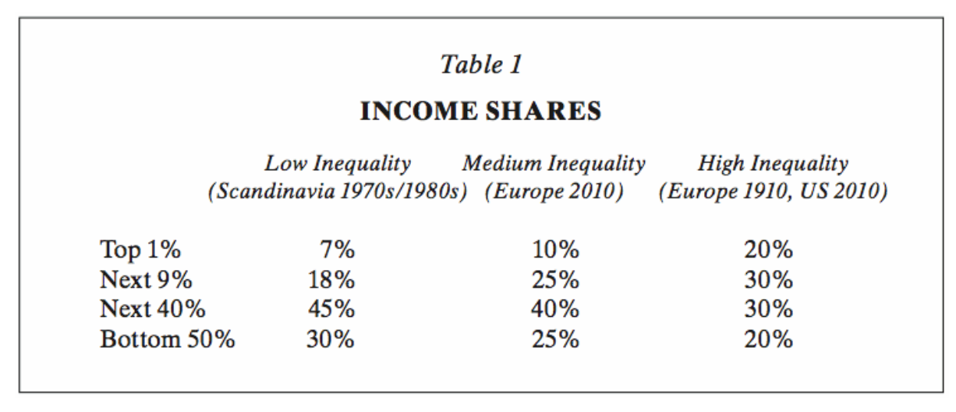

Krugman, P. (2014). Why We’re in a New Gilded Age. [online] The New York Review of Books. Available at http://www.nybooks.com/articles/2014/05/08/thomas-piketty-new-gilded-age/ [Accessed 15 April 2018].

Exhibit 2:
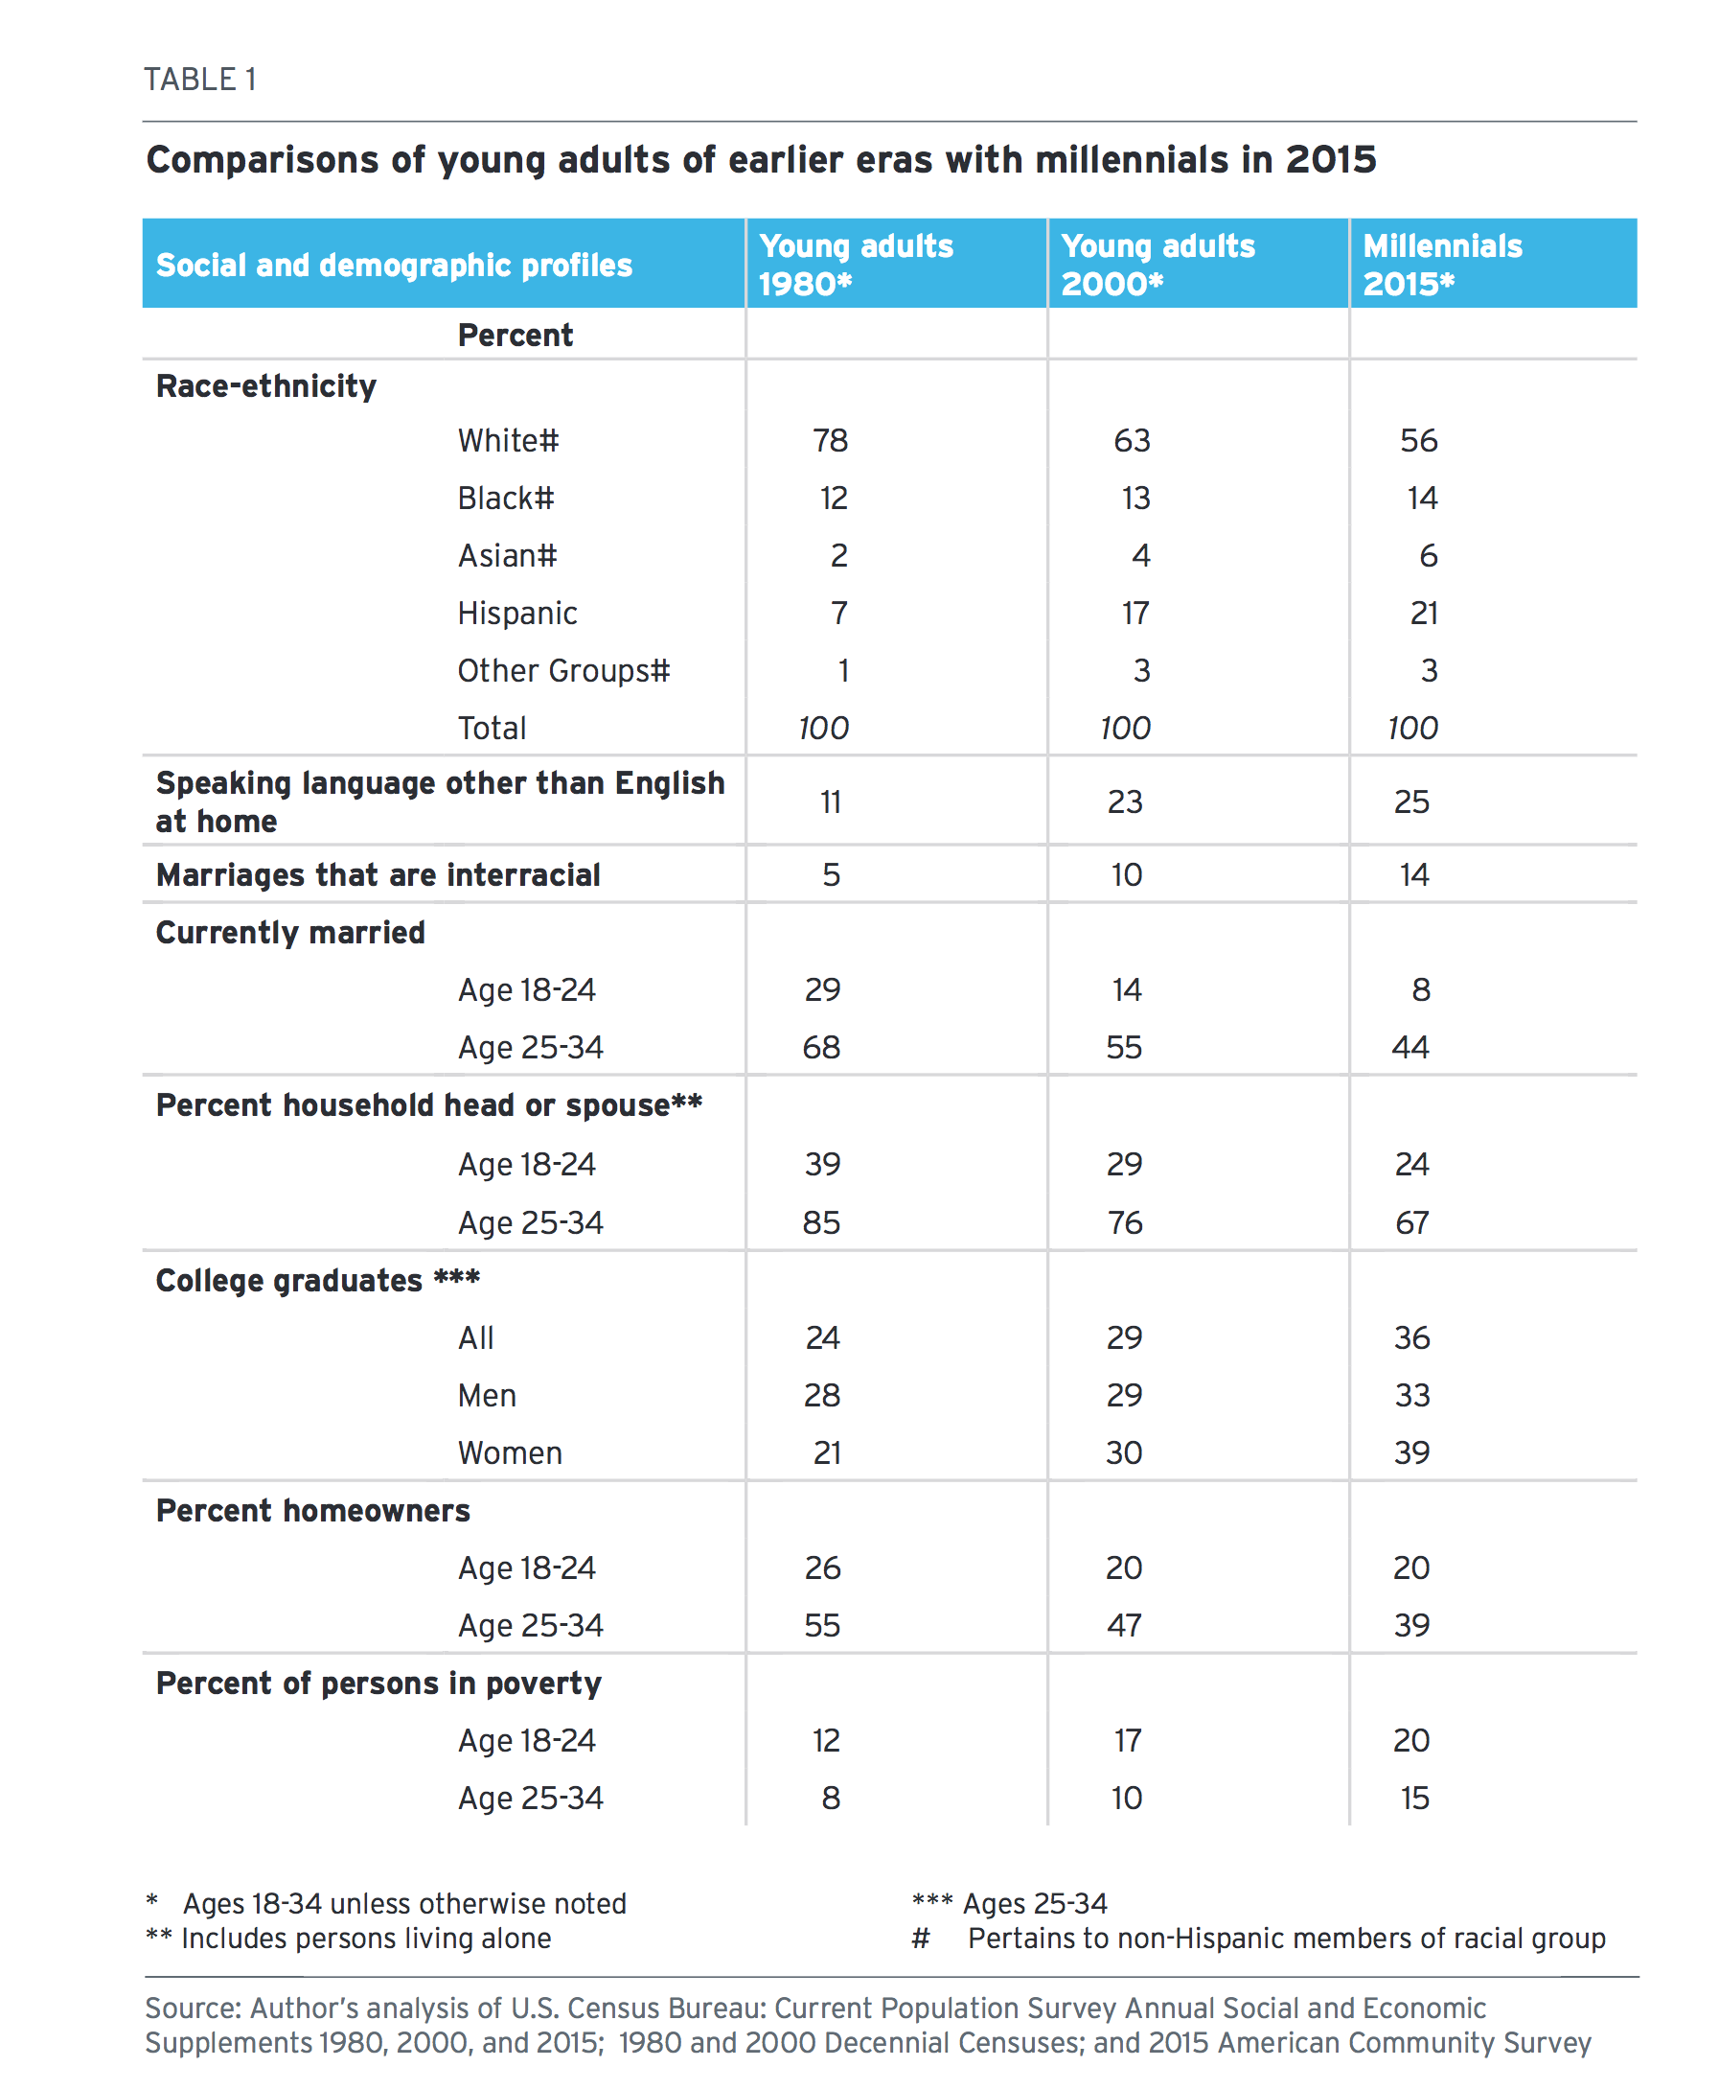
Frey, W. (2018) The Millennial Generation: A Demographic Bridge to America’s Diverse Future. Washington, D.C.: Brookings Institute.

