

LOCATION: Swansea | LLEOLIAD: abertawe
LEVEL 5 | LEFEL 5
EXAMINATION PERIOD | CYFNOD ARHOLIADAU
MAy 2020 | MAi 2020

MODULE CODE: ACCA5002
ROUTING AND SWITCHING CONCEPTS PRACTICAL
TIME: 2 HOURS

Student Name : ______________________
Student ID : ______________________
Date : ______________________

This is an individual practical lab-test, held under examination conditions. You will be assigned 3 Routers, 2 Switches and two PCs; you should configure these devices based on the following specifications.

This paper is marked out of 100.

TOPOLOGY DIAGRAM
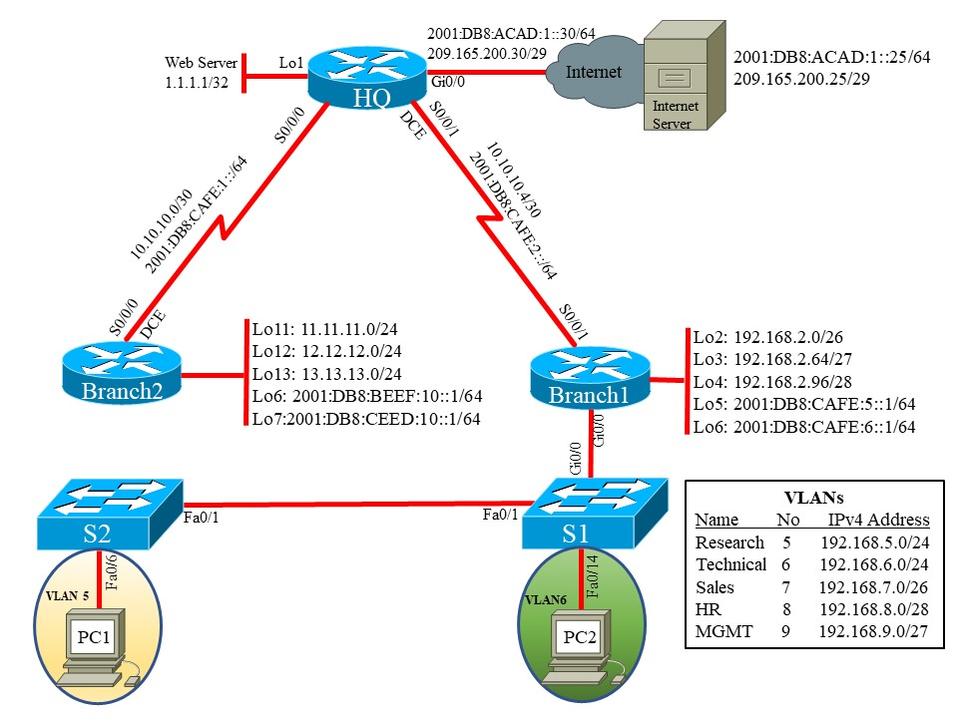

Switch 1 Ports to VLAN  Fa0/2 to 0/7 - VLAN 5  Fa0/8 to 0/14 - VLAN 6  Fa0/15 to 0/20 - VLAN 7  Fa0/21 to 0/24 - VLAN 8 | Switch 2 Ports to VLAN  Fa0/2 to 0/7 - VLAN 5  Fa0/8 to 0/14 - VLAN 6  Fa0/15 to 0/20 - VLAN 7  Fa0/21 to 0/24 - VLAN 8.

Task 1: IP addressing scheme (5 marks)

Device | Interface | IP Address | Subnet Mask | IPv6 Address
HQ | Ge0/0 |  | 255.255.255.248
 |  |  |  | Link-local:
HQ | S0/0/0 |  | 255.255.255.252
 |  |  |  | Link-local:
HQ | S0/0/1 |  | 255.255.255.252
 |  |  |  | Link-local:
HQ | Lo1 |  | 255.255.255.255
Branch 1 | S0/0/1 |  | 255.255.255.252
 |  |  |  | Link-local:
Branch 1 | Lo2 | 192.168.2.0 | 255.255.255192
Branch 1 | Lo3 | 192.168.2.64 | 255.255.255.224
Branch 1 | Lo4 | 192.168.2.96 | 255.255.255.240
Branch 1 | Lo5
Branch 1 | L06
 |  |  |  | Link-local:
Branch 1 | Gi0/0
Branch 2 | S0/0/0 | 10.10.10.1 | 255.255.255.252
 |  |  |  | Link-local:
Branch 2 | Lo11 | 11.11.11.1 | 255.255.255.0
Branch 2 | Lo12 | 12.12.12.1 | 255.255.255.0
Branch 2 | Lo13 |  | 255.255.255.0
Branch 2 | Lo6
Branch 2 | Lo7
S1 | VLAN 9 | 192.168.9.1 | 255.255.255.224
S2 | VLAN 9 | 192.168.9.2 | 255.255.255.224
Internet Server |  | 209.165.200.30 | 255.255.255.248
 |  |  |  | Link-local:

Task 2: Network Connection (5 Marks)

Using Packet Tracer software create the topology shown above and complete all task below.

Task 3: Configure the basic configuration (10 Marks)

            - Configure all devices with hostname
            - Disable DNS lookup
            - Configure all devices with interfaces as shown in the topology.
            - Configure Internet PC with IPv4 and IPv6 address.

Task 4: Configure Routers and Switches (65 marks)

1. Configure RIPv2 on all routers and advertise networks shown in the topology. Disable auto summary.
2. Configure IPv6 static route with exit interface on all routers.
3. On HQ, configure IPV4 and IPv6 default route out Gi0/0
4. On S1 and S2, configure VLANs
5. Assign the IPv4 address to Management VLAN on S1 and S2.
6. Assign default gateway on switches
7. On S1, force trunking on Gi0/0 and Fa0/1. Use VlAN1 as the Native VLAN
8. on S2, force trunking on Fa0/1. Use VLAN1 as the Native VLAN.
9. On S1, assign Fa0/6 to VLAN21 and on S2, assign Fa0/18 to VLAN23.
10. On both switches, shutdown all unused ports.
11. Configure Router-on-Stick inter-VLAN routing.
12. On all Routers, configure all Loopback and Ethernet interfaces as passive.
13. Configure Branch1 as the DHCP server for VLANs 5 to 8. Reserve first 10 IP addresses for static configurations.

VLAN 5  Name: Research  DNS-Server: 1.1.1.1  Domain-Name: SoAC.com  Set the default gateway | VLAN 6  Name: Technical  DNS-Server: 1.1.1.1  Domain-Name: SoAC.com  Set the default gateway | VLAN 7  Name: Sales  DNS-Server: 1.1.1.1  Domain-Name: SoAC.com  Set the default gateway | VLAN 8  Name: HR  DNS-Server: 1.1.1.1  Domain-Name: SoAC.com  Set the default gateway

14. Create a local database with 1 user account: username: webuser, password: soac1234, privilege: 15.
15. On HQ, configure a static NAT to the Web Server. Use the inside global address 209.165.200.26. Assign the inside and outside interface for static NAT.
16. Configure the dynamic NAT. Allow VLAN 5 and 6 networks on Branch 1to be translated.
17. Define the pool of usable public IP addresses, 209.165.200.225 to 209.165.200.228.
18. Define the dynamic NAT translation.

Task 5: Verify connectivity (15 marks)

After configuring each host computer, record the host network settings with the ipconfig /all command.

Host PC-A Network Configuration
Description
Physical Address
IP Address
Subnet Mask
Default Gateway

Host PC-B Network Configuration
Description
Physical Address
IP Address
Subnet Mask
Default Gateway

Verify PC-A can ping PC-B. Is it successful? __________________

Use a Web browser on the Internet PC to access the Web Server (209.165.200.26). Login with Username: webuser and password: soac1234.
Is the Web server accessible? _____________________________

Submission Requirement
The packet tracer file should be saved as “studentname_id” and uploaded on Moodle. In addition to packet tracer file, you must also submit
- the output of show running-configuration command in a text file for all devices configured.
- This document with task 1 and task 5 completed

All documentation for your solution should be submitted electronically on Moodle.
It is your responsibility that you submit all the outputs and files correctly.

