

Student Name: Yusuf Khan
Student Number: 2433537
Module Code and Title: BMHP5014 – Changemakers: Creativity and Value Creation Care
Task Title: Component 1 – Portfolio
Lecturer Name: Parese Ahmed

Table of Contents
Task 1 – Concept Map 3
Task 2 - Self-Reflection of Group Activity 4
Task 3 - Case Study of a UK innovation 6
Task 4 - Research Task: Barriers to Health and Social Care for Neurodivergent Older Adults 8
Task 5 - Podcast 9
Task 6 - NHS Leadership Framework Analysis 9
Task 7 - Self-Reflection Journal Entry 11
Reference List 13

Task 1 – Concept Map

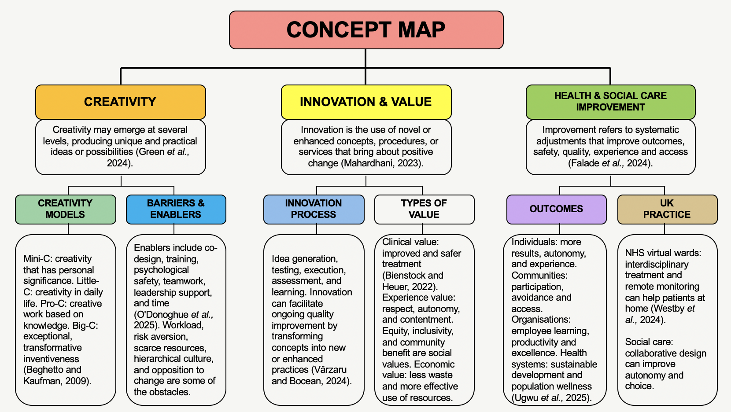

Task 2 - Self-Reflection of Group Activity
Description
Using Gibbs’ (1988) Reflective Cycle, I remember reflecting back on the convergent and divergent thinking exercise we did in class with paperclips. Five of us collaborated to find multiple uses for a paperclip. At first, it was utilised for the first. But together, we came up with 36 distinct uses. At first, I thought a paperclip is used to holding papers together. However, as a group, we realised that there are ways that we could use a paperclip.
Feelings
I was not sure how many ideas I could come up with at first. I was amazed by the diversity of perspectives among the group members. When we all shared our ideas and built on each other’s suggestions, I realised how we all have different ways of thinking about creativity.
Evaluation
The activity outcome was positive because working as a group allowed us to develop more ideas than I would have thought of independently. Although some of the concepts were out of the ordinary, they inspired us to think more imaginatively. Because one person's thought frequently inspired another, listening to others was very beneficial.
Analysis
Both divergent and convergent thinking were displayed in the exercise. Convergent thinking required evaluating and choosing the best ideas, but divergent thinking involved coming up with as many ideas as possible without immediately judging them. Divergent thinking involves producing multiple ideas, whereas convergent thinking focuses on reaching an appropriate solution (Barhak-Rabinowitz et al., 2026).
Conclusion
Through this module I have learned that creativity can begin with a simple object and that teamwork can improve problem-solving, as working in a team allows to form more ideas.

Action Plan
In the future, particularly when addressing issues related to health and social care, I will weigh many options before selecting one. To ensure to come up with better ideas, I will also pay close attention to what others have to say.

Task 3 - Case Study of a UK innovation
Case Study: AI-Enabled Stethoscope – Transforming Cardiac Detection in NHS Primary Care

Introduction

An inventive NHS initiative that shows how innovation and technology might enhance cardiovascular disease diagnosis in primary care is the AI-enabled stethoscope. The TRICORDER initiative, created by academics at Imperial College London and Imperial College Healthcare NHS Trust, brought an AI-enabled stethoscope to NHS general practitioners' offices. The technique uses a single-lead electrocardiogram (ECG), a conventional stethoscope, and artificial intelligence (AI) algorithms to detect heart failure, atrial fibrillation, and valvular heart disease symptoms (Kelshiker et al., 2026).

Creative Approach

The creativity of the innovation comes from enhancing an existing clinical tool rather than replacing established healthcare practice. The device takes ECG signals and heart sounds for around 15 seconds during a standard check-up. AI algorithms then analyse the data to look for patterns that could be challenging for medical professionals to identify. This makes it possible to integrate cutting-edge technology into a standard GP-patient session. The initiative additionally showed that it also highlighted its concentration on its creativity abilities. The TRICORDER trial involved 205 UK GP practices and examined not only whether the technology could detect disease, but also whether clinicians could successfully incorporate it into everyday practice. This is important because innovation in healthcare depends on both technological performance and effective adoption (Jia et al., 2026).

Value Created

The innovation has potential value for patients through earlier identification of cardiovascular conditions within primary care. According to the 2026 research, patients who underwent tests using the AI stethoscope had greater rates of heart failure, atrial fibrillation, and valvular heart disease than individuals who did not (Kelshiker et al., 2026). This may encourage earlier research and therapy and possibly lessen the need of individuals to receive a diagnosis after visiting the hospital. However, the research also revealed a critical limitation: because doctors did not regularly apply the equipment, the total improvement in heart-failure identification was not statistically significant. This demonstrates that implementing new technology alone is insufficient for effective innovation; proper training, workflow integration, and employee involvement are all necessary.

Conclusion

Overall, the AI-enabled stethoscope demonstrates how creativity can transform a familiar healthcare tool through AI. Its main value is the potential to bring more advanced cardiovascular screening into routine NHS primary care. The project also shows that innovation must be designed around patients, clinicians and existing healthcare systems to create sustainable change.

Task 4 - Research Task: Barriers to Health and Social Care for Neurodivergent Older Adults

Introduction
The difficulties elderly people with autism face in obtaining the support they require are a persistent problem in social and health care. Despite increased awareness of autism, many programs do not address the support, communication, and sensory needs of older autistic people. These disparities can be explained by two recent UK studies.

Research Finding 1: Healthcare Barriers
Mansour et al. (2025) examined the healthcare experiences of 19 autistic individuals who were 65 years of age or older in the United Kingdom. The researchers found that the patients had difficulty moving between different physicians, and they frequently described a lifetime of being misconstrued by medical professionals. Some individuals said that their autism was misdiagnosed or misrepresented, while others struggled to obtain an assessment or the appropriate support. Fear, inadequate treatment continuity, sensory sensitivity, and a lack of expert competence can restrict access to healthcare (Aitken et al., 2026). These results imply that the issue derives from healthcare systems being built on presumptions about patient behaviour and communication. According to Mansour et al. (2025), this makes it difficult for older people to ask for what they need or get the necessary accommodations.

Research Finding 2: Wider Service Access
The second study used focus groups and interviews, which investigated the experiences of older autistic people getting various services (Hersh et al., 2024). These outcomes showed that difficulties were caused by care-givers lack of comprehension and assistance. In order to navigate services, participants frequently had to come up with their own approaches. However, these techniques may be restricted, particularly if personnel were unaware of autism. Accordingly, the study indicates that services that do not meet the communicative, sensory, and support needs of individuals with autism also contribute to access issues (Hersh et al., 2024).

Conclusion
Overall, the studies demonstrate that inadequate knowledge, flexibility, and continuity in services can lead to health and social care disparities for older persons with autism. Enhancing employee education, communication, and customised modifications may contribute to more accessible and person-centred services.


Task 5 - Podcast

Task 6 - NHS Leadership Framework Analysis
Summary of the NHS Healthcare Leadership Model

A framework for comprehending the behaviours necessary for effective leadership across health and care services is provided by the NHS Healthcare Leadership Model. Inspiring a common purpose, leading with care, analysing information, linking our service, sharing the vision, engaging the team, holding ourselves accountable, growing capability, and influencing for outcomes are its nine dimensions (NHS Leadership Academy, 2026). In order to inspire shared purpose, choices must be made with patients, service users, and NHS values in mind. Supporting employee welfare and fostering a good work environment are key components of leading with care. When evaluating information, leaders must make judgements based on data from several sources. Collaborating across teams and companies is necessary to connect our service. Communicating a clear and inspiring path for progress is part of sharing the vision.

Involving employees, hearing their opinions, and promoting involvement are all elements of engaging the team. Setting clear expectations and making sure duties are understood are key components of holding people accountable. Building capacity promotes learning, skill improvement, and ongoing career advancement. To be able to attain favourable outcomes, influencing for results involves creating strong connections (NHS Leadership Academy, 2026).
When taken as a whole, these factors foster cooperation, supportive leadership, ongoing development, and excellent patient care.

Using “Engaging the Team” to encourage creativity
I have decided to use the Engaging the Team component. According to the NHS Leadership Academy (2026), this dimension encourages leaders to show that employees' opinions and expertise are appreciated by including them in decision-making. By holding frequent team meetings where nurses, healthcare assistants, physicians, and other professionals may identify issues and propose novel methods to patient care, an NHS leader may promote innovation.

For instance, the team leader may call the team together to design and test various ideas if staff members saw delays in informing patients. Establishing a welcoming environment will enable employees to discuss ideas, challenge current procedures, and grow from errors without worrying about being blamed. Instead of only adhering to established protocols, employees are actively involved in creating changes, which helps foster innovation. The leader may then try potential concepts, get input from staff and patients, and track results using quality-improvement techniques. NHS England (2026) highlights how crucial it is to include people in the creation and testing of changes. Therefore, including employees may foster innovation while advancing safer, more efficient, and patient-centred care.

Task 7 - Self-Reflection Journal Entry

My understanding of innovation and value creation in health and social care has evolved as a result of this session. Prior to finishing the module, I mostly thought of creativity as creating something original or imaginative. I now realise that being creative may also entail coming up with novel solutions to issues, enhancing current offerings, and paying attention to what patients, clients, and employees have to say.

I was able to comprehend the significance of divergent and convergent thinking thanks to the paperclip exercise. It demonstrated that coming up with several concepts before selecting the best one can result in successful outcomes. Studying innovation in the NHS showed that being creative does not entail overhauling a system. Enhancing an already-existing instrument, service, or procedure can occasionally provide patients with substantial benefits.

The module has made me think more about leadership and teamwork. I have learned that engaging staff and creating an environment where people feel comfortable sharing ideas can encourage innovation and improve care. My anxiety awareness campaign, “Break the Cycle – You’re Not Alone,” helped me apply these ideas by developing a creative approach to raising awareness and reducing stigma.

Additionally, the program has increased my awareness of cooperation and leadership
I have discovered that encouraging staff engagement and fostering an atmosphere where individuals feel free to share ideas may promote creativity and enhance service. I was able to put these concepts into practice by creating a strategy for increasing knowledge and lowering stigma through my campaign, "Break the Cycle – You're Not Alone." In my professional work, I will be more receptive to many viewpoints, consider several approaches to issues and explore how modifications might enhance patient outcomes and experiences. I believe creativity is a crucial component of person-centred, efficient and compassionate treatment

Reference List

Aitken, R., Berry, K., Gowen, E. and Brown, L.J. (2026) ‘How do autistic adults experience ageing? A qualitative interview study’, Autism, 30(4), pp.1047-1061.

Barhak-Rabinowitz, M., Karelitz, T.M. and Roll, I. (2026) ‘Measuring the iterative process of creative thinking: uncovering the interplay between divergent and convergent thinking’, Learning and Individual Differences, 125, p.102821.

Bienstock, J. and Heuer, A. (2022) ‘A review on the evolution of simulation-based training to help build a safer future. Medicine, 101(25), p.e 29503.

Falade, I.M., Gyampoh, G.K.S., Akpamgbo, E.O., Chika, O.C., Obodo, O.R., Okobi, O.E., Aguguo, J.C. and Chukwu, V.U. (2024) ‘A comprehensive review of effective patient safety and quality improvement programs in healthcare facilities’, Medical Research Archives, 12(7).

Green, A.E., Beaty, R.E., Kenett, Y.N. and Kaufman, J.C. (2024) ‘The process definition of creativity’, Creativity Research Journal, 36(3), pp.544-572.

Hersh, M., Mery, P. and Dawson, M. (2024) Older Autistic People, Access and Experiences of Services, and the Factors That Affect This, International Journal of Environmental Research and Public Health. Available at: https://pmc.ncbi.nlm.nih.gov/articles/PMC11593569/?utm_source (Accessed: 27 September 2026).

Jia, F., Aboagye, S., Shahzadi, G. and Chen, L. (2026) ‘Sustainable practices in healthcare supply chains: a review of strategies, challenges, and impacts’, International Journal of Logistics Research and Applications, 29(4), pp.417-441.

Kelshiker, M.A., Bächtiger, P., Petri, C.F., Nakhare, S., Mansell, J., Chhatwal, K., Alrumayh, A., Zaman, J., Shah, M., Young, H. and Roy, H. (2026) ‘Triple cardiovascular disease detection with an artificial intelligence-enabled stethoscope (TRICORDER) in the UK: a cluster-randomised controlled implementation trial’, The Lancet, 407(10529), pp.704-715.

Mahardhani, A.J. (2023) ‘The role of public policy in fostering technological innovation and sustainability’, Journal of Contemporary Administration and Management (ADMAN), 1(2), pp.47-53.

Mansour H, Gillions A, Brown J, Pattenden A, Hartley S, Patel S, James S, Styles M, Mandy W, Stott J, O'Nions E. (2025) 'It's designed for someone who is not me': A reflexive thematic analysis of the unmet healthcare support needs in UK autistic adults aged 65 years and over. Autism. Available at: https://pubmed.ncbi.nlm.nih.gov/39470046/ (Accessed: 30 September 2026).

NHS England (2026) What is improvement? NHS England. Available at: https://www.england.nhs.uk/nhsimpact/what-is-improvement/?utm_source (Accessed: 30 September 2026).

NHS Leadership Academy (2026) Healthcare Leadership Model. NHS Leadership Academy. Available at: https://leadershipnhs.uk/?utm_source (Accessed: 28 September 2026)
O'Donoghue, F., O'Donnell, M.T., Griffin, T.P., Fahy, E., Newell, E. and Creaven, A.M. (2025) ‘Enablers and Barriers to an Experience‐Based Co‐Design Process to Develop Service Improvements in Enhanced Community Care in Ireland: A Qualitative Study’, Health Expectations, 28(2), p.e 70206.

Ugwu, C.N., Ugwu, O.P.C., Alum, E.U., Eze, V.H.U., Basajja, M., Ugwu, J.N., Ogenyi, F.C., Ejemot-Nwadiaro, R.I., Okon, M.B., Egba, S.I. and Uti, D.E. (2025) ‘Sustainable development goals (SDGs) and resilient healthcare systems: Addressing medicine and public health challenges in conflict zones’, Medicine, 104(7), p.e 41535.

Vărzaru, A.A. and Bocean, C.G. (2024) ‘Digital transformation and innovation: The influence of digital technologies on turnover from innovation activities and types of innovation’, Systems, 12(9), p.359.

Westby, M., Ijaz, S., Savović, J., McLeod, H., Dawson, S., Welsh, T., Le Roux, H., Walsh, N. and Bradley, N. (2024) ‘Virtual wards for people with frailty: what works, for whom, how and why a rapid realist review’, Age and ageing, 53(3), p.afae039.

