

APPENDIX GA36c

LEVEL 6 ASSESSMENT SPECIFICATION

Programme: | BA (Hons) Leadership and Management Skills for the Workplace
Module: | Developing Emotional Intelligence Skills for the Workplace
Module code: | BMSW6106 | Contribution  to Overall  Module | 100%
Module Lecturer :  Student Name :  Student id no : | Amare Desta  Iosif Tcaciu  2022775 | Internal Verifier: | Md Kalam
There are components for this module CW: | Assessment Task 1 –Individual Report, and Task 2 Individual Poster. | Word count | 3,500 + 10% words

Table of Contents
LEVEL 6 ASSESSMENT SPECIFICATION 1
Introduction 3
Significance of Emotional Intelligence in the Business Organization 3
Key Model of Emotional Intelligence in the Business Organization 5
Necessity of Developing Emotional Intelligence in the Business Organization 6
Relationship Between Emotional Intelligence and Effective Management 8
Practices of Emotional Intelligence in Unilever PLC to Develop Workforce 10
Ways to Improve Emotional Intelligence for Develop Workforce of Organization 11
Conclusion 12
Reference 13
Appendix - Assessment Task 2 –Individual 15
Poster Presentation 15
Introduction 15
Major Benefits of Emotional Intelligence (EI) 15
Key Types of Emotional Intelligence (EI) 17
Key Ways Considered to Improve own Emotional Intelligence (EI) 18
Conclusion 20

List of Figures
Figure 1: Traits of Emotional Intelligence 4
Figure 2: Goleman’s Model of Emotional Intelligence 5
Figure 3: Necessity of Emotional Intelligence 7
Figure 4: Roles of Effective Management 9

Introduction
Emotional intelligence refers to the ability of people to interpret, perceive, control and demonstrate the emotions of people to adapt to the situation to communicate properly. It also indicates the use of emotions to effectively communicate with people and constructively adapt to the situation with proper balancing. It is recognized as the most significant skill in the workplace that helps to describe and identify people's feelings properly. It also boosts self-awareness and self-confidence which helps to balance work stress and daily life. It drives people to embrace changes and improve their ability to communicate people with in an effective manner (Arslan and Iseri, 2018). It helps to enhance the compatibility to accept responsibility properly and manage emotions in adverse situations in the workplace. Unilever PLC is one of the most successful consumer product companies in the UK which is also operating its business activities internationally. It is also known as the most ancient consumer goods company in the UK which concentrates on developing the workplace environment as well as improving the workforce of the company. Unilever focused on the quality of the goods that make them the most accepted brand among people. It concentrates on improving its employees by training up properly and adapting them to adverse corporate situations to handle them properly. They also take several initiatives to enhance the emotional intelligence quality among the employees for better outcomes. This report will discuss different models and the significance of emotional intelligence in the organization to build effective communication systems. It also interprets the impact of emotional intelligence skills among the employees of Unilever as well as their advantage in the organization to adapt to unfavourable situations.

Significance of Emotional Intelligence in the Business Organization
Emotional intelligence is recognized as a significant trait of the employees which helps them to perceive others feeling as well as build proper communication systems. It is required to enhance efficiency, embrace proper collaboration and communicate precisely. It helps to control the team members by regulating their emotions and intentions for better teamwork (Brooks and Nafukho, 2016). The employees work in different positions at the organization where people come from diversified places. A proper communication system is a prerequisite to achieving organizational goals by combining the efforts of the employees. For building and effective communication systems, all employees should be concerned about their emotions as well as understand the emotions of team members to obtain better outcomes. The team leader also has proper proficiency in emotional intelligence reflected in this leadership quality. A team leader is responsible for driving his employees to enhance the quality of work and efficiency as well as communication systems. He is also having the quality to understand the behaviours and emotions of the employees to combine their efforts for better outcomes. Emotional intelligence is an interpersonal skill that concentrates on improving critical emotional regulation that implies the performance of the individual (Severinsson, 2016). It also indicates the underlying behaviour characteristics as well as critical emotions of the people. It also develops the interpersonal skills of the individuals and improves the team combination in business organizations. The core traits of the emotional intelligence are given below:
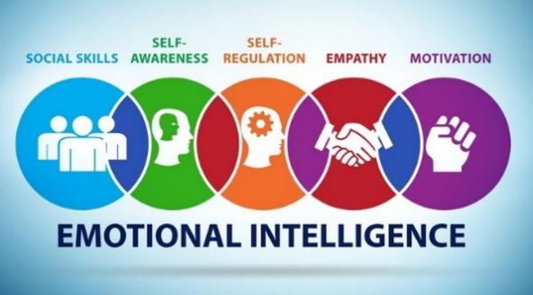
Figure 1: Traits of Emotional Intelligence
Source: (Petrides and Furnham, 2017)
Social skills indicate the ability to communicate with people effectively and conflict regulation to enhance empathy with people. It requires relationship management in the team and the business organization that improves their efficiency and interactions. It also helps to perceive the feelings of people and identify the emotional gestures of the people. Self-awareness drives a person to confess their feelings and their thoughts to improve their understanding as well as the weaknesses and strengths of individuals (Brody, 2017). People have to be concerned about feelings and emotions to control their activities as well as improve their interpersonal skills. Self-regulation drives a person to control their emotions and feelings appropriately to bring maximum outcomes of their efforts. The people concentrated on the adverse working situation by embracing the changes at the workplace. It also brings positive outcomes for the people in the business organization as well as developing the relationships among the employees. Emotional intelligence also enhances empathy among people to understand and critically evaluate the behaviours and feelings of the people. It also enhances the motivation among the people and drives them to put their best effort into achieving organizational goals (Akila and Thangavel, 2017). Emotional intelligence is the main driver to enhance team performance and efficiency in decision-making in business organizations. This interpersonal skill influences personal well-being positively and helps to reduce the employee turnover of the company. It also drives leadership skills positively and reduces the working stress of the employees helping to obtain predetermined goals. Emotional intelligence has a great impact on the workforce of Unilever PLC where employees are concerned about developing this particular skill for balancing work life appropriately. It also enhances the efficiency as well as excellence team performance of the organization (Calza and Passaro, 2016). It helps to build an appropriate communication system that helps to improve teamwork as well as leadership skills in the organization.

Key Model of Emotional Intelligence in the Business Organization
Interpersonal skills are crucial to developing communication and understanding for effective interaction with people. Emotional intelligence is focused on improving the understanding of other's perceptions and feelings. It also develops the insights of the people to understand the characteristics and signals of others to ensure proper interactions. It helps to improve the experience of negotiating and managing people efficiently. It mainly concentrates on particular problems of the business organization using critical insights and interpersonal skills. Emotional intelligence has a direct influence on improving the behaviour and gestures of people as well as understanding people (Brooks and Nafukho, 2016). The model of emotional intelligence implies that emotional intelligence helps to develop interpersonal skills as well as regulate the emotions of people positively. The emotional intelligence model also interprets the elements that have an impact on the self-development and improving the teamwork of the organization. It also interprets how emotional intelligence reflects on the perception, behaviour and feelings of people as well as mastering them to regulate emotions. The relevant model of emotional intelligence is given below:
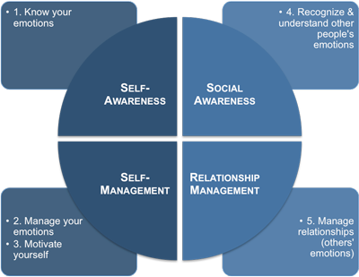
Figure 2: Goleman’s Model of Emotional Intelligence
Source: (Costa and Faria, 2020)
Goleman's Model of emotional intelligence provides insights that help to identify the capability of interpersonal skills to regulate emotions to better understand other's feelings. Emotional intelligence helps to enhance the learning and capability of the people which brings outstanding individual as well as team performance. The model also implies the significance of emotional intelligence which helps to understand the feelings and thoughts of others for better communication. David McClelland's Model of emotional intelligence demonstrated the proficiencies of executing cluster-based or level not only individually. He explained that a single set of elements or characteristics does not bring success to the individuals rather than team or combinations of proficiencies produce better results (Harrington and Musial, 2018). The business organization concentrated on developing the combination of teamwork for better outcomes. The team of the company are working like a cluster that integrates individual proficiencies in a single set. Diversification of the proficiencies in teamwork can lead to greater performance and success for the organizations. This model also emphasises that integrated proficiencies in teamwork or cluster-based are bring better results than individual proficiencies. Richard Boyatzi's model of emotional intelligence identifies four different relationships in cluster-based work that imply them to greater success. Complementary relationships in teamwork indicate that the proficiencies of one person affect the proficiency of another person in the teamwork. It helps to enhance reliability and consistency in a team by combining each other (Sommer and Wilhelm, 2015). Alternate manifestations indicate the representations of the identical proficiencies of an individual that are reflected in a specific situation. And compensatory relationship in teamwork ensures covering one's weaknesses with other strengths to balance the team. The antagonistic relationship of Richard Boyatzis' model interprets that one has the potential to show proficiencies to prevent the contribution of others to make balance to bring the best performance. These models develop the understanding of emotional intelligence that helps to regulate emotions properly and build effective communication in the business organization.

Necessity of Developing Emotional Intelligence in the Business Organization
Intelligence is a set of skills that assist in solving problems and developing critical thinking of individuals. It also helps to manage the situation using analytical skills to bring maximum outcomes. The emotional feelings and perceptions of the people are driving them to behave irrationally and conduct unregulated work. However emotional intelligence helps to develop the regulation of the feelings of the people and improve their interpersonal skills to communicate properly (Mayer and Salovey, 2016). Emotional intelligence also emphasizes to development of communication skills and social interaction among people by enhancing self-management. It also develops the insights of the individuals to perceive the thoughts of others as well as their feelings. Emotional intelligence is developing personal traits and cognitive abilities that help to improve the critical thinking and leadership of the individual. It provides great support to successfully execute the work of the business organization. The success of business organizations greatly depends on the effectiveness of the communication systems of the organization. The communication systems of the organization are greatly dependent on the interaction capability among the people which requires satisfactory emotional intelligence (Severinsson, 2016). Emotional intelligence also provides pertinent aspects to the emotions that assist individuals in navigating their feelings and emotions efficiently. It also helps individuals control their emotions reduce working stress as well and enhance balance in life. Emotional intelligence helps to regulate emotions by using a given procedure.
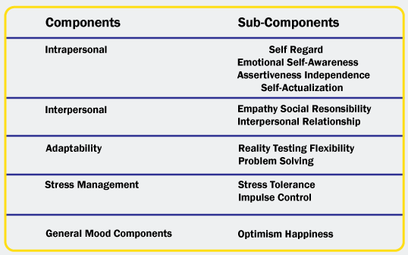
Figure 3: Necessity of Emotional Intelligence
Source: (Akila and Thangavel, 2017)
Emotional intelligence helps to develop intrapersonal skills of the employees in the organization that drive their performance in the organization. It helps to increase the self-regard of the people and enhance their accountability and responsibility towards the organization. It also improves the emotional self-awareness of the people which drives them to regulate their feelings and emotions towards others. It helps to increase the assertiveness of independence of the people which is to encourage them to control their daily thoughts and activities that drives their performance with appropriate self-actualization. Emotional intelligence has developed interpersonal skills of the people which helps improve empathy of the people and social responsibility (Costa and Faria, 2020). The people are proficient in perceiving the feelings of the individuals and their colleagues to maintain effective communication systems. emotional intelligence also progresses interpersonal relationships among the team members of the organization. They are facilitating the better opportunities that are shared among themselves. It also helps to improve adaptability to embrace the changes and adverse situations adequately. It assisted in developing the perception towards reality with flexibility and enriched problem-solving skills. Their problem-solving skills drive them to find a solution to the most required issues quickly (Brody, 2017). Emotional intelligence enhances the stress tolerance of people which makes proficient them in managing their working stress. It also drives the impulse control of the people positively bringing better performance among the people. Proper emotional intelligence optimises the happiness of the people and brings peace with intense working pressure of people. The business organization requires a higher level of emotional intelligence skills among the employees to build adequate communication systems as well as bring optimum performance to the employees.

Relationship Between Emotional Intelligence and Effective Management
The employees of the business organizations are responsible for regulating their feelings and controlling their emotions to perform their duties properly. If the employees have proper control over their feelings and emotions, they can perform their work appropriately. The employees of the organization should be trained to regulate and control their emotions to improve their work-life balance. It also emphasises improving interpersonal skills as well as boosting the interpersonal skills of the employees to enhance proper interaction. Emotional intelligence improves the emotional sense and cognition of the people and enhances their communication skills and interaction with the people (Arslan and Iseri, 2018). It also enhances the proficiency of the employees to perceive the emotional signals of the team members and predict the feelings that they want to express. Effective management of the organization is responsible for ensuring a favourable environment for the employees. It also ensures precise goals and managing and adequate communication systems that emphasise continuous improvement of the organization. The management of the organization is responsible for ensuring the proper development of the employees of the organization by conducting training and employee development programs. It also enhances the effectiveness of interpersonal skills and teamwork in an organization where emotional intelligence plays a significant role (Choudhury, 2021). The influence of emotional intelligence on effective management is given below:
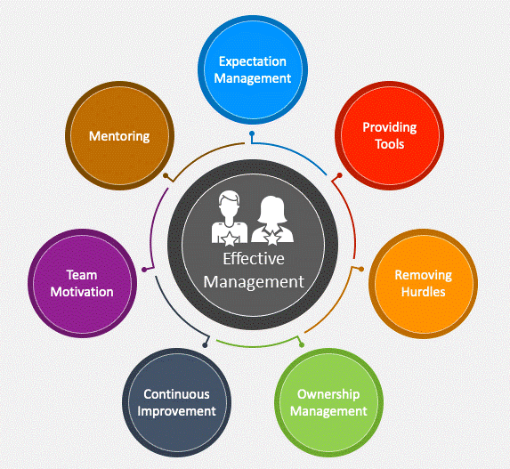
Figure 4: Roles of Effective Management
Source: (Ghoshal and Bartlett, 2014)
Effective management is providing developing tools for the employees as well as arranging different workshops and training programs to improve the skills of employees. The management has concentrated on emotional intelligence in the training program consequences interpersonal development as well as drives the performance positively. It also reduces hurdles for the organization by developing the skills of the employees. The management also ensures proper ownership management that drives the performance of the employees (Mayer and Salovey, 2016). Emotional intelligence boosts the self-confidence of the employees which helps them to perform better among different hurdles and difficult situations. The emotional intelligence of the employees results in continuous improvement of the organization structure with greater success. The teamwork of the organization is developing and improvised by efficient communication skills of the employees as well as drives their performance satisfactorily. The emotional intelligence of the leader helps to enhance team motivation by predicting the feelings and necessities of the team members who pursue them positively. The proper interpersonal skills of the team leader have provided appropriate direction and adequate mentoring to the people to enrich their experience and performance. the leader also mentors his team members properly to regulate the expectation management to obtain predetermined goals (Salovey and Woolery, 2018). Emotional intelligence plays a significant role in developing effective management in the organization.

Practices of Emotional Intelligence in Unilever PLC to Develop Workforce
Emotional intelligence is recognized as a significant personal trait of the employees to enrich their performance in the organization. It helps them to improve themselves by managing working stress and embracing the changes in the organization. It enhances the adaptability of the employees to embrace the unfavourable situation of the organization as well as removing hurdles. The management of the organization has taken different initiatives to improve this interpersonal skill to expedite the performance of the individuals (Ghoshal and Bartlett, 2014). Unilever PLC is one of the leading consumer goods companies in the international market. It is operating its business activities and promoting its business internationally. Unilever conducts its business in over 190 countries in the world with 400 brand names. The success of the company mostly relies on the appropriate decision of the management as well as initiatives to develop their working environment and workforce. Unilever has regulated their business activities to find inconsistencies and lacking among the employees (Calza and Passaro, 2016). The company emphasises the training program of emotional intelligence to ensure proper mental health and communication systems in the company. It helps to assist the employees to manage their working stress that can’t affect their performance. Emotional intelligence helps employees to regulate their feelings and emotions that are reflected in their performance. They are concerned about the feelings and thoughts of their colleague and team members which helps them to communicate properly. A leader of the team has to be proficient in emotional intelligence which helps him to estimate the necessity of the team member and fulfill those to bring optimum performance. The management also facilitates building and communication systems with the proficient employees of the company. They also adapt the changes in the company policy and objectives efficiently with the proficiency of emotional intelligence (Weingardt, 2015). The proficiency of emotional intelligence enhances the efficiency of decision-making of the management. It helps to improve the mental and physical well-being of the employees of the company as well as decline the turnover of the staff. It mainly concentrates on reducing the working stresses of the employees and ensuring mental stability to perform their duties adequately. Emotional intelligence also expedites leadership ability that improves the teamwork of the company which plays a significant role in promoting company products as well as expanding business over the world.

Ways to Improve Emotional Intelligence for Develop Workforce of Organization
To improve the emotional intelligence of the employees of the organization, the management should take different initiatives and train the employees. Emotional intelligence has expedited the performance of the employees positively which helps to achieve organizational goals properly. Employees are perceived as the signals of the colleagues that express their feelings and behaviour. Emotional intelligence helps to develop the understanding of the employees about the feelings and perceptions of coworkers to communicate effectively to form efficient teamwork (Salovey and Woolery, 2018). The teamwork can be expedited under the guidance of proficient emotional intelligence leadership that perceives the necessity of the employees as well as encompasses the interpersonal skills of the people. It also helps to develop the adapting skills of the employees to embrace the changes in the organization. The company has emphasised improving the emotional intelligence of the employees after the adverse effects of the Covid-19 pandemic. The world was stuck in an adverse situation and people were isolated in the house for a long time. The employees of different multinational companies conduct home office but couldn't build an affected communication system like regular days without physical interaction. During a pandemic, employees experience intense working stress as well as a lack of physical presence in the office that adversely affects their mental health and performance. The necessity of the emotional intelligence of the organization has impacted the performance of the employees and the organizational success (Harrington and Musial, 2018). Proficient employees with proper emotional intelligence can bring the success of the organizations. The ways to improve emotional intelligence in the organization are given below:
- Enhance the self-awareness of the employees by taking the initiative to ensure better understanding and identifying emotional triggers and feelings of the people.
- Improve the listening skills of the employees to ensure proper communication in the teamwork where employees are facilitating with adequate insights and better understanding.
- Demonstrate self-control of the employees by emphasizing the training program and workshop that enhance control over emotions and feelings.
- Improve the capability of the individual to regulate emotions and feelings to understand the conditions of other people as well as expedite appropriate interaction.
- Grow a strong sense of gratitude and appreciation to recognise the effort of others and perceive the needs of other people to encourage them to perform better.

Conclusion
Emotional intelligence is the capability to understand the emotions and feelings of individuals as well as others to regulate them properly to perform better. It also refers to the personal capability to regulate and monitor an individual's emotions and activity rationally. It emphasises the development of interpersonal skills to the consequences of effective communication systems in the organization. It also concentrates on improving the leadership style of the company to expedite teamwork to bring greater success to the company (Sommer and Wilhelm, 2015). Emotional intelligence plays playing significant role in developing effective management in the organization as well as improving the leadership style to drive the workforce to obtain organizational goals. Unilever PLC is a well-known multinational company in the world which also concentrates on emotional intelligence to improve the interpersonal skills of the employees. It emphasises the adaptability of the employees who embrace the changes and difficult situations such as the COVID-19 pandemic and other inconsistencies. By employing proper emotional intelligence among the employees, the company can drive its business activities with a strong communication system.

Reference
Akila, R. and Thangavel, N. (2017). Team Leader’s Emotional Intelligence Competencies and Team’s Emotional Intelligence Norms. Indian Journal of Applied Research, 3(3), pp.211–213. doi https://doi.org/10.15373/2249555x/mar2013/69.
Arslan, S. and Iseri, I. (2018). Social emotional learning and emotional intelligence: the predicting role of emotional intelligence. International Journal of Happiness and Development, 4(2), p.113. doi:https://doi.org/10.1504/ijhd.2018.10013184.
Brody, N. (2017). Emotional Intelligence: Science and Myth. Intelligence, 32(1), pp.109–111. doi:https://doi.org/10.1016/s0160-2896(03)00059-x.
Brooks, K. and Nafukho, F. (2016). Human resource development, social capital, emotional intelligence. Journal of European Industrial Training, 30(2), pp.117–128. doi:https://doi.org/10.1108/03090590610651258.
Calza, F. and Passaro, R. (2016). EDI network and logistics management at Unilever‐Sagit. Supply Chain Management: An International Journal, 2(4), pp.158–170. doi:https://doi.org/10.1108/13598549710191322.
Choudhury, Dr.J. (2021). Emotional Intelligence, Socio-Emotional Competence and Human Capital. RA Journal Of Applied Research, 07(04). doi:https://doi.org/10.47191/rajar/v7i4.08.
Costa, A. and Faria, L. (2020). Implicit Theories of Emotional Intelligence, Ability and Trait-Emotional Intelligence and Academic Achievement. Psihologijske teme, 29(1), pp.43–61. doi:https://doi.org/10.31820/pt.29.1.3.
Ghoshal, S. and Bartlett, C. (2014). The Multinational Corporation as an Interorganizational Network. Academy of Management Review, 15(4), pp.603–626. doi:https://doi.org/10.5465/amr.1990.4310825.
Harrington, A.M. and Musial, A. (2018). Improving Emotional Intelligence through Personality Development: The Effect of the Smart Phone Application based Dharma Life Program on Emotional Intelligence. Frontiers in Psychology, 9(3). doi:https://doi.org/10.3389/fpsyg.2018.00169.
Mayer, J. and Salovey, P. (2016). The intelligence of emotional intelligence. Intelligence, 17(4), pp.433–442. doi:https://doi.org/10.1016/0160-2896(93)90010-3.
Petrides, K. and Furnham, A. (2017). The Role of Trait Emotional Intelligence in a Gender-Specific Model of Organizational Variables1. Journal of Applied Social Psychology, 36(2), pp.552–569. doi https://doi.org/10.1111/j.0021-9029.2006.00019.x.
Salovey, P. and Woolery, A. (2018). Perceived Emotional Intelligence, Stress Reactivity, and Symptom Reports: Further Explorations Using the Trait Meta-Mood Scale. Psychology & Health, 17(5), pp.611–627. doi:https://doi.org/10.1080/08870440290025812.
Severinsson, E. (2016). Emotional intelligence: Part 1: The development of scales and psychometric testing. Nursing & Health Sciences, 11(1), pp.58–63. doi https://doi.org/10.1111/j.1442-2018.2009.00431.x.
Sommer, W. and Wilhelm, O. (2015). Perceiving and remembering emotional facial expressions — A basic facet of emotional intelligence. Intelligence, 50(5), pp.52–67. doi:https://doi.org/10.1016/j.intell.2015.02.003.
Weingardt, C. (2015). Organization Structure and Communication in the Unilever Company. International Studies of Management & Organization, 1(4), pp.377–393. doi https://doi.org/10.1080/00208825.1971.11656102.

Appendix - Assessment Task 2 –Individual

Poster Presentation
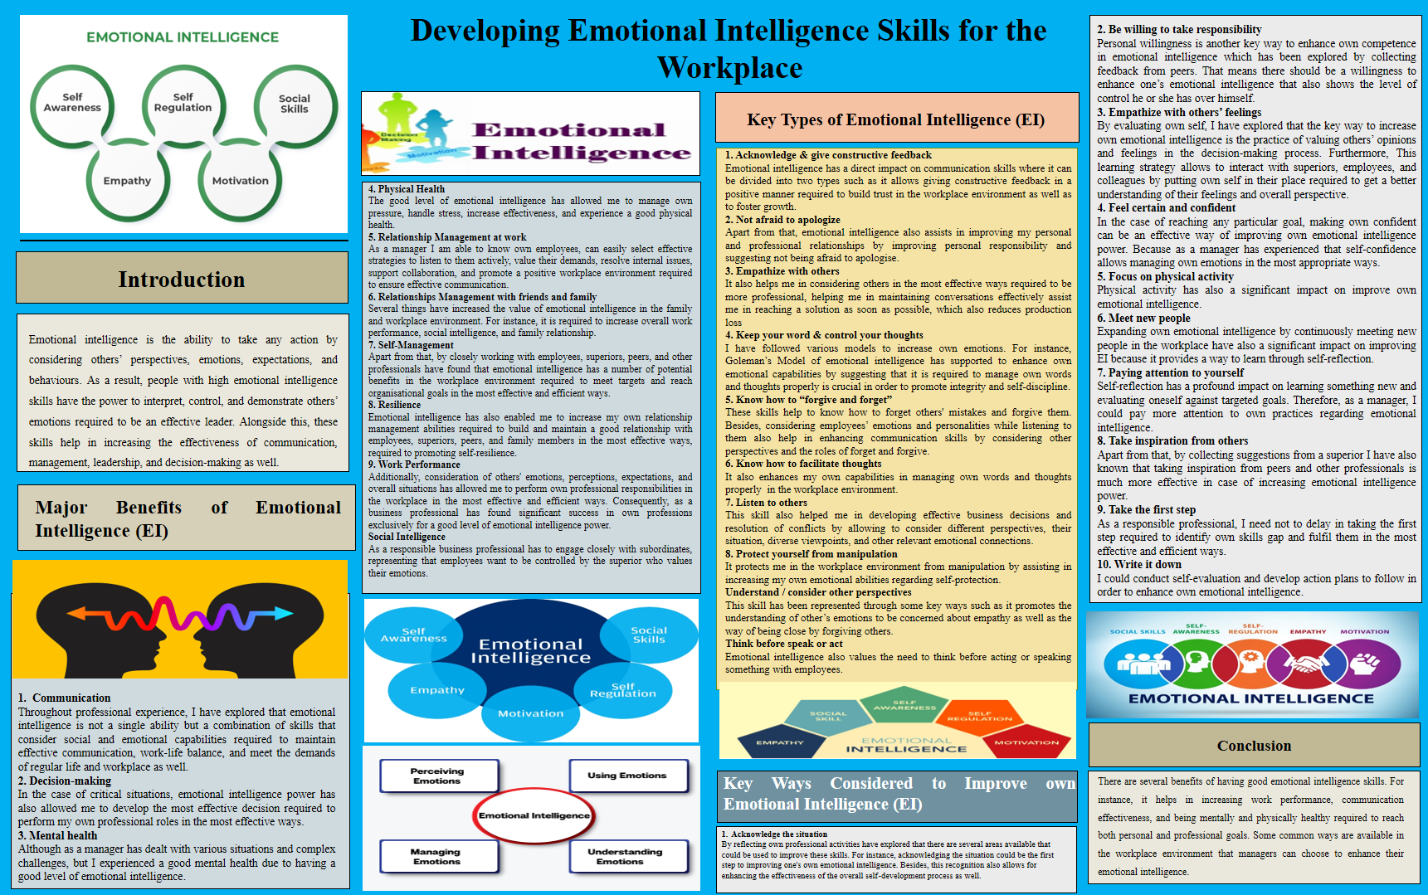

Introduction
Emotional intelligence is the ability to take any action by considering others’ perspectives, emotions, expectations, and behaviours. As a result, people with high emotional intelligence skills have the power to interpret, control, and demonstrate others’ emotions required to be an effective leader. Alongside this, these skills help in increasing the effectiveness of communication, management, leadership, and decision-making as well. Moreover, there are several ways available to improve these skills such as meeting new people, increasing willingness, etc.

Major Benefits of Emotional Intelligence (EI)
- Communication
Throughout my professional experience, I have explored that emotional intelligence is not a single ability but a combination of skills that consider social and emotional capabilities required to maintain effective communication, and work-life balance, and meet the demands of regular life and the workplace as well.
- Decision-making
In the case of critical situations, emotional intelligence power has also allowed me to develop the most effective decision required to perform my professional roles in the most effective ways. For instance, as a professional manager, I have analysed a situation from several perceptions by considering various emotions and their impact on the challenges or problems. Considering this way has developed an effective decision that further being well accepted by others.
- Mental health
Although as a manager I have dealt with various situations and complex challenges, I experienced good mental health due to having a good level of emotional intelligence.
- Physical Health
A good level of emotional intelligence has allowed me to manage my pressure, handle stress, increase effectiveness, and experience good physical health.
- Relationship Management at Work
A good level of emotional intelligence has assisted in getting a better understanding of employees required to know them more effectively. For instance, as a manager, I can know my employees, can easily select effective strategies to listen to them actively, value their demands, resolve internal issues, support collaboration, and promote a positive workplace environment required to ensure effective communication.
- Relationship management with friends and family
Several things have increased the value of emotional intelligence in the family and workplace environment. For instance, it is required to increase overall work performance, social intelligence, and family relationships. Therefore, as a professional manager, I am highly serious about emotional intelligence in my own personal and professional life.
- Self-Management
Apart from that, by closely working with employees, superiors, peers, and other professionals have found that emotional intelligence has several potential benefits in the workplace environment required to meet targets and reach organisational goals in the most effective and efficient ways.
- Resilience
Emotional intelligence has also enabled me to increase my relationship management abilities required to build and maintain good relationships with employees, superiors, peers, and family members in the most effective ways, required to promote self-resilience. That means only a single skill has increased overall relationship management capabilities, which are essential to increase control over self-regulation as well as self-awareness.
- Work Performance
Additionally, consideration of others' emotions, perceptions, expectations, and overall situations has allowed me to perform my professional responsibilities in the workplace in the most effective and efficient ways. Consequently, as a business professional, I have found significant success in my professions exclusively for a good level of emotional intelligence power.
- Social Intelligence
A responsible business professional has to engage closely with subordinates, representing that employees want to be controlled by a superior who values their emotions.

Key Types of Emotional Intelligence (EI)
- Acknowledge & give constructive feedback
Engaging in the workplace environment as a professional manager has explored that several types of emotional intelligence skills allow one to make everything in the most effective ways. For instance, emotional intelligence has a direct impact on communication skills where it can be divided into two types as it allows giving constructive feedback in a positive manner required to build trust in the workplace environment as well as to foster growth.
- Not afraid to apologize
Apart from that, emotional intelligence also assists in improving my personal and professional relationships by improving personal responsibility and suggesting not being afraid to apologise.
- Empathize with others
It also helps me consider others in the most effective ways required to be more professional, helping me in maintaining conversations effectively and assisting me in reaching a solution as soon as possible, which also reduces production loss
- Keep your word & control your thoughts
As a professional manager, I have followed various models to increase my own emotions. For instance, Goleman's Model of emotional intelligence has supported enhancing one's emotional capabilities by suggesting that it is required to manage own words and thoughts properly is crucial to promote integrity and self-discipline.
- Know how to “forgive and forget”
These skills help to know how to forget others' mistakes and forgive them. Besides, considering employees' emotions and personalities while listening to them also helps in enhancing communication skills by considering other perspectives and the roles of forgetting and forgiving.
- Know how to facilitate thoughts
It also enhances my capabilities in managing my own words and thoughts properly in the workplace environment.
- Listen to others
This skill also helped me in developing effective business decisions and resolution of conflicts by allowing me to consider different perspectives, their situation, diverse viewpoints, and other relevant emotional connections.
- Protect yourself from manipulation
It protects me in the workplace environment from manipulation by assisting in increasing my emotional abilities regarding self-protection. It shows the need to set boundaries and consider other emotions
- Understand/consider other perspectives
As a manager, I have also considered emotional intelligence to enhance my own empathy and compassion skills. In that case, this skill has been represented through some key ways such as it promotes the understanding of other's emotions to be concerned about empathy as well as the way of being close by forgiving others.
- Think before speak or act
Emotional intelligence also values the need to think before acting or speaking something with employees. By considering this, I have been able to be the most employee-friendly leader which increases own overall leadership performance as well.

Key Ways Considered to Improve own Emotional Intelligence (EI)
- Acknowledge the situation
A professional manager has the responsibility of improving their emotional intelligence to perform their roles in the most effective and efficient ways. By reflecting own professional activities have explored that there are several areas available that could be used to improve these skills. For instance, acknowledging the situation could be the first step to improving one's emotional intelligence. Besides, this recognition also allows for enhancing the effectiveness of the overall self-development process as well.
- Be willing to take responsibility
Personal willingness is another key way to enhance own competence in emotional intelligence which has been explored by collecting feedback from peers. That means there should be a willingness to enhance one’s emotional intelligence that also shows the level of control he or she has over himself.
- Empathize with others’ feelings
By evaluating myself, I have explored that the key way to increase my emotional intelligence is the practice of valuing others' opinions and feelings in the decision-making process. Furthermore, this learning strategy allows one to interact with superiors, employees, and colleagues by putting oneself in their place required to get a better understanding of their feelings and overall perspective.
- Feel certain and confident
In the case of reaching any particular goal, making own confidence can be an effective way of improving own emotional intelligence power. As a manager, I have experienced that self-confidence allows managing own emotions in the most appropriate ways.
- Focus on physical activity
Physical activity has also a significant impact on improving one's emotional intelligence.
- Meet new people
Expanding own emotional intelligence by continuously meeting new people in the workplace have also a significant impact on improving EI because it provides a way to learn through self-reflection.
- Paying attention to yourself
Self-reflection has a profound impact on learning something new and evaluating oneself against targeted goals. Therefore, as a manager, I could pay more attention to my practices regarding emotional intelligence.
- Take inspiration from others
Apart from that, by collecting suggestions from a superior I have also known that taking inspiration from peers and other professionals is much more effective in case of increasing emotional intelligence power.
- Take the first step
As a responsible professional, I need not delay in taking the first step required to identify my own skills gap and fulfil them in the most effective and efficient ways.
- Write it down
I could conduct self-evaluation and develop action plans to follow to enhance own emotional intelligence.

Conclusion
There are several benefits of having good emotional intelligence skills. For instance, it helps in increasing work performance, communication effectiveness, and being mentally and physically healthy required to reach both personal and professional goals. Apart from that, some common ways are available in the workplace environment that managers can choose to enhance their emotional intelligence. For instance, feeling confident, being willing to take responsibility, and meeting new people are key ways to improve these emotional intelligence skills.

