[Date]
1912914@student.uwtsd.ac.uk
furure plan

29 July 2022
Fadul Mikhail Omar
Student Number: 1912914
BA Leadership and Management Skills for the Workplace

Module Code: BMSW 6102
Lecture: Khaza Ahmed

Developing Innovation Creativity for Business Advantage

Table of contents

1. Introduction 2
2. The innovative services proposition 3
2.1. Customers and unique selling point 3
2.2. Competitors/strategic advantage 4
Figure 1. Innovation matrix 5
3. Photo studio store 5
3.1. Visual space 6
3.2. Financing costs 6
Table 1: Financial breakdown of the initial cost 7
3.3. Payment services 7
Figure 2. Payment structure 8
3.4. PCI-DSS compliance issues 8
Figure 3. secure payment 9
4. Marketing products and Services for (CFS) 9
4.1. Consider the use of physical or online marketing techniques 9
4.2. Pre-launch promotion 9
4.3. Customer journey 10
5. Reference 11

Introduction
Opening a new studio photos store is a great opportunity for the local community with a suitable location and huge car park one-stop area, with the help of the technology promise able to provide the latest software images editor easy to download from Google play if customer chooses to higher with little cost with huge online storage.
The brand name CFS promise to deliver the best services at competitive prices. Have taken a review of the market to empower unique products to ensure that saleable and sustainable SWOT analysts are used to identify strengths and weaknesses for a competitive future. opportunity and threats to minimize risks to increase positive income to achieve the objectives and goals of the business. And customers’ journey used how to engage people with the brand by creating activities such as physical and online marketing techniques and pre-launch promotions.

The innovative services proposition
The innovative products or services will be identified and how to sell them. To be a successful traditional photographer must have a list check to make a unique quality of products and services which others cannot deliver by interdicting new ideas or adding new feathers to products or services within the competitive price that can generate huge value to the business and the most important to be accessible and affordable for everyone. However, the brand name is Camera Focus Style (CFS) as a big store will open to provide quality products/services for the local community’s events like; weddings, Christmas, graduation, and all other annual events including summer activities CFS’s mobile van shows graphical photos shooting to attract customers in the parks, conference, cities, airports, etc.
To understand the market direction today many people, use a mobile camera for themselves or traditional photography that they want to be as memorable, but CFS comes with an innovative idea that people never experienced before a new creation of technology platform to make the world great and joyful to restore their pictures as alive.
  - Customers and unique selling point
This innovation looks like adding new features to the existing camera, but the difference is CFS uses the highest resolution in the new platform able to adjust and rotate posture to suit customers’ use backgrounds from the famous places of choice from all around the world. Customers do not need to worry about taking pictures, regardless of the background image as it is changeable. For example, if a customer wants to use Eiffel Tower as live background, the picture editor will bring it to live and provides the special need for customers to join discount membership and allow them to Download the CFS application compatible with all smartphone platforms, customer Able to takes a selfie by mobile phone to send to Home Office, DVA and others government official documents because the idea is approved by the government certification following all legal processes and procedures data protection law these services will add more value and keep the sustainability of CFS’s products and services.
To increase the unique selling point when customers use CFS’s application for a passport photo immediately recognised by officials, it is great news for those who want to apply for a British passport, indefinite, asylum seeker cad, driving licence etc. And relevant advice is available on the CFS website, or in-person all information is uploaded according to government policy changes. This is a new creation that can reduce costs of the colour printing images, logos and others that are already provided when customers using CFS’s application technology use automation colour printing.

Competitors/strategic advantage
SWOT Analysis: This is an effective tool used to assist businesses to identify the internal and external factors to prevent risks and increase the strategic development of strong businesses to stay prosper for long-term competitive advantage. However, according to Oetomo and Ardini (2012, P. 3) state that “SWOT analysis is a technique widely used in selecting an appropriate strategy in associated with the internal capacity strengths and weaknesses of the company and the external situation opportunities and threats”.
SWOT Analyse Factors for Camera Focus Style.
Internal impacts
Strengths | Weaknesses
- Developing a new idea  - New products and new services  - Unique products  - Technology improvements  - Introduction of the platforms  - New customers emerged  - Flexible price | - Exiting competitors  - Costs of new developments  - High employees’ turnovers  - Training and research  - Inflation and taxation  - Change in suppliers’ behaviour  - Lack of support
External impacts
Opportunities | Threats
- Easy customers accessibility  - Emerge in technology  - New partnership  - Adding new products  - Expand to other countries | - Competitors or New entrants  - Lack of support  - Government changes  - Customers’ adaptation  - Smartphones camera  - Slow transactions

The SWOT analysis identified the CFS’s upcoming strengths as providing new products and services new platform for smartphone images editor with higher resolution and a suitable location store accessible to all customers and mobile vans to follow customers events such strengths bring opportunities such as regular events partnership brand loyalty and aims to encourage market growth. The CFS managers must be vigilant about exiting rivalry by focusing on product quantity and differentiation and reasonable prices. Ability to watch threats very closely as shown above low risk of threats. The weaknesses include a lack of management and being unsure about the organisation’s goals.

Figure 1. Innovation matrix
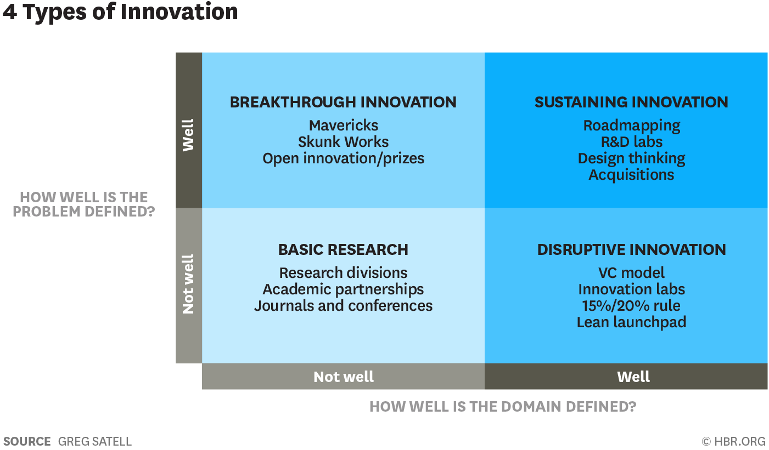
Adopted from: https://hbr.org/2017/06/the-4-types-of-innovation-and-the-problems-they-solve
Breakthrough innovation is a strategy that drives a company to the next level and opens more opportunities for customers to interact with the brand. While sustainable innovation creates change to value the public benefits to increase company growth and basic research aims to improve areas that may need to be developed. The CFS offers sustainable products and services because of the additional innovation unique and rare, that create advantages for customers switch and an opportunity for us to raise more awareness about other products.

Photo studio store
To open a new business first, need to have a good idea and conduct research on the business plan for a suitable budget to start with. The company name is Camera Focus Style (CFS) and identified location at the biggest shopping centre, as call Touchwood-Shopping-Centre in Solihull where people come daily for their needs and is an opportunity for us to let people know our new innovation styles of taking pictures in which big place is divided into three sections one side for the operating camera, other for technical to do with machines marking pictures frames etc, the final one for galleries to attract customers, explain how this products and services are different from others with reasonable prices. The property is a lease contract of over a hundred years within huge car park spaces and great advantage no similar business in the area.

Visual space
the CFS available building space is provided with visual merchandising which attracts customers to stay longer and discover more about the products displayed and when people stay longer expect more to come depending on how your business organises and offers for them. However, Pegler and Bliss (2006, p.13) state that “whatever you call it, it is about the presentation, about showing to sell creating a store’s look, promoting an image or a brand, and shaping the shopper’s attitude toward the retailer and the product”.
The CFS officers’ wide space display framed pictures with decorated backgrounds for camera shooting and on-the-desk services provide advice to customers to engage with the registration of our new platform application that gives options to users downloads on their smartphone image editor. For example, Kim (2013, p.1) says “visual Merchandising Design covers every space, environment, and visually stimulating factor. This includes not only the architectural appearance but interior, graphic sign boards, window display, layout, store appliances, lighting, and even the looks and service attitude that sales employees have and show to customers”.
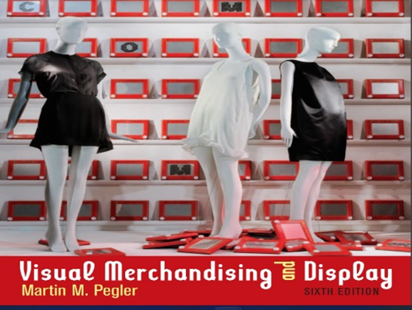
(Pegler and Bliss, 2006)
An example of this image shows attraction to customers to increase the visibility of the store and bring more visitors to add better sales and be beneficial for both sellers and buyers.

Financing costs
Any new business needs a clear budget to start with and is not easy to find lenders without a tangible business plan. Conducting research to support innovation but found that banks and lenders added higher interest rates plus inflation rates as the UK economy indicates facing more difficulties in the future. However, this proposal was shared with family and friends, and they accept to give full support fund of £30,000 because they like the business is substantial, profitable, and tangible assets, for example, cameras, laptops, printers, one van and an innovative application platform compatible with smartphone add value as sellable products in case of any changes to business easy to refund what we owe. And this part of our strengths gives us credit to get support from family and friends to pay back with no interest. Moreover, the table below explains the plan.

Table 1: Financial breakdown of the initial cost
Camera Focus Style (CFS) |  | Descriptions | Costs monthly |  | Total
Staffs full time  And part-time. | Three permanent low costs as owners.  Temporary three including software development professional cost estimated. |  |  | £1500  £2100 | £1500  £2100
Building  100 years of contract reviews after 100 years | Building rent 6 months free because of the maintenance costs. and then following ten years monthly costs. |  |  | £2000 | £2000
Registration | Company registration, legal advisor and document requirements. |  |  | £ | £600
Maintenance  Engineering | Partitions, skimming, painting, wallpapers. No costs as personal efforts. Cost added plumbers, and electricians. |  |  | £ | £3000
Equipment | Cameras, laptops, printers etc and kitchen stuff. |  |  | £ | £3000
Vehicles and maintenance | One van uses for business to mobilise events cash cost plus insurance and maintenance costs |  |  | £150 | £150  £12000
Suppliers | Printers’ ink, papers, etc estimated. |  |  | £150 | £150
Budgets | Total £30,000 |  |  | £5900 | £24,500

Payment services
Using PayPal systems is gaining consumers’ confidence and safe time for them because the PayPal protections system has been used for over 20 years well known to consumers and provides secure payment online purchasing stuff with great confidence. We want to use PayPal card payment to help with our innovative software image editor compatible with smartphones customers can download the basic free version and higher images resolution version as an optional monthly or unusual payment available. However, Niranjanamurthy (2014, p. 2) argues that “this study proposing PayPal is the best and recommended online payment method. PayPal has a reputation for security, protecting the interests of both merchants and customers. It is also a convenient option for patrons and merchants. Consumers spend less time entering their information; merchants can set up a payment system quickly”.

Figure 2. Payment structure
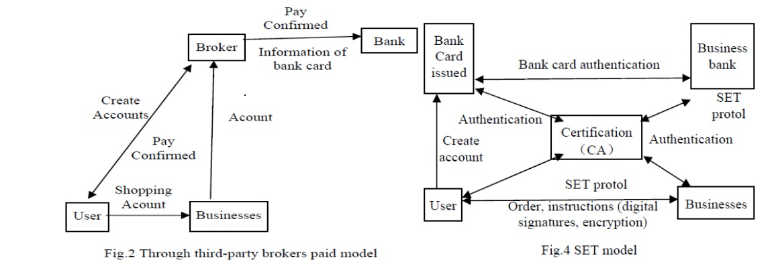
Adapted from (Niranjanamurthy, 2014)
This image shows the diagram of how the PayPal system works to ensure that the security of sellers’ and buyers’ successful online transactions have been made and provides an agreement of legal certificates.

PCI-DSS compliance issues
The PCI-DSS compliance issues are meant to protect card users’ data from thefts and many industries use online to sell their stuff and make it easier for consumers to pay without fear. However, we use the PCI-DSS card payment whether online or in-store because nowadays people do not use cash-hand, as usual, they use cards or mobile-APPS to pay for their services and products. Moreover, White et al. (2013, p. 2) argues that “the 12 PCI DSS requirements, developed in 2004 cover the need for businesses to have a secure network, protect cardholder data, maintain a vulnerability management program, have strong access control measures and monitor and test networks, and have an information security policy”.
The PCI DSS provides potential security for businesses to protect customers’ transactions from fraud that can affect both parties when buyers need to trust providers with clear communications and stay safe as we small businesses utilize this system to gain our consumers’ loyalty by letting them know that we take the serious step of responsibility when they are using card payment from us. The table below shows the process of transaction work.

Figure 3. secure payment
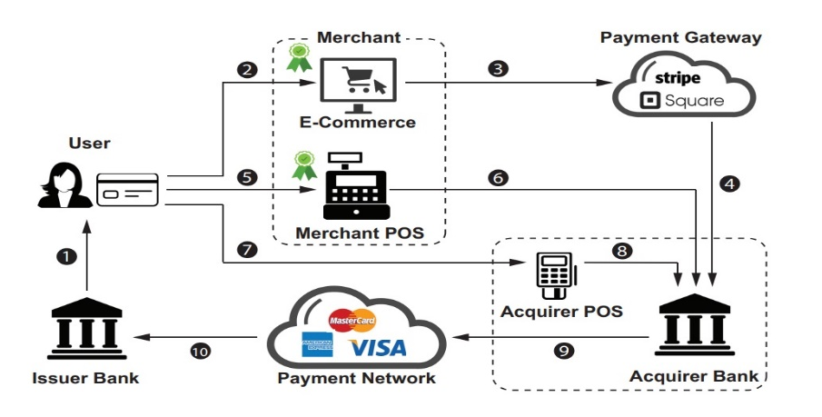
(Rahaman et al. 2019)

Marketing products and Services for (CFS)
Marketing is one way to be visible and known to consumers to empower business your profitability by using competitive marketing strategies to show how your product and services are important and able to make a difference from others not only to keep existing buyers, but it is very important to attract more consumers come for better. Moreover, Weber (2009, p.28) mentions that “if you wait much longer, your competitors will have figured out how to attract your customers to their environments. If that happens, you will have to work three times as hard to get them back”. Whatever, Camera Focus Style products as cameras shouting, printing pictures, using different sizes, frames to be ready for customers and provide software for image editor as service. To promote products, talk to the crowd of people whenever found in towns, shopping, etc, hand leaflets, ask them to join and show them the different products and services offer free, online space when users download software editor allow to users many things they have not experienced before.

Consider the use of physical or online marketing techniques
To engage more customers in a business visiting busy places like busy shopping areas, events, etc, it is ideal to approach people face to face conversations leaflets handed explain the quality of products/services, location and ask questions to gather information to evaluate how customers appreciate the offer if any doubt must be measured and develop.

Pre-launch promotion
The pre-launch promotion as a new business aims to raise awareness about the brand’s available products and is a marketing strategy activity carried out to target audiences and create an environment where customers ask questions that encourage mood to make a change about building trust. To make things interesting give free items like pens, calendars, car keys attachments, and show them google play how to download higher-resolution software image editor within immediate effect product can use but not able to save images ask for payment.
Our van shows graphics as useful tools to attract people and utilize social media, email, Facebook, Instagram, and YouTube videos the CFS offer them free software editor for their profiles as a technique to get more followers’ information to use as feedback and keep them posted at low prices and attractive social media content. Another way to track the customer’s WhatsApp link across family and friends is to spread our appreciation compatible with a smartphone when customers shared the link give the attractions of what they want for free then ask to upgrade at cheaper prices and unique ideas drive business for better future. Google has good advantages for digital markets strategy help companies to get more ads in resulting gaining first Pape. As utilising some strategies to improve engagement and may consider search engines in the future.

Customer journey
The experience that how customers connected with the company and brand which is a challenge for them to go through steps of making decisions and ask questions about the products or services’ quality, legality like data protection if they want to purchase and compare prices and they able to integrate with the available activities that you have created benefits for both. According to Nam and Kannan (2020, p.1) claim that “from the perspective of the customer journey. Customer journey is defined as customers’ experiences with a firm across multiple touch points in multiple channels and media throughout the purchase stages”.
The CFS added new features and a brand-new software editor unknown to customers who want to know how to use it. It is a challenge to put buyers on track. However, utilizing the customer journey map to allow buyers more options and make better decisions is an advantage for CFS to lead the competition. Taking care of customers requires understanding buyers’ journey for management to create a satisfactory motivated system to employees how to service customers.
The customers’ journey map steps identified a better knowledge of understanding what buyers think about what CFS provides. Employees’ duty to give awareness and provide services to customers such as low prices, products qualify, clear method of payment, on-time delivery, the process of guarantee, refund, and data protection are major issues for consumers but qualified staff able to communicate with customers effectively and to ensure them any deal from others competitors can be considered by showing immediate test if about qualify, pricing or even given a gift as already planned to motivate our buyers.

Reference

Kim, J. (2013) ‘A study on the effect that VMD (Visual Merchandising Design) in store has on purchasing products’, International Journal of Smart Home, 7(4), pp.217-223.
Nam, H. and Kannan, P.K. (2020) ‘Digital environment in global markets: Cross-cultural implications for evolving customer journeys’, Journal of International Marketing, 28(1), pp.28-47.
Niranjanamurthy, M. (2014) ‘E-commerce: Recommended online payment method-Paypal’. International journal of computer science and mobile computing, 3(7), pp.669-679.
Oetomo, H.W. and Ardini, L. (2012) ‘SWOT analysis in strategic management: a case study at Purabaya bus station’, Journal of Economics, Business, & Accountancy Ventura, 15(2), pp.171-186.
Pegler, M.M. and Bliss, L.L. (2006) ‘Visual merchandising and display’ New York: Fairchild Publications.
Rahaman, S., Wang, G. and Yao, D. (2019) ‘November. Security certification in payment card industry: Testbeds, measurements, and recommendations’, In Proceedings of the 2019 ACM SIGSAC Conference on Computer and Communications Security (pp. 481-498).
Satell, G. (2017) The 4 Types of Innovation and the Problems They Solve. Available at: https://hbr.org/2017/06/the-4-types-of-innovation-and-the-problems-they-solve (Accessed: Jul 11, 2022).
Weber, L., (2009) ‘Marketing to the social web: How digital customer communities build your business’. John Wiley & Sons.
White, B.J., Willey, L. and Stillwell, R. (2013) ‘Student Perceptions of Business Compliance with Payment Card Industry Security Requirements’: A Constructivist Approach. Issues in Information Systems, 14(1), pp.278-285.
Pegler, M.M. and Bliss, L.L. (2006) 'Visual merchandising and display' Fairchild Publications New York.

