University of Wales Trinity Saint David Birmingham

Student Name: Florentina Manolache
Student Number:2119958
Module code and title: Problem solving and decision making (BMSW 4004)
Lecturer’s Name: Julius Azasoo.

Executive summary

According to a recent survey of health leaders, the government must accept a proposed amendment to the health and care bill to strengthen workforce planning because staff shortages across the NHS are having a serious and detrimental impact on services and will impede efforts to address significant care backlogs and improve access to services.
Too many employees of the NHS put in a lot of effort every day but receive a salary that is below what is appropriate. We believe that the government should fund a systematic programme of job description review so that we can assist NHS personnel across the nation in receiving a just evaluation of their work and the appropriate compensation.
In addition, a lot of European medical professionals go across borders to work in the UK. Currently, there are more than 160,000 EU citizens employed in the UK. The free movement of people, particularly that of health and social care workers, will be impacted by the EU's exit. The number of nurses from EU nations enrolling in the professional nursing register has significantly decreased since the Brexit outcome, adding to the pressure on the NHS. The need to restrict borders was stated in the leave campaign's platform. In the short term, it's likely that a Brexit would result in a decrease in the number of workers from outside the UK. Longer term, it's likely that the UK will provide better conditions in an effort to draw both.

Introduction

To provide everyone in the UK with healthcare based on their needs, not their capacity to pay, the NHS was established in 1948. The NHS is recognized for the exceptional quality of healthcare that can provides to patients throughout the world. The National Health Service is referred to as NHS. It tells about government funded medical and healthcare services that are accessible to all UK citizens without requiring payment of the full service's cost.
The NHS is a complicated structure, which makes it quite difficult to understand, especially when determining who oversees what. It consists of a diverse group of organisations, within each set of responsibilities, roles, and skills. These organisations offer patients and their families a range of services and support.
With this announcement, the legal right for all UK citizens to receive free medical care from doctors, nurses, midwives, and dentists in England and Wales, Scotland, and Northern Ireland became effective.

Impact of staff shortage

Hardworking and overworked professionals are suffering because of significant staff shortages and staff stress throughout the NHS. Obviously, the past two years have been the most challenging in NHS history. Staff members continue to provide to the patients all attention and care but also working so hard, yet many of the issues we are currently dealing with existed before the pandemic and won't be solved overnight. Across NHS trusts, there are currently a big number of open positions, and primary care have thousands more.
NHS facing staff shortage because:
- Salary they are low
- Brexit
- Burnout from heavy workloads and constant pressure during shifts
- Compounded by the Covid-19 pandemic
Staff must receive a substantial salary increase from the government this year in response to the crisis brought on by rising living expenses. Trust leaders, who collectively employ 1.4 million people, are aware of the increasing everyday costs that their employees confront and are concerned about the effects on younger and lower-paid employees.
Over 40,000 nurses were reported to be needed by NHS England in 2017, placing a huge strain on the current staff. The following factors will likely cause the number of European employees in the NHS to decrease even more. Immigration regulations was become stricter.
In emergency medicine, there is a severe issue with information overload. The historic culture of emergency rooms being always available on the ward, which is made worse by email and other kinds of communication required to maintain best, evidence-based practise standards, was one of many daily factor’s participants reported as having an impact on their jobs. Not all knowledge is undesirable, though to deliver high-quality care, doctors also need to keep up with the most recent recommendations on diseases and treatments and interact with bigger medical teams.

Macro-environmental factors (PESTLE analysis)

PESTLE analysis is a method for determining how external influences affect a place, a company, or an organisation. It enables a person or organisation to see the large picture of the environment in which they operate.
PESTLE analysis is divided in 6 factors:

- Political
- Economic
- Social
- Technological
- Legal
- Environmental
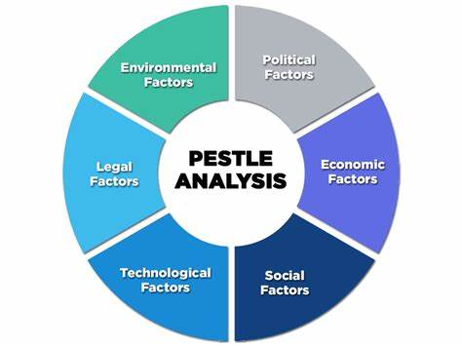
Political factor: these include elements that influence how much government involvement there is and how it affects a nation's economy. For instance, the political environment includes laws, taxation policies, monetary policies, and other things. (e.g.: the political stability of the country, political ideologies of the government, taxation policies).
Economic factor: the organization and its success are significantly impacted by economic conditions. (e.g.: economic growth, inflation rates, unemployment rates, current interest rates prevailing in the economy, important factors of the specific industry).
Social factor: the organisation is significantly impacted by everything that occurs in society, as a result, it's crucial to consider social elements when researching the social environment. (e.g.: religious and cultural factors, state, and influence of the media).
Technological factor: the technical environment's developments may present the business with advantages or risks. (e.g.: new production technology, new innovations, maturity of technology).
Legal factors: this is a reference to the regulations established by the government that the business must comply to continue working. (e.g.: business laws, environment laws and guides, health, and safety guidelines).
Environmental factor: this factor has an impact on industries' productivity. (e.g.: energy/power consumption, insurance policies, safe waste disposal).
Several factors are currently putting pressure on the NHS. Top of the list are the Brexit and the prior economic crisis. But to increase its functional capacity, it must also solve other problems. They believe that some of these issues can be resolved soon with the ongoing integration of technology and the development of educated staff for NHS.
To date, COVID-19 has had a severe negative influence on society, the economy, and health specially for staff which they were working true COVID19 in hospital.

Cause and effect analysis (FISHBOURNE diagram)

The fishbone diagram, also known as the Ishikawa diagram, is a cause-and-effect diagram that assists managers in determining the causes of flaws, variations, errors, or failures.
The problem is at the head of the diagram, which resembles the skeleton of a fish, and the causes of the problem feed into the spine. Managers can start looking for remedies to ensure that the issue doesn't come up again once all the underlying reasons have been located.
There is a critical nursing shortage in our nation, which obviously know unless you live under a rock. By 2022, the Bureau of Labour Statistics predicts a shortage of close to one million nurses. Although there has always been a nursing shortage, this one is distinct from some of its predecessors. When there was a shortage in the past, such in 2001, it was more due to a lack of supplies. Fewer people were deciding to pursue nursing as a profession.
The NHS is dealing with an economy that is expanding, an ageing population, and fewer workers to support them. It has been more and harder to find medical professionals, and shortages are frequently filled by hiring workers from other EU nations, which raises the population in the UK. Beliefs, values, and conventions are influenced by the social environment (Kotler). During the most recent general election, the public's concerns about the health service's essential values and the services it provides were at the top of the list, as if the NHS were an integral part of the UK and its culture. The discovery of new pharmaceuticals, improved operating methods, and other technical advancements have accelerated the rate of change in the health care industry.
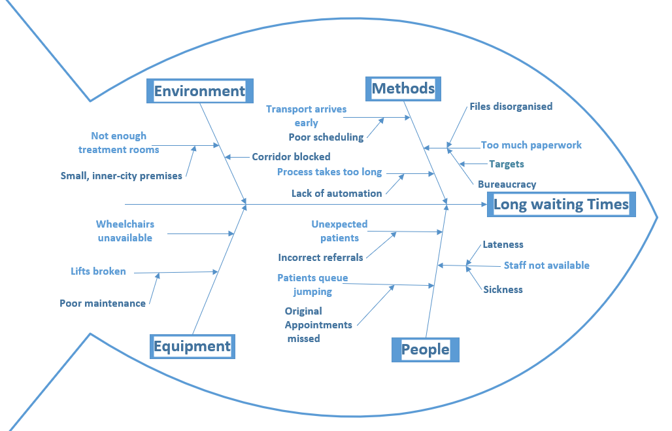

There are three factors contributing to the current shortage: the ageing staff, the ageing population, and the shortage of new nurses. To motivate nurses to work harder or hire travelling nurses, employers are already including financial incentives in their hiring processes, such as sign-on bonuses. These are, of course, at most short-term fixes for the issues and come at a high cost to the hospital.
Advantages:
- There is no real competitor for the NHS although it doesn’t have monopoly in the market.
- Accident and Emergency service is unique to the NHS though private hospitals are available throughout the UK.
- The NHS has continued to grow and expand upon its services since it was established in 1948.
- NHS maintains good relationship with health community partners.
Disadvantage:
- Due to increasing population NHS is unable to cope with the demand.
- High waiting time for the patients.
- Bad behaviours and attitudes of some staff.

Plan to implement decisions and indicators to measure the effectiveness

Understanding how our thoughts are influenced by our physiological and emotional responses to the environment we are in allows us to make wiser judgments. Our attempts to be reasonable can be defeated by emotions and reactions. On the other hand, when people recognise that the expense is worthwhile, they have the incredible ability to focus their attention and control their impulsive tendency. Understanding that biological influences on how we make decisions are ongoing and frequently unrecognised is a necessary part of being a human decision-maker.
The development of local systems' five-year strategic plans is a top priority. These plans will clearly outline the population's requirements and the rationale for change in each area, and they will then suggest doable things the system can do to fulfil the promises made in the NHS Long Term Plan.
To assist local system leaders in improving their planning and prioritisation, the Implementation Framework summarises these commitments along with additional information. Details on where additional funds will be made available to support certain commitments as well as information on where activity will be funded or commissioned nationally are included in this.
Finance, resources, and time are all in short supply in the real world. Shared decision-making has no incentives and is not systematically promoted at the national, regional, or organisational levels, despite being included in important policy papers. It is still a major problem to encourage cultural change among doctors and patients. Only when professionals see shared decision making as standard procedure and an essential part of providing patients with safe, efficient, and compassionate treatment will a responsive culture genuinely exist. It must be included into the curricula for medicine, nursing, and interprofessional training. Similar to how many health policies and professional practises have made patients feel helpless and passive. It's crucial to increase patient agency, engagement, and health knowledge.
The procedure is not standardised by these acts, even if they might aid in the process of embedding shared decision making. Every discussion differs based on the patient, clinician, their preferences, and the kind of decision being made. The outcome of shared decision-making may not always be perfect agreement between a doctor and a patient, nor does it always depend on it. Instead, it entails combining both types of expertise and evaluating the options considering both viewpoints. This increases the likelihood that the final choice will be influenced by both what the clinician knows (such as medical evidence and clinical experience) and what the patient knows (what matters to them, the outcomes they are prepared to accept).
Very difficult, cooperative decision-making can be implemented. No intervention will be successful on its own. A collection of interventions that function holistically together in all healthcare settings are needed to support organisations, physicians, and patients.

References
https://www.england.nhs.uk/get-involved/nhs/

https://fullfact.org/health/what-is-the-nhs/

NHS workforce shortages and staff burnout are taking a toll
BMJ 2022; 377 https://doi.org/10.1136/bmj.o945 (Published 11 April 2022)
Cite this as: BMJ 2022;377:o945

Mapping of Health Literacy and Social Panic Via Web Search Data During the COVID-19 Public Health Emergency: Endemiological Study

Chenjie Xu, Xinyu Zhang, Yaogang Wang

J Med Internet Res 2020 (Jul 02); 22(7):e18831

Archer, J., McManus, C., Woolf, K., Monrouxe, L., Illing, J., et al. (2015)
'Without proper research funding, how can medical education be evidence based?' BMJ, 350, p. 3445.
https://doi.org/10.1136/bmj.h3445

Makos J. What is pest analysis and why it's useful? [Accessed September 26, 2015];PESTLE Analysis website. 2014 Aug 22;
http://pestleanalysis.com/what-is-pest-analysis/

Williams, Steve W.. Making Better Business Decisions : Understanding and Improving Critical Thinking and Problem Solving Skills, SAGE Publications, Incorporated, 2001. ProQuest eBook Central,
http://ebookcentral.proquest.com/lib/trinity/detail.action?docID=996932.

