School of Sport, Health & Outdoor Education

Assessment Criteria

Student No./Name: _

Module: Health and Social Inclusion
Code: SHSS6031

Personal Evaluation – to support your academic progress please complete the section below BEFORE submitting your work.
What do you consider to be the best aspects of this work? | Understanding of the distribution of wealth and inequalities in income.
Which aspects do you consider could have been improved in this piece of work? | The introduction and other sections could be better supported and some areas such as housing and education could have been expanded
What have you found most satisfying whilst undertaking this submission? | Researching inequalities in health.

CRITERIA | Learning  Outcome | GRADE
CRITERIA | Learning  Outcome | Unsatisfactory  - 39% | Satisfactory  40 – 49% | Good  50 – 59% | Very Good  60 – 69% | Excellent  70% + | %
Background knowledge and understanding of the chosen aspect of Health and Inclusion, setting the theme in appropriate context | 3 |  |  |  |  |  | 30%
Ability to select, synthesise and evaluate appropriate sources relating to chosen theme | 1 |  |  |  |  |  | 30%
Evidence of independent research using a range of sources and the ability to present key findings clearly | 1,2,3 |  |  |  |  |  | 30%
Problem-solving skills in locating appropriate material within secondary sources, internet and primary material. | 3 |  |  |  |  |  | 10%
It is expected that students will present work that is proof read and follows the School Reference Guide and Assessment Checklist. Therefore a range of 0 – 10 marks will be deducted for poor referencing, spelling, grammar, punctuation, and presentation |  |  |  |  |  |  | 0/10
TUTOR COMMENTS:

Health and Social Inclusion
Health disparity is the difference experienced by individuals or specific groups within society, where people’s health is affected by their social status or the circumstances in which people find themselves. For example, people from deprived areas and with a low income and a poorer education, experience poor health and a shorter life expectancy (Public Health Wales, 2017).
As identified in the Marmot Review (2010), health inequalities are a result of social inequalities and this is a ‘social gradient in health; the lower a person’s social position, the worse his or her health.’ This suggests that individuals who earn less and who have a lower socio-economic status experience poorer health. Similarly, people with a better education have a higher chance to live better and longer than those who are not educated (Marmot Review, 2010).
The aim of this work is to talk about the social circumstances and influences on health, the societal determinants of health, and the circumstances affecting the health of individuals and groups, health variance and inequality. It will also be important to examine current policies that address poor health and proper lifestyle maintenance in Wales.
People’s health is affected by their social status and poor salary, poor access to health, housing and education (World Health Organization, 2018). People from lower social levels are more affected by poor health than others because they have less access to healthy choices and opportunities than people who have higher incomes. This is because those on higher incomes have more access to healthy choices and lifestyle opportunities (Bartley and Blane, 2008). The UK is one of the most developed countries in the world, and yet it has greater inequalities in terms of socioeconomic status and income inequalities; this affects children and adults from deprived areas who do not have access to health care system or dietary education. In turn, these causes can contribute to obesity (Independent, 2018; NHS, 2018). According James et al. (1997), obesity is linked to poverty which impacts negatively on people’s health. In deprived communities, people become more vulnerable to infectious diseases each year. People who have less access to money and social services are the ones most affected by preventable diseases such as obesity (Health Poverty Action, 2018). However, the UK government has different plans for making people healthier which includes tackling obesity in children and adults from the most deprived areas by providing them with education about health eating and lifestyle (Department of Health and social care, 2015; Zadro et al., 2017). The Government claims it has been supporting the local councils financially, so that they can use the money towards the public health for the provision of healthy programs for overweight people in their community, across all areas of the UK (Department of Health and Social Care, 2015). This allows people’s health and lifestyle to be improved by decreasing inequalities in health. However, a recent data from the UK Department of Health shows that health inequality seems to be in constant growth in places like England in relation to life expectancy between men and women from the most to the least deprived areas. Even with the government wishing to tackle health inequalities in the most deprived areas of North England, people including new-borns are still at a high risk of early death (Campbell, 2017). According to Theresa May the Prime Minister of the UK, she acknowledges the problems of ‘burning injustices’, which means the unjust difference between the poor and the rich in relation to health outcomes. The Prime Minster promised to bring a broad range of social improvements to fix the problems which she refers to ‘burning injustices’ (BBC News, 2015).

Furthermore, the income gap between rich and poor people is at 47 per cent according to a British Cohort Studies and the National Child Development Study. The UK government also plans to reduce tax credit which will affect inequalities more than now meaning that the poorer people will have even less to live on if this takes place (Waters et al. 2017; Stone, 2016). The UK government has introduced a new system called Universal Credit, which rolls all previous benefits, such as tax credits, income support and housing benefit, into one overarching benefit, called Universal Credit. However, there have been many issues in the roll out of this new benefit as families are being left unpaid and are losing as much as £48 a week. The Universal credit aims to simplify the payment method to one system and to motivate people on benefits to find work (BBC News, 2018). Unhealthy, people are more likely to develop different types of diseases such cardiovascular disease, cancer, diabetes type 2 and so on. This has a negative impact on social care and Public Health care services by increasing their costs towards treatment and becoming a burden for the social care system (Local Government Association, 2013; Public Health England 2017).
Health is a condition which is classified as mental and physical wellbeing of a person but not necessarily classified as the absence of an illness (WHO, 1948). According to Crawford (1980) Health is essential and plays major part in people’s everyday life but also, he refers to health as being an essential part of having a quality of life such as self- esteem, creativity and confidence rather than people being only on drugs and medications (Crawford, 1980, p. 365).
People view health differently according to their health experiences. A survey made by Seed and Lloyd (1997) found that most people interviewed referred to a healthy life as one where you would enjoy a happy marriage and good relationships with family and friends. However, people’s health is directly influenced by the circumstance that they find themselves in. In the UK the prevalence of Health inequalities is high in deprived areas of England for example affecting every age, gender and ethnicity. This notion stems from the fact that members of the poor families in the community will find it difficult to access quality healthcare resources in comparison to the wealthy (Newton et al., 2015). Considering the poverty statistics in Wales as showed under the Joseph Rowntree report, it is evident that approximately 14 million persons live in poverty in the UK (Joseph Rountree Foundation, 2017). The statistics show that in 2010, households in the UK were on an income under 60% of the median income, which means people were already living in inequality and poverty. Although household income may be improving each time it is not still considered to be satisfactory way of living (Poverty in the UK Statistics, 2018).

Children and young adults are the most ones affected by poverty in disadvantaged areas of Wales and are at a higher risk of developing different types of diseases including mental health illness, obesity and cardiovascular diseases (Public Health Wales, 2012) Most of these problems are related to inequalities and social exclusion. Children who do not have access to green spaces are more likely to become overweight or obese and find difficult to recover from illness because of the lack of physical activity and environmental fresh air (The Marmot review, 2010).
The group of adults who are at a higher risk of developing mental illness are the ones who have experienced any mental illness in the past as well as any sort of violence, abuse, drug and alcohol addiction and being homeless as well (Joseph Rowntree Foundation, 2016).
In the UK, the rates of death between children in the most deprived areas are much higher comparing to the wealthiest areas of England affecting children under the age of one (BBC News, 2019). However, the governments of Wales and England are focused on promoting equality in health in various ways. The focus has been put on aspects such as childhood, poverty, drugs, working conditions, and social support (Deaton and Paxson, 1998). Social economic status (SES) of a person is tied to the prevalence of diseases (Bowling 2014). Those with low SES are likely to be poor and to be affected physically and mentally due to risky health-related behaviours such smoking, drinking, use of sudden drugs, poor diet and a sedentary lifestyle (Bowling, 2014). People living in deprived areas are more exposed to air pollution, experience poor housing conditions such mould and damp; for example, studies show that there is an association of respiratory problems in children with moist and damp environments (Bartley and Blane, 2008; Bartley, 2004). According to some evidence, social differences may affect people emotionally; people who do not have social support and jobs or work in a very high stressful work environment are more likely to live a stressful life; these can increase the chances of heart disease (Bartley and Blane, 2008; Bartley, 2004).
At an individual and group level, several issues affect health. People’s wellbeing is highly influenced by the circumstances in which they find themselves. Some of the conditions include where individuals stay, the status of the surrounding, the level of income, and the education attained (Bowling 2014). This means that having higher wages can influence positively in people’s lives because people are more likely to experience better health, while people with lower salaries and lower levels of education are more likely to have a poorer health and to be live in a more stressful environment (WHO, 2018).
Recent studies show that a pay rise above the minimum wage could help minimize poverty and may bring benefits to people’s health by allowing them to have enough money to buy healthy food which costs more than unhealthy food. It also enables people to afford health care and better homes, consequently reducing depression and anxiety among people in society (Juan & Paul, 2018). Employees who are on low wages are more likely to be at a great risk injury and of developing diseases than people on high income as longer hours of work and high job demands can become a health risk factor (Science Daily, 2016). However, the Government have tried raising the minimum wages from £6 to £7.85 in 2008, but almost half of the population continue to be on low wages, particularly women (Partington, 2018).
The life expectancy gap between the poor and the rich has increased in the last decade in the UK. People from the richest parts of the country will on average be living about eight years longer than people from least advantaged areas (Independent, 2018). In the UK, the number of mortalities for males at all ages is greater than females as younger males are more likely to die of accidents, injury, suicide and for older aged men of cancer and vascular diseases. However, there are higher cases of women being mentally ill and suffering from depression and anxiety (Acheson, 1998). According to WHO, it is suggested that gender health differences results from genetics and social circumstances and the culture which they find themselves in (WHO, 2008).
In England for example, life expectancy for males from the most disadvantaged areas will live about 74 years, rising to 83 years in the least disadvantaged areas. Similarly, those people who are likely live in good health in the least disadvantaged areas is up to 70 years, but only living in good health for 51 years in the most deprived areas of England (Public Health England, 2017).

The graph below shows Male life and health expectancy from the most and least deprived areas by Region.
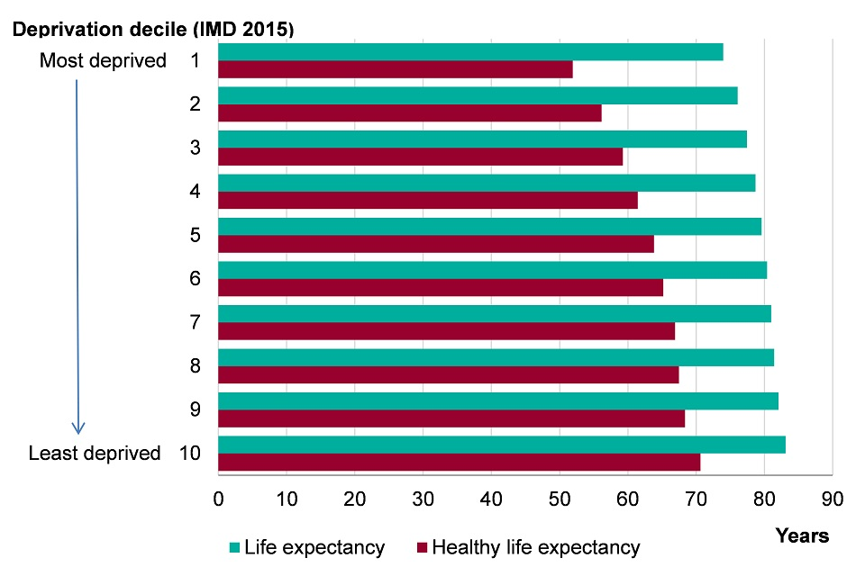

For females in at least disadvantaged areas of England, the life expectancy is 86 years and those living in good health, 78 years, while in most deprived areas, females are likely to enjoy good health until 52 years with a life expectancy of 71 years, making a gap of 7 years for life expectation and 20 years for a healthy life (Public Health England, 2017).

A graph of female life and health expectancy from the most and least deprived areas by region between 2013-2015
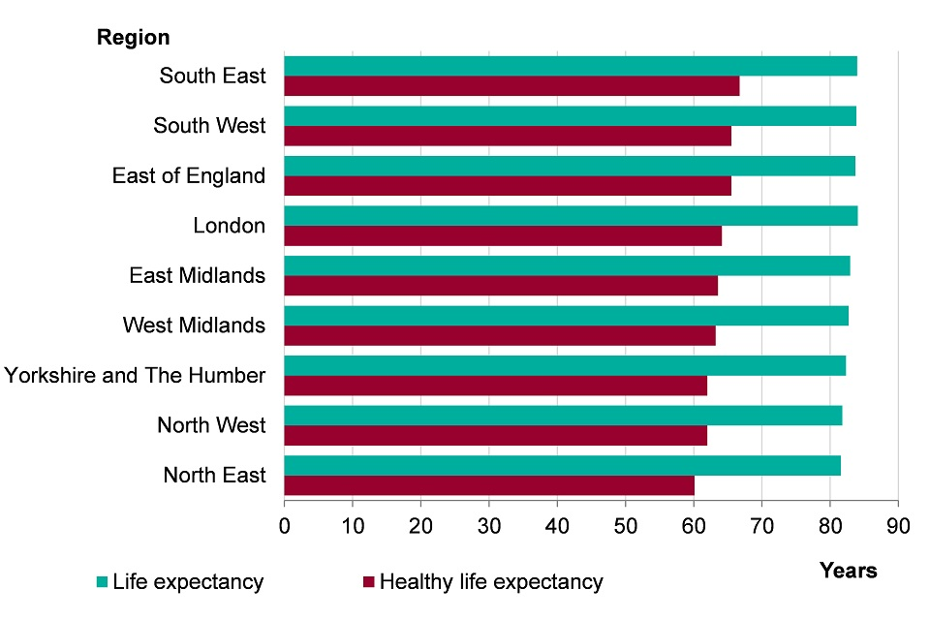
Graph from Public Health England, 2017

According to the WHO, normal health refers to the state of full physical and mental wellbeing of an individual. It does not necessarily denote the absence of physical illness or disease. Notably, normal health varies between groups according to their Socioeconomic status. In Wales, as a result of the circumstances addressed above, for instance, the inequality in society prevents people from having access to a better health (Crimmins, 2004; WHO, 2019). Poorer people living in disadvantaged areas of England are facing health disparities by having less access to GP services and receiving less care from GP surgeries. According to an analysis by the Nuffield Trust, these group of people find it difficult to get an appointment with their GP compared to the people in the least deprived areas (Nuffield Trust, 2018).
Normal health will vary between groups according to sex, country of birth, deprivation and ethnic group. There is a vast inequality in the health status among the groups of people who can find it difficult to access the Health system. They are also likely to find it more difficult to engage in society are this group of people are also likely to be the most difficult to reach. This is because they may be homeless or have drug and alcohol issues; they may also be smokers, be people with HIV, be immigrants, or people with language barriers. In addition, people in black and ethnic minority groups, the elderly, unemployed people, or mentally and physically disabled people are likely to experience more difficulties in accessing health services (Goddard and Smith, 2001). The main reasons that prevent those groups of people from getting better health care treatment are the availability for the health care services which in many cases do not always offer treatment to people that come from a different population or group. The health quality between groups may differ and the costs may vary among groups and population (Goddard and Smith, 2001). The prevalence of smoking and premature death for example are in between groups of people who come from mixed races and who live in the most disadvantaged areas of England. The death rates of men and women with lung cancer has increased by more than double in disadvantaged areas than from the least deprived areas (Public Health England, 2015). More than 50% of people from different ethnic groups who have large families live in the most disadvantaged areas of England. The Public Health England data shows that people born in different places but who live in deprived areas of England die before the age of 75 from cancer, cardiovascular diseases and suicide. On the other hand, the least deprived areas have lower cases of premature deaths (Gov, 2017; Public Health England, 2017). The rates of cancer for people under the age of 75 is the most likely cause of death for people living England. However, the death rates for cancer has decreased since 2001-2014. The cases of cancer resulting in death also differ between different socioeconomic groups, population, sex and country of origin.
Actions towards inequalities are being taken by the local Government based on some of Marmot principles such a good start in life for children. According to Marmot, universal action needs to be taken to tackle inequalities in health, education and employment through early interventions. Some policies regarding to young adults and adults aim to maximise their educational skills in order to improve their social mobility and to decrease the difference in social skills and education. Such policies will aim to guarantee that schools and families are involved in the maintenance of health and wellbeing in children and young adults (Marmot, 2010). Further policy recommendations by Marmot are that children’s education should be prioritized by bringing educational differences down by providing a broader schools support network to pupils involving parents and communities. Providing high quality educational training for students from ages 16-25 for jobs opportunities is also a priority, as well as providing work-based training for young adults (Marmot, 2010). Public Health England is an independent organization of health and social care that helps to improve people’s health and wellbeing around local communities. Public Health England (PHE) have been endorsing health policies with the support of the local Government to tackle inequalities in health. In England, health inequality continues, and the life expectancy is found to be lowest in the most deprived areas of England (Public Health England, 2016). Public Health England has put together a plan to improve Health and Health Fairness in every policy across the UK which aims to bring about an improvement on determinants of health and health outcomes. The Policies are designed to enable local government to understand how, in practice, to improve health through its multiple functions, programmes, service areas and partnership working (Public Health England, 2016).
Community work has the effect of combining health benefits with a reduction in Health disparities by empowering, connecting with and encouraging people to partake in healthy activities. Public Health England plan is to bring communities together for the development of new resources for each area for the improvement of health and wellbeing and to decrease health disparities. Because discussions with communities can be hard (PHE) have published a guide on how to engage with communities and how to work with communities which is found in the PHE (2015) Report (Public Health England, 2015). Furthermore, Public Health England wants to minimize smoking amongst young adults and adults, pregnant woman and amongst people with a mental disability by implementing policies that will reduce the use of tobacco in the next few years within the communities. Smoking is more common in groups of people that live in disadvantaged areas; this group suffers from diseases and death as consequences of smoking (HM Government, 2011). Apart from that, the cost for treating people who are smokers is high and it is estimated to cost £2.5 billion to NHS a year. The Government steps for the improvement of Public Health is to stop inequalities in health and to raise people’s self-awareness and self-worth from an early age, but to encourage health and welfare within the communities it is necessary to reform social rules so that smoking will be discouraged and be less needed across communities in England (HM Government, 2011). The (PHE) would like all groups within the communities to be smoke-free and the goal is to keep it from coming back to the next generation. To eliminate barriers that can make it difficult for people to quit smoking, PHE aim to encourage and to educate parents about the health consequences of tobacco, because the majority of tobacco users start from an early age. Another smoking prevention is to make sure tobacco is not sold for people under the age of 18 and that the packs of cigarettes contain strong messages about the harm that cigarettes bring.
Smoking during pregnancy increases health risks to both mother and baby by contributing to several outcomes such as thrombosis, miscarriage, premature birth and death. Mothers that smoke are putting their unborn foetus at risk of developing problems which include learning difficulties, behavioural and respiratory problems. In the UK, the most smoke prevalent group of smokers is mothers under the age of 20 (Public Health England, 2017). To reduce the number of pregnant women smoking cigarettes, guidance provided by NICE helps smokers to quit. The Public Health England and the NHS England have put together the smoke-free guidance. The NHS will provide training that will educate their health professionals about how to quit smoking for patients, particularly for those with mental health issues. The NHS aims to encourage smokers that visit and work for NHS to give up smoking to create a smoke free environment by 2020. The maintenance of high prices for cigarettes would make cigarettes less accessible to those on a low income (Public Health England, 2017).
According to Public Health Wales (2018), cases of lung cancer are growing between different age groups. The Public Health Wales specialists have accepted the offer from NHS to help people who want to quit smoking. Public Health Wales are aware of the harmful consequences smoking has been causing to the population of Wales. By 2017, 1,891 cancer deaths were recorded in Wales being lung cancer the most common cause of death. There is a big concern for Wales Public from lung cancer; death rates are increasing in the most deprived areas of Wales in both men and women. NHS Wales are offering free treatment the support those who are willing to quit smoking (Public Health Wales, 2018).
The Government has set up strategies to give the same type of services for people with mental and physical disabilities. These strategies are put in place to bring better services to those who suffer from mental health disability. The strategies aim to involve schools and councils to work together to help people with mental and physical health issues and to receive appropriate levels of care and treatments by 2020 (House of Commons library, 2018). The NHS has already started to improve the availability of Therapy programs for mental and physical wellbeing. The number of people getting such treatment has doubled in the last year and by next year the waiting list will be prioritised for mental health. The NHS has invested into new equipment such beds for young people with high needs to stop them by being located to adults’ wards. However, this is not all the NHS is doing, there are also strategies for the benefit of the physical and mental health that will be concluded by 2020. They also want to increase better services for diverse mental health conditions in children and adults such eating and bipolar disorders (House of Commons library, 2018).
There are several policies that have been adopted by the Welsh government which focus on behaviour and maintenance of health. The policies help in addressing the problems of poor health and the health lifestyle. One of the objectives of the Welsh government is to deal with the health disparities and the prevention of illness (Welsh Government, 2018). Policies concerning the health disparities are established by partnership, including NHS strategies towards health and social care. The Welsh Government has a commitment to using policies that will bring equal health opportunities for society between individuals and groups for those living in deprived areas. For the Welsh Assembly to overcome the problems, it is necessary to implement policies, public services and programs to make the difference in people’s lives by dealing with social and environmental problems which affect people’s health (NHS Wales, 2003).

Conclusion
Health and socioeconomic disparities in the most deprived areas of England and Wales show no sign of decreasing (Public Health Wales Observatory, 2016) and need to be addressed with the intervention of the UK Government and local authorities. In order to address the issues that arise because of health inequality, additional funding needs to be in place so that existing policies can be implemented successfully. Whilst there are policies in place to address maintenance in health and to minimise health inequalities, without additional resources it is unlikely that improvements will be seen. As this assignment had demonstrated, the difference in life expectancy and health outcomes are intrinsically linked to socioeconomic status. Therefore, in order to reduce the death rates as a result of diseases such cancer, obesity and cardiovascular disease in disadvantaged areas of Wales and England, the government needs to invest more to ensure that people can afford to make healthy choices to improve their lifestyles and reduce the risk of disease.
Word count without ref: 4,149

References

Bartley, M., Blane, D (2008)’ Inequality and social class in Scambler G (ed) Sociology as applied to medicine’, Elsevier Limited.
Bowling, A., (2014) Research methods in health: investigating health and health services. M Bartley, M., Blane, D (2008). Inequality and social class in Scamber G (ed) Sociology as applied to medicine. Elsevier Limited.

Bartley M (2004). Health inequality: an introduction to theories, concepts, and
methods. Cambridge: Polity Press.

BBC News (2017) Theresa May vows to correct 'burning injustices'. Available at:
https://www.bbc.co.uk/news/uk-politics-38545674 (Accessed: 13/01/19).

BBC News (2018) What is universal credit - and what's the problem? Available at:
https://www.bbc.co.uk/news/uk-41487126 (Assessed: 13/01/19).

BBC News (2015) Child deaths highest in poor areas, Public Health Wales finds. Available at: https://www.bbc.co.uk/news/uk-wales-33513199 (Accessed: 13/01/19).

Campbell, D (2017) Health inequality gap ‘is still growing’ in England, new Department of Health data shows. Available at:
https://www.theguardian.com/society/2017/aug/12/health-inequality-gap-growing (Accessed:13/01/19).
Crawford, R. (1980) ‘Healthism and the medicalization of everyday life’, International Journal of Health Services, Vol. 10, pp. 365–88.

Crimminis, LM., Hayward,MD; Seeman, TE (2004)’ Critical Perspectives on Racial and Ethnic Differences in Health in Late Life’, National Academies Press (US). Available at:
https://www.ncbi.nlm.nih.gov/books/NBK25526/ (Accessed: 9/01/19).
Department of Health and Social care (2015) ‘Government Policy: obesity and health eating.’
Available at: https://www.gov.uk/government/publications/2010-to-2015-government-policy-obesity-and-healthy-eating/2010-to-2015-government-policy-obesity-and-healthy-eating (Accessed: 10/01/2019).
Department of Health (2017) Towards Smoke free generation. A tabaco control plan for England. Available at: https://assets.publishing.service.gov.uk/government/uploads/system/uploads/attachment_data/file/630217/Towards_a_Smoke_free_Generation_-_A_Tobacco_Control_Plan_for_England_2017-2022__2_.pdf (Accessed: 09/10/19).
Goddard M, Smith P (2001). “Equity of access to health care services: theory and evidence from the UK”. Social Science and Medicine (53):1149-62. Available at: https://www.ncbi.nlm.nih.gov/pubmed/11556606 (Assessed: 09/10/19).
GOV.UK (2017), Understanding Health Inequalities in England. Available at:
https://publichealthmatters.blog.gov.uk/2017/07/13/understanding-health-inequalities-in-england/ (Accessed: 09/01/19).
Health Poverty Action (2018)
Available at: https://www.healthpovertyaction.org/info-and-resources/the-cycle-of-poverty-and-poor-health/key-facts/ (Accessed:10/01/19).
HM Government (2011) Healthy lives Healthy people: A tabaco control plan for England. Available at:
https://assets.publishing.service.gov.uk/government/uploads/system/uploads/attachment_data/file/213757/dh_124960.pdf (Assessed: 10/01/19).
House of Commons library (2018), Poverty in the UK: Statistics. Available at:
https://researchbriefings.files.parliament.uk/documents/SN07096/SN07096.pdf (Accessed: 10/01/19).
House of commons library (2018)’Obesity Statistics.’ Available at:
https://researchbriefings.files.parliament.uk/documents/SN03336/SN03336.pdf
(Accessed: 10/01/19).
House of commons library (2018) Mental health policy in England. Available at:

Independent (2018)’ Life expectancy gap between rich and poor widens. ‘Available at:
https://www.independent.co.uk/news/uk/home-news/life-expectancy-gap-rich-poor-england- increase-health-wealth-living-standards-diet-education-crime-a8211866.html (Accessed: 13/01/19).

Juan, D., Leigh, JP (2018) Effects of Minimum Wages on Population Health. Available at:
https://www.healthaffairs.org/do/10.1377/hpb20180622.107025/full/ (Accessed: 13/01/19).
Joseph Rowntree Foundation (2017)’UK Poverty.’ Available at: https://www.jrf.org.uk/report/uk-poverty-2017 (Accessed: 10/01/19).
Joseph Rowntree Foundation (2016) ‘Poverty and mental health.’ Available at: https://www.mentalhealth.org.uk/sites/default/files/Poverty%20and%20Mental%20Health.pdf (Accessed:15/01/19).
Newton J.N. et al (2015) “Changes in health in England, with analysis by English regions and areas of deprivation, 1990–2013: a systematic analysis for the Global Burden of Disease Study 2013”. The Lancet. Doi: Ihttps://doi.org/10.1016/S0140-6736(15)00195-6 (Accessed: 10/01/19).
Nuffield Trust (2018) Are parts of England left behind by the NHS? Available at: https://www.nuffieldtrust.org.uk/news-item/are-parts-of-england-left-behind-by-the-nhs (Accessed: 13/01/19).
NHS Wales (2003) Health social care and wellbeing strategies.
Available at: http://www.wales.nhs.uk/documents/policy-guide-e.pdf (Accessed: 09/01/19).

Partington, R (2018)’ How unequal is Britain and are the poor getting poorer? Available at:
https://www.theguardian.com/inequality/2018/sep/05/qa-how-unequal-is-britain-and-are-the-poor-getting-poorer (Accessed:13/01/19).

Public Health Wales (2012)’ Deprivation and inequalities.’ Available at: http://www.wales.nhs.uk/sitesplus/888/page/43764 (Accessed: 10/01/19).
Public Health England (2015)’ A guide to community-centred approaches for health and wellbeing.’ Available at: https://assets.publishing.service.gov.uk/government/uploads/system/uploads/attachment_data/file/768979/A_guide_to_community-centred_approaches_for_health_and_wellbeing__full_report_.pdf (Accessed: 10/11/19).
Public Health Wales Observatory (2016)’ Measuring inequalities: Overview.’ Available at: http://www.publichealthwalesobservatory.wales.nhs.uk/measuring-inequalities-2016-overview (Accessed:10/01/19).
Public Health England (2016)’ Local wellbeing, local growth Overview,’ Available at: https://assets.publishing.service.gov.uk/government/uploads/system/uploads/attachment_data/file/560598/Health_in_All_Policies_overview_paper.pdf (Accessed: 09/01/19).
Public Health England (2017)’Inequality in Health.’ Available at: https://www.gov.uk/government/publications/health-profile-for-england/chapter-5-inequality-in-health (Accessed: 10/01/19).
Public Health England (2017)’ Public Health Outcomes Framework: Health Equity Report,’ Available at: https://assets.publishing.service.gov.uk/government/uploads/system/uploads/attachment_data/file/733093/PHOF_Health_Equity_Report.pdf (Accessed: 09/01/19).

Public Health Wales (2017)’ North Wales Public Health Priorities: Health Inequalities. ‘Available at: http://www.wales.nhs.uk/sitesplus/888/page/87546 (Accessed: 10/01/2019).

Science Daily (2016)’Are low wages an occupational health hazard?’ Available:
https://www.sciencedaily.com/releases/2016/05/160503153029.htm (Accessed: 13/01/19).

Public Health Wales (2018)’ North Wales Public Health Priorities: Tobacco.’ Available at: http://www.wales.nhs.uk/sitesplus/888/page/87549 (Accessed: 11/01/19).
Stone, J (2016) Government cuts tax credits for 800,000 people without parliamentary debate. Available at: https://www.independent.co.uk/news/uk/politics/tax-credit-cuts-income-disregard-george-osborne-voted-without-debate-a6931676.html (Accessed: 16/01/19).

The marmot Review (2010) Fair Society, Healthy lives. Available at:
http://www.instituteofhealthequity.org/resources-reports/fair-society-healthy-lives-the-marmot-review/fair-society-healthy-lives-full-report-pdf.pdf (Accessed: 10/01/19).

Waters, T., Hood, A (2017)’ Living standards, poverty and inequality in the UK: 2017-18 to 2021-22.’ Available at: https://www.ifs.org.uk/publications/10028 (Accessed: 16/01/19).
Welsh Government (2018) A healthier Wales: Our plan for Health and social care. Available at: https://gov.wales/docs/dhss/publications/180608healthier-wales-mainen.pdf

World Health Organization (2019) ‘The determinants of health.’ Available at: https://www.who.int/hia/evidence/doh/en/ (Accessed: 10/01/2019).

Zadro et al., (2017) ‘The Beneficial Effects of Physical Activity: Is It Down to Your Genes? A Systematic Review and Meta-Analysis of Twin and Family Studies’, Sports Med Open. Dec;3(1):4. Available at: https://www.ncbi.nlm.nih.gov/pubmed/28074345 Accessed: 21/11/18

