Title Page:
Name: Khaled Kbies
Student Number: 2017907
Module Code: BMSW4004
Module Title: Problem Solving and Decision Making
Lecturer’s Name: Charles Oham
Assignment Title: Problem Solving and Decision Making
Programme: CertHE Skills for The Workplace
Decision- Making Technique
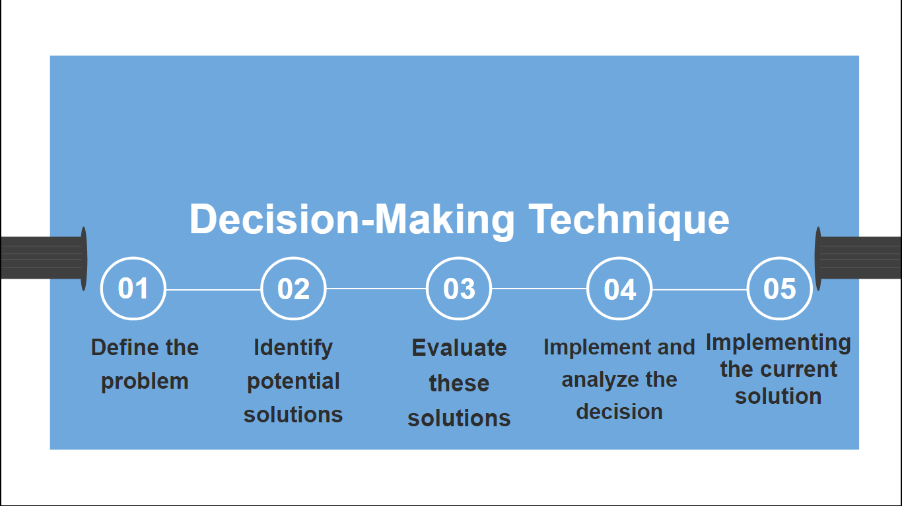

It is very common in the workplace to have a complicated situation or miscommunication between leaders and employees. Here are some company problems and proposed solutions for this type of issue.

- Define the problem

- Lack of Communication

- Communication Breakdown
Communication plays an important role in the workplace, in which everyone is on the same page and working toward the same long-term objective. Unfortunately, we regularly experience a lack of communication, which can result in a range of problems at work. Miscommunication is a frequent occurrence of ineffective communication, especially when information is vague. Misunderstandings created by a lack of communication can lead to major workplace issues. For example, if an employee's obligations are not clearly defined, or if the work assigned by the management is unclear, the employee may misinterpret them. They may not be able to perform as effectively as they could if they completely comprehended. In a number of scenarios, a lack of good communication can lead to distrust.

- Introvert Employees
When they are alone themselves, introverts are at their most focused and creative. They prosper in seclusion. Introverts typically don't need as much help in the beginning of a project because they tend to observe before acting. They have already planned a course of action and examined the necessary procedures. With one exception, you would be basically true in your opinion that an introverted co-worker can make you feel less "needed." The fact that the introvert does not ask for your guidance should not be interpreted as a sign of success. You may need to visit him. This could be a problem at work because co-workers might think they don't need them, and introverts' personalities can influence how others treat them.

- Behavioural Issues

- Attitude Problem at Work

Bad attitude can lead to chronic complaints, as can offensive, illegal, or life-threatening behaviour. If an employee violates the company's and work ethics, management or the employer must take appropriate action against him. Work productivity suffers because of this negative attitude. This type of disruptive behaviour is not typical of a high-performing normal employee.

- Consistent lateness and absenteeism

Naturally, a worker who puts in less time – whether by arriving late or missing work – will be less productive. While co-workers can occasionally fill in, this may not be possible in highly specialised roles. A lack of productivity lowers an employee's quality of work, jeopardising his chances of progression and suffocating the company's ability to compete. Co-workers may become irritated if an employee is frequently absent or tardy. Employees who arrive at work on time and on the schedule are frustrated because a chronically late or absent Manager increases their workload by forcing them to fill in

- Insubordinate behaviours

An employee intentionally refusing to follow a legitimate and reasonable command from their employer is referred to as insubordination at work. Such a refusal would put a manager's reputation and management skills at jeopardy and is typically cause for disciplinary action, including termination. At some point the worker is in any situation in which an employer or manager gives an instruction, and the employed person recognises it but neglects to finish the task.

- Performance Issues

- Managing Time

Although time tracking might seem like a tedious task, once it becomes a routine part of your life, it will reveal unexpected trends and insights. If you calculate how much time phone calls, emails, and other distractions take, you may develop a more strategic approach to managing your time, some are doing other tasks that are not assigned to them and will turn out they will forget what they should be done first.

- Procrastination

People who procrastinate at work avoid dealing with unneeded duties that are connected to their jobs. This behaviour is widespread and can lead to significant issues for both the procrastinators and their employers. Workplace procrastination negatively affects employees' performance and productivity. For instance, many people routinely lose hours of their workweek to procrastination, which results in them making less progress than they otherwise could. In many cases, this also forces people to rush through tasks in order to meet deadlines, which can lead to subpar work.

- Lack of Training

- Unmotivated Employees

The majority of employees lose motivation at work because the business is failing, they dislike the work they are doing, or they disdain the people they are working with. Since their actual job is rarely appreciated, people lose motivation. However, in marketing, you cannot promote a product that you do not firmly believe in. In a similar vein, you can't expect someone to give their all to your business if they don't personally recognize its benefits. The genuine fit that an employer should look for is that.

- Lack of Job-Related Accountability

Some employees hold positions that have nothing to do with the subjects or industries they studied in college. Employees seek employment that is both financially rewarding and sufficient to meet their demands on a daily basis. Today, earning potential is more important than whether or not you will be content in your current position. Employees are thus undertrained and unmotivated since they are unsure about how they will perform the responsibilities given to them by the manager.

- Bullying/ Harassment

- Different races

Some businesses fail to recognize the advantages of a racially and ethnically diverse workforce. Prejudice and stereotypes against certain racial or ethnic groups, whether conscious or unconscious, can lead to discriminatory hiring practices and sometimes leads to bullying.

- Gender Identity

In recent years, gender identity has been a hot matter of debate. This includes transgender and non-binary people, as well as anyone who chooses to express their gender identity through dress, makeup, hairstyle, or voice. They frequently encounter discrimination or harassment of anyone based on their gender identity choice or expression. In order to increase everyone's comfort at work, measures like a gender-neutral clothing code had to be implemented as a result of this.

2. Identify Potential Solutions
Proposing a range of alternative solutions to the problem that exists in a workplace to be able to identify what solutions to do in order to achieve harmony inside the workplace:

- Host and all-hands meeting
To ensure that the staff can simply process the information, you must communicate clearly. When communicating, you can't be sure that the majority of what you said was understood. Understanding your target and employing the right tone in your message are essential for maintaining employee engagement and productivity. The proper communication platform must be put in place so that you can monitor engagement while also serving the demands of your users. The correct objectives must be established and often reviewed to keep your messages interesting and pertinent. Additionally, make new messages and procedures as straightforward as feasible. Encourage employee feedback, pay attention to it, and strategically make adjustments in response to what you learn. It will benefit not only the employees but also the whole team regarding what issue should be fixed immediately or changes to implement within the company.

- Seminars and job-training before effectively can work
Creating seminars to all employees before doing their job on their first day will help them to be aware of what things they should do inside the company, the rules and protocols and what exactly is the mission and their goals. The speaker can help themselves to let go of any preconceived notions about another person's character by paying attention, listening, expressing interest, and being aware of their needs and goals. Employees who didn't have enough knowledge about the work assigned to them will be aware of their job training before they enter the field. You might find that they need additional feedback and suggestions to do their best work or that other obstacles are preventing them from moving forward. Even while none of these reasons fully excuses a lack of effort or follow-through, being aware of the underlying problems can help you decide how to move forward.

- Retreat Activities Two Times in a Year
Your employees will feel more relaxed, and conversations will flow more naturally at company retreats. Furthermore, strengthened relationships outside of the office will boost engagement and help your team members communicate more effectively at work. Choose activities that emphasise collaboration. This competitive event includes five different challenges that will help participants improve their communication and leadership skills while also highlighting the characteristics of individual team members. It will take time to get to know each other's personalities. A period of reflection allows everyone to look back on what they have accomplished in the previous few months. and they have the opportunity to think about how they can strengthen as well as what their weaknesses are.

3. Evaluate this Solution
Retreat Activities Two Times in a Year

List the actions in which each member of the team must comply with in order to integrate the solution. Start making a timeline or chart that illustrates who is responsible for full control of accomplishing each step as well as the perfect opportunity to begin each intervention. Scrutinise all the document data more about eventual results after the team has executed the solution to assess the efficacy of your problem-solving framework. Members of the team could accomplish this by having a conversation regarding their experiences among one another, or they can fill out an anonymous questionnaire that can provide comments. Formulate this relevant information either manually or electronically in order to assess the progress of your solution.

- Implement and analyse this solution

This Retreat Program in the company will be held 2 - 3 times a year: in March, December. This will represent a gathering of all employees from all departments within the company. The primary objective of this retreat program is to build a more efficient team in a workplace or company, to establish new connections with each other, particularly for newly recruits, to reflect on their own aim and motivating factors, but also to collaborate solely on a single or more specific goal. The Finance Department will be in charge of estimating the program's potential costs three months in advance. This includes costs for presenters, recording equipment, audio and visual aids, site fees, lodging, meals, and public transportation. The Marketing Department will indeed be researching for a venue where the company can conduct a retreat location, consequently they must discuss where else to check. The amount of funding for this retreat will also be known to the marketing department. They take into account free or inexpensive locations, such as public or private farms, beaches, rural, and state parks, which commonly offer their services for nothing or at extremely affordable prices. The Human Resources Management team will take the lead by inviting all workers to participate in the retreat activities and outlining the benefits of doing so.

- Implementing the current solution
As of now, since there's a new solution, the Human Resources Management will hold a seminar for all the employees of the company by preparing a meeting and announcing it the day before, they are also in charge of the PowerPoint presentation, which illustrates what this meeting is for together with the head of the company. Each other team leader will be called for a conference meeting so they will be one to tell what is the new things that will be done inside the workplace. Team leader will also one to be a factor for all the employees to join this program of the company by encouraging them what are the benefits of this. The expenses will be covered by the company, but it will ensure it won't affect their salaries. Before this current solution will be done- 3 months ahead of time, all the departments should be open for the suggestions of every employee. Teams can talk about the suggestions during their breaks so they will eventually start to know each other, especially what kind of employees they are inside the company.
Sources:
- (2021, December 30). Retrieved January 2, 2022, from https://resources.smartbizloans.com/search-page/?q=lack+of+job-related+accountability&oq&aqs=chrome.1.69i176j35i39i362l14.-1j0j7&client=%2F%3Fq%3Dlack+of+job-related+accountability&clientmployee-management%2Fcommon-workplace-issues-and-how-to-solve-them%2F

- The top 3 causes of workplace mental health issues (and how to solve them). Retrieved January 2, 2022, from https://www.benenden.co.uk/be-healthy/work/workplace-mental-health-problems-causes-and-solutions/

- Sarkis, S. (2019, January 31). Introverts can be your most valuable employees. Retrieved January 1, 2022, from https://www.forbes.com/sites/stephaniesarkis/2019/01/30/introverts-can-be-your-most-valuable-employees/?sh=4524368b2400

- Saez, A. (2018, April 5). The effect of absenteeism and tardiness on work. Retrieved January 2, 2022, from https://yourbusiness.azcentral.com/effect-absenteeism-tardiness-work-4991.html
- Editorial Team (23,June 2021). What Are Problem-Solving Models? Definition and Types. Retrieved August 24,2022, from
What Are Problem-Solving Models? Definition and Types | Indeed.com
6) Knobler, L. (16, October 2019). 27 Company Retreat Ideas Your Team Will Actually Enjoy. Retrieved August 24,2022, from
27 Company Retreat Ideas Your Team Will Actually Enjoy (helpscout.com)
7) Vipsania, P. (10 May 2022). 7 Benefits of Organizing Corporate Retreats(Example Events Included). Retrieved August 24,2022, from
7 Benefits of Organizing Corporate Retreats | TeamBonding
8) Agrawal, A. (10 July 2017). The Importance Of Having Team Retreats. Retrieved August 24,2022, from
The Importance Of Having Team Retreats | HuffPost Impact
9) Eddie, D,. & Kethley, A. (1994). Keys to successful board-staff retreat. August 24,2022, from
Chapter 12. Providing Training and Technical Assistance | Section 7. Organizing a Retreat | Main Section | Community Tool Box (ku.edu)

