  PORTFOLIO | Module: Emergent Leadership Skills in the Workplace Module code: BMSW6101 Student Name: Vasilica-Madalin Iliuta Student ID: 2007277 Lecturer’s name: Oluwaseun Adegbite

Table of Contents

Part I. Academic report. 2
Introduction 2
A critical explanation of Theory X, Y & Z leadership 3
Theory X 3
Theory Y 4
Theory Z 4
Similarities and differences between all the theories 4
Advantages and disadvantages of theory X, Y and Z 5
The role of culture in theory X, Y and Z 8
Personal differences in theory X, Y and Z 9
Different situations may determine a leader to apply different leadership style. 9
Different style of leadership and situation 11
Organizational Example 11
Conclusion 12
Part II. Reflective report. 14
Introduction 14
Main body 15
Conclusion 18
References 19

Part I. Academic report

Introduction
Leadership is a concept which involves a variety of traits, behavior, and skills. When a person has an excellent ability to lead a team by providing them with proper guidance and support, then he/she can be a good leader. Leadership not only involves skills to provide right direction to the staff members, but it also includes skills to influence people in a way that they do work according to what leader wants from them (Armstrong, 2016). Leaders must have a great vision so that they can plan good decisions for future growth. Moreover, leaders must have effective communication skills to make everyone understand what an organization expects from its staff (Adair, 2013). The purpose of this study is to learn about various leadership skills and styles.
It will critically analyze and explain theory X, Y and Z leadership with its similarities, differences and advantages and disadvantages of these styles, the role of culture and personal differences. This theory will help in gaining insights about how employees could be identified and what leaders can do to handle different types of employees. Leaders must be very cautious, very making decisions in different situations as not every leadership style can work best in every situation. Therefore, this report will critically evaluate contingency theory of leadership which explains that leaders cannot act the same in every situation, their style varies in different situations. Thus, this will be discussed to understand how leadership theory can help leaders to adopt different styles of leadership in different situations and the skills a leader must have to enhance Employee’s motivation for working hard for the organization.

A critical explanation of Theory X, Y & Z leadership
Theory X and Theory Y was introduced by Douglas MC Gregor in 1960s where he proposed different assumptions about employee’s attitudes and behaviour towards work. Douglas proposed these assumptions to make the leaders and management understand about the significant implications they can make to motivate each type of worker. First, let’s understand what each theory implies (McCauley and Palus, 2021).

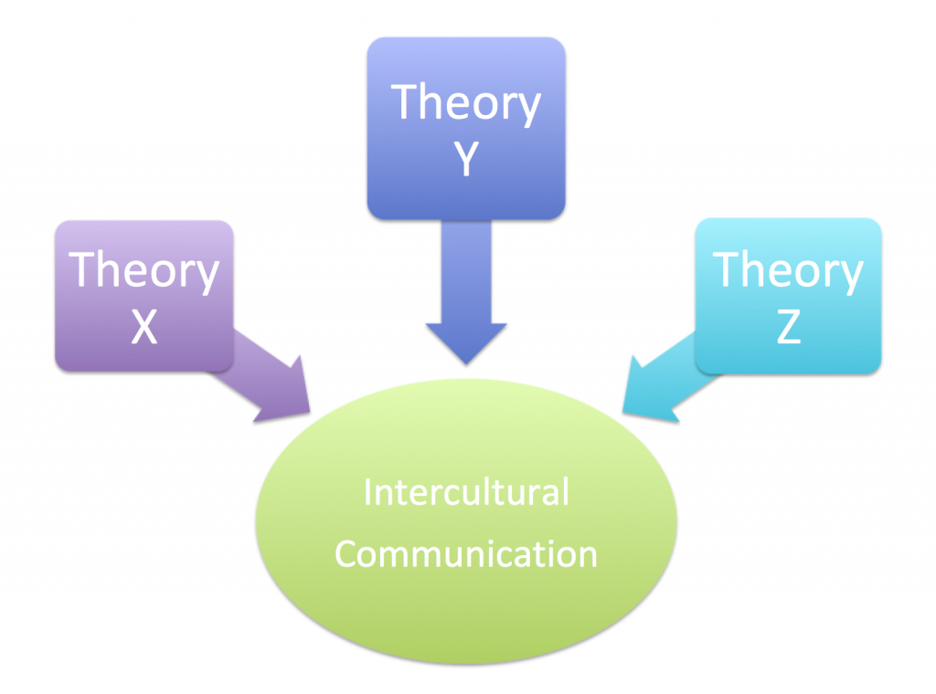
Figure 1 Theory X, Y and Z
(source: pressbooks.pub, 2023)

Theory X
Theory X proposed that people dislike work and they try to avoid it as much as possible. Such employees must be controlled or given proper direction to make them achieve organizational goals. These employees would not work willingly until leaders direct them and give them responsibility as such people avoid responsibility and are very less ambitious towards work (Brambilla et al., 2020). These assumptions were proposed by McGregor in theory X. The significant implications can be that leaders adopt an authoritative style of leadership or use directive style to make everyone work towards accomplishing organizational goal. With the help of extrinsic motivators like rewards and punishments, leaders can control such people (Armstrong, 2016). Moreover, leaders must monitor them continuously and put a strict control over them. They should never think about delegating authority to such people as they are irresponsible ones.

Theory Y
Theory Y states that people work as they get meaning and enjoyment out of it. Such people have the desire to work hard as it gives them self-fulfilment and a feeling of achievement (Mahmoud et al., 2021). Such employees are innovative, creative and try to brainstorm valuable ideas for the growth of the organization. To get the work done from such employees, leaders must adopt participative and collaborative style of leadership where they include everyone in company’s decision-making process. Theory Y leader can easily delegate the work as they can trust their employees high level skills to easily handle the give authority and responsibility. In this theory, organizations can promote self-management and individuality. With the help of intrinsic motivators such as appreciation and employee satisfaction, leaders can make employees work effectively (Mullins, 2019).

Theory Z
Theory Z was an extension theory proposed by William Ouchi in 1980’s. This theory was further based on assumptions that employees work effectively because they have a strong commitment with organization and work provides them stability and a sense of identity (Stefanovska-Petkovska et al., 2021). This theory values long term employment, employee development and job rotation. Its emphasis on participative and collaborative decision making. This theory states that if leaders want to get the work done, they need to nurture and develop employees. With the help of intrinsic motivators like honour and mastery, leaders can motivate employees to work effectively. Leaders can adopt collaborative and team-based leadership styles to make everyone feel valued in the organisation. When employee is delegated the work, leaders can trust them as they are not working for control or any other purpose, rather they want to build strong and loyal relationship with the organization (Mullins, 2019).

Similarities and differences between all the theories
Similarities: One of the biggest similarities between the three theories is that it is based on employee’s motivation and leadership styles to be used. All the theories help leaders and management to understand what different types of employees want from an organization and how can be pushed towards work (Solinger et al., 2020). The theories are similar because they focus on employee’s requirements. Theory X employees requires extrinsic motivators for working while theory Y and Z employees require intrinsic motivators to work in a firm. It also focuses on different leadership styles. Each theory states about leadership styles a leader must adopt to handle different types of employees. Another similarity is the communication techniques. All the three theories put emphasis on effective communication skills of leaders, whether it is for directing employees or involving them in decision making (Adair, 2013). Thus, this is how all the three theories are related to each other.

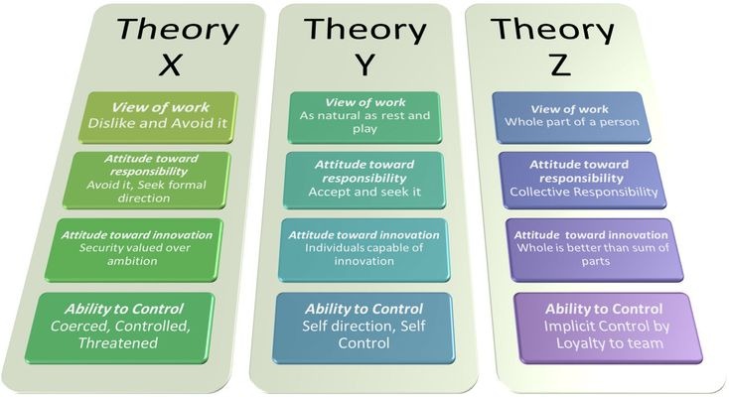
Figure 2 similarities and differences
(source: pressbooks.pub, 2023)
Differences: There are many notable differences in the three theories proposed by Douglas and Ouchi. Theory X focuses on control and supervision, theory Y focuses on contribution and recognition and theory Z focuses on Cooperation and loyalty. All the theories state different perspectives of employees. Theory X employees are lazy and self-centred and therefore have a perspective of working unwillingly. Theory Y employees are ambitious, thus wants to work hard and take work as an enjoyment (McCauley and Palus, 2021). Theory Z employees are committed and loyal and therefore wants to work hard as well built strong organizational culture of teamwork. Moreover, all the three focuses vary in term of leadership approaches as one theory focuses on directive approach, other focuses on participative and theory Z focuses on collaborative approach. Thus, these are the reasons behind differences in all the three theories.

Advantages and disadvantages of theory X, Y and Z
Theory X
Advantages: Theory X is very easy to be understood by leaders as it states the basic nature of employees, for example, to avoid work and delegate it to others. Most of the people do not like to have responsibilities on their shoulder and that’s work in a lazy manner. But this theory is very useful because once employees know that they are continuously monitored and they will be punished for irresponsible behaviour, they work in a better manner. Another advantage of this theory is it helps in less wastage of time and delay in work. When workers are closely monitored by supervisors, they work productively which reduce the time wastage. It also helps in fixing responsibilities as this theory is based on punishments and rewards for an individual’s action. Thus, leaders can fix responsibilities and give rewards to deserving workers (Jain et al., 2020).

Disadvantages: The biggest disadvantage of this theory is that it is made up of many assumptions which are not entirely true and authentic. It sees every worker as lazy, poor decision maker, not able to work without supervision which cannot be true in a generalized way. Every worker is different and generalizing everyone as same makes this theory inapplicable in all cases. Another disadvantage of this theory is that it gives leaders so much of power. Sometimes leaders could behave biased because of overpower and would give harsh punishments to those workers who they don’t like even if their actions do not justify the punishment. This theory also promotes negative organizational culture. When workers are closely monitored and supervised for everything they do, it creates a fearful environment and workers cannot do anything innovative on their own. It also increases turnover rate as people do not like to work in such culture (Gottfredson et al., 2020).

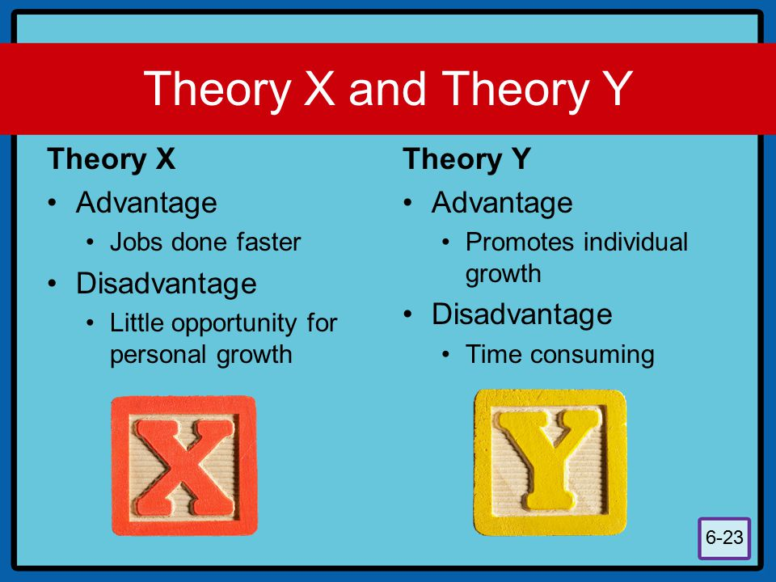
Figure 3: Theory X and Y advantages and disadvantages
(source: fourweekmba.com, 2023)

Theory Y
Advantages: Theory Y increases the overall performance of the organization as it encourages employees to work in collaborative projects and give them a flexible environment to perform productively. It gives freedom to employees to take decisions on their own which results in a positive work culture. The scope for career progression increases and it not only benefits the company but also employees for their future growth. Another benefit of this theory is that once an organization provides a friendly environment, it boosts the morale of the people working in the organization as well as attract talented candidates towards the organization. Moreover, innovative ideas are generated within the firm which gives competitive advantage (Gottfredson et al., 2020).

Disadvantages: The biggest disadvantage of theory Y is that it is too much lenient and employee friendly which can result in employees taking the organization for granted and accomplishing selfish goals over organizational goals. Another disadvantage is that every employee cannot be a good decision maker and can take poor decisions while accomplishing goals. This can be a huge negative point as workers need supervision and proper leadership to take right decision (Bernarto et al., 2020; Armstrong, 2016). A single inappropriate decision can lead overall loss of the company. Some of the assumptions of this theory are too simplistic, for example, employees viewing work as a challenge, acceptance of responsibility etc., which raises doubt that every worker is not too hardworking and responsible. Thus, applicability of this theory in real life can go wrong.

Theory Z
Advantages: The benefit of theory Z is that it helps in reducing employee turnover as it promotes collaborative working. When people work in a team and are valued, there are a very less chances of them leaning the company. It also increases commitment and boost morale of the employees. When employees are treated equally and are given flexibility in working, their morale enhances which results in working with loyalty. Theory Z stresses the need to help worker become generalists, instead of becoming specialists. This results in job satisfaction as employees are not forced to be a specialist in everything they do (Bernarto et al., 2020). Thus, theory Z provides a huge advantage of drastic increase in overall performance and productivity of the organization.

Disadvantage: As the theory relies upon inter-personal relationship for an organization’s efficiency, it can be difficult to manage everything smoothly. Without a proper structure, employees can create conflicts with each other and due to lack of accountability and responsibility, organization’s productivity could be affected. Employees may be reluctant to participate in decision making due to fear of being criticized (McCauley and Palus, 2021). This theory does not offer a complete solution to various motivational problems operating in different environment.

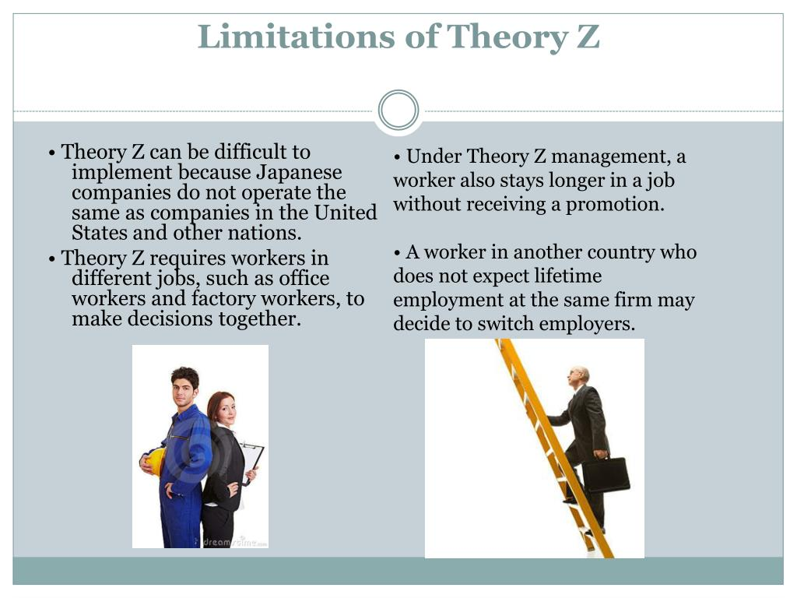
Figure 4 disadvantages of Theory Z
(source: fourweekmba.com, 2023)

The role of culture in theory X, Y and Z
An organizational culture plays a very vital role in adopting various leadership style proposed in all the three theories. A culture is a set of beliefs, values, and practices of an organization. When an organization adopts a flexible working culture, it will use theory Y and theory Z to make everyone work effectively (Armstrong, 2016). But if an organization uses a strict working culture and less innovation, it will use theory X for its employees. An organizational culture which follows a proper structure, flow of communication and clear roles and responsibilities, will always use theory Y to make everyone work effectively. As theory X is highly focused on direction and authoritative leadership style, most of the organization which works on a strict guideline follows this theory. While start-up firms mostly go for theory Z as they want to provide a culture where everyone can put innovative ideas on the table and work collaboratively to increase the growth of their organization. Moreover, cultures which values empowerment and individualism will always differ theory Y as it provides autonomy to employees to work in their own manner and bring valuable ideas to the organization.
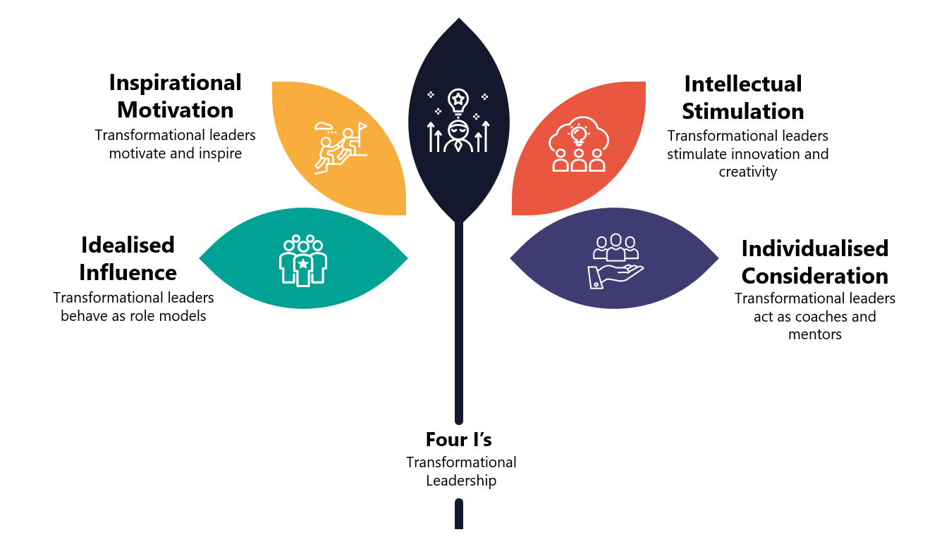
Figure 5 Leadership and culture
(source: fourweekmba.com, 2023)

Personal differences in theory X, Y and Z
Personal differences refer to psychological characteristic that differentiate one person from another and helps in identifying a person individuality. Theory X, Y and Z can have significant consequences on individuality and how different employees react to these theories. First, considering employees who want clear rules and regulations and can only work in a strict environment will find theory X beneficial. On the other hand, individuals who want freedom to work will always preferred theory Y as it will give internal motivation to them. Additionally, people who like challenging tasks and want to create something innovative, excels in theory Y. On the contrary theory Z is appreciated by people who want long term stability in organization. People who are loyal and are finding a place where they can have a sense of belongingness, social bond, and supportive colleagues, will enjoy theory Z (Northouse, 2021).

Different situations may determine a leader to apply different leadership style
Leadership styles are of many types such as autocratic, democratic, transactional, transformational, laissez-faire, servant etc. Every leader uses different types of leadership style in different situations because if a leader adopts only one type of leadership, then it cannot give appropriate results every time (Mullins, 2019). The most effective leadership style is contingent upon the internal and external factors such as specific task, situation, behaviour of the employee, stakeholder’s goal etc. Theorists have proposed a theory for such behaviour of leaders which is named a contingency theory (Carlos Pastor and Mayo, 2008).
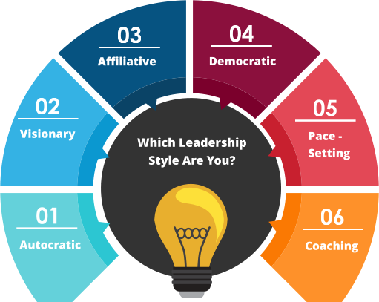
Figure 6 types of leadership styles
(source: liveandlearnconsultancy.co.uk, 2023)
This theory states that no leadership style is perfect or can be considered as the best style of leadership because it depends upon which leadership style works best in each time. For example: if there is a crisis situation, leaders would have to adopt autocratic style or coaching style of leadership to push employees to work hard in a given situation (Yang and Wei, 2018). Moreover, if the complexity of the task is tough, then leaders need to use directive approach to provide clear supervision and training to employees to accomplish such a complex task. Contingency theory includes situational leadership which is determine by three variables as
Leader Member relation, Task structure and Position power. Leader member relation are all about how much a team trust a leader when they trust in a very high amount when the situational favourableness is high. Task structure means the clarity of the task needed to complete a project. The more clear-cut task is the higher situation’s task structure and vice versa. Position power refers to authority a leader has over the team. High position power makes the situation more favourable (Manning and Curtis, 2019).

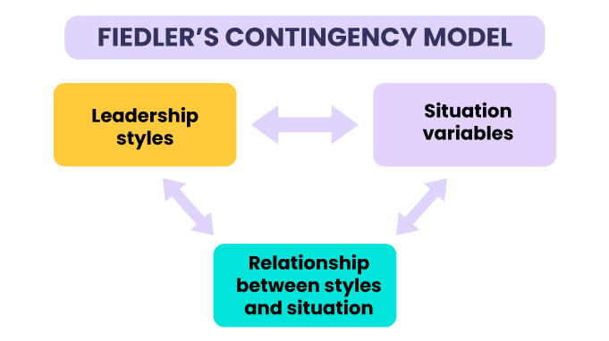
Figure 7 Contingency model
(source: liveandlearnconsultancy.co.uk, 2023)

Different style of leadership and situation
In a conflicted situation, a leader must act as a mediator and adopt a leadership style which promotes effective communication and taking proper decision. They should listen to both the parties and try to resolve the issue. They should use a collaborative leadership style and mix with the team members to enhance positivity in the team and improve inter-personal relationship (Chima and Gutman, 2020).
In a situation of change, leaders must use a very supportive style of leadership to make everyone adaptable to change. When leaders use directive style, they can make employees learn about why the change is necessary and the benefit out of it. Rather than using an autocratic style where they behave strictly to make everyone adaptable to change, they can use supportive style to understand the reason behind resistance to change and emotionally support employees for effective growth (Lee et al., 2020).
In a situation of recession, leaders must take the charge and make tough decisions. Therefore, in such situation leaders need to be autocratic so that they could communicate clear instruction to everyone and inform their team about what is expected from them in such situation. In addition to this, leaders can also use democratic style if they want everyone to share good ideas for fighting in such situation. When pool of ideas is generated, everyone can collectively pass the situation of recession (Sethuraman and Suresh, 2014).
In an economic growth situation, leaders must use democratic and transformational style of leadership as in such scenarios they would require innovative ideas for grabbing the opportunity of growth. Leaders should encourage open discussion and empower their team members by giving them flexibility to think beyond their limits and create valuable and innovative ideas for growth.
In a situation of seasonal time, when there is a lot of work on the shoulders of leaders and management, leaders must shift to laissez faire style of leadership to delegate the work to employees and trust them entirely. In this style of leadership, leaders do not have to continuously monitor and supervise employees which can provide leaders time to handle important work in the seasonal time (Tannenbaum and Schmidt, 1973).

Organizational Example
To understand the contingency theory and how leaders act in different situation, an example of an employee who regularly make excuses to work can be taken. A leader can use an autocratic style of leadership to make such people work effectively. With a strict behaviour and giving threats of punishment, such employees can be pushed towards effective work. When a leader behaves in a strict manner, employees work efficiently. Moreover, such employees when given a clear task and deadline can work effectively and cannot make excuses. Considering a live organizational example of Google where leaders use democratic style of leadership in the situation of innovation and growth. This leadership style emphasis on empowering employees to brainstorm innovative ideas and work collaboratively to achieve high goals in the situation of growth (Foss et al., 2023).
Google mostly focuses on leadership style which are highly focused on collaboration, transparency, and innovation. In the past situations, it took a laissez faire style of leadership to encourage employees to work independently so that they can become self –efficient in every situation (Adam et al., 2023). Another example can be taken is of Amazon which is an E-commerce company which uses different style of leadership in different situation. Most of the time leaders of Amazon behave in an authoritative manner to enforce a culture where everyone is clear about their roles and responsibility. According to research there are 16 leadership principles used by Amazon to change its leadership style in different situation to make rapid and quick decisions.
Thus, it is very essential for leaders to understand different style of leadership and use it in appropriate manner according to the situation. Fiedler’s contingency theory therefore clearly states that a leader can be excellent in one situation and can totally fail in other situation as it depends upon the situation that how a leadership style is effective. It is important for a leader to identify their own leadership style and situation before taking any decision for the company’s future. Thus, if leaders get successful in their role, then it was a perfect match of their situation and their leadership style (Retnaningdiah et al., 2023).

Conclusion
The study of leadership skills and styles concludes that every organization works with good leaders to achieve organizational goals. Leaders are the ones who tie everyone and take them together towards the success of the organization. Leaders need to become role models for their employees if they expect the same from their employees. This report studied theory X, Y and Z proposed by McGregor and Ouchi which concludes that all the theories are based on employee needs and motivational techniques used to drive and encourage employees towards effective work. All the theories have similarities, differences, advantages, and disadvantages which helps leaders to understand which leadership styles they should adopt to handle different types of people in an organization.
If people in an organization are lethargic towards work, then based on this assumption, theory X suggests leaders to be authoritative to make such people work effectively. Theory Y can help leaders to encourage self-motivated employees to work efficiently by giving them supportive behavior and intrinsic motivation. Theory Z was studied to understand that leaders can create friendly environments within an organization to make people work effectively. Thus, every theory is based on how employees can be pushed towards work for effective results. It also studied contingent theory to understand situational leadership and it was discovered that in different situations, leaders must adopt different leadership styles to get effective results. If this is not done, then results cannot be perfect and can lead to failure.

Part II. Reflective report

Introduction
Leadership plays a vital role in team management and change governance within a business organisation. With pace of time and diversification demand in work-based adoption factors leadership imperatives and its attributing effects have turned important for stimulated working of an organisation in an effective manner. Leadership traits and styles can articulate both positive and negative impact on staff which is a dicey situation for organisations. The application of leadership perspective in reflection form will be presented in the above report. The first section of essay will justify the effectiveness in leadership functions and the way traits of leadership can perceive effective team functioning. The analysis and highlights of personal leadership skills and way the traits can be acquired will be presented in the essay as well. The new aspects of leadership vitally important but not used in current module function will be analysed in the above essay.

Main body
Rationale of effective leadership styles lies in understanding the teammates in such a manner that transitional and transformational aspects of ones work positively impact on overall work of the team. Theory X, Theory Y and theory Z are the three types of leadership style theory-based situations which we discussed in our group-based project. I personally understood that attitude of employees and way employees perceive their work plays a vital role in lateral functioning of team. However, if he leaders in respective sector are having a personality that triggers out from best employees through motivation and controlling function the employees’ function in accountable manner (Kundu and Mondal, 2019).
The powers leaders have while functioning within an organisation and understood that powers hold huge responsibility. The application of Theory Z in current era that is driving employee’s motivation towards a focused parameter, governing different types of leadership styles and good communication techniques avails employee’s confidence and perspective towards work (Porfírio et al., 2021). Everyday business dynamics due to innovation and globalisation is changing so if the leaders support employees and not command the effectiveness within the work acceptance is more democratic rather than autocratic in nature. It can be understood that leadership is a trait that can be acquired by just understanding others and managing the culture of organisation that is supportive.
Personally, I feel sensitivity and control both are the major parameters that are required by leaders to foster the functioning of any task in an effective manner. From drafting the module in leadership management and each type of leadership style with my personal working experience and understood that employees have undergone each style by my mentor without recognising the swift approach taken by the respective (Shala et al., 2021). Autocratic leadership style is chosen at our workplace while managing time and ethics, daily working is drafted by democratic leadership styles is that each employee has some contribution within the work, supportive leadership was followed while we were undergoing training for new software, and we often have motivational lectures and gestures from side of leaders which is all about transformational leadership style.
Post cracking all types of leadership adoption by my mentors and teachers I have understood that leadership cannot be limited to one style. Every leader uses different types of leadership style in different situations because if a leader adopts only one type of leadership, then it cannot give appropriate results every time.
It can also be understood that some types of leaderships are based on conditions and require more care while selection. Contradiction to any type of leadership style selection and effective functioning of situation might govern adverse effects on organisation itself. For example, during change in Tesco that is lay-off of 2000 employees post covid 19 the corporate restricting process was drafted. In the case study of Tesco for adoption of changes in which leaders intentionally use transformational leadership to draft effective support and security to the employees (Abdelazim, 2023).
Additionally, in the case study by Dyson on leadership governance in which Sir James Dyson choose democratic type of leadership in making a strategic decision but to manage the quality and ethics at workplace autocratic type of leadership was carried (Poeske et al., 2021). It can be said that leadership built and fabricates the culture of any place, and this is also major attraction in new talent acquisition within the organisation. The leadership styles adoption-built culture of organisation which reflects on the attitude, behaviour and performing function of organisation and employees. Equity fabrication and positive image branding is also governed by business organisation through correct leadership follow up.
Many types of factors like communication skills, emotional intelligence, career supervision, consistency management and building of security perspective within team is also majorly triggered by leaders. Emotional intelligence in current era I think plays a vital role in managing employees with diversified skills and culture (Wittmer and Hopkins, 2022). I think balancing the emotions like stress, work pressure, happiness and work life balance all are part of employee’s life, and its perseverance must be drafted through good emotional stability. This is a type of aspect that I has not been mentioned within out module, but I think is very important and I need to acquire the respective trait in an effective manner.
Another major function of leadership style according to me is skill acquisition motivation to staff with its impact on performance of employees (Gómez-Leal et al., 2022). I think leaders must make employees understand that any type of training or skill program aids the employees in gaining new skills and amplify their personal performance. I think these types of communication are not governed by leaders in an effective manner. I think one major aspect of good leadership is feedback divining to employees which in current time must be consistently followed by leaders to have improve functioning of employees in effective manner.
My personal leadership ability in comparison to current fundamental analysis and perspective-based understanding is limited. I have traits of good leadership style by polishing of respective traits in justified manner by skills imposition is something that I require the most. I have good communication skills, orientation skills, I also have an ability to influence others and govern them with effective working perspective. I also have accountable understanding of team members and enhance the effectiveness of overall work (Rowley and Oh, 2020). I also work ethically through showing respect and empathy towards my peers and, I am the most active person while change management functioning within our organisation. I have good adaptation skills and try to understand things from perspective of client and work quality.
It can be simply understood that I have acquired basic leadership skills through my working and can handle team but not very seriously. Hence, I need to fabricate my skills in an effective manner to amplify my trait. I need to have good communication skills in both formal and informal language so that I can handle peers, executive staff, and clients in an effective manner. I need to learn to solve problems with larger perspective to draft effective support to all types of issues within the work section (Mansaray, 2019).
I think I can learn to solve problem by handling one with greater perspective and understand the consequences of any action (Leal Filho et al., 2020). Looking towards the future and forecasting the effective support to the leadership action is major function of leadership style that I think I must acquire in an effective manner. I most of time in my leadership career use transformational leadership style to have correct visionary approach for all staff and teammates working within the team. I use simple and clear communication to deliver the gaols and objectives to have effective understanding of work with no confusion.
From the analysis and explanation of leadership module-based function I have understood that leadership is more about motivation than commanding and more about understanding by using emotional intelligence (Sharp et al., 2020). In terms of change management that replacing of operating software within the organisation I choose to use Kotter’s eight step model for change application to have swift approach towards correct change management (Leal Filho et al., 2019). I think my leadership style is a mix of supportive and democratic type of leadership which not only govern the teammates with effective support but gain their confidence within the leaders as well.
During drastic change in everyday functioning that is from offline mode to online mode may of my peers and staff members faced issues in ICT skills and to solve all such issues I came forward to help the staff irrespective of the teams they function in. In that time, I not only mastered correct guidance and training style but also understood that way different employees have different understanding because of knowledge and culture. I think when given a responsibility I handle it with immense care and try to complete the task on time (Lazarus et al., 2019).
However, I personally feel that I must change and improve my skills to uphold the position of good leader. I need to acquire effective skills in software-based learning, understanding employees, ethical code functioning and motivational skills to have proper leadership personality. Fiedler’s contingency theory is something that I must follow to govern correct leadership assistance in correct time frame (Reams, 2023). I think I need to follow three types of leadership parameters that is leader member relations, task structure and leader’s position in power.
Confidence, domain knowledge understanding, communication skills, problem solving skills are the traits of good leaders which I already have. But I need to function well on problem solving skills through more reading and intense analysis (Moldoveanu and Narayandas, 2019). Empathetic relationship and understanding attitude towards other leaders in an effective manner is another major function of Fiedler’s contingency theory which I need to follow in an effective manner. Task structure and leader’s position in power is something which I need to understand in an effective manner.
Project based priority, governance of task monitoring and feedback giving to employees are skill-based functions which need to articulate in an effective manner. I am motivated by theory Z in which leaders can adopt collaborative and team-based leadership styles to make everyone feel valued in the organisation. I think I must build up my personality by correct mentorship program from my executive staff so that I can understand and learn some important traits of leadership in an effective manner (Reams, 2023).
Fiedler’s contingency theory also explains about ethics and unbiased decision making within the effective leadership style so that all types of staff and team members can be treated in equal manner (Purwanto, 2020). I will have to present an unfair path and be ethically oriented towards selection of my words and govern fair judging with correct feedback drafting. From above module and reflective essay, I have understood that application of my types of leadership styles and gesture are required to have better leadership practice. I have traits of good leader, but I require to improve and amplify my skills in assertive manner.

Conclusion
The above reflection concludes that leadership has many types of perspectives and parameters which have larger frame of reference. In the current essay, the effectiveness and understanding in leadership styles in context with assessment one has been presented in the essay. The understanding and learning in context with leadership traits has been presented in the above essay. The personal understanding of personal traits for leadership has been presented in essay in reflective manner. The skills acquired with examples and the skills to be articulated in an effective manner has been presented in last section of essay.

References
- Abdelazim, Z. (2023) Organisation Behavior-TESCO Case.
- Adair, J. (2013) Develop Your Leadership Skills. 2nd ed. London, Kogan Page.
- Adams, D., Thien, L.M., Chuin, E.C.Y. and Semaadderi, P. (2023) The elusive Malayan tiger ‘captured’: A systematic review of research on educational leadership and management in Malaysia. Educational Management Administration & Leadership, 51(3), pp.673-692.
- Armstrong, M. (2016) Armstrong’s handbook of management and leadership for HR : developing effective people skills for better leadership and management. Fourth edition. London, England; Kogan Page
- Bernarto, I., Bachtiar, D., Sudibjo, N., Suryawan, I.N., Purwanto, A. and Asbari, M., (2020) ‘Effect of transformational leadership, perceived organizational support, job satisfaction toward life satisfaction’, Evidences from Indonesian teachers, 29, pp. 5459-5503.
- Brambilla, N., Eidelman, S., Hanhart, C., Nefediev, A., Shen, C.P., Thomas, C.E., Vairo, A. and Yuan, C.Z. (2020) ‘The XYZ states: experimental and theoretical status and perspectives’, Physics Reports, 873, pp.1-154.
- Carlos Pastor, J. and Mayo, M. (2008) ‘Transformational leadership among Spanish upper echelons: the role of managerial values and goal orientation’, Leadership & Organization Development Journal, 29(4), pp.340-358.
- Chima, A. and Gutman, R. (2020) ‘What it takes to lead through an era of exponential change’, Harvard Business Review. Aavailable at: https://hbr.org/2020/10/what-it-takes-to-lead-through-an-era-of-exponential-change
- Foss, N.J., Schmidt, J. and Teece, D.J. (2023) ‘Ecosystem leadership as a dynamic capability’, Long range planning, 56(1), p.102-270.
- Gómez-Leal, R., Holzer, A.A., Bradley, C., Fernández-Berrocal, P. and Patti, J. (2022) ‘The relationship between emotional intelligence and leadership in school leaders: A systematic review’, Cambridge Journal of Education, 52(1), pp.1-21.
- Gottfredson, R.K., Wright, S.L. and Heaphy, E.D. (2020) ‘A critique of the Leader-Member Exchange construct: Back to square one’, The Leadership Quarterly, 31(6), p.101-385.
- Jain, L., Katarya, R. and Sachdeva, S. (2020) ‘Recognition of opinion leaders coalitions in online social network using game theory’, Knowledge-Based Systems, 203, p.106-158.
- Kundu, S. and Mondal, P. (2019) ‘Luminance of contingency theory in revealing the leadership style of the academic librarians’, Library Philosophy and Practice, pp.1-11.
- Lazarus, G.N., Ijanikin, L., Adesoji, N.A.A. and Jinadu, I. (2019) ‘Leadership and management practices in the 21st century academic libraries’, Journal of Library Services and Technologies, 1(2), pp.51-61.
- Leal Filho, W., Eustachio, J.H.P.P., Caldana, A.C.F., Will, M., Lange Salvia, A., Rampasso, I.S., Anholon, R., Platje, J. and Kovaleva, M. (2020) ‘Sustainability leadership in higher education institutions: An overview of challenges’, Sustainability, 12(9), p.3761.
- Lee, A., Lyubovnikova, J., Tian, A.W. and Knight, C. (2020) ‘Servant leadership: A meta‐analytic examination of incremental contribution, moderation, and mediation’, Journal of Occupational and Organizational Psychology, 93(1), pp.1-44.
- Live and learn consultancy (2023) 6 Different leadership styles every leader in business must know. Available at: https://www.liveandlearnconsultancy.co.uk/different-leadership-styles/ (Accessed on 18th October 2023).
- Mahmoud, A.B., Fuxman, L., Mohr, I., Reisel, W.D. and Grigoriou, N. (2021) ‘“We aren't your reincarnation!” workplace motivation across X, Y and Z generations’, International Journal of Manpower, 42(1), pp.193-209.
- Manning, G. and Curtis, K. (2019) The art of leadership. McGraw-Hill Education.
- Mansaray, H.E. (2019) ‘The role of leadership style in organisational change management: a literature review’, Journal of Human Resource Management, 7(1), pp.18-31.
- McCauley, C.D. and Palus, C.J. (2021) ‘Developing the theory and practice of leadership development: A relational view’, The Leadership Quarterly, 32(5), p.101456.
- Moldoveanu, M. and Narayandas, D. (2019) ‘The future of leadership development’, Harvard business review, 97(2), pp.40-48.
- Mullins, L.J. (2019) Organisational behaviour in the workplace. Twelfth edition. Harlow, United Kingdom, Pearson Education Limited.
- Northouse, P.G. (2021) Leadership: Theory and practice. Sage publications.
- Poeske, L.D., Harstad, J., Dyson, J.C., Cheddar, L.A., Yelman, A. and Stober, S.S., (2021) ‘Traditional curriculum versus hidden curriculum’, Ethical Leadership and Decision Making in Education (pp. 59-78). Routledge.
- Porfírio, J.A., Carrilho, T., Felício, J.A. and Jardim, J. (2021) ‘Leadership characteristics and digital transformation’, Journal of Business Research, 124, pp.610-619.
- Purwanto, A. (2020) ‘The role of job satisfaction in the relationship between transformational leadership, knowledge management, work environment and performance’, Solid State Technology, 63(2), pp. 293-314.
- Reams, L.C. (2023) ‘Fred Fiedler’s contingency model revisited: 30 years later. Filosofiya osvity’, Philosophy of Education, 29(1), pp.111-124.
- Retnaningdiah, D., Muzakir, M.F.A., Rahayu, N.E.E., Sangaji, R.C., Triono, T.A. and Hidayat, A. (2023) ‘A literature review: future prophetic leadership’, Management Analysis Journal, 12(1), pp.42-50.
- Rowley, C. and Oh, I. (2020) ‘Trends in Chinese management and business: change, Confucianism, leadership, knowledge & innovation’, Asia Pacific Business Review, 26(1), pp.1-8.
- Sethuraman, K. and Suresh, J. (2014) ‘Effective leadership styles’, International Business Research, 7(9), p.165.
- Shala, B., Prebreza, A. and Ramosaj, B. (2021) ‘The contingency theory of management as a factor of acknowledging the leaders-managers of our time study case: The practice of the contingency theory in the company Avrios’, Open Access Library Journal, 8(9), pp.1-20.
- Sharp, G., Bourke, L. and Rickard, M.J. (2020) ‘Review of emotional intelligence in health care: an introduction to emotional intelligence for surgeons’, ANZ journal of surgery, 90(4), pp.433-440.
- Solinger, O.N., Jansen, P.G. and Cornelissen, J.P. (2020) ‘The emergence of moral leadership’, Academy of Management Review, 45(3), pp.504-527.
- Stefanovska-Petkovska, M., Bojadjiev, M.I. and Blazevski, P. (2021) ‘Application of McGregors's XY leadership theory in education management: investigation of the link between preferred leadership style, intrinsic motivation, and turnover intention’, International Journal of Transitions and Innovation Systems, 6(4), pp.366-380.
- Styles of Management (2023) Available at: https://ecampusontario.pressbooks.pub/commbusprofcdn/chapter/styles-of-management/ (Accessed on 18th October 2023).
- Styles of Management (2023) Available at: https://fourweekmba.com/theory-x-and-theory-y/ (Accessed on 18th October 2023).
- Tannenbaum, R. and Schmidt, W.H. (1973) How to choose a leadership pattern. Harvard business review.
- Wittmer, J.L. and Hopkins, M.M. (2022) ‘Leading remotely in a time of crisis: relationships with emotional intelligence’, Journal of leadership & organizational studies, 29(2), pp.176-189.
- Yang, Q.I. and Wei, H. (2018) ‘The impact of ethical leadership on organizational citizenship behavior: The moderating role of workplace ostracism’, Leadership & Organization Development Journal, 39(1), pp.100-113.

