

Certificate in Higher Education in Employability Skills (Level 4)
Module Name: Digital Skills for Personal and

Professional Growth (BMSW4008)

Module Lead: Philippa Fitzgerald

Email: p.fitzgerald@uwtsd.ac.uk

Student name: William Kakande

Student number: 2330337
Date: 28th/03/2025

2024- 2025

Table of contents.
- Questionnaire Analysis
- Website and Marketing materials
- Microsoft Excel spreadsheet
- Storytelling
- References

Task1: Questionnaire Analysis.
Introduction.

A questionnaire is a research tool that gathers quantitative and qualitative information from respondents via a questions or prompts (MonkeySurvey, 2025).
Questionnaire is one of the leading tools in market research that can assist business owners in assessing and understanding of the state of the market and their customers’ needs.
In this essay, I am going to analyse the trends of the market with regards to the research survey conducted through the questionnaire.
Attached are screen shots of the most significant questions with regards to market research of my business proposal.

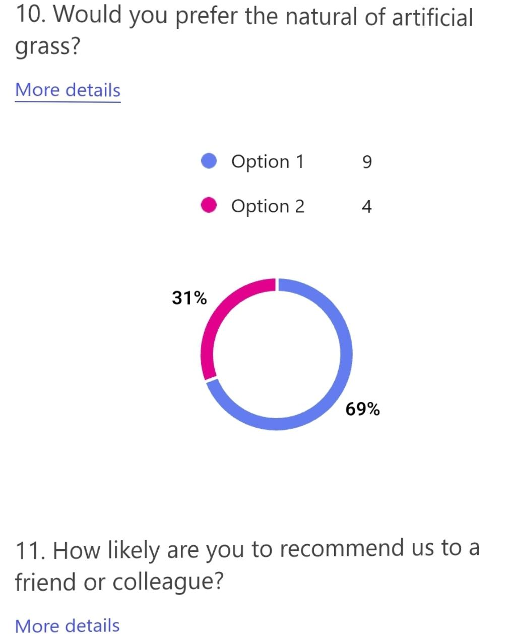

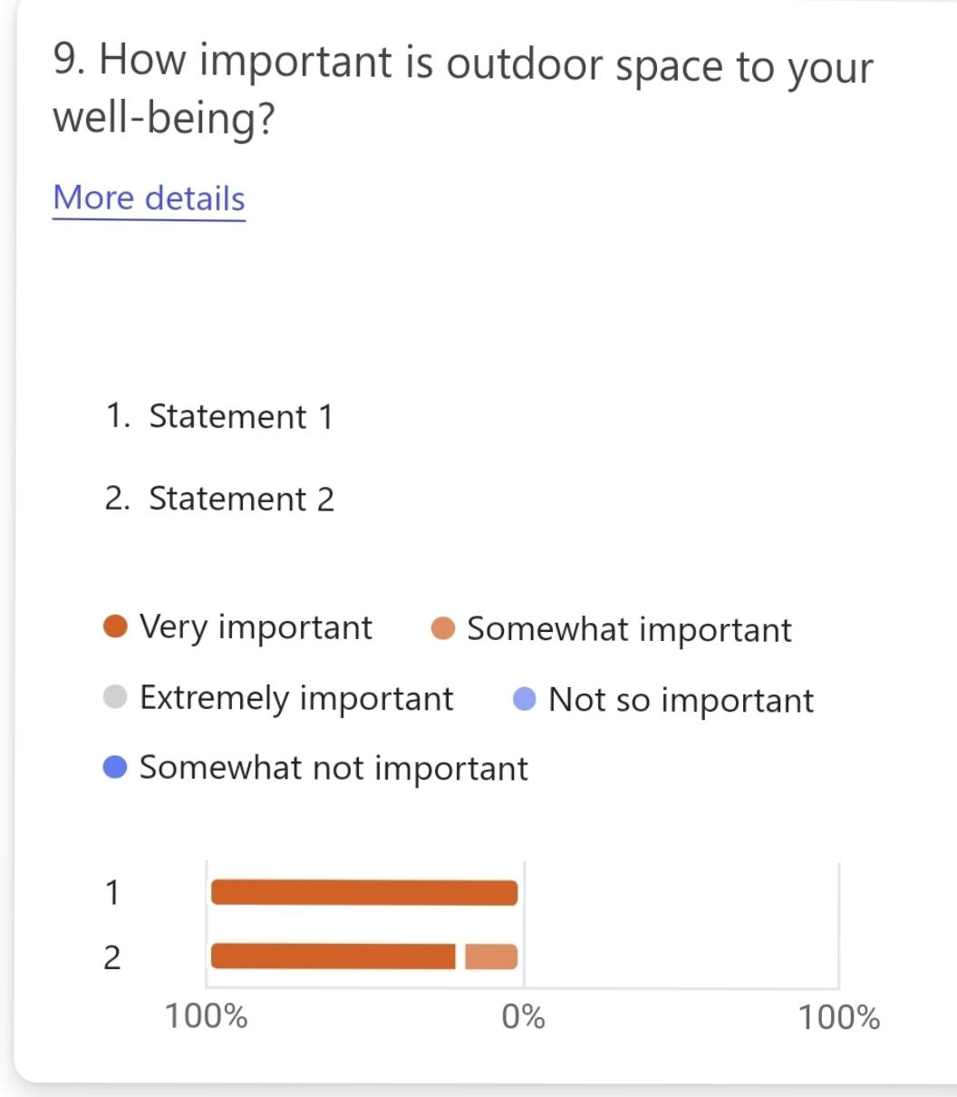

Assessing the outcomes of the survey, it’ quite important to note that customers are more interested in the natural turf, and this can be attributed to the fact that green grass enhances cool temperature according to the Ground Guys, 2025.
So, I intend to equip myself with more knowledge about the natural turf, plants and flowers as they will boost customer experience and satisfaction.
Through the questionnaire responses, I have also learned that outdoor spaces are very important to people as they use them for improving their quality of life.
According to the Ground Guys 2025, outdoor spaces help in both physical and psychological aspects of life. This is important to my business as it widens the market.
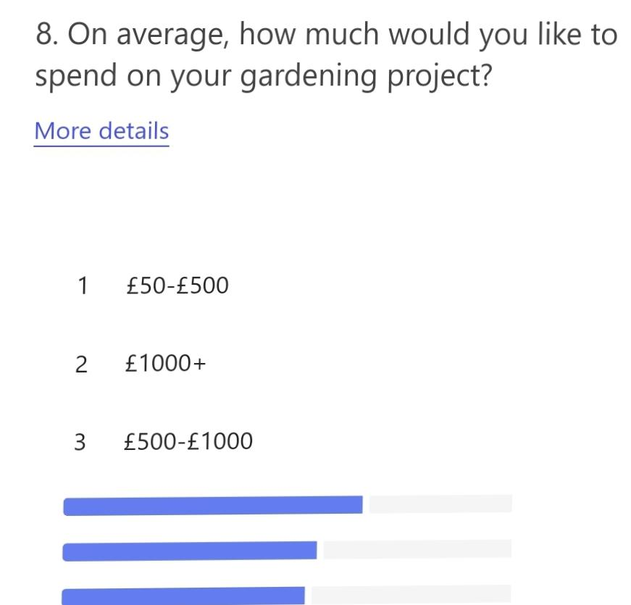

Looking at the financial figures regarding the response given by our researched group, it’s significant to note that customers are willing to spend on their gardens quite reasonably.
This is so because the majority choose a spending cup between £500-£1000 on improving their outdoor spaces. This is quite a good figure to start off with as a new business.
(Alice, 2023), a recent study of homeowners has found many want to create garden space that can cater for their work life balance.
Such findings will assist me in forecasting the market depth of my business and how much investment in terms of capital and labour.
(Alexandra,2020), the greater the quantity of those orders, the deeper or more liquid, the market is.
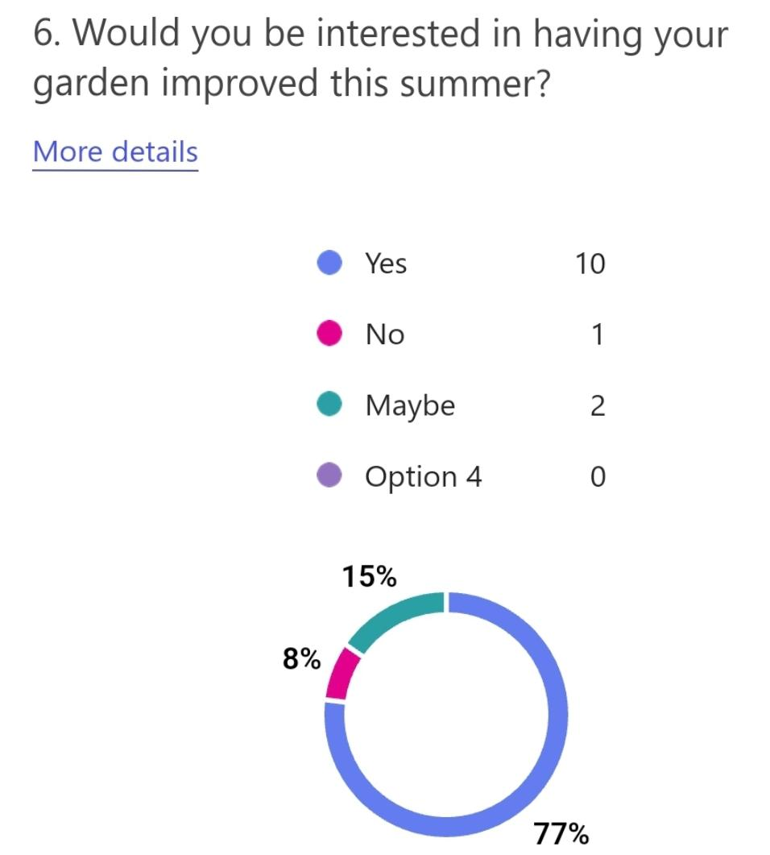

It has also come to my knowledge that a big number of homeowners and landlords are interested in improving their outdoor spaces this summer. This is so as a survey conducted came out with 77% of positive responses when asked if they would be interested in improving their gardens this summer.
According to Twin Oaks 2025, when you grow your own food, cooking can be as easy to walk in the backyard to pick fresh carrots and tomatoes for your dinner.
That is a good projection of business booming for my new business. I intend to tap into the deep market and get manageable jobs to do to enhance the development of my business. In addition, I’ll increase on my workforce with an addition 2 members to ensure there’s prompt completion of quality work on customer’s jobs.
I addition also, having assessed my business through the survey, I’ve come to an understanding that gardening and landscaping is a marketable business as it has several advantages such as, adding value to the property or house. According to The Garden Design Co 2025, landscaping can increase property value by 20% according to studies.
In addition, it can also help with property utilisation. Creating designated areas of relaxation, entertainment and sports bring about maximisation of outdoor spaces, (The Garden Design Co 2025).
According to the outcomes of the survey, landscaping as a business season reliant, there are more jobs in the summer and spring than other seasons. This therefore projects a low turnover in less busier months of the year.
The business is also weather dependant since most of the work goes on outside, during harsh weather conditions such as heavy rains, in the cold winter season and during the very warm heatwaves of the summer season, there’s a lot of work disruption leading to delays and pile up of jobs. This becomes frustrating to both the customers and my team.
Conclusively, having analysed the results from the survey, landscaping as a business is worthwhile trying, I intend to invest in tools, marketing the business and recruiting personnel for a smooth running of the business. Capital investment from my savings, a grant from the Cardiff council and a secured bank loan, will be my sources of finance.

Task 2: Website and Marketing Materials
A website is a place on the internet where you can easily post information about yourself, your business or topics you’re passionate about (Rachel, 2024).
Marketing materials refer to a collection of media and content businesses use to promote their products, services, or brand (Zinfi, 2025).
In this this section, I’ll be analysing questionnaire data to identify key insights that could be used to shape my website and marketing materials.
In designing my website, having analysed the findings from the questionnaire, I engaged nature as part of the leading elements. Having realised how important natural turf is to customers, I have included a lot of green grass and plants in the visuals.
I the website I highlighted that we work throughout the course of the year. This is derived from the fact that findings showed people more interested in improving their outdoor spaces close to or during summer. This helps me to engage in business in both busy and quiet times.
Offering snow ploughing and driveway shovelling can help your income steady in winter months (Nitin, 2024)
On the website, I highlight the fact that we deal in both small- and large-scale projects this is to help target both individual homeowners, landlords and companies for jobs.
Whilst designing my business website, I considered the fact that my customers would mostly want to use their outdoor door spaces especially in the summer season. I have included a lot of work for outdoor spaces.
I also incorporated the art of using sustainable and affordable designs and construction materials for my customers as it revealed they’re ready to spend reasonable amounts of money to improve their outdoor spaces.
Also, improvements needed for parents to have playing space for their children influenced my website design. This is so because the findings highlighted most correspondents as parents.
Children need spaces to run and stay for, gaining the agility and stamina to stay fit (Gardeners Club, 2025)
I’ve designed my business website in a way that attracts more customers, the survey revealed they would recommend me somewhere else at a rate of 95%. Putting customer experience and satisfaction as one of my targets on the website meets that.
According to (Dan, 2023), to maximise success in your landscaping business, take time to develop a unique brand identity.
In designing my website, the SEO was at the forefront of elements considered. I made sure the content is fresh.
(Bryony, 2020), another important factor in keeping your content fresh is to regularly post new content.
I have also kept up with key words on my website, the most commonly used phrases by the search engine users (Bryony, 2020).
In analysing my questionnaire findings, I’ve been able to design my website in a way that attracts more customers by prioritising customer experience and needs, highlighting major interests there by.
My marketing materials are well articulated with clear information. This has also motivated my website design for customers to find what information they need quite easily.
Attached are screen shots of some marketing materials.
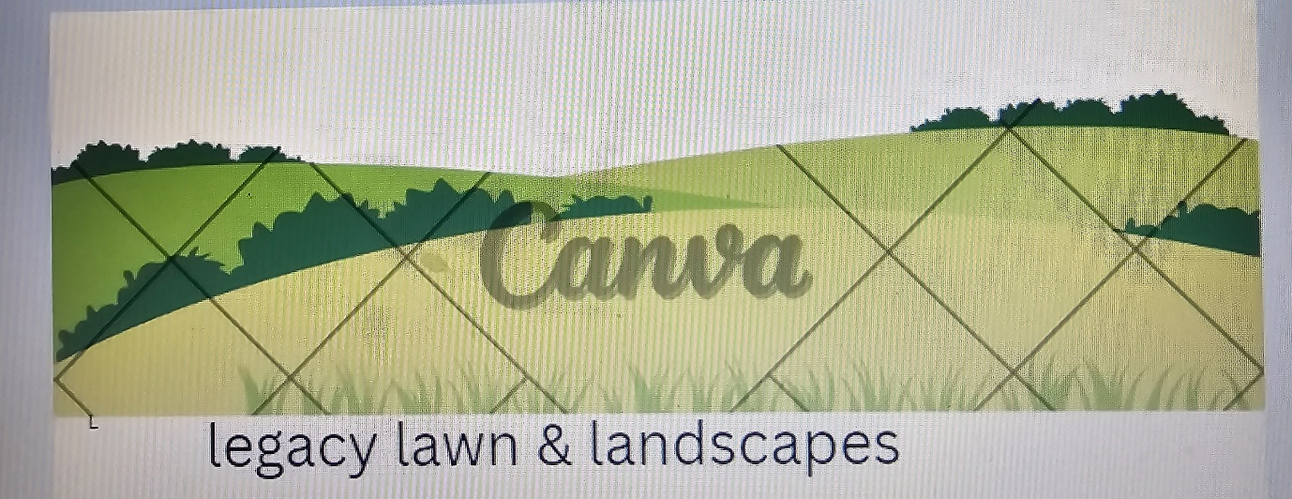
Your paragraph text - Business Card (US) - Canva

A van banner designed to show who nature is ambient, this banner is to be placed on the van and will also be visible throughout.

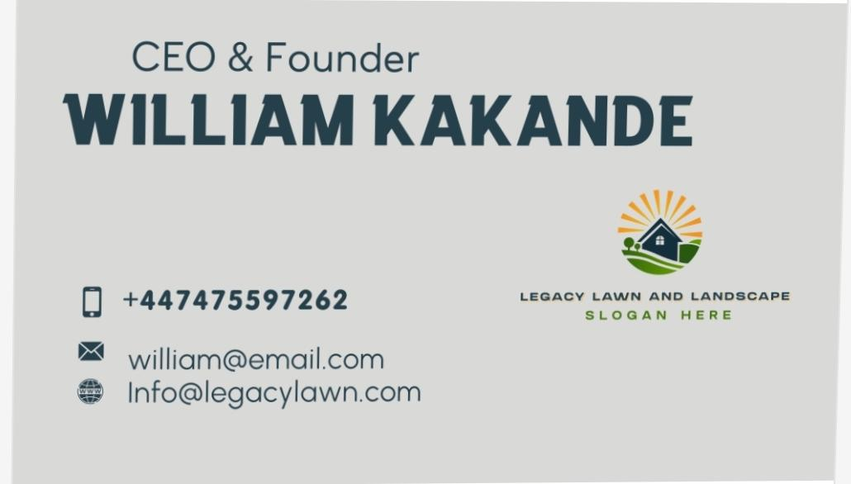
Your paragraph text - Business Card (US) - Canva
A company business card has also been designed with unique brand identity, contact information that is very clear, and precise. (David, 2023), concise information helps businesses cut through the noise and grab attention of their target group.

Below are a couple of screenshots of the webpages designed,
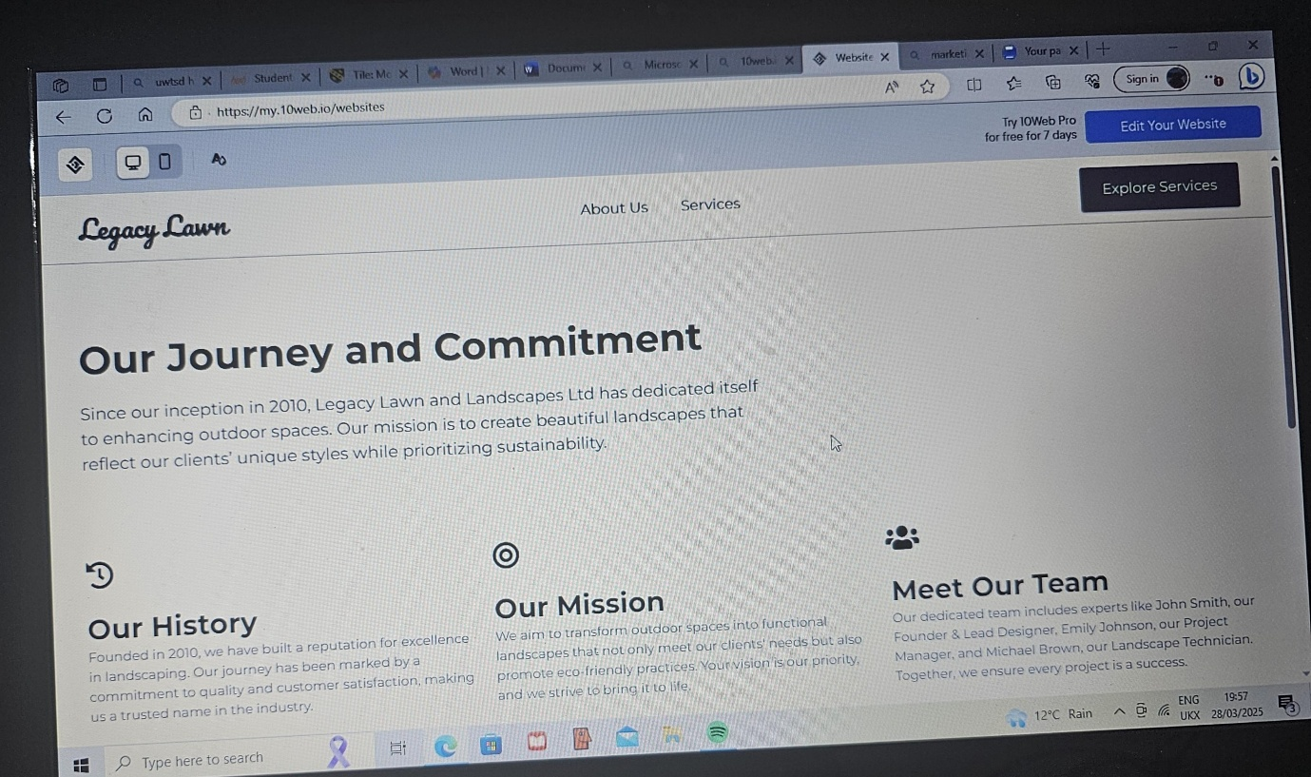
Single Page Demo - Dashboard (10web.io)

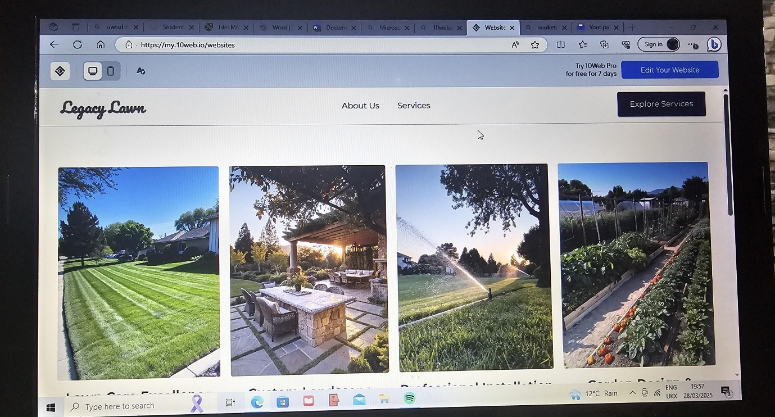

Single Page Demo - Dashboard (10web.io)

The above screenshots show both webpages designed with a Contact Us and Services pages showing what we offer and where to find us.
In the segmentation of our target audience, we noticed that some of the correspondents are both homeowners and landlords at the same time, I therefore designed the website to meet their needs by emphasising building of a good customer relationship to consolidate job base.
In conclusion, questionnaire Analysis and survey is an important tool in as far as designing and formulating of a website is concerned. The breakdown of information and segmentation is quite paramount.

Task 3. Microsoft Excel spreadsheet

Cash Flow Forecast

The Importance of Microsoft Excel in the Digital Era
In today’s digital world, almost everything we do involves technology. Whether running a business, managing personal finances, or completing schoolwork, digital tools have become a part of everyday life. One of the most powerful tools that people continue to rely on is Microsoft Excel. It is a digital tool that helps individuals and businesses stay organised, make better decisions, and work more efficiently (Microsoft, 2023).
For students and business owners alike, Microsoft Excel is an important skill to have. It helps turn ideas into action by making it easier to plan, calculate, and present information in a clear way. In my Managing Enterprise assignment, I used Microsoft Excel to create a cash flow forecast for a small business. At first, it looked complicated. However, once I started working with it, I realised how useful and helpful it really is (University of Edinburgh, 2022).
One major reason why Microsoft Excel is important is that it helps people organise large amounts of information. When working on a business plan, especially for a new or small business, there is always a lot to keep track of. You have income, expenses, expected growth, and month-by-month plans. Microsoft Excel allows you to create neat tables where you can arrange all this information in a simple, easy-to-read format (TeachICT, 2022). In my case, I created a spreadsheet that showed all the expected income and expenses over a twelve-month period. It made the planning process much more manageable.
Another benefit of using Microsoft Excel is that it makes calculations automatic. For example, formulas such as =SUM or =A1-B1 can help you add totals or subtract values instantly. This is especially helpful when you are working with financial data. You do not need to add numbers by hand or use a calculator. Instead, Microsoft Excel does the calculations for you. If anything changes, the totals update automatically (GCF Global, 2022). In my project, this made everything faster and more accurate, while also reducing the risk of errors.
Microsoft Excel also helps with presenting your data visually. While numbers are important, sometimes it is hard to understand what they mean just by looking at them. That is where charts come in. Microsoft Excel lets you create bar charts, line charts, and other types of visuals. In my cash flow forecast, I made a bar chart that compared income and expenses across three months. Even someone who had not seen the full spreadsheet could understand the business’s financial situation just by looking at the chart (Microsoft, 2023).
Another reason Microsoft Excel is useful is that it helps people make better decisions. When you can clearly see your income and expenses, you can tell if your business is on the right track. If the expenses are too high, you might look for ways to reduce costs. If the income is growing, you might decide to expand your services. Microsoft Excel does not make the decision for you, but it gives you all the information you need to decide wisely and confidently (Harvard Business Review, 2020).
Learning how to use Microsoft Excel can also improve your job skills. Many employers look for people who know how to use spreadsheets. Whether you are working in an office, retail, education, or technology, understanding Microsoft Excel is a useful and transferable skill (Indeed, 2023). Even if you do not plan to run a business, knowing how to manage your own budget or schoolwork using Microsoft Excel can be very helpful.
One thing I personally liked about using Microsoft Excel was how flexible it is. You can use it for simple things like making a personal budget, or for more advanced projects like analysing business performance. It is suitable for beginners, but it also has tools that professionals use for data analysis and reporting. It can grow with your needs, which is something that not many tools offer (SkillsYouNeed, 2021).
At first, Microsoft Excel can feel overwhelming. There are many buttons, options, and features that can be confusing to someone who is just getting started. But once you learn the basics, it becomes easier with practice. I found that beginning with small tasks, such as formatting a table or using a basic formula, helped me gain confidence. Over time, I was able to create a full forecast, apply formulas, and insert charts without feeling lost.
In conclusion, Microsoft Excel is an essential tool in the digital age. It helps with planning, organising, calculating, and presenting data in a way that is clear and helpful. For my own project, Microsoft Excel helped me understand how money would move through a business and allowed me to present my ideas in a professional and convincing way. It is not just a spreadsheet tool — it is a skill worth learning (Microsoft, 2023).

Task 4
Youtube Video advert
The script for Legacy Lawn and Landscape Limited uses storytelling techniques to make the advert more engaging and persuasive. One of the main techniques used is creating a relatable scenario at the start. It talks about broken fences, cracked patios, and tired gardens, which helps viewers connect with the situation and see their own problems in it. Another storytelling method used is transformation, where the messy garden is turned into a beautiful space. This gives the script a clear beginning, middle, and end, which keeps the viewer interested in what happens next. The use of humour is also very strong. Phrases like “smooth as your uncle’s bald head” and “we make dirt cry and run away” add a funny and friendly tone, making the advert more memorable and fun to watch. The business is also personified like a helpful character, shown as reliable, professional, and cheerful. This kind of characterisation helps build trust with the audience. Finally, the script ends with persuasive language that encourages people to take action, like calling or sending a message. All these techniques work together to make the viewer feel more connected to the brand and more likely to want their services.

References

Bistricer, R. (2024) What is a website? Definition + examples. Available at: https://www.wix.com/blog/what-is-a-website
Bryony (2020) 10 SEO tips to keep your website healthy in 2020. Available at: https://www.takepayments.com/blog/business-growth/10-seo-tips-to-keep-your-website-healthy-in-2020
David (2023) The Power of Concise and Accurate Information in Marketing. Available at: https://www.linkedin.com/pulse/power-concise-accurate-information-marketing-david-lamb
Escalas, J. E. (2004) Narrative processing: Building consumer connections to brands. Journal of Consumer Psychology, 14(1-2), pp.168–180.
Fog, K., Budtz, C. and Yakaboylu, B. (2005) Storytelling: Branding in Practice. Berlin: Springer.
Gardener's Club (2025) The importance of outdoor living spaces. Available at: https://www.gardeners-club.co.uk/the-importance-of-outdoor-living-spaces
GCF Global (2022) Excel basics: What is Excel and what is it used for. Available at: https://edu.gcfglobal.org/en/excel
Ground Guys (2025) Benefits of Landscaping. Available at: https://www.groundsguys.com/blog/2015/may/the-benefits-of-landscaping
Harvard Business Review (2020) Why Excel remains indispensable in business. Available at: https://hbr.org
Indeed (2023) Top Excel skills to include on your CV. Available at: https://uk.indeed.com
Independent (2023) Millions of homeowners are planning to embrace the ‘great outdoors’ in their garden this year. Available at: https://www.independent.co.uk/life-style/homeowners-gardening-diy-home-improvements-b2307562.html
Investopedia, Twin, A. (2020) Depth of market meaning and how to use demo data. Available at: https://www.investopedia.com/terms/d/depth-of-market.asp
Microsoft (2023) Overview of Excel features. Available at: https://support.microsoft.com/excel
Nitin (2024) Understanding seasonal demand in the landscaping industry. Available at: https://www.linkedin.com/pulse/understanding-seasonal-demand-landscaping-industry-rwouc
Paving4Me (2023) The ways to succeed in landscaping business. Available at: https://www.paving4me.co.uk/2023/02/04/10-ways-to-succeed-in-your-landscaping-business
SkillsYouNeed (2021) Why learn Microsoft Excel? Available at: https://www.skillsyouneed.com/rhubarb/excel-skills.html
SurveyMonkey (2025) What is a questionnaire? Definition, examples and purposes. Available at: https://uk.surveymonkey.com/mp/what-is-a-questionnaire
TeachICT (2022) Benefits of using spreadsheets. Available at: https://www.teach-ict.com
The Garden Design Co. (2025) The Benefits of Landscaping. Available at: https://www.thegardendesignco.co.uk/the-benefits-of-landscaping
Twinoaks Landscape (2025) The benefits of having a summer garden. Available at: https://www.twinoakslandscape.biz/summer-gardens
University of Edinburgh (2022) Introduction to Microsoft Excel. Available at: https://www.ed.ac.uk/information-services/help-learning/it-learning
Woodside, A. G., Sood, S. and Miller, K. E. (2008) When consumers and brands talk: Storytelling theory and research in psychology and marketing. Psychology & Marketing, 25(2), pp.97–145.
Zinfi Technologies Inc. (2025) Glossary: Marketing Materials. Available at: https://www.zinfi.com/glossary/what-are-marketing-materials

