Introduction: 2
Research: 2
General: 2
Quantitative Research: 3
Proposal or conclusion idk decided later: 5
References: 5

Introduction:

Mental health affects everyone regardless of ethnicity, race, gender, or spiritual belief; it can also affect anyone at any point in their life, making it important to have a solid foundation of mental health support, awareness, and methods to minimise its effects on daily lives. That is why it is important in high-stress environments like universities and other higher educational institutes to be aware and offer guidance and other services to reduce negative effects and connotations attached to mental health struggles. My goal is to research and highlight the positive outreach that the university has made as well as where there could be an improvement.

Research:

General:

Mental health is the mental state of a person including the emotional, physiological, and social well-being; mental health is similar to physical health in the way that it can be affected by illness and can experience highs and lows (MentalHealth.gov, 2022). Mental health plays majorly into how a person thinks and operates on a day-to-day basis, and someone with poor or ill mental health could need more support than someone whose mental health is in a better state.

Many universities have recognised that students may be struggling with their mental health during their time studying at their institutions and have introduced mental health policies. An organisation or institute’s mental health policy is a written document outlining its approach, plans, and goals for tackling its members' or associates' mental health (Rosier, 2022). Mental health policies typically outline the goals of an organisation, why these goals are important, and how they plan to implement them (this is also usually given within a certain time parameter).

These mental health policies are very important as many university and higher education students have reported having detriments regarding their mental health. A survey conducted by The Insight Network in 2019 showed that out of 38,000 students who participated, 42.8% (18,316) had high levels of anxiety being “often or always worried;” building on that 87.7% (33,326) of participants had “struggled with feelings of anxiety.” Three-quarters of participants also reported concealing their mental health symptoms from their peers and friends.

These survey results are worrying and mental health in universities is a major concern. Chris Skidmore, a former minister of education with a focus on universities, stated that “Student mental health is a top priority for me and from my regular visits to our universities across the country, I know this is an issue that they are taking seriously too" (Weale, 2019).

The University’s (University of Wales Trinity Saint David, hereafter referred to as UWTSD) mental health policy, or Student Health and Wellbeing Strategy, is set to outline and improve conditions for students between 2020 and 2024. This four-year plan was highlighted in four sections labelled ‘Learn,’ ‘Support,’ ‘Work,’ and ‘Live,’ with each segment corresponding to a different context of mental health support for students (University of Wales Trinity Saint David, n.d.).

The ‘Learn’ segment outlined the plan to incorporate a more inclusive curriculum, to enhance a create more support from the transition into a university setting and then out of it, and the development of an extensive system of academic support. All of these would support students and the university to track and observe academic progress.

The ‘Support’ segment outlined ways for the university to support their students with the services that students could use when experiencing mental health concerns or problems as well as to develop the method and services available for students with more worrying concerns such as suicide and other crosses and/or emergencies. This segment also set out to develop support for long-term mental health struggles and diagnoses. Lastly, they also set out to introduce support outside of the university’s ecosystem with a partner network.

The ‘Work’ segment outlined the progress to be made for the staff to respond to mental health needs and requests appropriately for their roles within the university.

The ‘Live’ segment outlines the university’s goals to create a culture which allows an easy transition from unhealthy to healthy behaviours, as well as make the community as inclusive as possible. This also includes having opportunities to improve students’ experiences whilst also making them feel safe and integrated within the university and the campus itself.

Quantitative Research:

Despite the extensive measures that the university is taking students have reported that they are still struggling within the environment. I surveyed a small pool of participants that highlights students' opinions on the highs and the lows of the university’s mental health outreach and support.
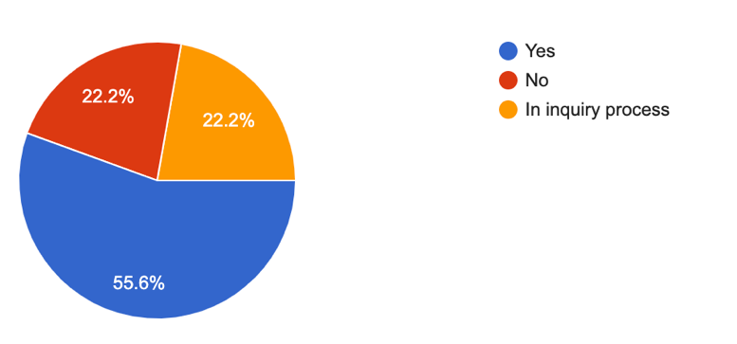
The first question I asked was whether the participant had any mental health diagnosis (e.g., depression). I did this to gather I base to build upon if the participants had any experience with mental health services prior. The majority of participants (55.6%) had a mental health diagnosis whilst the number of people who were in the inquiry process and the number of people who hadn’t were tied at 22.2%.

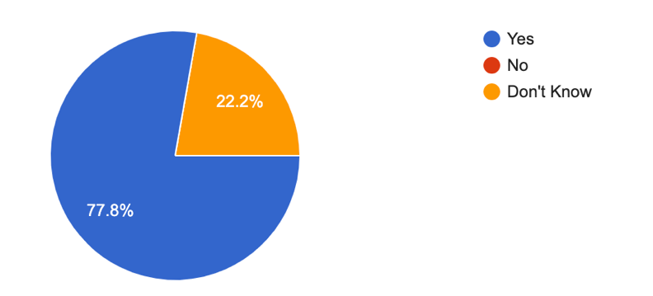
I then asked if their mental health suffered since starting higher education, more specifically because of the academic environment and standards. I received an overwhelming majority answer with 77.8% of people answering ‘yes’ and only 22.2% of people unsure if their mental health had declined. These answers show a clear opinion that university life and academic standards, at least within the UWTSD community, can be negative on the mental well-being of a lot of students.

Next, I wanted to begin to gather some opinions on my previous question so I asked all participants that answered ‘yes’ to state three factors which caused this decline (it should be stated for the record that not all participants gave the full three answers asked for). The biggest factors noted were both stress and various social settings with four answers noted for each. This was followed shortly by assessments, exams, and deadlines with three responses. Self-inflicted factors and plans following university both had two answers whilst time management and lack of support both gathered one answer each.

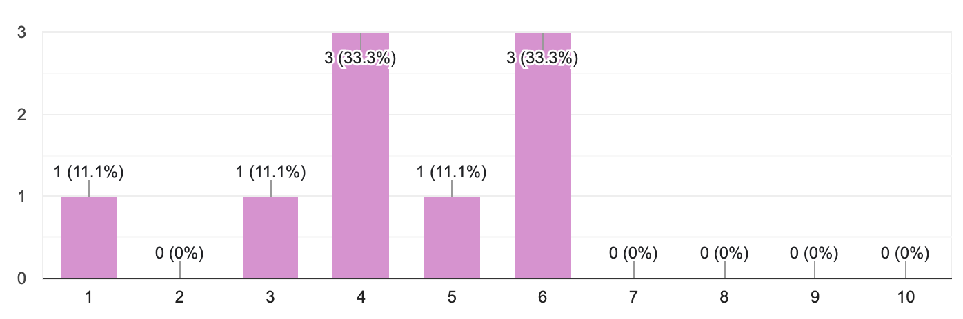
After this, I asked the participants to rate the universities mental health support on a scale from one to ten, with one being the lowest and ten being the highest. Nobody scored the university above a six.

I then moved on to what the participants found worked well and were beneficial in the universities current approach to mental health. I asked each participant for three answers (it should again be noted that not all participants gave three answers or answers that answered the question). Four people noted the offering of counselling whilst three mentioned the offering of support. Providing mental health materials and the ability to use the extenuating circumstances portal both gathered two responses. Lastly, the one-to-one sessions, student services group services, peer support, easy-to-contact, quickness in dealing with matters, and helpfulness were all singularly noted.

After this, I asked for three factors where the participants feel that the university falls short in mental health support. The majority of people noted that the lack of communication/contact is the biggest downfall with six answers. The next highest contender is the Self-referral system, initial signs recognition with three people noting this. Two people responded that the university has a lack of availability and is limited in regard to mental health services. A lack of following up, the uncertainty of asking for help, and the fact that asking for help can be scary were also singularly mentioned. Lastly, one person also mentioned that the university (namely lecturers) needs to be more forgiving around bad mental health days.

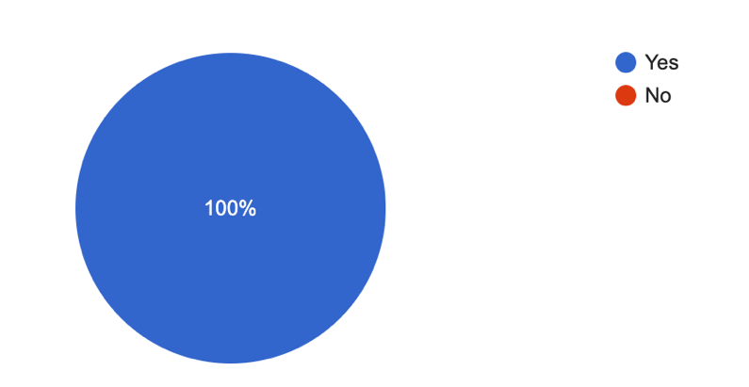
The last open question I asked was where the participants think that the university could improve upon their mental health support. Three people noted that the improvement of communication and outreach from the university could be improved. Three people also noted that there could be more drop-ins, and more one-to-one sessions offered. Two people said that the university could be more assertive in its approach; another two people mentioned making mental health services easier to access. Adding more variety of support, such as group support, was also mentioned alongside More recognition of poor mental health symptoms, especially in the early stages of this decline.

Lastly, as a way to measure the participants' openness to trying new ways to support their mental health within an academic environment, I asked if they would be open to any unconventional mental health treatments (e.g., chatrooms, musical therapy, destressing routines etc). 100% of participants stated that they would be.

Conclusion:

Overall, it is clear that the academic environment of a university or likewise institution (as well as other contributing factors) had a negative impact on a student or associate's mental health. It is also clear that whilst the university has taken great steps, and has plans to continue, aiding their student’s mental health concerns the students are not being fulfilled in the way they had hoped to be. I have hopes that my findings help aid the call to need in students' mental health with the first steps to begin a larger survey, with more specific and sensitive questions going out to students across the university and its numerous campuses to be able to build a more solid base to make improvements from.

References:

MentalHealth.gov (2022). What Is Mental Health? [online] Mentalhealth.gov. Available at: https://www.mentalhealth.gov/basics/what-is-mental-health [Accessed 26 Feb. 2023].
Rosier, J. (2022). What should be included in a mental health policy? [online] QMS International. Available at: https://www.qmsuk.com/news/what-should-be-included-in-a-mental-health-policy#:~:text=A%20mental%20health%20policy%20is [Accessed 26 Feb. 2023].
The Insight Network. (n.d.). Research. [online] Available at: https://www.theinsightnetwork.co.uk/research/ [Accessed 25 Feb. 2023].
University of Wales Trinity Saint David (n.d.). Student Health & Wellbeing Strategy. [online] https://www.uwtsd.ac.uk/media/uwtsd-website/content-assets/documents/strategies-policies/Student-Health-and-Wellbeing-Strategy.pdf. Available at: https://www.uwtsd.ac.uk/media/uwtsd-website/content-assets/documents/strategies-policies/Student-Health-and-Wellbeing-Strategy.pdf [Accessed 26 Feb. 2023].
Weale, S. (2019). Levels of distress and illness among students in UK ‘alarmingly high’. [online] the Guardian. Available at: https://www.theguardian.com/education/2019/mar/05/levels-of-distress-and-illness-among-students-in-uk-alarmingly-high?CMP=share_btn_tw [Accessed 26 Feb. 2023].

