LCLM 4005 - Employability and Career Development
Student Name: Daylia Gavin
Student Number: 2427090
Lecturer Name: Sujeewa Herath
Assignment Title: Job interview

Table of Contents
1. Job Advertisement 3
2. Cover Letter 5
3. CV 6

1. Job Advertisement
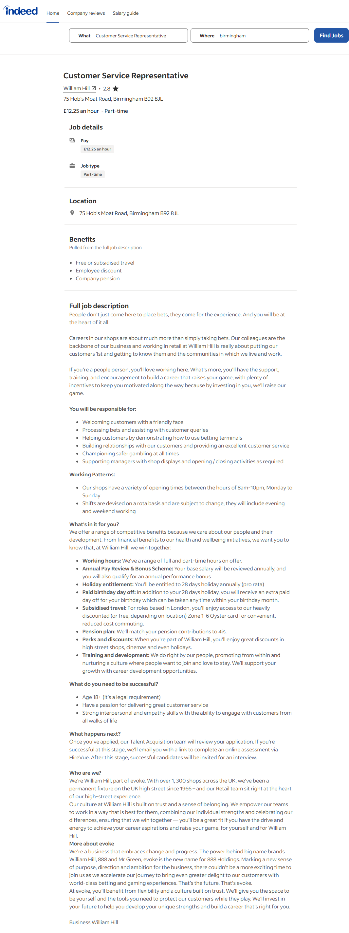
Link: https://uk.indeed.com/viewjob?jk=00d4be2929cd9b91
Job Title: Customer Service Representative
Company: William Hill
Location: 75 Hob's Moat Road, Birmingham B92 8JL
Salary: £12.25/hour – Part-time
Key Responsibilities:
- Welcoming customers with a friendly face
- Processing bets and assisting with customer queries
- Helping customers use betting terminals
- Building strong customer relationships and ensuring excellent service
- Championing safer gambling
- Supporting shop managers with displays and opening/closing
Skills and Qualities Required:
- Age 18+
- Passion for customer service
- Strong interpersonal and empathy skills
- Teamwork and communication skills
Benefits:
- Paid holidays, annual pay review, birthday leave, pension, and discounts
- Career growth and internal promotions

2. Cover Letter
Daylia Gavin
Birmingham, B20 3LJ
William Hill
75 Hob's Moat Road, Birmingham B92 8JL
16/10/2025

Dear Hiring Manager,
I am addressing you to show my interest in the Customer Service Representative job at William Hill, Birmingham, which was posted online. I attach my CV to your attention.
I have gained strong interpersonal and communication skills through several years of experience in the retail and hospitality sector, working in Gatwick Airport, Morley Restaurant and McDonald's, which fit well with the values of William Hill. My experience has taught me the importance of fostering a friendly and welcoming atmosphere, managing customer inquiries effectively, and maintaining professionalism in all interactions.
In my latest position as a Sales Advisor at Team Spirits Airport Operations Ltd, I had to do a lot of work with various customers, process payments, and give them product advice. This has enhanced my capability of working in pressure situations and ensuring accuracy and outstanding customer care attributes that I think is the key to success in this position at William Hill.
I also find it quite attractive that William Hill also focuses on customer satisfaction and employee growth. I find the prospect of working with a firm that has a good presence in the community and a conducive working culture very enticing. I strongly believe that my passion, trustworthiness, and practical experience will help me to make a difference in your team in Birmingham.
I appreciate your interest in my application. I would be happy to have a chance to talk about how I will be able to use my skills and experience to make William Hill continue to be successful.

Yours faithfully
Daylia Gavin

3. CV
Daylia Gavin
gavindaylia20@gmail.com | 07359552901 | Birmingham, B20 3LJ
Professional Profile:
A friendly and customer-oriented person who has more than four years of experience in customer service and hospitality. Experienced in the development of positive relationships, transactions, and providing a friendly customer atmosphere. Shows a high level of teamwork, flexibility and problem-solving. Applying to work as a part-time Customer Service Representative at William Hill to achieve a great experience with customers and to gain more professional experience in the retail industry.
Key Skills:
- Good customer care and people communication.
- Handling cash and till operations.
- Teamwork and multitasking in high-speed settings.
- Good attention to detail and accuracy.
- Trustworthy, time-conscious, and eager student.
- Compliance with health, safety and customer care practices.

Employment History
Team Spirits Airport Operations Ltd, Gatwick Airport, London
Sales Advisor Aug 2024 – Dec 2024
- Delivered high quality customer service and went beyond the expectations of airport shoppers.
- Assisted team members to have a friendly atmosphere.
- New and managed till staff on operations.
- Added to in-store advertising and product promotion.
Morley’s Restaurant, Birmingham
Food Counter Assistant/Cashier Feb 2023 – Apr 2023
- Provided effective and cordial customer service within a crowded restaurant environment.
- Made cash and card payments with electronic tills.
- Ready and packed carry-away orders immediately.
- Clean and food safety standards.
Pastry Patty, Birmingham
Food Counter Assistant (Work Experience) Feb 2022
- Accepted and served customers effectively at peak times.
- Abided by hygiene and safety standards.
- Helped to cook and keep the service area clean.
McDonald’s, Birmingham
Crew Member Aug 2021 – Oct 2021
- Performed efficiently in a high-reward workplace.
- Ordered, paid and customer requests.
- Cleaned food preparation zones to company requirements.
Quelas Jamaican Restaurant, London
Food Counter Assistant (Work Experience) Jun 2021 – Aug 2021
- Served and ready food and drinks.
- Assured customer satisfaction by friendly and prompt service.
Purispo Property Services, London
Tenancy Support / Cleaner Jul 2020 – Mar 2021
- Cleaning and guest preparation of property.
- Backed tenancy operations and health and safety compliance.

Education and Training
GSS UK Ltd, Croydon - NCFE Level 2 in Customer Service Mar 2025
Lewisham College, London - Level 3 in Performing Arts (2024)
Birmingham Metropolitan College - Business Diploma Level 1 (2022)
Metropolitan Bolton, Birmingham - Level 2 English (2022)
Metropolitan College - Functional Skills Level 1 in Maths (2022)
University of Wales Trinity Saint David (UWTSD), Birmingham Campus - Business Studies (Ongoing)

