


LCBB4004
Marketing Fundamentals
Assessment 1
Blogging to communicate
Module Lecturer: Tushara Balendran
Student Name- Florentina Fistoleanu
Student ID- 2115309

Background of Loake

Loake is a British shoe-making firm serving quality shoes to the market for a couple of hundred years. Like brothers, John, Thomas and William Loake, has established this historic business in 1880 in Kettering, Northamptonshire. They are still using this location as their production point (Bhamra et al., 2018).
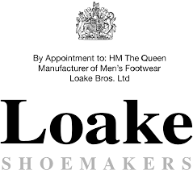
Figure: Loake Shoemakers (Grumiller & Raza, 2019).
This historic business has moved their production centre to Wood Street, with about 20,000 square feet of space. This location still can be found as their factory. They are specialised in making handmade men’s shoes. The sublime art of handmade shoes takes approximate 8 weeks to be produced with perfection. At the time when it moved to Wood Street the number of the employee was 300 worker’s accommodation. The factory was divided into three portions.

The first portion contained the soles of the shoes, the second portion contained the actual factory specially referred to as the making room and the last portion contained the stock of the finished goods (Trollope, 2018).
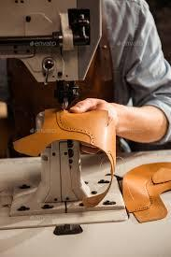
Figure: Handmade sewing (Hariharan et al., 2019).
It has also some contribution to the first and second World Wars. They have produced the shoes for the army as well. Among them, Terrain boots, Convalescent boots and Despatch Riders boots for the British Army were most famous. Locke had to produce 2500 pairs of shoes during the second war in a week. They also participated in the royal program like the British Empire Exhibition and so on (Kelion, 2021).
At last, the historic shoe company has decided to shift some of their operations to other countries to cut some costs down. They established a joint venture with an Indian company whose factory is located near Chennai (Bhamra et al., 2018).

Loake Products

The product range of Loake
1. Men’s shoes: The best and primary product of the Loake is men’s shoes. They have a wide range of offering in this section. They offer modern, traditional and shoes of ancient design. Their product line is so long that they could not display all the models in all the stores all the time. The products are produced with a journey or 8 weeks through the 130 pairs of hands with up to 75 different components. Thus, the product becomes sublime and premium (Grumiller & Raza, 2019).
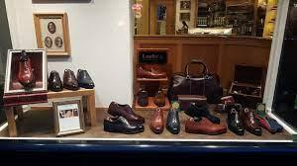
Figure: Loake Shoes (Xiaoyang, 2019).
2. Belts: Another thing in their product line is the original leather belt. In a formal setting, the belts need to match the colour of the shoes. So, they sell these leather items too in their outlets and online shops. These are of the same quality as the shoes but the only difference is that the belts are not handmade (De Klerk et al., 2020).
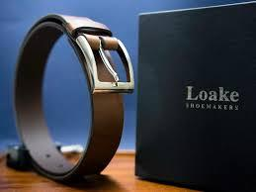
Figure: Loake Belts (Hariharan et al., 2019).
3. Bags: They have bags too in their product line. The bags are also premium and made of leather. Unlike belts, all the products are not handmade. The bags are the symbol of excellence for the loyal and regular customers of Loake (Kelion, 2021).
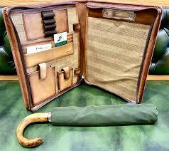
Figure: Loake Bag (De Klerk et al., 2020).

4. Accessories: Apart from the mainstream product there are other leather accessories too. Wallets, Gloves, Men’s slippers and socks are included in this category. They provide the best match of the accessories made of leather and premium material (Xiaoyang, 2019).
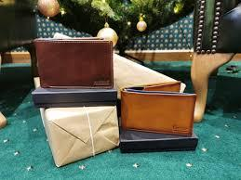
Figure: Loake accessories (Hasan, 2018).
5. Shoe care: The products for shoe care are also available in this historic shop. The things that are necessary to clean and keep safe from harmful materials are sold here at a reasonable price (Trollope, 2018).
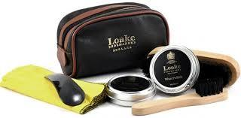
Figure: Loake Shoe Care (Grumiller & Raza, 2019).

Features of product
Premium and unique design is the primary feature of the products of Loake. Durability is another noteworthy feature of the products of Loake. This facility is still used by them as a factory. They specialise in the creation of handcrafted men's shoes. Handmade shoes are a wonderful art form that takes around 8 weeks to master. The number of employees at the time of the shift to Wood Street was 300, with 300 workers' quarters. Three sections of the plant were created.
The products of the Loake are comfortable as well according to the review of the customer. The unique design made the products fashionable regardless of time. They have a wide range of products for their customers as well (Kelion, 2021).
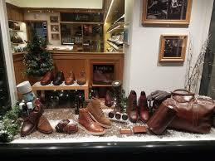
Figure: Loake Product line (Xiaoyang, 2019).

Mass Customization
Shoes should be designed and built according to the choice and preferences of the customer. It is the symbol of goodness as it makes a person confident and breath-taking for the customer who wants premium and reliable products.
For such customers, Loake has a wide range of variations in their products. Loake's product line includes: 1. Men's shoes: Men's shoes are the Loake's greatest and most popular product. In this department, they have a vast selection of options. They include contemporary, classic, and antique-style shoes. Because their product range is so extensive, they are unable to exhibit all models in all shops at all times.
The range is too wide that they had to express that all the models they produce and marketize may not be available to all the shops all the time round the year. So, they request the customer to be informed about the availability of the specific model (Hariharan et al., 2019).
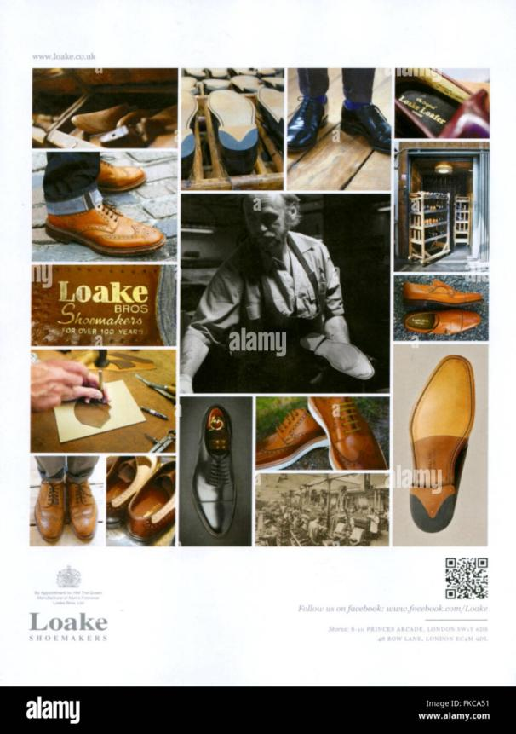Figure: Loake mass customization (Xiaoyang, 2019).
But the choice of the customer knows no bounds. That’s why Loake has a system by which it is possible to produce custom-made products for all people. The first section included the shoe soles, the second section contained the real factory, often known as the manufacturing room, and the third section contained the final products stock (Trollope, 2018).
So, the space for the customization is there to take on. The customer can order according to the design they got or there are catalogues to choose from how the customer wants to have the shoes for him or her (De Klerk et al., 2020).

Loake prices

Their prices for the products are of various categories. Their shoes differ from £50 to £400 regardless of colour, size and style. Their shoes are mostly handmade and the products are offered with original leather. That’s why the price of their product is reasonable as the positioning of the shoes is in the sky (Grumiller & Raza, 2019).
Another product they offer is their belt for menswear. Their original leather belt starts from £50 to £80. The product quality is high and durable so the price is pretty reasonable. Apart from this, their bags start from £40 to £240. The price is not so high as the shoes because all the bags are not handmade (Hasan, 2018).
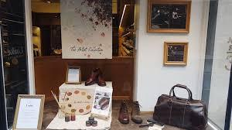
Figure: Loake Supremacy (Kelion, 2021).
They also offer some accessories like socks, wallets and gloves that ranges between £00 to £240.
Some of their accessories come free with other products. The shoe care items are also standard here the price the customer need to pay to avail those ranges between £00 to £160. The original leather belt is another item in their product range.
The belts must match the colour of the shoes in a formal environment. As a result, they offer these leather things in their stores and online. These are of comparable quality as the shoes, with the exception that the belts are not handcrafted (De Klerk et al., 2020).
Some shoe care items come free with selected premium shoes. Last but not least they also offer the service of repairing the shoes. The price for the service differs according to the service quality amount and the demand of the customer. Last but not the least, Loake provides the opportunity of free shipping at a purchase of a certain amount of product. On special occasions like the month of Christmas, they offer free delivery as a part of marketing inside the whole UK (Nobar et al., 2020).

Where to find Loake

Offline Outlets
Loake products are served in various locations in the UK and Europe. The people here find approximately 1000 retail stores from where they can collect their pair of shoes. Being a premium brand, they offer a wide range of quality products all over the UK and Europe. So, finding out them in the desired location is not too difficult (Xiaoyang, 2019).
Apart from this they also have the factory store to find out their collection of shoes. Their product is now available in different locations. Their hotspot for the shoes is in Kettering, Northamptonshire. They are producing their product since 1894, so all the models should likely be available there. But they cannot ensure that all the models are available in every store. The range of the product variation is huge. That’s why they have expressed the cautionary words on their website that all the models may not be available in all the stores all the time. That’s why they want the customers to call before the visit in case of the choice of a specific model (Kelion, 2021).

Here are some popular stores to get the desired pair of Loake shoes.
1. Loake Factory Shop
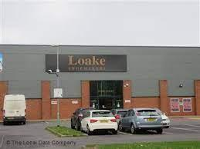
Unit 7, Three Manors Retail Park
Rockingham Road
Market Harborough LE16 7BA
Phone: +44 (0)1858 434 962
E-Mail: factoryshop@loake.co.uk

2. Loake Nottingham
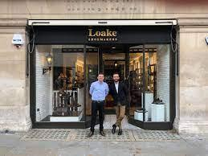

Exchange Arcade
Exchange Walk
Nottingham NG1 2DD
Phone: +44 (0)1158 077 698
E-Mail: nottingham@loake.co.uk

3. Loake Outlet Birmingham
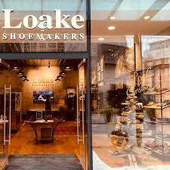
Unit 5 Grand Hotel
31 Colmore Row
Birmingham B3 2BS
Phone: +44 (0)121 233 9656
E-Mail: birmingham@loake.co.uk

Online Shopping
It is very difficult to spread all the factory in worldwide. Most of the countries does not have enough facilities to establish an outlet. The investment for such a huge project is not always available.
So, besides the offline physical outlets, there are online opportunities for customers around the world. Through the system, the customer can order their favourite product online from anywhere in the world.

The busy customers can also order their product from the nearby outlet with the catalogue posted on their website (Worku & Virdi, 2019).

Figure: Free shipping (Henninger et al., 2017).
There are many opportunities for foreign and local customers. The shipping day also known as lead time can be shortened or extended to prioritise the urgency or the saving of the money. Apart from that, the customer can also purchase the products using their local currency. Thus, they are present everywhere in the world (Grumiller & Raza, 2019).

Loake Promotion

The promotion of the Loake can be divided into two parts. They operate their marketing campaign online and offline. In offline they have taken lots of measures by which it is possible for them to understand the market and grab more customers as much as possible. Their product range also includes bags. The bags are likewise made of leather and are of high quality. Unlike belts, none of the items are handcrafted. For Loake's devoted and frequent consumers, the bags are a mark of quality (Kelion, 2021).
They are giving discount vouchers. They are undertaking the direct marketing approach and so on. Sometimes they are taking pull strategy to bring the customer into the outlets. But the thing is the people who know and can purchase the shoes of Loake don’t go away because of the quality and comfort of the products (Xiaoyang, 2019).
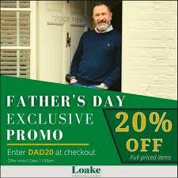
Figure: Promotional campaign of Loake (Bhamra et al., 2018).
From an online point of view, they are stepping up into the online marketing campaign. During the covid-19 lockdown, they were fast and agile to take all the black Friday sales. It also had a role in the first and second World Wars. They have also made shoes for the army. Terrain boots, Convalescent boots, and Despatch Riders footwear were the most well-known for the British Army.
Their activities included the Paid search and display. They did well in their online marketing. This thing has returned them a benefit and more revenue. They could increase their sales by 84% and then they have achieved a +108% return on ad spending. Thus, the marketing campaign was successful from their side (Kelion, 2021).

References
Bhamra, T., Hernandez, R.J., Rapitsenyane, Y. and Trimingham, R., 2018. Product service systems: a sustainable design strategy for SMEs in the textiles and leather sectors. She Ji: the Journal of Design, Economics, and Innovation, 4(3), pp.229-248.
De Klerk, H.M., Kearns, M. and Redwood, M., 2019. Controversial fashion, ethical concerns and environmentally significant behaviour: The case of the leather industry. International Journal of Retail & Distribution Management.
Grumiller, J. and Raza, W.G., 2019. The Ethiopian leather and leather products sector: An assessment of export potentials to Europe and Austria. ÖFSE, Austrian Foundation for Development Research.
Hariharan, S., Murugesan, R. and Mahalakshmi, A.G., 2019. Modelling and analysis of supply chain risks in leather industry. International Journal of Manufacturing Technology and Management, 33(5), pp.329-341. F.Zaman
Hasan, M., 2018. An Analysis of Marketing Activities of Yako Leather Industry in Bangladesh (Doctoral dissertation, Daffodil International University).
Henninger, C.E., Alevizou, P.J., Tan, J., Huang, Q. and Ryding, D., 2017. Consumption strategies and motivations of Chinese consumers: The case of UK sustainable luxury fashion. Journal of Fashion Marketing and Management: An International Journal.
Kelion, E., 2021. Factors influencing growth of fashion leather shoes. A review of literature. International Journal of Fashion and Design, 1(1), pp.22-30.
Nobar, H.B.K., Kalejahi, H.K. and Rostamzadeh, R., 2020. Impact of social media marketing activities on brand equity and brand commitment in the leather industry. International Journal of Business Excellence, 20(2), pp.191-204.
Trollope, C.A., 2018. The relevance of luxury value perceptions in international tourists' acceptance of a sustainability-focused exotic leather marketing mix (Doctoral dissertation, University of Pretoria).
Worku, H.A. and Virdi, S.S., 2019. Green Supply Chain Management Practices in Ethiopia's Leather and Leather Product Industry. IUP Journal of Supply Chain Management, 16(2), pp.25-42.
Xiaoyang, T., 2019. Export, employment, or productivity? Chinese investments in Ethiopia’s leather and leather product sectors. Johns Hopkins University, School of Advanced International Studies, China Africa Research Initiative.

