
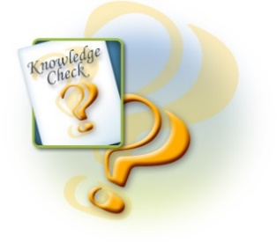
Knowledge Check

- Identify 2 resources used in own subject area for each of the headings below.
ICT – People – Visual Aids – Other Resources
- Name 4 ‘needs’ students might have. Answers could include: Different ways of: ways of learning, learning styles, speeds of learning, backgrounds, levels of motivation, past experiences, abilities etc.
- Which of the following teaching and learning methods have been identified as the 3 most effective ways to learn and retain information?

- Demonstration
- Reading
- Teaching others
- Lecture
- Discussion
- Audio visual
- Practice doing
- Name 4 specialist delivery techniques.
- Give 1 purpose of using specialist delivery techniques. Answers could include: Gain specialist knowledge (case studies, paper feeds, HYDRA), develop specialist skills & technical expertise (simulations & role-plays), provide opportunities for practical activity and application in a safe learning environment (simulations & role-plays)
- Identify 2 ‘needs’ met by using specialist delivery techniques. Answers could include: enhance problem-solving and decision-making skills (simulations & role-plays), improve interpersonal and communication skills (simulations & role-plays), develop team-based competencies (simulations & role-plays), develop behaviours and attitudes – you can see how a student reacts in different situations (simulations & role-plays)
- Identify 1 way in which specialist delivery techniques can be adapted. Answers could include: Learning styles, group work, independent learning, environment, breaking activities into small sections
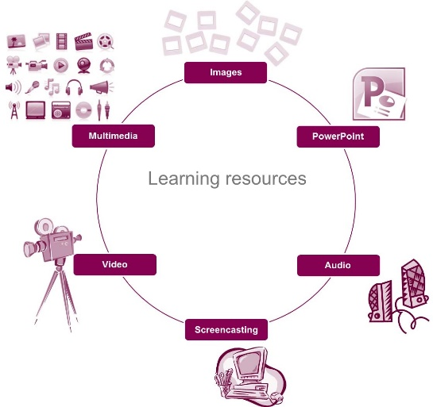
- Describe 1 issues which might affect the development of a specialist delivery technique. Answers could include: adapting to changing technologies, availability of resources, keeping up to date with requirements of skills and knowledge

