Master of Business Administration

Name – Rishith Reddy Jammidi
Student ID – 2429155
Module code: LCMB7035
Module: Dissertation

Dissertation Proposal
The Impact of Social Media Marketing on Consumer Purchase Behaviour
Table of Contents
1. Introduction 2
2. Literature Review 2
2.1 Concept of Social Media Marketing 2
2.2 Social Media and Consumer Behaviour 4
2.3 Role of Influencers and Online Advertising 4
2.4 Research Gap 5
3. Methodology 5
3.1 Research Approach 5
3.2 Data Sources 5
3.3 Data Collection 6
3.4 Data Analysis Method 6
3.5 Ethical Considerations 6
4. Expected Findings 6
5. Limitations 7
6. Timeline 7
Table 1: Timeline (Gantt Chart) 7
7. Conclusion 8
References 9

1. Introduction
The fast technological development of digital means has radically changed the marketing process, making social media one of the most important platforms to communicate the brand and interact with consumers. Over five billion individuals in the world use social media, which is why organisations have begun to use social media as their strategic marketing platforms, including Instagram, Facebook, TikTok, and YouTube (Mude and Undale, 2023). These platforms provide companies with opportunities to generate interactive content, build brand communities and influence consumer decision-making. The research has shown that approximately 70% of buyers are guided by social media in social media purchase decisions, and 54% look up products on social media and subsequently purchase them (Guoqiang and Bhaumik, 2024).
In theory, the Theory of Planned Behaviour is characterised by attitudes, the social influence, and the perceived control to influence the purchase intentions (Sansom, 2021). As a result, clarifying how social media marketing practices can impact the purchasing behaviour of consumers has been a crucial research goal.

2. Literature Review

2.1 Concept of Social Media Marketing
Social media marketing (SMM) is a concept that encompasses providing services through the application of social networking sites in digital marketing of products, communication as well as enhancing brand marketing among consumers (Babore, 2025). As Web 2.0 technologies evolved, marketing has ceased to be a one-way communication of promoting the product, but a form of interactivity, which enables organisations to share information, stimulate participation and influence buying decision making amongst consumers.
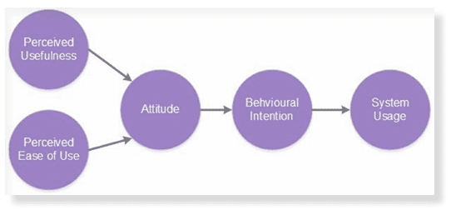
Figure 1: Technology Acceptance Model (TAM)
(Source: Allen, 2020)
Theoretically, the Technology Acceptance Model (TAM) provides us with the understanding of consumer acceptance toward online platforms premised upon the perceived usefulness and comfortable usage, which determines the interactions between the users and digital marketing content (Musa et al., 2024).
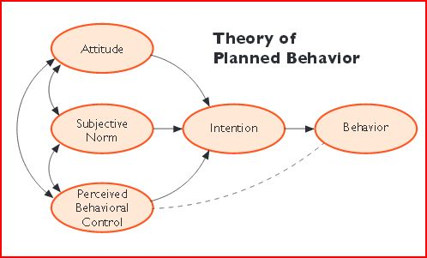
Figure 2: Theory of Planned Behaviour (TPB)
(Source: Comminit, 2014)
Likewise, the Theory of Planned Behaviour implies that the customer intentions towards purchasing are predetermined by the attitude, subjective norms and perceived behavioural control (Sansom, 2021), and social media interactions and peer influence influence the way in which customers make a decision.

2.2 Social Media and Consumer Behaviour
It is proven by empirical research that social media marketing has had a great impact on purchase intention, brand loyalty and consumer trust. Specifically, electronic word-of-mouth (eWOM) has become an important force of consumer behaviour within the virtual sphere (Thuy et al., 2024).
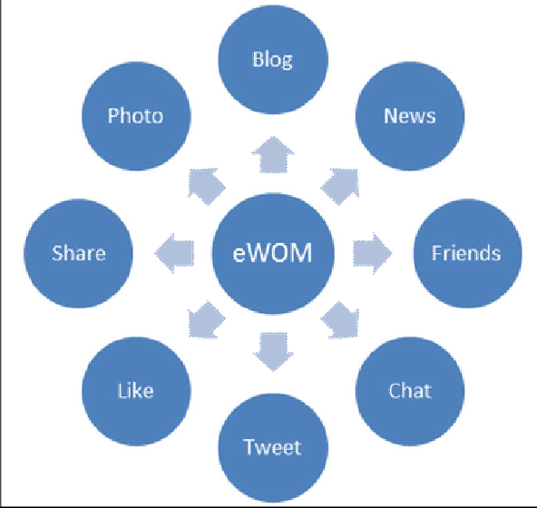
Figure 3: The type of eWOM on social media platforms.
(Source: Alghizzawi, 2019)
eWOM can facilitate the sharing of product experiences and recommendations and help to generate greater trust, as well as perceived risk in purchasing a product. Furthermore, content generated by users and online reviews will enable consumers to consider products using peer-to-peer experience, which plays a major role in attitude towards brands and in making purchasing decisions.

2.3 Role of Influencers and Online Advertising
Influencer marketing has been adopted as a significant element of social media advertising tactics. Influencers produce convincing online content that increases brand recognition and deep, emotionally rooted messages between brands and consumers. It has been found that the marketing efforts of social media, such as interactive content, ads, and influencer recommendations, have a positive impact on consumer engagement and purchase intention (Alnaser et al., 2024).

2.4 Research Gap
Though prevailing literature addresses the influence of social media marketing on consumer behaviour, the majority addresses individual factors, including eWOM or influencer marketing. This research thus incorporates the current literature to explore the overall impact of various aspects of social media that affect consumer buying behaviour on different platforms.

3. Methodology
In this research, a secondary research strategy is used based on qualitative research, which addresses the phenomena between social media marketing and consumer purchase behaviour. Secondary research allows one to analyse systematically existing academic evidence to facilitate patterns and insights of digital marketing. The research paper is based on literature-based research, which critically reviews past empirical research and conceptual models associated with social media strategy of marketing and consumer behaviour.

3.1 Research Approach
It is a qualitative interpretive study, that is, based on the analysis of published academic literature. This method will enable the researcher to investigate the impact of the activities of social media marketing on the attitudes of consumers, level of trust and intent to purchase in various digitised settings.

3.2 Data Sources
Peer-reviewed academic journals, scholarly articles and industry reports will be used in data collection. Relevant literature will be identified with the help of academic databases like Google Scholar, Emerald Insight, ScienceDirect and Statista. Preference will be given to the articles of the past 5-10 years, since the latest and most trustworthy evidence should be used.

3.3 Data Collection
In the research, peer-reviewed studies on the topic of marketing through social media, digital consumer behaviour, and using the Internet will be reviewed and selected. Included in the analysis will be only credible and high-impact journal articles.

3.4 Data Analysis Method
A qualitative method will be employed to analyse the collected literature by thematic analysis, which is a common approach and helps recognise common trends and topics within the sets of data (Kiger and Varpio, 2020). This approach allows to compare the results of several studies and provides access to the revealing of the key factors affecting consumer purchase behaviour.

3.5 Ethical Considerations
The research ethics will also be observed through credible academic sources, appropriate citation methods and Harvard referencing. None of the data will be manipulated or misrepresented, and this will provide academic integrity during the research process.

4. Expected Findings
According to the available literature, it is anticipated that the study will reveal that the role of social media marketing in determining consumer purchase behaviour is significant because the marketing approach utilises brand engagement, electronic word-of-mouth (eWOM) and influencer communication mechanisms. In the past, studies indicate a positive correlation between information quality, credibility, and utility posted on social media and purchase intentions and attitudes towards the products of the consumers (Jian and Wu, 2016). Moreover, through social media marketing, there are chances that brand trust and engagement will intensify and that bridges the correlation between marketing communication and buying behaviour (Babore, 2025).

5. Limitations
This paper has some limitations, as it is based on secondary research:
- The study solely relies on the published academic research, which limits the availability of real-time consumer data and behavioural information.
- Differences in study designs, sampling techniques and methods of analysis used in past studies may lower the comparability/ consistency of results.
- Current literature that gives attention to such large platforms as Instagram and Facebook has a tendency to narrow the external validity of findings regarding other platforms that have arisen more recently, like TikTok or other new digital realms.

6. Timeline
Activity | W1 | W2 | W3 | W4 | W5 | W6 | W7 | W8 | W9 | W10 | W11 | W12 | W13
Topic selection & proposal development
Literature review
Secondary data collection
Data analysis (thematic analysis)
Dissertation writing
Editing & final submission preparation

Table 1: Timeline (Gantt Chart)
(Source: Author)

7. Conclusion
The proposal explores the impact of social media marketing and consumer behaviour of purchasing products and services in digital contexts. The growing role of social media in the search for information and the interaction of the brand with consumers has made the study of their importance in the consumer decision-making process a strategic issue for organisations. The research will undertake a qualitative secondary study, where existing academic literature is to be analysed to gather an insight into how other elements of purchasing behaviour, like electronic word-of-mouth, influencer marketing and online engagement, can influence buying behaviour. It is anticipated that the findings would have an impact on the marketing literature as well as offer some practical suggestions to businesses aiming at producing an effective marketing strategy that is effective in digital marketing.

References
Alghizzawi, M. (2019). A survey of the role of social media platforms in viral marketing: The influence of eWOM. [online] 3(2), pp.54–60. Available at: https://www.researchgate.net/publication/335110016_A_survey_of_the_role_of_social_media_platforms_in_viral_marketing_The_influence_of_eWOM [Accessed 7 Mar. 2026].
Allen, R. (2020). Digital Marketing Models: The Technology Acceptance Model. [online] Smart Insights. Available at: https://www.smartinsights.com/manage-digital-transformation/digital-transformation-strategy/digital-marketing-models-technology-acceptance-model/ [Accessed 7 Mar. 2026].
Alnaser, F., Alghizzawi, M., Abualfalayeh, G., Omeish, F., Alharthi, S. and Al Koni, S.R. (2024). The Impact of Social Media Marketing Activities on Purchase Intention. International Review of Management and Marketing, 14(6), pp.288–300. doi:https://doi.org/10.32479/irmm.16839.
Babore, K. (2025). THE STRATEGIC IMPERATIVE OF SOCIAL MEDIA MARKETING IN THE MODERN BUSINESS LANDSCAPE EXECUTIVE SUMMARY. Journal of Social Media Marketing, [online] 1(1), p.33. Available at: https://www.researchgate.net/publication/392771929_THE_STRATEGIC_IMPERATIVE_OF_SOCIAL_MEDIA_MARKETING_IN_THE_MODERN_BUSINESS_LANDSCAPE_EXECUTIVE_SUMMARY [Accessed 7 Mar. 2026].
Comminit (2014). Theory of Planned Behavior | The Communication Initiative. [online] Comminit.com. Available at: https://global.comminit.com/content/theory-planned-behavior [Accessed 7 Mar. 2026].
Guoqiang, Z. and Bhaumik, A. (2024). The Influence of Social Media on Consumer Behavior and Digital Marketing Strategies: A Comprehensive Review. Advancement in Management and Technology (AMT) , [online] 5(2), pp.30–38. doi:https://doi.org/10.46977/amt.2024.v05i02.004.
Hajli, N. (2015). Social commerce constructs and consumer’s intention to buy. International Journal of Information Management, 35(2), pp.183–191. doi:https://doi.org/10.1016/j.ijinfomgt.2014.12.005.
Jian, Y.-C. and Wu, C.-J. (2016). The function of diagram with numbered arrows and text in helping readers construct kinematic representations: Evidenced from eye movements and reading tests. Computers in Human Behavior, 61, pp.622–632. doi:https://doi.org/10.1016/j.chb.2016.03.063.
Kiger, M.E. and Varpio, L. (2020). Thematic Analysis of Qualitative data: AMEE Guide no. 131. Medical Teacher, [online] 42(8), pp.846–854. doi:https://doi.org/10.1080/0142159X.2020.1755030.
Mude, G. and Undale, S. (2023). Social Media Usage: A Comparison Between Generation Y and Generation Z in India. International Journal of E-Business Research, [online] 19(1), pp.1–20. doi:https://doi.org/10.4018/ijebr.317889.
Musa, H.G., Fatmawati, I., Nuryakin, N. and Suyanto, M. (2024). Marketing research trends using technology acceptance model (TAM): a comprehensive review of researches (2002–2022). Cogent Business & Management, 11(1).
Sansom, R. (2021). Theory of Planned Behavior. [online] Change Theories Collection. Available at: https://ascnhighered.org/ASCN/change_theories/collection/planned_behavior.html [Accessed 7 Mar. 2026].
Thuy, T., Bui, C.T., Chau, L. and Tran (2024). Electronic word-of-mouth (eWOM) on social networking sites (SNS): Roles of information credibility in shaping online purchase intention. Heliyon, 10(11), pp.e32168–e32168. doi:https://doi.org/10.1016/j.heliyon.2024.e32168.

