Questions and Guidelines for Assessment Component 1


Changemakers: Creativity and Value Creation
Professions (BMHP5014)

Component 1: Online portfolio of set exercises

Student name: Saskia Green
Student number: 2416443
Lecturer’s name: Leila Surani

Table of contents
Introduction
Defining key concepts in practice
Mind Map Explanation
Self reflection of group activity
Case study Analysis of a Uk Innovation
Research Task
Exploring Digital Innovation in Health and Social Care
Understanding the NHS Leadership Framework

Self-Reflection Journal Entry
References

Introduction
Health and social care services are always changing. This assignment will look at four main ideas: innovation, creativity, value creation, and change. Each one will be explained and linked to health and social care. Examples will be used to show how these ideas work in real life to improve care.There are more people needing care, not enough resources, and people’s needs are different all the time. Because of this, organisations need to improve how they work. Innovation, creativity, value creation, and change are important because they help improve care and support patients better. The assignment will also mention some models and theories that help guide how care is given and how decisions are made. Overall, it will show how new and creative ideas can lead to better care and positive change in health and social care.

Task 1 Defining key concepts in practice
Innovation in health and social care refers to the use of new or improved ideas, services, or technologies to enhance the quality and efficiency of care (Rogers, 2003). This is important because services are under constant pressure from rising demand and limited resources, so new approaches are needed to improve outcomes. For example, the use of tele-health allows patients to speak to healthcare professionals remotely, which can save time and increase access to care, particularly for those in rural or underserved areas. Rogers Diffusion of Innovation Theory suggests that innovations are not adopted instantly but spread gradually depending on how useful and easy they are for staff to implement (Rogers, 2003).
Creativity in health and social care refers to the ability to develop new and useful ideas that improve how care is delivered (Amabile, 1996). It is important because professionals often work in complex situations where standard approaches may not fully meet individual needs. Being creative allows staff to adapt care to suit each person. For example, a care worker supporting someone with dementia might design personalised activities based on their past interests, which can improve engagement and emotional wellbeing. Amabile’s Componential Theory of Creativity explains that creativity occurs when individuals combine their knowledge, skills, and motivation in a supportive environment (Amabile, 1996).
Value creation in health and social care refers to improving patient outcomes while making effective use of available resources (Porter, 2010). It is important because healthcare systems often face financial pressures, so services must deliver high-quality care without unnecessary costs. Focusing on value ensures that patients receive better results rather than just more treatment. For example, preventative services such as health screenings or early interventions can identify problems sooner, reducing the need for more expensive hospital care later on. Porter’s Value-Based Healthcare framework explains that value is achieved when the outcomes that matter to patients are improved relative to the cost of delivering care (Porter, 2010).
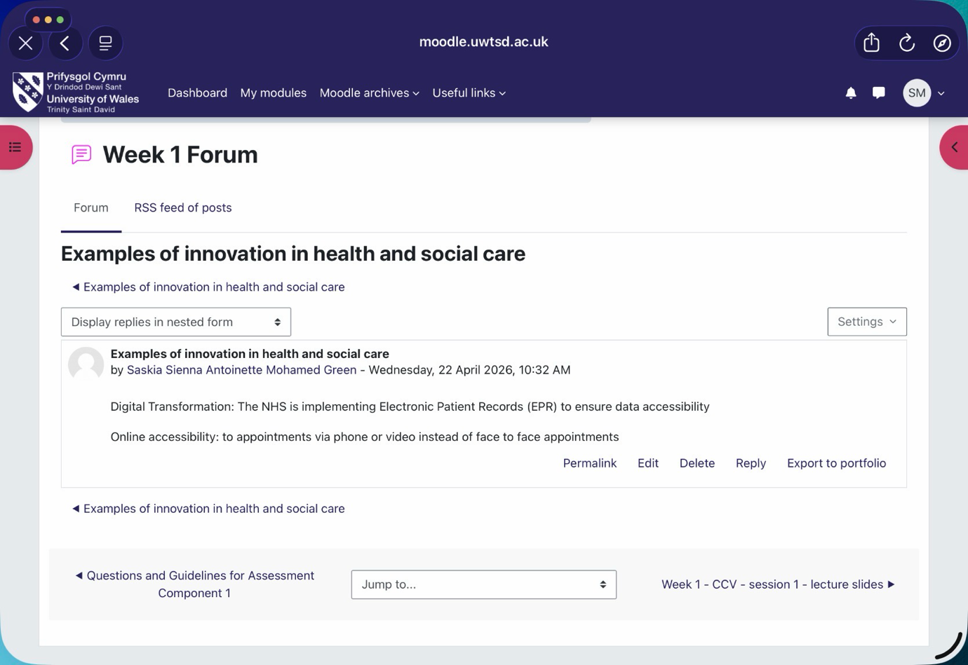
Change is the process of moving from current practices to improved ways of working (Burnes, 2017). It is vital as organisations must adapt to modern technologies, policies, and patient expectations. For example, implementing electronic health records requires staff to adopt new systems and workflows. Lewin’s Change Management Model explains change through unfreezing, implementing, and refreezing stages (Burnes, 2017). However, change can be difficult if staff are not fully engaged.

Task 2 Mind Map Explanation
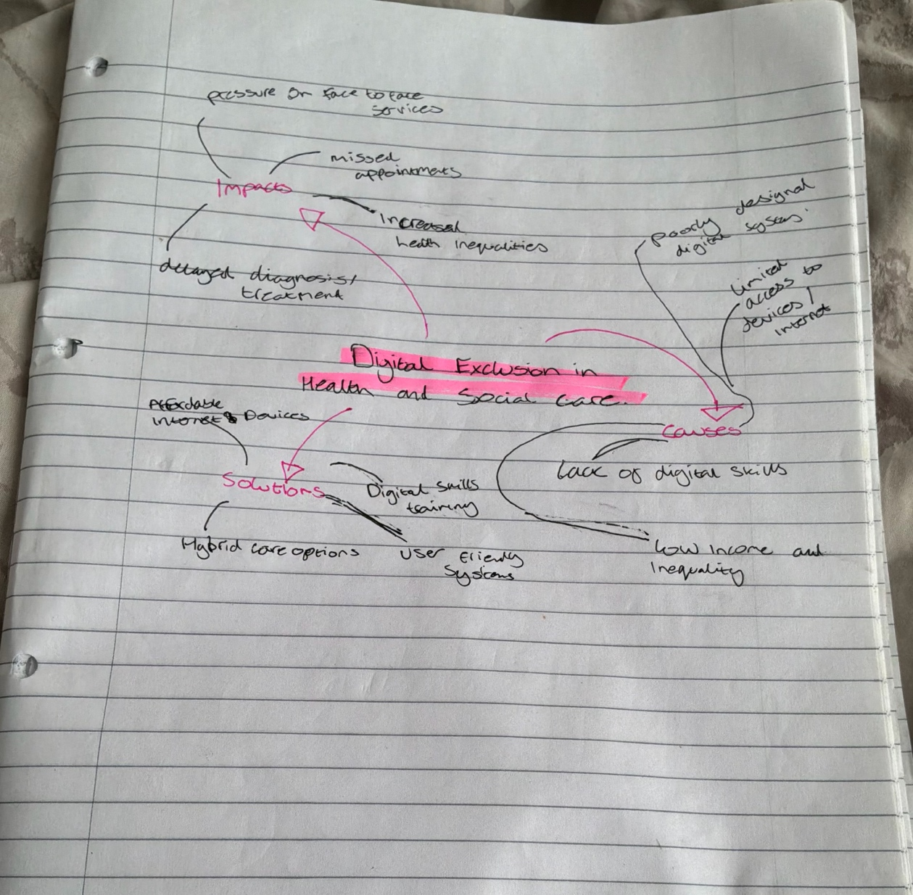
Digital exclusion is a key issue in health and social care because many people do not have the skills, access, or confidence to use online services. This matters as more healthcare are now delivered digitally, meaning some individuals may struggle to get the support they need. The mind map shows how causes such as low income, poor digital skills, and difficult-to-use systems are linked together. These can lead to problems like missed appointments, delays in treatment, and increased health inequalities, especially for older adults. If this issue is not addressed, it could put more pressure on healthcare services and make inequalities worse. Possible solutions include digital skills training, better access to devices and internet, and keeping face-to-face services available. A systems thinking approach shows how these issues are all connected and need joined-up solutions (Meadows, 2008).

Task 3 Self reflection of group activity
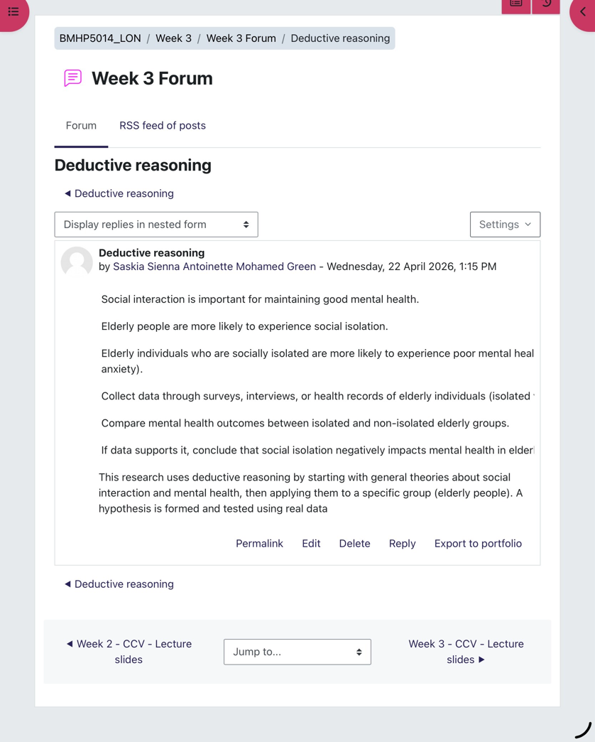
To review my experience of a convergent and divergent thinking activity. Divergent thinking involves generating a wide range of ideas, while convergent thinking focuses on selecting the best solution. In the group task, we first wrote down ideas (divergent thinking) and then worked together to choose one solution (convergent thinking). I felt more comfortable during the brainstorming stage because I enjoy sharing ideas, but I was less confident when narrowing them down. The activity was useful as everyone contributed, but we struggled to agree on the final idea. When we could not agree, I suggested using a pros and cons list, which helped us compare options and make a decision. This showed how convergent thinking supports group decision-making. I learned that I prefer creative thinking but need to improve my confidence in decision-making and speaking up during final discussions. Next time, I will take a more active role in the decision stage and support my group in reaching agreement more effectively. This reflection shows how structured reflection supports learning and skill development (Gibbs, 1988).

Task 4 Case study Analysis of a Uk Innovation
A good example of innovation in the NHS is virtual wards, where patients receive hospital-level care at home using digital technology. The main problem was hospital overcrowding and long waiting times, especially after COVID-19, which put pressure on beds and staff (NHS England, 2023). This created a need for alternative ways to safely manage patients outside hospital settings.
Creativity helped address this by combining remote monitoring devices, apps, and regular virtual check-ins from healthcare professionals. Instead of traditional inpatient care, patients could be treated at home while still being closely monitored. This shows a creative approach to redesigning care delivery. The value created includes improved patient comfort, as people can stay in their own homes, and reduced pressure on hospital beds and staff. It also supports faster recovery and lowers the risk of hospital-acquired infections. Reported outcomes show that virtual wards have reduced hospital admissions and improved patient satisfaction (NHS England, 2023).
This links to Diffusion of Innovation Theory, which explains how new ideas are adopted when they are seen as useful and beneficial (Rogers, 2003). Virtual wards could be used more widely across different services.

Task 5 Research Task
A current issue in health and social care is staff stress and burnout, which affects both care quality and staff wellbeing. One key study by Christina Maslach and Michael Leiter (2016) explains that burnout is mainly caused by high workload, lack of control, and emotional demands. Their work, based on Maslach Burnout Theory, shows that ongoing stress can lead to emotional exhaustion and reduced job performance. This helps explain why staff in busy hospital wards often feel overwhelmed and less able to provide high-quality care.
Another study by Jari Hakanen et al. (2006) uses the Job Demands–Resources (JD-R) model to show that burnout occurs when job demands are too high and support or resources are too low. For example, limited staffing and lack of managerial support can increase stress levels. This reflects real care settings where staff shortages put extra pressure on workers.
Both articles agree that high demands are a major cause of stress, but the JD-R model places more focus on the importance of support systems. Together, they show that reducing burnout requires both lowering workload and improving workplace support.

Task 6 Exploring Digital Innovation in Health and Social Care
Benefits of using wearable health technologies to support the management of chronic health conditions.
Wearable devices such as smartwatches are increasingly used to support the management of chronic conditions. One key benefit is continuous monitoring, which allows early detection of health changes. For example, patients with heart conditions can use devices like the Apple Watch to track heart rate and detect irregular rhythms, helping to prevent serious complications. This supports self-management and encourages patients to take an active role in their health. It also reduces the need for frequent hospital visits. The Technology Acceptance Model (Fred Davis, 1989) suggests that patients are more likely to use these devices if they find them useful and easy to use. Studies show wearable technology can improve patient engagement and health outcomes (Piwek et al., 2016).

How electronic health records (EHRs) improve communication and collaboration between healthcare providers.
Electronic Health Records (EHRs) improve communication by allowing healthcare professionals to access and share patient information in real time. This reduces errors and ensures continuity of care. For example, a GP, nurse, and hospital consultant can all view the same patient record, including test results and treatment plans. This improves collaboration and decision-making, especially in complex cases. In practice, this means patients do not have to repeat their medical history multiple times. According to the Technology Acceptance Model (Fred Davis, 1989), EHRs are more effective when staff find them easy to use and beneficial to their work. Research shows EHRs improve efficiency and patient safety (Kruse et al., 2017).

How digital technology can support preventative care and health promotion, using a real or hypothetical example.
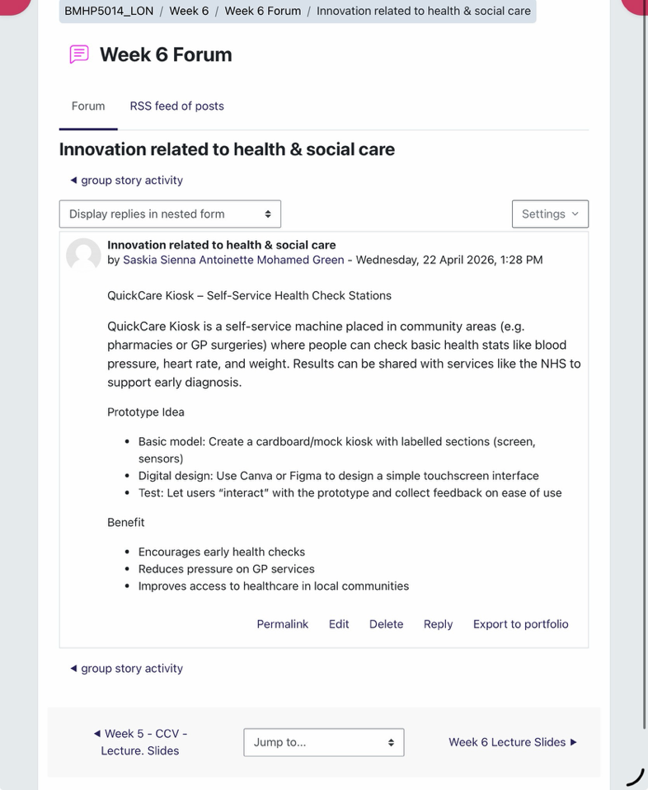
Digital technology plays an important role in preventative care and health promotion by helping individuals monitor and improve their health behaviours. For example, mobile apps like the NHS weight loss app support users in tracking diet and physical activity, encouraging healthier lifestyles. This can help prevent conditions such as obesity and diabetes. Digital reminders for vaccinations or screenings also support early intervention. The Technology Acceptance Model (Fred Davis, 1989) explains that people are more likely to engage with these tools if they are simple and helpful. Evidence suggests digital interventions can positively influence behaviour change and reduce long-term healthcare demand (Michie et al., 2017).

Task 7 Understanding the NHS Leadership Framework

NHS Leadership Framework
The NHS Leadership Framework, also known as the Healthcare Leadership Model, sets out the key behaviours needed for effective leadership in health and social care. It includes areas such as leading with care, inspiring shared purpose, evaluating information, and working with others. The framework shows that leadership is not just for managers, but for all staff, as everyone has a role in improving care. It is important because it helps create a positive working culture where staff feel supported, which can lead to better patient outcomes. It also encourages teamwork, communication, and continuous improvement. In real practice, this means staff are more likely to work together and share ideas to improve services. Overall, the framework helps ensure that care is safe, effective, and focused on patient needs (NHS Leadership Academy, 2013; West et al., 2015).
Leadership behaviour
Inspiring a shared purpose means creating a clear goal that everyone in the team understands and works towards. A leader can encourage creativity by making staff feel involved and valued, for example by asking for their ideas on how to improve patient care. This can lead to new and better ways of working. This links to Transformational Leadership, which shows that leaders can motivate staff through support and a shared vision (Bass and Avolio, 1994). When staff feel motivated, they are more likely to be creative and provide higher quality care for patients.
Short Reflection
During this module, my understanding of creativity and value creation in health and social care has improved a lot. At first, I thought creativity just meant coming up with new ideas, but now I understand it is about creating useful solutions that actually improve care. Activities like the convergent and divergent thinking task helped me see how ideas need to be developed and then carefully chosen. I also learned that value creation is about improving patient outcomes while using resources effectively, not just saving money. This has changed how I think about innovation in healthcare. In the future, I will try to be more open to new ideas and take part in improving services. This learning will help me in my career by improving my teamwork, communication, and problem-solving skills.

Task 8 Self-Reflection Journal Entry
My reflection uses Graham Gibbs Reflective Cycle (1988) to explore my learning from this module. I have developed a clearer understanding of creativity, innovation, and value creation in health and social care. At first, I thought creativity was just about new ideas, but I now see it as developing practical solutions that improve patient care. The convergent and divergent thinking activity changed my perspective, as it showed me the importance of both generating ideas and selecting the best one. I also learned that value creation is about improving patient outcomes while using resources effectively. In future placements, I will try to share ideas more confidently and take part in problem-solving within teams. This learning will help me become a more effective healthcare professional by supporting innovation and improving service quality (Gibbs, 1988).

References
Amabile, T.M. (1996) Creativity in context : Amabile, teresa : Free Download, borrow, and streaming, Internet Archive. Available at: https://archive.org/details/creativityincont0000amab
(Accessed: April 2026).
B.M, B. and B.J, A. (1994) Improving Organizational Effectiveness through Transformational Leadership., American Psychological Association. Available at: https://psycnet.apa.org/record/1995-97316-000
(Accessed: April 2026).
C, M. and M.P, L. (2016) Understanding the burnout experience: Recent research and its implications for psychiatry, Burnout. Available at: https://onlinelibrary.wiley.com/doi/epdf/10.1002/wps.20311
(Accessed: April 2026).
CS, K. (2017) Impact of electronic health records on long-term care facilities: Systematic review, JMIR medical informatics. Available at: https://pubmed.ncbi.nlm.nih.gov/28963091/
(Accessed: April 2026).
D.H, M. (2008) Meadows 2008. thinking in systems.pdf, Thinking in systems. Available at: https://research.fit.edu/media/site-specific/researchfitedu/coast-climate-adaptation-library/climate-communications/psychology-amp-behavior/Meadows-2008.-Thinking-in-Systems.pdf
(Accessed: April 2026).
E.M, R. (2003) (PDF) diffusion of Innovations, Diffusion of innovations. Available at: https://www.researchgate.net/publication/311487299_Diffusion_of_Innovations
(Accessed: April 2026).
F.D, D. (1989) (PDF) perceived usefulness, perceived ease of use, and user acceptance of Information Technology, Perceived usefulness . Available at: https://www.researchgate.net/publication/200085965_Perceived_Usefulness_Perceived_Ease_of_Use_and_User_Acceptance_of_Information_Technology
(Accessed: April 2026).
G, G. (1998) Gibbs’ reflective cycle: Reflection toolkit, Reflection Toolkit. Available at: https://reflection.ed.ac.uk/reflectors-toolkit/reflecting-on-experience/gibbs-reflective-cycle
(Accessed: April 2026).
J.J, H., A.B, B. and W.B, S. (2006) Burnout and work engagement among teachers, Burnout and work engagement Available at: https://www.wilmarschaufeli.nl/publications/Schaufeli/246.pdf
(Accessed: April 2026).
M.E, P. (2010) Perspective: New England Journal Medicine. Available at: https://www.scribd.com/document/458645780/Porter-What-is-value-in-healthcare
(Accessed: April 2026).
Michie, S. et al. (2017) Evaluating the effectiveness of behavior change techniques in health-related behavior: A scoping review of methods used, Translational behavioral medicine. Available at: https://pmc.ncbi.nlm.nih.gov/articles/PMC6062857/
(Accessed: April 2026).
NHS (2013) healthcare leadership model . Available at: https://www.leadershipacademy.nhs.uk/wp-content/uploads/dlm_uploads/2014/10/NHSLeadership-LeadershipModel-colour.pdf
(Accessed: April 2026).
NHS (2023) Virtual Wards, NHS choices. Available at: https://www.england.nhs.uk/nhs-at-home/covid-virtual-wards/
(Accessed: April 2026).
Piwek, L. et al. (2016) The Rise of Consumer Health Wearables: Promises and barriers, PLOS Medicine. Available at: https://journals.plos.org/plosmedicine/article?id=10.1371%2Fjournal.pmed.1001953
(Accessed: April 2026).
West, M. (2015) Leadership and leadership development in health care | The King’s Fund. Available at: https://www.kingsfund.org.uk/insight-and-analysis/reports/leadership-development-health-care
(Accessed: April 2026).

