Learning In the digital era
Paige Hodgson
The purpose of this document is to highlight my understanding and process of 3D modelling development in the form of a planned diary. The models featured below were created using Maya2023-2024.
Products Featured:
Lamp 13/10/2023
. One of the very first models that I worked on
. Looking at X, Y, Z axis in comparison to scaling selected areas of a model and part
. Started off with basic shapes such as squares and cylinders
. Experimenting with the edge loop tool as well as extrusion
. Basic scaling and movement/rotation tools
. Playing around with polygons to see how finely I can round it off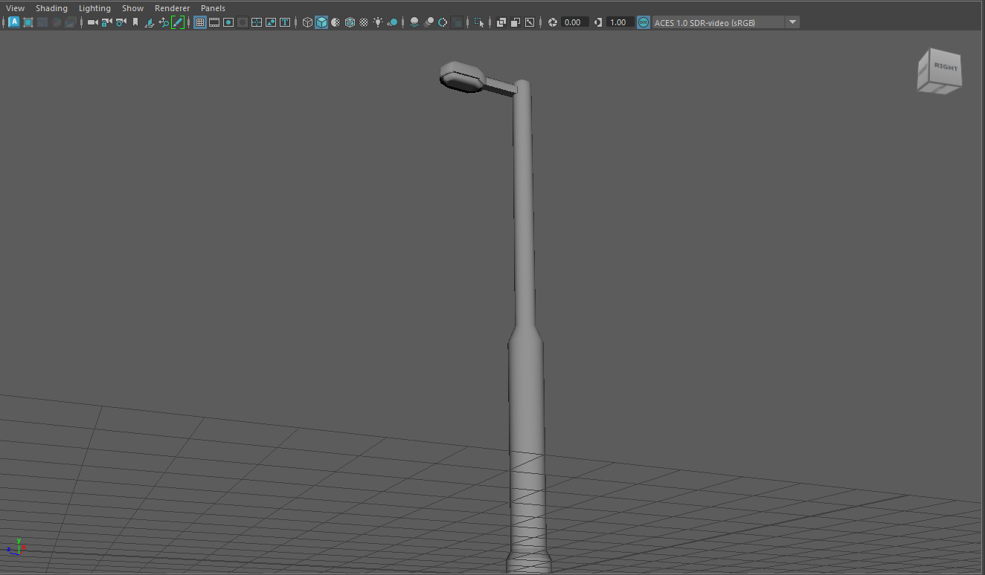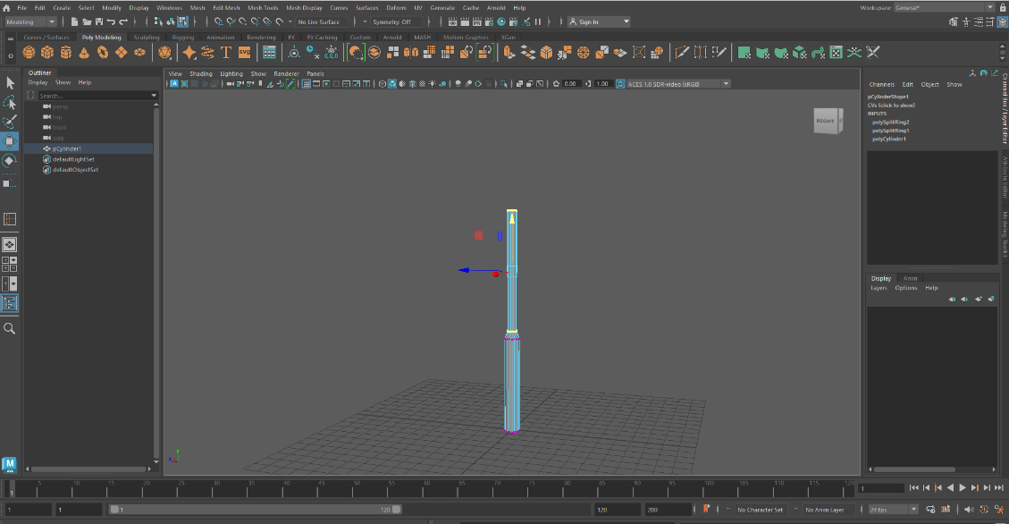
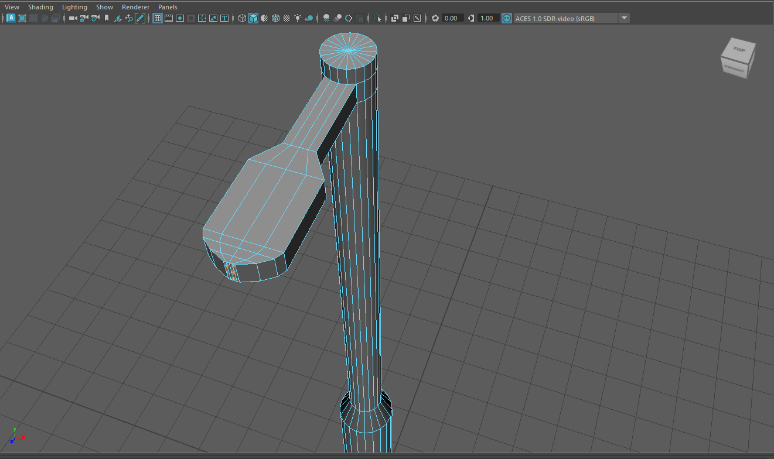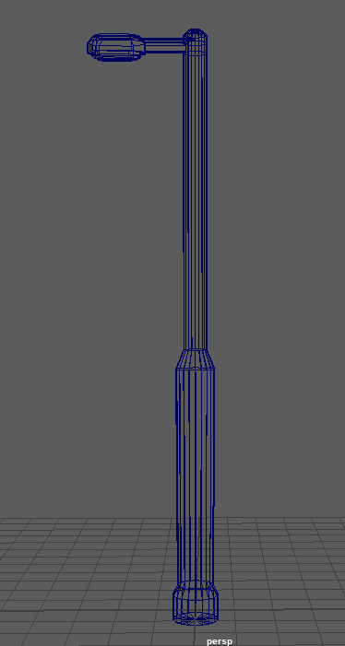
[1]

Dumpster 19/10/2023
. Creating from basic shapes such as rectangles and cylinders
. Used the welding tool to piece together each of the faces that were disconnected/leaving a black space
. Created one wheel and duplicated them for each corner of the dumpster
. Found that I needed to link the tool to my object instead of the world itself, I had started making the model at a different angle/axis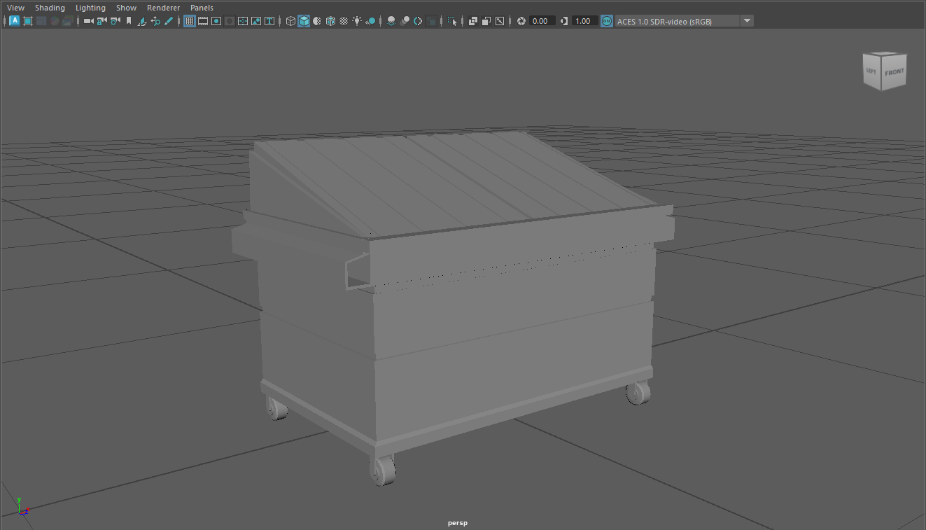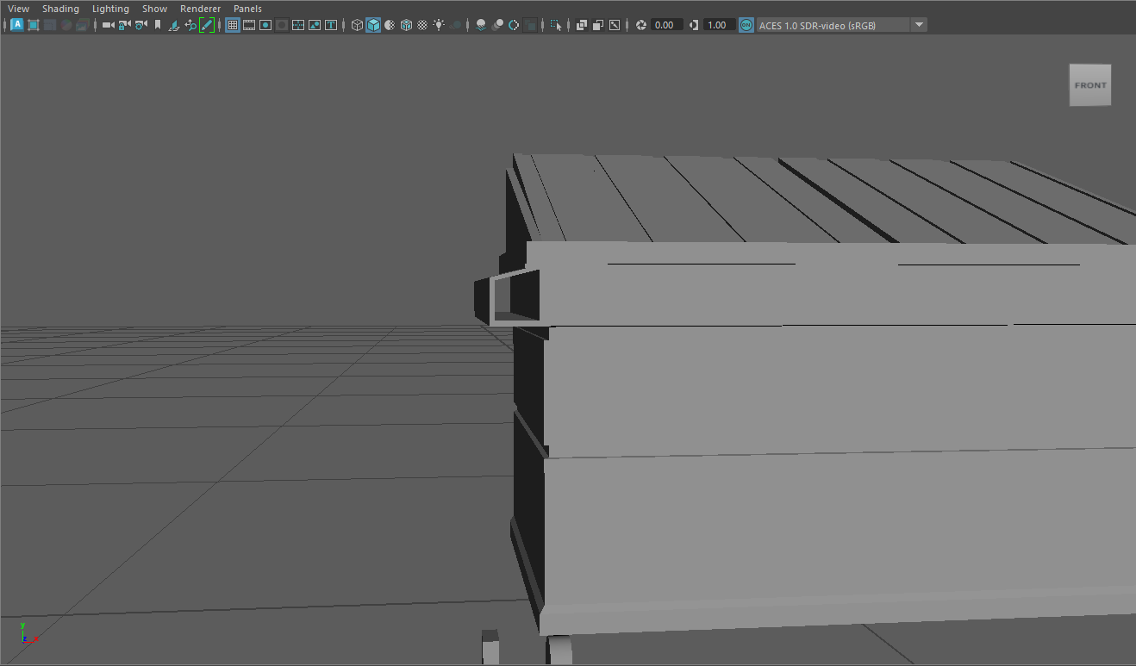
[2]
.Soda Can 20/10/2023
.The soda can on the left of the first image was created using no references and you can see my progress with each screenshot
.Making use of the bevel feature to round out and add parts to the can, mostly the rim
.Smoothing/ softening the edge ridges of my model to make it appear seamless
.Making the tab of the can required me to use a polygon plane where I was able to select where I wanted to insert edge loops to cut out the shape of my tab
.Pulling and moving where the vertexes would go to assure the topology works hand in hand with my edge flow to appear almost seamless
[3]
[4]
.Cup & Saucer 20/10/2023
.The process of using a guide to make my mug at first made the shaping process a lot easier
.Looking at what each tool was used for, I struggled when realigning the handle of the mug to the shape I wanted to
.I found I could not bend the curve evenly for the top and the bottom
.I got a handle shape I was happy with after looking at different example pictures.
.On the base of the mug I was using the attribute editor, I had to change the thickness of the poly faces to copy how thick my mug would look in comparison to a real mug
.Extruding areas of the base to get the right shape all around my model
.Using bridge techniques to create the connection of my handles to my mug from open faces
Maya Tutorial: Model a Coffee Cup - YouTube [5]
.As for the saucer I used a reference image as usual
.In comparison to the mug you can see the difference in polygons
.When placed in object mode with softened edges the overall product looks well paired together
.Using edge and vertex selection to pull the base of the plate inwards through extrusion

[6]
.Anvil 26/10/2023
.This was my first introduction to using an orthographic for an anvil reference to place into the world
.I had to place 3 of the same images and fit precisely in frame of the centre of the world for my basic polygon cube
.I was using the different camera views as it became necessary to make sure I did not warp or select a face I didn't need to
.Its extremely handy to use the wireframe view in the top-down camera when pulling the corners/ Vertex of each polygon into the preferred shape
.I wasn't sure how to warp the corners into the diagram however this was solved by selecting multiple vertexes either side by holding shift and pulling inwards with the scale tool

[7]
.Screwdriver 26/10/2023
.This time only using 1 image reference so that I can create the scale of my model accurately
.Ideally better to find a flat facing image of the object I want to base it on
.Its only needed for me to use 1 image this time as something simple like a screwdriver is usually the same at all angles
.Having given only 20 minutes for myself to make this model I was unable to create a detailed/ accurate head for the screwdriver
.This is something I would like to improve on in the future within a time period

[8]
.Desk 26/10/2023
.This model is based on the same Ikea desk I have at home however I needed to find the product reference online to create an accurate model in maya
.Inside of the desk cupboards are 2 sets of shelves that can be placed at any height, however as im using the reference with a closed door I will not be including the insides
.I found it challenging to create the rounded edges of the legs on the right side of the desk as they aren't completely flat
.Limitations of this project meant I could not find a way to create the cord hole on top of the desk, this is something I'd like to learn how to create in the future however as a model of a desk it fits its purpose regardless
.When comparing my reference photos to my model its clear to see that I have improved upon and extended the overall length of the desk, it's something that I believe makes the model look more realistic as I often found my desk too small in general
[9]

.Sofa 27/10/2023
Quick design thrown together in Maya, the idea for this product was a combined mixture of many different examples of a modern sofa.
.Hatchet 2/11/2023
.This week I had modelled various random items in under a brief period of time to the best of my ability
.this included using some reference imagery, various tools, and techniques to perfect certain aspects of my models that I was struggling to achieve
.For the hatchet I could create the sharp faced blade by adding an edge loop to the center of the surface
.I could then drag and stretch it into the width and height of a hatchet blade from its edges selected
.As for the handle of the hatchet I did not want to completely bevel the edges like the reference photo so instead I extruded the side faces that were on point with the blade and scaled them inwards to create a choppier rounded off design
.It changes the overall look of the material that could be used for its base, and I prefer this detail as it looks like it was from other examples that I briefly looked at
[10]
.Chest 2/11/2023
.Started from a cube and, extruding from the top faces of the model I created a curved lid
.The key lock was difficult to work with as the rounded edge loops made the model confusing and trying to delete useless edges distorted the shape, so I opted to leave them in
.I created extruded edges for the metal support frames of the chest to round them off

.Monitor 2/11/2023
.Model referenced from the Samsung Monitors provided in the lecture room
.Creative liberties were taken when creating the stand of the monitor, I changed the overall thickness and depth of its flat bottom
.In order to clean up the model it would have been better to delete unneeded edge loops

.Mobile Phone 5/11/2023
.The inspiration of this model is based on older generations of the smartphone in the 2010’s
.Most notably being that of Apple and Samsung products
.I should have improved by limiting its width and depth, despite being an older model of a mobile phone the backing case is still too tall (as I am now recording the process ive noticed)
.House 23/11/2023
.I began the model with a basic cube that I shaped to the rough dimensions of the house itself
.Creating a singular model for each window/door design from the orthographic to duplicate
.I found it challenging to create the roof bump out at the front of the house because I found that instead of making it apart of the whole roof, I separated it into its own model to fit in flush with its extension
.I ran into an issue when removing unwanted faces of the separate models, specifically with the roof, I overcame this by creating a polygon plane and altering its subdivisions to 0 so that I can clearly see all 4 points of the model
.I could then use the snap to point tool to connect each corner with the underside of the roof piece that was missing a face with my plane
.Making sure to remove faces behind the windows and doors I could connect and duplicate as many variants as I needed when aligning doors and windows in the wireframe mode to view my orthographic behind
[11]

Bibliography
[1] “Mallatite,” Lighting Columns | Street Lighting Posts & Columns, https://www.mallatite.co.uk/street-lighting/lighting-columns/steel-column/ (accessed Dec. 05, 2023).
[2] “Dumpster diving tips and tricks,” ThriftyFun, https://www.thriftyfun.com/Dumpster-Diving-Tips-and-Tricks.html (accessed Dec. 06, 2023).
[3] Nevodka, “Photograph of blank blue aluminum soda or alcohol drink can for...,” iStock, https://www.istockphoto.com/photo/blank-blue-aluminum-drink-can-gm922996624-253374797 (accessed Dec. 06, 2023).
[4] lepas2004, “Drink metal bottle,” iStock, https://www.istockphoto.com/photo/drink-metal-bottle-gm97929744-7320196?phrase=soda%2Bcan%2Btop%2Bview&searchscope=image%2Cfilm (accessed Dec. 06, 2023).
[5] “Maya tutorial: Model A coffee cup,” YouTube, https://www.youtube.com/watch?v=V59XKklgfDE (accessed Dec. 07, 2023).
[6] “Food NetworkTM 4-PC. Butter Cream Salad Plate set,” Kohl’s, https://www.kohls.com/product/prd-263542/food-network-4-pc-butter-cream-salad-plate-set.jsp (accessed Dec. 07, 2023).
[7] “Category:sheet metal drafting (book),” Wikimedia Commons, https://commons.wikimedia.org/wiki/Category:Sheet_Metal_Drafting_(book) (accessed Dec. 10, 2023).
[8] “Screw driver star RB 6×200mm 8",” Othoba.com, https://www.othoba.com/screw-driver-star-rb-6200mm-8-rmd00334 (accessed Dec. 10, 2023).
[9] “Micke White, desk, 105x50 cm. get it here!,” IKEA, https://www.ikea.com/gb/en/p/micke-desk-white-80213074/ (accessed Dec. 10, 2023).
[10] “TBS grizedale forest hatchet,” The Bushcraft Store, https://www.thebushcraftstore.co.uk/tbs-grizedale-forest-hatchet-63731-p.asp (accessed Dec. 12, 2023).
[11] “House plan and Elevation Drawings December 2023,” House Floor Plans, https://www.supermodulor.com/house-plan-and-elevation-drawings/ (accessed Dec. 12, 2023).

-Summary-
The entire process of learning to use the 3D modelling software of maya to begin with was extremely daunting to grasp, however being slowly introduced to its various tools and capabilities I became curious to see just how vastly each person would begin to learn and practice their skills in Maya. My own introduction to 3D modelling began with blender however I found the user interface to be too much for a beginner. The development of my first few models with maya began slowly, and as I wanted to create and understand the use of more tools it became clear that I was slowly grasping the confidence to experiment with my various models and interactions of UI settings.
I would say that the improvements to be had on my end would be towards understanding and getting used to Maya’s various keyboard shortcuts. I often found myself doing tasks and selections very slowly, I would then learn a new shortcut that would speed up my processes a lot. I'd like to move forward with a goal in mind when using Maya as a 3D modelling software to improve upon making more in depth models with intricate details. So far, I would class some of my models to be quite basic, however as a beginner this step is necessary for my development.
YouTube tutorials and Lecturer advice vastly helped in my development towards some of my models, for example the mug and soda can I find to be much higher in quality, despite these models having had much more time put into them I still can see room for improvement. Aside from my own reference images I also found many online examples and references that I have mentioned above for a vast majority of the models in this development diary.

