c

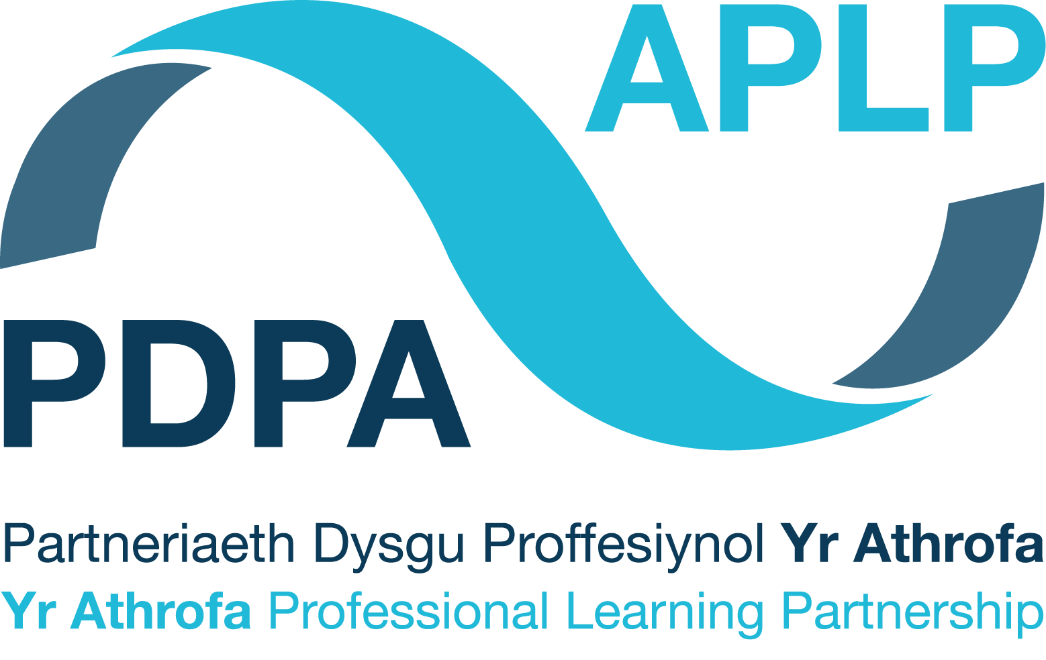


Diwrnod CWRDD | MEET day | 12.11.25
TAR Diwrnodau PROFI | PGCE TEST days | 13.11.25 – 25.11.25
TAR Diwrnod RHANNU | PGCE SHARE day | 26.11.25
Pontio 1 BA3 & TAR
Gwelliant Ysgol
BA3 & PGCE Bridge 1
School Improvement

Cofnod Tystiolaeth Ymholi Darpar Athrawon
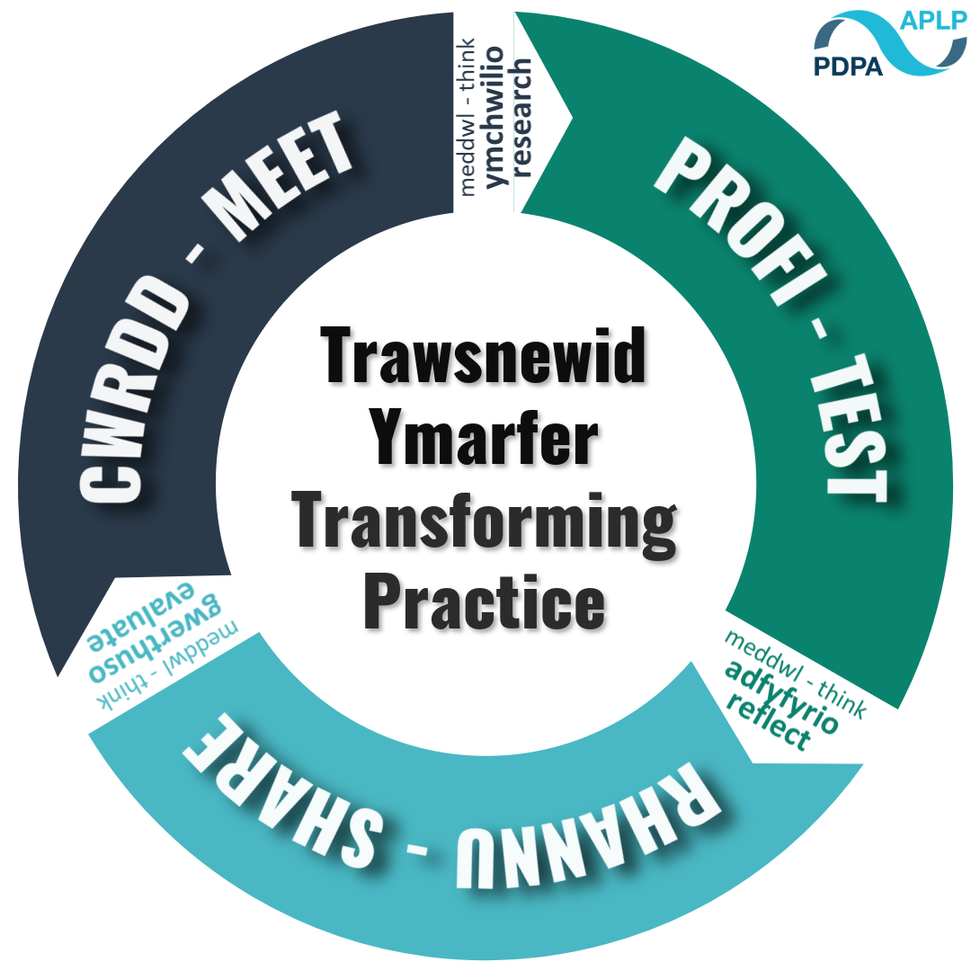
Student-Teacher Enquiry Evidence Record
(STEER)

Student-Teacher Enquiry Evidence Record

11th -25th November 2020

Beth yw pwrpas y gweithgaredd pontio hwn?
Cyfnod CWRDD (Ysgol Arweiniol Rhwydwaith)
Bydd y diwrnod CWRDD yn eich galluogi i ddeall diben gwelliant ysgol, ystyried ffyrdd y mae ysgolion yn nodi targedau ysgol ac adnabod sut mae’r rhain yn perthnasu i’r blaenoriaethau cenedlaethol a osodwyd gan Lywodraeth Cymru.
Cyfnod PROFI (Ysgol Rwydwaith PAP)
Yn ystod y cyfnod PROFI bydd disgwyl i chi:
- Dysgwch am flaenoriaethau eich ysgol leoliad, fel y gwelir yn ei Chynllun Gwella Ysgol, ei Chynllun Gwella Adran, neu Gynllun Gwella MDPh – efallai y bydd angen cyfarfod gyda’r unigolyn/unigolion perthnasol er mwyn gwneud hyn, a dylai’r cyfarfod gael ei drefnu gan eich uwch fentor
- Os yw'n bosibl, mynnwch gopi o'r cynllun
- Ar ôl cael mynediad at y cynllun a’i ddarllen, nodwch un flaenoriaeth/maes targed yr hoffech ei archwilio ar gyfer eich cyfnod PROFI.
- Meddyliwch pam mae hyn yn flaenoriaeth i’r ysgol a sut rydych yn bwriadu cyfrannu at gyflawni’r flaenoriaeth hon drwy eich addysgeg eich hun.
- Rhannwch gyda’ch mentor dosbarth/pwnc flaenoriaeth/maes targed yr ysgol/adran rydych yn dymuno mynd i’r afael ag ef yn eich gwersi yn ystod y cyfnod PROFI.
- Cynlluniwch eich gwersi i nodi ffyrdd y byddwch yn gweithio tuag at gyflawni'r flaenoriaeth hon
- Cyflwynwch ac adfyfyriwch ar eich gwersi a roddodd gyfle i chi gyfrannu at flaenoriaeth/maes targed yr ysgol.
- Efallai yr hoffech ystyried pa brosesau hunanwerthuso aeth yr ysgol drwyddynt i nodi'r targed hwn, pa strategaethau y mae wedi'u gweithredu, sut mae’n bwriadu gwerthuso effaith.

What is the purpose of this bridging activity?
Meet Phase (Network Lead School)
The MEET day will allow you to understand the purpose of school improvement, consider ways in which schools identify school targets and identify how these relate to the national priorities set by Welsh Government.
TEST phase (PTE Network School)
During the TEST phase you will be expected to:
- Find out about your placement school’s priorities as seen in their School Improvement Plan, Departmental Improvement Plan or AoLE Improvement Plan – this may require a meeting with the relevant person(s), which should be arranged by your senior mentor.
- If possible, get a copy of the plan
- From having access/read the plan, identify one priority/target area that you would like to explore for your TEST phase.
- Think about why this is a priority for the school and how you intend to contribute towards meeting this priority through your own pedagogy.
- Share with your class/subject mentor the school/department priority/target area that you wish to address in your lessons during the TEST phase.
- Plan your lessons to identify ways in which you will work towards meeting this priority
- Deliver and reflect upon your lessons which gave opportunity for you to contribute towards the school’s priority/target area.
- You may wish to consider what self-evaluative processes did the school go through to identify this target, what strategies have they implemented, how are they intending to evaluate impact

Cynllun Gweithredu

Action Plan

Ystyriwch y cynllun gweithredu a ganlynol i gefnogi eich camau nesaf.
Consider the following action plan to support your next steps.

1. Maes targed sydd o ddiddordeb i mi |  | 1. A target area that interests me
2. Targed fel y nodwyd yn y CDY/CDA |  | 2. Target as stated in the SDP/SIP
3. Sut mae’r targed yn cysylltu i flaenoriaethau Cenhadaeth Genedlaethol Llywodraeth Cymru? |  | 3. How does the target relate to the priorities of the Welsh Government's National Mission?
4. Beth alla’i ei wneud i weithio tuag at fynd i’r afael â’r targed hwn yn fy ngwersi/yn fy arfer |  | 4. What can I do to work towards addressing this target in my lessons/in my practice
5. Beth sydd angen i mi ei wneud nesaf (siarad gyda mentor dosbarth, trefnu cyfarfod gyda’r Pennaeth Adran)? Darllenwch lenyddiaeth am...? |  | 5. What do I need to do next (talk to a class mentor, arrange a meeting with the Head of Department)? Read literature about...?

Defnyddiwch y cwestiynau a ganlyn i gefnogi eich ymgysylltiad beirniadol â’r maes targed rydych wedi dewis canolbwyntio arno:
Use the following questions to support your critical engagement with the target area you have chosen to focus on:

Y targed o CDY/CDA fy ysgol lleoliad yw... | The target of my placement school's SDP/SIP is...
Beth mae data’r ysgol yn ei ddangos ar hyn o bryd? Data meintiol neu ansoddol – rhowch fanylion. | What does the school data currently show? Quantitative or qualitative data – please provide details.
Pa brosesau hunan-werthuso a gynhaliwyd er mwyn nodi pam bod hyn yn darged? | What self-evaluation processes have been undertaken to identify why this is a target?
Ydy’r targed hwn yn berthnasol i BOB disgybl ar draws yr ysgol? | Does this target apply to ALL pupils across the school?
Pa arferion sydd ar waith ar hyn o bryd yn yr ysgol i ymdrin â’r targed hwn a beth allwn ni ei ddysgu gan y rhain? | What practices are currently in place at the school to deal with this target and what can we learn from these?
Oes strategaethau wedi’u cynllunio (neu efallai ymagwedd ysgol gyfan/adran/MDPh) sy’n cael ei weithredu i ymdrin â’r targed hwn? | Are there planned strategies (or maybe a whole school/department/AoLE approach) that are being implemented to address this target?
Oes anghenion hyfforddi penodol ar gyfer y staff? Oes angen i athrawon fynychu unrhyw gyrsiau? | Are there specific training needs for staff? Do teachers need to attend any courses?
Oes yna randdeiliaid eraill a beth yw eu rôl? | Are there other stakeholders and what is their role?
Oes unrhyw agwedd ar y targed wedi’i werthuso yn barod? Os felly, beth fu’r canlyniad/effaith? | Has any aspect of the target been evaluated already? If so, what has been the result/impact?
Sut mae ymdrin â’r targed hwn yn effeithio ar fy nghynlluniau gwers? | How does addressing this target impact my lesson planning?

Diwrnod RHANNU TAR (YSGOL ARWEINIOL RHWYDWAITH)

Yn y cyfnod RHANNU bydd disgwyl i chi adrodd ar wers neu gyfres o wersi y gwnaethoch eu treialu yn ystod y cyfnod PROFI a ystyriodd yn ofalus un o dargedau eich ysgol lleoliad.
Bydd angen i chi baratoi cyflwyniad adborth 5-10 munud i rannu eich canfyddiadau a dangos eich ymgysylltu beirniadol â’r cyfnod PROFI yn ysgol eich lleoliad. Os ydych yn defnyddio cyflwyniad PowerPoint, peidiwch â defnyddio mwy na 4 sleid. Rhaid i chi strwythuro eich canfyddiadau/cyflwniad gan ddefnyddio’r 3 chwestiwn:
- Beth wnaethoch chi a pham?
- Beth ydych chi wedi’i ddysgu?
- Cyflwynwch eich canfyddiadau a’ch adfyfyrdodau eich hun am ddim mwy na 10 munud.
- Byddwch yn feirniadol wrth feddwl am eich profiad chi a phrofiad pobl eraill.
- Cymharwch y theori ag arfer (cysylltwch yr hyn rydych wedi’i brofi â llenyddiaeth rydych wedi ymgysylltu â hi).
- Ystyriwch ddatblygiad eich dealltwriaeth o Ysgolion Gwella ers y Diwrnod Cwrdd.
Bydd yr Arweinydd Rhwydwaith a’r Tiwtor Cwricwlwm ill dau yn gweithredu yn rôl y trafodwr – byddant yn herio tybiaethau.
- Beth Nesaf?
A oes unrhyw beth rydych yn bwriadu ei wneud o ganlyniad i’r profiad hwn? Efallai y byddech eisiau ystyried rhai o’r cwestiynau canlynol:
  - A oes unrhyw gamau penodol y byddwch yn eu cymryd?
  - Beth fyddech chi’n ei wneud mewn amgylchiadau tebyg yn y dyfodol?
  - A oes unrhyw beth yr ydych yn bwriadu ei newid?
  - A oes gennych unrhyw gynlluniau ar gyfer dysgu pellach neu gyfleoedd datblygu?

Pan fydd eich cymheiriaid yn rhannu eu canfyddiadau a’u hadfyfyrdodau byddwch chi’n cael fformat i wneud nodiadau a gofyn cwestiynau.

PGCE SHARE day (Network Lead School)

In the SHARE phase you will be expected to report on a lesson or sequence of lessons you trialled during the TEST phase that gave careful consideration to one of your placement school’s targets. This will provide evidence for related teaching standards within your PLP.
You will need to prepare a 5-10 minute feedback presentation to share your findings and illustrate your critical engagement from the TEST phase in your placement school. If using a PowerPoint presentation, do not use more than 4 slides. You must structure your findings/presentation using the 3 questions:
- What did you do and why?
- What have you learned?
- Present your own findings and reflections for no more than 10 minutes.
- Be critical in your thinking with regards to your experience and the experience of others.
- Compare the theory with practice (link what you have tested with literature you have engaged with).
- Consider the development of your understanding of school improvement since the Meet Day.
The Network Lead and Curriculum Tutor will both act in the role of the discussant – they will challenge assumptions.
- What Next?
Is there anything you intend to do as a result of this experience? You might want to consider some of the following questions:
  - Are there any specific actions that you will take?
  - What would you do in similar circumstances in the future?
  - Is there anything you intend to change?
  - Do you have plans for any further learning or development opportunities?

When your peers are sharing their findings and reflections you will be given a format to make notes and ask questions.

Ar ôl y Pontio – gosod targed(au) personol

Ar ôl y profiad diwrnod Rhannu dylech rannu fersiwn electronig o’ch taflen adfyfyrio cymdeithasol gyda’ch tiwtor.
O ganlyniad i’r hyn rydych wedi’i ddysgu/adfyfyrio arno yn ystod diwrnodau cwrdd, profi a rhannu y pontio hwn, gosodwch darged i chi’ch hun i wella eich arfer.

After the Bridge – setting of personal target(s)

As a result of what you have learnt/reflected upon during the meet, test and share days of this bridge, please set yourself a target to improve your own practice.

TARGED  Pa faes ydych chi eisiau ei ddatblygu o fewn eich arfer eich hun? | TARGET  What area do you want to develop in your own practice?
GRADDFA AMSER  Erbyn pryd ydych chi eisiau cyflawni hyn? | TIMESCALE  When do you want to achieve this by?
ADNODDAU  Beth sydd ei angen arnoch i’ch helpu i gyflawni hyn? Pwy ddylech chi siarad â nhw / eu harsylwi? Beth mae angen i chi ymchwilio iddo? | RESOURCES  What do you need to help you achieve this? Who do you need to talk to/observe? What do you need to research
MEINI PRAWF LLWYDDIANT / CANLYNIAD  Sut fyddwch chi’n barnu a yw wedi bod yn llwyddiannus ai peidio? Pa effaith ydych chi’n gobeithio ei weld mewn dysgu ac addysgu? | SUCCESS CRITERIA/ OUTCOME  How will you judge whether it has been successful or not? What impact do you hope to see in teaching and learning?
MONITRO/GWERTHUSO  Sut byddwch chi’n gwirio eich bod wedi cyflawni eich targed yn llwyddiannus? | MONITORING/EVALUATION  How will you check that you have successfully achieved your target?

