STRATEGIC FINANCIAL PERFORMANCE ANALYSIS AND INVESTMENT APPRAISAL OF TOYOTA MOTOR CORPORATION

Table of Contents
1. Introduction 4
2. Financial Health Check 4
2.1 Overview of Toyota Financial Performance 4
2.2 Profitability Analysis 5
2.3 Liquidity Analysis 6
2.4 Efficiency Analysis 7
2.5 Gearing and Financial Risk 9
2.6 Cash Flow Performance 9
2.7 Key Financial Strengths and Threats 9
3. Working Capital Management Analysis 10
3.1 Cash Operating Cycle 10
3.2 Working Capital Problems 11
3.3 Strategies to Improve Liquidity 11
3.4 Short-Term vs Long-Term Financing 12
4. Strategic Financial Restructuring Plan 13
4.1 Need for Financial Restructuring 13
4.2 Possible Restructuring Strategies 13
4.3 Impact on Shareholder Value 14
4.4 Operational Flexibility 14
4.5 International and Ethical Considerations 15
5. Investment Appraisal and Capital Budgeting 16
5.1 Overview of Proposed Projects 16
5.2 Investment Appraisal Methods 17
5.3 Project Evaluation Results 18
5.4 Investment Decision 19
5.5 Capital Rationing Analysis 19
5.6 Strategic Justification 20
6. Conclusion 20
Reference List 22

1. Introduction
Toyota Motor Corporation is a large automobile company in the world and a key player in the global automotive and electric vehicle (EV) market. The company was founded in 1937 in Japan and has established a good reputation due to its innovativeness, efficiency in production and international markets. The growing environmental policies and the need to adopt greener transport are contributing to the growing pace of switching to electric predominance, and financial resources would also be vital in supporting technological investment.
The present report has analysed the FY2021-2025 financial performance of Toyota through financial statements and ratio analysis. It also studies working capital management, suggests financial restructuring policies, and also uses investment appraisal methods to evaluate future capital investment procedures.

2. Financial Health Check
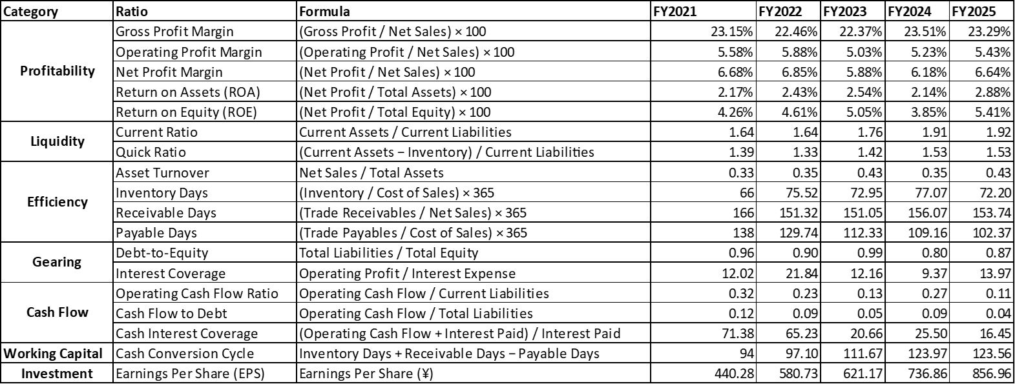
Table 1: Ratios analysis
(Source: Self-Created)

2.1 Overview of Toyota Financial Performance
Financial report FY2021-2025 Toyota financial report indicates a good growth in company revenue, profitability and assets. The net sales in FY2021 improved to 2,118,302 million which, as compared to 2025, improved to 4,084,984 million which shows a growth in the global demand and market growth. There was also an improvement in the gross profit and operating profit which is indicative of efficient operation and control of cost (Xinyao et al., 2023). The net profit increased to 271,247 million as compared to 141,435 million within the same period. The total assets grew to ¥9,403,481 million that is increased by ¥6,503,986 million, and the equity also grew, which points to the improved shareholder value. But the operating cash flow decreased to 171,578 million as compared to 382,386 million and this is an indication that there is a possibility of difficulties in the management of working capital although there was an increase in profitability.

2.2 Profitability Analysis
Profitability ratios will balance whether Toyota is able to make profits off of its sales, assets, and shareholder investments. During the five years Toyota recorded relatively steady gross profit margins that ranged between 22-23. The gross profit margin changed marginally into 23.29 in FY2025 as compared to FY2021 which was 23.15. This stability shows that the firm has been successful in controlling the production cost and staying in charge in the international car market (Putra and Daryanto, 2026).
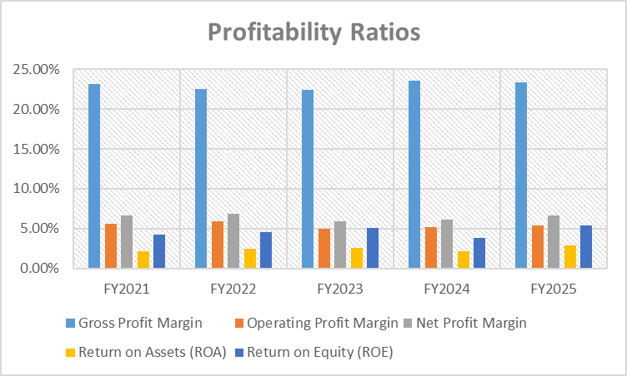
Figure 1: Profitability Ratios
(Source: Self-Created)
The operating profit margin varied at an average rate within the period. The ratio was 5.58 percent in FY2021 and 5.88 percent in FY2022 and then reduced to 5.03 percent in FY2023. It then increased to 5.43 percent by FY2025. These results indicate that profitability has been affected by operational costs, as well as external market elements but the trend is relatively steady.
Net profit margin had the same fluctuations. The ratio was slightly higher than that of FY2021 (6.68%), and then higher than FY2022 (6.85%), and lower in FY2023 (5.88%). In 2025, the net profit margin has gone back to 6.64, which means that the company has shown better results in the last couple of years.
The Return on Assets (ROA) went up to 2.88 in FY2025 compared to 2.17 in FY2021, which is an indication of efficiency in the usage of assets to make a profit. This growth implies that the asset base of Toyota has improved in the course of the years (Mishra and Celestin, 2025).
Also in overall Return on Equity (ROE) growth was positive. The ROE of FY2021 was 4.26% and decreased to a transitory period of 3.85% in FY2024 before rising to 5.41% in FY2025. The increase in ROE shows that Toyota has been in a position to raise returns to shareholders by growing profitability and retained earnings.
All in all, Toyota profitability ratios indicate a comparatively stable financial performance with slow increase in proportion of asset utilisation and returns to shareholders.

2.3 Liquidity Analysis
Liquidity ratios are used in examining how a company can meet its short term financial commitments. The current ratio of Toyota has been above 1 during the five years showing that current assets were always greater than current liabilities (Babo et al., 2024). The current ratio has also improved by increasing to 1.64 in the FY2021 year and stood at 1.92 in the FY2025 year, which indicates a progressive check on the short-term fiscal transparency of the firm.
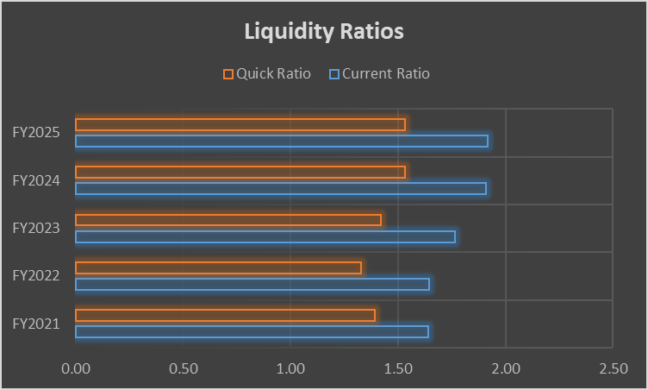
Figure 2: Liquidity Ratios
(Source: Self-Created)
The current ratio that is more conservative is the quick ratio that is not inclusive of inventories as current assets. Toyota has an increment of 1.39 in FY2021 to 1.53 in FY2025. This is an improvement which means that the company has enough liquid assets to finance its short term obligations without substantial liquidation of inventory (Mojumder, 2025).
The improving liquidity position is an indication that Toyota has had a very good financial management and the working capital base is stable. The fact that both liquidity ratios have steadily improved is a pointer that the company is in a good position in terms of covering short term financial commitments.

2.4 Efficiency Analysis
Efficiency ratios are the ratios used to analyse effectiveness of the company in using its assets and operational resources. The asset turnover ratio of Toyota was also on the rise with 0.33 in FY2021 to 0.43 FY2025, which indicates that the company has become more effective in converting its assets into revenues (Vahedi et al., 2026).
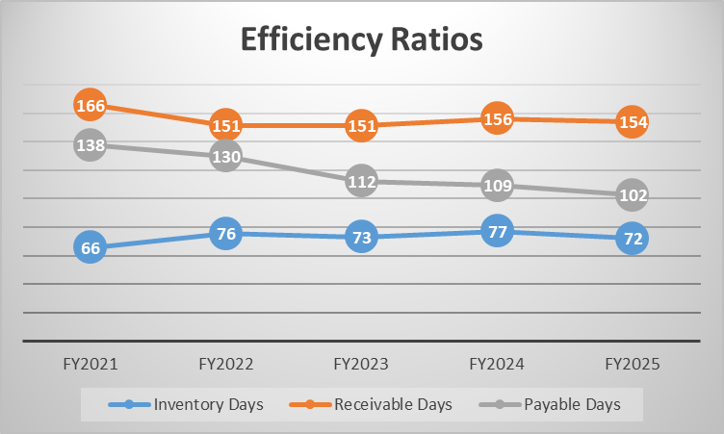
Figure 3: Efficiency Ratios
(Source: Self-Created)
The performance in inventory management had moderate changes throughout the period. The inventory days grew to 66 days in FY2021 and approximated 77 days in FY2024 and then decreased slightly to 72 days in FY2025. The short-run upsurge means that the inventory levels increased compared to the cost of sales which could be an indication of disruption in the supply chain or higher production capacity.
Days of receivables were relatively high during the period and went between 150 days and 150 days. The amount of receivable days decreased compared to the 166 days in FY2021 to around 154 days in FY 2025, which shows some positive progression in credit management practices at the company (Jia, 2026). The rather prolonged collection period, however, tells that Toyota offers prolonged credit conditions to the customers and distributors.
The number of payable days reduced dramatically to an estimated 102 days in FY2025 as compared to 138 days in FY2021. This decrease shows that Toyota is paying suppliers faster which can improve relationships with suppliers and also pressure on working capital.
Generally, efficiency ratios indicate that Toyota has enhanced the use of assets but it might experience difficulties with regard to the management of working capital.

2.5 Gearing and Financial Risk
The gearing ratios are used to assess the degree of dependence on debt by a company. The debt-to-equity ratio of Toyota was lower than 1, as it was during the period, which means that the debt has the same share with equity (Bhattacheryay, 2023). The ratio has dropped down to 0.87 in FY2025 compared to 0.96 in FY2021, implying that the company has been cutting down progressively on the debt ratio vis-a-vis equity.
Interest coverage ratios show that the company can fulfil interest payments of operating profits. The interest coverage ratio of Toyota has risen significantly to 21.84 times during FY2022 compared to 12.02 times during FY2021 and going down to 9.37 times during FY2024. It again increased to 13.97 times in FY2025. Although it has fluctuated, the ratio is still well above the normal risk limits, which means that Toyota has a high ability to service its debt factors.
All in all, the financial profile of the company seems to be financially healthy with moderate leverage and strong interest coverage.

2.6 Cash Flow Performance
Cash flow ratios help one understand how a company can make cash out of operations. Toyota operational cash flow ratio has fallen to 0.11 in FY2025 as compared to 0.32 of FY2021. This reduction of cash flows implies that the operating cash flows are dwindling in comparison with current liabilities (Okanga, 2022).
Equally, the cash flow to debt ratio improved to 0.12 in FY2021, and 0.04 in FY2025 meaning that the company has lost its capacity to cover up total liabilities with help of operating cash flows.
Cash coverage of interest also decreased greatly, that is, 71.38 times in FY2021 reduced to 16.45 times in FY2025. Despite the ratio being comparatively healthy, the negative style reveals that the performance of cash flow is worse than it used to be in the past years (Lee and Raschke, 2023).
These dynamics indicate that the profitability of Toyota has been getting better, and the rate of increase of the operational cash generation has not been equal.

2.7 Key Financial Strengths and Threats
The financial analysis shows that there are a number of strengths in the financial position of Toyota. The company has shown high increase in revenue, better profitability and consistent capital structure. The liquidity ratios show that Toyota has enough current assets to fulfil the short-term liabilities, and the medium level of leverage minimises the risk of financing.
Nonetheless, a number of possible threats can be identified as well. Cash conversion cycle is increasing; this means that working capital is becoming inefficient. Increased level of inventory and length of receivable days can put extra strain on the liquidity unless handled efficiently (Shmelev and Gilardi, 2025). Moreover, the ratios of operating cash flows have been on the decline, and it means that the generation of cash flows in the company through its operating activities has decreased in comparison to its liabilities.
On the whole, the financial position of Toyota is good, yet the working capital management and operational cash flows performance can be better to maintain the long-term financial stability.

3. Working Capital Management Analysis

3.1 Cash Operating Cycle
The management of working capital is important in the automobile industry due to the fact that there is a lot of production on a large scale, the large number of suppliers and credit sales that may put up considerable amounts of cash in their daily operations (Simamora et al., 2025). The cash operating cycle of Toyota can be measured by the use of inventory days, receivable days and payable days and the general cash conversion cycle which are a combination of all these days to the overall cash conversion cycle that is a measure of how well its operations are transformed into cash.
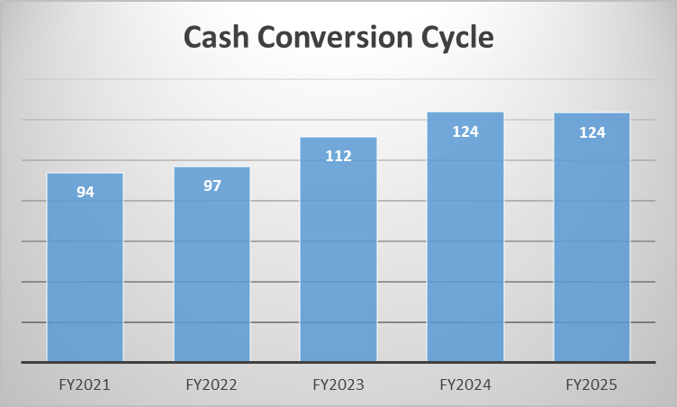
Figure 4: Cash conversion cycle
(Source: Self-Created)
Inventory days of Toyota improved to 75.28 days in 2022 (an increase of 75.28 days compared to 66 days in 2021), however with steady drop in inventory it continued to increase to 72.07 days in 2024 and then 72.20 days in 2025. This means that the average inventory held was higher as per FY2021 implying that greater amount of capital was represented in the sale of its vehicles, parts, and raw materials (Pratama et al., 2022). Receivable days had also been elevated and stood at 166 days in FY2021 and slightly worse to approximately 151 days in FY2022 and FY2023 and then improved to 156.07 days in FY2024 and 153.74 days in FY2025. The long collection period is an indication that a high level of working capital is being held as customer credit.
In the meantime, the payable days dropped as well, as FY2021 showed 138 days and FY2025 was 102.37 days. This means that Toyota has been paying suppliers faster. This led to an increase in cash conversion cycle of 94 days to 123.56 days indicating lower working capital efficiency and an increased burden on operating cash flow.

3.2 Working Capital Problems
There are two key working capital issues. To begin with, the Toyota receivable period is abnormally high. The number of collection days exceeding 150 days will imply that large amounts of money were tied up in customer credit. This undermines cash to reinvest and use it in payment of debts and flexibility on operations. It can also expose it to credit risk in case the customers forward payments further.
Second, the company has increased inventory holding as compared to FY2021. Increased inventory can contribute to preventing production disruption, particularly in a business subject to periodic supply disruption, but increased spaces, insurance, and obsolescence. A high inventory in a dynamic automotive market would lead to high risk (Mazur, 2026). Once the demand among the consumers changes or the technology changes at a rapid rate. Collectively, the prolonged cash conversion cycle is placed by high receivables and increasing inventory into obesity of operating cash flow efficiency.

3.3 Strategies to Improve Liquidity
Toyota has a stronger working capital to enhance liquidity. The first is to manage its receivables better. This may involve stricter credit screening, better payment conditions, stricter enforcement of the follow-up and the selective provision of early payment discounts. Quick collection would mean less cash is carried in the receivables and better the operating cash flow.
The second strategy is supplier credit negotiation. Despite the importance of good relations with suppliers, Toyota might also revise the conditions to pay and have a more balanced value between commercial goodwill and maintaining liquidity (Ali Khan and Siddiqui, 2023). The moderate extension of the payable period without the harm to the confidence of suppliers would allow extra short-term funding and less strain on the cash reserves.
The third strategy is inventory optimization. Unnecessary stockholding can be minimised by improving demand forecasting, tight control of inventory, and improving coordination of procurement and production. This would free up the cash that would be in the inventories and enhance the overall operating cycle. Such reforms would enable a stronger liquidity without making significant alterations to the capital structure of the company.

3.4 Short-Term vs Long-Term Financing
Bank overdrafts and trade credit are temporary financing methods that are beneficial to meet temporary liquidity shortages. Bank overdraft gives flexibility and fast access to cash hence it is apt when it comes to seasonal or unplanned working capital. Nevertheless, it may be costly when interest rates increase and cause a pressure of refinancing in case it is utilised in full (García-Cutrín and Rodríguez-García, 2024). Although trade credit is less expensive and of course associated with business activity, over reliance may cause poor supplier relationships in case payment is made after negotiated time.
There is long-term finance (bonds and equity financing) provision. Bonds would supply huge sums of capital with a comparatively low predictable cost and they are suitable in strategic investment or restructuring. They however add to the fixed financial commitments and expose the company to interest rate and refinancing risk. Equity financing also enhances the balance sheet and is not accompanied by an obligatory interest payment, nevertheless, it can weaken the dominance of the existing shareholders and lower the earnings per share.
In the case of Toyota, short term finance proves to be more efficient in temporary working capital demands whereas long-term finance is used when the investment in question entails a strategic aspect. A mixed financing system is thus required where working capital reforms are to be employed first in order to decrease unwarranted reliance on external funding.

4. Strategic Financial Restructuring Plan

4.1 Need for Financial Restructuring
The financial analysis of Toyota is showing an essentially strong company with new tensions that are compelling it to acquire selective financial structuring. The net sales were growing between the FY2021-2025 as there was an increase in net sales by ¥2,118,302million to ¥4,084,984million and a rise in net profit by 141,435million to 271,247million. It was profitable and had gross profit margins ranging between 22-23 and net profit margins between 6-7 (Nwachukwu et al., 2024). The liquidity also has been enhanced because the current ratio has risen by 1.64 to 1.92, and the quick ratio has risen by 1.39 to 1.53, a good short-term liquidity.
Nevertheless, there are inefficiencies at the backdrop. The cash conversion cycle was improved as compared to FY2021 (94 days) with 123.56 days in FY2025, indicating that the company took longer to convert its operations into cash. The receivable days and inventory were above 150 and 70 days respectively, which is an indication of capital being tied in working capital. Meanwhile the operating cash flow has dropped sharply to 171,578 million cash flow as compared to 382,386 million and operating cash ratio has decreased to 0.11 compared to 0.32.
Such trends imply that financial restructuring is needed not because it is weak, but because they want to become more efficient, generate more cash, and invest in EV technologies and innovations over the long term.

4.2 Possible Restructuring Strategies
One of the restructuring strategies available to Toyota is selective asset divestiture. The company has a huge and varied asset portfolio, consisting of non-core investments which might not be relevant to its future EV-oriented expansion. The disposal of non-strategic or nonprofit-making assets will unlock funds to be reinvested in high-growth business units including battery technology, EV initiatives and digital mobility, as well as enhance asset efficiency and returns (Palhau et al., 2024).
Another significant strategy is strategic partnerships. Existence of collaboration in the field of semiconductors, batteries and mobility software will help in cutting the cost burden and speeding up the innovation. Joint ventures provide Toyota with the access to the new technologies and resolve the risks sharing without depending only on the internal investments, which are extremely important in a fast-developing EV market.
Long-term strategic projects that are highly uncertain can also be financed through equity. It consolidates the balance sheet and provides liquidity to the company at least financially, though it can dilute the shareholder ownership. Also, debt restructuring may enhance financial efficiencies because of refinancing and matching the debt maturity with the investment periods (Kumar et al., 2025).
In general, a selective and balanced restructuring would render Toyota more financially strong and it would favour long-term strategic development.

4.3 Impact on Shareholder Value
The restructuring decisions are to be measured in terms of influence on the shareholder value. Shareholder value has also improved by increasing retained earnings, profitability, and equity in the case of Toyota in the past five years. These gains can further be improved through effective restructuring which would work to increase capital efficiency and long term returns.
The value of asset divestiture is the redirection of the funds of low-performing assets into more lucrative investments, enhancing profitability and capital discipline. VSP also facilitates the value creation through minimising innovation expense, risk, and faster access to higher technology, especially in the EV industry (Hong, 2024). Even though equity financing may water down ownership, it may add value when it is utilised in ventures that yield returns at rates above cost of capital. Value can also be enhanced through debt restructuring which will lower financing cost and enhance stability of cash flow.
The balanced capital structure of Toyota implies that reorganisation must be directed towards improving the quality of capital instead of raising the leverage, which will preserve investor confidence and financial sustainability in the long run.

4.4 Operational Flexibility
A significant advantage of financial restructuring is enhanced flexibility in terms of operations. Flexibility is required in a swift automotive market in order to sustain the capacity to invest and innovate. Toyota needs to invest in battery technologies, digital technologies, low-emission production, supply chain robustness, and customer-facing technology (Mayndarto et al., 2026). These investments need financial investments as well as managerial flexibility.
In case capital is trapped in working capital inefficiencies or assets of low returns, the efficiency of Toyota in responding to new market opportunities may be minimised. Working capital reform and asset divestiture would free up internal cash which can be reinvested into innovation. Flexibility would also be enhanced through the strategic partnerships since Toyota will be able to manage the risk sharing and access specialist capabilities more rapidly than in the case of in-house development (Burdak et al., 2025).
Restructuring debt allows flexibility in that the debt repaying requirement is adjusted to the timing of long-term project returns. Equally, selective equity financing can offer a stable source of funds to the transformational investments that may not yield direct cash flows. Financial restructuring thus promotes not only the balance sheet strength, but also the capacity of the company to take decisive action in a competitive and uncertain market.

4.5 International and Ethical Considerations
Toyota has operations around the world and therefore, the restructure of finances should take into account both international and ethical concerns. Currency risk is one of its major factors. The revenues, costs, assets, and liabilities are distributed among a large number of countries, which puts the company at risk of fluctuations in exchange rates.
Another pertinent matter is taxation. The company should also make sure that the restructuring decisions that can be made, like divestiture, forming partnerships or financing in another country, should be tax-efficient, but at the same time, transparent and legitimate (Süzen, 2023). Aggressive tax practice can cause damage to reputation and risk of increased regulation. Sustainable taxation policy is more in line with the creation of long-term values.
Inflation is also relevant. Increased inflation may increase the cost of production, interest rates and stock prices. This impacts on working capital requirements as well as the capital budgeting decisions. An adaptable financing system can make Toyota adapt to the inflationary pressure and have the ability to invest.
CSR should be of central concern to the restructuring. Environmental performance, labour practises, supply chain ethics and sustainable innovation have a direct impact on brand value and investor confidence in the automotive industry. Any reorganisation must then help uphold the larger customer, employee, supplier, regulatory, and societal-related accountability of Toyota (Redhu et al., 2026). Ethical standards and long-term sustainability should not be sacrificed in favour of financial efficiency.

5. Investment Appraisal and Capital Budgeting

5.1 Overview of Proposed Projects
Toyota must consider three alternative investment projects that will entail initial capital expenditure of £50 million. These projects vary with the time and amount of anticipated cash flow during five years and as such, comparative financial analysis is required.
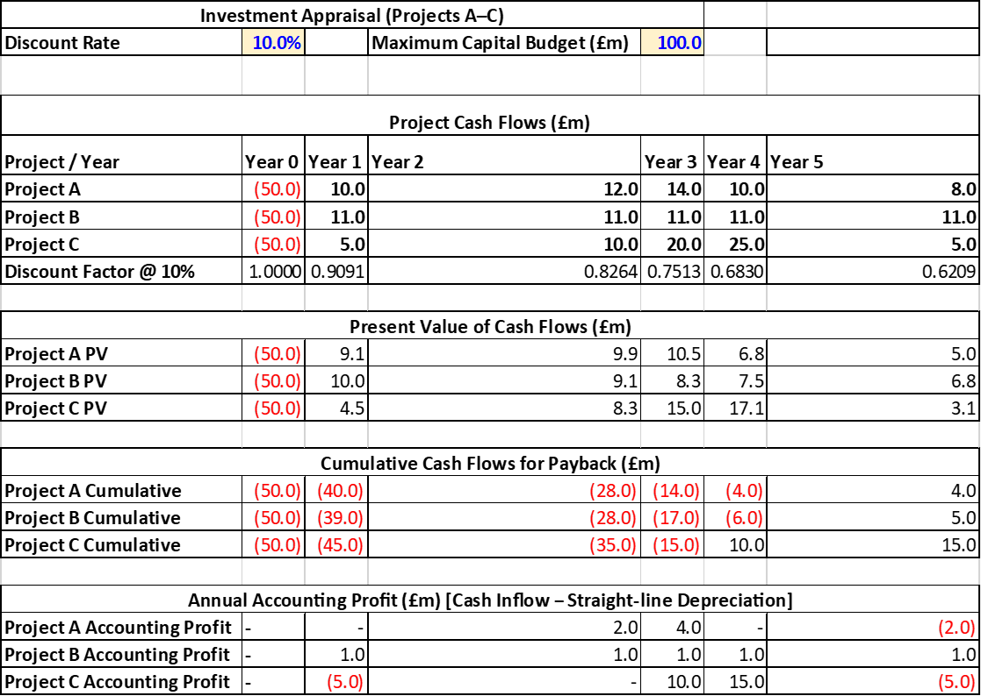
Table 2: Proposed projects
(Source: Self-Created)
Project A offers inflows of cash amounting to 10 million pounds, 12 million pounds, 14 million pounds, 10 million pounds, and 8 million pounds within a period of five years. The present project has an average and quite stable returns with higher inflows in the middle period. Project B has a regular and expected pattern which helps bring a steady and predictable pattern which makes it earn £11 million on an annual basis within the five years. This standardised format will lower the risk of uncertainty but could limit potential upside (Nina et al., 2025). In Project C, the distribution is less steep with less initial returns of £5million and 10 million, and a lot higher inflows on the year two, three, and four of 20million and 25million respectively.
These differences point to the variation in the nature of investments. Project A represents balanced growth, Project B represents stability and Project C represents greater returns in the later periods. Based on these differences, an overall assessment based on various financial methods is required to ascertain the liquidity, profitability, and value creation aspects.

5.2 Investment Appraisal Methods
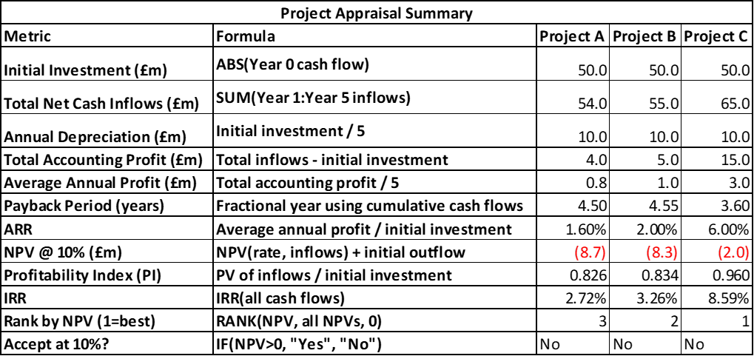
Table 3: Project Appraisal analysis
(Source: Self-Created)
Payback period is a measure of the speed at which the initial investment can be repaid with cash inflows. The technique is especially applicable when determining liquidity risk and susceptibility to uncertainty. It however does not account for cash flows that are obtained after the break even point and it does not apply the time value of money, which diminishes its application as a decision tool in its own right.
Accounting Rate of return (ARR) is a measure of average accounting profit expressed as a percentage of the initial investment. It is a straightforward calculation of profitability using financial statements (Birsan, 2024). ARR however is based on accounting profit and not cash flow thus does not take into account timing of returns, which undermines its dependability when making capital budget decisions.
The Net Present Value (NPV) is the most popularly held as the most sound technique of appraisal. It is used to value future cash flows discounted at the level of required rate of return, which in this case is 10 percent and then compares the initial investment. A positive NPV would mean that it adds value whereas a negative NPV would mean that the project does not earn the needed back.
The Profitability Index (PI) is a report that represents the current value of the future inflows against the investment. A PI of over 1 means that the project is viable whereas a PI of less than 1 means that the project is rejected (Tóth et al., 2025). The method is most applicable in cases of capital rationing when funds available to invest in place are scanty.
The Internal Rate of Return (IRR) is used to show the discount rate at which NPV is zero. It offers a natural scale of return and this may be compared to the rate needed. But sometimes IRR will provide misleading ranking in cases when there is a great divergence in the size or timing of projects.

5.3 Project Evaluation Results
The payback outcomes indicate that Project C is the best with a payback period of 3.60 years. Project A is recovered in 4.50 years whereas Project B is recovered in 4.55 years. Project C will obviously be better on payback basis as it will settle the initial capital at a faster rate and this will eliminate loss of exposure to uncertainty and provide liquidity.
The results of ARR are also favourable to Project C, whereby the ARR is 1.60, 2.00 and 6.00 in Project A, Project B and Project C respectively (Kawai, 2024). This indicates that Project C is the one that creates the highest average accounting return.
The 10% discount rate analysis of NPV yields negative values in all three projects. The NPV of Project A, B and C is -8.7 million, -8.3 million and -2.0 million respectively. These outcomes suggest that no one of the projects can be profitable with regard to the necessary minimum. Project C is the best performer however since its NPV is the least negative.
PI and IRR also support the same conclusion. Project A PI = 0.826, Project B PI = 0.834 and Project C PI = 0.960. All values given are less than 1 and therefore none of the projects is viable at 10 percent discount rate (Ghelani, 2023). Project A, Project B, and Project C have IRRs of 2.72, 3.26 and 8.59 respectively. Once again, the best result is achieved on Project C yet all the IRRs are less than the 10% hurdle rate.
All in all, the appraisal outcomes indicate that Project C is the best project in terms of majority of the criteria, with no project being accepted in terms of finance at a 10 per cent cost of capital.

5.4 Investment Decision
The overall rule of decision to be used in capital budgeting is to accept a project where the NPV is positive and reject one where the NPV is negative. At the 10% discount rate, as all three projects produce negative NPVs, it would mean that financially the best decision to make is to remove all the options (Anuno et al., 2024). This will make sure that there is no capital invested in some investments that do not generate value to shareholders.
Nonetheless, in the real-life business world, investment decision-making processes will not always revolve around financial measures. The issues of market positioning, technological progress, and competitive advantage may be considered as strategic factors in decision-making. Toyota would be needed to choose one of the projects in the case of negative NPVs, and Project C will be the best choice (Piątek, 2023). It has minimum payback period, maximum ARR, maximum IRR and minimum negative NPV, resulting in preferable choice in consideration with other options which have high negative NPV.

5.5 Capital Rationing Analysis
Toyota is only able to invest two out of the three projects under a capital limit of the three projects of up to £100 million. The combinations considered are A + B, A + C and B + C. To evaluate these combinations the combined NPVs and profitability indices are to be evaluated.
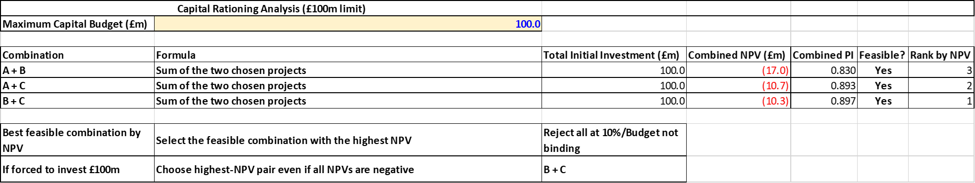
Table 4: Capital Rationing Analysis
(Source: Self-Created)
The overall NPV of A + B equals - London business brokers would be the least appealing choice and is -17.0 million. A + C gives an equivalent NPV of - £10.7 million and B + C gives - £10.3 million. B + C is the most desirable of all these as it has the highest or the least negative NPV (Hasibuan et al., 2025).
The Profitability Index proves this conclusion further. The PI of A + B is 0.830, A + C is 0.893 and B + C is 0.897. As such, B + C is the optimal under capital constraint in terms of investment cost.
All the combinations yield negative NPVs despite this ranking meaning that none of the options results in the necessary return threshold. Financially speaking, the right option would be to reject all combinations (Baruwa et al., 2025). Nevertheless, in case investment should be done based on strategic reasons, B + C will be the most harmless.

5.6 Strategic Justification
The investment decision that Toyota has made should be viewed in the wider perspective of its financial performance and the industry in which it operates. The company is highly profitable, has steady liquidity and an average leverage (Apu et al., 2022). Nevertheless, the cash flow operating has decreased greatly and the cash conversion cycle has risen signalling the presence of inefficiencies in the working capital management.
These reasons indicate that one should be careful when investing capital in new ventures. Investing in a project with a negative NPV would only add more pressure on the liquidity and lessen the financial flexibility. Thus, the decline of the proposed projects is in line with the financial discipline and shareholder value preservation.
Meanwhile, as the automotive industry and the EV industry are being characterised by the speed of technological change, regulatory demands, and fierce competition. A company can make such investments in such an environment where the payoffs of the investments are not necessarily financial but rather strategic. These can be the acquisition of technological knowledge and venturing into new markets or competitive positioning.
Assuming that such strategic considerations are applicable, the Project C will be the most appropriate alternative as it possesses a better relative performance and investment is recovered promptly (Widyantoro et al., 2026). In the case of capital rationing, the B + C combination would give the most appropriate balance of financial performance and strategic positioning.
Finally, although financial analysis can be used to reject all projects at the 10 percent discount rate, there can be strategic reasons to selectively invest. Any of such a decision must be well considered in line with the long-term goals of Toyota and such financial discipline must be upheld without compromising on innovation and competitive advantage.

6. Conclusion
The financial performance of Toyota (FY2021-2025) shows that it has remarkable revenues, which has increased profitability and maintained a steady capital base. There are however working capital inefficiencies as high inventory and days outstanding receivables are adding to the cash conversion cycle and undermining operating cash flow. This puts strain on liquidity in the case of favourable operating profits trends.
The recommended process is selective financial restructuring, which involves the optimisation of assets, strategic partnerships, and better management of working capital. This policy is shown by the results of investment appraisal showing that all projects with a 10% discount rate will have negative NPVs. Thus, the projects are not to be accepted, but Project C or B + C can be regarded in case strategic investment should appear.

Reference List
Journals
Ali Khan, H. and Siddiqui, D.A., 2023. The effect of corporate diversification, investment, capital structure and dividend policies on firms' financial performance: A Global sectorial analysis. Danish Ahmed, The Effect of Corporate Diversification, Investment, Capital Structure and Dividend Policies on Firms' Financial Performance: a Global Sectorial Analysis (April 28, 2023).
Anuno, F., Madaleno, M. and Vieira, E., 2024. Testing of portfolio optimization by Timor-Leste portfolio investment strategy on the stock market. Journal of Risk and Financial Management, 17(2), p.78.
Apu, K.U., Rahman, M.M., Hoque, A.B. and Bhuiyan, M., 2022. Forecasting future investment value with machine learning, neural networks, and ensemble learning: a meta-analytic study. Review of Applied Science and Technology, 1(02), pp.01-25.
Babo, F.S., Wiagustini, N.L.P. and Ximenes, M., 2024. FINANCIAL REPORT ANALYSIS IN ASSESSING THE FINANCIAL PERFORMANCE OF AUTO TOYOTA TIMOR LESTE COMPANY. TIMOR LOROSA'E JOURNAL OF BUSINESS AND INNOVATION (TORBIN), 1(01), pp.129-143.
Baruwa, Z., Yuan, H., Li, S. and Zhu, Z., 2025. Constructing and Analysing Global Corporate Networks With Wikidata: The Case of Electric Vehicle Industry. Global Networks, 25(4), p.e70029.
Bhattacheryay, S., 2023. Multinational working capital management a study on Toyota Motor Corporation. International Journal of Finance & Economics, 28(1), pp.236-256.
Birsan, A., 2024. Challenges and practical approaches to implementing triple bottom line strategies: From theory to practice.
Burdak, S., Vanhorodska, N., Vasylyshyna, A. and Zalizniuk, V., 2025. THE IMPACT OF GLOBAL ECONOMIC UNCERTAINTY ON CORPORATE FINANCIAL STRATEGY. UNIVERSUM, (26), pp.52-61.
García-Cutrín, J. and Rodríguez-García, C., 2024. Enhancing corporate sustainability through Just-In-Time (JIT) practices: A meta-analytic examination of financial performance outcomes. Sustainability, 16(10), p.4025.
Ghelani, H., 2023. Six Sigma and Continuous Improvement Strategies: A Comparative Analysis in Global Manufacturing Industries. Valley International Journal Digital Library, pp.954-972.
Hasibuan, P.A., Sami’an, S.A., Hardjomuljadi, S. and Pribadi, D.T., 2025. Analysis of the Dynamics of the Global Business Environment on the Adaptation Strategies of Multinational Companies. Interdisciplinary Social Studies, 5(1), pp.387-400.
Hong, J., 2024. Competitive Strategies and Market Positions of Global Automotive Giants: Toyota, Tesla, and BMW. In International Conference on Educational Information Technology (Vol. 6, No. 2).
Jia, Z., Take Volkswagen as an Example to Critically Analyze the Feasibility and Market Response of the Future Sustainable Development Strategy in the Automotive Industry.
Kawai, T., 2024. Evaluation of Honda’s Strategy for Electric Vehicles—Based on the Theory of Dynamic Managerial Capabilities—. Journal of Strategic Management Studies, 16(1), pp.51-72.
Kumar, G., Murty, A.V.N. and Rao, S., 2025. Strategic Decision Making in Uncertain Environments Using Optimized Financial Model. International Journal of Economics and Financial Issues, 15(5), p.160.
Lee, M.T. and Raschke, R.L., 2023. Stakeholder legitimacy in firm greening and financial performance: What about greenwashing temptations?☆. Journal of Business Research, 155, p.113393.
Mayndarto, E.C., da Cruz Alves, O. and Sularto, L., 2026. Management Accounting Strategies for Environmental Cost Control and Performance Optimization in Green Manufacturing Companies. Jurnal Ilmiah Manajemen Kesatuan, 14(1), pp.537-548.
Mazur, B., 2026. Concept of a TCO-based car fleet composition model for a rent-a-car company. Journal of Transportation Engineering, 140, pp.79-98.
Mishra, A.K. and Celestin, M., 2025. Strategic Cost Accounting: How LargeCorporations Use Costing Methods to DriveLong-Term Decision-Making. NOLEGEIN Journal of Financial Planning and Management, 8(1), pp.1-17.
Mojumder, M.U., 2025. Impact of lean six sigma on manufacturing efficiency using a digital twin-based performance evaluation framework. ASRC Procedia: Global Perspectives in Science and Scholarship, 1(01), pp.343-375.
Nina, P.N., Nina, P.N., Bacho, R., Róbert, B., Makarovych, V., Viktória, M., Loskorikh, G., Gabriella, L., Stoika, N., Natália, S. and Pataki, G., 2025. Economic and mathematical methods for optimizing financial flows and accounting processes of corporate enterprises.
Nwachukwu, G., Oladepo, O. and Avickson, E.K., 2024. Quality control in financial operations: Best practices for risk mitigation and compliance. World Journal of Advanced Research and Reviews, 24(01), pp.735-749.
Okanga, B., 2022. Radical and incremental innovations as critical leveragers of a firm's financial performance: Best practices from Tesla and Toyota. Universal Journal of Financial Economics, 2(2), pp.1-22.
Palhau, M., Sá, J.C., Ávila, P., Dinis-Carvalho, J., Rodrigues, C. and Santos, G., 2024. Toyota Way–the Heart of Toyota Production System and Its Impact on Sustainable Company Growth. Quality Innovation Prosperity, 28(3), pp.23-45.
Piątek, R., 2023. Analysis of brand portfolios of automotive concerns using the BCG matrix. Journal of Modern Science, 54(5), pp.83-96.
Pratama, A.Z., Sutopo, W. and Rochani, R., 2022. Financial performance analysis and business strategy using profitability ratio analysis: A case study. Proceedings of the 3rd Asia Pacific International Conferenc on Industrial Engineering and Operations Management (hal. 1266-1273). Johor Bahru, Malaysia: IEOM Society. https://doi. org/10.46254/AP03, 20220238.
PUTRA, E.P.F. and DARYANTO, W.M., Financial Performance Analysis of Toyota Motor Corporation Indonesia During the Period of 2019-2023. Transformations in Business: Case Studies on Governance, Economics, Finance, Performance, Logistics, and Sustainability for the Future, p.5.
Redhu, K., Hooda, R. and Grover, M., 2026. Impact of Inventory Management Practices on Financial Performance of Sugar Manufacturing Firms in India. Advances in Consumer Research, 3(2).
Shmelev, S.E. and Gilardi, E., 2025. Corporate environmental, social, and governance performance: The impacts on financial returns, business model innovation, and social transformation. Sustainability, 17(3), p.1286.
Simamora, S.J., Ulkhaq, M. and Handayani, N.U., 2025. Consumer decision-making in car purchases: insights from a logistic regression analysis. LogicLink, pp.70-77.
Süzen, E., 2023. Analysis techniques for strategic management in the aviation sector. In E3S Web of Conferences (Vol. 452, p. 05022). EDP Sciences.
Tóth, Á., Suta, A., Szauter, F. and Lukács, E., 2025. Quantitative analysis of green investments in European automotive companies: a digital reporting analysis. Clean Technologies and Environmental Policy, 27(12), pp.8749-8761.
Vahedi, N., Parhi, S., Farinloye, K. and Hajebi, M., THE IMPACT OF ENVIRONMENTALLY SUSTAINABLE PROJECT MANAGEMENT ON FINANCIAL PROFITABILITY RATIOS: A CASE STUDY OF TOYOTA MOTOR CORPORATION.
Widyantoro, I., Sutopo, W.R. and Rochani, R., R.: Evaluation of financial performance and business strategy at the ministry of religion employee cooperative. In Proceedings of the 3rd Asia Pacific International Conference on IEOM, Malaysia, September (pp. 13-15).
Xinyao, D., Wen, X., Jingjing, X., Xiaohui, W. and Loang, O.K., 2023. Financial and Non-Financial Analysis of Toyota and Ford: A Comparative Study. Journal of Islamic, Social, Economics and Development, 8(52), pp.203-214.

