Engineering Problem
Programme: BEng Automotive/Motorcycle/Motorsport Engineering
Module: Engineering Design
Module Code: ACHA4001
Student Name: William Davies
Student Number: 2400569
Lecturer Name: Kevin Rogers
Date of Submission: 02/04/2025

Contents
Engineering Problem 1
Introduction 3
Introduction & Interpretation of Client of Brief 4
Key Legislation Considerations 4
Specification 4
Time Plan for Producing Product 5
Relevant Research 5
Annotated Sketches of Multiple Design Concept 6
Fully Dimensioned Technical Drawings 8
Manufacturing Processing 9
Justification 10
Conclusion 10
Bibliography 11

Introduction
In this assignment I shall be reproducing a metal plate that is able to be moved by one person. I will be producing a CAD design of the new model and sticking within the tolerances and producing a time plan for the product.

Introduction & Interpretation of Client of Brief
The main objective of this design is to ensure that the operators are able to move the steel lid with ease and safely. The lid hasn’t been majorly modified just some minor adjustments which will allow the operators to safely manoeuvre it.

Key Legislation Considerations
There are many key legislations that are going to be involved with the whole manufacturing process from the design process to prototyping the design and then manufacturing it.
ISO 12100 – regarding the general principles for a risk assessment when starting a design
ISO 14120 – the safety of guards and enclosures when producing a design
ISO 14001 – the environmental management within the design and manufacturing process
ISO 21930 – the legislation considering the sustainability of construction materials
ISO 3834 – this is the legislation when it is considering the quality requirements for welding
HASAWA (1974) – this is the legislation was came into play with this design as it was to legislate the workplace health and safety and the welfare of the workers
COSHH – this legislation was a consideration as the lid was being designed to withstand anodization, and harmful chemicals was involved

Specification
Length:1770mm
Width: 1020mm
Height 20mm
Material: Aluminium
Time | The time for this product from the design sketches to the final design and manufacturing will take 4-5 weeks. This is enough time for it all to be done especially with the amount of people working on this project
Target Marketing | The target market is for the companies with the anodization process. Its for the companies that do this type of industry
Aesthetics | There isn’t much aesthetics with this design. I’ve prioritised the design outcome and the results over the look of the product
Durability | With the use of Aluminium and against anodization, this product is quite durable against the chemicals in the chamber
Safety | I considered the safety features of the lid, regarding the sharp edges and the weight and of the lid, and I think with the material used and the materials used I think it’s a very safe piece of manufacturing
Function | The function of this lid is to be light so the operators can lift and operate but strong enough to withstand the chemicals within the chamber. It needs to hold in the chemicals and the fumes of the chamber

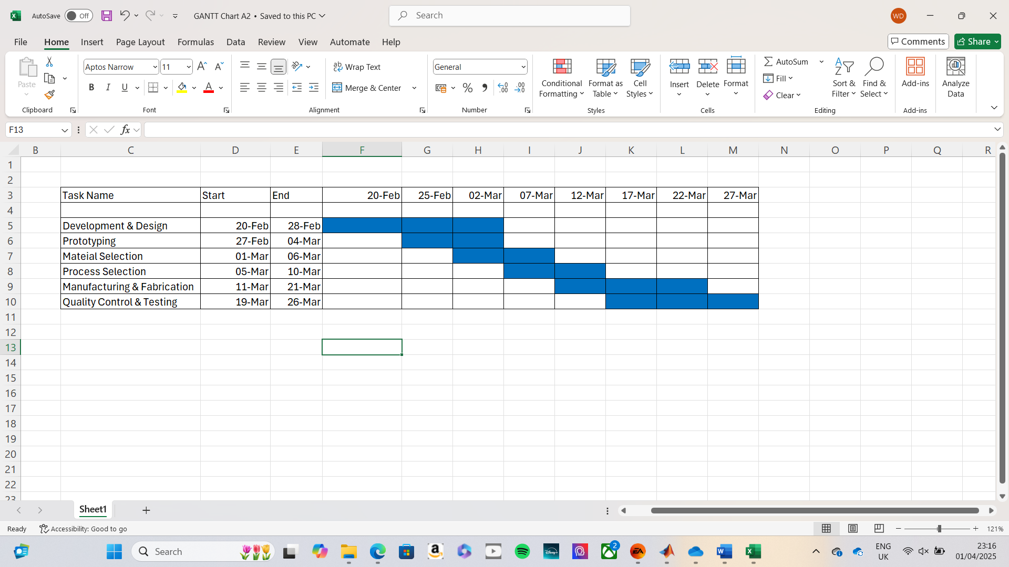
Time Plan for Producing Product

Relevant Research
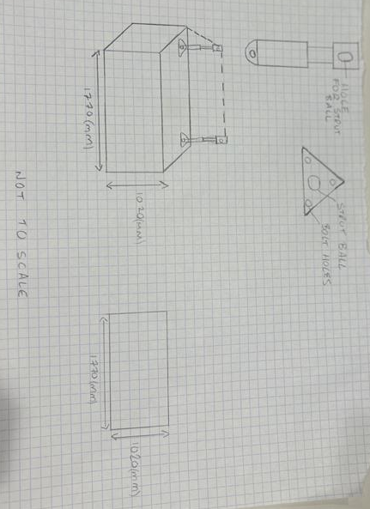
To back up my design I have done external research and within my design I have introduced leverage. I think leverage is important to my design as it will allow the operator to lift the lid with ease as leverage creates a mechanical advantage, applying a force away from the chamber to pull the lid up and to the side with ease. By applying a force greater than the distance from the fulcrum, it will generate a much larger output of force. By using this system, it has required less effort to lift the lid and conserves energy from the operator. I have opted to use Aluminium as the material of choice as Aluminium is able to withstand the high temperatures of the anodised chamber. It is much lighter to manoeuvre on and off the chamber itself. Compared to the stainless steel of the original lid, Aluminium is much easier to machine, cut and weld. However, stainless steel is much better for strength. Its much stronger than aluminium. Aluminium naturally forms an oxide layer which makes it very corrosion resistant. Aluminium is much cheaper to buy and to import compared to stainless steel.

Annotated Sketches of Multiple Design Concept
I chose the design of using gas struts as this would hold the Aluminium lid up when the lid needs to be opened. However, I opted out of using this design as the gas struts weren’t extending back as what they should be which ended up stopping metal plates entering the chamber as there wasn’t enough room.

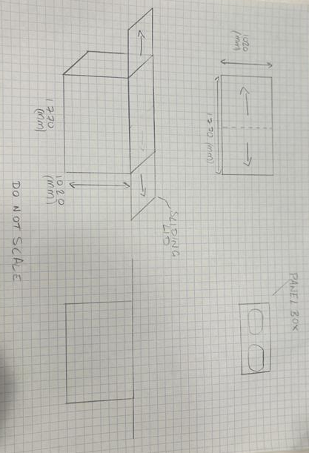
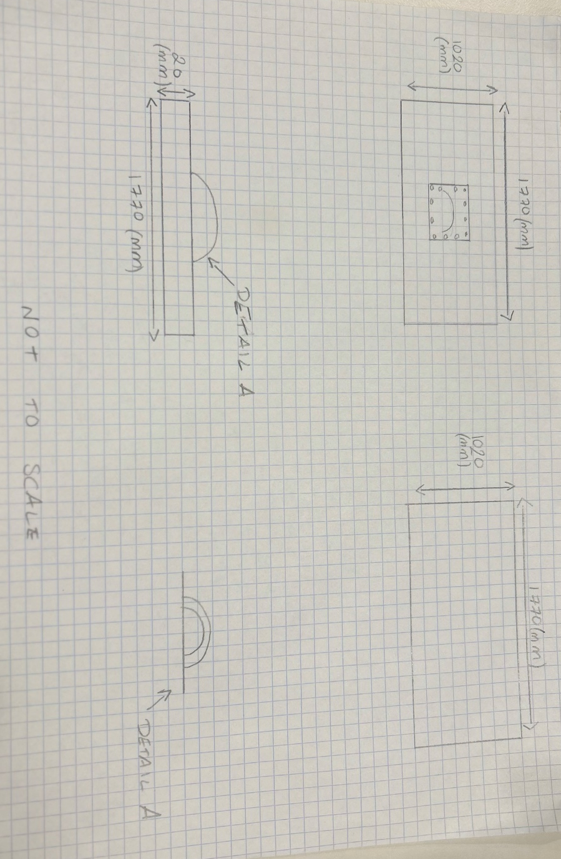
This design is very practical as lifting the lid using the hook eye is practical, it’ll move the lid up and to one side. It is a manual pulley system and it is not mechanical or electronic of any kind.
This design is ideal and is used to ensure that there is enough space to drop the metal plates in and out of the chamber. It is electronically controlled, however as its is used constantly, a lot of electricity is used to power this design.

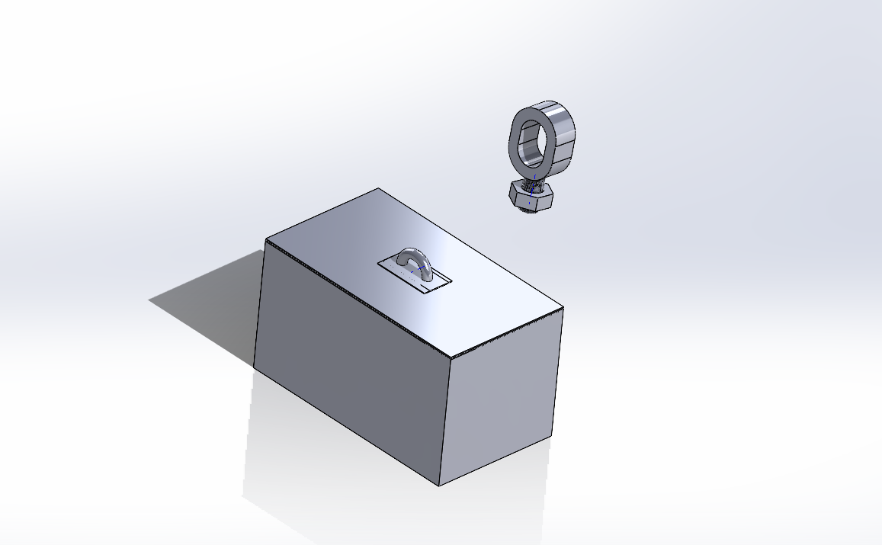
CAD Final Design Model

Fully Dimensioned Technical Drawings
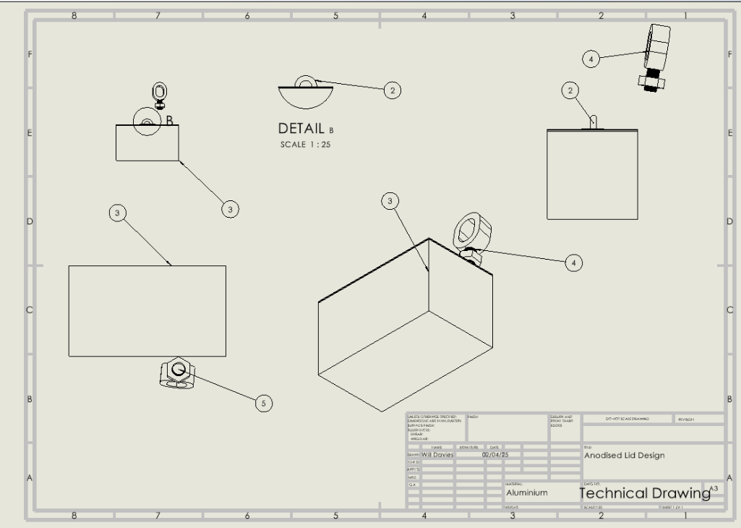

Manufacturing Processing
Aluminium Lid
I firstly started with the selection of material. There were many materials to choose from like Aluminium, Copper, Titanium etc. The material that we chose was Aluminium. It is cheap to buy and import, its much easier to shape and weld compared to the other materials. Its easy to modify and it can be used for a lid of an anodised chamber.
After selecting Aluminium as the material to use, I then went onto the process of cutting and shaping the material into what I need it to be. So, I cut and shaped it to be a flat 1770mm long and 1020mm width piece of Aluminium. The material was ordered in to be 20mm thick to withstand the anodization of the chamber. Using water jet cutting, it insured precision to the tolerances and it minimized the material waste of the Aluminium. I then made the bracket and the handle using the a same process and I did some bending of the material to get a semi-circle shape. I then welded the semi-circle to a square plate and then welded and bolted the Aluminium plate to the lid. This ensured stability and strength when it is being levered up into the air.
I then started to finish the surfaces with edge polishing and anodizing the material, which is adding a protective layer, improving the durability of the Aluminium and preventing any corrosion resistance.
I then went onto quality inspection ensuring that I was happy with the product I have made and that everything was smooth and finished to the dimensions to what it needs to be.
Aluminium Hook Eye
I did the exact same process as the Aluminium lid, however I did much more bending and welding and had to tape and die a thread into the material. Bought in some bolts for the customer as they had to be specifically made. The circular hook eye was a rectangle block of Aluminium but was cut through the centre, and around the sides was chamfered to create the circular area. A threaded cylinder was made using a tap and die set allowing a bolt to keep it attached to a piece of metal, so the lid can be hoisted up.

Justification
To justify my design and manufacturing choice I will now provide reasons to why I’ve chosen this design. I felt like a good way for this design to be efficient and allow one single person to lift it. I think leverage is a good way to lift this lid by one person and allowing metal plates to be dropped in. So, this design will have a rope hooked onto the hook eye, and a metal hook eye bolted to the ceiling to allow leverage to be an effect. It will be placed further back from the chamber, as when the rope is pulled the lid will go up and to the side of the chamber. This design accommodates all the needs of this chamber and is very practical. The choice of material is just ideal, as its light but strong. Its cheap but very effective. It’s a perfect match for its purpose. I feel this design is very practical for the needs.

Conclusion
To conclude this design project, there were a couple of designs that would fit the purpose of this lid. However, the rope leverage stood out and is a practical and easy design to implement and use. The material used is cheap and very effective. Its easy-to-get hold of. The design is very practical, and I hope the customer is satisfied with the design. The use of CAD aided this design to happen and also to see the fitment of the new designed lid and the technical drawings allows us to see how its looking and to see the dimensions.

Bibliography
Relevant Research - What is “Leverage” and How Can Project Managers Use It To Their Advantage? – Author: Mel Bost. Accessed on 01/04/2025. Page 5
Key Legislation Considerations - UK law on the design and supply of products - HSE. – Author – HSE & UK Parliament. Accessed on 02/04/202. Page 4
Manufacturing Processing - What types of Anodising are there, and which materials can you Anodise? » Manufacturing Network. – Author – Manufacturing Network. Accessed on 02/04/25. Page 8

