BMSW 5103

UNDERSTANDING AND ENGAGING IN CUSTOMER EXPERIENCE

Tutor DR Richmond Lamptey

Wendy Barrier

Student number 2019211.

Part 1 Customer relationships management emerging themes

Part 2 Critical review of quality models

Part 1 Customer relationships management emerging themes

Table of content.

- 1 Introduction …………………………………………………………….. Page 3

- 2 The Apple company …………………………………………………... Page 3

- 3 Touch points……………………………………………………………. Page 4

- 4 What is CRM …………………………………………………………… Page 5

- 5 Brand experience ……………………………………………………... Page 5

- 6 Customer experience ………………………………………………… Page 6

- 7 Conclusion……………………………………………………………… Page 6

Part 2 Critical review of quality models

- 8 What is TQM……………………………………………………………. Page 7

- 9 Deming’s fourteen points for total quality management ……. Page 7

- 10 Philip Crosby four absolutes of quality ………………………… Page 8

- 11 Similarities and comparisons……………………………………... Page 8

- 12 Critic…………………………………………………………………… Page 8

- 13 How does it influence quality model and CRM relate in…….. Page 9
the smart phone industry

- 14 Conclusion……………………………………………………………. Page 9

- References………………………………………………………………… Page 10/11

Part 1 Customer relationships management emerging themes

1, Introduction,

The most important part of any business is its customers, without customers there is no business. So, it falls in line that customer satisfaction and customer relationships should be at the top of any companies list when it comes to getting it right. This report will be looking at the iPhone brand of Apple. It will be discussing the touch points that customer experience when looking at purchasing an Apple product in particular the iPhone, firstly it will explain the touch points and then move on to the customer and branding experience. It will move on to look at the relationship Apple have with their customers and the impact management policies have on the customer. In conclusion do Apple do it right compared to other global companies. Following on from looking at apple This paper will be looking at TQM total quality management, it will look at two models that are used in business to enhance the quality of the company. The chosen models are Deming’s fourteen points of total quality management and Philip Crosby’s absolutes of quality. This report will compare the two models and look at how they are used in the mobile phone industry.

2, The Apple company 

The Apple company was established on April 1st, 1976, in California. The co-founders Steve Jobs and Steve Wozniak called it Apple commuters for its first 30 years but in January 2007 they dropped the computer and just used the Apple name for the brand,as they were expanding into consumer electronics. Throughout the years Apple went on to introduce various electronics including the Apple all in one computer and in the first five months sold close to 800,000 units and returned apple to a profitable position for the first time since 1993. In 2001 Apple introduced the iPod and since then have progressively moved on to the titanium PowerBook the flat panel iMac and on to in 2008 when the iPhone hit the market. On august 20th 2012 rising stock rose the company to the value of a world record value of $624 billion (New World Encyclopaedia, 2022).

3, Touch points

Customer touch points are the different ways a consumer experiences a product or service from when they first become aware of it until the dispose of it. Some digital and physical touch points are shown here, starting from seeing an advert on a website, doing research on the product including comparisons to other similar products, going on to the purchase via a website or store then moving on to the customer service after you own the product. Each touch point can have a positive or negative customer experience, a longer than expected wait time, one unfriendly employee or a slow loading website. To maximise customer satisfaction companies must control information to work in their favour, collecting data, monitoring customer feedback, training staff to give the best customer service are just some of the ways touch points can be used to a company’s advantage (Aichner, 2017).

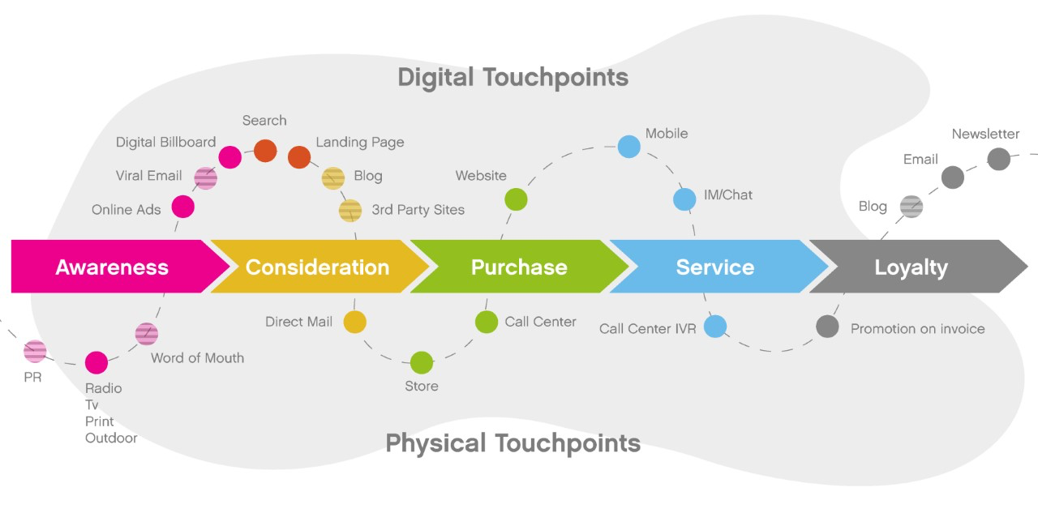

(What are Customer Touch Points? | Pro Guide & 3 Super Tips, 2022)

According to Greenwood (2022) “I have personally never seen a brand master customer touch points as well as Apple does”. From easy to navigate websites to, in store demos, and guest speaker during instore events. Greenwood says People often become loyal to products and services for reasons beyond the primary features and attributes all competitors offer. Touchpoints that address important but overlooked aspects consumers also care about can be importantly differentiating. Mastering touchpoints is also more likely to result in customers trading up to larger amounts per purchase occasion and additional purchases. In recent years apple have become one of the strongest brands in the world, marketing study guide suggests this is due to the excellent touch points, from word of mouth to iPhone being seen in movies and television programmes. Nothing sells a product more than seeing your favourite actor using that phone (the Marketing Study Guide, 2022). In 2020 amazon, Netflix and Disney were among the top companies for outstanding customer touchpoints. At Disneyland a Disney princess is expected to greet 172 guests every hour because in Disney its all about the children. Netflix went from 21.5 million subscribers in 2011 to a staggering 158 million in 2019. Personalization is the key to this you can choose your package but all of them will monitor your viewing and make suggestions of what to watch (Omniconvert Blog, 2022). Apples iCloud also monitors your phone use your choice of downloads and anything else that will improve the service you receive.

4, What is CRM

Customer relationship management is basically managing the interaction and relationships with a business’s customers, it’s a combination of practices, strategies and technologies that help companies analyse customer wants and needs. By compiling data on the customer via past purchases and interaction history the company can drive sales and grow their business. Touch points are a great way to assist CRM. By collecting data via company websites, telephone, marketing and social media, and Apple certainly make good use of these. You can boil Apples CRM strategy down to just two words … Apple ID

The top four ways Apple use CRM
- Knowing its customers
- Anticipating customer needs
- Stores focussing on customer experience
- Branding that speaks to a generation
All of these are monitored and upgraded using Apple ID. All of Apple’s policies revolve around its Apple ID. When you buy a new iPhone, you’ll be prompted to create an Apple ID which gives you a unique identity for accessing your device. You can use the ID on other Apple devices and platforms without having to make another one. Now here’s where it gets interesting. The tech giant uses your ID to record your sale, recommend other products to you. They’ll also suggest handpicked TV shows, music, content and games that align with your personal information. This further delights the user and make them enjoy the product. With an Apple ID, users can find their devices, personal items, friends and families, Mac, Air pods and Apple watch on iCloud. It gives users the ability to search and recover their stolen items quickly. At the end of the day, Apple customers feel safe knowing that the brand is always there to help (Data-Backed, 2022).

5, Brand experience

Brand experience is the customers relationship with the brand. The Apple logo is so very well known that its unmistakable. Apple have been one of the top mobile phone companies for many years and their brand is known globally. What we know is Apple produce iPhones one of the best mobile phones. We see the Apple logo and it tell us we are buying a good product with good customer service. However, in 2013/2014 Apple fell from the top selling brand by 2.5% and Samsung leapfrogged apple to become the top of the list. This was because customer satisfaction dropped, although Apple were selling almost twice the number of smartphones, Samsung gained 7% brining their ACSI (American customer service index) score to 81% (Apple customer satisfaction report, 2022). Apple iPhone 6 was given a poor launch which in part cause this, also an IOS update was breaking devices. This all lead to apples demise from the top. The apple brand experience needed to find a way to restore customer faith. Apple produced the iPhone 7 which was their big hope of restoring their brand name. the company announced the release the day before worlds AIDS day in 2017. The new phone would be available in red to signify support for AIDS day and some profits from the red phone would be donated to HIV research. The donations were made to the charity Red founded by U2 front man Bono and activist Bob Shriver’s. When looked at more sceptically Apple did it right, everyone loves a charity and by using a frontman of a global rock band Bono Apple brand were back on top (2022). By 2018 Apple were back at number one selling phone in the US followed by Samsung. Globally the picture is different Apple were still number two after several years with Samsung hitting top place again. Huawei are in third place and Rossoilio warns that Huawei are coming up fast (Rossoillio, 2018). Both Samsung and Huawei offer the top an singing all dancing smartphone but they also offer the cheaper not so many functions, less camera pixels, less storage and smaller phones, this contributes to the sales figures.

6, Customer experience

Anyone who has looked at buying a mobile phone recently has had to navigate the best offers the most data, free calls, allowances, carry overs and so on. Good Customer experience will display every aspect that the company is offering advertising the packaging, product, ease of use, services and reliability. But what is customer experience, it is the direct contact between the customer and the purchase (Meyer,2007). Being buying a product or a service. When buying an Apple phone, you instantly expect the best customer experience, due to the branding and the touch points you will have experience when deciding what mobile phone to buy. The Apple customer experience begins well before buying a phone, we see adverts on television, billboards and magazines. We know the Apple logo, so we expect the best. My eyes were drawn to the television just last night when seeing what looked like a beautiful summer scene only to find that Apple were advertising their new green mobile phone. In honesty I am an iPhone user but had not yet considered upgrading to the iPhone 13 until I saw this amazing summer holiday that would be delivered in a box posing as a new green iPhone 13. So again, Apple have given me a customer experience that is now stuck in my mind and leaving me choosing to upgrade, well done Apple you got me.

7, Conclusion

Do Apple do it right, yes, they do apart from the iPhone 6 disaster yes, they seem to have customers in hand. But Netflix are doing it better as are Disney. Of the top global companies Apple is not mentioned in the top twelve companies that are the best at touchpoints and customer relationships. The problem is mud sticks and customers will remember that the iPhone 6 was not a good phone so some customer loss will never be regained. Customers moved on to other mobile companies and have not gone back to apple. All the shinney mobile phone adverts can not remove the bad press Apple received at the time. The iOS breakdown apple experience also contributes to customer loss. To suggest ways to improve on what Apple do would be a hard task as they are doing it right, their touchpoints are looked at as one of the best in the world, customer relationship management is also up there with the best. But Samsung and Huawei are above them in sales. Both Samsung and Huawei sell the top of the range smart phone but also sell cheaper alternatives where Apple only produce and sell the top range smartphones. This puts Apple out of reach for some customers, not being able to afford the latest greatest iPhone they are turning to other manufacturers to get the latest cheaper model.

Part 2 Critical review of quality models

8, What is TQM
Total quality management
The interest of TQM has increased over recent years, some companies see it as necessary others say it is just a management fad. Although much has been written on TQM little attention has been paid to the potential effects of TQM and TQM performance relationships (Sila, 2007). TQM is a structured approach to overall organisational management. Its focus is to improve the quality of an organisation, including goods and services. It is considered to be customer focused and aims to constantly improve the service and product as well as improving procedures. (TQM, 2022). There are not real disadvantages to TQM if its implemented correctly however a half-hearted attempt can lead to all kinds of issues.

9, Deming’s fourteen points for total quality management

W. Edward.Deming Produced a fourteen-point plan for total quality. The fourteen points can help a company build quality into every level of the organization. Deming’s aims are to create a chain reaction as the fourteen points are followed. By improving quality cost should decrease, productivity will improve, market shares increase, more jobs may be available and so on. This works because in improving quality there will be less rework you have fewer mistakes and fewer delays. This leads to less time wasted which will in turn improve productivity. When explained like this you can clearly see how the model will work.
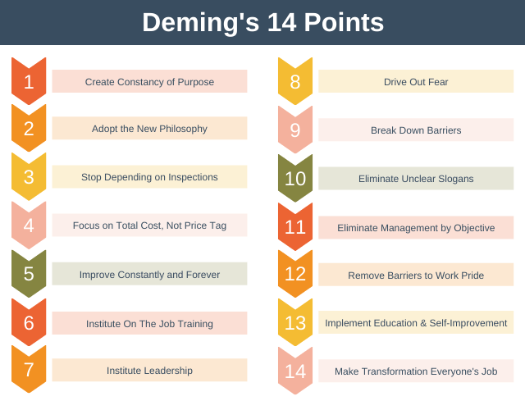
(2022)
Deming looks at long term improvement, at first, I found the fourteen points complicated until I realised that no single point stands alone. For example, the way not to depend on mass inspection (point 3) is to continually improve the process (point 5) to do that you will need quality supplies (point 4) when looking at it in this way I totally understand and see it much less complicated (W. Edwards Deming Institute, 2022). Deming says management think by just reducing costs we will solve the companies’ problems. This is where the quality management comes to play. Reducing cost without reducing quality.

10, Philip Crosby four absolutes of quality

In the 1980’s Crosby came up with the four absolutes of quality he wrote that quality is free (Absolutes of Quality, 2022) Crosby emphasised that is neither intangible or immeasurable, it is a strategic imperative that can be quantified and put back into the work to improve the bottom line. Crosby believes that quality starts at the top, good quality comes from good management, Crosby also states that it should be about prevention. We can redo and rework to get top quality but that serves for waste of time and materials Crosby says get it right the first time. Zero defects do not mean that workers will not make mistakes, but companies should be clear in their expectations and identify clear required outcomes.
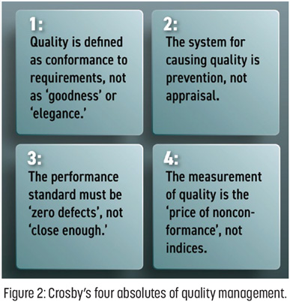

11, Similarities and comparisons

Both Deming and Crosby use fourteen steps to reach the absolute quality, but Crosby groups them into four sections, both have a large focus on training, and both are suggested to be customer based. When Crosby's name is not mentioned in the very same sentence as the best-known quality thinker, Deming, then it would certainly be mentioned in the next. Crosby's practical and easy-to-read books on quality became - and remain - bibles to many, demystifying some of the jargon formerly associated with quality. His timing was perfect for the quality movement, and his writing has marketed quality to a wide audience.

12, Critic
TQM can be time consuming it needs full evaluation to work to its full capacity, it can be expensive to maintain. The cost of training staff, improving the infrastructure of the organization. But the largest critic is changing culture, to fulfil and satisfy the customer the organization needs using TQM the organization must fit this into their operation. Not all companies can or are willing to change. TQM needs a lot of strong commitment and if one person is not onboard then it will fail. If training is given but evaluations are not completed, then the knowledge and skills are likely to be forgotten. Coaching and evaluations should follow training and if the management are not 100% on board to commit to this then it will fail.

13, How does it influence quality model and CRM relate in the smart phone industry.

Both Deming and Crosby’s models are customer focused. TQM and customer relationship management are similar forms of management models. They are both used to improve company. Quality management is always based on the customer needs and expectations and customer relationships works towards the same goal (Havlicek,2013).
Apple uses TQM to keep staff motivate and satisfied, they have effective meetings among employees and use forums. The company use cause and effect diagrams along with control and other charts. By implementing TQM the company have reduced the wastage of the whole supply chain. (apple, 2022) The concept of Total Quality Management was developed by William Deming. TQM is the process that detects and reduces the errors that arise in the process of manufacturing. It ensures the activities of employees, improves the experience of customers and streamlines the supply chain management. Apples TQM policy is: The aim of Total Quality Management is to ensure the internal guidelines and standards that help in reducing the errors and flaws. The main aim of this process is to focus on the activities that help in improving the quality of the organizational outputs and internal practices of the business. In all the organizations, every member is committed to maintain a high standard of work. Thus, TQM is adopted by every organization to maintain an end-to-end process of management. It has also been noted that the objectives of Total Quality Management in the manufacturing industry are different from the objectives of TQM in the consumer goods sector. (jues, 2019)

14, Conclusion.

Total quality management is used by many companies successfully in conjunction with CRM. In looking at TQM it seems that most companies adopt Deming’s fourteen-point TQM which at first, I found complicated and thought Crosby’s to be the easier of the two, however on reflection I find Deming’s is defiantly the more effective of the two seeing how all the points are connected. As I said earlier, they are TQM and CRM are used alongside each other in some companies Apple being one of them, and it works. Would it be better to see maybe a TQCRM which would place the two models together as they are very similar in their aim? Using personal development plans along side TQM would be useful. The ongoing evaluation of staff needs in training and other commitments all contribute to a successful business. A start as you mean to go on attitude would mean things being done right first time, properly trained and evaluated staff will make this more accessible.

Reference list

John jues p.(2019),total quality mangment &TQM analysis at apple inc Available at: https://assignmenthelp4me.com/article-total-quality-management-of-apple-inc-459.html [Accessed 31 March 2022].

2022. [online] Available at: <https://expertprogrammanagement.com/2022/02/demings-14-points/> [Accessed 31 March 2022].

Aichner, T. and Gruber, B., 2017. Managing customer touchpoints and customer satisfaction in b2b mass customization: A case study. International journal of industrial engineering and management, 8(3), pp.131-140.

Assignment Help 4 Me. 2022. Total Quality Management of Apple Inc and its analysis. [online] Available at: <https://assignmenthelp4me.com/article-total-quality-management-of-apple-inc-459.html> [Accessed 31 March 2022].

Bl.uk. 2022. British Library. [online] Available at: <https://www.bl.uk/people/philip-crosby> [Accessed 31 March 2022].

CRMside. 2022. 33 Global Podcast Statistics & Facts 2022 (Data-Backed). [online] Available at: <https://crmside.com/podcast-statistics-and-facts/> [Accessed 26 March 2022].

Greenwald, M., 2022. 20 Ways Apple Masters Customer Touchpoints And Why It's Great For Business. [online] Forbes. Available at: <https://www.forbes.com/sites/michellegreenwald/2014/05/21/20-ways-apple-masters-customer-touchpoints-why-its-great-for-business/> [Accessed 27 February 2022].

GroHawk. 2022. What are Customer Touch Points? | Pro Guide & 3 Super Tips. [online] Available at: <https://www.grohawk.com/what-are-customer-touch-points/> [Accessed 28 February 2022].

Havlicek, K., Breckova, P. and Zampeta, V., 2013. Quality Management as a Part of CRM.
Investopedia. 2022. How Total Quality Management (TQM) Works. [online] Available at: <https://www.investopedia.com/terms/t/total-quality-management-tqm.asp> [Accessed 31 March 2022].

Itpro.co.uk. 2022. [online] Available at: <https://www.itpro.co.uk/mobile/25813/iphone-7-uk-release-date-specs-and-price-apple-releases-red-iphone-7-to-help-fight-aids> [Accessed 26 March 2022].

Meyer, C. and Schwager, A., 2007. Understanding customer experience. Harvard business review, 85(2), p.116.

Newworldencyclopedia.org. 2022. Apple Inc. - New World Encyclopedia. [online] Available at: <https://www.newworldencyclopedia.org/entry/Apple_Inc.> [Accessed 28 February 2022].

Omniconvert Ecommerce Growth Blog. 2022. 12 companies with great customer experience - Omniconvert Blog. [online] Available at: <https://www.omniconvert.com/blog/companies-great-customer-experience/> [Accessed 26 March 2022].

Sila, I., 2007. Examining the effects of contextual factors on TQM and performance through the lens of organizational theories: An empirical study. Journal of Operations management, 25(1), pp.83-109.

The top 3 selling smartphone Nicholas Rossolillo,2018 available at: https://nz.finance.yahoo.com/news/3-top-selling-smartphone-makers [Accessed 31 March 2022].

The Daily Dot. 2022. What everyone missed about that Samsung vs. Apple customer satisfaction report. [online] Available at: <https://www.dailydot.com/debug/samsung-apple-customer-satisfaction/> [Accessed 28 February 2022].

THE Marketing Study Guide. 2022. Examples of brand touchpoints for Apple - THE Marketing Study Guide. [online] Available at: <https://www.marketingstudyguide.com/examples-brand-touchpoints-apple/> [Accessed 27 February 2022].

The W. Edwards Deming Institute. 2022. Dr. Deming's 14 Points for Management - The W. Edwards Deming Institute. [online] Available at: <https://deming.org/explore/fourteen-points/> [Accessed 31 March 2022].

Think Different. 2022. Quickie: Phil Crosby’s Four Absolutes of Quality. [online] Available at: <https://flowchainsensei.wordpress.com/2021/08/20/quickie-phil-crosbys-four-absolutes-of-quality/> [Accessed 31 March 2022].

