Education
In
Action















Work Placement Portfolio


Contents

- Work Placement Overview
- Correspondence
- Placement Form
- DBS Certificate
- Safeguarding Policy
- Placement Completion Form
- Learning Activity Evidence
- Reflection
- Reference List



Overview
This portfolio outlines the participation for a work placement module, Education in Action, and for the duration of the placement I attended Mary Immaculate Primary School in Haverfordwest, Pembrokeshire. My role involved supporting the pupils and class teacher during lessons and throughout the school day in a range of different classes with most of my time spent with a year 5 class. During my time at the school, I had the opportunity to observe and learn from experienced and knowledgeable educators as well as to observe and absorb the school ethos, their values and virtues and to see how they are facilitated and promoted through the staff and pupils.

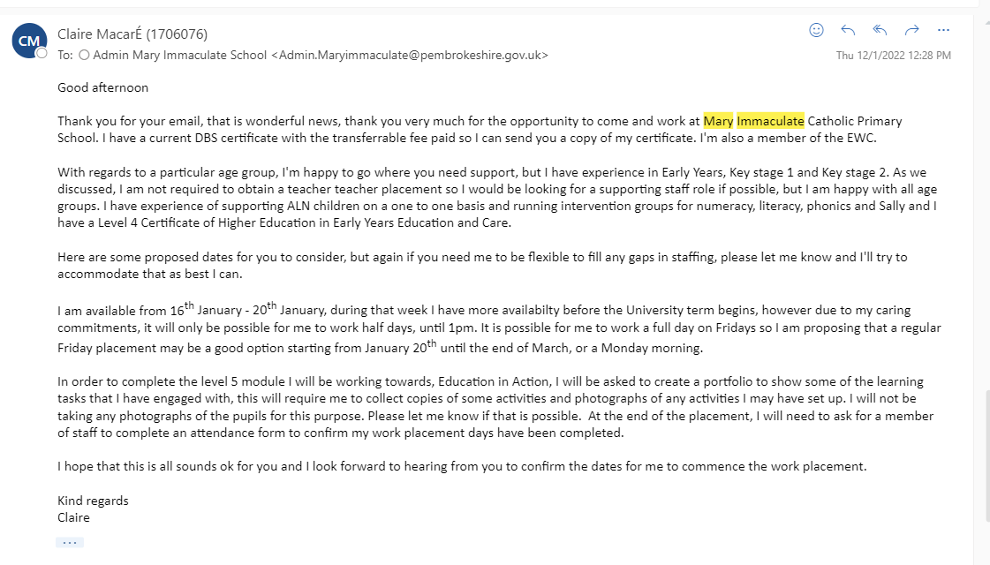
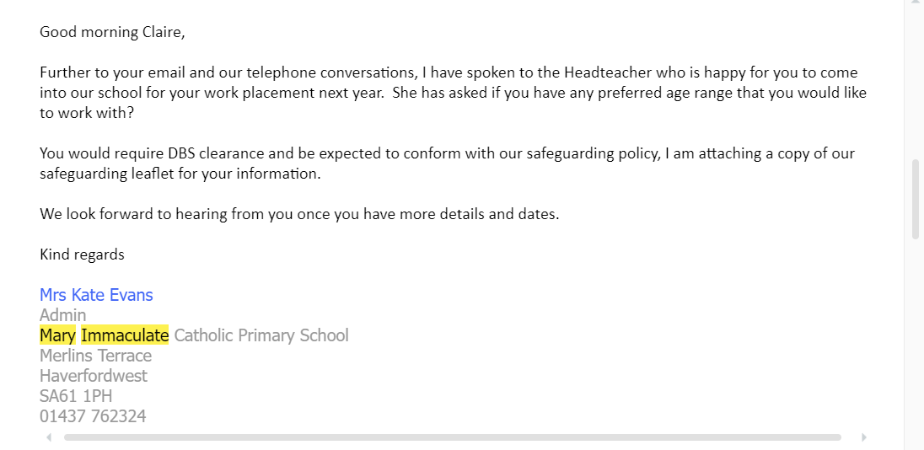
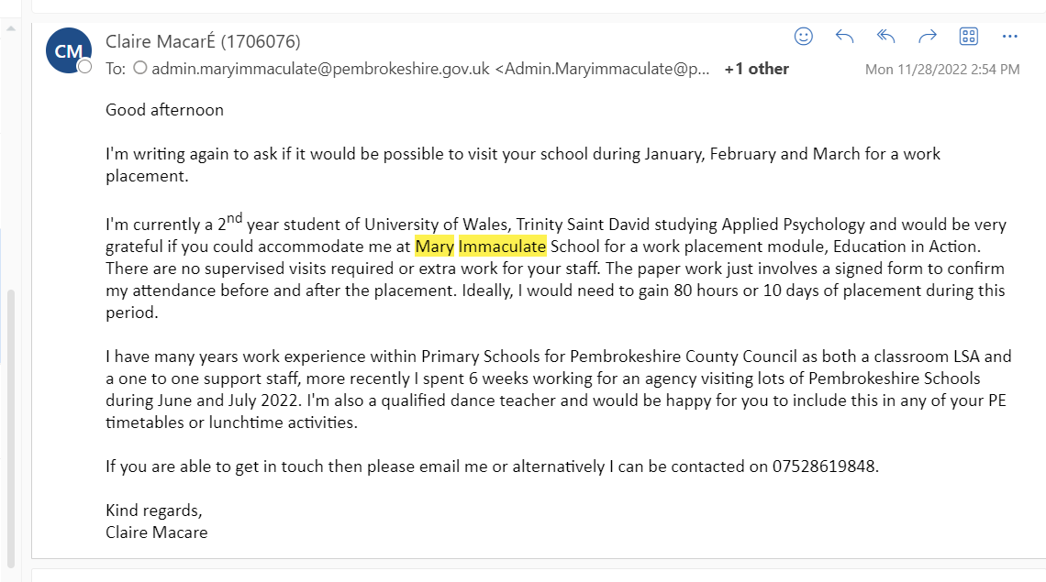
Further telephone correspondence was used to discuss and confirm exact dates for attending the work placement.
Email correspondence between myself and Mary Immaculate Catholic Primary School
Correspondence
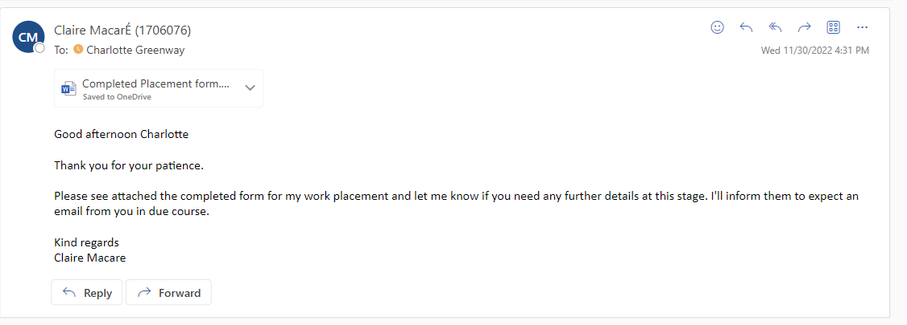
Email correspondence with the lecturer
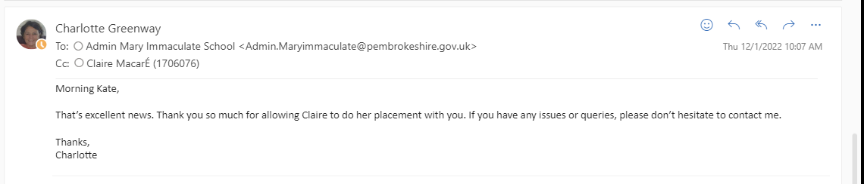
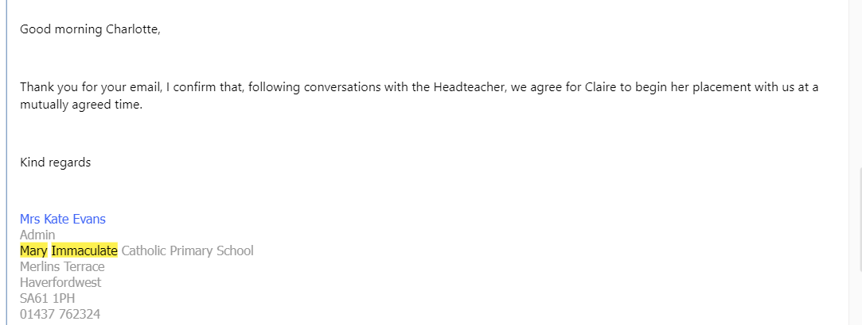
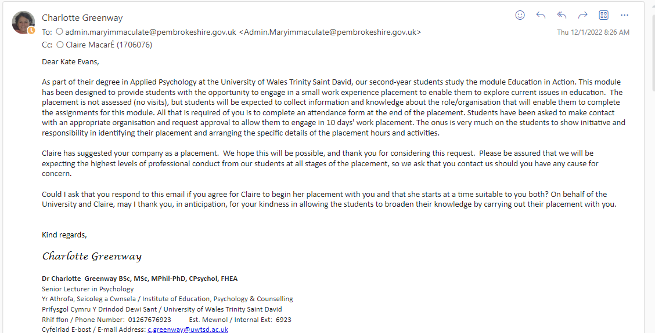
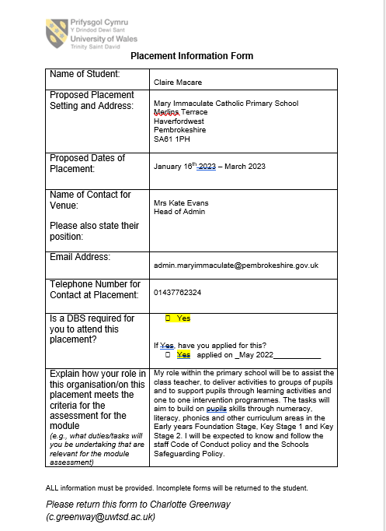

DBS Certificate

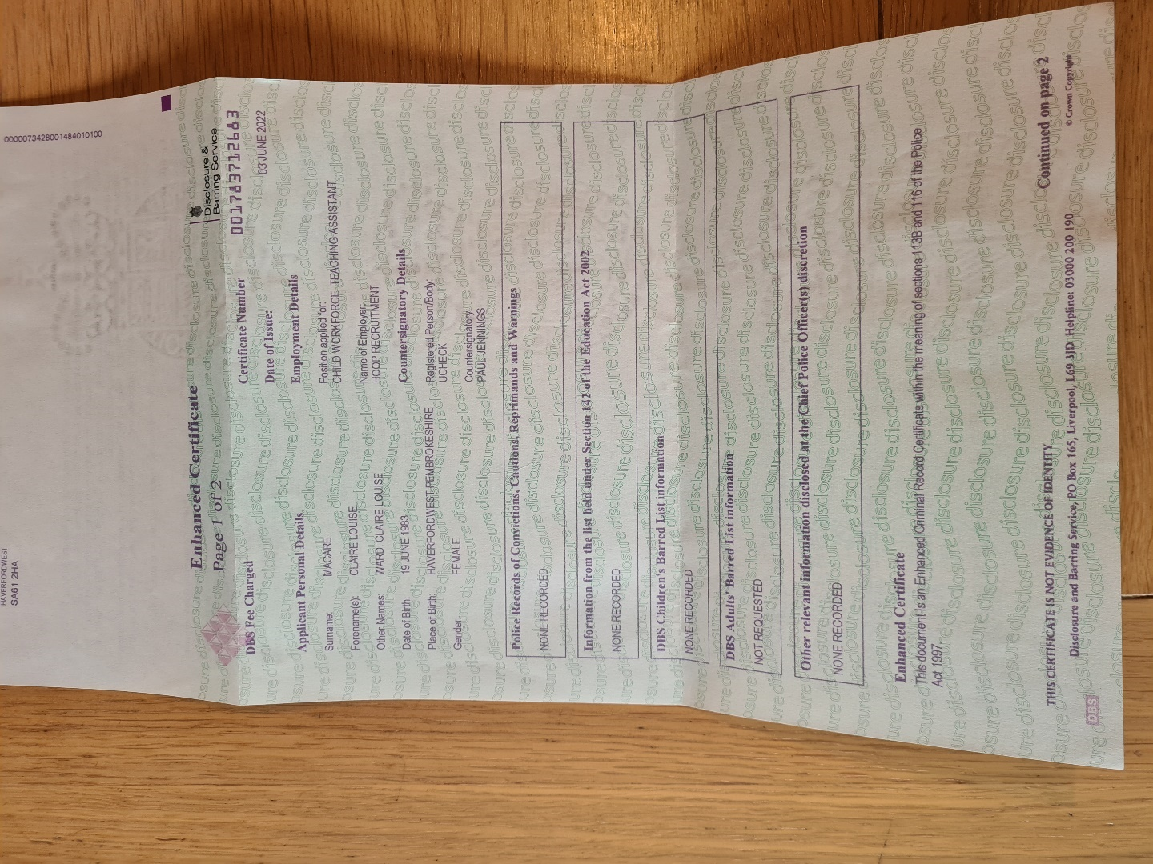

Volunteer Safeguarding Policy

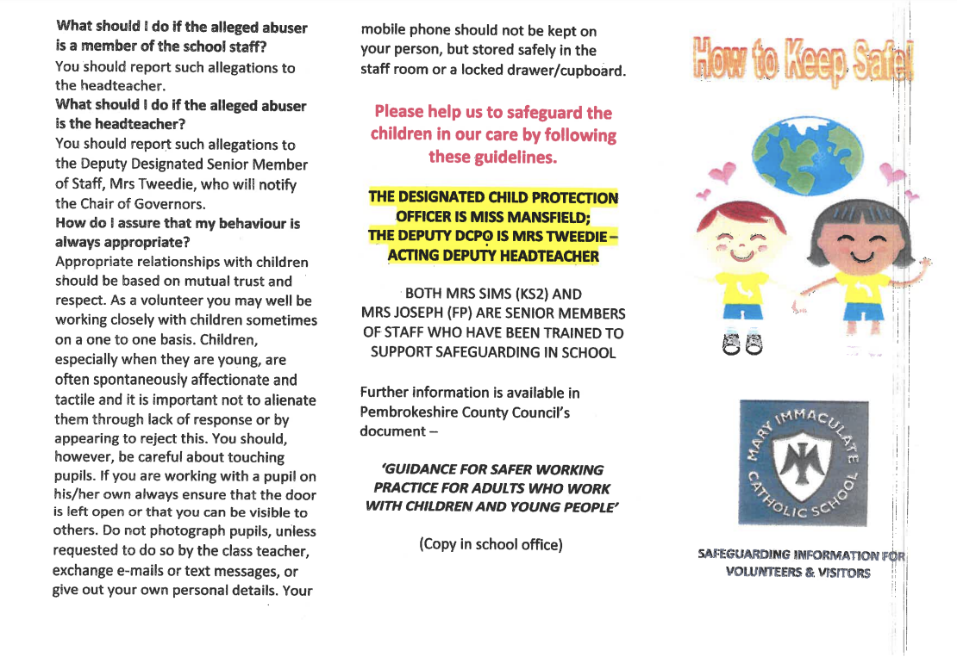

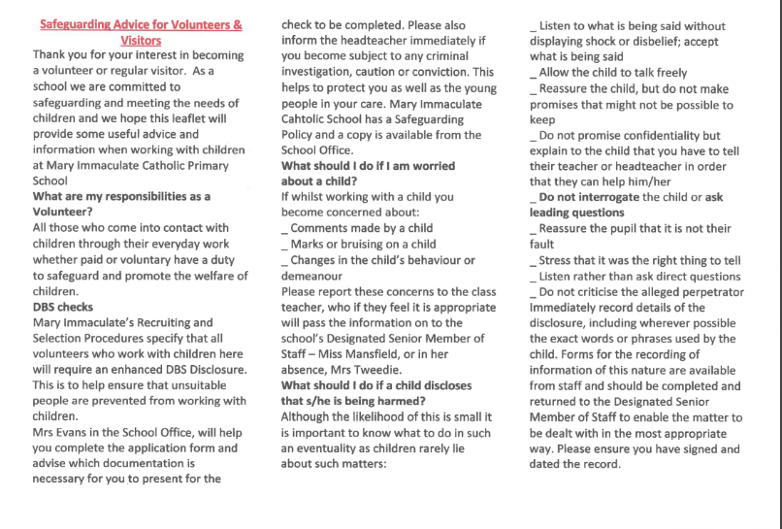

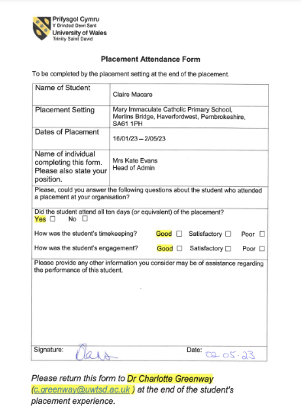

Placement Evidence and Activities

1. Cymraeg

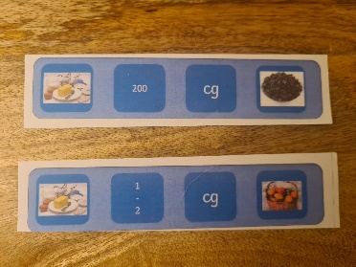


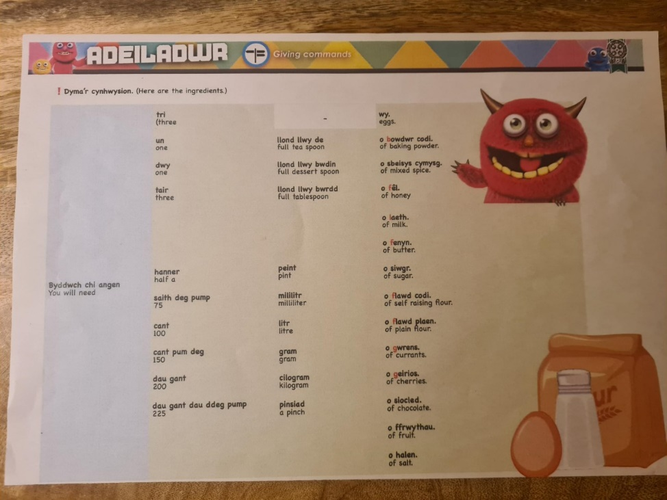

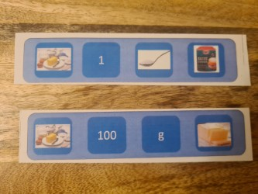

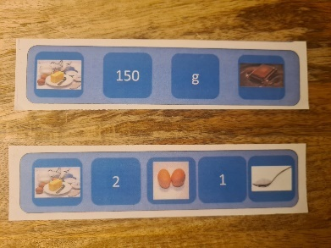

In this year 5 Welsh lesson the children were asked to form 3-5 simple sentences giving recipe ingredient instructions using the visual prompt sheets (left). They were provided with a vocabulary sheet (above) to work from and worked in pairs. My role involved supporting 2 low ability groups to develop and sound out the sentences they wanted to create and to keep the groups on task. Once the sentences were practiced the children were asked to record a video of themselves using the iPad as evidence.

2. Numeracy

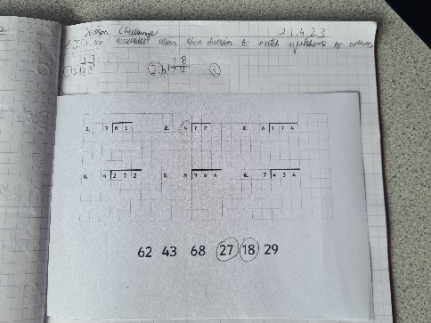
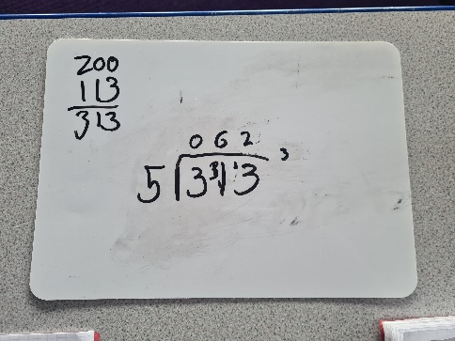


Initially my role during this activity was to assist one group to access Mathletics using laptops and begin the correct division tasks. Following that I assisted the other groups where needed to understand the task using the correct bus stop division method, encouraging students to gain independence and self-correct when necessary.

3. Literacy
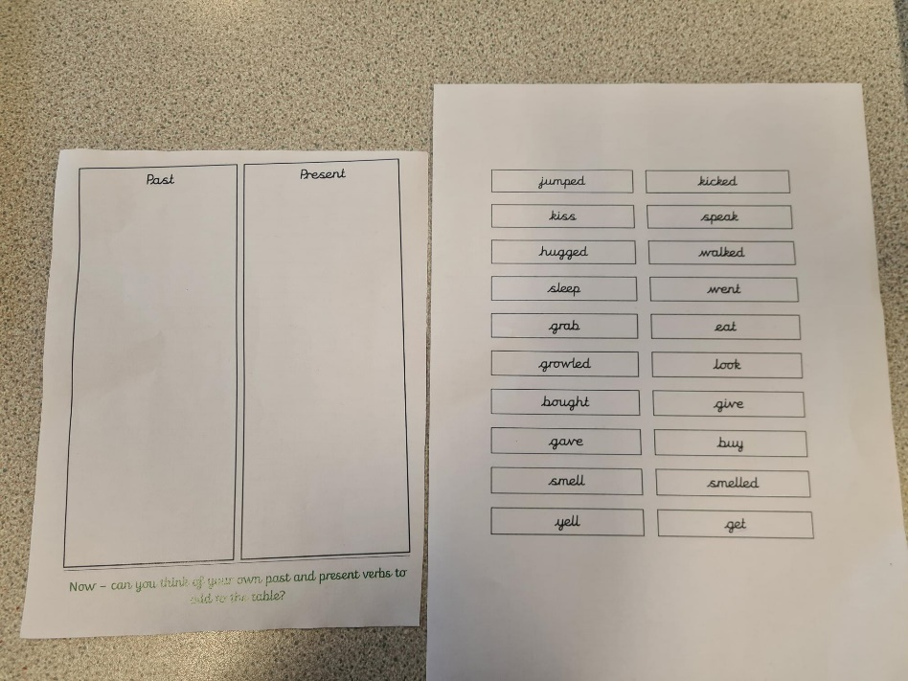
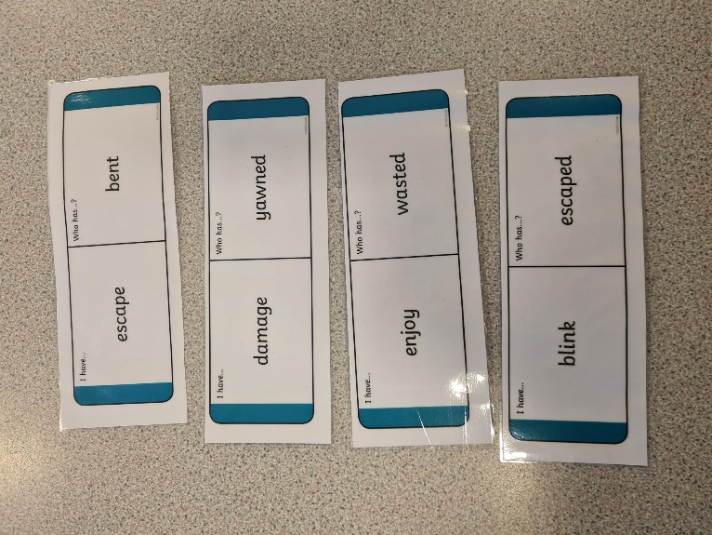

Past and Present Tense Words
Once the group had practiced verbally they completed the activity below, first deciding if the word was a past or present tense word and writing each word into the table. Further support in identifying the correct tense was given where needed but independent work was encouraged.
During a year 4 literacy lesson that focussed on identifying words in past and present tense I was asked to support a low ability group. We began with a warm-up task using the cards in the picture (left) by identifying and selecting the correct word verbally. I held up the card and the first to answer correctly won the card.

4. Reciprocal Reading
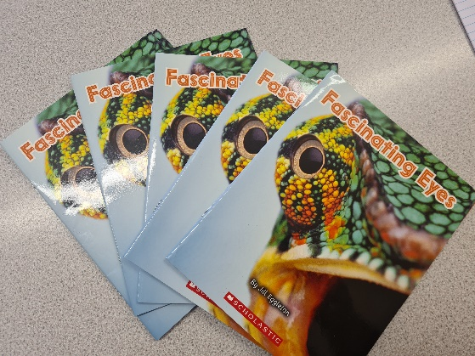
Reciprocal reading is a small group task where between 5-7 children read a book together. My role during the task was to facilitate one group at a time, by helping them work together effectively in a shared task, to prompt or explain where needed and to encourage everyone to participate in their role as leader or listener.

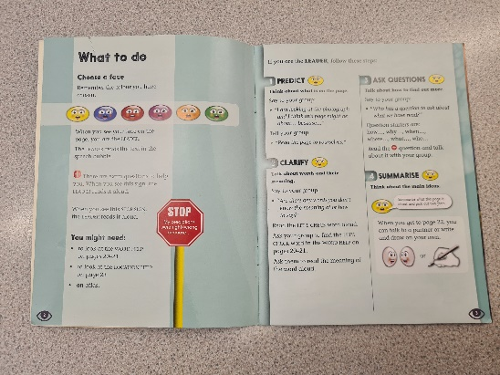
As seen in the picture to the right, each child is assigned a role, such as leader and takes it in turns to read, ask questions and instruct the group as to which task is next.




Children are asked to consider the topic, ask questions and discuss facts.

Children are asked to listen while following the words and to respond increasing vocabulary, literacy and oracy.
Confidence and self-esteem are developed by having your voice heard and being able to volunteer knowledgeable information.
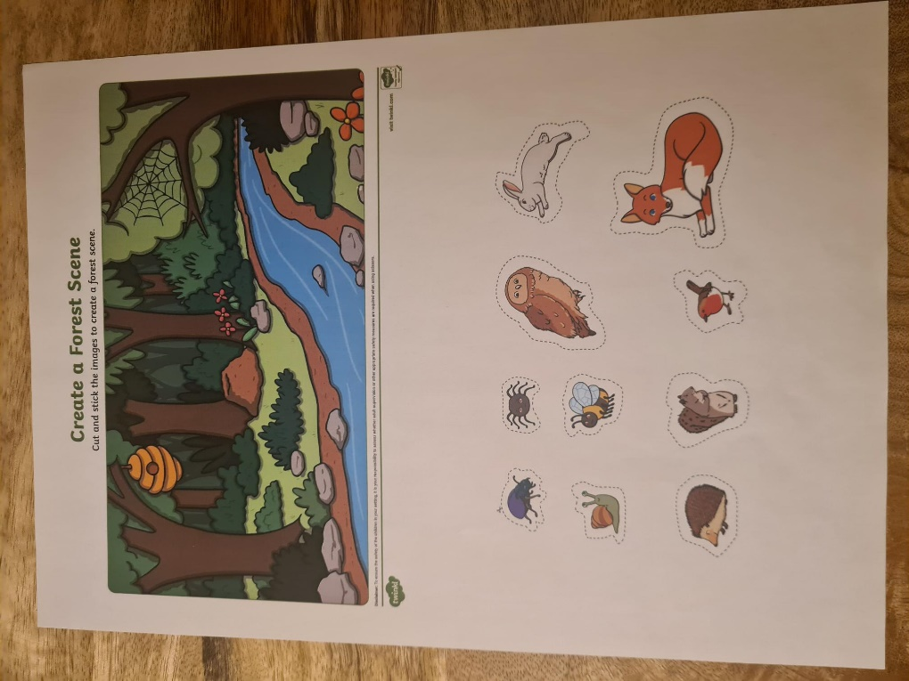


In a Nursery and Reception class I was assigned to work with a small group of Nursery children to practice their fine motor skills by cutting out the animals with scissors and using glue to attach them appropriately to the picture. I supported the children by modelling the correct way to hold scissors and discussing the animals and woodland scene as we completed the task. I encouraged them to talk about their picture scene. This continued as a free activity throughout the afternoon session.
Fine motor control task
Maths Intervention Activity


I was asked to run a maths intervention session for a lower ability year 3 group of 7 children who needed further support in basic number bond understanding. We began working as a whole group working with number bonds up to 20, they then worked in pairs to find as many different ways to make 20.

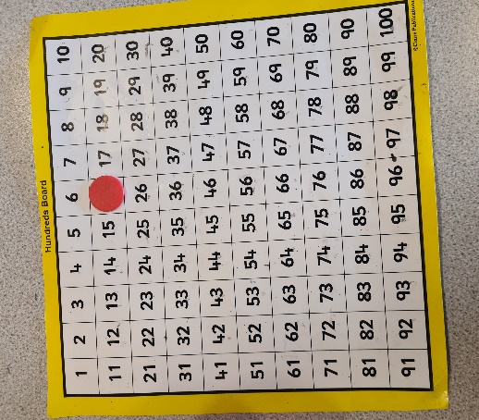
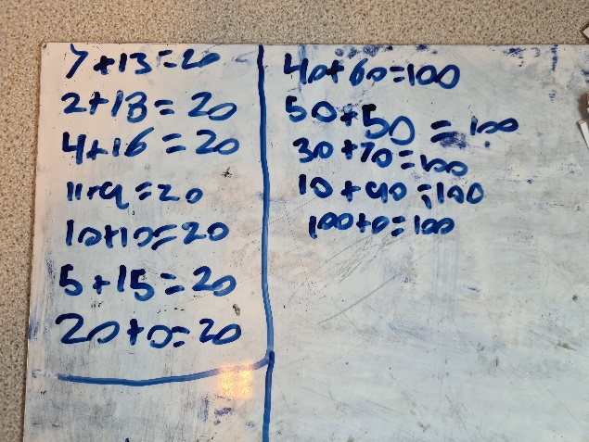

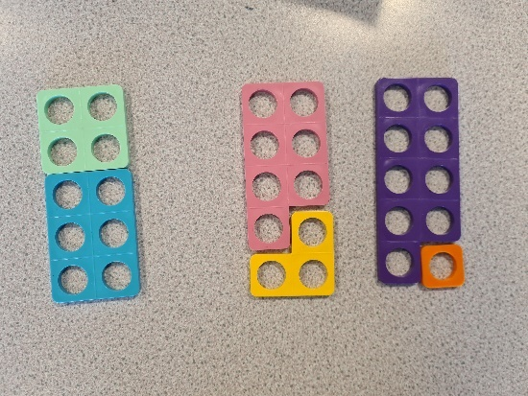
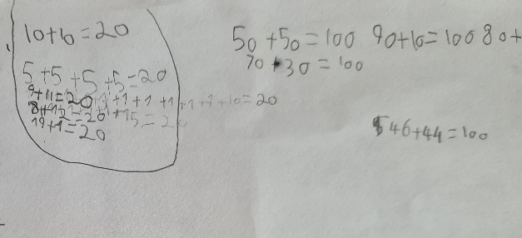

Within the group the students were of different abilities. Some of the children were challenged to work on number bonds up to 100 and some needed further basic skill development looking at number bonds up to 10.

Some of the resources used during the intervention session included number squares, counters, whiteboards, and numicon.


Reflection

The Gibbs Reflective Cycle (Gibbs, 1988) has been used for guidance in writing a reflection to support the learning from experiences of working in an educational setting. It is recognised as an effective strategy for students to gain understanding in developing their professional practice (Paterson & Chapman, 2013).
Over the months that I spent in a primary school in a rural town in Wales, I was able to observe many of the different teachers, their teaching styles and approach to class attitude, academic development and pastoral care. After visiting each year group, it was decided I would focus more on the junior classes (Key stage 2) in order to further develop my skills and to offer support in the areas most needed in the school whilst working as a learning support assistant. Some examples of my role include supporting children with their tasks or leading a small group during lesson time, listening to children read, leading small groups for reciprocal reading, accompanying the class to assembly, pastoral care to resolve peer conflicts or to encourage pupil confidence and self-esteem.
My initial feelings before beginning the work placement were apprehension and some nervousness due to meeting new people and being in a new work environment. I wanted to make good first impressions and develop successful professional working relationships with the staff and to establish rapport with the pupils I was working with. I felt confident in my abilities of delivering activities, supporting pupils and knowledge of school curriculum and vocabulary due to previous experience within a school setting. I was immediately put at ease and welcomed into the school by all staff and pupils which helped to make me feel valued and able to offer a worthwhile contribution to the school community. This further improved after receiving positive feedback from staff members during the placement which was beneficial to my confidence during activity time and situations of peer conflict resolution and class behaviour management. Findings by Michaelson et al. (2014) supports this outcome by suggesting that employees are more engaged in the workplace when they feel that their contribution has meaning and they feel valued.
Supporting a group or individual during a learning activity was my preference because it felt like it was beneficial to the students. I think that one of my strengths is how I identify able students and encourage them to work independently and to support other students when necessary, helping them stay on task. Sometimes I would find it challenging to keep them working to the class timeframe and managing behaviour which sometimes led to class disruption. For example, shouting out or continuing to talk over the class teacher. This is where the teacher’s knowledge of class management and school discipline procedures was helpful for me to observe and learn from.
At times I became frustrated by the rigid structure and strict daily/weekly timetable, sometimes seeming counterproductive to academic learning with never ending interruptions. Individual lesson and activity time felt too short or inadequate for developing necessary skills. From a personal perspective I worried I was not involved in enough of the learning activities and it appeared both the teacher and the pupils were under immense time pressures to complete work and learning activities in an unrealistic time scale, and sometimes the children were hurried or interrupted during their learning time due to the school schedule. In some situations, I felt it would have been beneficial to continue the learning to allow some students to cement their understanding, develop ideas or to remove the pressure of being rushed to complete something or simply to continue with something they are enjoying. However, this simply was not possible due to school assembly gatherings, break times, assessments, other academic subjects, class discussion/communication time and extracurricular activities.
I became increasingly aware of the importance of non-academic tasks and activities, seeing the benefit to the child of the holistic approach to their academic and social development. The use of assembly and giving time to listen to pupil voice and to clearly communicate to the student body about events, news, values and celebrating successes, is equally important for developing a sense of school community, identity and belonging. Incidental interactions building healthy relationships between teachers and pupils. Mayes et al. (2019) state that when a school community facilitates the use of student voice, influenced by the UNCRC ‘Rights of the Child’, there are many benefits to both the students and teachers. In a case study approach in three primary schools, found that student/teacher relationships are strengthened, peer relationships across year groups improve, and that students demonstrate better social skills by working well in groups and listening to each other. Other reported benefits include improved student engagement, motivation and self-esteem. By allocating time to develop the school community in this way it would be expected that the skills will be transferred into academic performance.
According to McGrath and Bergen (2015) the student-teacher relationship is critical for the academic, behavioural, social and emotional development of the child. When positive student/teacher relationships are nurtured, particularly for children at risk of negative teacher relationships (minority, low socio-economic background, disability and learning disabled, behavioural disordered, boys, low ability students), it has a protective factor against negative outcomes and can influence peer relationships, student engagement and motivation, school attendance and academic achievement. More specifically, negative student/teacher relationships at primary education can lead to negative student/teacher interactions at secondary education so it is imperative to develop positive relationships from an early age to reduce the negative consequences of poor student/teacher relationships and to build secure attachments to support social, behavioural, emotional as well as academic growth.
In conclusion, building staff and student relationships through their shared school values felt like an integral part of the school ethos that developed a trusting and respectful atmosphere in which the pupils felt safe. While academic learning remains the focus for parents and teachers, it cannot be the only focus for the holistic development of the child. This experience has taught me that building a rapport and relationship with the students is important for my understanding of the individual, fostering motivation, self-esteem and academic learning. To be an effective educator you must be able to quickly establish relationships, be a good communicator and demonstrate empathic understanding. These are all valuable lessons that I will carry forward into my future professional development, the ability to see beyond academic focus and consider patterns of behaviour and social development in order to achieve future academic success.

Reference List

Gibbs G (1988). Learning by Doing: A guide to teaching and learning methods. Further Education Unit. Oxford Polytechnic: Oxford. https://thoughtsmostlyaboutlearning.files.wordpress.com/2015/12/learning-by-doing-graham-gibbs.pdf

Mayes, E., Finneran, R., & Black, R. (2019). The challenges of student voice in primary schools: Students ‘having a voice’and ‘speaking for’others. Australian Journal of Education, 63(2), 157-172. DOI: 10.1177/0004944119859445
McGrath, K. F., & Van Bergen, P. (2015). Who, when, why and to what end? Students at risk of negative student–teacher relationships and their outcomes. Educational Research Review, 14, 1-17. https://doi.org/10.1016/j.edurev.2014.12.001
Michaelson, C., Pratt, M. G., Grant, A. M., & Dunn, C. P. (2014). Meaningful work: Connecting business ethics and organization studies. Journal of business ethics, 121, 77-90. https://doi.org/10.1007/s10551-013-1675-5
Paterson, C., & Chapman, J. (2013). Enhancing skills of critical reflection to evidence learning in professional practice. Physical Therapy in Sport, 14(3), 133-138. https://doi.org/10.1016/j.ptsp.2013.03.004
United Nations Convention on the Rights of the Child(UNCRC), November 20 (1989). https://www.unicef.org.uk/rights-respecting-schools/wp-content/uploads/sites/4/2017/01/UNCRC-in-full.pdf

