University of Wales Trinity Saint David

BENG2H-PT Ordnance, Munitions and Explosives



Mk-3 Rapid Cratering Charge Test & Evaluation Portfolio
Work Based Group Project (ACDA5022)

Adam Mayo

2112088

05/2024

Lecturer: Dave Holley

Contents
Table of Figures 3
List of Tables 4
Abstract 5
1.0 Introduction 6
1.1 Problem Outline 6
1.2 Testing overview 7
1.3 Team Structure 9
2.0 Design and Concept Creation 11
3.0 Design Review and Presentation Feedback Influences 13
4.0 Communicating within the Team 14
5.0 EMTAP testing 18
5.1 Rotter Impact Test (No 1) 19
5.2 Mallet & Rotary Friction Testing (No 2 & 33) 19
5.3 Temperature of Ignition (No 3) 20
5.4 Ease of Ignition (No 4) 20
5.5 Behaviour on Inflammation (No 5) 21
5.6 Ignition by Electric Spark (No 6) 22
5.7 Tube test – Internal Ignition, Fast Heating & Electrically Heated (No 35, 41 & 42) 22
6.0 Shape Charge Performance 24
6.1 Testing Overview 24
6.2 Testing Requirements 24
6.3 Instrumentation 25
6.4 Results Reporting 26
7.0 IM testing 27
7.1 Overview 27
7.2 AOP-4220 Fast Heating 30
7.3 AOP-4382 Slow Heating 31
7.4 AOP-4241 Bullet Impact 31
7.5 AOP-4496 Fragment Impact 31
7.6 AOP-4396 Sympathetic Reaction 31
7.7 AOP-4526 Shaped Charge Jet Impact 32
8.0 Hazard Classification 33
8.1 Overview 33
8.2 Compatibility Groups 33
8.3 Testing Guidance 34
9.0 Conclusion 38
10.0 References 39

Table of Figures
Figure 1, Mk-2 cratering charge diagram [1]. 6
Figure 2, Example trial plan contents page. 9
Figure 3 - CAD Drawing of Mk-3 cratering charge. 12
Figure 4, Example of a generic trial reports structure. 15
Figure 5, Rotter impact test setup [4]. 19
Figure 6, Ease of Ignition test procedure [5]. 21
Figure 7, Train test apparatus [5]. 22
Figure 8, Tube tests - three variants [6]. 23
Figure 9, A generic cratering charge performance testing. 25
Figure 10, Response descriptor scoring [13]. 30
Figure 11, Performance indicator triangle [13]. 30
Figure 12, Description of Substance or Article to be Classified [14]. 34
Figure 13 - Series 7 test descriptors [4]. 35
Figure 14, Procedure for assignment to a division of the class of explosive [4]. 36

List of Tables
Table 1, Mitigation Technologies, Mechanisms and Applications [3]. 15
Table 2, System requirement allocation. 16
Table 3, Meeting dates of the team. 17
Table 4, FOI Data. 19
Table 5, Figure of friction data. 20
Table 6, Temperature of Ignition data. 20
Table 7, Reaction Definitions for tube tests [6]. 23
Table 8, Threat and Baseline Threat Range [3]. 28
Table 9, IM Compliance Matrix 28
Table 10, Stakeholder and situation information [3]. 29
Table 11, Hazard Division descriptions [15]. 37

Abstract
This portfolio discusses the design process of a cratering kit and the test and evaluation of the design using recommended guidance accepted by the ordnance, munitions and explosives industry. The test and evaluation process will first test the sensitiveness and explosiveness of the replacement explosive. The filling is required to change as it needs to change to have higher prospects of the munition being insensitive munition compliant. With a suitable plastic-based-explosive chosen, performance testing is required, as it is important the performance remains the same or better with a new explosive, when compared to the previous cratering design. However, some issues with the design have been highlighted within this portfolio that may present a problem during this testing and have brought forward some recommendations for further designs of the cratering charge.

However, by following guidance set out in industry-accepted documents the procedures for insensitive munition and hazard classification testing would remain the same regardless of the munition's performance. Therefore, a series of tests were proposed within the portfolio and discussed.

Introduction
In certain military operations there may be a requirement to create a crater rapidly in order to obstruct a road or runway etc in order to meet a counter-offensive objective. This is currently done by the Mk-2 rapid cratering kit, which first fires a shaped charge into the ground. The shaped charge creates a narrow hole 2-3m into the ground, for additional explosives (bag charges) to be placed in [1]. The bag charges create pressure underneath the ground and expel mass upwards as it follows the path of least resistance, creating a crater. The two-stage process is illustrated by Figure 1.

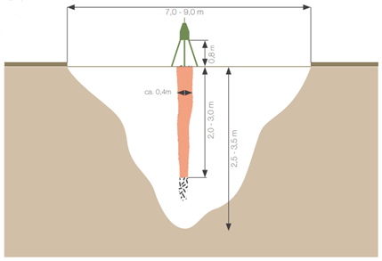
Figure 1, Mk-2 cratering charge diagram [1].

1.1 Problem Outline
The current rapid cratering kit mk-2 is comprised of a shaped charge for creating a channel in the ground, which is RDX/TNT (Comp-B) based. Bag charges for the cratering effect by dispersing mass. However, the customer requires an Insensitive Munitions (IM)-compliant cratering charge which the Mk-2 is not. Comp-B is generally considered an effective explosive with a good performance record but is not considered safe enough anymore as the shift of the munitions industry moves towards IM. There is an internationally agreed policy to make the munitions inventory safer with in the united nations.

A Plastic-Based-Explosive (PBX) could be considered a safer alternative to the current Comp-B composition, but small-scale testing is required to first establish the response of the explosive to insults before an “all-up” munition is made, which would come under EMTAP testing.

1.2 Testing overview
When considering a new explosive for a munition, compatibility has to be considered with components of the munition during short-term or long-term storage. Guidance is set out in STANAG-4147 [2], it details five tests:
- Vacuum stability
- Heat flow calorimetry
- Thermogravimetric analysis
- Differential scanning calorimetry
- Chemical analysis after ageing

However, these tests have already been completed historically, therefore the data for compatibility was available to the S&D-Engineer. This is useful when they were choosing materials for the munition.

Performance testing should be conducted before any IM or Hazard Classification (HC) testing programs, as it would be a waste of money to follow these time-consuming and expensive processes if the munition doesn’t meet the right performance requirements. The performance testing will find out any effects associated with changing the explosive fill of the shape charge and the design of the catering charge and the effect of removing the bag charges. The performance of the munition should still remain effective in its intended use [3], which the testing will agree or disagree with.

Progressing to IM testing on an “all-up” munition which would assess its vulnerability and consequences of potential accidents in storage and transport conditions [3]. HC testing would assess the munitions classification when subject to transport and storage regulations [4].

The test and evaluation of this munition will be conducted at Cranfield Ordnance Test and Evaluation Centre (COTEC). The range limit at COTEC has a Net Explosive Quantity (NEQ) limit of 10kg, which is defined by the range standing orders that COTEC follows. This is important as the munition has a NEQ of 9.8kg, which is under the range limit.
The range standing orders are set out by the governing authority of the range. COTEC has access to Area 9 of Sailsbury plain training area, which offers a large space for fragmenting munitions like the cratering charge that will generate natural fragmentation from the steel casing.

The test/ trials purposed in this portfolio will follow a trial plan structure that is presented in Figure 2. This covers safety as well as the trial conduct and more, which is in accordance with regulations set out by the health and safety executive for example.
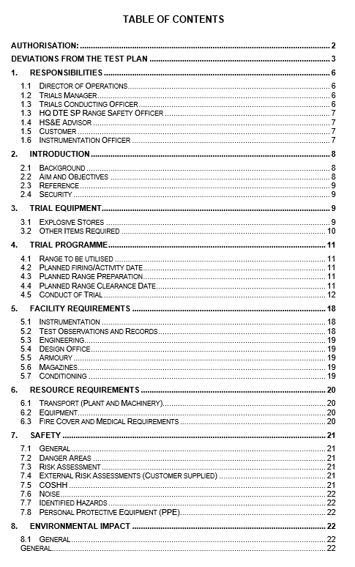
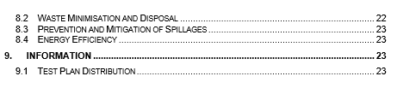
Figure 2, Example trial plan contents page.

1.3 Team Structure
This portfolio focuses on the testing aspect of the proposed Mk-3 cratering charge that the team has designed, with everyone providing design ideas and contributing to the design, qualification and breakdown of this munition. The roles of the team are shown below:
- Josh Gourlay (BAE Systems) – Systems & Design Engineer
(S&D-Engineer)
- Sam Miles (BAE Systems) – Design & Manufacturing Engineer
(D&M-Engineer)
- Adam Mayo (COTEC) – Test & Evaluation Engineer
(T&E-Engineer)
- Albie Willett (QinetiQ) – Environmental Test Engineer
(ET-Engineer)
- Creighton Rees (BAE Systems) – Breakdown & Disposal Engineer
(B&D-Engineer)

2.0 Design and Concept Creation
During the initial stages of the rapid cratering kits development, members of the team had a degree of input, which allowed patterns and important requirements to be identified that considered all the stages of the munition’s lifecycle. This included members of the team from design and manufacturing, end-of-life disposals, environmental testing, HC, IM testing and performance testing. Each of these areas having differing requirements for the munition, but by including these in the early development stages it reduces the potential cost that may have been encountered. This approach is known as “left shifting”, which is key to designing a good system/ munition, which designs a munition whilst factoring in its potential failures.

The proposed munition (Mk-3 rapid cratering charge, Figure 3) would consist of a shaped charge with an aluminium-based PBX called IMX-310, which is runoff from an in-service explosive. This was ideal as the team had access to historical data which would negate the need for a large portion of testing to see how compatible and sensitive it is. However, the team decided to remove the bag charges from the kit, to reduce the time setting up the kit and to have one IM-compliant munition. It is important that performance testing is completed as this could alter the crater size when compared to the Mk-2 cratering kit.

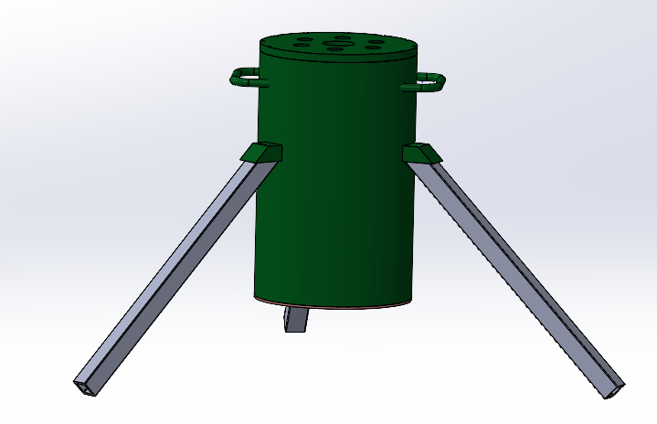
Figure 3 - CAD Drawing of Mk-3 cratering charge.

3.0 Design Review and Presentation Feedback Influences
The design team presented the design to the reviewers within a meeting, and the feedback would have influenced the munition to incorporate the changes/ improvements the reviewers suggested. However, the reviewers in the meeting agreed the munition proposal would be a suitable choice.

On presenting the test program to the reviewers on the 23rd of April, the following questions were asked and consequently answered in the relevant sections of this portfolio:

- What do small-scale tests give you? EMTAP vs Explosiveness (Handling vs Store)
This is answered in the section 5.0 EMTAP testing.

- Why not use the tube tests?
From the feedback in the presentation, tube tests were considered and researched within this portfolio and presented in the section 5.7 Tube test – Internal Ignition, Fast Heating & Electrically Heated (No 35, 41 & 42).

- Performance testing…… What happened to the charge bags?
This question is answered in the section 6.4 Results Reporting.

- Flash x-ray…how does this work when burrowing underground?
This answer is explained in the section 6.3 Instrumentation.

- Communication of trial results. What type of test report are you supplying?
4.0 Communicating within the Team

4.0 Communicating within the Team
Test and evaluation was a two-man team, and throughout the test and evaluation process communication was strong to coordinate an equal distribution of testing assigned to each person. Throughout the planning stages, knowledge of testing programmes was shared between test engineers to ensure the type of testing was applicable to this munition as well as the assessment criteria were correct.
Correspondingly, the communication of the various trial results would be presented in individual trial reports that follow a similar structure to the one presented in Figure 4. This would ensure all relevant performance or safety data was shared with the right people in the team, in case any changes have to be recommended.

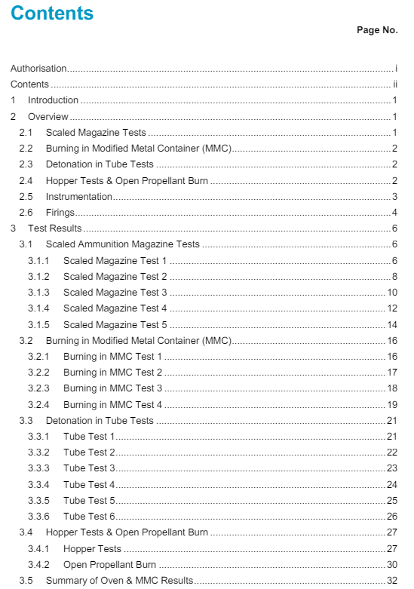
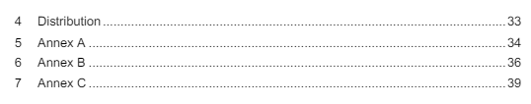
Figure 4, Example of a generic trial reports structure.

Through reading the policy for IM assessment and development [3], certain design features needed to be communicated to the S&D-Engineer, as it is important to consider ways to make the munition IM compliant from the early development stages so that it does not fail the expensive IM testing program. Table 1 shows some examples of mitigation designs. However, the team incorporated two ideas from this table, which were aft venting holes and a rubber internal liner.

Table 1, Mitigation Technologies, Mechanisms and Applications [3].
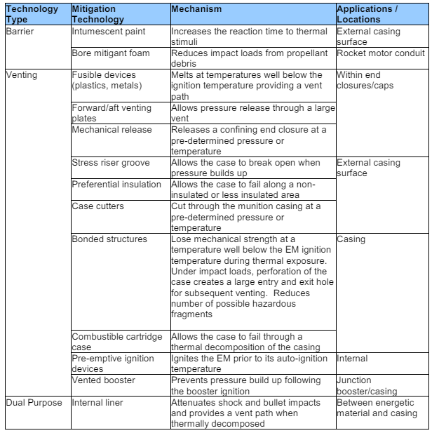

During the design and planning stages the team came up with requirements for our cratering munition, which all members of the team were assigned individually to cover each requirement, as shown in Table 2. The allocated requirements were distributed to the relevant people who knew how to meet the requirements. Tests to meet the requirements assigned to “Adam” were discussed in later parts of this portfolio.

Table 2, System requirement allocation.
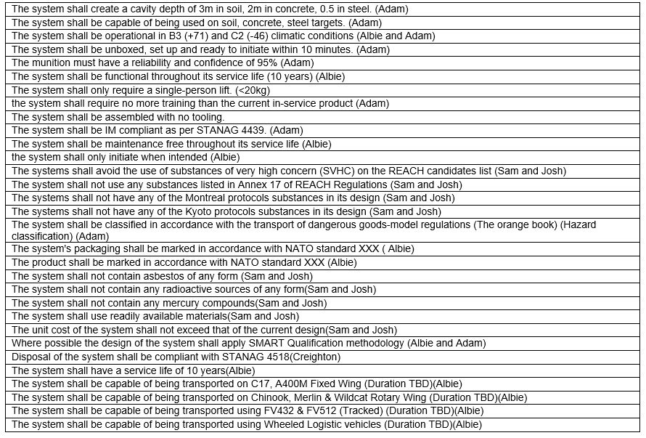

Throughout the design process, regular meetings (Table 3) were had to discuss the group’s combined progress and design choices. This would support the S&D-Engineer’s choices and progress through the systems engineering tools they implemented into the design process.

Table 3, Meeting dates of the team.
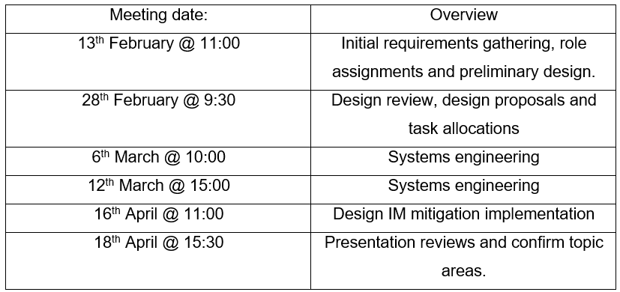

5.0 EMTAP testing
The Energetic Materials Testing and Assessment Policy (EMTAP) tests are to provide a compilation of the sensitiveness and explosiveness data of an energetic material. In addition, the chemical, physical, compatibility and stability of the energetic material is gathered through a selection of tests outlined in the EMTAP manual [5]. The data gathered through testing will be used in Ministry Of Defence (MOD) hazard data sheets, commonly referred to as Material Safety Data Sheets (MSDS). However, the EMTAP manual has previously been used to find out the handling characteristics of IMX-310 as it is already an in-service explosive that is used in other munitions. Therefore, safety measures can be put in place to reduce the likelihood and severity of accidents/ incidents. Furthermore, the compatibility tests set out in STANAG 4147 will have also previously been completed, so the data would be available to the S&D-Engineer allowing compatible materials to be selected in the design.

The EMTAP testing for IMX-310 would have been completed using the following test methods:
- Rotter Impact Test (No 1)
- Mallet Friction Test (No 2)
- Rotary Friction Test (No 33)
- Temperature of Ignition Test (No 3)
- Ignition by Flash Test (No 4)
- Behaviour on Inflammation Test (No 5)
- Ignition by Electric Spark (No 6)
- Tube Tests (35, 41 & 42)

Therefore, by incorporating smart qualification methods into the EMTAP testing programme we can negate the need to repeat time-consuming and expensive EMTAP testing. Smart qualification is what the Ordinance, munitions and explosives (OME) industry is transitioning to, but not all testing can apply this methodology at the moment due to a lack of data and accurate models. However, future programs may implement smart qualification methods.

5.1 Rotter Impact Test (No 1)
This test determines the sensitivity of an explosive substance to a dropped weight impact. This test is applicable to both solids and liquids but as IMX-310 is a solid the test method below in Figure 5 was used historically. The Figure of insensitiveness (FOI) for IMX-310 is presented in Table 4. By comparing the value of Royal Demolition Explosive (RDX) and Trinitrotoluene (TNT) to IMX-310 it can be seen that it lies between the two values, suggesting the new filling will not be more sensitive than the previous cratering kit comprising of both RDX and TNT.

Table 4, FOI Data.
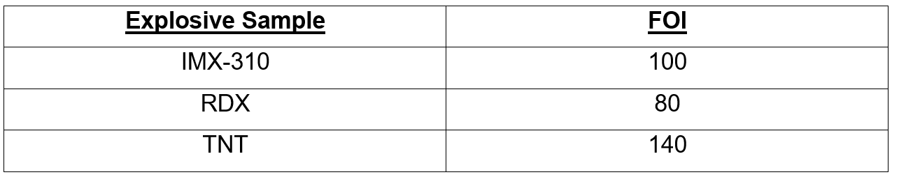
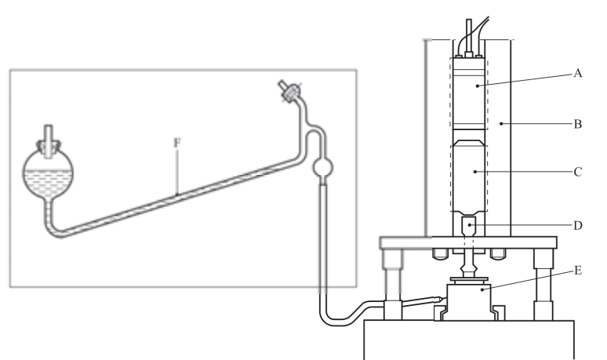
Figure 5, Rotter impact test setup [4].

5.2 Mallet & Rotary Friction Testing (No 2 & 33)
The figure of friction is generated by performing both the mallet and rotary friction tests, as they replicate differing accident scenarios. The figure of friction for IMX-310 is shown by Table 5, and IMX-310 achieves a sensitive response. Nonetheless, this test is split up into three response types:
- Very sensitive = less than 3
- Sensitive = greater or equal to 3 but less than 6
- Comparatively insensitive = greater than or equal to 6
And from this IMX-310 is close to being a comparatively insensitive explosive which is a good response.

Table 5, Figure of friction data.
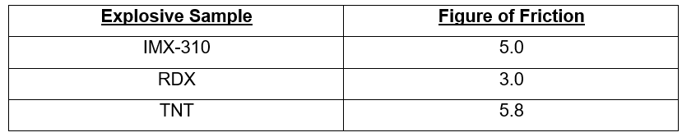

5.3 Temperature of Ignition (No 3)
The temperature of ignition is the temperature at which samples inflame, explode or undergo rapid decomposition which all produce a puff of smoke. The values of RDX and Pentaerythritol tetranitrate (PETN) represent relatively insensitive and relatively sensitive results respectively. IMX-310 (Table 6) tends towards the value of RDX which indicates it is not a relatively sensitive result.

Table 6, Temperature of Ignition data.
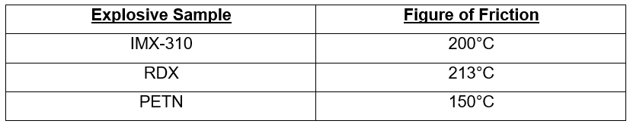

5.4 Ease of Ignition (No 4)
The sample in this test is subjected to a short burst of flame emitted from Bickford Fuze (safety fuze). The following responses may be observed:
- Fails to ignite
- Ignites and burns quietly
- Ignites and burns vigorously
- Explodes
However, IMX-310 response historically was it fails to ignite, which is a good response suggesting it is insensitive to flashes of flames.
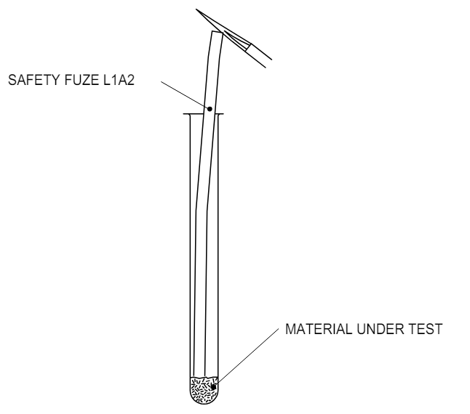
Figure 6, Ease of Ignition test procedure [5].

5.5 Behaviour on Inflammation (No 5)
This test involves heating 12 inches (30cm) of a sample by a naked flame for up to 2 minutes, and observations are made on the liability of the sample to burn and how vigorously it does so. There are four response types for this test:
- Fails to ignite
- Ignites and supports train steadily throughout
- Ignites and supports train vigorously throughout
- Explodes
When this test was performed historically, IMX-310 ignited and supported the train steadily for 10+ inches which is a good response for the sample.
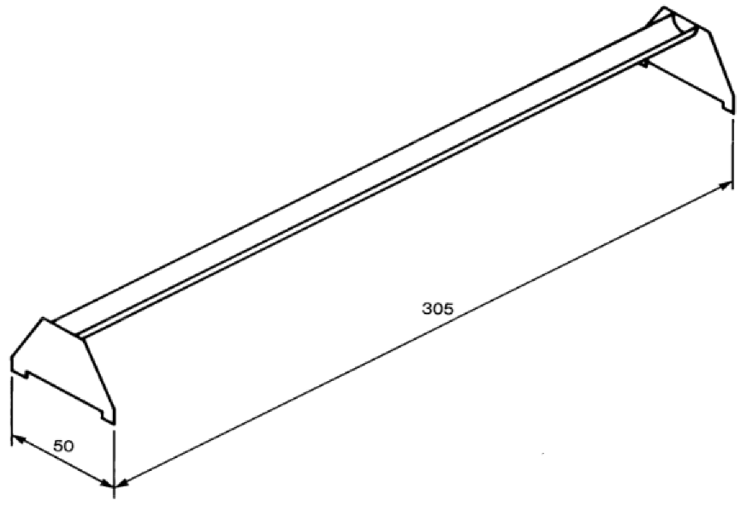
Figure 7, Train test apparatus [5].

5.6 Ignition by Electric Spark (No 6)
This test determines the electrostatic risk of a sample from a human discharge. The historic results from IMX-310 suggest it is insensitive to electrostatic discharges as it had ignitions at 4.5J but not 0.45J. But if a sample did have an ignition at 0.045J, it would require an investigation and the recommendation that stringent electrostatic precautions be applied.

5.7 Tube test – Internal Ignition, Fast Heating & Electrically Heated (No 35, 41 & 42)
The responses from these tests provide information on the relative explosiveness of the test sample, this is shown by the tendency of an explosive to undergo deflagration to detonation. The degree of fragmentation of the tube and the proportion of the recovered explosive are used to assess the severity of the reaction, as shown in Table 7. The tests in Figure 8, show the three variants of the tube test, each test replicates different credible stimuli that the sample may be subjected to.

Table 7, Reaction Definitions for tube tests [6].
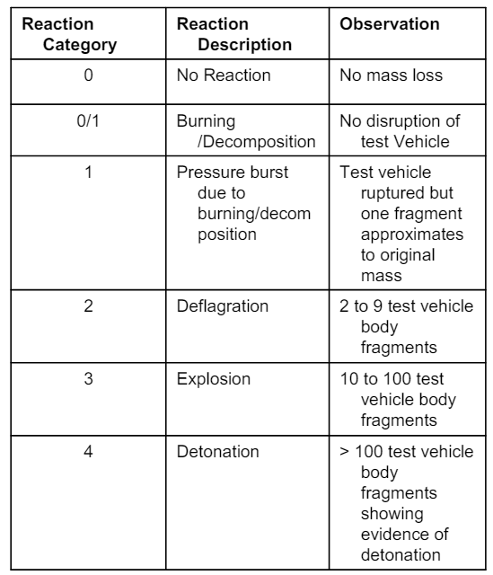
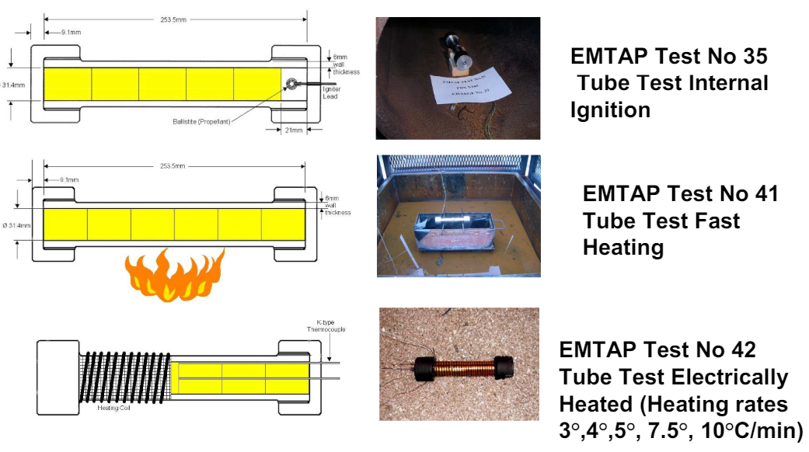
Figure 8, Tube tests - three variants [6].

6.0 Shape Charge Performance

6.1 Testing Overview
The test and evaluation of this munition will be conducted at COTEC. The range limit at COTEC has a Net Explosive Quantity (NEQ) limit of 10kg, the Mk-3 cratering charge has an NEQ of 9.8Kg which is within the noise pollution limits set out by the range standing orders that COTEC follows. This NEQ limit is subject to weather conditions as low cloud cover can reduce the NEQ limit of the range. These tests will evaluate the performance of the munition, following requirements set out by the design team.

6.2 Testing Requirements
Testing is required to check whether it meets the requirements of the customer, which are:
Cavity depth of,
- 3m in soil
- 2m in concrete
- 0.5m in steel
Test serials will be repeated to the customer's desire to ensure a reliability and confidence of 95%.

In order to test for these requirements, the Mk-3 cratering charge will be set up by the end user to assess how long it takes to deploy, to meet a customer requirement. Then the three targets of soil, concrete and steel (Figure 9) will need a density and humidity measurement. This will provide performance data when operating in different environments, with ranging humidities and target types.

Its worth considering, factors that will affect the depth and size of the crater:
- Target Type
- Stand-off Distance
- Liner Angle
- Net Explosive Quantity (NEQ)
However, simulation work should provide the optimum stand-off distance on each target type, using the adjustable tripod legs.

6.3 Instrumentation
In order to capture the relevant data, the following instrumentation will be used:
- Pressure Gauges,
To provide information on how much work is being done on the ground. However, vibrations on the gauges can attenuate the signal and add noise to the pressure trace. As well as ground reflections introducing spurious data.
- Flash X-Ray,
To give formation data of the shaped charge before it impacts the target. This can be compared back to simulation work for correctness checking. The X-Ray will focus on the gap between the charge and the target (Figure 9). This is done as COTEC only has access to a 150KV X-Ray system which is not powerful enough to see into a 1m³ block of steel.
- Measuring Equipment,
To compare the size and depth of the crater to previous cratering charges, for a direct comparison.

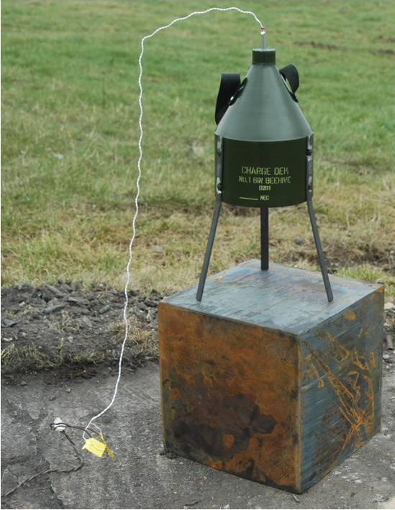
Figure 9, A generic cratering charge performance testing.

6.4 Results Reporting
Through the performance testing, the shaped charge will likely perform similarly to the Mk-2 cratering kits shaped charge component. And a lot of data will be collected through the use of X-ray images, to aid in the analysis of the PBX-based shaped charge.
However, it is likely that the Mk-3 cratering charge will not meet the crater size requirements as it lacks a motive force upwards to disperse mass from the target. Only generating a shaped charge crater that would be deep and narrow.

On the other hand, bag charges would generate pressure under the target causing a crater to be formed as the pressure would follow the path of least resistance. Therefore, it may be advisable to recommend an IM-compliant bag charges to the Mk-3 cratering charge, and this would be presented in the trial report that is distributed to the whole team. This allows the S&D-Engineer to reconsider the design of the mk-3 cratering charge to meet performance requirements.
Considering this, the IM and HC testing programs shall still be considered within this portfolio. As the tests would apply to the current Mk-3 cratering charge and any future iterations.

7.0 IM testing

7.1 Overview
Due to a requirement given by the customer, for the munition to be IM compliant it is advised that the munition should undertake an IM programme. The requirement was to follow STANAG-4439 but it is the policy for introduction and assessment of IM. Whereas, AOP-039 is used as it is the guidance on the assessment and development of IM, and the tests are recommended within this document [3].
These will test to confirm if munitions reliably fulfil their performance, readiness and operational requirements on demand, but minimise the probability of inadvertent initiation and severity of subsequent collateral damage to weapons platforms, logistics systems and personnel when subjected to unplanned stimuli. These munitions may improve efficiency and cost in transport, storage and general handling requirements. These benefits could be realised through the assignment of a more favourable HC.
The IM policy is dependent on each nation assessing its own munitions introduced into service with their forces. All IM testing shall be completed on an “All up round” and at a range of environmental conditioning states and within its packing that the munition will use [3].

The IM assessment consists of:
- Identifying threats
- Identifying the munitions configuration
- Assessing the response of the munition to the threats
- Generating the IM signature for any particular configuration

The likely threats a munition may encounter are common to all munitions unless they are exposed to a specific operational or logistical environment. Table 8 outlines the threats and baseline threat range deemed within AOP-039 ( [3]) to be reasonable.

Table 8, Threat and Baseline Threat Range [3].
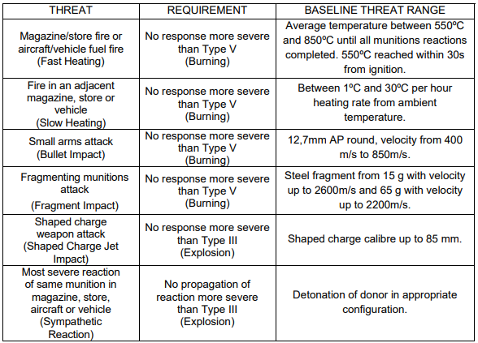

When considering the lifecycle of the munition, credible threats can be identified that are additional to the ones within Table 8. Conversely, situations within Table 8 can be reduced or discounted if they are not a credible threat. The desired response of an IM-compliant munition is illustrated by the green area in Table 9.

Table 9, IM Compliance Matrix
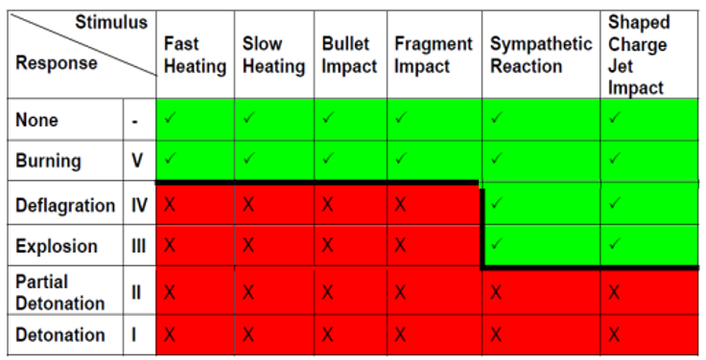

The above tests in AOP-039 [3] are further described by the Allied Ordinance Publication (AOP) that replaced the NATO Standardization Agreement (STANAG):
- AOP-4240 Fast Heating [7]
- AOP-4382 Slow Heating [8]
- AOP-4241 Bullet Impact [9]
- AOP-4496 Fragment Impact [10]
- AOP-4396 Sympathetic Reaction [11]
- AOP-4526 Shaped Charge Jet Impact [12]

A munition can have several differing configurations and temperature states. The transport configurations include (transport, tactical, operational, fuzzed, unfuzed ...) throughout its lifecycle [3].
Conditioning in a testing program will test 3 conditions (hot +73 °C, Cold -46 °C and Ambient ≈21 °C), which is applicable to IM and HC testing.
Each stakeholder should be consulted on how the munition will be used, handled and operated throughout its lifecycle. For determining the life cycle profile and considering the configurations and Table 10 should be consulted.

Table 10, Stakeholder and situation information [3].
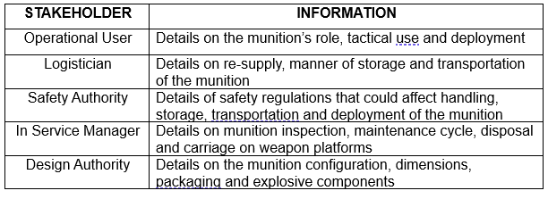

To give a rating to a munition a Performance Indicator (PI) is used, which assigns a score to each response type during IM testing. Figure 10 shows the scoring for each response type. The simplified process for working out the PI score is done by multiplying each response descriptor score (0-10) by 10 then taking an average of the scores to get a value between 0 -100 [13].
The PI score will assign it to one of the four categories in Figure 11.

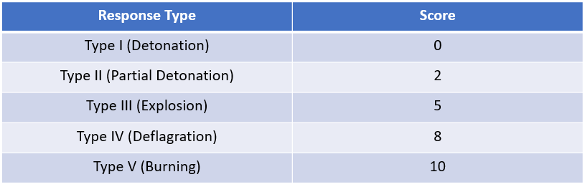
Figure 10, Response descriptor scoring [13].
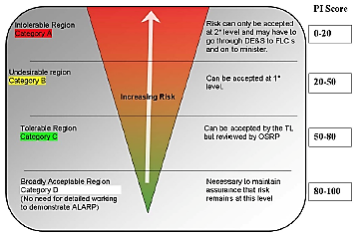
Figure 11, Performance indicator triangle [13].

7.2 AOP-4220 Fast Heating
The trial plan for the fast heating of the munition will follow the guidance set out in AOP-4240 [7]. This test is designed to provide evidence of the reaction of the munition when it is subjected to very high rates of heating. Which replicates a fuel fire of a transport vehicle. An IM should achieve a no more severe than type V (Burning), when subjected to an average temperature of 550ºC-850ºC within 30 seconds of ignition [3].

7.3 AOP-4382 Slow Heating
The trial plan for the slow heating of the munition will follow the guidance set out in AOP-4382 [8]. This testing procedure determines the response of a munition when it is subjected to a heat source (fire) that slowly heats a nearby or adjacent magazine, which may be found on a ship, depot or on a railcar. The IM response to this threat shall be no more severe than type V (Bruning), when the munition is heated at a rate of 1ºC-30ºC per hour until a reaction occurs [3].

7.4 AOP-4241 Bullet Impact
The trial plan for assessing the bullet impact of the munition will follow the guidance set out in AOP-4241 [9]. This testing procedure will assess and provide evidence for its response when subjected to being struck by small arms projectiles (12.7mm Armor Piercing). An IM response to this would be no more severe than type v (Burning) [3].

7.5 AOP-4496 Fragment Impact
The trial plan for this test will follow the guidance outlined in AOP-4496 [10]. The threat in this test is from the munition being struck by a fragment that could originate from nearby munitions detonating and generating natural/preformed fragments. The response type that an IM would give would be a type V (Burning) [3], from a steel fragment of 15g @ 2600 m/s and 65g @ 2200 m/s.

7.6 AOP-4396 Sympathetic Reaction
The test requirements and procedures will be specified by AOP-4396 [11], to provide evidence for the munition to sympathetically react to the worst-case reaction of an adjacent munition. The IM response to this test would be to type V-III (Burning-Explosion), with the Deflagration to Detonation Transition (DDT) and Compression, Release, Recompression Process to detonation (XDT) less likely with PBXs.

This test may also be used for HC, if an agreement between safety authorities on the number of test items, test item configuration and number of tests to be performed.

7.7 AOP-4526 Shaped Charge Jet Impact
The trial plan will follow the standard specified in AOP-4526 [12], which outlines the test requirements and procedures to provide evidence of the reaction of the munition from being struck by a shaped charge weapon. Reactions of a munition normally occur due to direct Shock Initiation (SDT), Bow Shock Initiation (BSDT) or for confined munitions DDT. However, an IM reaction would be type V-III (Burning-Explosion).

8.0 Hazard Classification

8.1 Overview
IM and HC differ to all other ordnance and munitions safety testing, as the pass criterion involves a potential explosive response. In other safety testing, the pass criterion should be no apparent explosive response and the munition is expected to remain safe for use. For HC, the response descriptors are similar to IM response types but the test responses and assignment of a Hazard Division (HD) are detailed in test series 6 and 7 [4]. As well as using Figure 14, to outline the procedure for the division of the class of munition.

The full-scale tests used in IM testing may additionally be applicable to hazard classification purposes. Which could allow only one test to be conducted for both testing programmes, but in order to achieve this, it is vital that the test requirements of each program are considered when proposing a test programme.
Although the combination of the two programs is possible it is necessary to bear in mind the issues that will be generated by achieving HC through combined testing and may require additional information or supplemental details.

8.2 Compatibility Groups
In addition to HDs munitions are assigned to one of thirteen compatibility groups, as shown in Figure 12Figure 14. The grouping of similar munitions allows the correct segregation in storage and transport. Using the definitions in Figure 12, it can be assumed that the Mk-3 cratering charge will be assigned to group D.
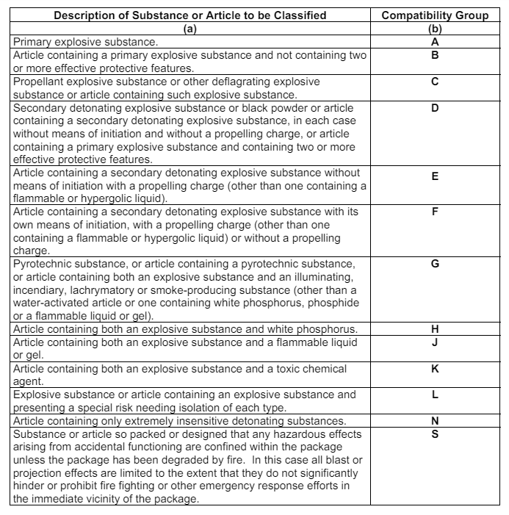
Figure 12, Description of Substance or Article to be Classified [14].

8.3 Testing Guidance
Series 7 testing comprises eleven tests (Figure 13). The first six tests (a – f) are used to establish if a substance is an Extremely Insensitive Substance (EIS) [4]. The last five tests (G – l) are to determine if an article containing EIS can be assigned to HD 1.6. Tests G – l share some similarities with IM testing and can be completed at the same time if data set out by the governing authority is collected.
In spite of this IMX-310 is not an EIS therefore the series 7 testing is irrelevant for the purpose of HC and series 6 testing should be followed.

Series 6 testing is used to assign a munition/ article to the division of 1.1, 1.2, 1.3, 1.4 (Table 11) or exclude it from the class of explosives [4]. Test 6 (c): External Bonfire Test assesses the munition and can assign one of the four divisions previously mentioned through analysis of the results of this test. Additionally, the compatibility group S can be achieved in this test by having no events that class it lower than 1.4 and having evidence of projections with kinetic energy not exceeding 8J on witness screens [4].
However, as IMX-310 is assigned an HD of 1.1D, it is likely that the Mk-3 cratering charge will gain the same HD through testing, as shown by Figure 14. An HD of 1.1 relates to a mass explosion hazard, which is shown in Table 11.

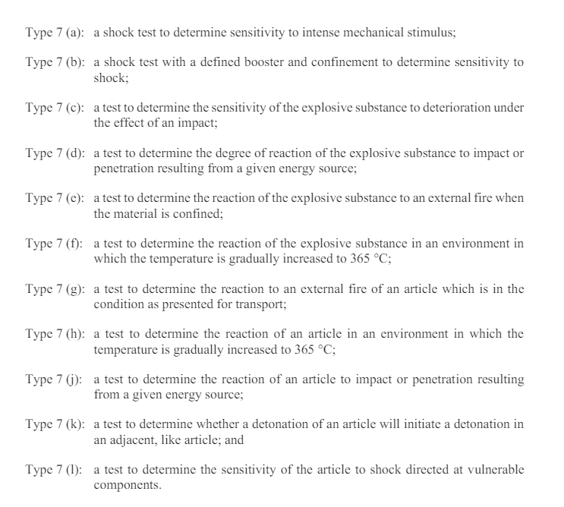
Figure 13 - Series 7 test descriptors [4].
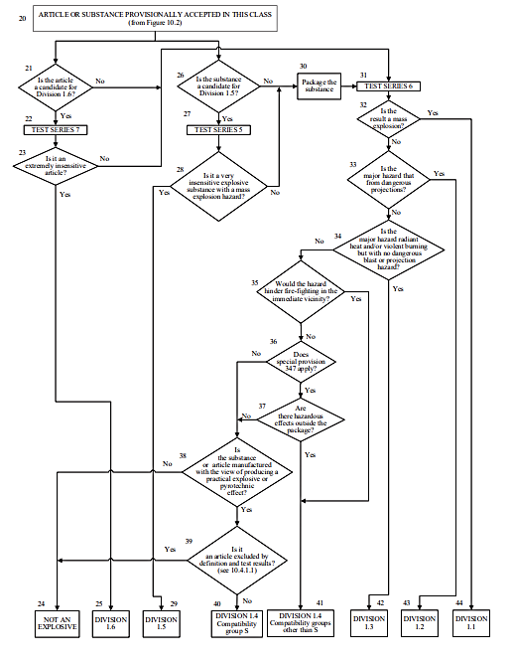
Figure 14, Procedure for assignment to a division of the class of explosive [4].
Table 11, Hazard Division descriptions [15].
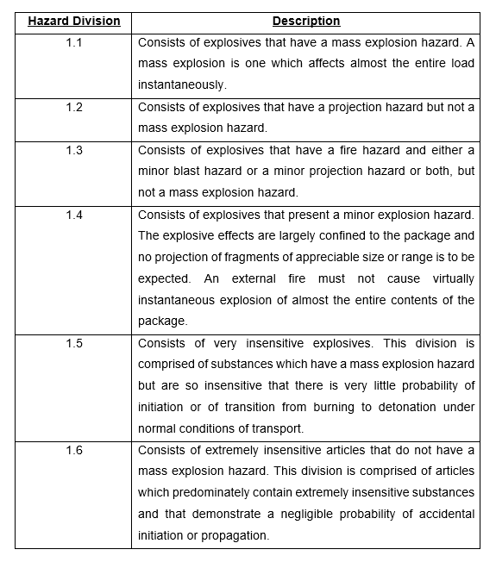

9.0 Conclusion
This portfolio set out to design and outline a test and evaluation plan of the purposed munition. The portfolio outlined how testing methods would be applied to each stage of the qualification of the munition. This involved EMTAP, Performance, IM testing and hazard classification testing which all followed the correct guidance and were compliant with health and safety regulations, through the construction of individual trial plans. The testing methods would allow the T&E-Engineer to achieve the requirements set out by the team.

By discussing the likely results in each of the tests, the portfolio has determined that IMX-310 and the use of mitigation design features that were identified by the T&E-Enigneer would likely make the munition IM compliant.

However, as IMX-310 is not an EIS, it would not achieve the HD of 1.6. in addition to this the munition is also expected to underachieve in performance testing, resulting in inadequate results. This led to the recommendation of a design re-evaluation, that would include ideas like an insensitive bag charge to keep the overall system IM compliant. A new design would still utilise the testing set out in this portfolio but with differing expected outcomes.

10.0 References

[1] | CBRNergetics ltd, “Charge, Demolition, Rapid Crater Kit (RCK) Mk. 2,” [Online]. [Accessed 01 05 2024].
[2] | NATO, STANAG-4147, Chemical Compatibility of Ammunition Components with Explosives (Non-Nuclear Applications), A ed., NATO, 2001.
[3] | North Atlantic Treaty Organisation, “AOP-039 , Policy for Introduction and Assessment of Insensitive Munitions (IM),” NATO Standardization Office (NSO), 2022.
[4] | United Nations, Manual of Tests and Criteria, Eighth ed., New York and Geneva, 2023.
[5] | Defence Ordnance Safety Group, Manual of Tests, 4 ed., vol. 1, Energetic Materials Testing and Assessment Policy Committee, 2007.
[6] | R. Hollands, Explosive Booster Selection Criteria for Insensitive Munitions Applications, Bristol: BAE Systems, 2006.
[7] | NATO, AOP-4220 Fast Heating Munition Test Procedures, A ed., vol. 1, NATO Standardization Office (NSO), 2018.
[8] | NATO, AOP-4382 Slow Heating Test procedures For Munitions, A ed., vol. 1, NSO, 2020.
[9] | NATO, AOP-4241 Bullet impact Munition Test Procedures, A ed., vol. 1, NSO, 2018.
[10] | NATO, AOP-4496 Fragment Impact Test Procedures For Munitions, A ed., vol. 1, NSO, 2019.
[11] | NATO, AOP-4396 Sympathetic Reaction Test Procedures For Munitions, A ed., vol. 1, NSO, 2020.
[12] | NATO, AOP-4526 Shaped Charge Jet Munition Test Procedure, A ed., vol. 1, NSO, 2018.
[13] | T. Lawrence, Email Communication, Outlining the methodology for ranking a munition that undergoes IM testing, 12th April 2024.
[14] | UK Gov, JSP 482 - Storage and Handling of Explosives, 4 ed., 2013.
[15] | Code of Federal Regulations, “49 CFR Part 173 Subpart C,” Pipeline and Hazardous Materials Safety Administration, Department of Transportation, 1990. [Online]. Available: https://www.ecfr.gov/current/title-49/part-173/subpart-C. [Accessed 11 05 2024].

