Shabilah Hussain
Student number- 1806501
Task name | Completion date | Members name
Marketing/Conclusion | 10/06/2019 | Alisha Powell 1806288
Finance/Introduction | 10/06/2019 | Shabilah Hussain 1806501
Human Resources | 10/06/2019 | Azmul Hussain

Introduction
The current business name is New Line, the choice of our legal status is a sole trader, mainly because it allows us to be able 100% of profit after tax and also allows us to focus on personal paperwork and finances however, the tax office will need to be informed before any action takes place, the company will also need to be protected by liable business insurance and income protection. “your business plan is the heart and soul of your operation and the most important set of documents provided by you to any lending institution or potential investor” (Covello & Hazelgren, 1995,p.2).
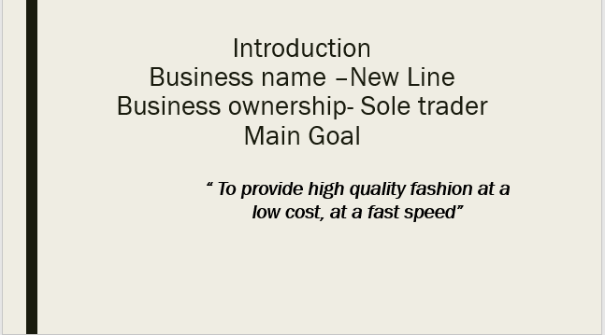
Our main goals are to provide high quality fashion at a low cost, in a fast speed. The type of products that will be sold are women’s clothes for age between 15 to 30 years old. With seasonal changes to keep up with the latest fashion on trends, the product price will be sold for more from the initial price that it was bought for e.g. top bought from the wholesalers could cost £5.00 and will be sold for £10.00. The company will be based in Newport in a small medium warehouse which will be rented at the cost of 16000 per annum for e.g.
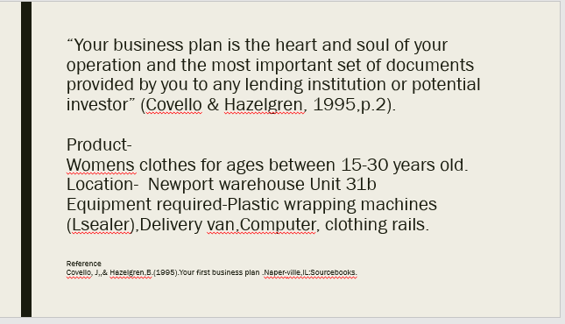
Thomas Edison said “anything that won’t sell, I don’t want to invent” (Abrams,2010,p.4).Questions for business owner to ask include:
- Is this something new?
- Is it something better?
- Does it have niche in an understand or new market?
- Would I buy it or use it?
Taking a look through different sources of finance. There were many came to mind:
Personal investment-which allows you to use personal savings, finances from family and friends.
Crowd funding- is normally a project raising money from a large variety of people that share interest.
Bank loans- when borrowing money and paying very high interest back to the company.
Grants- are funds given by a government, they often funded by foundation or trust, to help and support local businesses.
A preferable choice would be business grant, business loan and using savings:
£200,000 personal investment
£50,000 business grant
£50,000 business loan.
Business costs fall into 3 categories:
Fixed costs is when the cost do not vary for e.g.utility bills e.g. telephone, gas rent, advertising and insurance.
Direct or variable cost is when cost that increases with the level of output or sales such as raw materials, direct labour costs for staff, packaging, delivery charges, warehouse costs.
Capital costs is when money put into a business for long term items such as machinery, equipment, business vehicles.

The business should give some indication of the cost producing and its prices it proposes to charge. If It is then possible to make a profit. “The rest of that the financial projections the plan is material that makes the financial backer believe that the financial projection will come true” (Lasher, 1994)).

Start-up costs
Facilities | Cost
Initial rent | £16,000 per annum £1,333
Deposit | £850.00
Improvements | £300.00
Equipment | £800
Production machines/equipment | £5000,00 packaging£7000
Computer/Software | £100
Cash registers | £100
Tele communication | £80
Vehicles | purchased£15000
Materials/ supplies | £10,000
Office Supplies | £150
Stationary- business card | £80.00
Brochures/advertising | £300.00
Licences/ permits | £300
Accountants | £80.00
Insurance | £300,00
Marketing | £500.00
Design and technical consultants | £100
Promotional activities | £10,000 one off payment
Employees | 8 staff £888,00 per month
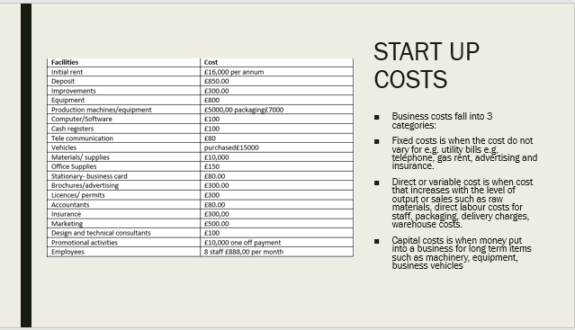
 | Month 1 | Month  2 | Month  3 | Month 4 | Month 5 | Month 6 | Month 7 | Month 8 | Month  9
Purchase raw material | £10,000 |  |  |  | £10,000
Bulking and transport | £3000 |  |  |  | £3000
packaging | £2000
Personal cost | rent £1333 | rent £1333 | rent £1333 | rent £1333 | rent £1333 | rent £1333 | rent £1333 | rent £1333 | rent £1333
Loans from bank | £300 | £300 | £300 | £300 | £300 | £300 | £300 | £300 | £300
Wages | £888.00 | £888.00 | £888.00 | £888. | £888.0 | £888.0 | £888.0 | £888 | £888

Cash flow forecast should highlight periods when problems may appear, it lists all of cash receipts and payments month by month and keeps track of the monthly bank balance . Cash flow will list all expected incoming and outgoings over the first year. Cash flow calculations are important, but at this stage it can be approximate.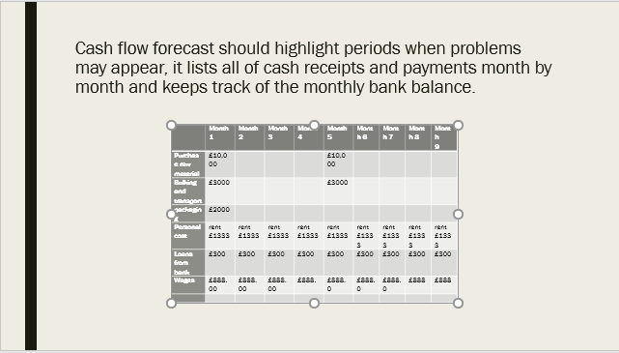
Gantt chart is a planning resource created by Henryl Gantt, it is frequently used in a project management, business. this chart will support the business going forward it provides a schedule that helps to plan and track specific task.
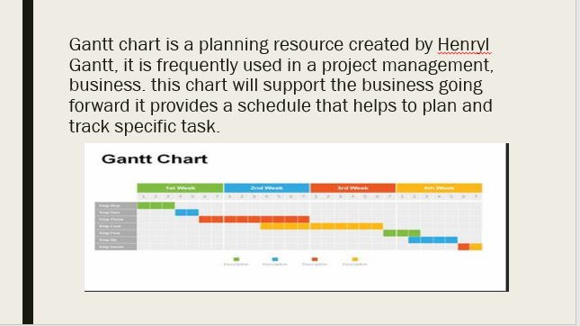

References

Covello, J,,& Hazelgren,B.(1995).Your first business plan .Naper-ville,IL:Sourcebooks.
Abrams,R.M.(2010). The successful business plan: secrets & strategy (5th ed.). Palo Alto,CA: The planning Shop.
Arkebaur,J. B (1994). The McGraw-hill guide to writing a high-impact business plan: A prove blue print for entrepreneurs.New York,NY: McGraw- Hill.
Bangs,D.H.,Jr.(1995) the business planning guide: creating a plan for success in your own business. Chicago,IL: upstart publishing.
Toolshero. (2019, june 07). Toolshero. Retrieved from H.Gantt: https://www.toolshero.com/toolsheroes/henry-gantt/

Lasher, W.(1994).the perfect business plan made simple. New York, NY: Doubleday Dell

