Network and Cyber Security Essentials

Name: Aidan Griffiths
Student Number: 2501271
Module: Network and Cyber Security Essentials
Course: Software Engineering

Cisco Packet Tracer Certificate
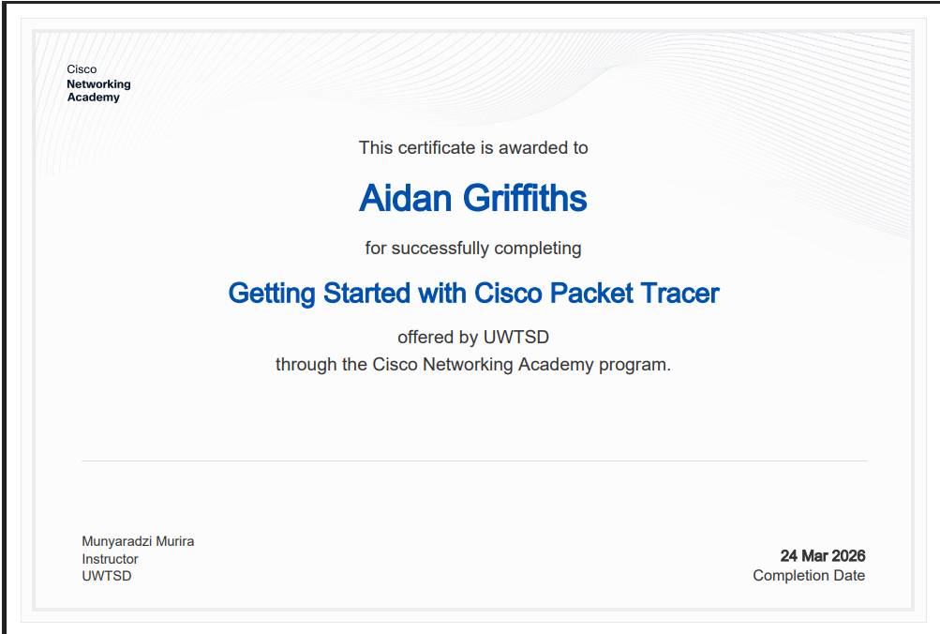

Identification of Modern Threats
Right now, companies are dealing with loads of different cyber threats, and honestly a lot of them are getting worse because everything is moving online and people are working from home more. AI has also made some attacks way easier for hackers to pull off. One of the biggest issues is Ransomware-as-a-Service, this is when attackers can buy ransomware kits online then use them without needing technical skill. This makes ransomware attacks much more common and more damaging, especially because many groups now steal data before encrypting is. Another big threat is Ai-powered social engineering which includes phishing, vishing, deepfake videos and voice calls. Attackers use ai tools to create extremely convincing messages or impersonations which makes it harder for staff to recognise scams.
Another major issue is AI-powered social engineering. Phishing has always been a thing, but now attackers are using AI to create super convincing emails, fake voices, and even deepfake videos. ENISA reports that phishing is still the number one-way attackers get into systems, and around 60% of initial breaches start with it. With AI tools, these scams look way more realistic, so staff are more likely to fall for them.
Supply chain compromises are also a growing problem. Instead of going straight for a big company, attackers target smaller suppliers because they’re easier to break into. ENISA points out that supply chain compromises are increasing, especially in sectors like manufacturing and transport. Once a supplier is hacked, the attacker can move through the chain and hit bigger organisations.

Modern Security Policies
To deal with these threats, organisations need more up to date security policies that follow the Zero Trust model and work with NIST CSF and ISO 27001. An important part of this is having strong identity and access management policies. This includes making sure that companies use multi-factor authentication, using limited access and monitoring user behaviour to spot unusual activity. Password less authentication is also becoming more common as it reduces risk of credential theft.
Another important policy is device and endpoint security. All devices should meet security requirements before connecting to the network. This means having full disk encryption and keeps everything updated. Organisations also need network segmentation policies which break the network into smaller sections so attackers can’t move around easily if they gain access.
For cloud environments, a cloud security policy is important. This should include using CSPM tools to detect misconfigurations, following CIS benchmarks and logging all cloud activity. Finally, supply chain security policies help reduce third-party risks. This means assessing vendors requiring them to follow standards like ISO 27001 and asking for SBOMs for critical software.

Technical Mitigation Measures
There are several technical and administrative measures that organisations can implement to reduce the risks from modern day threats. One of the most effective is multi-factor authentication which protects accounts even if passwords are stolen. Hardware keys or authenticator apps are recommended because they are much harder to bypass than just SMS codes. Another tool is SIEM which collects logs from across the organisation and uses them to detect suspicious behaviour. SEIM is especially useful for spotting early signs of ransomware or insider threats.
To speed up response times, many organisations also use SOAR which automates incident response tasks. For example, if malware is detected on a device, SOAR automatically isolates is without waiting for a human. Finally, Zero Trust Network Access replaces traditional VPNs with identity-based access meaning users only get to access to specific resources they need.

Proactive Monitoring and Incident Response
A modern organisation needs 24/7 monitoring to detect threats quickly. This usually involves a combination of SIEM for log collection, SOAR for automated responses and a SOC team to handle escalated alerts. Threat intelligence feeds such as CISA known exploited vulnerabilities list, help organisations stay aware of active threats and update their detection rules.
Incident response should follow the NIST SP 800-61 framework. This starts with preparation which includes having the right tools, training and backups. The next step is detecting and analysing. SIEM is used for alerts or user reports help identify an incident. After that, eradication removes malware and patching vulnerabilities. Recovery restores systems safely and finally lessons learned helps to improve policies and prevent similar attacks from occurring in the future.

Continuous Training and Awareness
In cyber incidents, human error is still one of the biggest causes. Organisations need a strong training programme which should include monthly training such as short videos or quizzes on topics like phishing, cloud safety and password hygiene. Regular attack simulators are also used and include fake phishing emails, vishing calls, USB drop tests and social engineering scenarios to help staff members recognise real threats.
An annual certification gives everyone a better understanding of the basics of cybersecurity and Zero Trust principles. To keep people engaged, organisations create games such as leaderboards, competitions and rewards for spotting phishing attempts. Finally, executive-level training is important because managers need to understand the business impact of cyber-attacks and how to communicate during a cyber crisis and what their legal responsibilities are.

Diagrams
Zero Trust
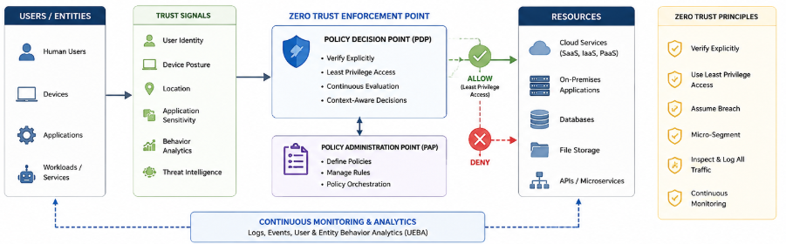

SIEN Process Flow
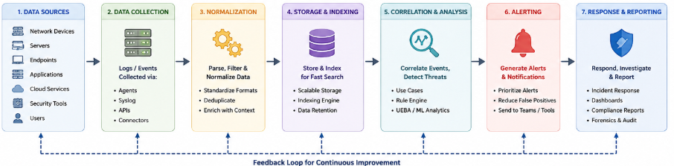

References
Cybersecurity and Infrastructure Security Agency (2023). Known Exploited Vulnerabilities Catalog | CISA. [online] www.cisa.gov. Available at: https://www.cisa.gov/known-exploited-vulnerabilities-catalog.
Computer Security Division, Information Technology Laboratory, National Institute of Standards and Technology, U.S. Department of Commerce (2019). Publications | CSRC. [online] Nist.gov. Available at: https://csrc.nist.gov/publications.
NIST (2025). Cybersecurity Framework. [online] National Institute of Standards and Technology. Available at: https://www.nist.gov/cyberframework.
International Organization for Standardization (2022). ISO/IEC 27001 standard – information security management systems. [online] ISO. Available at: https://www.iso.org/standard/27001.
Google (n.d.). Privacy and security & Cloud compliance. [online] Google Cloud. Available at: https://cloud.google.com/security.

