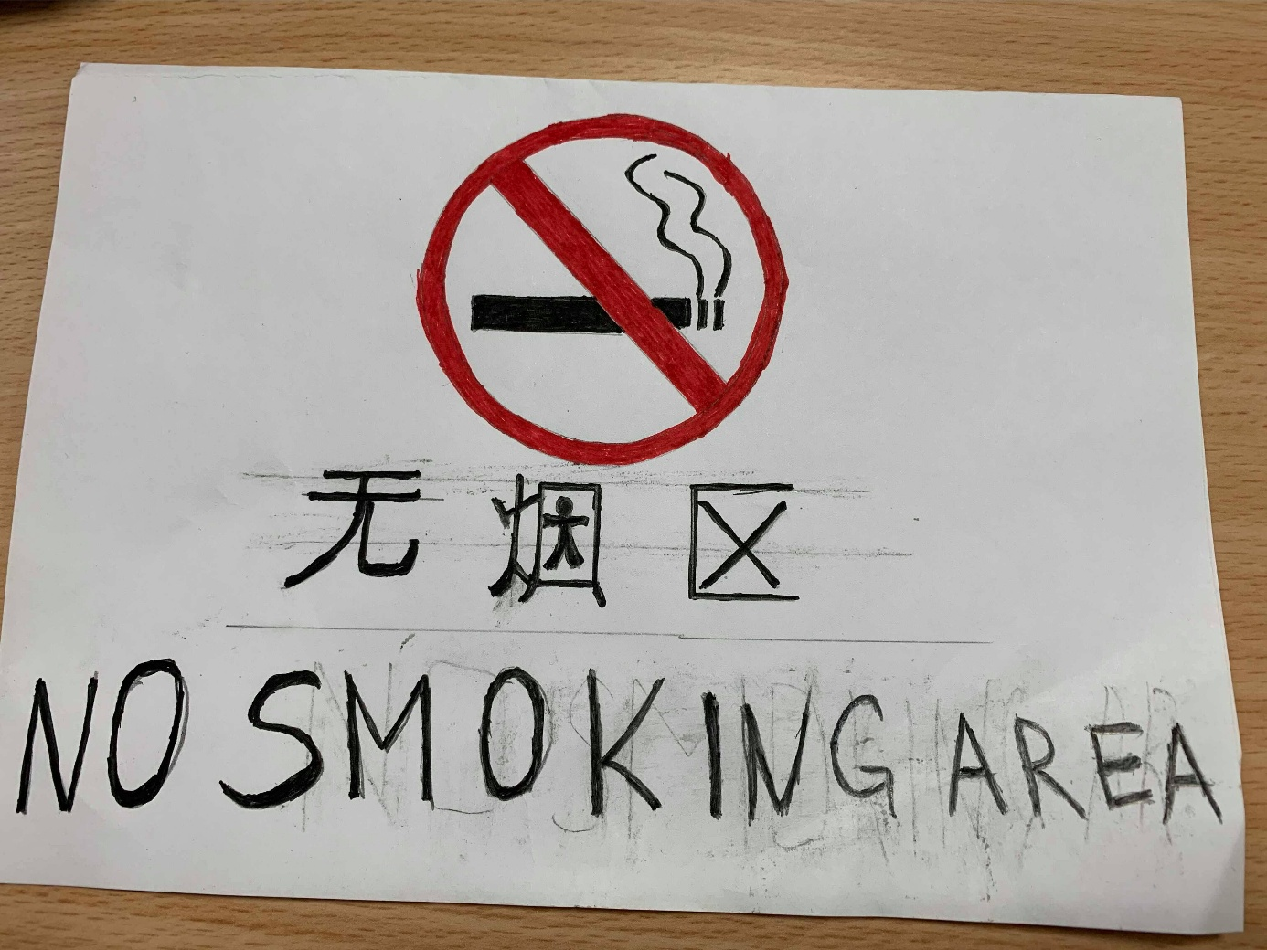
University of Wales Trinity Saint David – International Hotel Management
M5X01923_FLC_A5_Oct 19 - Part 1
Student: Stoyanka Tsvetkova
Student Number: 1815041
Chinese Signboard

