A Critical Evaluation and The Identification Of The Next Teaching And Learning Steps Focusing On A Case Study Of An Individual Of A Learner Or Group Of Learners, Based On An Observed Critical Incident.
Introduction
In this essay I report my findings from spending a day in a Secondary School, and the incidents I deem to have been critical, which I observed in a variety of lessons throughout the day. After careful review I will choose a singular critical incident and investigate further. It became clear from observing a variety of lesson throughout the day that, to deem an incident ‘critical’, it does not have to be a catastrophic event, nor does it have to be a standout moment. It is the level of critically which I apply to the situation and allows me to give thought to my own teaching practise and how it can be improved to make for a better learning experience for both myself and the pupils. For a better learning experience to take place I believe that better teaching is required and as Paul Ramsden states ‘self-reflected evaluation’ and communication and scholarship (‘Learning to Teach in Higher Education’, p.216,2002.) must be used frequently alongside observations from colleagues to become a well- rounded teacher who is constantly developing their professional practise, and is done throughout a teachers career. Thus, giving pupils from lower KS3 to upper KS4, the best learning experience possible. And in my opinion, teachers who allow themselves time to do this are the most well rounded.
Observation
The school I attended, which will now and throughout the Essay be known as ‘School A’ is considered a ‘super school’, where the school caters for children from ages 3 to 16 and has approximately 1080 secondary pupils and is an English medium school. The school does not promote Welsh as the date was written in English and the pupils answered the register in English. The school places a huge emphasis on pupils emotional and mental wellbeing. There is a full time ‘school councillor’, who was strategically ‘tucked away’, so pupils did not feel embarrassment if support was needed. The school also has ‘ready to learn rooms’ which are designed especially for pupils who have been removed from their lessons, and will spend a full school day there, where they will continue with their school work, and are given time to self-reflect on their behaviour. The school has a well-established ethos, which is at the heart of all they do which can have a huge effect which is supported by Wilhelm Kirch in the ‘European Journal of public Health’ as ‘A strong school ethos was linked with lower levels of recurring sickness absence among the students’ ( Kirch,p.316 2019) . The school believes that the three cornerstones which make up their ethos are the building blocks to becoming a well-rounded individual. The ethos is as follows, Aspiration (ambitious, capable learners) Belonging (ethical, informed citizens) and Character (healthy confident individuals), which encapsulates three of Donaldson’s four purposes. Pupils are streamed after their first term in Year 7. ‘Aspiration’ is the highest stream and that was the band, where I did a pupil trail. ‘Belonging’ is the middle stream, and ‘Character’ was the lowest stream. The pupils would stay in these streams throughout the day. However, during morning registration the abilities are mixed. The school has a very well- established behaviour policy that was clearly displayed in the hallways and in the classrooms, which I believe allowed the children to immediately know what was expected of them and according to Roy Lund in his book ‘Behaviour Policy. A whole School Behaviour Policy: A Practical Guide’, ‘with positive beliefs about success in teaching and learning and appropriate behaviour, there will be very few children whose behaviour remains inappropriate’ (Lund, p.17,2014). Teachers were encouraged not to shout, and to use other behaviour management techniques. This created a calm environment where the teachers and pupils had a mutual respect and allowed for a safe place for the pupils to learn.
Methodology
I felt it pertinent to become a non -participant observer because I felt this method to be the most viable for several reasons, although there were many other strategies available to me. By becoming almost invisible to the pupils, which I did for all lessons, allowed me to get more of an organic glimpse of the pupils and collected data which is supported by the view of Ann Bonner and Gerda Tolurst in their book ‘Insider Outsider Perspective Of Participant Observation’ ‘which was occurring in the natural setting in which the participants are located’ (Bonner and Tolurst,2003). I was able to form a non-biased opinion when observing the pupils, because I was only given the first name of the child I was trailing and their time- table for that day. I do feel that there are potential pit falls of choosing the non- participant observer method. My presence alone could still have had a Hawthrone effect, as the pupils might have acted differently, especially the pupil I was trailing. Because I was observing from a distance, I had to use educated guesses and my own judgment to reach certain conclusions, like, if the teacher always maintained control in the classroom, and if pupils spending a whole lesson doing paired work was an established norm. I was aware of impression management; perhaps pupils were on their best behaviour so they could present themselves in the best light possible and as Derek Rowntree states in his book ‘Assessing Students, How Shall We Know Them’ ‘the very act of observing or measuring may alter the thing being observed or measured’ (Rowntree 2013). Perhaps if I had not been an observer in the classroom, the dynamics might have changed. Using quantitative data to collect evidence to establish a critical incident, would have been incredibly difficult because factors out of my and the teachers control can occur during a lesson, like relationships between a friendship group disintegrating or if the lessons takes place before or after the pupils break and lunch time. Even if I were able to observe the same Religious Studies lesson carried out by the same teacher at the same time with another top band year 8 class, the outcomes could be totally different from one other. I am aware that there are both negative and positive arguments to both methods mentioned above, I feel that the one I chose, was the method best suited to not only myself, but the class.
Critical incident
The incident that I deemed to be ‘critical’ occurred during a Year 8 top band Religious Studies lesson see Appendix 2. The teacher explained to the pupils, that they would be building on their idea of community-an idea they had previously explored in year 7. The teacher asked the pupils to write their own definition of ‘community’, so prior knowledge could be established. The teacher explained how the pupils needed to create a ‘life journey map’, beginning from when they are born spanning until death. This critical incident relates to two of Donaldson’s Four Purposes: The first being ‘ambitious, capable learners’, and makes up one third of the school’s ethos as it is written underneath ‘Aspire’. By giving pupils total autonomy of their work, and making it clear that what they included was their decision, and as Jacob Belik,Miroslaw Pawlak, Anna Mystkowska-Wiertelak sates in their book ‘Autonomy In Second Language Learning: Managing The Resources’ ‘introducing the principals of autonomy on a young learner is undeniably possible thanks to learner’s natural inclination to be independent.’( Belik,Pawlak and Mystkwska Wiertelak,p.81,20.6). The teacher did place some example milestones on the board but stressed that the examples were not compulsory and entirely optional. The teacher continuously told the pupils how much potential and possibility they possessed and how they should aim hight, which gave the pupils the confidence to create ambitious goals. But the teacher reminded pupils that a lot of hard work and determination would be needed to succeed. The pupils putting pen to paper and writing down their ambitions for their future makes it something tangible rather than being out of reach and ‘you can see for yourself what it takes to get it’ according to John and Sarah Maclure in their book ‘How To Find Your Dream Job And Make It A Reality’ ( Maclure,p.50, 2003). The teacher included numeracy in the lesson as pupils had to apply mathematical concepts, like probability to make an educated guess about their futures and the ages they would hit certain milestones. The task also showed the pupils that learning is lifelong and does not end after year 11. The teacher explained that some may choose to continue their educational based learning and go onto university, whilst others may choose a vocational route and will need to learn the necessary skills to gain their qualification. They made all pupils feel included by giving a third option where some will choose to leave school at aged sixteen and get a job that does not require further education or qualifications. Healthy Confident individuals was the second purpose to be identified and made up the second corner stone of the school ethos as it is written underneath Character. The teacher gave the pupils the independence to create their own version of the task. This gives the impression that the pupils were confident in their capabilities ‘to carry out a task with little instruction and gives learners the feeling of accomplishment and success’ (Bielak, Pawlak,Mystkowska-Wiertelak p.81,2016). The pupils demonstrated self-confidence and self-belief as they set such high targets for themselves. This task allowed pupils to build on their self- esteem because the teacher constantly rooted for the children and reassured them that they could achieve anything. Which was spurred on by the safe and supportive atmosphere the teacher created in the classroom, which Joan Young supports in her book ‘Encouragement In The Classroom: How Do I help Students stay Positive and Focused’ because ‘students learn better when they view the learning environment as positive and supportive’ (Young,p.1, 2014), as the pupils would cheer on and vocalise how much they believed in their classmate.
Literary Review
After investigating my chosen critical incident further, I feel addressing the Constructivism school of thought is essential, as it has, in my opinion the most influence on a student’s success in the classroom which is supported by Patil Arun in her book ‘New Media Skills For Engineers In IT’ ‘because knowledge is actively constructed by students based on existing knowledge and create new knowledge in mind with the help of social interactions with teachers and peers’(Arun, p.185,2012). Which was evident in the lesson as the pupils were encouraged to build on their previous knowledge to complete a new task. To look at Constructivism we must also look at the opposing school of thought called Constructionism, which places much of the pupil’s success on the teacher’s ability to teach and is a method I feel is not as successful as constructivism, because I feel it allows pupils to rely on teachers to solve problems. However, we do need to take into consideration how powerful the instructors influence and chosen teaching method is on the learner. It can massively impact on learner’s success which is highlighted in John Hattie and Eric M Anderman’s book ‘International Guide To Student Achievement’ because ‘teachers are the most important mediators of knowledge within a school’, which is especially true during exam time. (Hattie and Anderman, p.80,2013)
This literary review will compare the Constructivist approach, how it has been both criticized and praised, along with the gradual evolution of the Constructionist approach. If one believes that Constructivism is the best method to use, we must look at social pioneers like Vygotsky and Leontiev as well as Brown, Collin, and Duguid and Swiss Psychologist Jean Piaget, who is according to Silke Mikekskiks-Siefert in his book ‘Four Decades Of Research In Science Education’ ‘is the father of personal (cognitive) constructivism’ (Mikekskiks-Seifert, p.165,2008). We must also look at the learners and how to create a collaborative, interactive environment within the classroom. Vygotsky was able to bring a social element to Constructivism as he created the Zone of Proximate Development (ZPD) and as Janet Salmens and Lynn Wilson explain in their book ‘Handbook Of Research And Electronic Collaboration And Organizational Synergy’ describes ‘the distance between what one can do alone and what can be accomplished in collaboration with others who are more capable’ (Salmens and Wilson, p.283,2008). This still holds precedent as one of the most prevailing constructivist concepts within education. Vygotsky believed before knowledge can be internalised by the individual, knowledge needs to pass between several individuals. He also believed that children make the most important discoveries when they are in a social environment. We cannot discount how vital those more able are in relation to a child’s learning, as the more abled other can help move children through the ZPD, where learning and cognitive development took place. Which emphasises how important a more able other is because learning can be enhanced via their interactions with a person who is more knowledgeable than themselves. Although it is not specified how the more knowledgeable other should support the individual, it does emphasise the importance between social interactions and collaborations alongside the individuals cognitive development and social collaborations. I feel that the pupils were able to complete the task so well was because the encouraging interactions they had with their fellow classmates.
Piaget, however, believed that a child’s cognitive behaviour is not extrinsically motivated but is intrinsically motivated instead, even though it is a well-known fact that children are influenced on how they think via social interactions, which is supported by Robert Berns in his book ‘Children, Family, Community: Socialization and Support School’ ‘socialization exerts a strong influence on children's ideas and behaviour (Berns,P.52,2006).Yet Piaget still maintained that children are designed to think and learn because they have been designed to and have evolved over time to do so. To justify his argument, he created the Stages of Cognitive Development to reiterate his point that children become intellectually developed through a process of experience and maturation.
Although Constructivism has been accepted by many educators, it still faces some criticism. An argument that has been put forward by Kirschner, Sweller, and Clark, and can be found in David W Kriitt’s book. ‘Construction Education in An Age of Accountability’ is that ‘it is minimally guided and assumes students can rediscover major scientific ideas for themselves, whereas teaching will only be successful when there is direct instruction of difficult abstract ideas’. (Kritt, p.79,2018) However, the pupils received ‘minimally guided instruction’ and were still able to build upon their previous knowledge and created a well thought out and detailed piece of work. Critics also feel that Constructivism ignores contextual factors within a learning environment, like recourses available to the individual, and the learner’s preferences, does the learner learn best via visual, audio or kinesthetics methods?
Although Constructivism has its opponents, it remains a powerful school of thought due to the many supporters it has. Supporters claim that Constructivism allowed for the creation of knowledge for the learner which alleviates the pressure from the child because the instructor does not place the responsibility for learning solely on students. Implementing the Constructivist approach allows the students to become active participants in their lessons as opposed to passive recipients of the information being given. Constructivism will enable them to generate new ideas and better themselves, and this view is supported by Christine Phin Mushibwe who writes in her book ‘What Are The Effects of Cultural Tradition On Education Of Women’ ‘their curiosity will enable them to critically evaluate the relevance of some cultural ideas instilled in them’ (Mushibwe,p.222,2014). Which I feel is hugely important, as the new curriculum will revolve around Donaldson’s Four Purposes which, strives to make learners ‘culturally informed citizens’, and allowing the learner to generate their own ideas in a controlled environment is the best way to do this. Supporters of this school of thought feel that this approach enables children to be led by curiosity when learning takes places, instead of being led by a large quantity of data. Furthermore, people of various ages can construct knowledge and as Anne Watson, Keith Jones and David Pratt state in their book ‘Key Ideas In Teaching Mathematics’ ‘we are constantly confronted with decision making situations to which they might apply strategic thinking’ (Watson, Jones and Pratt, 2013). This must be done without constant guidance and instruction, as the individual can construct their own knowledge using prior knowledge. Jeff C Marshall writes in his book ‘Overcoming Student Apathy’ ‘using scaffolding as a means of support still gives pupil the freedom to be led by their curiosity by, providing engaging ideas that sparks curiosity’ (Marshall,p.125,2008). This, in my opinion, is far more effective than giving the individual large amounts of information. Additionally, scaffolding still allows the pupil to take an active roll in their learning without relying massively on the instructor. When I observed scaffolding taking place, the pupil was able to complete the task independently, as they had the correct tools to learn.
As previously established Constructivism, is a process where the individual learns from previously acquired knowledge, and it can be built upon in a collaborative environment. Constructionism, however, places its focus on the teaching process. It needs to be acknowledged that Constructivism and Constructionism although different from one another, David L Blustien reminds us in his book ‘The Oxford Handbook Of The Psychology Of Working’ ‘there is some overlap with each of these domains’(Blustien,p.38,2013). Yet, with Constructionism learners are given more instructions to be able to learn. Which I feel does not benefit the learner in the long term, as they become dependent on an instructor to supply them with knowledge.
Seymour Papert a former student of Piaget criticised his methods. Thus, encouraging Papert to develop a theory known as Constructionism - which has evolved from Constructivism. Unlike Constructivism, Papert believed that for learners to gain knowledge, the learner must be able to create physical artifacts, to allow them to put into practise the newly acquired knowledge they have gained. This is done so the learner can process the newly acquired knowledge and make it tangible, whilst they are engaged. A learning outcome can be viewed and used by those around the learner. Knowledge is constructed by the learner physically practising their skills- such as handwriting, instead of intangibly .Papert also believed that knowledge is constructed in a learning environment when complex issues and real world issues are brought to the forefront, and as Edith Ackerman states in her Article ‘Piaget’s Constructivism, Papert’s Constructionism, Whats The Difference’ ‘he stresses the importance of tools such as media, and context in human development, which optimises their interactions with the world’, (Ackerman,P.1 2001). This was threaded throughout most lessons as teachers had chosen relevant topics in relation to today’s issues, such as racist poetry in English (see appendix 4). Most importantly the learner must be engaged and involved because knowledge is a vital element when learning.
Researchers such as Ackermann believes that Papert’s theory of learning can help with our understanding of how the learner forms ideas due to cognitive learning. Papert’s creation of Constructionism places great emphasis on designing products of learning and that is where authentic learning can happen. Which suggests that learning can not only occur cognitively, which is believed by Constructionist’s, but also needs to be both tangible and physical for the learner. Constructionism differs from Constructivism as they believe physical products need to be used, while Constructivists focuses on cognition for learning to take place. For Constructionism to occur the learner must create a product that is tangible, and as Seymour A Papert tells us in his book ‘Mindstorms: Children, Computers and Powerful Ideas’ uses the phrase ‘object-to-think-with’. (Papert, p.10,2020)
Personal understanding is another important part when looking at the Constructivist school of thought because it is largely founded by prior knowledge. Therefore, it is essential that the learner is both involved within a democratic environment that has been created, so collaboration can be established. However, those who follow the Constructionist school of thought, students are blank canvases that teachers must mould by giving them instruction. Constructivists, however, feel that instructors do not have to be, specifically teachers. It places a focus on the learner’s cognitive process and Constructionism focuses more on tangible knowledge.
Reflection/Evaluation:
After allowing myself time to reflect on my day in School A, and the variety of lessons I had the opportunity to observe, and a deeper investigation of my chosen critical incident. I can say with confidence that observing was not only a worth-while experience but a very enlightening one and I am in agreement with Edward Conrad Wraag, in his book ‘An Introduction To Classroom Observation’ as he says ‘it can be one of the most rewarding and effective means of improving teaching’ (Wraag p.120, 1994). I found it very inspiring to see how each teacher regardless of the subject or topic, taught with such enthusiasm, that a real love for not only their subject but their passion to see each child succeed and thrive shone through. I felt that the Critical incident I chose to further explore was very interesting, but also a great example of how to include both cross curricular and Donaldson’s four key purposes in a lesson, without it becoming unnatural or strained. As an English PGCE student, I was able to see how you can make your subject so much broader than what the pupils believe it to be, and how with the enough creativity cross curricular elements and the four purposes can be included and make up a well -rounded, purposeful lesson. Like Johnathan Barnes says in his book ‘Applying Cross Curricular Approaches Creatively’ that ‘cross curricular learning and subjects are not opposites’(Barnes p.10, 2018). Each teacher I observed managed the classroom and did so without having to raise their voice which adhered to the school’s ethos of a ‘non-shouting culture’. However, that could be attributed to the Hawthorne effect which I mentioned earlier in my essay. Although I have praised the teacher on how well they manged the class, it does need to be taken into consideration, that the class was the highest stream, and presented no challenging behaviour during the other lessons. It could be argued that the reason why the teacher managed the class so well, was not because of excellent behaviour management but because the pupils had an excellent attitude towards learning. I do feel that the level of engagement, was partly because of the pupil’s attitude. But it must be noted that the teacher created an engaging lesson and Herbert Grossman highlights this in his book ‘Classroom Behaviour Management For Diverse And Inclusive Schools’ that ‘students are usually well behaved and absorbed when their classes are interesting’(Grossman,p.110, 2004), additionally the lesson did not require a vast amount of prior knowledge or understanding. Which meant pupils, did not have to spend a long period of time sitting quietly listening to the teacher speak. So, it would be interesting to see the level of engagement from pupils when the teacher is talking for a prolonged period and delivering instruction after instruction. Although a starter activity was included, which allowed the pupils to warm up to the lesson and get a feel for the upcoming task. I felt that the lesson could have been improved if a plenary had been included which is supported by Cathy Burnett and Julia Myers in their book ’Teaching English,3-1: The Essential Guide For Teachers as ‘plenary sessions provide a valuable opportunity for self-reflection, enabling children to re-visit what they have done’ (Burnett and Myers,p.163, 2014). I understand that given the nature of the lesson, it would have been difficult for the teacher to create a plenary, but I do feel it would have been useful for the pupils to receive one, instead of packing up and then moving straight onto their other lesson. However, this is easy for me to suggest when I am not delivering the lesson. To reach a more concrete conclusion I will implement these techniques in my own lessons and teaching practise to see if ability, type of activity, and the length of teacher talking time, has an impact on student behaviour regardless of ability. Alongside this, I will dedicate time to carrying out my own research, to ensure I am practising the correct pedagogical principles to meet the needs of all pupils in my class and the importance of this is highlighted in Terrance Lovat, Kerry Dally, Neville Clements and Ron Toomey’s book ‘Values Pedagogy and Student Achievement: Contemporary Research Evidence ‘the correct pedagogy can make the difference in enhancing student learning and participation’(Lovat, Dally, Clements and Toomey P.17,2011). I have also learnt that observations are a key part of teachers being able to review their practise, as long as it is done ethically and does not aim to humiliate or negatively criticize the teacher, but rather, offer constructive criticism and feedback, which allows them to continue their professional development and improve.
Conclusion:
To conclude, the time spent in School A was a very positive experience and will help greatly in not only the coming months but throughout my career as an English Teacher. I do not regret my decision to choose the non- participant method of observation because I had the freedom to look at the classroom, pupils and teaching as a whole, which allowed me to pick from a wealth of interesting incidents that I witnessed throughout the day. Furthermore, my chosen method allowed me to make many notes throughout day, and write them down as they occurred, something I would have been unable to do if I had focused my attention else-where, like speaking with pupils or looking through their books. By sitting at the back of the classroom and not engaging with pupils it allowed me to build a clearer picture of classroom dynamics and the different pedagogies different teachers implemented in their classroom, even though they all had the same class. And as Sally Brown, Carolyn Earlman and Phillip Race state in their book ‘500 Top Tips For Teachers’ ‘the way we work with children is a very personal thing’ (Brown, Earlman and Race p.3,1998 ), and what may work well for one teacher in a certain subject area may not work for you. But as Brown, and Earlman and Race remind us ‘whilst you can implement some tactics that other teachers use it is important you develop your own style’ (Brown, Earlman and Race p.3). My day spent observing showed me how teachers from all subjects can make cross curricular links whilst implementing the four purposes and doing so purposefully. But most importantly how vital it is that those in the teaching profession take the time to critically reflect on their practise and pedagogy for their continued professional development and to maximise pupil’s experience.
Word Count 4494

Appendices- Observation/ Field notes
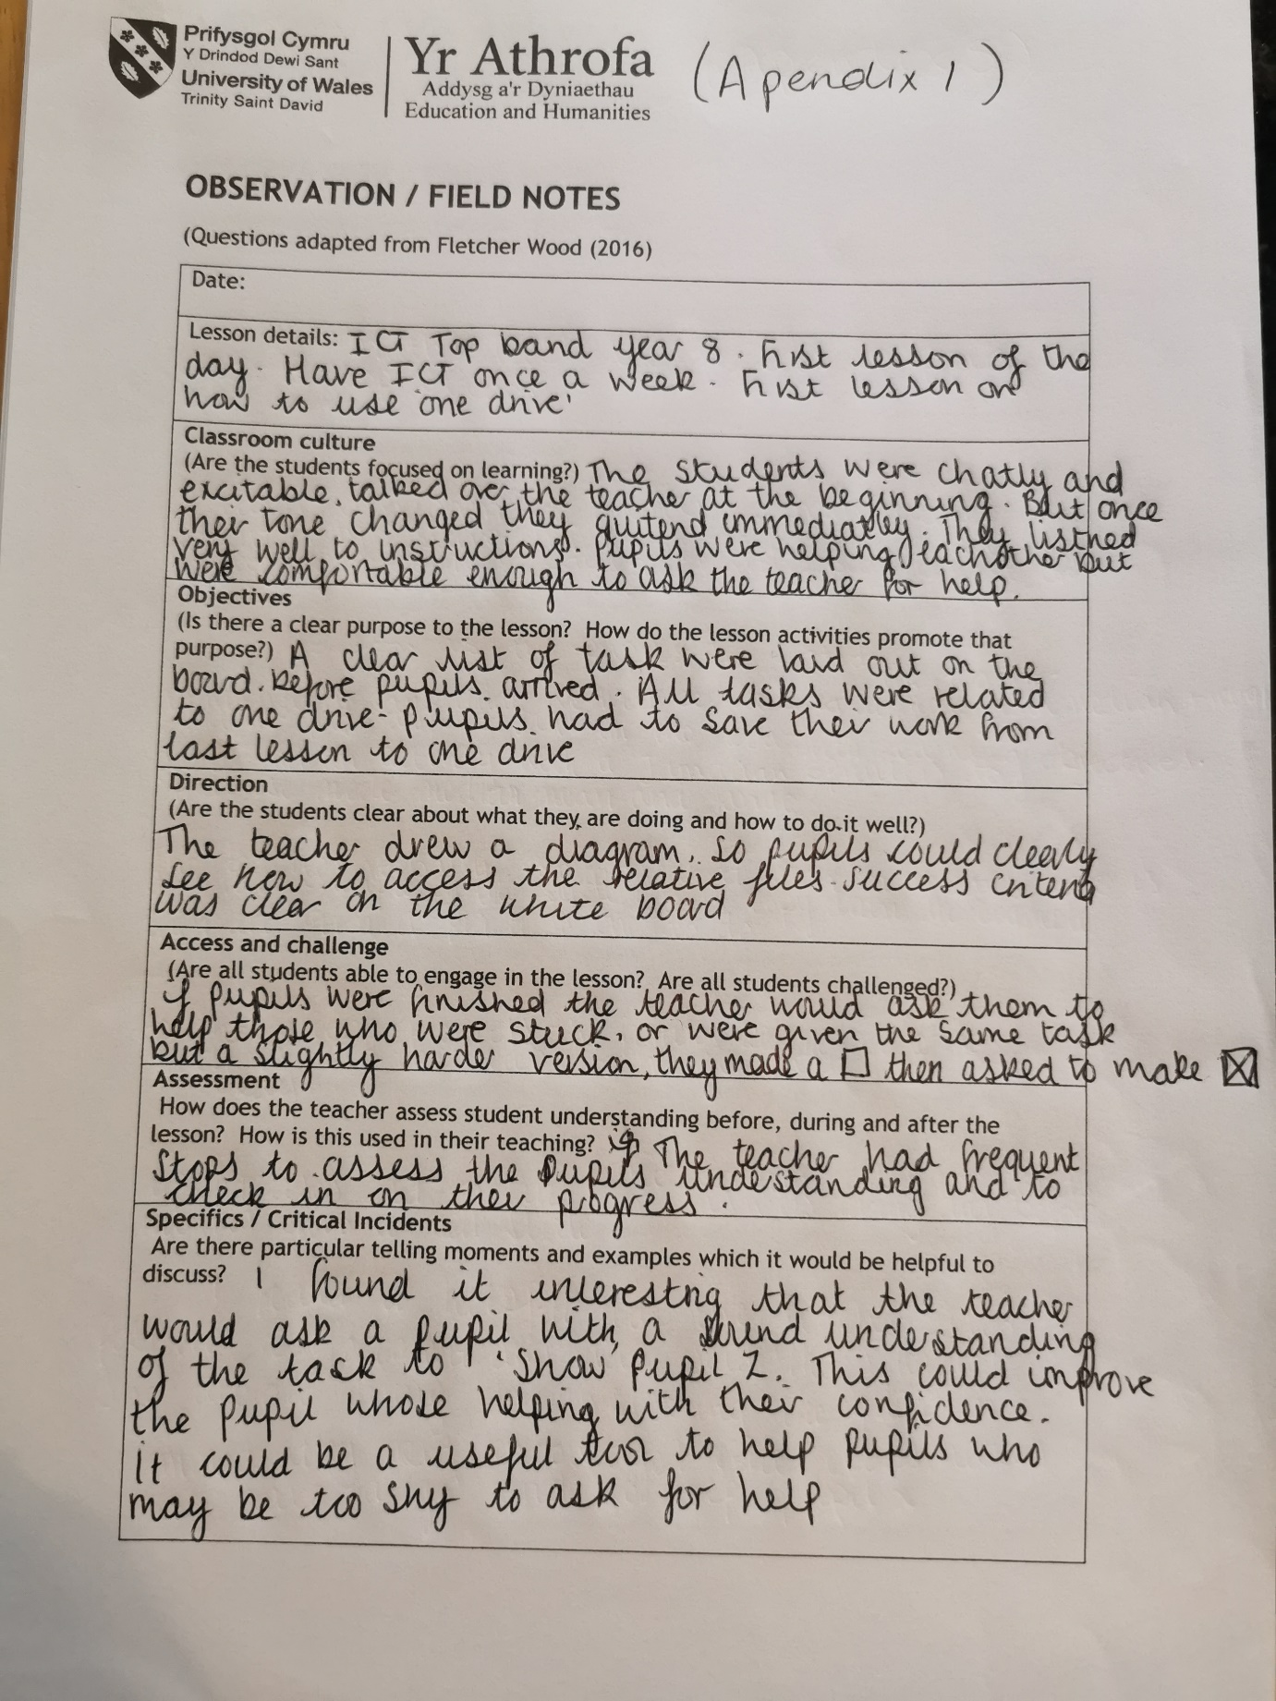

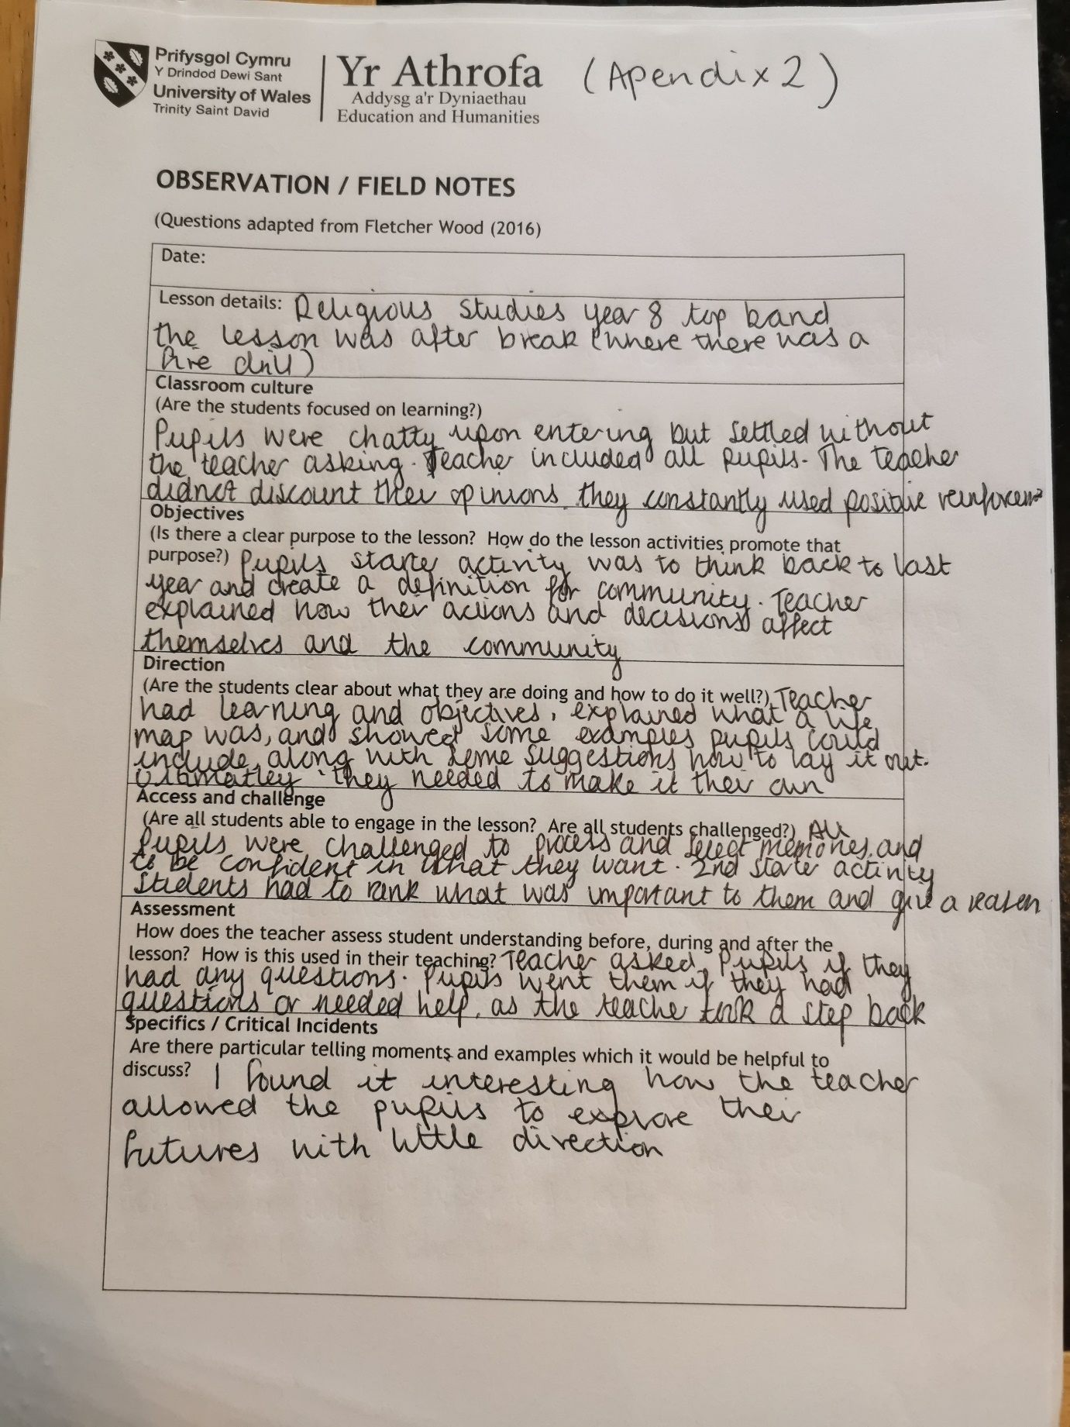

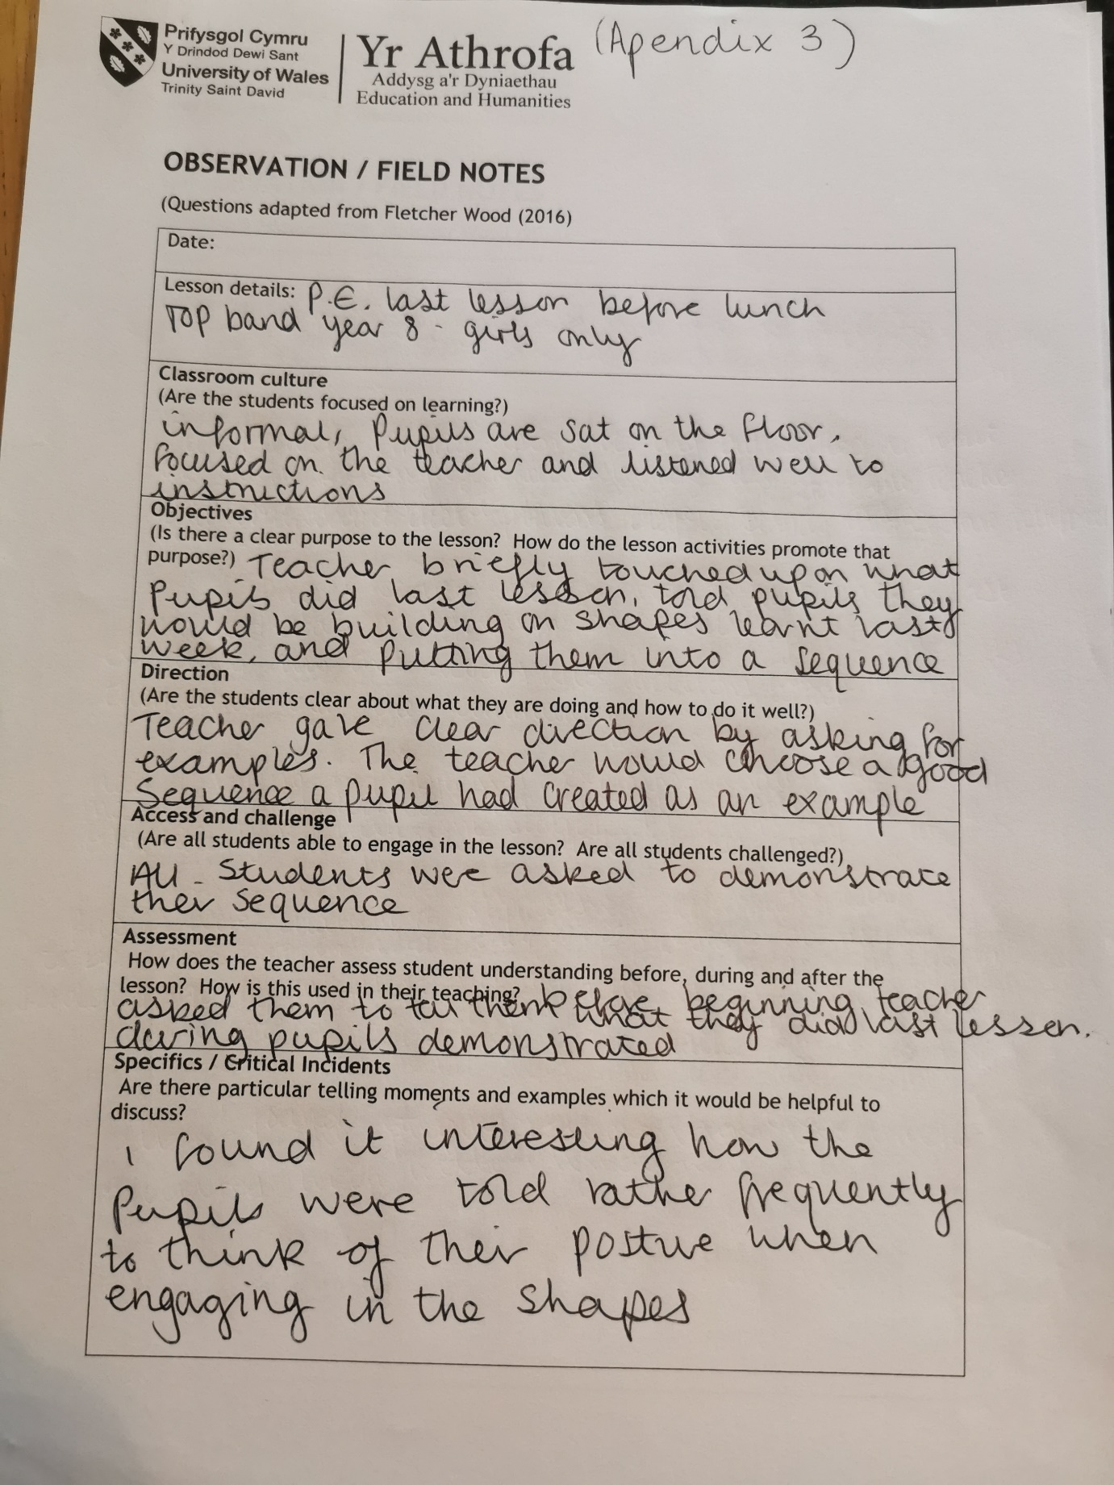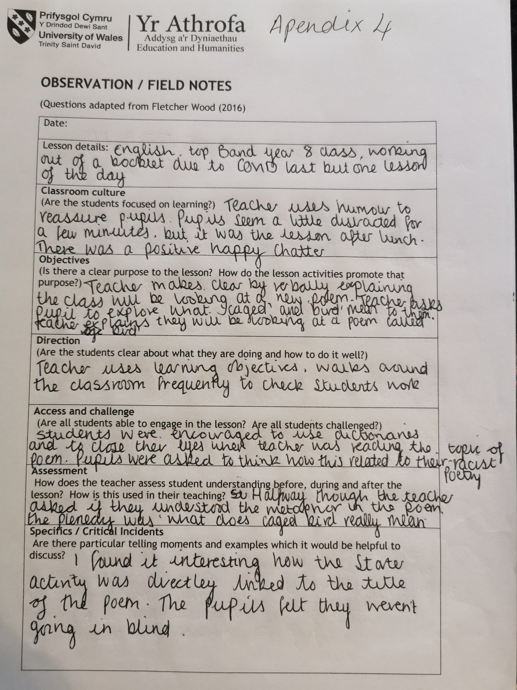

Critical Incident Identification Record
Details relevant to the research context.  Date/time.  Age/Stage of group.  People involved.  Contextual  information from field notes. | 29/09/2020, First lesson after morning registration,9:55, Year 8 top stream-KS3 (see appendix 1)  The first lesson of the day was ICT, the lesson took place in a state-of-the-art computer suite. The teacher had already written down a title for the pupils along with a ‘to do list’ before their arrival. Thus, allowing for pupils to see clear aims and objectives and what they needed to do to meet them. All tasks related to one drive a topic the pupils had been working on for several weeks. The pupils seemed comfortable and relaxed in the lesson, as there was quite a lot of chatter, but as soon as the teacher asked for silence the pupils quietened immediately. The pupils had a clear focus because the teacher kept checking in on their progress and drew diagrams and flow charts to help students’ complete certain tasks. The pupils were challenged throughout the lesson as the teacher always had a more challenging tasks available if the pupil had finished.
What happened? A detailed decription of what you observed and what thoughts on pedagogy and practice occurred to you as a result, looking towards your research. | An incident that became critical for me , was how the teacher would explain something to a pupil who was stuck, but then told them that now that they knew what to do, they had to go and help others who were stuck. I felt that this was a clever strategy as it freed up the teacher’s time, but also instilled a level of confidence in the pupil who began helping their peers. It was also beneficial to those students who were unsure of the task and how to complete it but lacked the confidence to ask the teacher for help, perhaps due to embarrassment. But as soon as the pupil noticed their peer helping others and taking on a teacher role, they then raised their hand. I felt this was good practise as it showed me that as a teacher you don’t constantly have to be giving pupils instruction and you can rely on other pupils in your class to help, which I believe created a warm and safe environment for pupils to learn and rely on one another, which created a real team effort.

Details relevant to the research context.  Date/time.  Age/Stage of group.  People involved.  Contextual  information from field notes. | 29.09.2020, Religious Studies, lesson2, after morning break,11.20, year 8 top band Key Stage 3, (see appendix 2).  Although the pupils were chatty upon entering, they soon quietened down without the teaching asking, which suggests that they had trained the pupils to be silent. Although there was not a lot of talking during the lesson, it was clear the pupils felt comfortable as they were facing forward and laughing and smiling when the teacher said something funny. The teacher explained the task at hand and got a feel for the pupil’s knowledge as they created a starter activity where pupils had to look back on previous knowledge from year 7 to write a definition of community. The teacher once asking for some pupil’s answers, displayed the correct definition on the board, and further explained about community. The teacher made the task that needed to be completed as they listed the aims and objectives, and displayed some examples of a life journey map, and answered any questions the pupils had. All pupils were challenged to use probability for future events, along with choosing select memories. The students were also given a sheet of paper with a list of milestones and had to rank their importance from a scale to 1-10 and had to justify why. This inspired healthy debate within the classroom and allowed pupils to work on their oracy skills too. This gave the impression that the teacher enjoyed hearing pupils’ thoughts feelings and opinions.
What happened? A detailed decription of what you observed and what thoughts on pedagogy and practice occurred to you as a result, looking towards your research. | I feel it pertinent to discuss how the teacher gave minimal instruction and guidance to the pupils, and actively encouraged the pupils to make the life journey map their own. They did not tell pupils what they could and could not include and explained to the class how each person’s life journey map will be different because we all have different things that are important to us. Even though the pupils received little direction they were still able to complete a well thought out piece of work. This suggested to me that the teacher encourages independent thinking, which boosts self-esteem and confidence because the pupils can achieve independently.

Details relevant to the research context.  Date/time.  Age/Stage of group.  People involved.  Contextual  information from field notes. | P.E, lesson3, Year 8 girls-top band,12.10 key stage 3 (see appendix 3)  because the lesson took place in the sports hall, the pupils were all sat on the floor, but they were still focused on the teacher and the instructions being given to them. The teacher touched upon what they had done last lesson, and explained that they would be adding to this, and would be putting the shapes they had learnt last week into a sequence. The teacher gave clear direction as they asked pupils to give examples of their sequence and selected a variety of examples ranging from advanced to beginner. The pupils were challenged as they had display their sequence to the whole class, and the pupils had to then give a what went well and even better if, so had to think of constructive points to give their peers.
What happened? A detailed decription of what you observed and what thoughts on pedagogy and practice occurred to you as a result, looking towards your research. | I found it interesting how the teacher frequently told the pupils to think about their posture when creating their shapes and using body tension. This related to physical literacy and how the teacher was trying to break the pupils out of bad postural habits, which are developed when we are on electronic devices or walking in general. It was startling to see how the pupils struggled to hold body tension in simple shapes such as the dish or pike, apart from a select few how did outside sporting activities. By the teacher getting a pupil who displayed good posture and body tension to demonstrate to the class, positively reinforced what could be achieved. Furthermore, the teacher never singled out one pupil in particular if they had poor body tension or posture but spoke to the group as a whole. This, I feel created a real team atmosphere amongst the pupils.

Details relevant to the research context.  Date/time.  Age/Stage of group.  People involved.  Contextual  information from field notes. | English lesson, lesson 4, 12:45, after lunch, year 8 top band KS4 (see appendix 4)  The classroom was very relaxed as the teacher used humour and relatable topics to build an understanding of poerty- a topic that was still relatively new to the pupils. The teacher did not list aims and objectives on the board but did verbally explain the instructions to the pupils. The teacher began the lesson with a starter activity, by asking the pupils to write down what comes to mine when thinking of the word ‘caged’ and ‘bird’. The teacher then explained they class would be looking at poem called ‘Caged Bird’. The teacher walked around the classroom to check on pupil progress and asked them questions related to the poem, to check their understanding. Pupils were challenged to discover unfamiliar words by looking in the dictionary, instead of the teacher telling them. They were also asked to link this to their current topic of racist poetry and explore the idea of metaphor-another concept that was quite new to them.
What happened? A detailed decription of what you observed and what thoughts on pedagogy and practice occurred to you as a result, looking towards your research. | I found it interesting how the teacher, gently eased the pupils into a harder poem that they were used to by giving them an easy starter where they had to use their imagination. It was then, once ideas had been think paired and shared did the teacher reveal that they would be looking at a poem called ‘Caged Bird’. By doing this I feel the teacher took away the initial fear of poetry and made the pupils feel as if they were not going in blind, because they had already and unknowingly annotated and further explored the poem. By the time it came to analysing the poem, the pupils had plenty of ideas to choose from. This allowed for the pupils to gradually build up their confidence in poetry because the teacher did not overwhelm, but went at a pace that suited the pupil, not the teacher, thus putting the pupils needs first.

Bibliography
Appendix Observation/Field Notes1-4
Critical Incident Identification record
Refrences
Ann Bonner and Gerda Tolurst (2003) Insider Outsider Perspective Of Participant Observation, Cumbria : Langham Partnership.
Anne Watson, Keith Jones and David Pratt (2013) Key Ideas In Teaching Mathematics’ , Oxford : Oxford University Press.
Cathy Burnett and Julia Myers (2014) ’Teaching English,3-1: The Essential Guide For Teachers , New York: Conitnuum.
Christine Phin Mushibwe (2014) ‘What Are The Effects of Cultural Tradition In Education’ , Hamburg: Anchor Academic Publishing .
David L Blustien (2013) The Oxford Handbook Of The Psychology Of Working , Oxford : Oxford University Press.
David W Kritt (2018) Construction Education in An Age of Accountability’, New York : Palgrave Macmillan.
Derek Rowntree (2013) Assessing Students, How Shall We Know Them’ , Great Britain : Routledge.
Edward Conrad Waag (1994) An Introduction To Classroom Observation, New York: Routledge.
Herbert Grossman (2004 ) Classroom Behaviour Management For Diverse And Inclusive Schools, London: Rowman and Littlefield Publishing.
Jacob Belik,Miroslaw Pawlak, Anna Mystkowska-Wiertelak (2016) Autonomy In Second Language Learning: Managing The Resources, Switzerland : Springer.
Janet Salmens and Lynn (2008) Handbook Of Research And Electronic Collaboration And Organizational Synergy’ , United States of America: Information Science Refrence.
Jeff C Marshall (2008) Overcoming Student Apathy , New York: Roman And Littlefield Education .
Joan Young (2014) Encouragement In The Classroom: How Do I help Students stay Positive and Focused’ , America: Arias.
John and Sarah Maclure (2003) ‘How to Find Your Dream Job and Make It A Reality’ , Canada: .
John Hattie and Eric M Anderman’s (2013) International Guide To Student Achievement’ , New York : Routledge.
Johnathan Barnes (2018) Applying Cross Curricular Approaches Creatively’ , New York: Routledge .
Judith Ackerman (2001) 'Piaget’s Constructivism, Papert’s Constructionism, Whats The Difference’ ', , (), pp. .
Patil Ann (2012) New Media Skills For Engineers In IT , The United States of America: Information Science Reference .
Paul Ramsden (2002) Learning to Teach in Higher Education’, London : Routledge Falmer.
Robert Berns (2006) ‘Children, Family, Community: Socialization and Support School’, America: Cengage Learning .
Roy Lund (2014) Behaviour Policy. A whole School Behaviour Policy: A Practical Guide’, New York: Routledge.
Seymour A Papert (2020) Children, Computers and Powerful Ideas’ , Ney York : Basic Books .
Silke Mikekskiks-Siefert (2008) Four Decades of Research In Science Education’ , Germany : Die Deutsche Bibliothek.
Terrance Lovat, Kerry Dally, Neville Clements and Ron Toomey’s (2011) Values Pedagogy and Student Achievement: Contemporary Research Evidence, Newcastle : Springer .
Wilhelm Kirch (2019) European Journal of public Health, Germany:

