University of Wales, Trinity Saint David
London Campus
Name: Ayokunle Odesanya
Student ID: 2519267
Group: 2

Lecturer: Redhwan Al Amiri
Computer Architecture and Operating Systems
ACCA 4022
Table of Contents
Introduction 2
Computer Architecture and Operating Systems 2
1: Key functions of General Operating Systems 3
Process Management and Memory Management 3
File Management Systems 5
Security and Access Control 6
2: Use of Windows OS CLI Commands Document 8
3: Use of Linux OS CLI commands Document 14
4: Use of Windows OS scripts 19
5: Use of Linux OS scripts 21
Conclusion 21
Reference 22

Introduction
Almost every piece of software that runs on a computer, from a simple text editor to a large enterprise database, depends on an operating system to manage the underlying hardware and to provide a stable, predictable environment in which programs can execute. This report examines that relationship from two angles. First, it looks at the general functions that a modern operating system performs and where those functions can be observed in practice. Second, it takes a hands-on approach to two of the most widely used operating system families in industry, Microsoft Windows and Linux, by demonstrating a range of command-line tools and by writing short scripts that automate simple administrative tasks. Working directly with the command line, rather than only reading about it, was chosen deliberately, because it exposes how the operating system responds to instructions and how the same underlying concept (for example, listing running processes) is implemented differently across platforms. The report is organised so that each Windows topic has a direct Linux counterpart, which makes it easier to compare the two ecosystems side by side.

Computer Architecture and Operating Systems
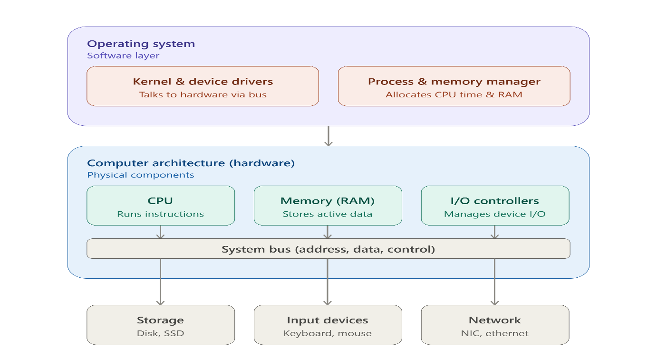

1: Key functions of General Operating Systems
An operating system sits between the physical hardware of a computer and the applications a user wants to run, and its main job is to hide the complexity of that hardware while sharing it out fairly and safely. Textbook treatments of the subject typically group this job into a handful of core responsibilities, PROCESS, MEMORY, FILE SYSTEM, DEVICE and I/O management, and security and access control [1], [2].

Process Management and Memory Management
Process management is concerned with creating, scheduling, and terminating the programs that are running at any given moment. Because a modern CPU can only execute a small number of instruction streams at once, the operating system's scheduler decides which process gets access to the processor and for how long, switching between them quickly enough that a user perceives several applications as running simultaneously. This behaviour can be observed directly through tools such as Windows Task Manager or the Linux top and ps utilities, both of which display live information about CPU usage, memory consumption, and process identifiers .
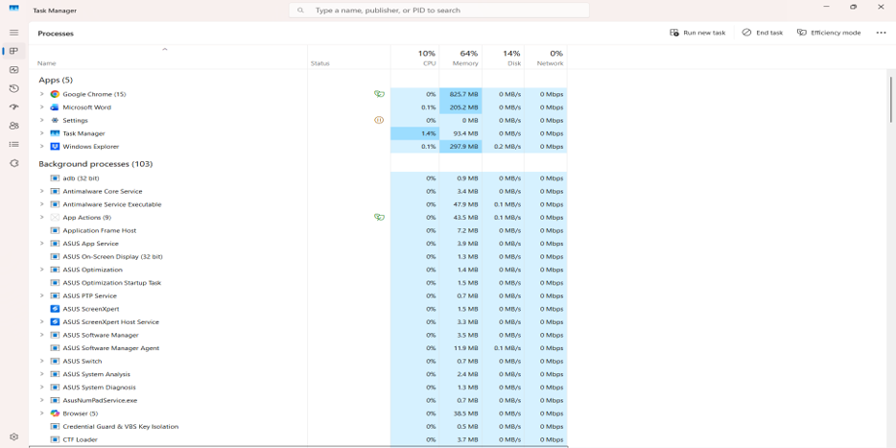

Memory management is the second major function. The operating system allocates portions of RAM to each running process, keeps those portions isolated from one another so that one faulty program cannot corrupt another, and, when physical memory becomes scarce, moves less active data out to a page file or swap area on disk. Windows exposes this through the Performance tab of Task Manager, while Linux systems expose it through utilities such as free and vmstat [1], [3].
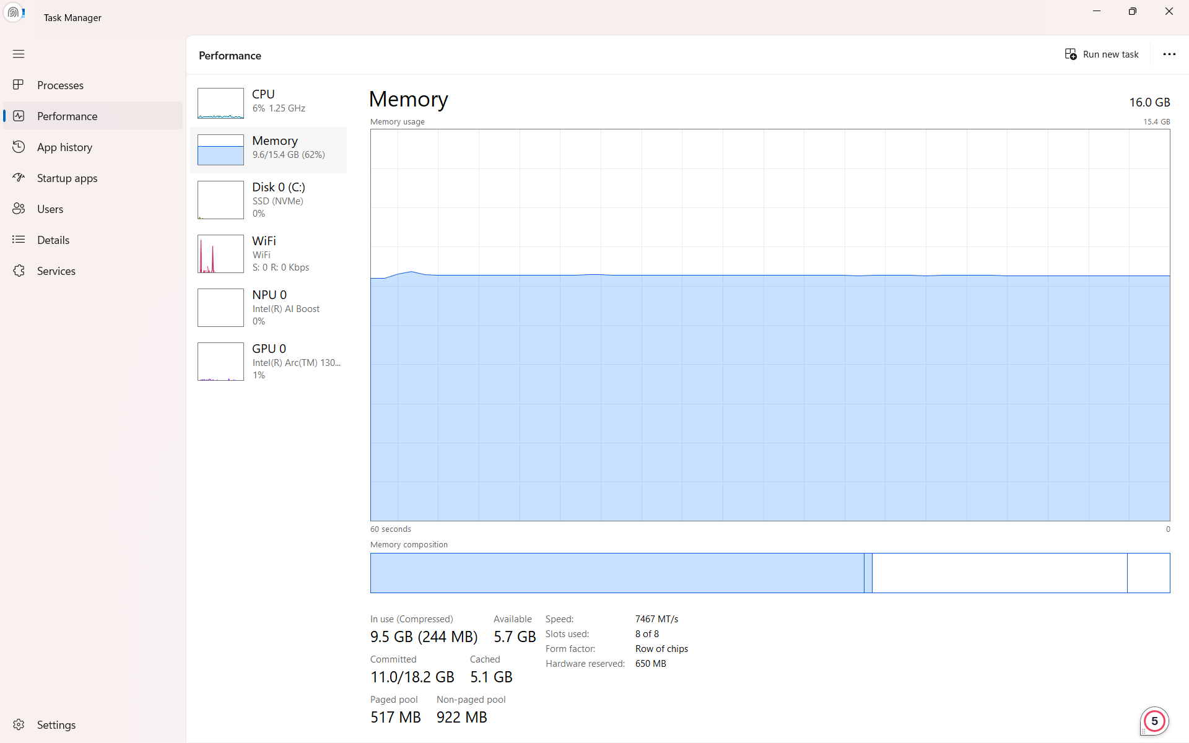
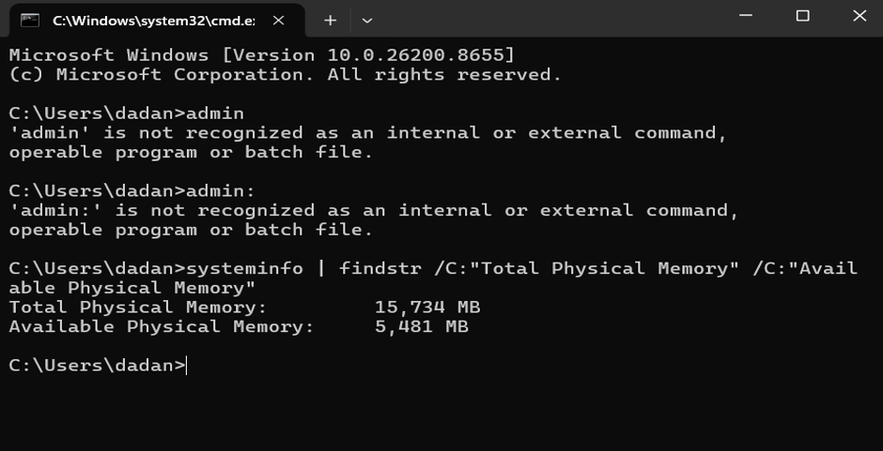

File Management Systems
File system management governs how data is organised, named, and retrieved from persistent storage. Both Windows (through NTFS) and Linux (through file systems such as ext4) maintain structures that map human-readable file names to the physical blocks on a disk, alongside metadata such as permissions, ownership, and timestamps [4], [5]. Device and I/O management, meanwhile, allows the operating system to communicate with peripherals, printers, network adapters, and storage controllers through a layer of drivers, so that application software does not need to know the low-level details of the hardware it is using.
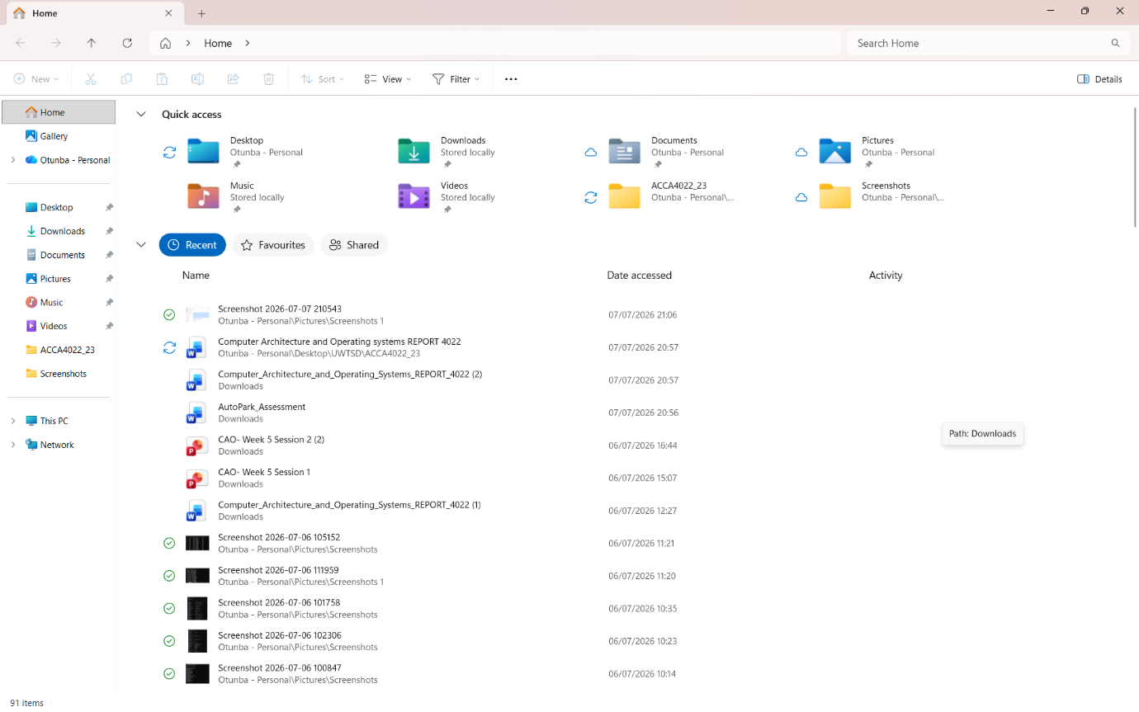
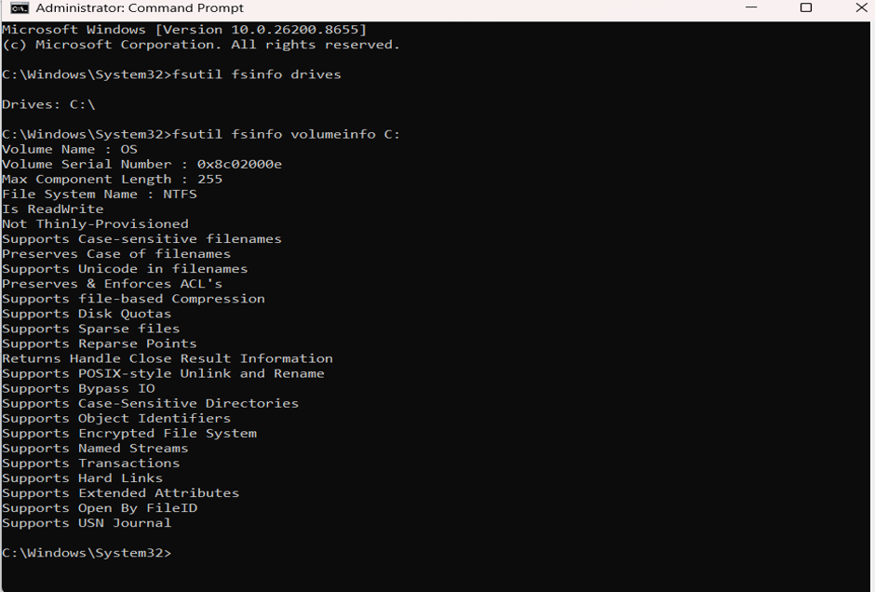

Security and Access Control

Security and access control tie these functions together by ensuring that only authorised users and processes can read or modify particular resources. On Windows, this is implemented through user accounts, groups, and NTFS permissions, and on Linux through a combination of user IDs, groups, and read/write/execute permission bits [6], [7]. Task scheduling, covered in more depth later in this report, is a related administrative function that allows both operating systems to run commands automatically at predefined times, through Windows Task Scheduler or the Linux cron daemon [8]
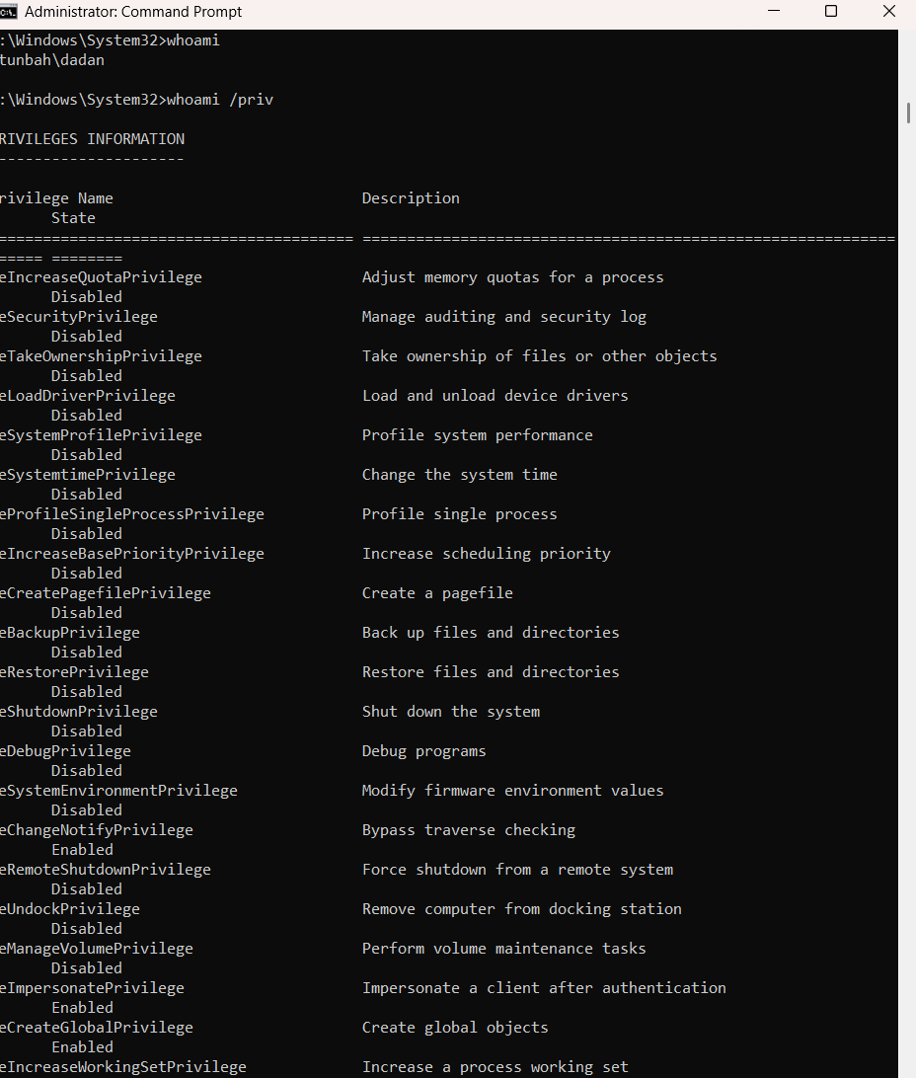

Taken together, these functions explain why an operating system is often described as a resource manager. it is constantly making decisions about which process gets the CPU next, which pages of memory are kept in RAM, and which user is permitted to touch which file, all while presenting a consistent interface to the software running above it. The remainder of this report demonstrates these functions concretely, first by exploring the relevant command-line tools on Windows and Linux, and then by scripting some of those tools together into small pieces of automation.

2: Use of Windows OS CLI Commands Document
Windows offers two native command-line environments: the legacy Command shell (cmd.exe), which interprets Batch commands, and PowerShell, a more modern, object-oriented shell that Microsoft now recommends for serious automation work [4]. The commands below were chosen to cover the five areas requested in the brief, using switches that go beyond the default behaviour of each command so that the underlying options can be demonstrated as well as the command itself.
1) Tasklist /svc
Lists every process currently running on the system together with the Windows services hosted inside each one. The /svc switch is what surfaces the service information; without it, tasklist only shows the process name, ID, and memory footprint.

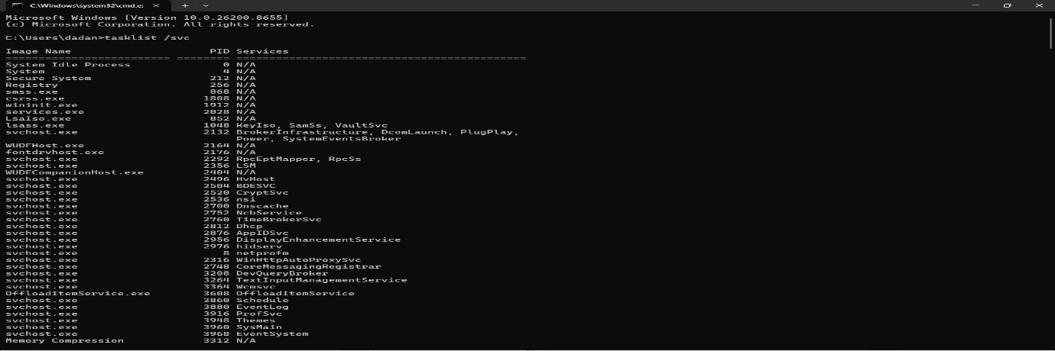
2) Chkdsk
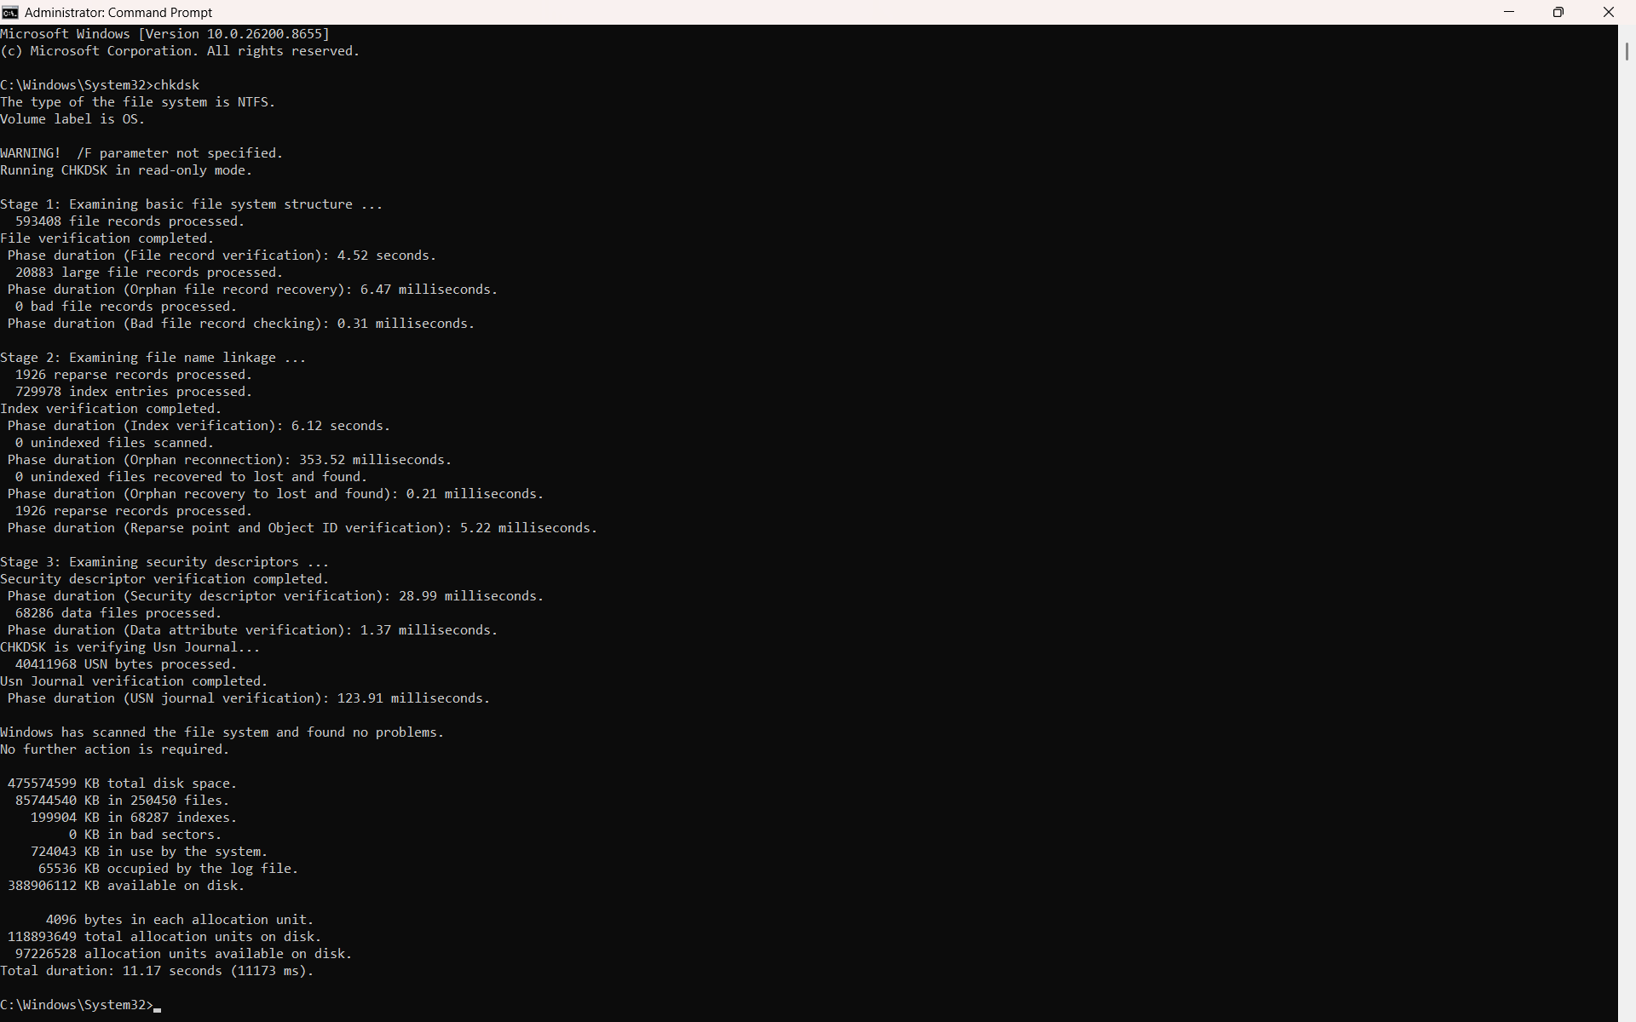

3) dir /a /o:d
Displays the contents of the current directory, including hidden and system files (/a), sorted by date (/o:d), which makes it easier to spot recently modified files. [9]

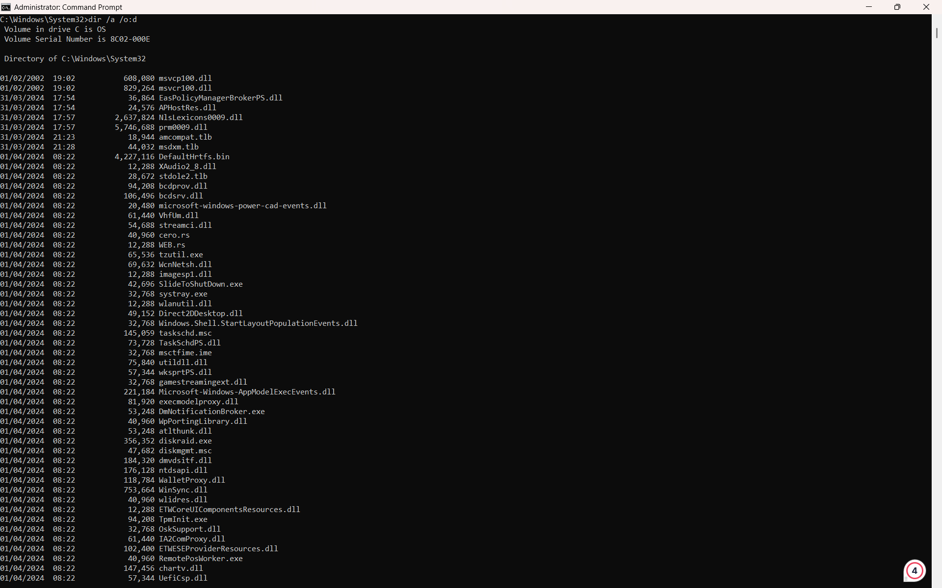
4) robocopy C:\Reports D:\Backup /MIR
Mirrors the contents of one folder into another, including subfolders, and removes files from the destination that no longer exist at the source. robocopy is more robust than the older copy or xcopy commands for large or scheduled backups. [10]
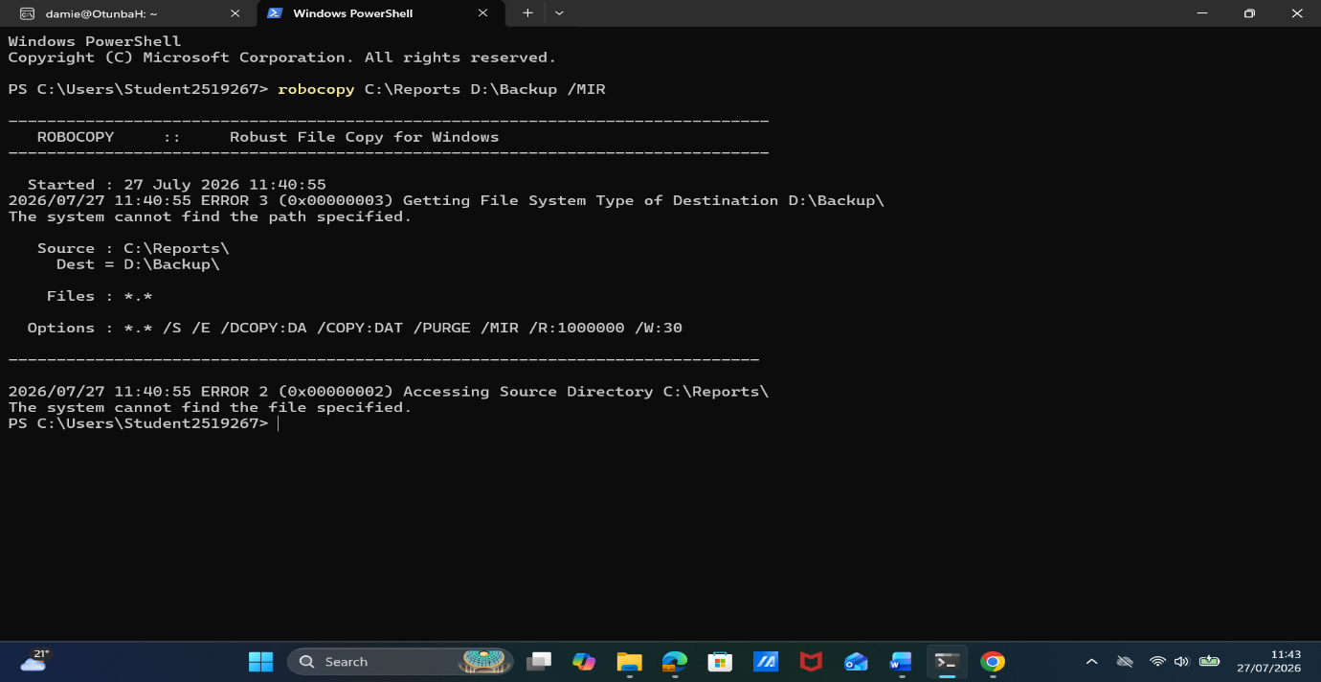
In my case, these files do not exist, yet anyways.

5) netstat -ano
Lists every active network connection and listening port together with the process ID (-o) that owns it, using numeric addresses (-n) instead of resolving host names, which makes the output return much faster. [4], [11]
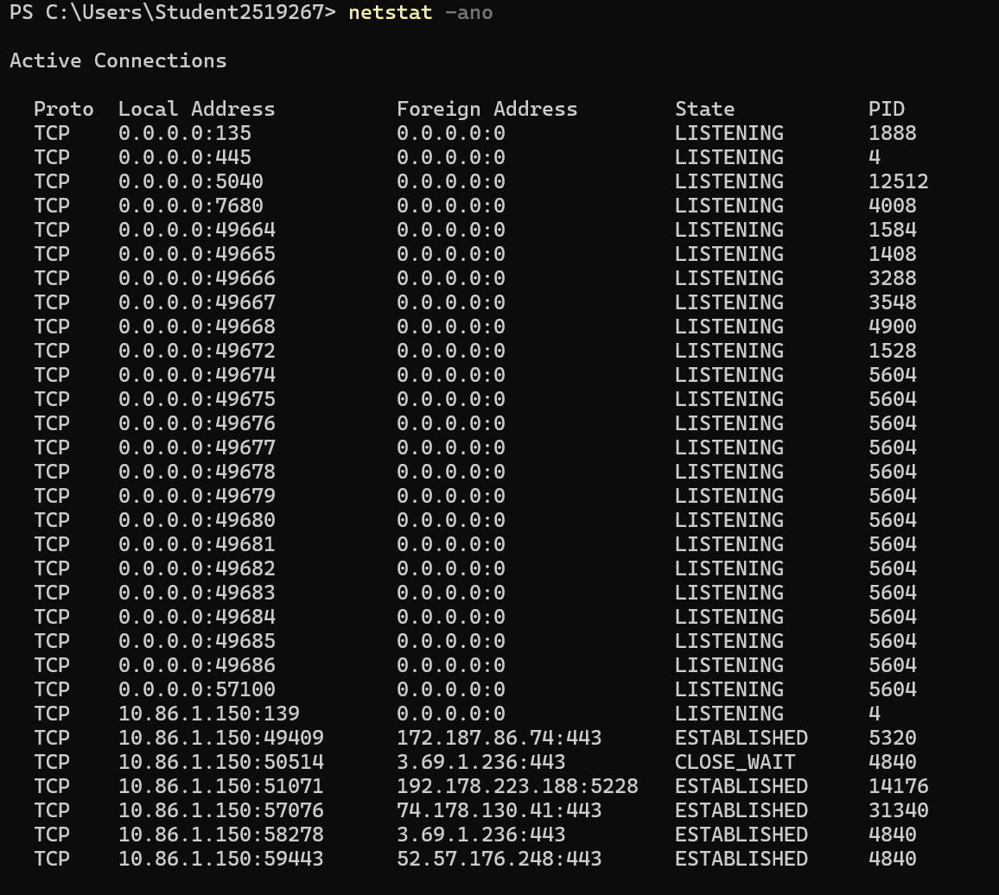

6) schtasks /create /tn "DailyBackup" /tr backup.bat /sc daily /st 22:00
Registers a new scheduled task named DailyBackup that runs backup.bat every day at 22:00. The /sc switch defines the schedule type (daily, weekly, or at logon, among others), while /st sets the start time. [4]
7) schtasks /query /fo LIST /v
Displays a detailed, list-formatted view of every scheduled task on the machine, including the last run time and result, which is useful for confirming that an automated job actually executed as planned. [4]
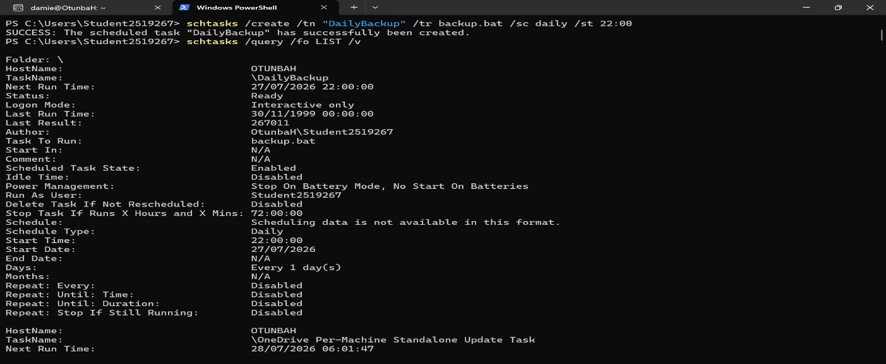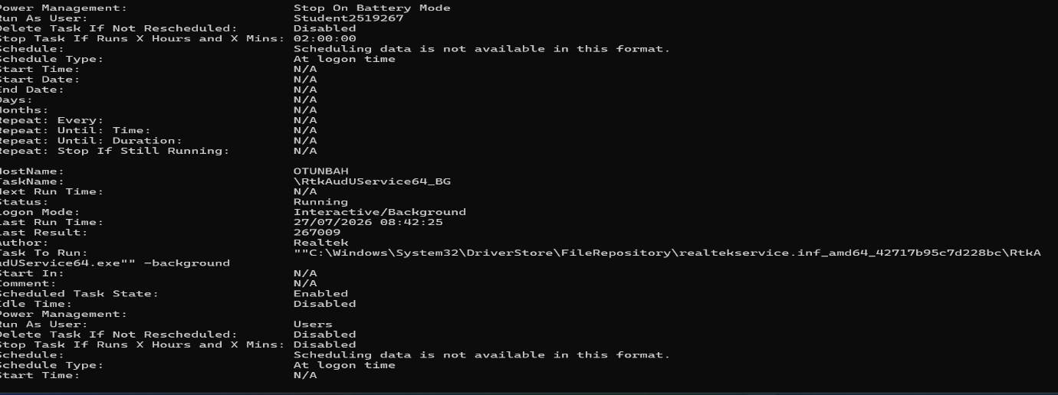

8) diskpart
Disk Partition Manager is opened displaying options for changes one can make on the hard disk.
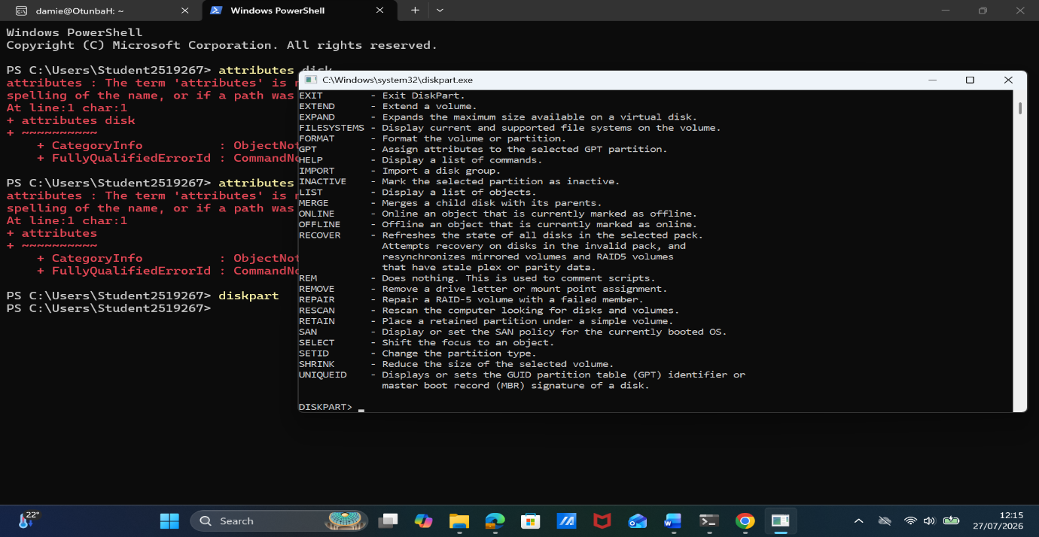

9) ipconfig
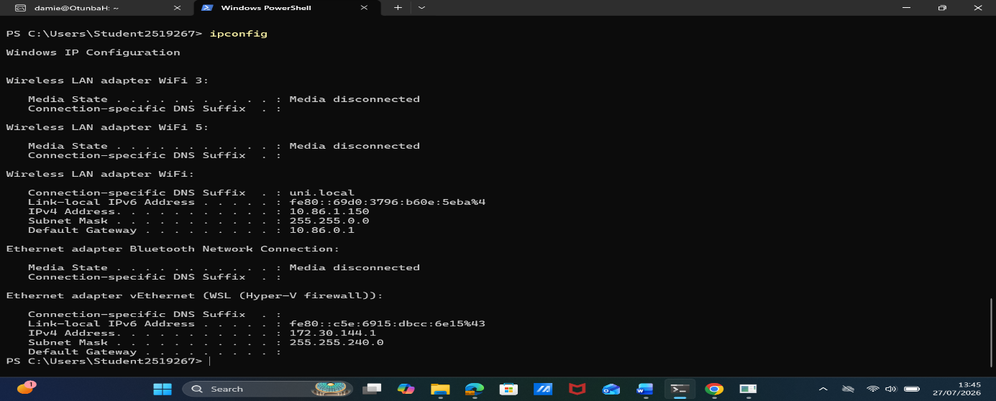

10) Sysdm.cpl
System properties displayed
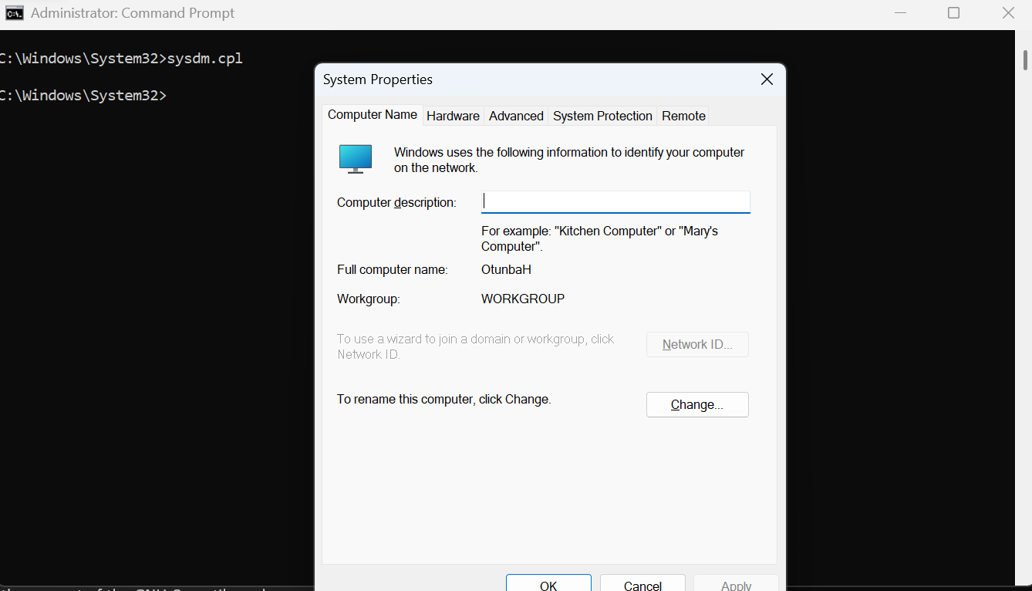

11) sfc.exe /scannow
Scans and repairs or replace corrupt files.
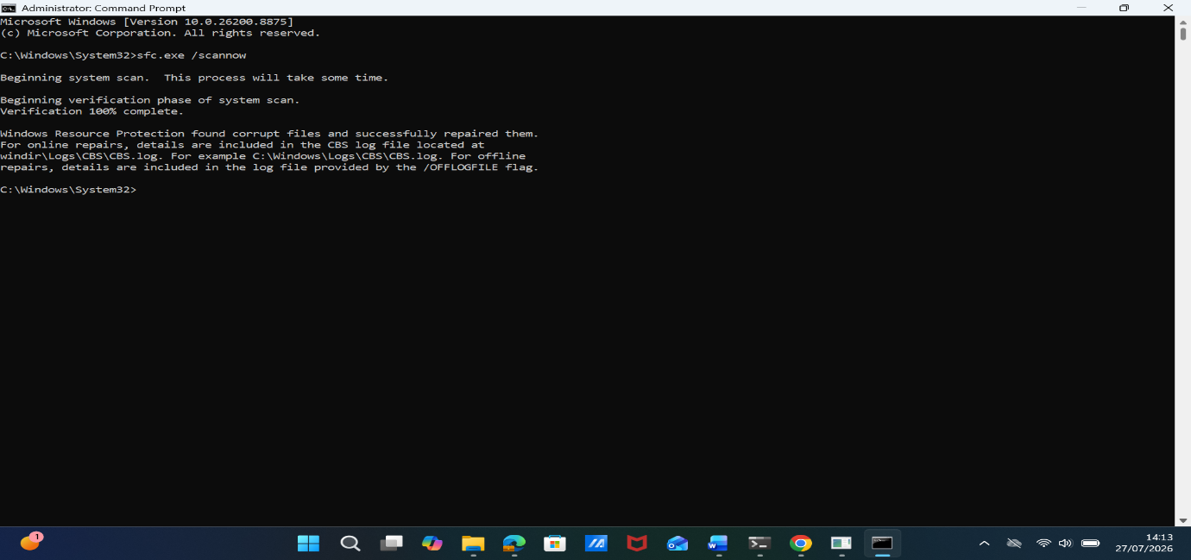

12) tree "C:\program files"
Displays folders in tree like form
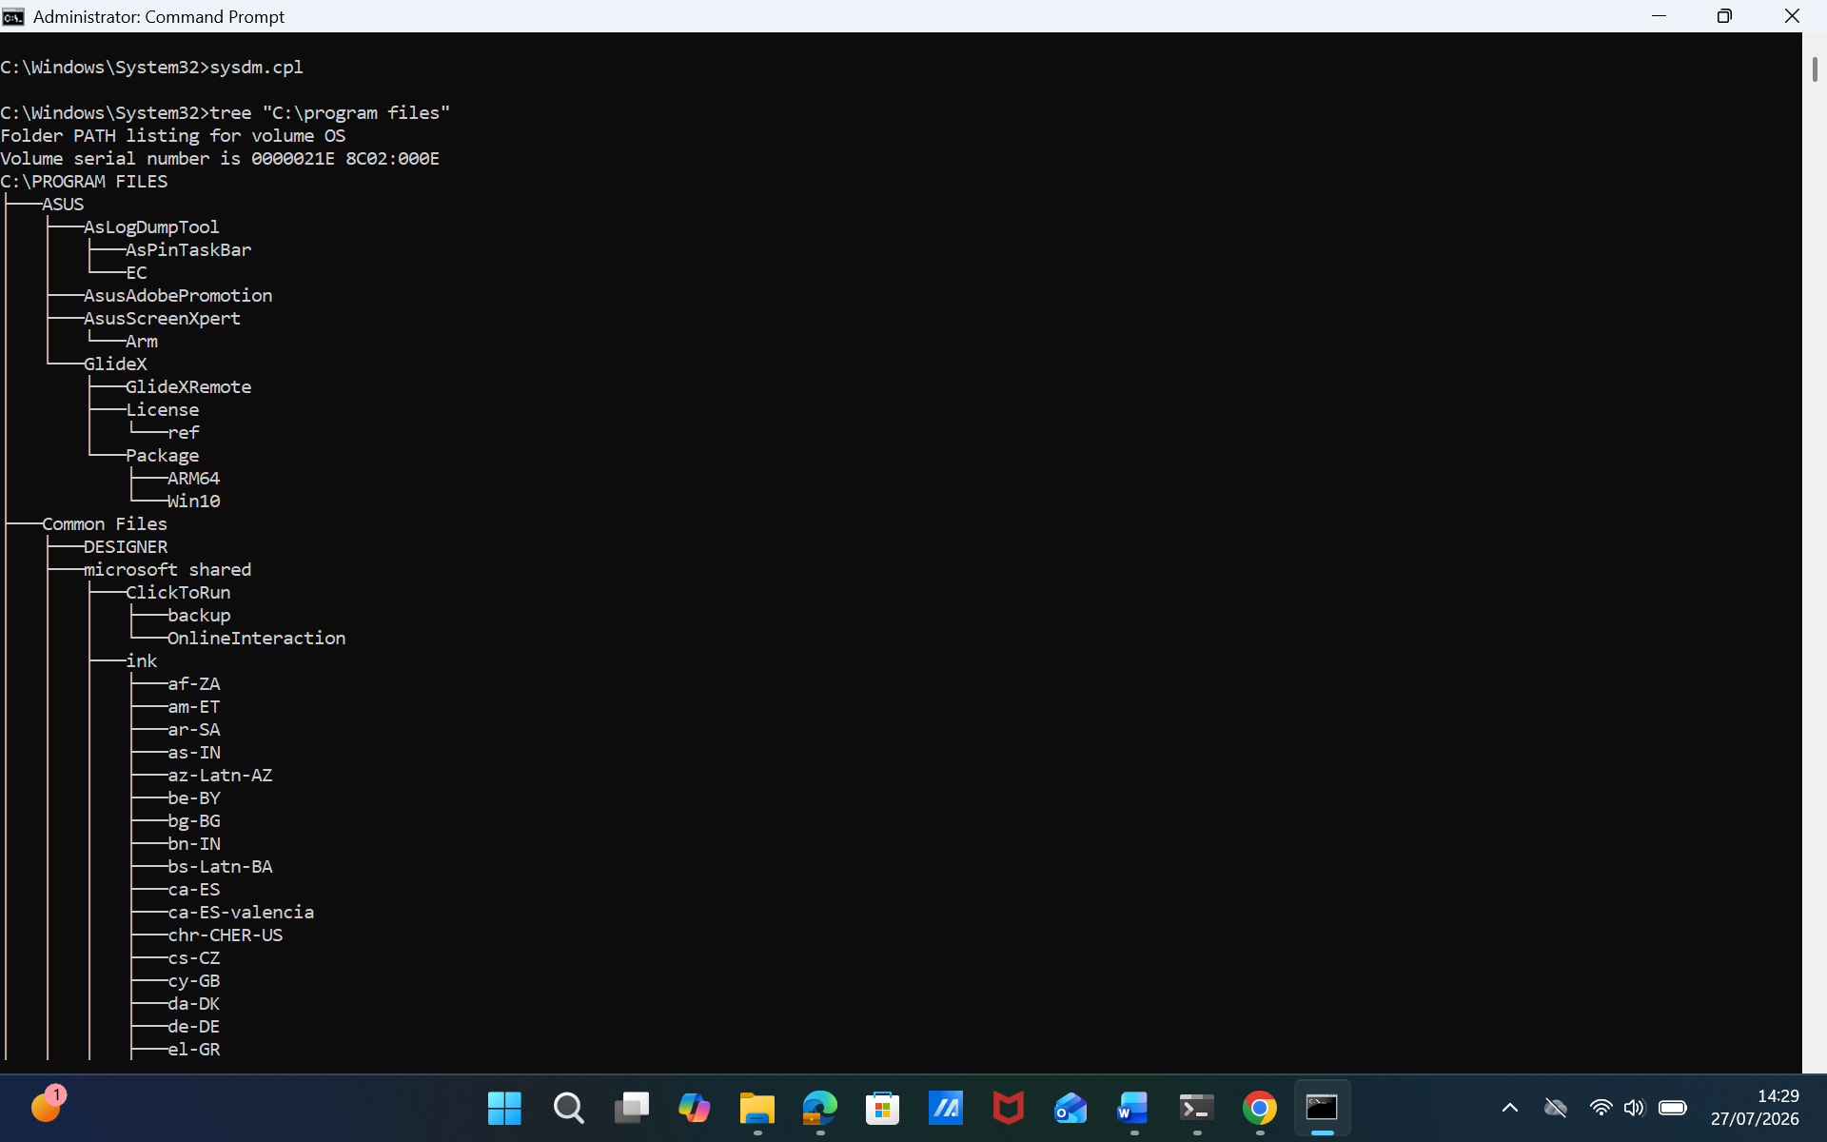

3: Use of Linux OS CLI commands Document
Linux exposes almost all of its administrative functionality through Bash, and the vast majority of the commands used below are documented either as part of the GNU Coreutils package or in the Linux man-pages project, both of which are the authoritative reference for the syntax and options of these tools, [12], [5]. As with the Windows section, each command is shown with a switch that changes its default behaviour.

- ps aux --sort=-%mem
Lists every process on the system (aux shows processes for all users, not only the current one) and sorts the output by memory usage, with the heaviest process first, which is useful for quickly spotting a runaway program.

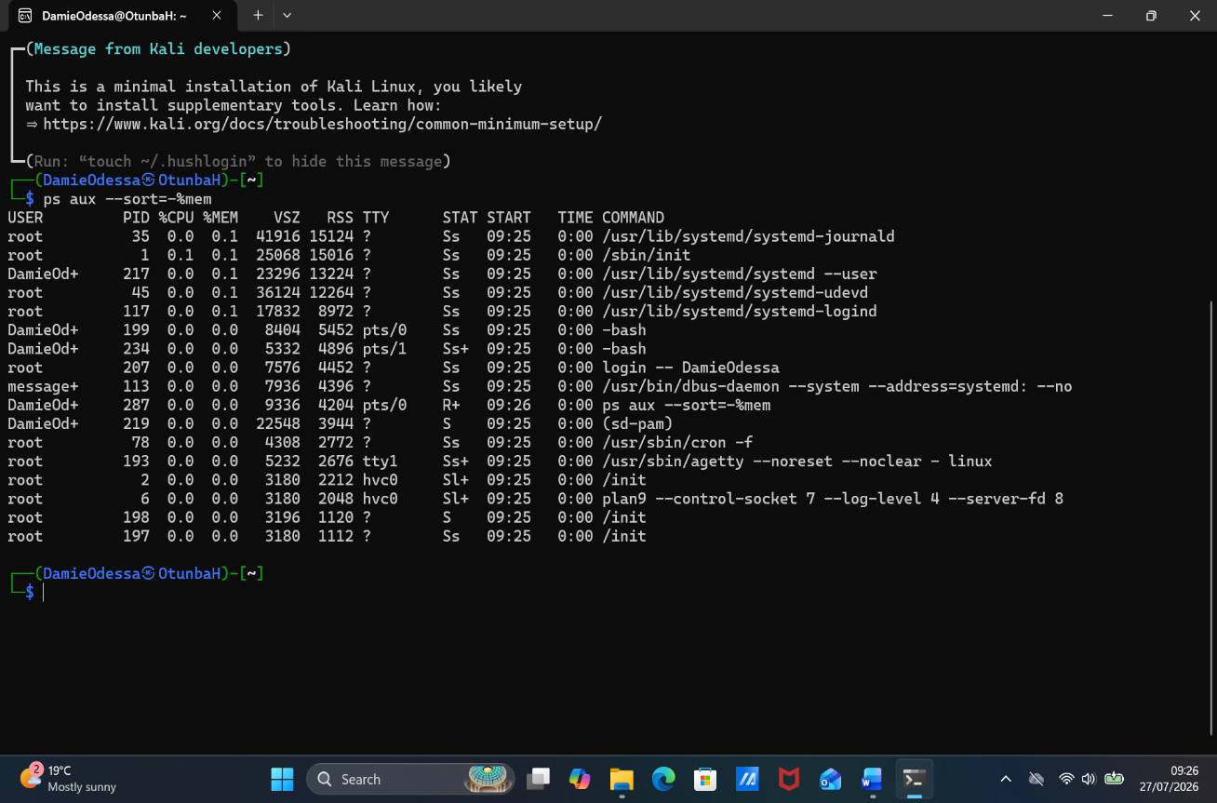
- kill (options)
Sends a SIGKILL signal to the process with a given ID, forcing an immediate, unconditional termination rather than the more polite SIGTERM signal sent by kill on its own. [5]
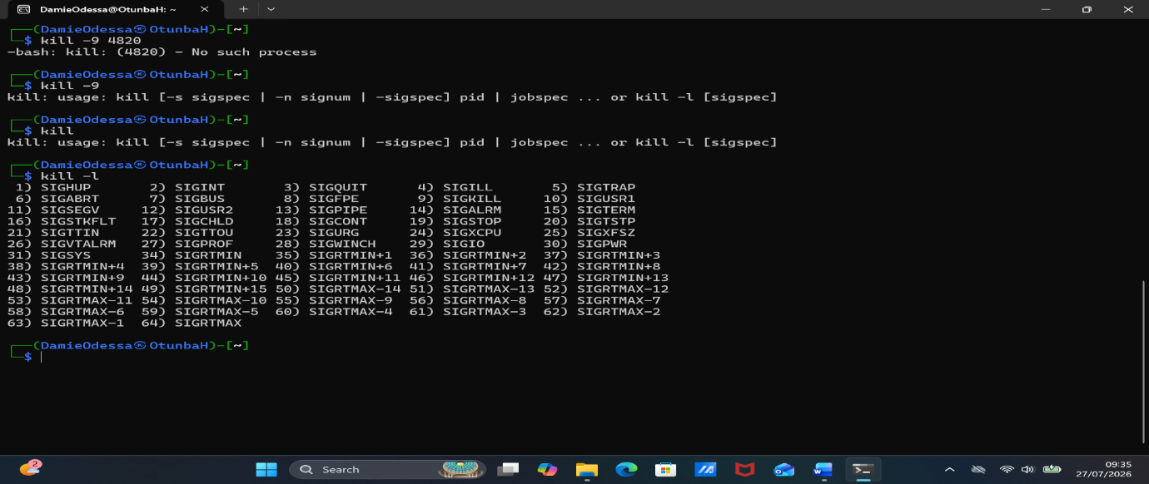

3) ls -lart
Produces a long-format listing (-l) that includes hidden files (-a), sorted by modification time (-t) in reverse order (-r) so that the most recently changed file appears at the bottom, next to the prompt. [6]

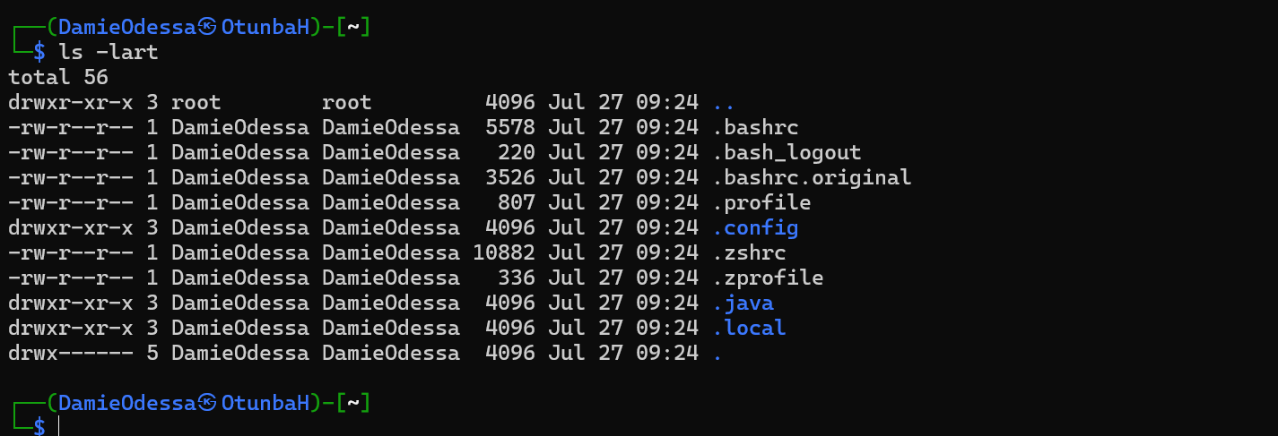

4) ping -c 6 8.8.8.8
Sends six ICMP echo requests to a remote host and then stops automatically, because on Linux ping runs indefinitely by default unless a count is given with -c. [5], [11]

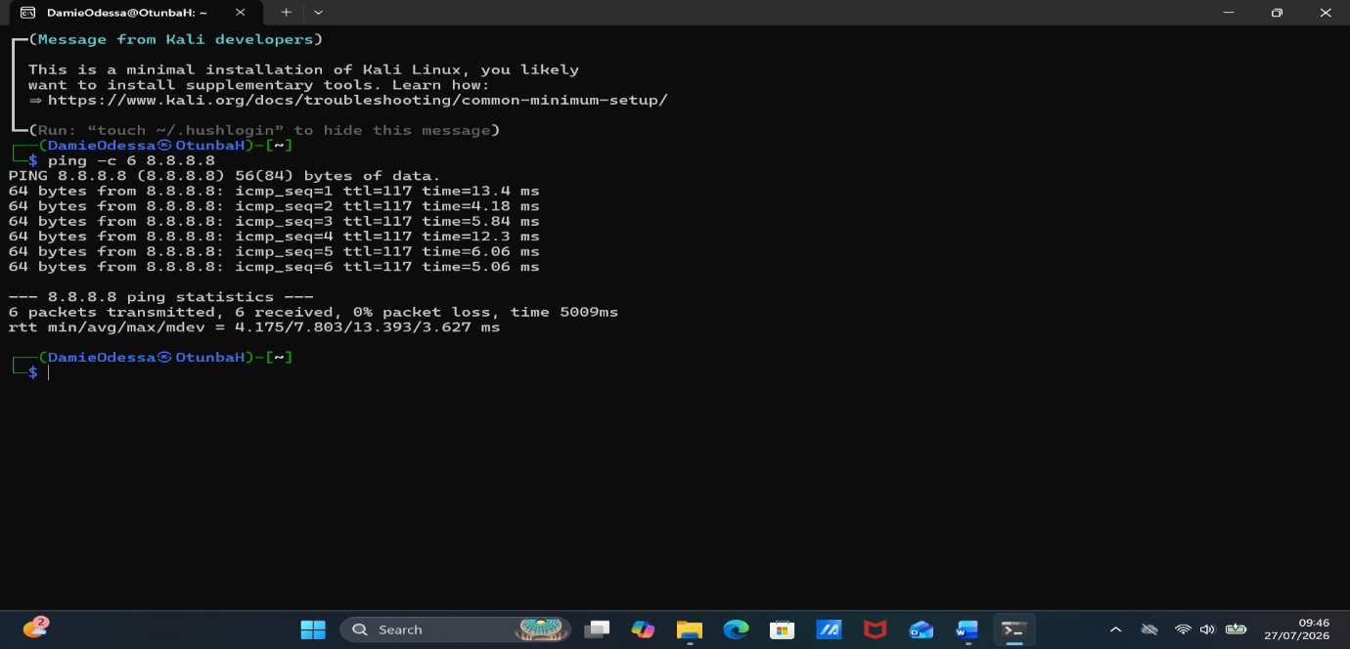

5) ss -tulpn
Displays listening TCP and UDP sockets (-tu) together with the process that owns each one (-p), using numeric ports and addresses (-n) for speed. ss is the modern replacement for the older netstat command on most current distributions. [11]

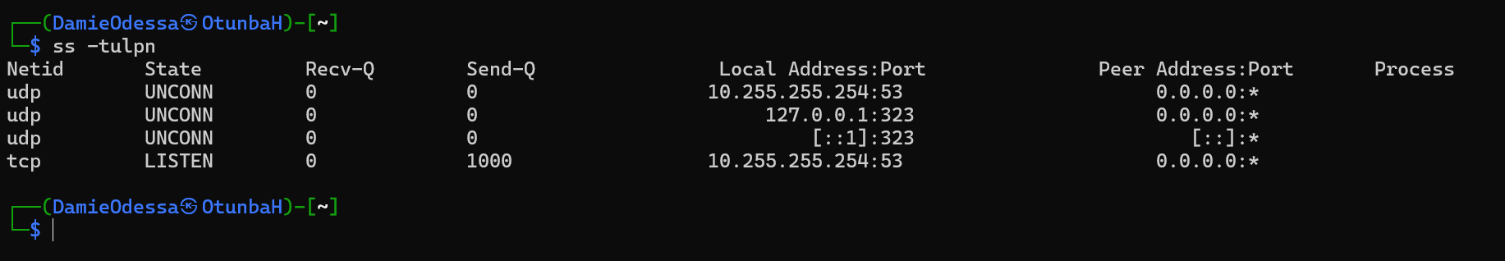

6) sudo useradd -m -s /bin/bash student2519267 or oluwayomitriplestars
Initial issues with registering a username, then realised that capital letters are not allowed, then I ran the command. This creates a new user account, automatically creating a home directory (-m) and setting Bash as the account's default login shell (-s), rather than leaving both at their system defaults.

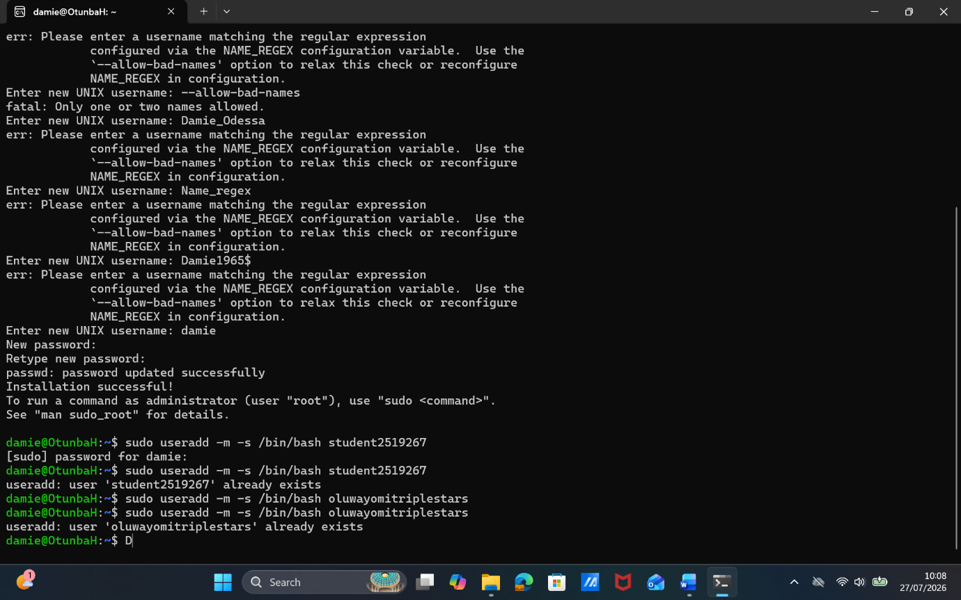

7) crontab -e
Opens the current user's crontab file for editing

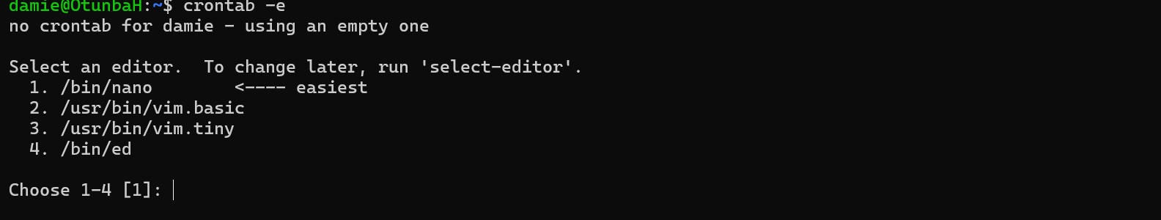

8) find . -ls
Not only can this find files, it can also find long listings.

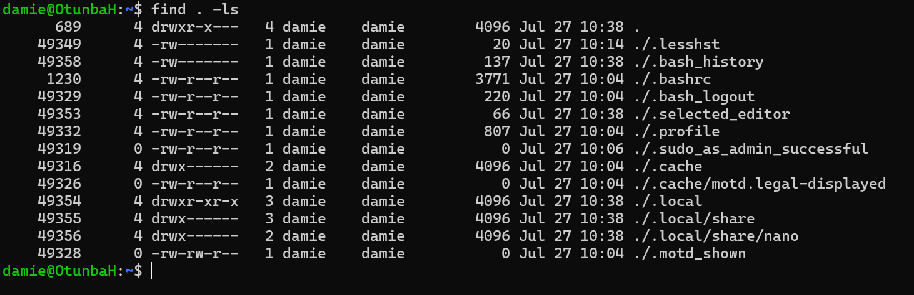

9) ssh tux@10.0.0.33
OpenSSH not only helps secure connections to remote systems (including virtual machines), it also enables other commands

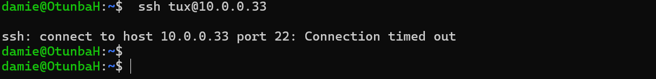

10) history
Shows the LIST OF COMMANDS you have been running since the session started.

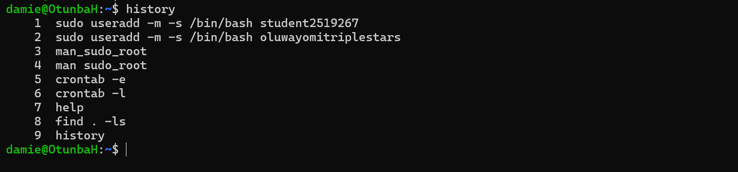
11) mkdir
Created a directory with sub-directories and viewed with ls command.

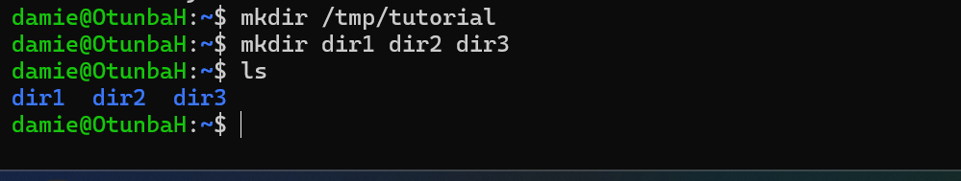

12) id
Displays users identity information.

4: Use of Windows OS scripts

- Sysinfo.bat. This is a system Infor checker
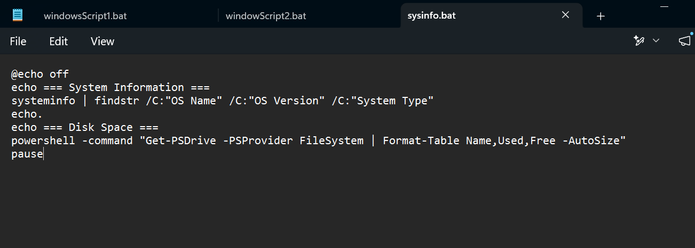
Executed as….
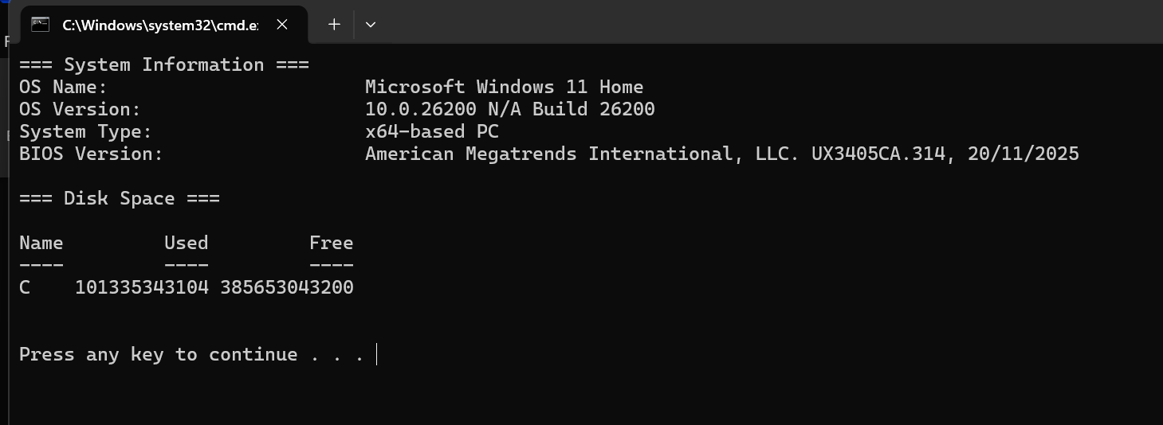
OR
To see the result in GB, a longer version is written..
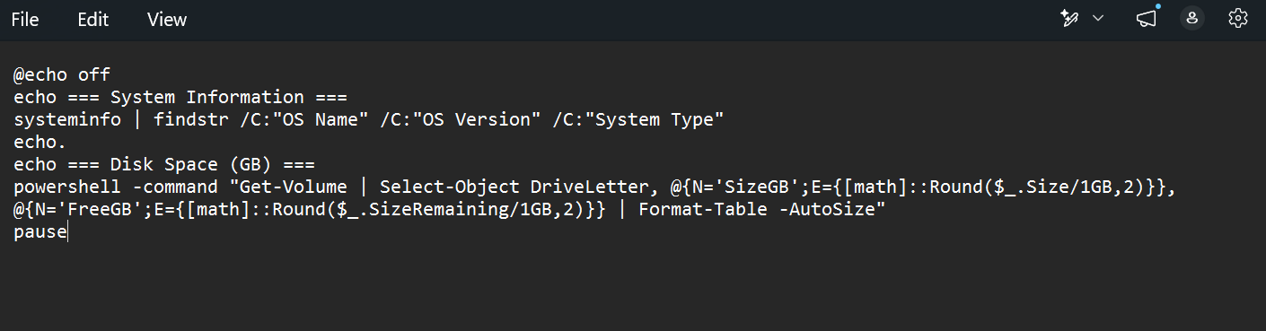
And executed as..
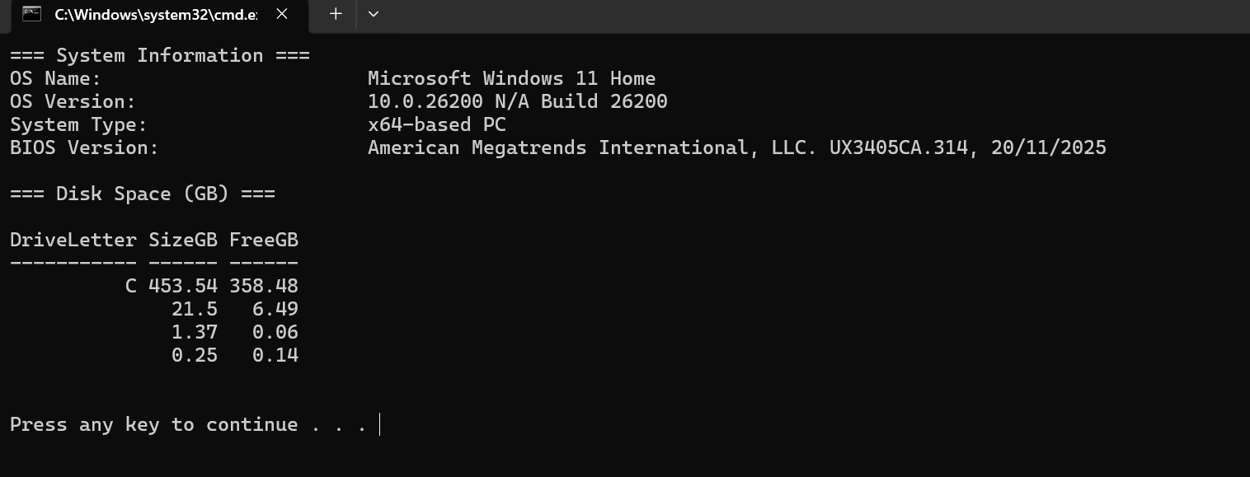
- Ipconfig.bat
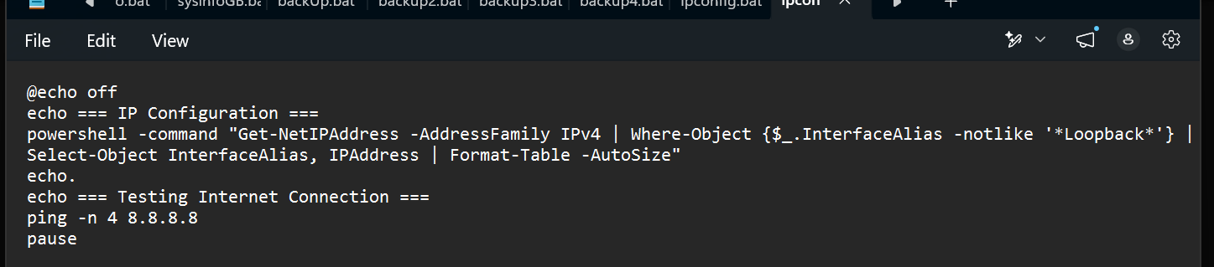
Executes as..
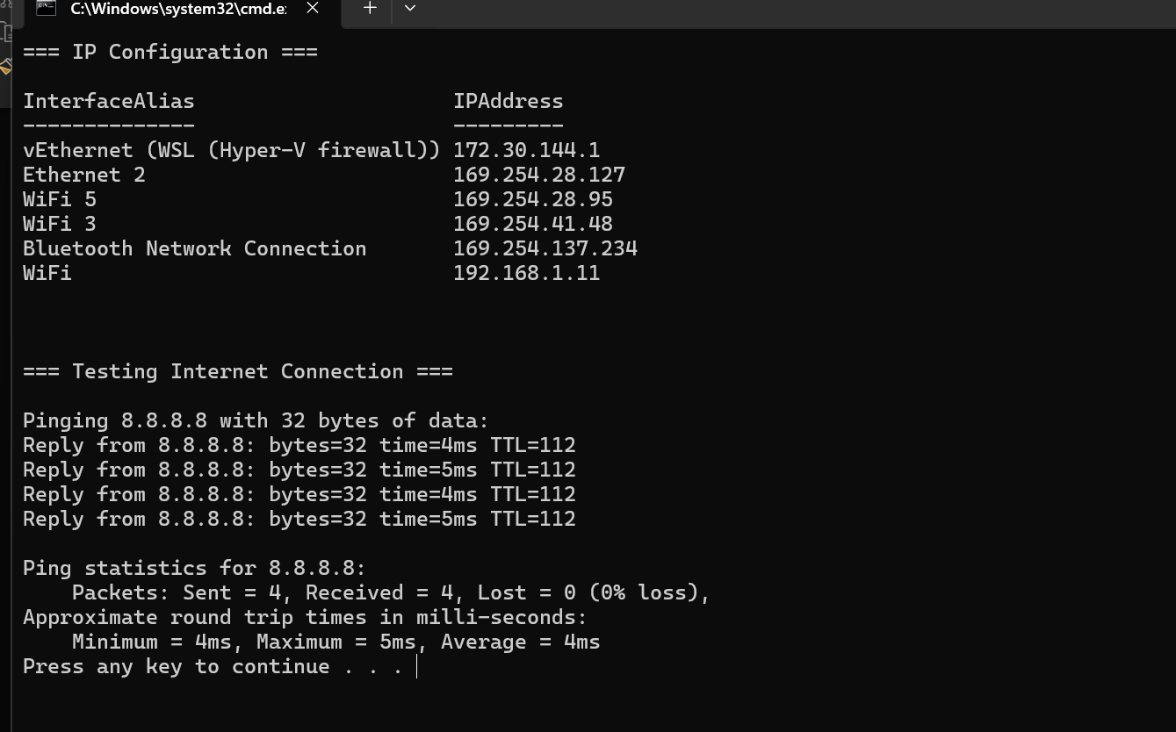

5: Use of Linux OS scripts
calculator.sh
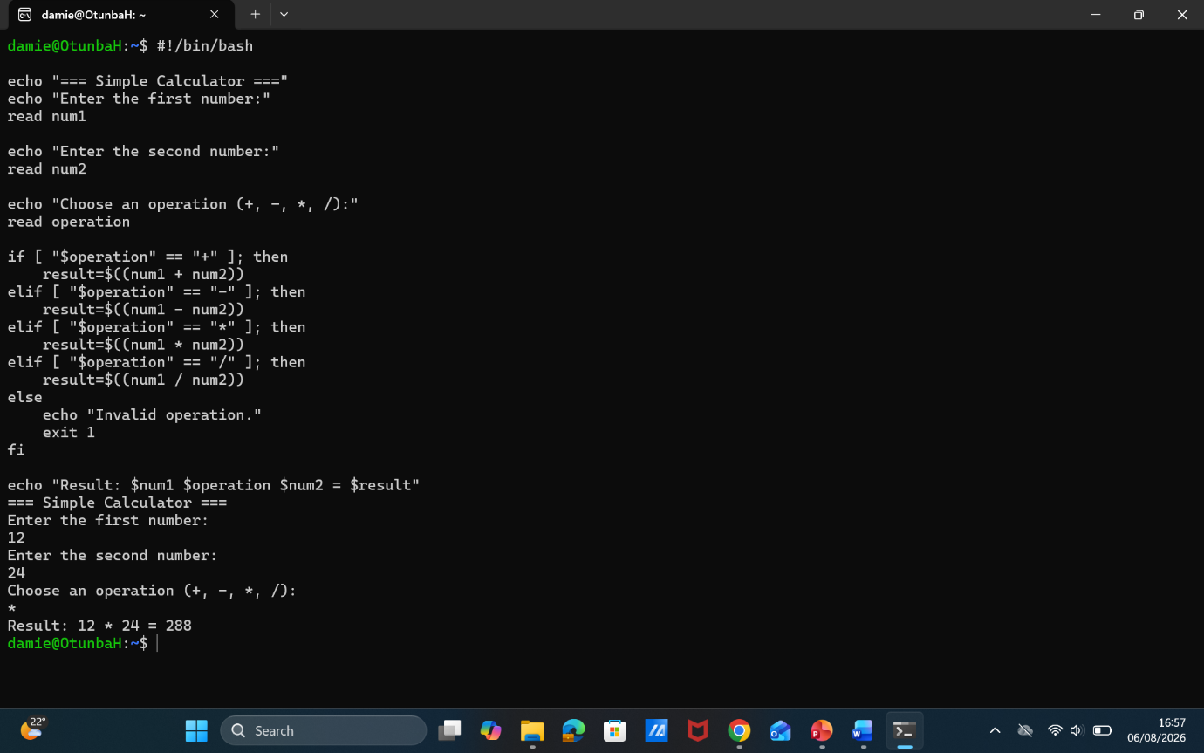
The Script
Expected Result

Countdown Timer
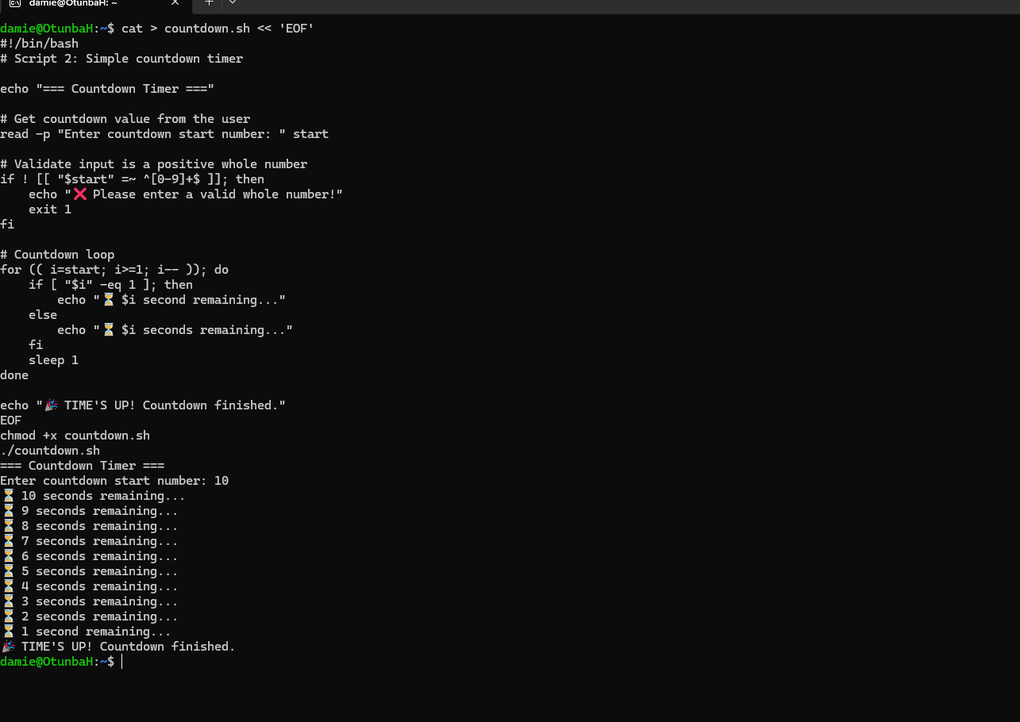
Expected result after adding a number
The script: variable, loops

Conclusion
Working through this report reinforced how much of an operating system's behaviour, which can otherwise feel abstract when read about in a textbook, becomes concrete once it is observed directly at the command line. Viewing process, memory, and network information through tasklist, ps, netstat, and ss made the scheduling and resource-management functions described in the first section tangible rather than theoretical.
Comparing Windows and Linux side by side also highlighted how differently the two platforms approach the same underlying problem. Windows tends to bundle a wide set of options into a smaller number of general-purpose commands, such as net or schtasks, whereas Linux favours a larger set of small, single-purpose utilities that are combined together, a philosophy that is reflected in the design of Coreutils itself [4], [5]. Neither approach was clearly superior; each has trade-offs between discoverability and flexibility.
Finally, writing the four automation scripts was the most practical part of the exercise. It required paying close attention to details that are easy to overlook when only running commands interactively, such as handling division by zero, checking whether a source folder exists before attempting to back it up, and retrying an operation that might fail temporarily. These are exactly the kinds of defensive habits that separate a script written for a one-off task from one that could safely run unattended, for example as a scheduled job, which is ultimately the point of learning Batch and Bash scripting in the first place.

Reference
References
[1] J. M. Rushby, "Design and verification of secure systems," vol. 15, no. 5, pp.12–21, 1981,
[2] M. K. McKusick, W. N. Joy, S. J. Leffler and R. S. Fabry, "A fast file system for UNIX," vol. 2, no. 3, pp.181–197, 1984,
[3] P. J. Denning, "Working sets past and present," IEEE Trans.Software Eng., no. 1, pp.64–84, 1980,
[4] L. L. Peterson and B. S. Davie,Computer networks: a systems approach, San Francisco, CA, 2007.
[5] A. S. Tanenbaum and H. Bos,Modern operating systems, prentice Hall Englewood Cliffs, 1992.
[6] MIcrosoft: LEARN. "Task Scheduler for developers." https://learn.microsoft.com/en-us/windows/apps. [Online]. Available: https://learn.microsoft.com/en-us/windows/win32/taskschd/task-scheduler-start-page
[7] Microsoft and LEARN, "Robocopy." [Online]. Available: https://learn.microsoft.com/en-us/windows-server/administration/windows-commands/robocopy
[8] "Ubuntu Server." [Online]. Available: https://ubuntu.com/server/docs/
[9] Kerrisk Michael. "introduction to user commands." Linux man pages online. [Online]. Available: https://www.man7.org/linux/man-pages
[10] "LEARN." [Online]. Available: https://learn.microsoft.com/en-us/windows-server/administration/windows-commands/windows-commands
[11] A. Silberschatz, P. B. Galvin and G. Gagne,Operating System Concepts, 10e Abridged Print Companion, John Wiley & Sons, 2018.
[12] A. Elahi and A. Cushman,Computer networks: data communications, internet and security, Springer Nature, 2023.
[13] D. E. Comer, The Internet book: everything you need to know about computer networking and how the Internet works, Chapman and Hall/CRC, 2018.
[14] T. Husu, "Expert Performance in System Administration," 2020,
[15] W. Stallings, Operating systems: internals and design principles, Prentice Hall Press, 2011.
[16] A. Silberschatz, H. F. Korth and S. Sudarshan,Database system concepts, McGraw-Hill New York, 2002.

