

Component 1: Design and Implementation of a Relational Database System
Introduction to Web and Database Concepts.
Student name: MOSES PAPPOE
Student Number: 2507709
Module code: ACCA4023
July 9, 2026
UNIVERSITY OF WALES TRINITY SAINT DAVID

Contents
Scenario Analysis 2
Entity Relationship Diagram (ERD) 2
1. List of attributes and their descriptions 2
2. List of relationships and their meaning. 3
3. ER diagram: 3
Normalization 4
Sample Data Population 5
Query Development 6
Testing and Validation 6
Design Decisions and Future Work 6
1. Design Decisions: 6
2. Future Work: 6
References: 6

Scenario Analysis
In this section you explain the scenario given in the coursework brief in your own words.
As postulated by Elmasri and Navathe, a database is described as the logical collection of similar data, created with meaning and made for a specific purpose which mirrors some aspects of real life scenarios [1].
The AutoPark Management System has been designed to replace an error-prone manual paper tracking system of a city-based parking service provider, into a centralized, relational database system with tracking capabilities using Microsoft Access. The absence of real-time visibility into vehicle movements, operational slot availability, and payment transactions creates operational inefficiencies, leading to bottlenecks and revenue leakage.
This database solution will map the identified entities and their corresponding attributes and relationships into a structured system. The six core entities based on the business logic are detailed below:
- ParkingSite: Refers to the physical parking locations managed by AutoPark.
- ParkingSlot: The individual spaces allocated within a parking site for a vehicle to park.
- Customer: The client or driver of the vehicle.
- Vehicle: The car or asset that will utilize the parking facility.
- Booking: The transaction that grants permission for the use of the parking facility and links a vehicle to a parking slot for a specified duration.
- Payment: The financial transaction that settles the booking between the client and AutoPark.
This architecture delivers real-time data accuracy, reduces data duplication, maximises space utilisation, and provides management with actionable insights into revenue performance and occupancy levels.

Entity Relationship Diagram (ERD)
An E-R Diagram is a concise logical imagery of the data elements for an organization or business area which shows the entities, their attributes and the associations/ relationships that exists between them [2]

List of attributes and their descriptions.
From the identified entities, the following are the attributes of each.
- ParkingSite – SiteID. Primary Key. (Unique number for each site)
SiteName, Location (Geographical place), TotalSlots (Number of slots available at the site).
- ParkingSlot – SlotID. Primary Key. (Unique number for each slot)
SiteID, SlotNumber, SlotStatus(empty/occupied)
- Booking – BookingID. Primary Key. (unique number of booking)
SlotID, VehicleID, CheckInTime (arrival time), CheckOutTime
- (exit time).
- Customer- CustomerID. Primary Key. (Unique number of client)
FirstName, LastName, ContactNo (Telephone/mobile)
- Vehicle- VehicleID. Primary Key. (unique number for each vehicle)
CustomerID, LicensePlate, VehicleType(make/model)
- Payment- PaymentID. Primary Key (unique payment reference)
BookingID, AmountPaid, PaymentDate, PayMethod(cash/card)
- List of relationships, the cardinality and participation constraints

- ParkingSite contains ParkingSlot (1: N): One parking site hosts many individual slots; however, one parking slot can only belong exclusively to one site, therefore a one-to-many cardinality relationship exists.
ParkingSite has a partial participation because a site can be newly acquired and registered but the slots not yet mapped out, yet the site can exist. However, a ParkingSlot cannot exist without being in a parking site, therefore it has a mandatory participation.

- Customer owns Vehicle (1: N): One customer can register multiple vehicles; however, one vehicle is registered to only one primary customer, therefore, a one-to-many cardinality relationship exists.
Customer has a partial participation in the relationship because it’s possible to register/create an account for parking services for future use without necessarily adding their car details at the present time, however a Vehicle will have a mandatory participation as it cannot be registered in the system without a valid customerID attached to it.

- Vehicle assigned Booking (1: N): A vehicle can make multiple distinct bookings for different dates and time, but a specific booking applies to exactly one vehicle, therefore, a one-to-many cardinality relationship exists.
Vehicle has an optional/partial participation because a vehicle might not necessarily utilize the booking, not obliged to physically park. On the contrary, a Booking cannot be generated without a vehicleID being logged, therefore it has a mandatory participation.

- ParkingSlot held_In Booking (1: N): One parking slot can have multiple bookings covering different dates and time but one single booking will be for exactly one slot at that time. Therefore, a one-to-many cardinality relationship exists.
ParkingSlot is a partial participant because a parking slot can exist without being tied to any active booking when vacant, but a Booking will have mandatory participation as it cannot exist in a vacuum because a vehicle cannot be checked into the system without a SlotID attached.

- Booking generates Payment (1:1): Every single booking will generate exactly one total payment record for its duration, and a single payment can be traced back to one unique booking. Therefore, a one-to-one cardinality relationship exists.
Booking has a partial constraint because it does not necessarily equate to a payment unless the customer makes payment. Payment has a mandatory constraint because for a payment to be made, a BookingID is needed.

ER diagram:
This diagram is modelled using Chen's Entity–Relationship (ER) approach, which visually represents entities, attributes, their relationships and leverages attribute mapping to bridge conceptual views with physical relational tables [3].

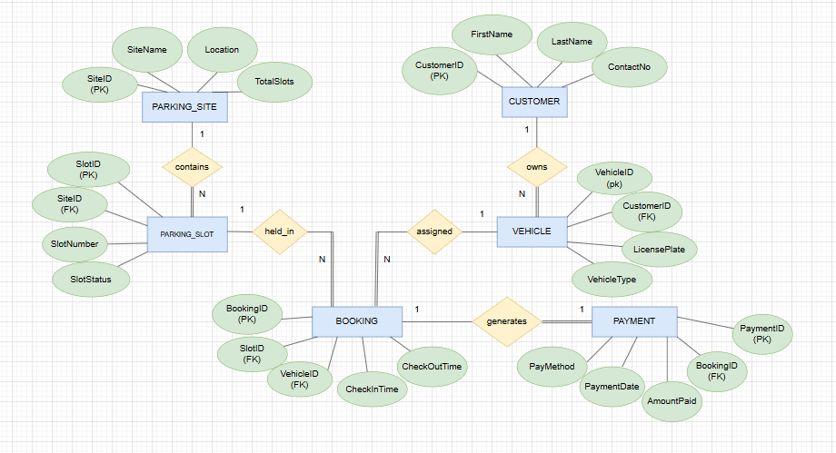
Figure 1 : screenshot of the ER diagram showing all the entities, their attributes, relationships, cardinality and participation constraints.
Diagram Link: drive.google.com.url

Relation Schema seeks to provide the structural framework of the database and as explained by Silberschatz et al., it is made up of the list of attributes and their matching domains, which combine to form the logical blueprint for a table's structural state [4]. It establishes clear primary/foreign key connections and normalization structures (up to 3NF).
- CUSTOMER (CustomerID PK, FirstName, LastName, ContactNo)
- VEHICLE (VehicleID PK, CustomerID FK references CUSTOMER(CustomerID), LicensePlate, VehicleType)
- PARKING_SITE (SiteID PK, SiteName, Location, TotalSlots)

- PARKING_SLOT (SlotID PK, SiteID FK references PARKING_SITE(SiteID), SlotNumber, SlotStatus)

- BOOKING (BookingID PK, SlotID FK references PARKING_SLOT(SlotID), VehicleID FK references VEHICLE(VehicleID), CheckInTime, CheckOutTime)

- PAYMENT (PaymentID PK, BookingID FK references BOOKING(BookingID), AmountPaid, PaymentDate, PayMethod)

Normalization
The normalization stage of database modelling involves applying a set of rules designed to structure database tables efficiently and reduce data redundancy. These rules are applied to the relational schema through a series of steps. The process begins with an unnormalized table, where all data is stored in a single, unstructured table, and progressively transforms it into normalized forms through three stages.
CustomerID | CustomerName | VehicleID | LicensePlate | Booking Details
C001 | Pam Smith | V001 | AB12 XYZ | (B001, SL01, 01/06/2026, £12), (B002, SL02, 05/06/2026, £6)
C002 | John Brown | V002 | CD34 ABC | (B003, SL15, 06/06/2026, £15)
Table 2: Example of an unnormalized table.
The table must be processed to a First normal form(1NF), eliminating repeating groups and non-atomic attributes. The Booking Details entity will have to be split into a separate table so that each field contains only a single (atomic) value and each row represents one booking. Primary key in Customer table, ‘CustomerID’ used as a foreign key in Booking to create a relation between the tables.
CUSTOMER
CustomerID | CustomerName | VehicleID | LicensePlate
C001 | Pam Smith | V001 | AB12 XYZ
C001 | Pam Smith | V001 | AB12 XYZ
C002 | John Brown | V002 | CD34 ABC
Table 1 : Customer Table split from unnormalized table to attain 1NF.
BOOKING
CustomerID | BookingID | SlotID | BookingDate | Fee
C001 | B001 | SL01 | 01/06/2026 | £12
C001 | B002 | SL02 | 05/06/2026 | £6
C002 | B003 | SL15 | 06/06/2026 | £15
Table 2 :Booking Table split from unnormalized table to attain 1NF.

‘CustomerID’ and ‘BookingID’ are composite keys in the Booking table. Next step is to ensure every non-key attribute is fully dependent on the whole composite primary key to achieve Second Normal Form(2NF). SlotID, BookingDate and Fee depend only on BookingID, which is only part of the composite key.
This is a partial dependency, violating 2NF.

BookingID uniquely identifies each booking, therefore CustomerID must not form part of the primary key. So, the primary key will remain BookingID and CustomerID, as a foreign key. This satisfies the 2NF requirement. The third step is to check that there are no transitive dependencies to attain Third Normal Form(3NF).
Since CustomerID does not determine SlotID, BookingDate nor Fee. SlotID does not determine BookingDate nor Fee and the BookingDate in turn does not determine Fee, then every non-key attribute depends directly on BookingID, and the table is in 3NF.
We can proceed to create the tables in Ms Access.
BookingID (PK) | CustomerID (FK) | SlotID | BookingDate | Fee
B001 | C001 | SL01 | 01/06/2026 | £12
B002 | C001 | SL02 | 05/06/2026 | £6
B003 | C002 | SL15 | 06/06/2026 | £15
Table 3 : Table in 3NF.
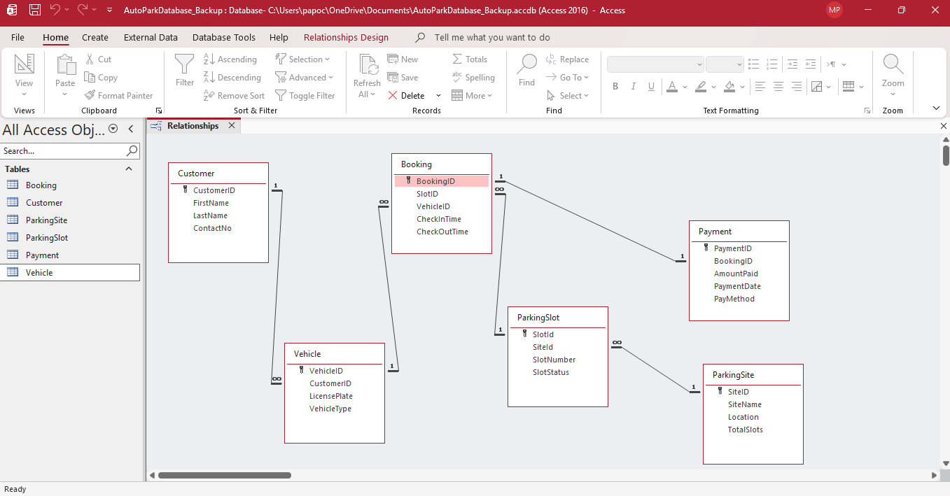
Figure 5: Entity and Attribute Tables and Relationships in MS Access.
Ms Access link: AutoParkDatabase_Final.accdb

Sample Data Population
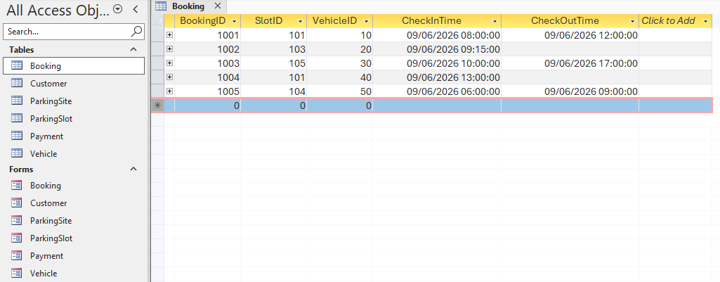
Table 4 : Booking table populated with sample data.

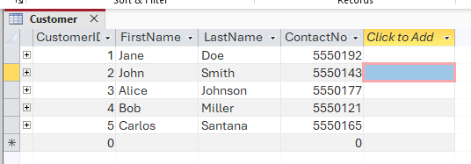
Table 5 : Customer table filled with sample data.

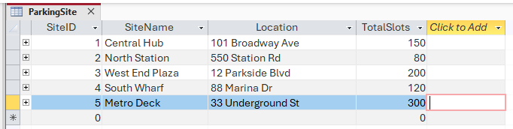
Table 6: ParkingSite table showing data entry.
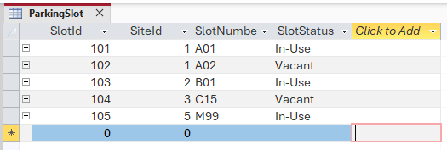
Table 7 : ParkingSlot table with data entry.

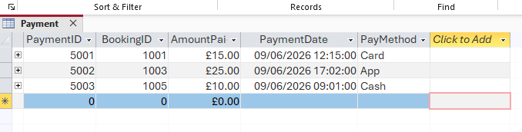
Table 8 : Payment table with populated fields.

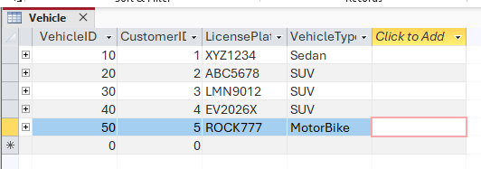
Table 9 : Vehicle table showing data entry.

Query Development
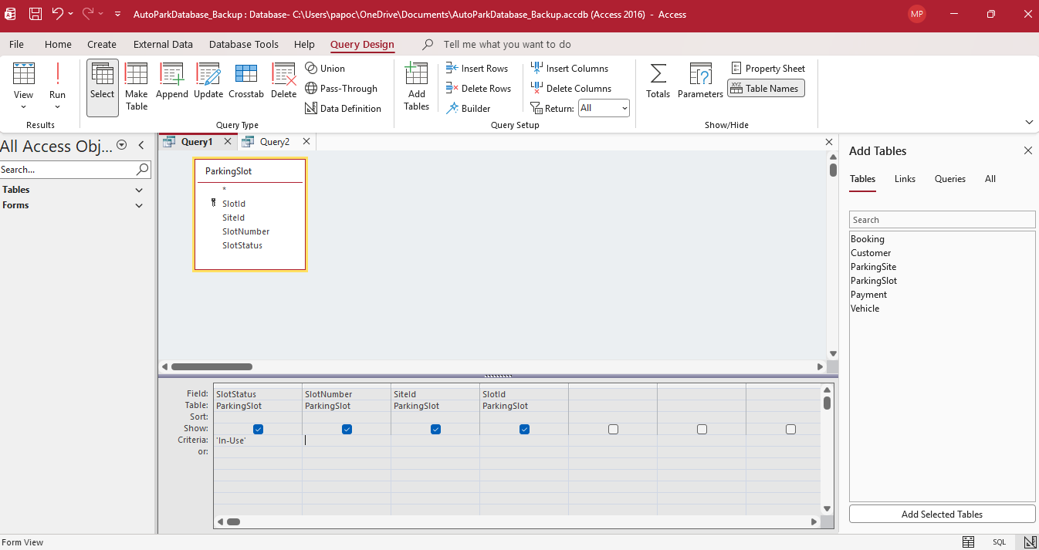
- Which ParkingSlot is currently In-Use?
Figure 7: Query to determine number of ParkingSlot in-use.

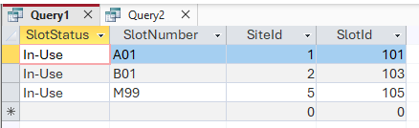
Figure 8: Result of the runned query showing 3 ParkingSlot currently in-use.

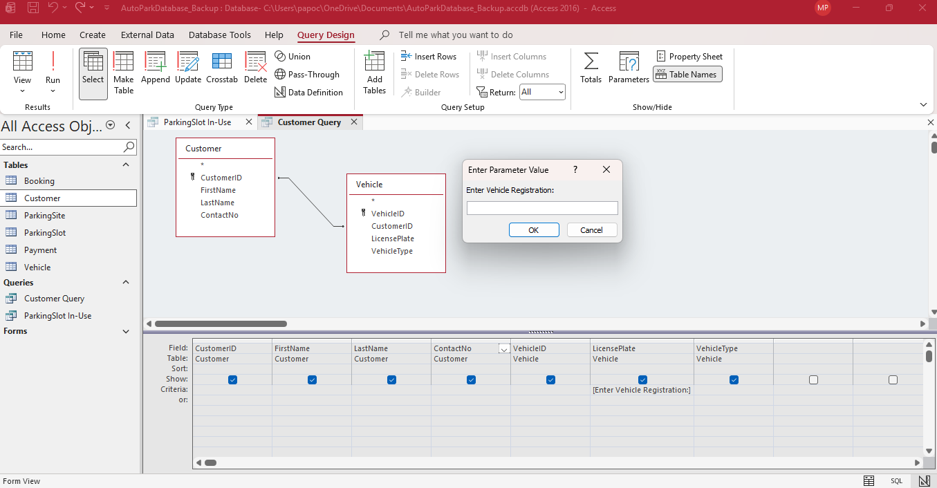
- Find a Vehicle Owner by License plate using a parameter query.
Figure 9: A parameter query to search for vehicle and customer data via LicensePlate.

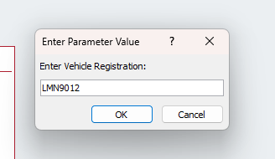
Figure 10: LicensePlate inputted in the search box.

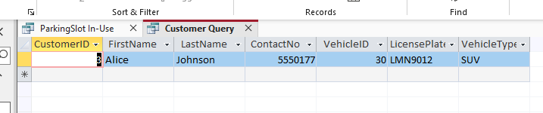
Figure 11: Returned Customer Information after search was run.

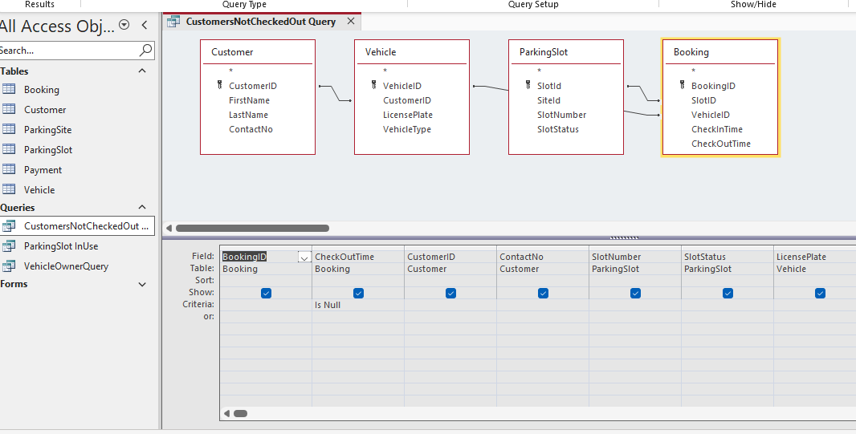
- Customers not checked out.
Figure 12: Query to pull up list of Customers who have not yet Checked Out.

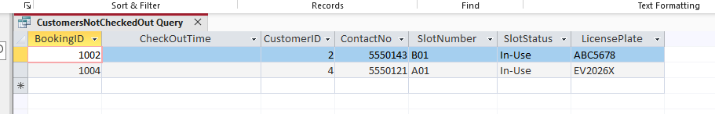
Figure 13: The results of the query showing 2 customers have not Checked out.

Testing and Validation
This Parking Management System was thoroughly run through various data integrity checks using Ms Access, to ensure it was equal to all functional requirements highlighted in the initial analysis and design stages. Relationship constraints, data entry validation, and query functionality were tested and validated.
The database was tested using both valid data and intentional entry errors to cement the database’s ability to seamlessly store, retrieve and update real-time operational parking metrics. This helped to ensure that primary keys, foreign keys and referential integrity rules have been adhered to.
This will stop data anomalies and redundancies from occurring.
- TEST 1. Enforce one-to-one relationship.
Checked that Booking and Payment relationship was strictly unique and duplicate proof.
This was done by attempting to create a second payment for the same BookingID.
The system flagged this error and prevented a duplicate payment.
Duplicate payment was rejected and system passed the test.
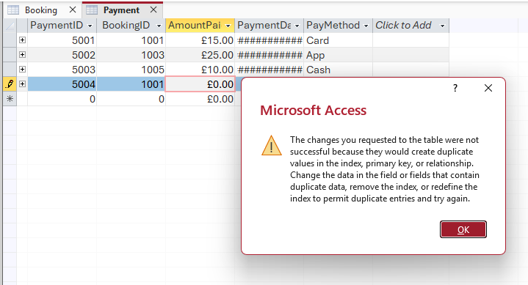
Figure 14: Ms Access flags duplicate BookingID payment attempt.
- TEST 2. Enforce referential integrity.
Checked that data entries in the tables are all linked properly by attempting to create a booking using a non-existent VehicleID. Ms Access flagged this, error message was displayed and booking rightly rejected as there was no related record of the entry in a related table. System passed the test.
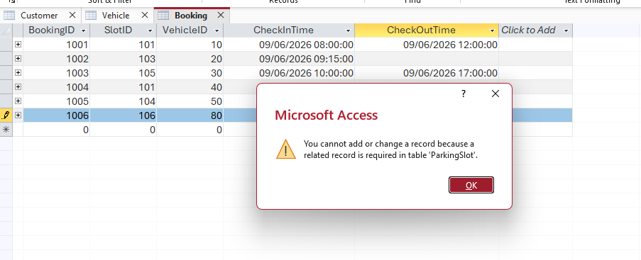
Figure 15 : Error message in Ms Access pointing to referential integrity issue.

Design Decisions and Future Work
- Design Decisions: This database system was modelled using Microsoft Access as the RDMS due to its ease of use, built-in query tools, and suitability for developing small to medium-sized database applications.
I encountered a few challenges were during development. One challenge involved enforcing the one-to-one relationship between Booking and Payment, as Microsoft Access initially interpreted the relationship as one-to-many. This issue was resolved by indexing the BookingID field in the Payment table with the "No Duplicates" property.
Another challenge involved maintaining referential integrity when entering records into related tables. This was addressed by ensuring that parent records were created before dependent records and by carefully configuring the database relationships. So, a Customer table must be populated first before a dependent table, Vehicle can be successfully created.

- Future Work: Although the current system satisfies the identified requirements, some enhancements that could be implemented in future versions are an online booking and payment service to allow customers to reserve parking spaces in advance through a web or mobile application.
Automatic Number Plate Recognition (ANPR) technology could be deployed to automate vehicle entry and exit registration.
Customer experience could be enhanced with automated notifications of parking time remaining, booking confirmations and payment reminders.

References:

[1] | R. E. a. S. B. Navathe, “Databases and database users,” Fundamentals of Database Systems, vol. 7, pp. 3-28, 2016.
[2] | T. M. C. a. C. E. Begg, “Database Systems,” A Practical Approach to Design, Implementation, and Management, vol. 6, 2015.
[3] | P. P. S. Chen, “The Entity-Relationship Model—Toward a Unified View of Data,” ACM Transactions on Database Systems (TODS), vol. 1, no. 1, pp. 9-36, Mar 1976.
[4] | H. F. K. a. S. S. A. Silberschatz, “Introduction to the Relational Model,” Database System Concepts, vol. 1, no. 7, p. 27–42., 2020.

