BMHS4005: Skills for academic success.
Assessment 1: 30 Minute in class referencing activity.
Instructions
You have 30 minutes.
You may use:
- University Harvard Referencing Guide
- Printed or electronic copy (if permitted)
You may not:
- Use AI tools
- Access the internet (unless your referencing guide is online)
- Discuss answers with other students

Activity 1: Read each question carefully and indicate the correct answer.
Question 1: Which is the correct in-text citation? (3 Marks)
A.) (Smith)
B.) (Smith 2022)
C.) (Smith, 2022)
D.) 2022 Smith.
Answer:
C

Question 2: Which citation could correctly be used to show a direct quotation?
A.) (Smith, 2022)
B.) (Smith, 2022, p.15)
C.) Smith, p15
D.) Smith (2022)
Answer:
B
Question 3: Which answer is one of the ways to correctly present a citation for a source with two authors?
A.) (Smith and Jones, 2021)
B.) (Smith & Jones 2021)
C.) (Smith, Jones 2021)
D.) Smith and Jones
Answer:
A

Activity 2: Each of the following references contain mistakes. Spot the errors and rewrite the reference correctly. (4 Marks)
Question 1: Smith J 2022 Understanding Care Sage London
Answer:
Smith, J. (2022) Understanding Care Sage. London:

Question 2: Social Care Institute for Excellence 2024. Safeguarding adults sharing information. www.scie.org.uk/safeguarding/adults/practice/sharing-information Accessed 10 October 2025
Answer:
Social Care Institute for Excellence (2024) Safeguarding Adults Sharing Information. Available at: www.scie.org.uk/safeguarding/adults/practice/sharing-information (Accessed: 10 October 2025)

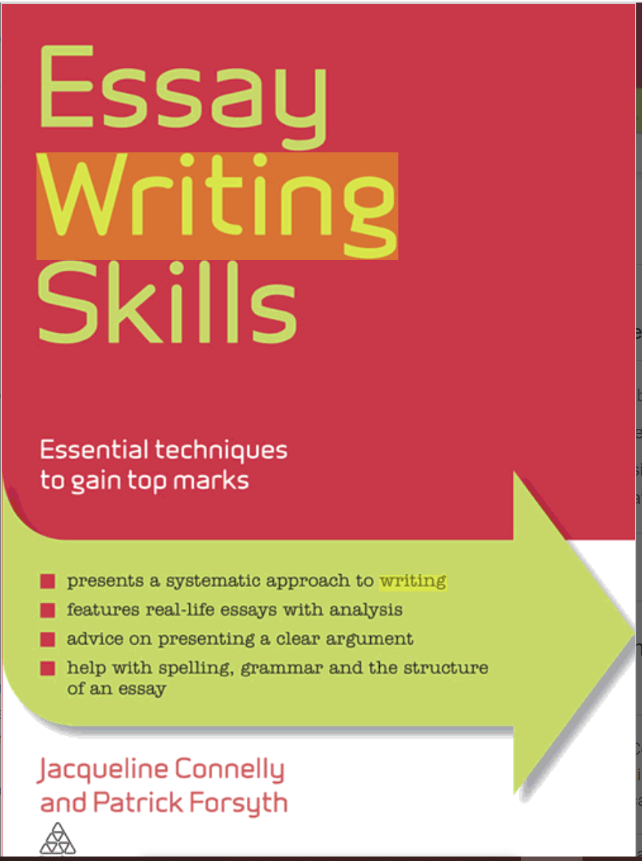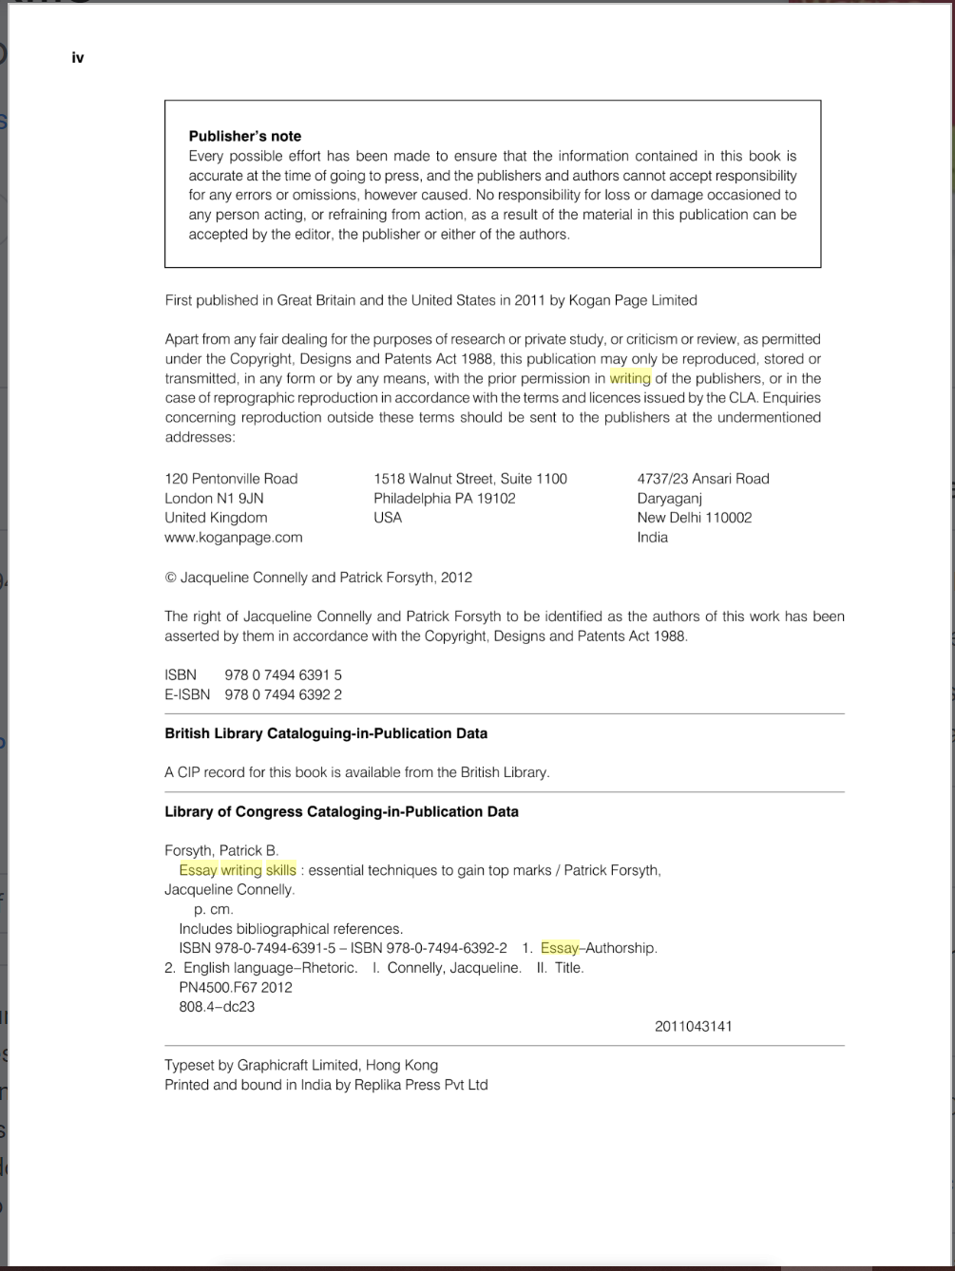
Activity 3: In the following Activity you will find 2 different credible sources
You need to identify the source type, provide the citation (both variations) and the full reference in the spaces provided. (8 Marks).

Answer:
Source type: published Book
Citation variation 1: Connelly and Forsyth (2011)
Citation variation 2: (Connelly and Forsyth, 2011)
Reference:
Connelly, j., Forsyth, P., (2011) Essay Writing Skills

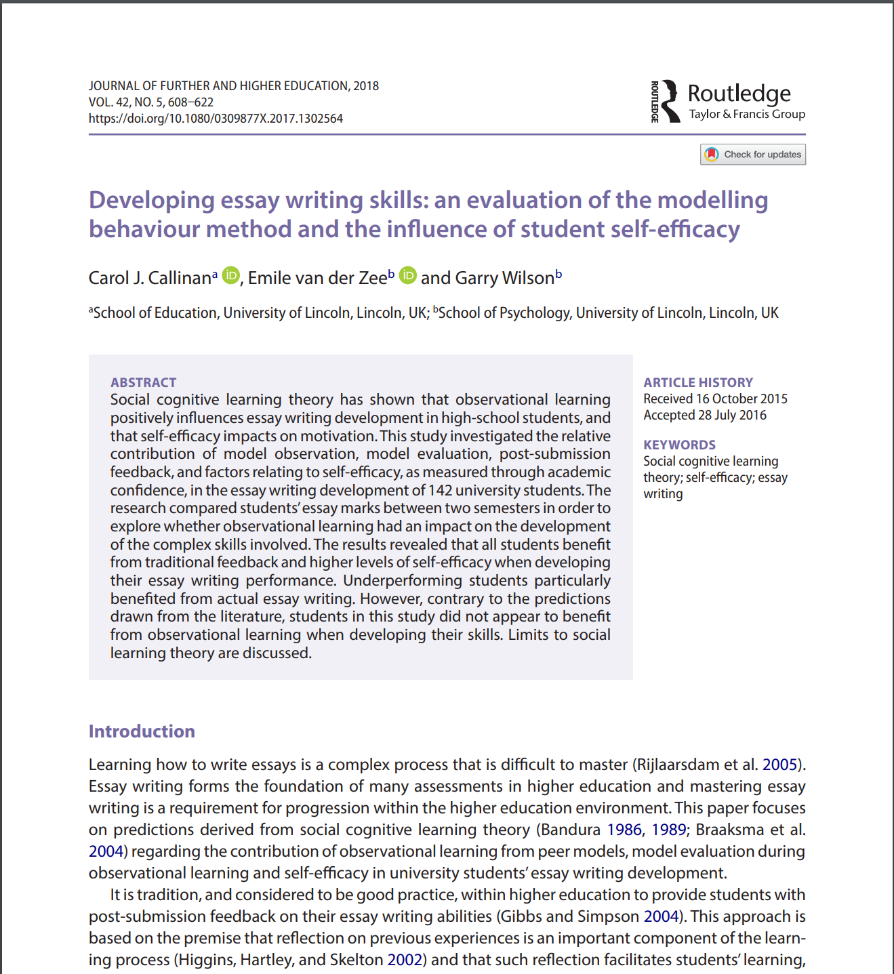

Answer:
Source type:
Citation variation 1:
Citation variation 2:
Reference:

Activity 4: Match each reference to the correct source type by writing the correct letter (A–C) in the table. (3 Marks)
References
A.) Brown, A. (2023) Communication in Health and Social Care. 3rd edn. London: Sage.
B.) Jones, L. and Patel, R. (2022) 'The importance of person-centred care in healthcare settings', Journal of Health Care Practice, 18(2), pp. 45–58. Available at: https://doi.org/10.1177/1748895818781199.
C.) Department of Health and Social Care (2023) Adult Social Care Reform: Next Steps. London: Department of Health and Social Care.
Answer table:
Source Type | Correct Answer/Letter
Government report | C
Journal article | B
Book | A

Activity 5: Insert appropriate in-text citations using the sources below. (3 Marks)
According to Smith (2022),
(Brown, 2021)
(NHS England, 2023)
Paragraph for citation practice:
Person-centred care improves patient satisfaction and health outcomes (NHS England, 2023). According to Smith (2022), Communication between professionals is essential for safe care. Reflective practice supports lifelong learning (Brown, 2021).

Activity 6: Academic Integrity. Read each question carefully and select the best answer. (5 Marks)

Question 1: Which statement best describes plagiarism?
A.) Working with classmates.
B.) Using another person's ideas without acknowledging them.
C.) Using books.
D.) Reading journal articles.
Answer:
B

Question 2: Why do we use a referencing? Select two answers.
A.) To acknowledge authors
B.) To increase word count
C.) To allow readers to locate sources
D.) To make assignments longer
Answers:
C

Question 3: Which statement best describes academic integrity?
A.) Completing work as quickly as possible
B.) Producing honest work and acknowledging the ideas of others
C.) Using as many websites as possible
D.) Writing long assignments
Answer:
B

Question 4: Which of these should be referenced?
A.) A statistic taken from a government report
B.) A theory discussed in a textbook
C.) A quotation from a journal article
D.) All of the above
Answer:
D

Question 5: A friend offers to let you copy part of their assignment because they completed the module last year. What should you do?
A.) Copy it because they have given permission.
B.) Rewrite a few words and submit it.
C.) Decline and produce your own work.
D.) Copy only the introduction.
Answer:
C

Mark:
Marker:
Date:
Moderator:
Date:

