University of Wales Trinity Saint David
Wales Institute of Science and Art



Electronic Circuits Testing and Applications
Charlie Jones
2103718
Motorsport Engineering (BEng, HND, Foundation Entry)
ACHA4010
Electrical Control Systems
24th/ 31st March 2024
Contents
1 Task 2 1
1.1 Scope Time Division Calculations (4) 1
1.2 Function Generator output sine wave (3) 2
1.3 Unsmoothed Rectifier Wave (3) 3
1.4 Smoothed Rectifier Wave with capacitor (3) 4
1.5 Drop in Voltage Question (4) 4
1.6 Different Voltage Readings Question (5) 4
1.7 Rectifiers use in Automotive applications Question. (4) 5
1.8 Probing Question (4) 5
2 Task 3 6
2.1 Scope Time Division Calculations (4) 6
2.2 Function Generator output square wave (3) 6
2.3 Capacitor charge and discharge wave marked at correct points. (3) 7
2.4 Basic Capacitor Calculations (3) 8
2.5 Capacitor discharge table (4) 8
2.6 Gradient Plot and calculations (4) 8
2.7 Capacitor Uses (5) 8
2.8 Inaccuracies Question (4) 9
3 References 11

Task 2

Scope Time Division Calculations (4)

For displaying a total period of a 10 Hz sine wave on an oscilloscope, we calculate the period ($Τ$) using $Τ$ = $\frac{1}{f}$ With $f$ being the frequency (10 Hz). This calculation yields $Τ$ = 0.1 seconds (100 milliseconds). To picture this on an oscilloscope, traditionally having ten horizontal divisions, we align the time division to fit 0.1 seconds comfortably across the screen. The provided data files indicate a clock setting of 20.0 ms, confirming this setting allows detailed observation of the waveform, as five divisions span 100 ms, offering a clear view of one cycle. Therefore, setting each division to 20 ms is optimal for displaying the waveform without distortion, supporting accurate analysis. This approach, validated by theoretical and practical evidence from oscilloscope readings, ensures the waveform is neither compressed nor stretched, facilitating precise measurement and analysis. Therefore, the correct time division for observing a 10 Hz sine wave is 20 ms/division, confirmed by both calculations and the oscilloscope data files from the practicals.
Time Division = $\frac{Period}{Number of Divisions}$ = $\frac{0.1 Seconds}{10}$ = 0.01 seconds per division

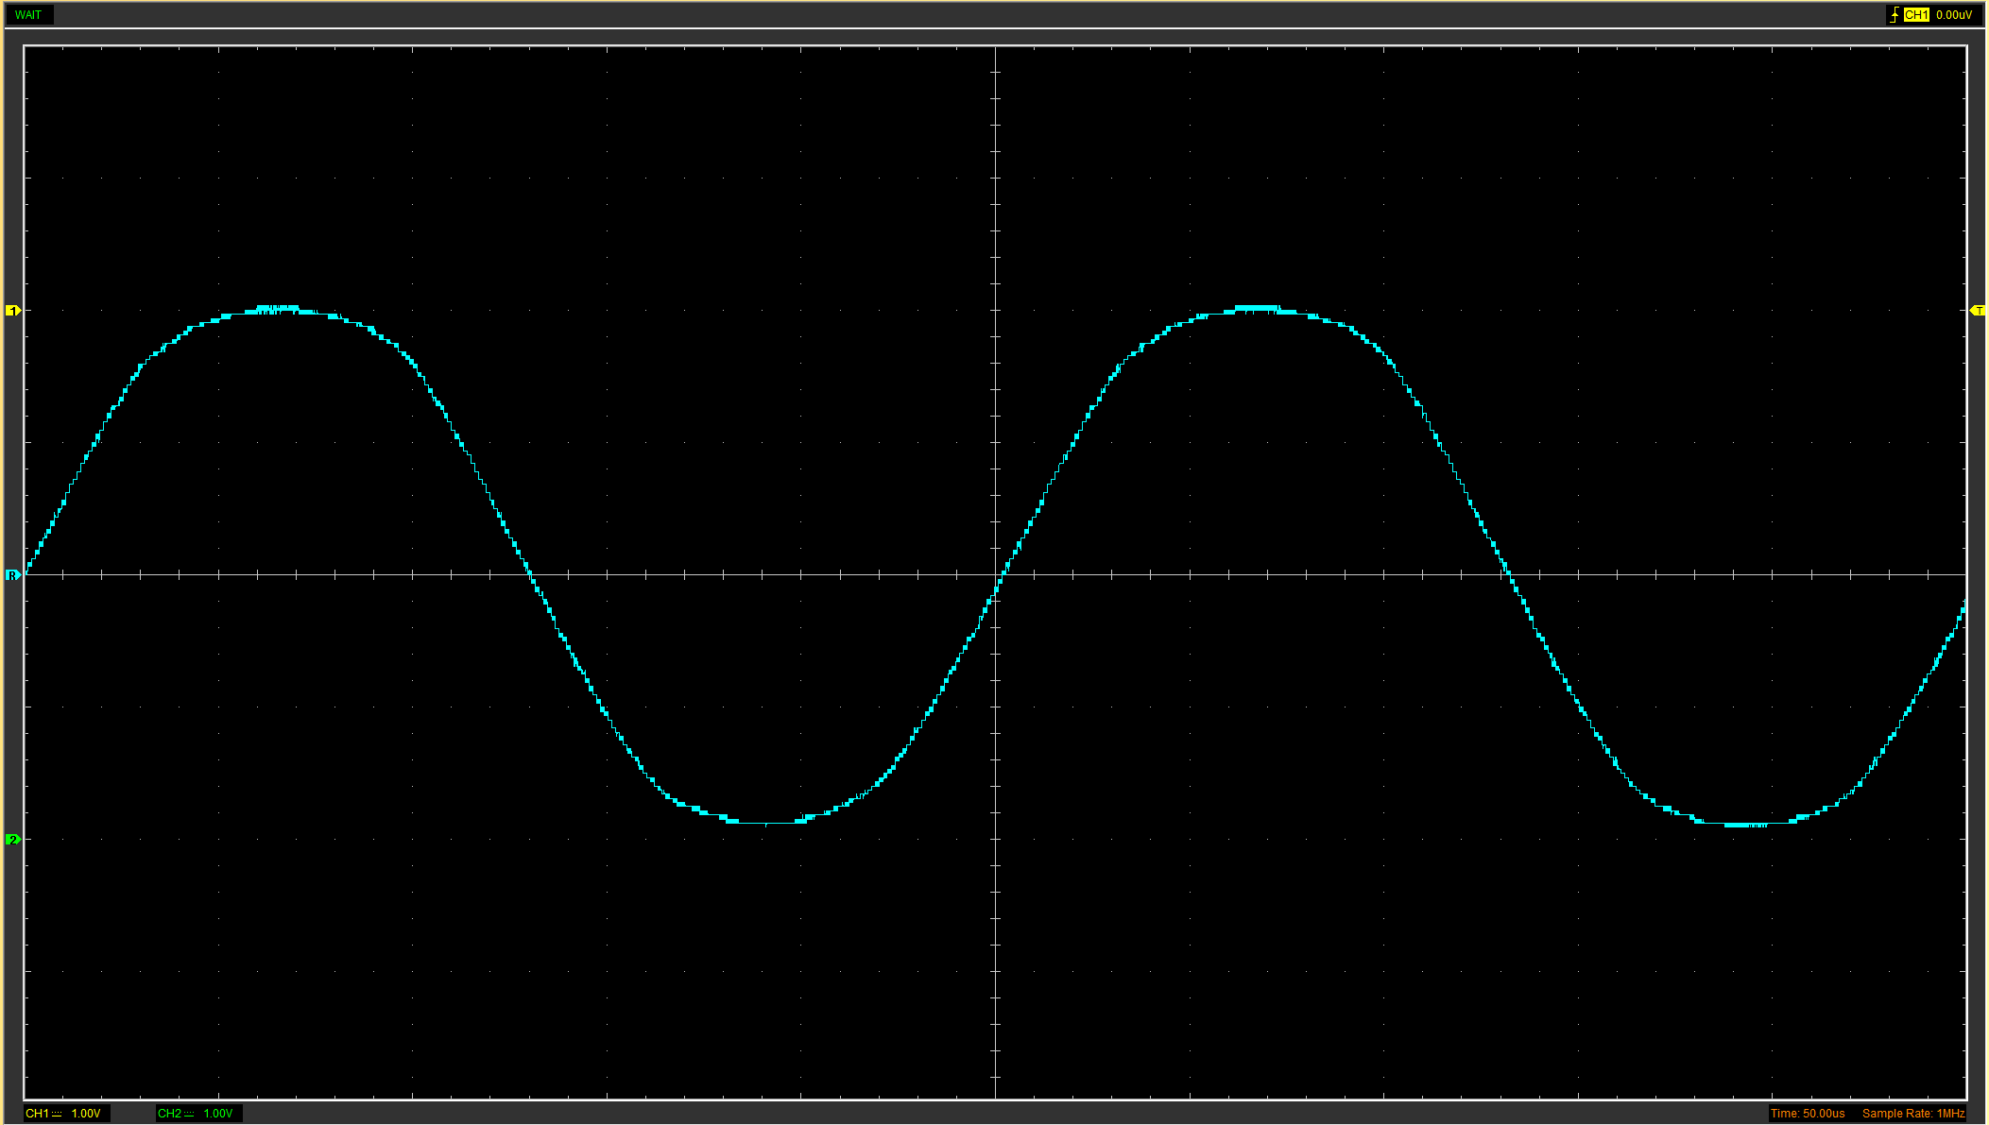
Function Generator output sine wave (3)
Figure 1 Screenshot of T2W1 Wave
The function generator was set to a 10Hz frequency to produce a sine wave, with a peak-to-peak amplitude target of 10V, ensuring no DC offset. The oscilloscope's time division setting was adjusted to display a complete waveform period across the screen; for a 10Hz wave, this required a setting of 10 milliseconds per division. The resulting oscilloscope data shows a precise sine wave with accurate amplitude and frequency, fulfilling the set requirements and demonstrating an understanding of waveform generation and oscilloscope operation.

Unsmoothed Rectifier Wave (3)
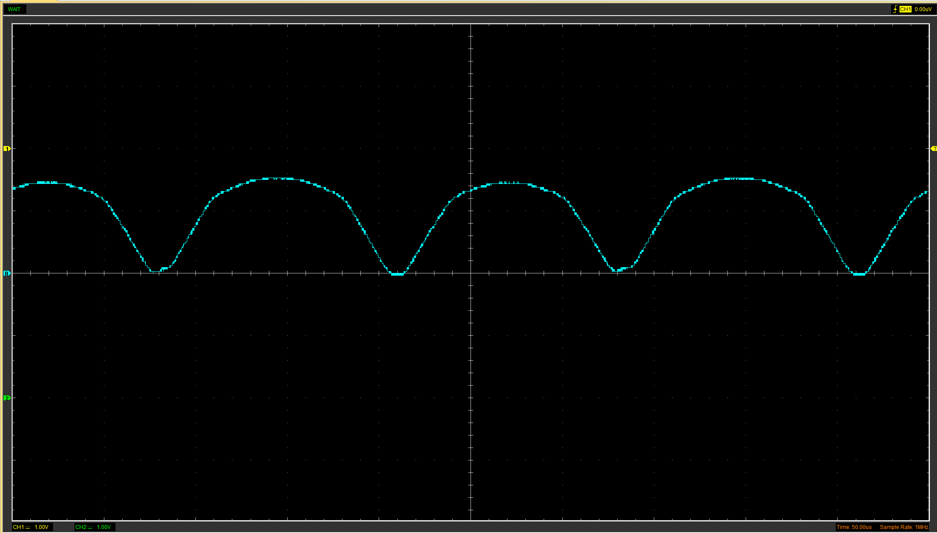
Figure 2 Screenshot of T2W2 Wave
The output of a full bridge rectifier without a smoothing capacitor is a fluctuating DC waveform, showing peaks that compare to the AC input's positive and negative cycles, rectified to the same contradiction. This results in a rippled voltage with twice the frequency of the input AC signal. Without the capacitor's smoothing influence, this ripple can cause instability in electronic circuits that require a steady DC supply.

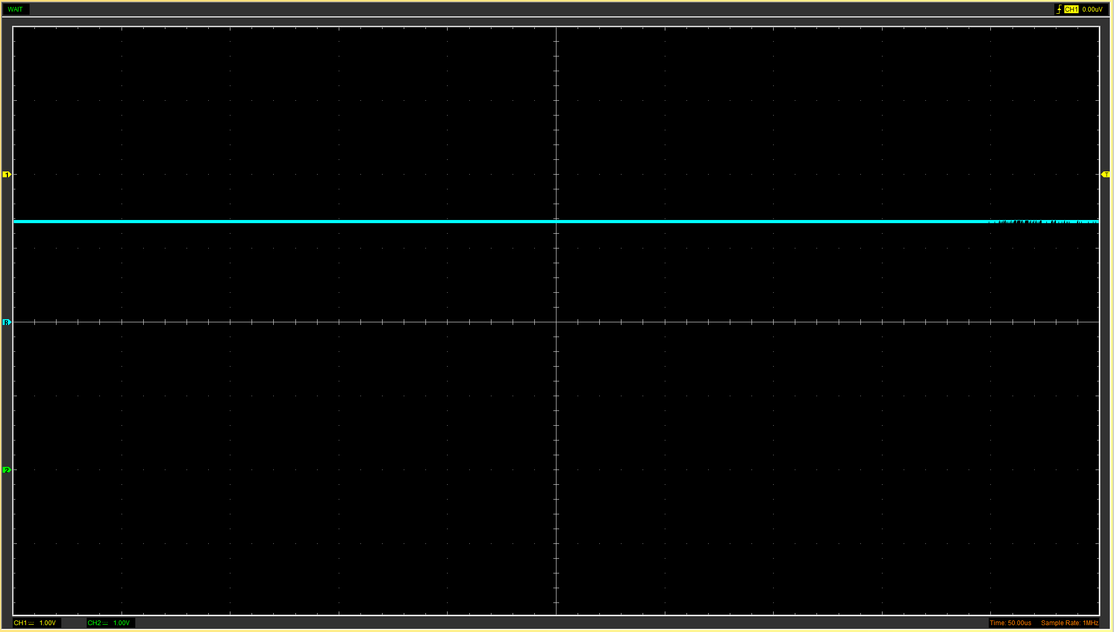
Smoothed Rectifier Wave with a capacitor (3)
Figure 3 Screenshot of T2W3 Wave
When a capacitor is added to a full bridge rectifier circuit and placed before the resistor, it significantly improves the output signal quality. The capacitor charges to the peak voltage of the rectified waveform and discharges during the intervals when the input voltage is below its peak, effectively minimising the voltage ripple. This smoothing action of the capacitor results in a more stable and continuous DC output. Oscilloscope traces would show a reduced peak-to-peak variation in the output voltage, confirming the sight of a smoother DC level suitable for powering sensitive electronic devices.

Drop in Voltage Question (4)
The DC output from a full bridge rectifier is typically less than the input's peak voltage due to inherent diode voltage drops. Each diode in the bridge circuit incurs a forward voltage drop, commonly about 0.7V for diodes, effectively lowering the peak output by this forward drop multiplied by the number of diodes in the conduction path, which is two for a full bridge. Additionally, diodes could be better and have internal resistances, causing further voltage reduction under load conditions. Thus, the peak DC output is the input's peak minus these voltage drops during each half-cycle of the AC input.

Different Voltage Readings Question (5)
 | T2W1 Voltage (V) | T2W2 Voltage (V) | T2W3 Voltage (V)
Peak Positive Input | 4.2039 | 2.949 | 2.7608
Peak to Peak | 8.0941 | 3.0117 | 0.0628
RMS | 3.0154 | 2.1892 | 2.7576

The RMS value of an AC waveform is the square root of the mean of the squared immediate values, representing the effective voltage in terms of its power delivery to a load as a DC voltage (Electronics Tutorials, 2014). RMS is essential because it equates the heating effect of AC and DC voltages, making it a key component in power calculations. The RMS value is exclusive to time-varying signals and not constant magnitudes like those in DC systems. The RMS voltage of a sinusoidal waveform is $V_{RMS}= V_{Peak} x 0.7071$, indicating the effective voltage for a given power level. (Electronics Tutorials, 2014)

Rectifiers use in Automotive applications Question. (4)
In automotive systems, rectification via diodes is essential. Critical to the vehicle's alternator, these components convert alternating current (AC) to direct current (DC), which is necessary for charging the battery and powering the electrical systems. The stability of DC is vital for the functionality and longevity of the vehicle's electronics. Diodes also protect against voltage spikes and electrical noise, preventing damage to sensitive components (Mughees, 2023). Their use in automated systems like rain-detecting wipers and light-sensitive displays enhances safety and comfort. In manufacturing, diode lasers ensure precision in bodywork and component welding. Thus, rectifiers are foundational to the vehicle's electrical integrity and efficiency. (Mughees, 2023)

Probing Question (4)
When using a Hantek oscilloscope, it is not easy to simultaneously probe the input of a function generator and the output of a rectifier if they do not share a different ground potential. Typical oscilloscope probes have a ground lead referencing the oscilloscope's earth ground. Connecting two points with differing ground potentials can create a short circuit through the oscilloscope's grounding system, leading to erroneous measurements or hardware damage.
Differentiated probes can be employed to address this issue. These specialised probes enable the measurement of voltage differences between two points independently of the oscilloscope's ground. Differential probes achieve this by isolating the measured signal from the reference ground, which prevents the short circuit and allows for accurate, simultaneous measurements across different parts of a circuit.
Tektronix highlights that probe loading effects, such as those caused by the probe's input resistance and Capacitance, must be considered when performing precise measurements. The probe's electrical characteristics can modify the signal under test. Differential probes mitigate these issues with high input impedance and low Capacitance, allowing for more reliable measurements. (Tektronix, 2021)

Task 3

Scope Time Division Calculations (4)
An RC circuit with a 100kΩ resistor and a 0.1μF capacitor has a time constant (T) that we calculate as $Τ=R x C$ With $R=100kΩ$and $C=0.1μF$, one-time constant $T is 100,00 x 0.1 x {10}^{-6} seconds or 0.01 seconds$. Therefore, 20-time constants (20T) would be $20 x 0.01$ seconds, totalling 0.2 seconds.

To display one complete waveform lasting 20-time constants on the oscilloscope, we divide the total period of 0.2 seconds by the number of horizontal divisions on the oscilloscope screen, typically 10. Thus, the time division setting for the oscilloscope should be $\frac{0.2 Seconds}{10}$ resulting in 0.02 seconds or 20 milliseconds per division. This setting displays the complete waveform of 20T across the ten divisions of the oscilloscope screen.

Function Generator output square wave (3)
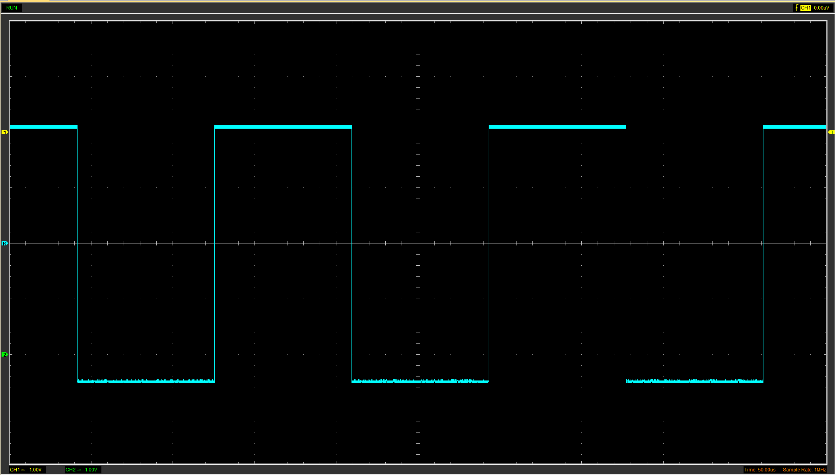
The function generator outputs a square wave with a peak-to-peak voltage of 1V, transitioning from 0V to +1V. The frequency of the square wave was determined based on the RC time constant previously calculated to ensure that the waveform would allow for 20 complete charge and discharge cycles within the observable time frame while also within the oscilloscope's bandwidth capabilities.
Figure 4 Screenshot of Square Wave
The square wave was captured and displayed clearly on the oscilloscope. The oscilloscope settings were adjusted to ensure that at least two complete cycles of the square wave were visible, which aids in visualisation of the capacitor's charging and discharging characteristics within the RC circuit. They set the oscilloscope's time base to accommodate the complete cycles within the screen width and adjusted the voltage scale to display the amplitude accurately from 0V to +1V.

The capacitor charge and discharge wave are marked at the correct points. (3)
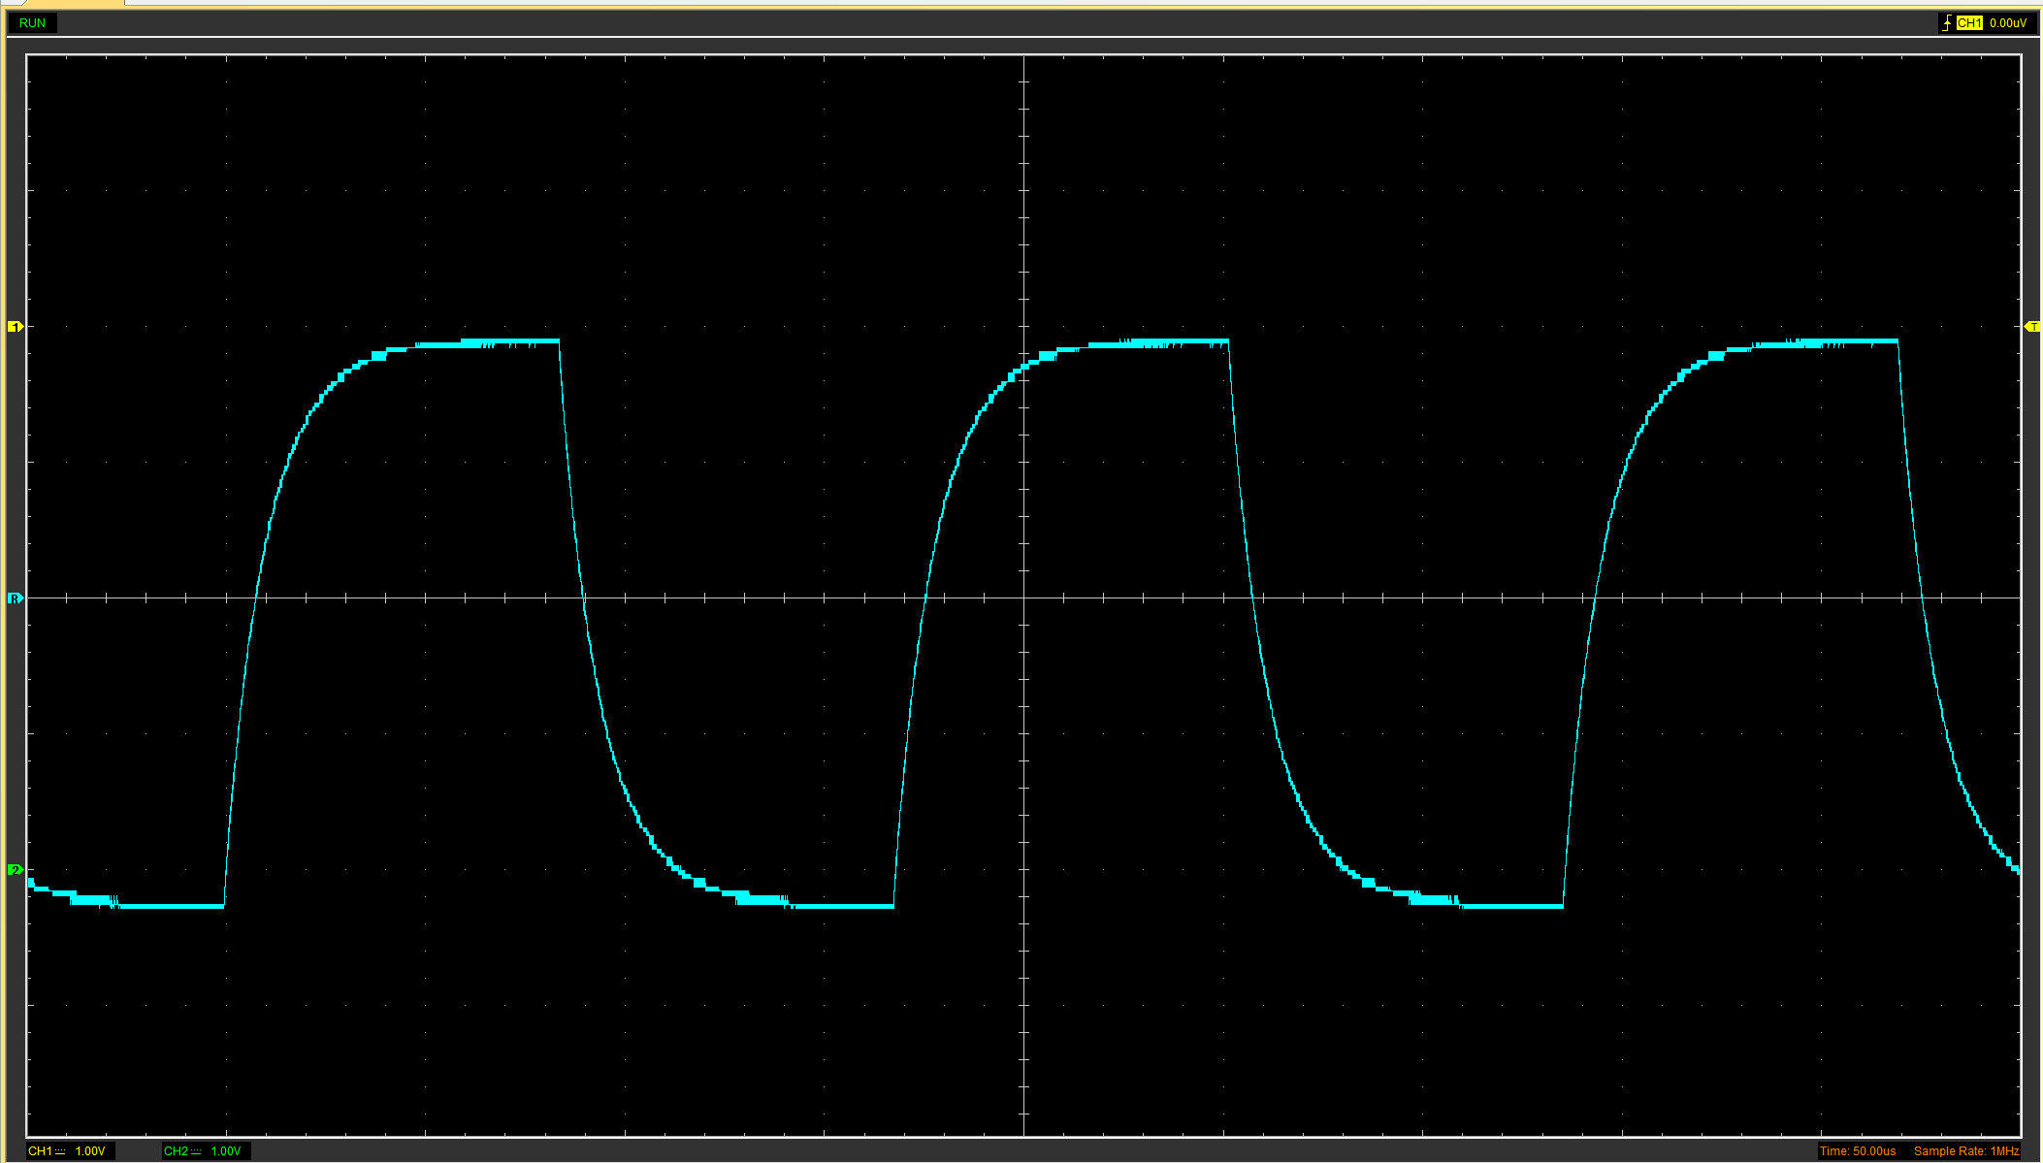
Figure 5 Screenshot of a RC Circuit Wave
This experiment used the oscilloscope to record the capacitor's response to a square wave input. The experimenter identified the essential points of interest in the waveforms during the charging and discharging phases. These points correlate to specific percentages of the maximum voltage with the time constants of the capacitor in the RC circuit.
For the charging phase, the point of interest is when the capacitor reaches 63.2% of its maximum voltage. The oscilloscope screenshot clearly shows the waveform rising and stabilising at a level that represents 63.2% of the square wave's peak voltage. This point has been accurately marked on the oscilloscope's display, showing the time constant during the charging cycle.
During the discharging phase, the point of interest is when the capacitor's voltage drops to 36.8% of the maximum voltage or, more straightforwardly, when it has declined by 63.2% from the maximum voltage reached during the charging phase. The experimenter marks this point on the oscilloscope's readout, corresponding to the Time constant for the discharging cycle.

Basic Capacitor Calculations (3)
To calculate the Capacitance (C) of the capacitor using the time constant (τ) method and the given resistance (R), we apply the formula τ = R·C. From the oscilloscope measurements, we have determined the Time constant (τ) to be 0.01 seconds. The RC circuit features a resistance (R) of 100kΩ (100,000 ohms). Rearranging the formula to solve for Capacitance gives us C = τ/R. Substituting the values calculates the Capacitance as follows:
$$C= \frac{0.01 seconds}{100,000 ohms}=1 x{10}^{-7}farads$$
Therefore, the capacitor's Capacitance is 100 nanofarads (nF). This calculation is crucial for analysing circuits where accurate timing is required, such as in filtering and signal-processing applications.

Capacitor discharge table (4)
Time (s) | Voltage (V) | ln (V) | dy = y2 – y1  dy = ln(V)2-ln(V)1 | dx = x2- x1  dx = Time2 – Time1 | dy/dx
0.007099 | 1.6 | 3.6 | x | x | x
0.007232 | 0.8784 | 2.8784 | -0.2237 | 0.000133 | -1681.95
0.007365 | 0.2824 | 2.2824 | -0.23201 | 0.000133 | -1744.41
0.007498 | -0.1882 | 1.8118 | -0.23091 | 0.000133 | -1736.14
0.007631 | -0.5961 | 1.4039 | -0.25507 | 0.000133 | -1917.8
0.007764 | -0.9098 | 1.0902 | -0.25289 | 0.000133 | -1901.45
0.007897 | -1.1294 | 0.8706 | -0.22493 | 0.000133 | -1691.23
0.00803 | -1.349 | 0.651 | -0.29067 | 0.000133 | -2185.51
0.008163 | -1.5059 | 0.4941 | -0.27577 | 0.000133 | -2073.47
0.008296 | -1.6 | 0.4 | -0.21127 | 0.000133 | -1588.52

Gradient Plot and calculations (4)
- Capacitance Calculation Using log(v) and Time:
  - Average Gradient (dy/dx): Calculated from provided logarithmic data.
  - Resistance (R): 100kΩ (given).
  - Capacitance (C): Calculated using ​$C= -\frac{1}{average gradient x R}$
- Capacitance Results:
  - Calculated Capacitance (using log method): 5.45 nF.
  - Previously Calculated Capacitance (using Time constant): 100 nF.
- Comparison of Results:
  - Percentage Difference: 94.55%.
  - Delta Difference: 94.55 nF.

Capacitor Uses (5)
Capacitors are essential components in both automotive and motorcycle electrical systems. Here are ten uses for capacitors in these applications:

- Energy Storage: Capacitors store and release electrical energy when required. In automotive applications, they can help power electric boost systems that supplement the engine during acceleration.
- Noise Filtering: Capacitors are used in the multimedia audio systems of cars and motorcycles to smooth out electrical noise, ensuring a clearer sound from the Multimedia system.
- Signal Processing: With other components, capacitors can shape electrical signals, essential in electronic control units (ECUs) for processing sensor inputs.
- Stabilising Voltage: Capacitors help stabilise voltage and power flow in electronic systems, crucial for protecting sensitive microelectronics in vehicles.
- Spark Ignition: In petrol-powered vehicles, capacitors store the energy needed for the spark to ignite the fuel-air mixture.
- Regenerative Braking Systems: In electric and hybrid vehicles, capacitors quickly store energy captured during regenerative braking and release it when needed for acceleration.
- Start-Stop Systems: In vehicles with start-stop technology, capacitors provide the necessary power to restart the engine promptly, reducing the strain on the battery.
- LED Lighting: In motorcycle and automotive LED lighting systems, capacitors regulate the power supply to ensure consistent light output and prolong the life of the LEDs.
- Power Conditioning: Capacitors condition the power from the alternator, smoothing out the output and safeguarding other electrical components.
- Ride Control Systems: They are employed in electronically controlled suspension systems to respond swiftly to changing road conditions, providing power to adjust the suspension for a smoother ride.

These functions show the importance of capacitors in managing and enhancing vehicle performance and functionality.

Inaccuracies Question (4)
Measurements in electrical engineering can diverge from specified values due to various factors, encompassing human errors, environmental conditions, instrument inaccuracies, and limitations of simulation tools. Human errors, such as misinterpretation of data or operational mistakes, play a significant role in measurement discrepancies. (Cho & Ahn, 2019) Examined failures in electrical components within South Korean Nuclear Power Plants, identifying human errors as a crucial factor. Environmental conditions, particularly temperature, significantly impact the performance of electronic components like photovoltaic panels, as detailed by (Surles, et al., 2019), showing that deviations from optimal conditions can alter expected measurements. (Coles, 2005) Discusses that test instrument accuracy is vital for reliable measurements; one must regularly calibrate instruments to ensure their precision. Lastly, the design and simulation tools used in developing electronic circuits, such as those described in (Fitzpatrick, 2008), can introduce inaccuracies if not calibrated adequately against real-world conditions. Collectively, these factors underscore the importance of rigorous testing, regular calibration, and accounting for environmental impacts to ensure measurement accuracy in electrical engineering.

References
Cho, W. C. & Ahn, T. H., 2019. A classification of electrical component failures and human error types in South Korean NPPs during the last 10 years. [Online]
Available at: https://www.sciencedirect.com/science/article/pii/S1738573318305837
[Accessed March 2024].
Coles, M., 2005. Ongoing Accuracy Of Test Instruments. [Online]
Available at: https://electrical.theiet.org/media/1696/ongoing-accuracy-of-test-instruments.pdf
[Accessed March 2024].
Electronics Tutorials, 2014. RMS Voltage Tutorial. [Online]
Available at: https://www.electronics-tutorials.ws/accircuits/rms-voltage.html
[Accessed March 2024].
Fitzpatrick, D., 2008. Analog Design and Simulation Using OrCAD Capture and PSpice. [Online]
Available at: https://www.sciencedirect.com/book/9780081025055/analog-design-and-simulation-using-orcad-capture-and-pspice
[Accessed March 2024].
Mughees, N., 2023. The importance of diodes for automotive applications. [Online]
Available at: https://electronics360.globalspec.com/article/19803/the-importance-of-diodes-for-automotive-applications
[Accessed March 2024].
Surles, W. et al., 2019. Photovoltaic Efficiency: The Temperature Effect. [Online]
Available at: https://www.teachengineering.org/lessons/view/cub_pveff_lesson02
[Accessed March 2024].
Tektronix, 2021. How Oscilloscope Probes Affect Your Measurement. [Online]
Available at: https://www.tek.com/en/documents/application-note/how-oscilloscope-probes-affect-your-measurement
[Accessed March 2024].

