
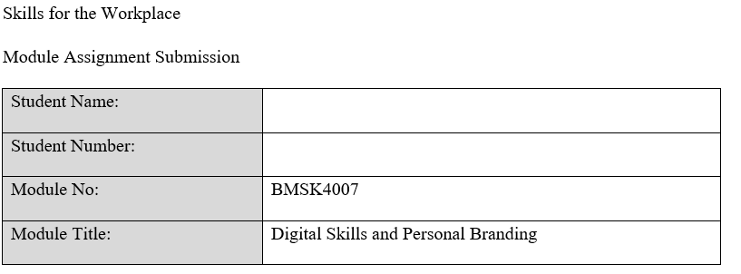
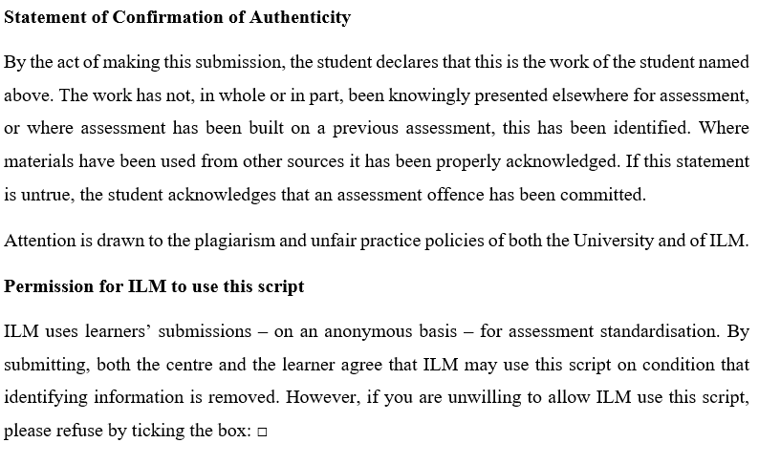

Table of Contents

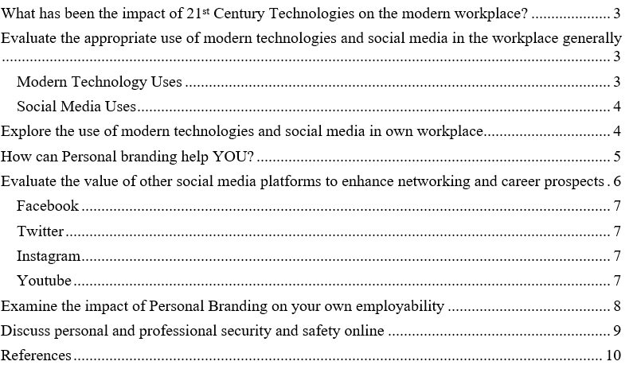

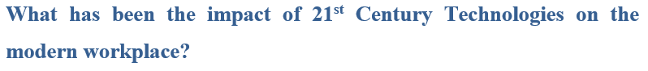
Modern technologies have made our life easier than before. People of different profession can witness and take advantage of these new inventions. Due to the new technologies, huge change is seen in the modern workplaces and employees are enjoying different types of work benefits. Some of the major changes and impacts on workplace nowadays due to the 21st century technologies are: if we think that modern technologies have made it easier for workers that they can now get the facility of working less hours than before, then the thought is partially wrong. American workers are now working 47 hours a week on average which was 40 hours a week before (Wellenius, 2010). But the medium of working has changed. Now people are working through telecommunicating, mobile devices etc. Modern technology has made it easier for workers to have their own flexibility. Due to the invention of modern technologies, workers are now retiring at a very later age which is expanding everyone’s working ability. The scopes of working from home has increased to a level due to the advancement of modern technologies. Not only in workplaces, modern technologies are also impacting on the education sector. Due to the invention of modern technologies and pandemic situation, teachers are now completely dependent on virtual classes and education. Every type of academical activities is done through modern technologies which includes telecommunicating, virtual meeting apps etc. It has also made easier for students as any type of information about anything is just a click away. The web enables up-to-date information should be easily available. Education providers keep flooding the web with their skills, journal articles, and findings (Dina, 2011). The online is becoming our primary important figure nowadays. Because knowledge is so readily available, academic establishments and teachers must start to alter the way universities educate learners to think and fix issues. These elements have remained unchanged.

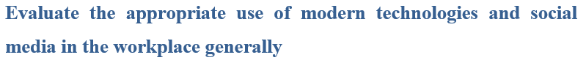Modern Technology Uses
Modern technologies have made it easier for us to work and do our everyday life activities. Invention of modern technology has made it easier for people to handle workloads easily and to avoid manual errors in the work field. Time consuming works has turned into time saving programs. There are many digital tools and advantages nowadays which can improve and help a company to earn more profit. Through modern technologies, work repetition can now be controlled and handled easily. Now, it is easier to handle accounts and save data which was previously very hard and time consuming (Dostie and Jayaraman, 2008). Moreover, modern technologies have made a new platform for entrepreneurs and small business owners to run their business easily. It has also offered people to work from home and do freelance jobs which ensures work flexibility. It has also offered the advantage of cloud meetings and virtual meetings when clients are far away from people which reduces the travel expenses.

Social Media Uses
Nowadays, social media has advanced a lot and people are getting more interested in using social media. Spread of social media usage is increasing every day. Vast usage of social media has resulted in social media marketing opportunity. This gives us the advantage to promote our business through social media like: Facebook, Instagram, LinkedIn, YouTube etc. Their goal with social networking sites is to promote a product, garner attention, and inevitably lead to a transaction, all while maintaining a steady company's brand across all promotional materials (Sohaib, 2021). It can help to reach more people and attract people more towards a particular business. This will increase the possibility of profit too. And through social media, one can build their business and become a successful entrepreneur.

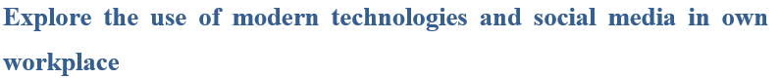
Modern technology has allowed people to do works more easily and effectively. Again, the use of social media has made it easier for people to promote their business online and provide business advertisements there. Modern technology allows to cut out the lengthy work procedures and avoid phone call hassles. For example, American Express has an extremely popular social media crew that appears to reply with every social networking reference. This helps customers to get their own satisfaction and know about unknown information. It also helps the employees to work easily (Loverd, 2015). Moreover, social media marketing or advertisements helps the company to get more attention from customers which promotes the business. Moreover, through social media, staffs can also communicate with customers to solve their general FAQ’s and other inquiries. As people are getting more involved with social media and modern technologies, this will help the company to get benefits and earn more customer satisfaction as well as attraction.
Personal branding refers to a person's conscious and deliberate attempt to shape public opinion, improve their reputation, and set oneself apart from the competitors in order to progress their career, expand their circle of influence, and have a greater effect. Personal branding is extremely essential for everyone on the planet (Sood, 2018). Even if the person is a worker or an owner of a business company/industry. Finding one's individuality, establishing a reputation for the things one wishes to be known for, and then allowing oneself to be recognized for those things are all part of the personal branding process. Ultimately, the objective is to produce something unique and creative that reflects and highlights a person's personality and traits. Personal branding has become very important as the use of social media and technologies increased to a higher rate (Ismail, 2020). Moreover, nowadays, interviews are also held based on their online profile which is provided by the employee on their social media site. Nowadays, employees are hired by observing their online profile and then they are being called for face-to-face interviews. On the other hand, personal branding can be very essential for a person who wants to do outsourcing or freelancing works. They need to organise their online profile to express themselves in front of different clients and other business companies too which are hiring employees. Such as: LinkedIn profile is used for business and professional works. Through this site, people hire employees by checking one’s profile and their qualities. Personal branding can help a person to get their desired or dream job too. It can also help people to represent themselves in front of their co-workers and let people know about their unique qualities. However, if one’s professional profile is not updated or personal branding is not done properly, one might lose their job or it might have a negative impact on their career and professional image.
LinkedIn is one of the most popular and influential social media nowadays. All the professionals, workers, freelancers, entrepreneurs etc. have a LinkedIn profile now. LinkedIn helps people to find jobs and those who are looking for employees, they can also search for eligible employees here. LinkedIn profile is a kind of personal branding too. Through this profile one can get the idea about your educational qualifications as well as your fields of expertise. Here, contacts are built by connecting with people. These connections help a person to join a community of professionals which can helps to find them their desired job or build their career. Moreover, those who work or want to work as a freelancer, for them, creating a professional and high-quality profile is very important otherwise clients will not be attracted. LinkedIn is also an option for those people who wants to connect with local or international corporate people and wants to communicate with them. In order to attract more clients or people, some tactics might be followed so that one’s profile can reach to more people. Such as: optimizing one’s LinkedIn profile with decently structured, SEO-rich material that represents the person while also addressing the brand. This will help to attract more people and might create more connections (Nanayakkara and Dissanayake, 2020). Using 3 useful actions like: becoming a team member, generating valuable content, and discussing it with the community are all examples by which accelerate one’s LinkedIn profile. Through LinkedIn, one can promote their own business and it can also help them to get more customers and earn more profit. Businesses nowadays must have a personal element to their presence as a result of online marketing. Because each LinkedIn page is related to a specific worker, it gives the organization a more human face which makes it feel more intimate. Regular updating one’s LinkedIn profile can help a person to get more involved with different groups of people and it might also impact on their personal brand/company. Corporations may connect on LinkedIn’s website or ‘news feed’ whether through LinkedIn communities with specialized industries (Jain and Yadav, 2017). Therefore, to get build more connections and to get more recognition one must create a highly qualified, well-written account with a high-quality photo so that a person can communicate with one’s contacts and their organizations. It allows the users to share on a regular basis and communicate with humans to demonstrate not just what a business offers. In this way, one can promote their personal brands through LinkedIn easily.

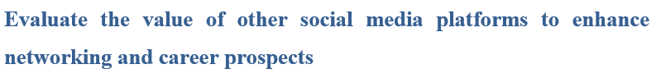
With the advancement of modern technologies, many social media platforms are now available to make our life and work easier. Discussion about some of the most influential social media platforms are done below:

Facebook
Facebook was founded on 2004 by Mark Zuckerberg. Facebook helps people to connect with friends and family. It also helps to connect with other professionals too. Facebook profile can help a person to represent themselves in front of everyone (Oh and Syn, 2015). It can also help a person to show one’s field of expertise, commercial skills, employable traits hobbies etc. which can attract different types of people and help to build network with different corporates/professionals. Thus, it can build a person’s career and it can also impact on their professional life too.

Twitter
In twitter, conversations generally take place as digital Q&A that typically contain hashtag keywords to identify the topic of conversation (Theviot, 2018). Here, one can observe a twitter conversation via monitoring the trending hashtag. This can help a person to connect and build communication with different level and kind person which can impact on the career.

Instagram
This is very much like the Facebook app but the difference is, the privacy here is much more restricted and public accounts usually reach to many people by using proper hashtags and following consistency (Oh and Syn, 2015). This can help small business owners to reach and connect with more people. This also helps to promote their business page or any other products. Through Instagram, one can get the benefits of building more connections which can help in their career too.

Youtube
It is the second-most-visited website on the internet. Here, people create videos like: daily blogs, skincare blogs, recreational blogs, doctors’ expertise, tutorials etc. which can help people every day in different ways. A person who is a YouTuber can build their career here and can also earn from here by gaining subscribers. YouTube Play Buttons are a part of the YouTube Creator Rewards program, and they are a way for YouTube to show its appreciation for its most successful channels. Channels having at least one hundred thousand, a million, ten million, fifty million, and one hundred million subscribers get trophies made of nickel-plated copper-nickel alloy, golden plated brass, silver plated metal, ruby, and red tinted crystal glass, respectively (Theviot, 2018).
Napoleon Hill coined the terms "personal branding" and "self-positioning" in 1937. It is the deliberate/intentional effort to create and influence public perception by positioning oneself as an industry authority, elevating one's credibility, and differentiating oneself from the competition in order to advance one's career, expand their circle of influence, and have a greater impact. Every person's personal branding is extremely essential. This helps to build a person’s career and help to create their own identity. In order to do personal branding, one must create their profile in a unique way. This profile can be made on social media or in professional CV too. Nowadays, technology has advanced so much that many industries hire their employees primarily by observing a person’s online information (Ismail, 2020). For these types of works, LinkedIn, Facebook, Instagram etc. are the best choices for a person to provide their qualifications and expertise in different fields. In this way, people from different professions can check out the profile and might get interested in hiring them. Personal branding is very much important for freelancers. Because, clients from outside the country do check their business profile and then hire them so it is very important for them to keep their profile updated every day and they must follow it in a unique way. When people see regular and as usual profiles, they usually do not get interested that much. Therefore, to keep one’s profile attractive and classy, a person must use their creativity to update their profile in a unique way. This will help them to reach more people and also more people will be interested in their profile (Nanayakkara and Dissanayake, 2020). When this happens, connections increase automatically and the id gets boosted. In this way, a person can get more opportunity to get their desired or dream job which will help them to build their career too. Moreover, interviews and recruitment procedures are very much costly which companies try to ignore nowadays as they do have the facility of modern technologies now. So, most of the companies try to finish their primary recruitment procedures through online in which personal branding is very necessary. This will help a person to be highlighted among thousands of other candidates. This will even represent one’s personality and knowledge about technology and how they are able to cope and handle social media or other modern technologies easily. This helps to create a positive outlook of the person.
Safety and security issues are not a new thing but the problem is risks are now higher than before. With the advancement of technologies, the issue of security is increasing too. The issues of hacking, cybercrime and harassment is increasing daily. Even data protection has become an issue nowadays which can cause problems for a person or a company too (Kayes and Iamnitchi, 2017). However, cyber security defends these problems in every possible way but still the damage can’t be repaired. For these kinds of problems, some necessary steps need to be followed. They are:
- It’s best not to open files like phishing scams that contains virus. Drive-by installations do have higher potential to infect user computer with a virus, so it is best to have some antivirus apps or not to accept messages from different senders.
- In case of social media platforms or id’s, the passwords have to be strong enough so that hackers cannot hack the id easily and something which the owner can memorise easily.
- Not to give one’s passwords to another person or have some backups of these passwords.
- Keep backup of professional and important data so that if any type of problem occurs, one can get the important files immediately.
- The privacy settings have to be kept on so that any type of manipulation with the device or online profile can be notified to a person.
- A person has to be very careful when he downloads something from the internet. Most of the files might contain virus which can create problems for the device.
- It is better to keep one’s circle in the social media limited and short. This helps to keep an id secure and risk factors becomes less.
- Devices like: Personal computer, laptop etc. should have an up-to-date antivirus. This lowers the risks of virus attack which might corrupt and damage important personal or professional files.

References
Dina, Y., 2011. Regulating Social Media Use in the Workplace. SSRN Electronic Journal, 2(5), pp.456-460.
Dostie, B. and Jayaraman, R., 2008. Organizational Redesign, Information Technologies and Workplace Productivity. SSRN Electronic Journal, 2(1), pp.135-140.
Ismail, E., 2020. Personal Branding and Behavioural Changes among the Millennial Generations in the Social Media. Asian Journal of Humanities and Social Studies, 8(6), pp.256-260.
Jain, D. and Yadav, A., 2017. Marketing and Technology: Role of Technology in Modern Marketing. IOSR Journal of Business and Management, 19(05), pp.49-53.
Kayes, I. and Iamnitchi, A., 2017. Privacy and security in online social networks: A survey. Online Social Networks and Media, 3-4(2), pp.1-21.
Loverd, R., 2015. The Challenge of a More Responsible, Productive Public Workplace. Public Productivity & Management Review, 13(1), p.43.
Nanayakkara, N. and Dissanayake, D., 2020. Application of Social Media for Personal Branding: A Conceptual Review. The International Journal of Business & Management, 8(1), pp.34-56.
Oh, S. and Syn, S., 2015. Motivations for sharing information and social support in social media: A comparative analysis of Facebook, Twitter, Delicious, YouTube, and Flickr. Journal of the Association for Information Science and Technology, 66(10), pp.2045-2060.
Potgieter, A. and Doubell, M., 2020. The influence of employer branding and employees’ personal branding on corporate branding and corporate reputation. African Journal of Business and Economic Research, 15(2), pp.109-135.
Sohaib, O., 2021. Social Networking Services and Social Trust in Social Commerce. Journal of Global Information Management, 29(2), pp.23-44.
Sood, S., 2018. Networking and Personal Branding. CSA News, 63(7), pp.22-25.
Theviot, A., 2018. Facebook, Twitter, Youtube. Idées économiques et sociales, N° 194(4), p.24.
Wellenius, B., 2010. The impact of modern telecommunications. IEEE Technology and Society Magazine, 8(4), pp.3-6.

