

LCMB7001: Marketing Management - Assessment 1

Student Name: Hardikkumar Solanki
Student ID:2220271
Submitted To Tushara Balendran
Table of Contents
Introduction 3
Organisational overview 3
Role of communication in marketing management 3
Innovative marketing strategies 5
Impact of Strategies to build brand awareness 6
Integrated Marketing Communications 8
Influence of various communication channels on the customer journey 8
Aaker’s Brand Equity Model in Ocado Group plc 9
Advantages and disadvantages of Aaker’s Brand Equity model 11
Customer journey and customer touch point for Ocado Group Plc 11
Customer journey map for Ocado Group plc 12
Strength and Weaknesses of customer journey touchpoints 14
Use of Total Engagement model for Ocado Group plc 15
Recommendations 16
Conclusion 17
Reference List 18

Introduction
The groundwork of Ocado's business methodology is a mix of state-of-the-art innovation, strategic skills, and joint efforts with respectable stores like Imprints and Spencer and Morrisons. Ocado has concentrated on creating cutting-edge marketing plans recently to raise brand recognition and boost customer engagement. All to ensure the drawn-out progress of the organisation, Ocado has additionally attempted to areas of strength for production with its partners, including clients, staff, investors, providers, controllers, and networks. The customer journey of Ocado will be examined in this report, along with the company's generic strategy according to integrated communication and stakeholder analysis.

Organisational overview
Ocado Group plc is a UK-based licensed grocery technology business brand, founded in 2000, with headquarters at Hatfield, Hertfordshire in London. Ocado Group holds an approximately 50% market share in the retail business sector of the UK and it is also a listed company on “London Stock Exchange” and is an organiser of the “FTSE 100 index”. This retail sector is a technology pioneer in the online grocery sector, with nearly 19,347 employees, and sells general commodities goods through its website ocado.com, within the United Kingdom and international market as well. Ocado Group conducts its business in different locations in the UK and also has nearly £481.3 million yearly revenue (ocadogroup.com, 2020).”.

Role of communication in marketing management
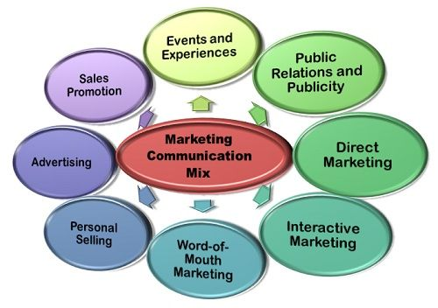
Figure 1: Marketing and Communication
(Source: Gartner, 2020)
Digital marketing: According to Tim Steiner, (2019), digital marketing is one of the methods Ocado uses communication to market its products. This covers social media marketing, SEO, and tailored online advertising. Ocado can reach a larger audience and increase traffic to its website by utilising these platforms.
Email marketing: As per Gecheo, (2020), another significant communication instrument used by Ocado is email marketing. The business updates its subscribers on new goods, exclusive offers, and other pertinent information through newsletters and promotional emails.
Direct mail: Ocado additionally employs direct mail as a tool for contact. The business advertises its goods and services by distributing flyers and catalogues to homes in specific regions. This increases sales and creates fresh leads.
PR: For Ocado, PR is a crucial instrument for communication. PR is used by the business to develop and preserve its brand reputation (Ebrahim, 2020). This includes securing favourable media coverage, planning activities, and lending support to charitable causes.

Innovative marketing strategies
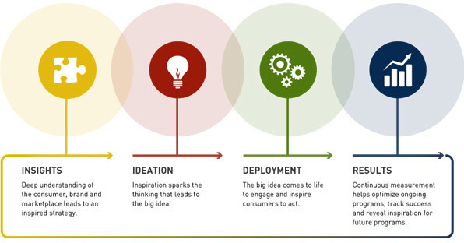
Figure 2: Innovative Marketing Strategy
(Source: Farooq, 2019)
Focus on Customer Experience: Ocado has consistently placed a high need on giving clients top-notch insight. This idea fills in as the establishment for the organisation's showcasing drives, which put an exceptional accentuation on comfort and personalization (Bierganz, 2021). For instance, Ocado tracks customer purchasing patterns and offers tailored suggestions using algorithms.
Leverage social media: Ocado has had achievements utilizing web-based entertainment to increment organisation acknowledgement and collaborates with clients. Mason, (2019), stated that the business is deeply grounded via web-based entertainment locales like Facebook, Twitter, and Instagram, where they habitually share refreshes and promotions.
Partner with Other Brands: To give their clients extraordinary items and offers, Ocado has cooperated with a few different brands. For instance, the business collaborated with celebrity chef Jamie Oliver to solely give a selection of his products on their platform (Monte, 2021). These collaborations not only help to draw in new clients but also offer cutting-edge goods to current clients.
Offer Unique Subscription Services: Offering distinctive subscription services that give consumers extra value is part of Ocado's marketing strategy. As part of its marketing plan, Ocado also offers distinctive subscription services that benefit consumers. The business, for instance, provides a "Smart Pass" subscription service, which offers free shipping and savings on goods (Nassar et al. 2023). They also provide a "Zoom" subscription service, which charges extra but provides faster shipping times.
Embrace New Technology: The business has made critical interests in computerization and advanced mechanics, which have further developed delivery times and diminished costs. Also, they have fiddled with state-of-the-art advances like expanded reality, which empowers clients to picture products in their homes before making buys (Duncan, 2021). Ocado has had the option to situate itself as a groundbreaking organisation at the front line of development by embracing innovation.

Impact of Strategies to build brand awareness
Focus on Customer Experience: Ocado has gained a name as a customer-centric business by placing a high priority on the customer experience. As a result, repeat business has increased and company loyalty has been strengthened. As per, Leite, (2020), a positive customer experience, which can result in recommendations from friends and family and social media sharing, has also been aided by Ocado's tailored recommendations and practical delivery options.
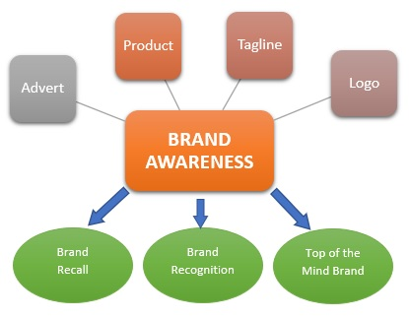
Figure 3: Brand awareness
(Source: Team, 2022)
Leverage social media: Ocado has had success using social media to connect with customers and promote its brand. Social media has grown to be an essential instrument for increasing brand awareness. According to Chao, (2021), the business has been able to maintain its brand at the forefront of its followers' minds by frequently sharing updates and promotions on social media.
Partner with Other Brands: Ocado has been able to offer exclusive goods and promotions through partnerships with other brands, which can help to set the company apart from rivals and generate buzz among consumers (King, 2019). Additionally, these alliances offer chances for cross-promotion, which can increase the reach of the business.
Offer Unique Subscription Services: By giving customers more value and fostering loyalty, Ocado's unique subscription services, like the Smart Pass and Zoom subscriptions, have helped to increase brand recognition. Customers who utilize these administrations consistently are probably going to prescribe them to loved ones, which can help with building memorability.
Embrace New Technology: Ocado has had the option to situate itself as a groundbreaking organisation that is at the bleeding edge of development by putting resources into innovations like mechanization, mechanical technology, and increased reality (İyiler, 2019). This might assist with attracting clients who are keen on imaginative and fun strategies to shop and are well-informed.

Integrated Marketing Communications
As per Thornton, (2022), one of the biggest online grocery retailers in the world, Ocado Group Plc, has effectively adopted an integrated marketing communications strategy to connect with its target market and advance its brand.
Content Marketing: Ocado Group Plc uses educational blog entries, videos, and other forms of content to engage and enlighten its audience (Alnoor et al. 2022). This strategy aids in establishing the business as a market thought leader and fosters client loyalty.
Traditional Advertising: To reach a larger audience and advertise its brand, Ocado Group Plc also uses traditional advertising platforms like TV, radio, and print advertisements. These platforms are especially helpful for reaching audiences who might not be as engaged online.
Direct Marketing: Ocado Group Plc uses direct marketing strategies to reach out to its consumers, including email marketing, direct mail, and catalogues. These channels give the business the ability to tailor its messages and promotions based on the unique preferences and behaviour of each client (Maulana et al. 2019). Ocado Group Plc employs an integrated marketing communications strategy that combines conventional and digital marketing platforms.

Influence of various communication channels on the customer journey
Ocado plc is already a technology-based retail sector, conducting its entire business on digital platforms. To attract more customers Ocado plc may implement various communication channels like web platforms and email. These digital platforms make communication easier with customers.
Email: It is one of the formal communication channels, without wasting time, Ocado plc can communicate with their customer by sending Emails. Alakbarov, (2021), stated that in the present scenario, Email is one of the less expensive, fastest and most accessible ways to communicate with target customers or for any business purpose. Ocado plc can send Emails with the help of a computer or any electronic communication gadgets as long as this business firm has an internet connection that mainly gets from an internet service provider.
Video conferencing: As per Gray et al. (2020), video conferencing is one of the most effective and advanced communication channels and also can read anyone’s facial expression during video conferencing. With a dependable network and video conferencing software, anyone can easily communicate like hear, talk and see with anyone in real-time.
Social Networking Sites: Voorveld, (2019), said that social networking sites are virtual platforms which are used by millions of people to build social relationships and create a network with different people, who share similar activities, personal content, background and interest. Multiple social networking sites are available on digital platforms which differ from one another in format and features.
Online text conversation: Online text conversation refers to the conversation between different people with the help of a digital platform by typing text messages. This process involves two or more people, who can make conversation between themselves by using some software or chatting services. Berger et al. (2020), mention that this online text conversion process is sometimes also represented as internet chat or chatting, online chatting. This process of online communication enables people to appreciate and realise different perspectives and also to understand the difference between appropriate and inappropriate behaviour.

Aaker’s Brand Equity Model in Ocado Group plc
Aaker’s brand equity model has five components and using these components Ocado plc can increase its brand identity and relationship with its customers. By implementing “Aaker’s brand equity model” any sector like Ocado plc may increase its brand loyalty, brand awareness, perceived quality, Brand association and Proprietary assets.
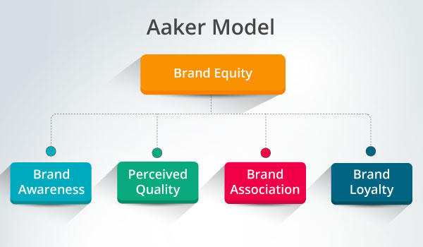
Figure 5: The Aaker Brand Equity Model
(Source: canto, 2019)
Brand loyalty: Brand loyalty measures the dependency and support that consumers show for a brand. As an example, it can be said that if someone buys groceries from Ocado plc that means that person has brand loyalty towards Ocado plc. Çınar, (2020), stated that an organisation having strong brand loyalty provides an opportunity for the company to concentrate on handling its loyal customers, which can help minimise the marketing cost of Ocado plc.
Brand awareness: As per Beig and Nika, (2019), brand awareness refers to the customer’s knowledge about a brand. It can be said that an organisation like Ocado plc has good brand awareness if a large number of people know about the company, recognise the brand name and have information about what are the products and services they offer. Organisations having high brand awareness can attract more customers and increase their revenue. This factor also helps customers to be more reliable and comfortable while making decisions about purchasing services or products from that company.
Perceived quality: The perceived quality of a brand represents the understanding of its services and products. Das, (2020), said that it helps the organisation to hold customer reliability even after selling a product at a price higher than the price of other brands because customers highly depend on the quality of the product delivered by this brand than others and are willing to pay extra money for that quality. This perceived quality helps Ocado to differentiate its organisation from other competitors.
Brand association: Brand association is a factor that brings forward the connection between the customer and the brand. Brand association of customers represents the customer’s emotions regarding a brand after observing or hiring any advertisement. According to Bashir et al. (2019), if a customer is happy after seeing advertisements of a brand that gives a positive attitude towards the company, it can help to encourage other customers to buy products or services from that brand.
Proprietary asset: Proprietary asset is the major factor of brand equity; it refers to the brand's assets. Assets of any brand may include tread marks, copyrights, property rights, patents etc. These proprietary assets have no financial value but these assets help to enhance the organisation’s reputation.

Advantages and disadvantages of Aaker’s Brand Equity model
Advantages: As per Aaker’s brand Equity model, strong brand loyalty may allow an organisation to concentrate on maintaining its loyal customer which can aid to minimise marketing costs. It also provides organisations with an advantage over their competitors in the market (Gao and Choy, 2019). Another advantage of this model is, this model gives more focus to create a brand image and brand equity, both of which are very important for any business operation.
Disadvantages: This model did not mention any single measure of brand equity and indicates a set of items which can be contributed to being measured. As per this model, it is also not clear which and how this item should be combined to get an exact brand valuation. The equity of manufacturer brand names is not taken into consideration by Keller's method, in contrast to specific product brands (Uford and Duh, 2021). An interesting finding was the comments given in response to a question on one of the brand slogans.

Customer journey map for Ocado Group plc
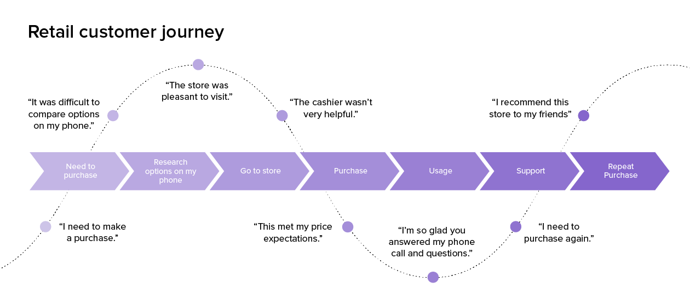
Figure 6: Customer Journey Map
(Source: Delighted, 2023)
Awareness: The awareness stage, which is the initial phase of the customer journey, is when Ocado focuses on building its image and attracting new clients. According to Duncan, (2021), to connect with potential clients, the business uses a variety of platforms, including social media, TV commercials, word-of-mouth, and search engines. In this stage, Ocado's internet presence is essential, and they make significant investments in SEO and paid advertising to make sure that potential customers can easily find them. To entice current consumers to recommend the brand to their friends and family, they also provide referral programs and loyalty programs.
Consideration: Customers start analysing Ocado's offerings and contrasting them with those of other shops during the contemplation stage. The user-friendly Ocado website and mobile app offer a large selection of products, aggressive pricing, and promotions. In addition, they provide a premium delivery service with a variety of delivery windows to accommodate consumers (Mazumdar, and Perkins, 2021). The customer care team at Ocado is ready around-the-clock to assist with any questions, and their product reviews and suggestions enable customers to make well-informed choices. To accommodate consumers with dietary limitations, they also offer nutritional data and allergy warnings.
Purchase: Customers choose whether to buy through Ocado during the purchase step. Multiple payment alternatives and secure payment gateways are offered during the checkout process on the company's website and mobile app. As per Cao, (2021), a crucial differentiator for Ocado is its delivery service, which offers clients customizable delivery windows, real-time tracking, and notifications. They provide eco-friendly packaging, and clients can select a bagless delivery option. Customers are guaranteed a seamless and trouble-free experience thanks to Ocado's customer support team.
Post Purchase: Ocado concentrates on encouraging client loyalty and promoting repeat business throughout the post-purchase phase. To keep clients updated on the status of their orders, they send confirmation emails and order updates. The customer support team at Ocado is ready to respond quickly to any post-purchase questions or concerns. Customers are also allowed to rate their experiences and offer suggestions for improvement by sending feedback requests. Customers who use Ocado's loyalty programme receive points for their purchases, which they may exchange for deals or free goods.
Loyalty: Ocado concentrates on establishing enduring relationships with clients throughout the loyalty stage. Loyal clients receive a variety of incentives from the business, including exclusive discounts, complimentary products, and early access to specials (Hampton et al. 2021). Customers who participate in Ocado's loyalty programme earn points for their purchases, which they can then exchange for deals or free goods. To improve their clients' buying experiences, the business delivers personalized product recommendations and offers to devoted customers.

Customer journey and customer touch point for Ocado Group Plc
Pre-purchase: While this phase of the pre-purchase company can adopt various methods. The company should try to reach a huge base of audience and they must try to attract new customers and retain the previous ones. Always try to connect with customers via different channels of social media platforms, including Instagram, Facebook, Whats app, and many others (Bierganz, 2021). The company must try to keep its websites and mobile applications updated and make them user-friendly.
Purchase: Ocado Group Plc as a leader in the retail business, while purchasing phase, should try to identify their ideal new customers and must try to follow them because, in the long term, they will convert into loyal customers. The company should also try to give some extra offers to those ideal customers. The company must try to resolve their customer’s issues or inquiries as early as possible. While shopping company can provide a live demo to their customer on “How to use or handle the products” (Butrus et al. 2020). The company can also offer exceptional customer service during the new product launch, this will help the company in spreading positive word of mouth and help to attract more new customers.
Post-purchase: The best and most effective way to make the customer’s journey more attractive, the company should try to make an easy process for returning and refunding their products. The company should also try to give some bonus or rewards or some kind of gift appreciation to their loyal customers, it will also help to make the customer journey more attractive and assist in increasing the customer base.

Strength and Weaknesses of customer journey touchpoints
Strengths
Ocado Group is a UK-based online grocery retailer that has been growing rapidly in recent years. Some of the strengths of Ocado Group include:
Technology: Ocado is known for its advanced technology, particularly its automated warehouses and proprietary software (Iliyer, 2019). This technology allows for fast and efficient processing of orders, which is a major advantage in the competitive online grocery market.
Customer service: Ocado is known for its excellent customer service, which includes on-time deliveries, high-quality products, and responsive customer support.
Strong partnerships: Ocado has formed partnerships with major retailers such as Morrisons, Marks & Spencer, and Kroger, which has helped the company expand its reach and increase its market share.
Sustainable operations: Ocado is committed to sustainability and has implemented a range of initiatives to reduce its environmental impact. This includes using electric delivery vans, minimizing food waste, and investing in renewable energy.
Innovative solutions: Ocado is constantly looking for new and innovative ways to improve its operations and better serve its customers. This includes initiatives such as developing robotic technology for warehouse operations and using data analytics to improve inventory management.
Weaknesses
Dependence on technology: Ocado's business model relies heavily on its technology platform, which is used to manage its automated warehouses and order processing systems (Law et al. 2020). Any technical glitches or cyberattacks could potentially disrupt the company's operations and affect customer satisfaction.
Limited geographical reach: Ocado operates primarily in the UK and has a limited presence in other countries, which could limit its growth opportunities and make it vulnerable to local economic conditions.
High capital expenditure: The company's expansion plans require significant capital investments, such as building new warehouses and investing in technology. This could put pressure on the company's cash flow and profitability.
Competitive market: The online grocery market is highly competitive, with established players like Amazon and Tesco dominating the space. As a relatively new entrant, Ocado faces intense competition for market share.

Use of Total Engagement model for Ocado Group plc
Brand promises: For engaging customers and attracting a new customer base, brand promise is the most effective way. Under this phase, each point must be considered by the company which can assist to create a good interaction between the company and its customers. For making the brand promise more strong and effective company should try to keep its eyes on three important questions, are first, what can my clients expect from me? Second, what does my business stand for? And most important Third, what distinguishes us? These are helpful to grow the brand, and building the trust of customers.
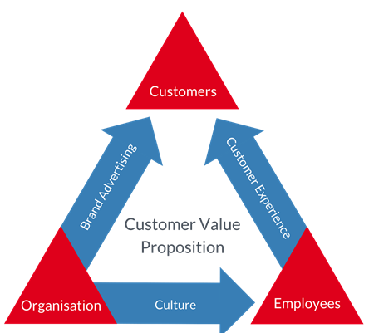
Figure 7: Total Engagement Model
(Source: engagedstrategy.com, 2022)
Customer experience design: A company that boosts client engagement emphasizes adding value to an outstanding service or good, providing outstanding after-sales support, and developing efficient channels of communication that reinforce the experience of the consumer. Give customized services, including how to handle, the products, offers, and guarantees or warranties related to the product, as for the real feedback or experience while visiting the stores.
Employee engagement: Employees are the real key to the success of any organization hence, the employee engagement activity should be more effective and effective, especially in the retail business, where employees are one-to-one dealing with customers and presenting the face of the organization (Market et al. 2019). Hence, the company should adopt an effective employee engagement policy that can provide a feeling of sharing their ideas, job security, safety, involvement, proper training and most important give some authority to them. The company should also try to foster an open communication platform among all levels of employees and also encourage idea sharing as well as feedback, and give importance to them. These will help to boost the motivation of the employees, and they feel like their own and give their best possible contribution.
Continuous improvement: Under the process of total engagement, continuous improvement is also one of the important phases, under this step, Ocado as a leading retail business in the UK, should try to keep its technology updated, must adopt an effective supply chain management system which will help reduce wastages and increase the profit of the company (Tsolakis et al. 2022). The Company should also try to adopt some innovative ideas continuously so that they can beat their customers and make a good market share also increase their profit.
Employee engagement: The employee engagement strategy, which emphasises fostering a healthy work environment and boosting employee motivation and job satisfaction, includes employee engagement as a critical component. As per Godsmark, and Richards (2019), using this methodology, Ocado may create employee engagement initiatives that support skill advancement, career promotion, and employee accomplishment recognition. Ocado can boost staff morale, which can result in improved productivity, better customer service, and commercial success by fostering a supportive work environment and offering opportunities for growth and development. Additionally, motivated staff members are more likely to remain with the business over the long term, which lowers training and recruitment expenses and maintains the calibre of services.
Continuous improvement: Another essential component of the total engagement approach that can help Ocado stay competitive and satisfy the changing demands of its customers is continuous development. Utilising client input, the business may pinpoint areas for improvement and put steps in place to improve the customer experience (Plangger et al. 2019). Ocado can also encourage staff members to offer criticism and ideas for enhancements, which can spark creativity and streamline processes. Ocado can raise client satisfaction and foster customer loyalty by enhancing its procedures and services constantly. A culture of continuous improvement can also promote cost-cutting, increased productivity, and corporate expansion, all of which contribute to long-term success.

Recommendations
Implement various communications: Ocado Group plc can implement different advanced communication features like online texting, emails, social media, web conferencing and many more (Kushwaha et al. 2020). All of these communication features not only help Ocado plc to communicate with its customers but also help to enhance communication within the organisation and also reduce the communication gap.
Develop products according to customer choice: Customer demand changes day by day, to fulfil this rapidly growing customer changing demand Ocado plc may develop new products or modify some old products (He et al. 2020). On the other hand, people are seeking healthy food but these foods are not increasing their weight in single-word diet food.
Increasing product marketing: Ocado plc may increase its brand or product marketing, by which it can attract more customers (Tien et al. 2019). Being a digital retail company, Ocado Group plc should focus more on digital marketing activities and customer interactions. This would help them to build a sustainable brand in the competitive business market and fit its products among its targeted audience.

Conclusion
From the above discussion, it can be concluded that Ocado Group Plc has turned into a critical player in the web-based staple and retail area because of its imaginative business procedure, cutting-edge innovation, and strong unions. To increment memorability and client commitment, the organisation has put resources into creating state-of-the-art advertising techniques. All simultaneously, it has put a high need on guaranteeing that its partners including clients, representatives, investors, providers, controllers, and networks are blissful. Ocado has seen a significant impact from various communication channels on the customer journey. The company uses social media, email marketing, and mobile applications to provide a seamless and customised customer experience. Furthermore, Ocado's adoption of Communication marketing has helped the business stick out from its rivals and keep a competitive edge in the market. The business must continue to put its stakeholders' requirements and expectations first while achieving strong financial performance and long-term growth.

Reference List
Alakbarov, R.G., (2021). Challenges of Mobile Devices' Resources and in Communication Channels and their Solutions. International Journal of Computer Network and Information Security, 13(1), pp.39-46.
Alnoor, A., Khaw, K.W., Al-Abrrow, H. and Alharbi, R.K., (2022). The hybrid strategy on the basis of Miles and Snow and Porter’s strategies: An overview of the current state-of-the-art of research. International Journal of Engineering Business Management, 14, p.18479790221080214.
Bashir, M.A., Faheem, S.M. and Hassan, M., (2019). Impact of brand equity on consumer brand preference and brand purchase intention. IBT Journal of Business Studies (JBS), 1(1).
Beig, F.A. and Nika, F.A., (2019). Brand experience and brand equity. Vision, 23(4), pp.410-417.
Berger, J., Humphreys, A., Ludwig, S., Moe, W.W., Netzer, O. and Schweidel, D.A., (2020). Uniting the tribes: Using text for marketing insight. Journal of marketing, 84(1), pp.1-25. Available at: https://journals.sagepub.com/doi/pdf/10.1177/0022242919873106
Bierganz, M., (2021). Delivering virtual value: the role of virtual value creation in e-grocery business models and resulting implications for today’s grocery retail firms (Doctoral dissertation).
Bierganz, M., (2021). Delivering virtual value: the role of virtual value creation in e-grocery business models and resulting implications for today’s grocery retail firms (Doctoral dissertation).
Butrus, R., Halai, J., Mohammad, R. and Bottrill, D., ONLINE SHOPPING EXPERIENCE.
Cao, L., (2021). Artificial intelligence in retail: applications and value creation logics. International Journal of Retail & Distribution Management.
Çınar, K., (2020). Customer Based Brand Equity Models in Hotel Industry: A Literature Review. Strategic Innovative Marketing and Tourism: 8th ICSIMAT, Northern Aegean, Greece, 2019, pp.281-288.
Das, S., (2020). Innovations in digital banking service brand equity and millennial consumerism. In Digital transformation and innovative services for business and learning (pp. 62-79). IGI Global.
Delighted.com, (2023). Guide to retail customer journey mapping. [Available at: https://delighted.com/blog/guide-to-customer-journey-mapping], [Accessed on: 05-04-2023].
Duncan, G., (2021). Looking Beyond the Car in Front: A Guide to Making the Right Career Choices at the Right Time. Routledge.
Ebrahim, R.S., (2020). The role of trust in understanding the impact of social media marketing on brand equity and brand loyalty. Journal of Relationship Marketing, 19(4), pp.287-308.
engagedstrategy.com.au, (2022). Total engagement Model. [Available at: https://www.engagedstrategy.com.au/home/total-engagement-model-round/], [Accessed on: 27-04-2023].
Farooq, U. (2019) What is innovative marketing - strategies and 3 famous examples, Marketing Tutor. [Available at: https://www.marketingtutor.net/innovative-marketing/], [Accessed: April 5, 2023].
Gao, Y. and Choy, N.W.K., (2019). Brand awareness, purchase intention and price premium of international airlines operating between Australia and the United Kingdom. International Journal of Aviation, Aeronautics, and Aerospace, 6(3), p.10.
Gartner_Inc (2020) Definition of Marketing Communications (MARCOM) - gartner marketing glossary, Gartner. [Available at: https://www.gartner.com/en/marketing/glossary/marketing-communications-marcom-], [Accessed: April 5, 2023].
Gecheo, S.N., (2020). Porter’s generic strategies and competitive advantage of small and medium enterprises within industrial area of Nairobi City County (Doctoral dissertation, University of Nairobi).
Godsmark, J. and Richards, G., (2019). The logistics outsourcing handbook: A step-by-step guide from strategy through to implementation. Kogan Page Publishers.
Gray, L.M., Wong-Wylie, G., Rempel, G.R. and Cook, K., (2020). Expanding qualitative research interviewing strategies: Zoom video communications. The qualitative report, 25(5), pp.1292-1301.
Hampton, S., Knight, L., Scott, H., Budnitz, H., Killip, G., Wheeler, S., Smith, A. and Eyre, N., (2021). Pathways to a zero carbon Oxfordshire.
He, J., Evans, N.M., Liu, H. and Shao, S., (2020). A review of research on plant‐based meat alternatives: Driving forces, history, manufacturing, and consumer attitudes. Comprehensive Reviews in Food Science and Food Safety, 19(5), pp.2639-2656.
https://www.canto.com, (2019). The Aaker Brand Equity model [Available at: https://www.canto.com/blog/aaker-model/], [Accessed on: 05-04-2023]
İyiler, Z., (2019). The mediating role of brand strength and supplier relations between firm orientations and export performance in e-retailing companies.
King, K., (2019). Using Artificial Intelligence in Marketing: How to harness AI and maintain the competitive edge. Kogan Page Publishers.
Kushwaha, B.P., Singh, R.K., Varghese, N. and Singh, V.N., (2020). Integrating social media and digital media as new elements of integrated marketing communication for creating brand equity. Journal of Content, Community & Communication, 11(6), pp.52-64.
Law, C., Cornelsen, L., Adams, J., Penney, T., Rutter, H., White, M. and Smith, R., (2020). An analysis of the stock market reaction to the announcements of the UK Soft Drinks Industry Levy. Economics & Human Biology, 38, p.100834.
Leite, B.T.D.S., (2020). Marks & spencer out of fashion the case of an outdated brick and mortar (Doctoral dissertation).
Market, A.A.I. and SE, A.A., Alphabet Alphabet Inc. Amazon Amazon. com, Inc. AMC AMC Entertainment Holdings, Inc. AMEX American Stock Exchange (now known as NYSE America).
Maulana, Y.S., Munawar, A.H. and Nurjanah, D.S., (2019). Analysis of Porter’s Generic Strategies in Enhancing Competitiveness in Retail Industry (A Survey on Pajajaran Sindangkasih Minimarket, Ciamis). Jurnal Bisnis dan Kewirausahaan, 15(3), pp.175-184.
Mazumdar, S. and Perkins, C., (2021). The Innovation Engine for Growth: An Actionable Roadmap to Thriving in a Hyper-competitive World. Routledge.
Monte, A., (2021). A study of value chain reconfiguration processes under Covid-19 pressures: the case of Tesco PLC in the United Kingdom.
Nassar, M., Goddard, T. and Freeman, R., (2023). Walk the Talk: The Boohoo Case Study. Journal of Macromarketing, p.02761467231164960.
ocadogroup,(2020). Ocado Group, Technology & Automation of Online Grocery. [Available at: https://www.ocadogroup.com], [Accessed on: 05-04-2023]
Opinaldo, N. and Graham, C. (2022) Porter's generic strategy: Explained with examples, GitMind. [Available at: https://gitmind.com/porters-generic-strategy], [Accessed: April 5, 2023].
Plangger, K., McCarthy, I.P., Kietzmann, J., Robson, K. and Pitt, L.F., (2019). 18 Dynamic game plans. Strategic Renewal: Core Concepts, Antecedents, and Micro Foundations, p.391.
Team, W. (2022) Brand awareness, WallStreetMojo. [Available at: https://www.wallstreetmojo.com/brand-awareness/], [Accessed: April 5, 2023].
Tien, N.H., Phu, P.P. and Chi, D.T.P., (2019). The role of international marketing in international business strategy. International journal of research in marketing management and sales, 1(2), pp.134-138.
Tsolakis, N., Bechtsis, D., Vasileiadis, G., Menexes, I. and Bochtis, D.D., (2022). Sustainability in the digital farming era: A cyber-physical analysis approach for drone applications in agriculture 4.0. In Information and Communication Technologies for Agriculture—Theme IV: Actions (pp. 29-53). Cham: Springer International Publishing.
Uford, I. and Duh, H.I., (2021). Measuring the Sources and Outcomes of Customer Based Brand Equity in a Service Industry. African Journal of Business & Economic Research, 16(2).
Voorveld, H.A., (2019). Brand communication in social media: A research agenda. Journal of Advertising, 48(1), pp.14-26.

