Tirion Wall
Student number: 2023509
Changemakers: Creativity and Value Creation
Assignment 2: Project Management
July 2023

Contents
Link to e-Portfolio 3
References 7
Appendix 8

Link to e-Portfolio

Changemakers assignment 2

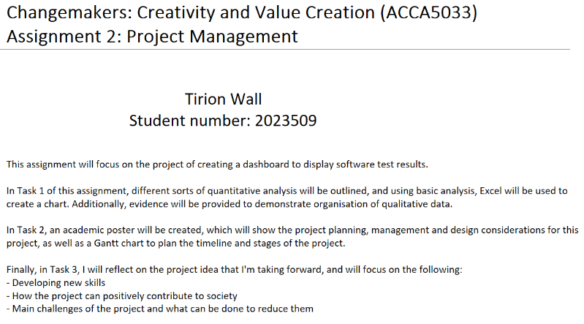

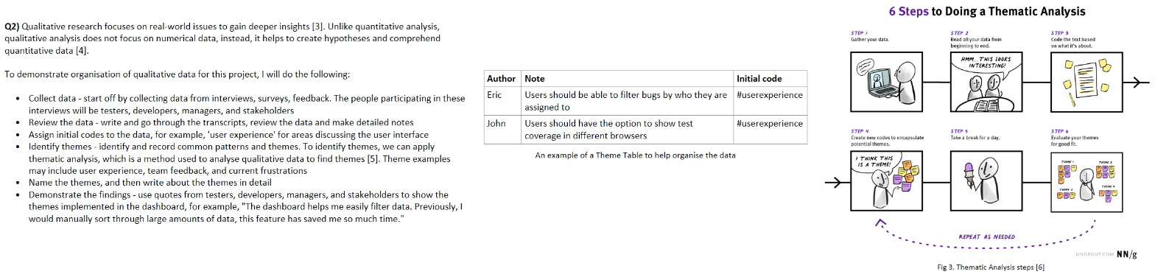
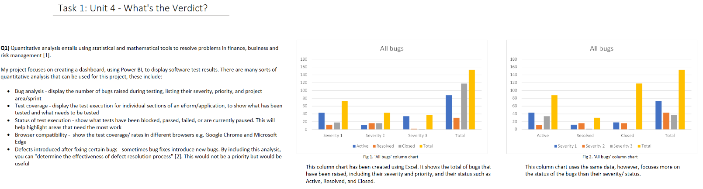

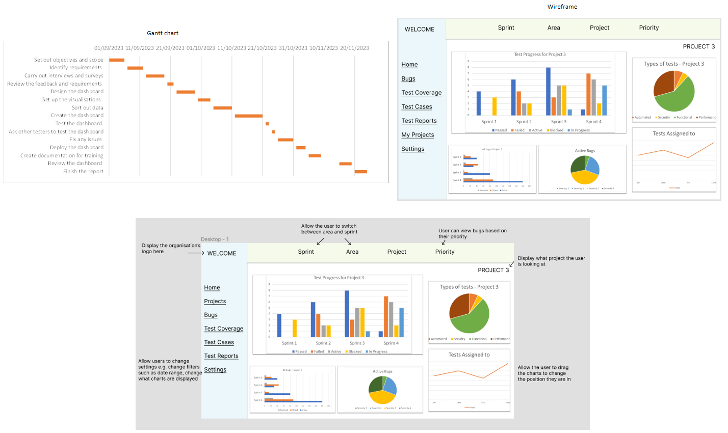
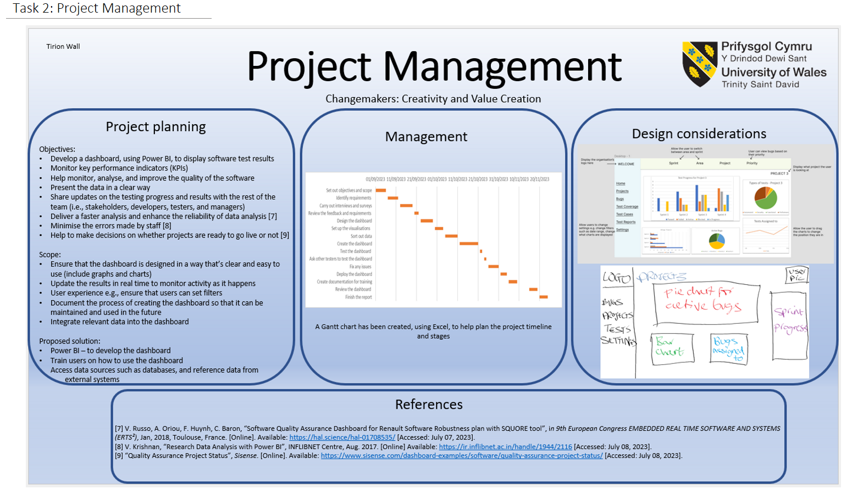

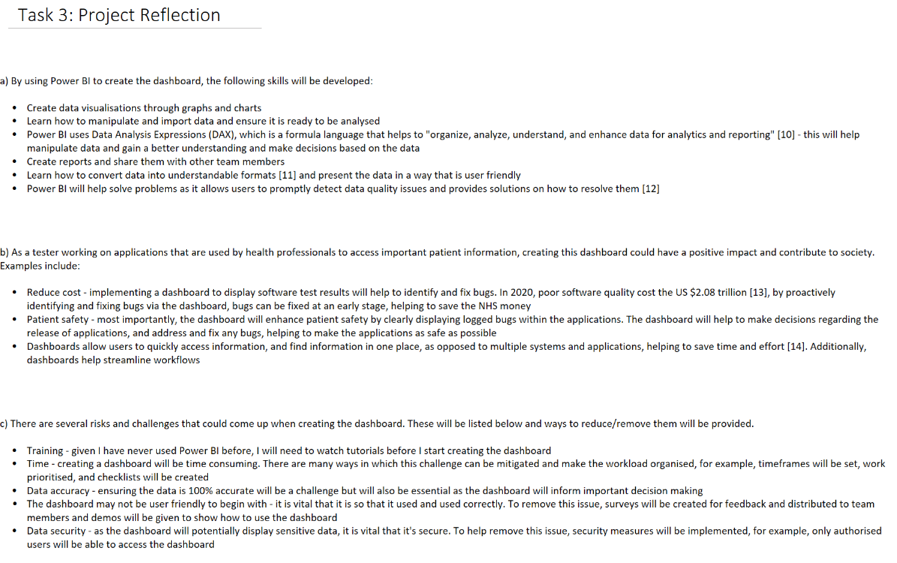

References

[1] “What is quantitative analysis? (With definitions and examples)”, Indeed, Mar. 27, 2023. [Online]. Available: https://uk.indeed.com/career-advice/career-development/quantitative-analysis [Accessed Jul. 04, 2023].
[2] R. M. Sharma, “Quantitative Analysis of Automation and Manual Testing”, International Journal of Engineering and Innovative Technology (IJEIT), vol. 4, no. 1, Jul. 2014. [Online] Available: https://citeseerx.ist.psu.edu/document?repid=rep1&type=pdf&doi=4705f69033ea278213b4980326d7ba893e1e1cfd [Accessed Jul. 04, 2023].
[3] A. Moser, I. Korstjens, “Series: Practical guidance to qualitative research. Part 1: Introduction”, Eur J Gen Pract, Nov. 29, 2017. [Online]. Available: https://doi.org/10.1080/13814788.2017.1375093 [Accessed Jul. 04, 2023].
[4] S. Tenny, J. M. Brannan, G. D. Brannan, “Qualitative Study”, StatPearls Publishing, Treasure Island (FL), 2022.
[5] V. Braun, V. Clarke, “Thematic analysis”, in APA Handbook of Research Methods in Psychology, vol. 2, American Psychological Association, 2012.
[6] M. Rosala, “How to Analyze Qualitative Data from UX Research: Thematic Analysis”, NN/g Nielsen Normal Group, Aug. 17, 2022. [Online]. Available: https://www.nngroup.com/articles/thematic-analysis/ [Accessed Jul. 04, 2023].
[7] V. Russo, A. Oriou, F. Huynh, C. Baron, “Software Quality Assurance Dashboard for Renault Software Robustness plan with SQUORE tool”, in 9th European Congress EMBEDDED REAL TIME SOFTWARE AND SYSTEMS (ERTS²), Jan, 2018, Toulouse, France. [Online]. Available: https://hal.science/hal-01708535/ [Accessed: Jul. 07, 2023].
[8] V. Krishnan, “Research Data Analysis with Power BI”, INFLIBNET Centre, Aug. 2017. [Online] Available: https://ir.inflibnet.ac.in/handle/1944/2116 [Accessed: Jul. 08, 2023].
[9] “Quality Assurance Project Status”, Sisense. [Online]. Available: https://www.sisense.com/dashboard-examples/software/quality-assurance-project-status/ [Accessed: July. 08, 2023].
[10] P. Seamark, Beginning DAX with Power BI: The SQL Pro’s Guide to Better Business Intelligence, Apress, 2018, ch.1, pp.2
[11] “Why Power BI skills are essential in 2023”, Test Gorilla. [Online] Available: https://www.testgorilla.com/blog/power-bi-skills-2/ [Accessed: July 16, 2023].
[12] “Challenges solved by Power BI”, alpha bold, Feb. 6, 2022. [Online]. Available: https://www.alphabold.com/challenges-solved-by-power-bi/ [Accessed: Jul 16, 2023].
[13] H. Krasner, “The Cost of Poor Software Quality in the US: A 2020 Report”, CISQ, 2021. [Online] Available: https://www.it-cisq.org/cisq-files/pdf/CPSQ-2020-report.pdf [Accessed: Jul. 16, 2023].
[14] "How Important are Dashboards for Business?", Linkedin, May 20, 2023. [Online]. Available: https://www.linkedin.com/pulse/how-important-dashboards-business-rapid-e-suite [Accessed: Jul. 16, 2023].

Appendix


