Halt2Proceed / Motiv8andInspir8
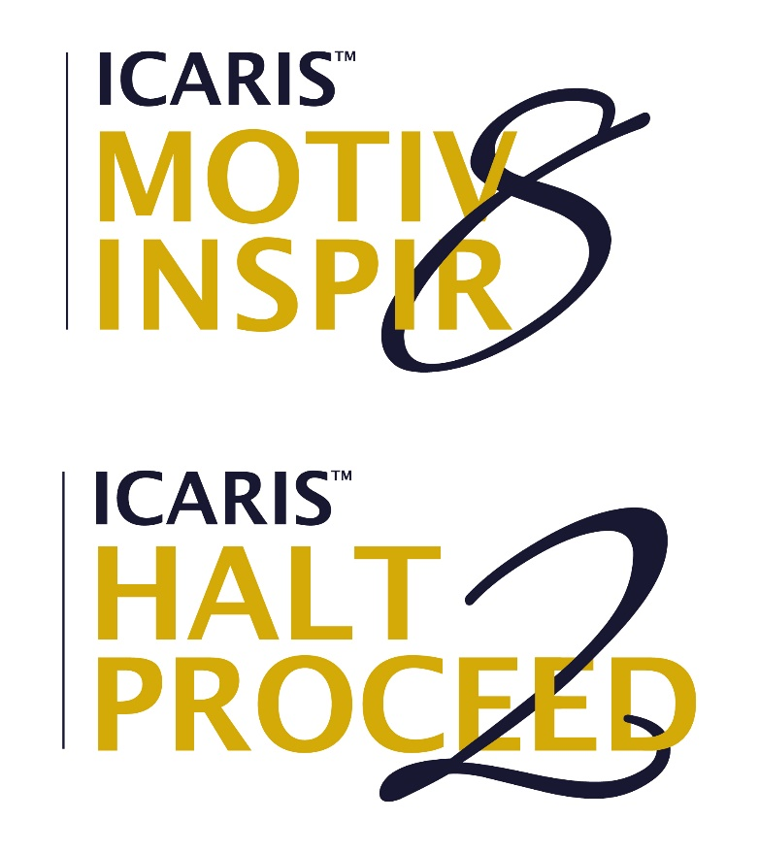

Author | Alan Owen
Course | MBA – BMMB70072D  University of Wales Trinity Saint David
Lecturer | Dr Roisin Mullins
Submission Date | 14th June 2021

PART A
YouTube link to Video
https://youtu.be/reqImCN0hWE
References for Part A

- Osterwalder, Pigneur (2010a) "Business Model Canvas" http://www.cenda.cl/images/descargas/sanvicente.pdf
- Verrue, Johan. (2014) “A Critical Investigation of the Osterwalder Business Model Canvas: An In-depth Case Study.” Belgian Entrepreneurship Research Day, Proceedings. http://hdl.handle.net/1854/LU-5712151
- Ladd,T. (2018) "Does the business model canvas drive venture Success?”
- https://www.emerald.com/insight/content/doi/10.1108/JRME-11-2016-0046/full/html
- Osterwalder, Pigneur (2010b) "Aligning Profit and Purpose Through Business Model Innovation" https://discoversocialsciences.com/wp-content/uploads/2018/08/CANVAS-1.pdf
- Murray, Scutto (2015) "The Business Model Canvas" https://symphonya.unicusano.it/index.php/symphonya/article/view/12040
- Elia et al. (2020) "Digital entrepreneurship ecosystem: How digital technologies and collective intelligence are reshaping the entrepreneurial process"
- http://www.sciencedirect.com/science/article/pii/S0040162519301969
- Henderson, Clark (1990) "Architectural Innovation: The Reconfiguration of Existing Product Technologies and the Failure of Established Firms” http://www.jstor.org/stable/2393549
- Gluckman, Allen (2018) "Understanding wellbeing in the context of rapid digital and associated transformations" https://www.ingsa.org/wp-content/uploads/2018/10/INGSA-Digital-Wellbeing-Sept18.pdf
- Wilson, C. (2018). Is it love or loneliness? Exploring the impact of everyday digital technology use on the wellbeing of older adults. Ageing and Society"
- https://www.cambridge.org/core/journals/ageing-and-society/article/is-it-love-or-loneliness-exploring-the-impact-of-everyday-digital-technology-use-on-the-wellbeing-of-older-adults/F391725A9584A666B1EDCEC68E03BCF3
- Fernandez et al. (2017) "InMyDay: A Digital Diary to Promote Self-care Among Elders" https://link.springer.com/chapter/10.1007/978-3-319-67585-5_49

PART B
YouTube link to Video
https://youtu.be/an60i9X0K9g
References for Part B
- Diener, Ed (2009) “Assessing Well-Being” https://link.springer.com/book/10.1007%2F978-90-481-2354-4#toc
- Farrand, P et al. (2016) “Behavioural activation written self-help to improve mood, wellbeing and quality of life in people with dementia supported by informal carers (PROMOTE): a study protocol for a single-arm feasibility study” https://link.springer.com/article/10.1186/s40814-016-0083-x
- Lisle, N (2019) “Get out of your mind and into your life: Using a self-help book to improve wellbeing in adolescents” https://researchcommons.waikato.ac.nz/handle/10289/12438
- Chamberlain, J (1996) “Self-help programs: A description of their characteristics and their members.” https://psycnet.apa.org/record/1996-03132-004
- Ibrahim, S (2011) “From Individual to Collective Capabilities: The Capability Approach as a Conceptual Framework for Self‐help” https://www.tandfonline.com/doi/abs/10.1080/14649880600815982
- Howels, A, Ivtzan , I, Eiroa-Orosa, F (2016) “Putting the ‘app’ in Happiness: A Randomised Controlled Trial of a Smartphone-Based Mindfulness Intervention to Enhance Wellbeing” https://link.springer.com/article/10.1007/s10902-014-9589-1
- Siligman, M (2011) “Flourish: A Visionary New Understanding of Happiness and Well-being” https://www.researchgate.net/publication/264972318_BOOK_REVIEWS_Policy_BULLET_Vol_27_No_3_BULLET_Spring_2011_Flourish_A_Visionary_New_Understanding_of_Happiness_and_Well-being
- Gaggioli, A, Riva, G (2013) “From Mobile Mental Health to Mobile Wellbeing: Opportunities and Challenges” file:///C:/Users/Alan/Downloads/Gaggioli2013FromMobileMentalHealth.pdf
- Simpson, B et al. (2020) "Making the World a Better Place: How Crowdfunding Increases Consumer Demand for Social-Good Products" https://journals.sagepub.com/doi/abs/10.1177/0022243720970445
- Mollick, E (2014) The dynamics of crowdfunding: An exploratory study https://www.sciencedirect.com/science/article/pii/S088390261300058X
- Babich, V, Marinesi, S, Tsoukala, G (2020) Does Crowdfunding Benefit Entrepreneurs and Venture Capital Investors? https://pubsonline.informs.org/doi/abs/10.1287/msom.2019.0835

