Project Initiation Document – S.H.A.R.D

Section 1

Background
S.H.A.R.D (Subzone Hazard Assistance Recovery Device) will take already existing technologies and combine them together to aid in the recovery of those affected by natural disasters. Our project is an application that can be used to track recovery workers and survivor locations whilst allowing the workers constant communication between each other.

Our device relies on two technologies :-
- The mobile communications system in use by the Royal Air Force[1]
- Cell, WiFi Repeaters

Our app will be loaded onto a simple android device such as a phone and worn on the wrist for easy access, the app will display a map of the area affected and will have location markers for the workers specific team and any located survivors. This will aid in the efficient deployment of recovery workers especially in remote areas.
Due to the limitations of the mobile communications system the repeater devices (Shards) will have to be deployed occasionally to keep all workers connected to the main recovery station, this has the secondary advantage of giving cellular and WiFi coverage to any civilians affected by the disaster.

Project Definition

Objectives
- Live App Tracking over multiple (5) devices
- Each device can 'see' all other devices in 'real-time'
- Ability to wrist-mount device
- Possibility over inter-device text communication
- Device must be 'always-on'

Scope

In
- WiFi only
- Uses Android hardware and software
- All devices use same WiFi network
- Simple user Interface

Out
- No mobile data (GSM)
- No BluTooth
- No NFC
- No single map

Constraints
- Can't develop for Apple IOS
- Time is an issue due to assignment and course deadlines
- Our own limited collective knowledge
- Restricted funding
- Our separation from campus and each other in terms of commute distance
- Google and their open source software (android studio, googlemaps API)

Authority
- Course Lecture - Sue Maw
- Head Of Faculty (SOAC) - Ian Wells

Resources
- Android AppDev IDE (Android Studio)
- Google Play Services
- Android Devices
- Ergonomic wrist mounting system
- The team
- University staff
- University library space (Meeting Room)
- Course Lecture - Sue Maw
- Student Software (MindView, Microsoft Project)
- Google Maps
- David Williams - Learning Support

Deliverables

Hardware
- 4 wrist mounted device (4 team members personal devices)
- 1 repeater station (1 team member personal device)
- 1 server/database

Software
- Show location of each device
- Show map
- Always on
- Live location tracking

Section 2

Team and Team Roles
- Richard Davies - Project Leader
- Dylan Evans - Software Engineer (Back End)
- Austin Hooper - Software Engineer (Front End)
- James Millns - Software Design (Back End)
- Sarann Strange - User Experience Designer
- Liam Salter - Web Developer (Front End)

Stakeholders

Within Project Team
- Richard Davies
- Dylan Evans
- Austin Hooper
- James Millns
- Sarann Strange
- Liam Salter

Outside Project Team/Inside Organization
- Course Lecture - Sue Maw
- University staff
- H.E.L.P

Outside Project/Outside Organization
- Multiple Government Agencies
- Team Member Families
- Public Services
- General Public

Section 3

Assignment Milestones
- Project Initiation Document Deadline - 18/11/2018
- Prototype Demonstration - 18/01/2019
- Final Project Report Deadline - 25/01/2019

Schedule [2]

Gantt chart
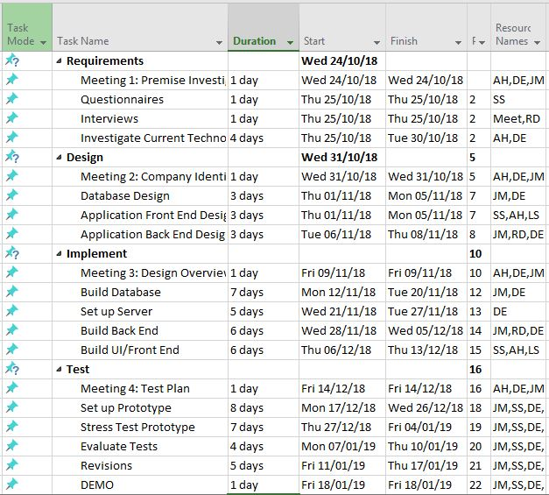

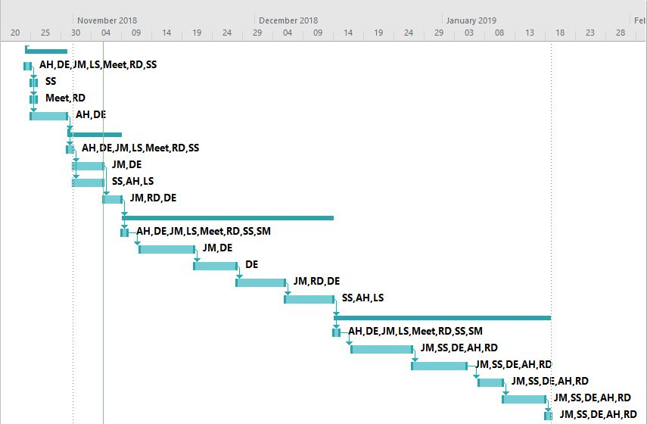

Network Diagram
Due to the size of the network diagram it was impossible t have it as one screenshot but even in this broken down view you can still see the critical path (in red)
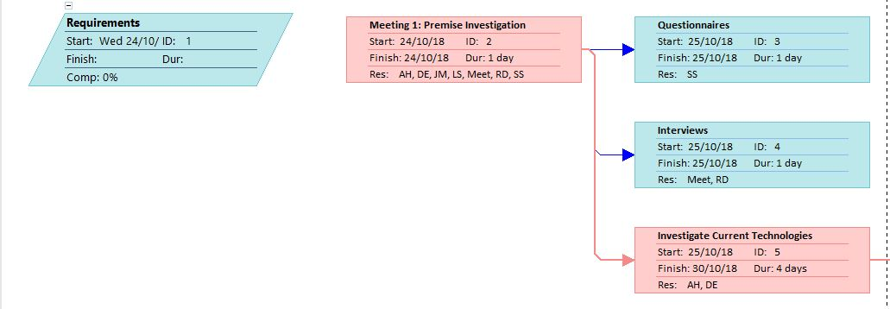
------------------------------------------------------------------------------------------------------------------------------------------------
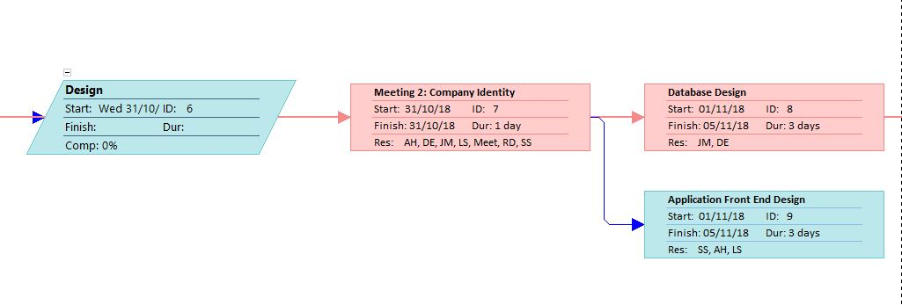
------------------------------------------------------------------------------------------------------------------------------------------------

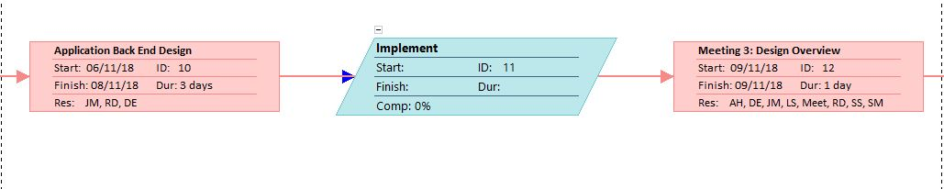
------------------------------------------------------------------------------------------------------------------------------------------------

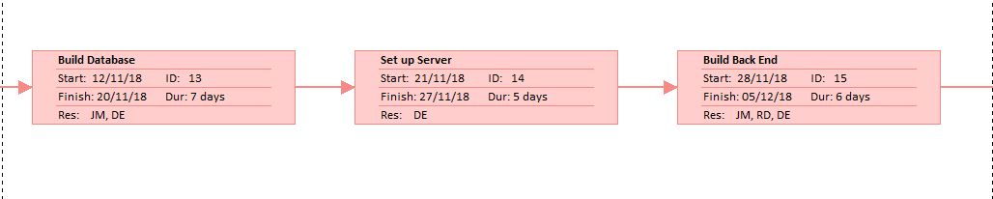

------------------------------------------------------------------------------------------------------------------------------------------------
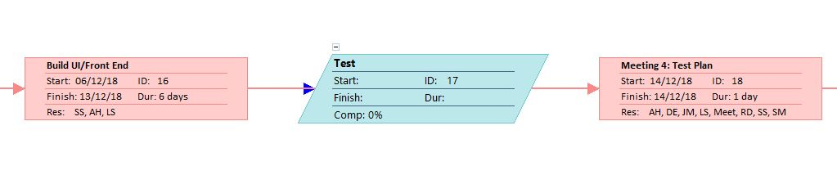
------------------------------------------------------------------------------------------------------------------------------------------------

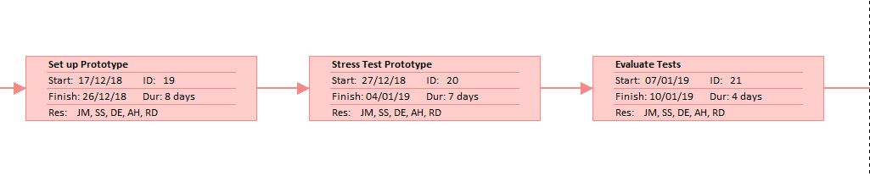
------------------------------------------------------------------------------------------------------------------------------------------------

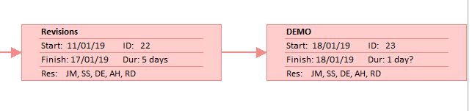
------------------------------------------------------------------------------------------------------------------------------------------------

Risks Identified
- Team member absence due to illness/ holiday/ family commitments
- University closure
- Google company collapse

References
- [1] - Corporal Gareth Davies – Royal Air Force
- [2] – James Millns – Team member

While this document was completed by myself all work done as part of a team.

