CLAIRE MARIE HANCOCK

TALENT MANAGEMENT AND WORKFORCE PLANNING

Assessment ID / 669 5HR02 22 01.

Background information on Amcor Flexible’s Swansea

Amcor is a global leader in developing and producing high quality, responsible packaging solutions for the food, beverage, pharmaceutical, medical, home and personal care markets. With 225 sites based in around 40 countries and employing over 46,000 employees.

Amcor Flexibles Swansea is located in South Wales and was formerly owned by Bemis but were taken over by Amcor Flexibles In June 2019. And specialise in flexible packaging for the meat and cheese industry.



Swansea has an approximate headcount of 200 employees. Around 150 working on the production lines, these are referred to as hourly paid employees, whilst the other 50 employees are referred to as staff or white collar workers.

The manufacturing process is continuous process, with production departments operating 24hrs, 7 days a week whilst other departments work 24hrs, 5 days per week.

  - Explain how organisations strategically position themselves in competitive labour markets.
Amcor understands it must be seen as an employer of choice if they want to position themselves strategically in the competitive labour market. Implementing retention strategies to help attract and retain the best talent with a desirable company culture, employee engagement and leadership style (Onoufriou, 2021).
So have invested in three characteristics
- Organisational values
- What it offers employee’s financially and non-financially including diversity and inclusion, work life balance and career development opportunities.
- Working practices
- Rewards, benefits and investing in its people to attract and retain talent.
- Perception of the organisation
- The branding, reputation of the company including being seen as an ethical employer who understands the important of safeguarding its employees and business, as demonstrated below.
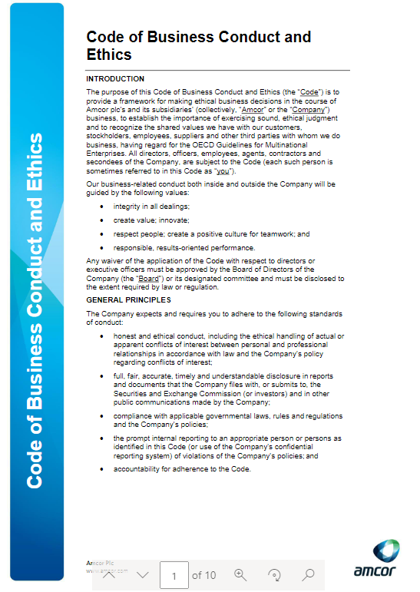
(Amcor, 2022a)
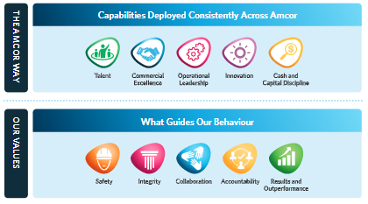
(Amcor.com, 2022)
They conduct a competitive analysis to help evaluate the competitive landscape to identify all direct and indirect competitors battling for talent within the labour market based on current and future state. Helping make informed decisions on best resourcing strategies that helps differentiate themselves in the competition and gain a higher share of the labour market.
Different strategic aspects used to conduct a competitor’s analysis:
- Identified the brand image of each competitor.
- Checked where each competitor is positioned within the market.
- Assessed strengths and weaknesses of each competitor.
- Analysed how the target groups of talent perceived each competitor as an employer?
(Taylor and Woodhams, 2016h, pp.60–61)
Market Rate Analysis

Amcor conducted a market rate exercise to compare their rates of pay against other similar manufacturers within a 25 mile radius which would show how competitive their current salary structure is. The finding’s highlighted Amcor’s rates of pay were significantly lower than its competitors. Therefore a 2 year pay deal has been agreed to try to make the salaries more attractive to attract and retain its workforce.

(Amcor, 2021)

  - Explain the impact of changing labour market conditions on resourcing decisions.
The labour market is built upon the supply and demand for labour, where the employees provide the supply and employers provide the demand (Kenton, 2022). It’s a key concept in employee resourcing and is influenced by these factors (Taylor and Woodhams, 2016a, pp.54–55).
PESTLE ANALYSIS

Political | Introduction of or changes to migration policies, i.e. Brexit affected the availability of low paid/skilled workers making recruitment harder. And changes to employment legislation including the increase in minimum wage resulting in increased costs for employers.
Economic | Changes within the economy impacts the performance of the company with consumer spending falling, unemployment will rise and the economy will become less stable. Economic conditions determines how many workers an organisation can employ to meet customer demand (CIPD, 2021d). Amcor experienced high production demand during covid due to the people stock piling food.
Social | Demographic changes including an aging society, people working longer and youngsters staying in education longer means fewer youngsters are entering the labour market, impacting the workforce. (Taylor and Woodhams, 2016b, pp.110)  Amcor have introduced a graduate scheme to attract young workers.  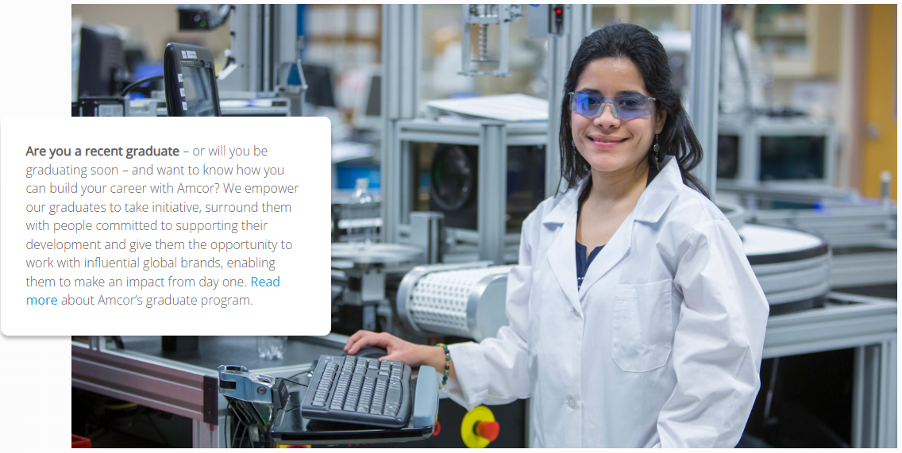  (Amcor.com, 2022)
Technology | Advances in technology and especially in automation has reduced the number of workers required and impacted the need for new skills. Covid has brought about changes to job design with the use of mobile technology for homeworkers .
Legal | Changes to legislation where employment law has changed, limiting working hours increasing the number of workers required. And a change in working patterns including zero hours contracts and the gig economy.
Environmental | The recent pandemic has caused a shift in working arrangements for many businesses who are now offering employees to work from home.  Giving employee more options as location is no longer a barrier (Taylor and Woodhams, 2016c, pp.54–55)  Amcor central unit are seeing an increase in turnover and difficulty in recruiting employees as they are not offering home working flexibility therefore are struggling to fill vacant positions.

Amcor understand their ability to recruit depends upon the nature of the market they are targeting at a particular point in time and levels of unemployment. Having recently experienced difficulty in recruiting due to the tight labour market. Where employment is high, insufficient skilled workers and more job opportunities available than active job-seekers, making it harder to fill vacant roles. Giving job seekers greater bargaining powers and forcing them to be more flexible to adapt to emerging changes and be creative with their people management recruitment strategies.
Previously this wasn’t an issue, labour market was loose, with high levels of unemployment and skills were readily available. Benefiting with more choice because of the large number of job seekers competing for a smaller number of opportunities giving Amcor increased bargaining powers (Taylor and Woodhams, 2016c, pp.53)

  - Discuss the role of government employers and trade unions in ensuring future skills needs are met.
The government introduced several initiatives aimed at upskilling the nation’s workforce to boost skills and get more people into work. Influenced by the UK’s poor literacy, numeracy and computer skills, due to weaknesses in the education system and low investment in workplace training (GOV.UK, 2021).
They’ve created a blueprint for post-16 education system to ensure everyone will gain the skills required to process in work during their working lives. And have introduced National skills fund to help adults gain skills required by employers, supporting economic recovery and improving job prospects (GOV.UK, 2021).
It’s expected future jobs will require far higher levels of competence than previously required. With the rise in digital technologies employees need to learn new skills and learn to continually adapt as new occupations emerge. This has been accelerated by Covid-19 (Dondi et al., 2021)
Apprenticeships are another initiative, supporting individuals of all ages to get recognised industry qualifications and skills needed to enter the labour market. And progress into higher skilled work to achieve their full potential whilst meeting the needs of employers. They’re a major benefit to employers, they drive productively and prosperity in the economy, reduce turnover. And are an effective way of filling the skills gaps and meeting future skills demands (GOV.UK, 2021).
Trade unions have a positive impact in supporting greater access to training and development in the workplace. With the introduction of the Union Learning agenda to boost the number of workers accessing training and development through the Union route (TUC, 2018).
Amcor Training and Apprenticeships

Amcor currently have a number of apprentices employed throughout the organisation, ranging from Business Improvement Techniques, HR, Mechanical and Electrical. Some are school leavers others are existing staff members who the company want to invest in. Regardless of age they have all had to complete the essential skills including application of numbers, communication and digital literacy.

Amcor believe this method of training is a productive way to grow talent from within, bringing a fresh approach and positive attitude to the workplace. Help develop skills to match the company’s future needs, to develop motivated and qualified workforce, which can lead to improved business performance and a positive effect on the company finances. And by supporting apprenticeships shows the company is taking a positive approach to Corporate Social Responsibility (National Apprenticeship, 2022).

2.1 Analyse the impact of effective workforce planning.
Amcor consider workforce planning a core business process which aligns the changing organisational needs with people strategy. It enables them to balance labour supply (skills) against the demand (numbers required). Ensuring they have the right number of employees with the skills required in place at the right time and right cost (CIPD, 2021).
They apply a hard approach to workforce planning as it’s all about the numbers. Each year sales and production targets are set which determines the required levels of resources and skill sets needed to meet those demands. Comparing current workforce skills against future requirements to identify skills gaps and manning levels. This data is translated into a set of actions to meet that demand and implement strategies to meet company’s strategic objectives (CIPD, 2021b).
The alternative is a soft approach where strategic workforce planning is about defining a strategy or developing a strategic framework from which information can be assessed. This information can’t be quantified but is pivotal in getting results to enhance the company’s performance.
Effective workforce planning can positively impact the organisation, benefiting from.

- Reduced labour costs due to flexibility and deployment of the workforce.
- Improved employee retention and work-life balance.
- Highlight inefficiencies to improve productivity and quality output
- Identify and respond to the customers ever changing needs
- Identify strategies based on people development.
- Make recommendations to deliver strategic value through talent
(CIPD, 2021b)

To streamline this process Amcor are considering implementing a database system i.e. Mecpd that will capture resourcing levels, key skills and costs, with the added benefit of providing insights into the organisations training and development shortfalls instantly.

(www.mecpd.co.uk, 2022)
2.2 Evaluate the techniques used to support the process of workforce planning.
Workforce planning tools are an essential part of the HR practitioner’s toolkit and requires effective communication with the rest of the organisation. Its data-driven to help analyse the current capabilities and future needs of the employee population to identify the gaps (Van Vulpen, 2018).
This diagram illustrates main stages of the workforce planning process (CIPD, 2021b)
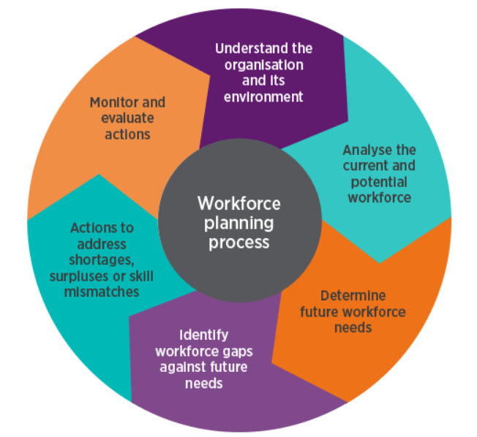

Amcor’s approach to:
Forecasting demand
To determine the demand for future skills required Amcor apply a combination of these three approaches:
- Systematic techniques – analysing past trends to predict the future needs or deriving figures from the desired output.
- Managerial judgements – knowledge and experience of senior managers, based on internal, external knowledge and of the industry itself is considered.
- Working back from costs – determining how many staff can be afforded based on the future budget.
This data identifies job roles required, number of employees and skills needed. (Taylor and Woodhams, 2016d, pp.58–59).
Forecasting supply using trends and patterns.
Looking at current workforce data to identify number of employees, wage costs, composition and sickness absenteeism levels and how this affects the ability to meet production targets. Assessing skills recorded in the training matrix. Estimating number of employees that are likely to still be employed in the future, review turnover trends, average employees that resign, or due to retire. And even roles that people may work in in the future or lateral moves, promotions and demotions. (Taylor and Woodhams, 2016d, pp.58–59).
Amcor then consider any external factors that have/will affect i.e. state of labour market, impact of Brexit and Covid and advances in technology.
Identifying the gaps
A skills audit is completed to determine the mismatch between the skills and job roles required for the future against current (Taylor and Woodhams, 2016d, pp.58–59).
Strategic Workforce Planning Map
This stage helps understand how the workforce planning activities will align with the organisational strategy. Focusing on what’s happening in the market with trends in supply and demand, what products or services are being produced and what competitors are doing.
Amcor also apply the scenario planning tool which helps anticipate multiple possible futures that could have severe impacts on the organisation, including how it would affect sourcing of people requirements to needs.
Knowledge gained from this exercise helps support the contingency and adaptive workforce planning actions.
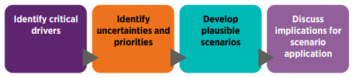
(Van Vulpen, 2018)

2.3 Explain approaches to succession and contingency planning aimed at mitigating workforce risks.
Succession planning is the process of identifying and developing future leaders, senior managers and other employees to fill business-critical roles. Aiming to fill the roles effectively if a current post holder leaves the organisation (CIPD, 2020c)
Amcor has a succession planning committee that conducts an annual exercise to match individuals to particular roles. And have adequate contingency plans in place to mitigate risk to the organisation. Ensuring there are enough employees with the right skills and leadership potential to step into business-critical roles at the right time. These individuals are selected based on competencies and feedback from managers. This process ensures a smooth transition with minimal effect to the organisation during the periods of change. Example of Amcor’s Succession Chart.
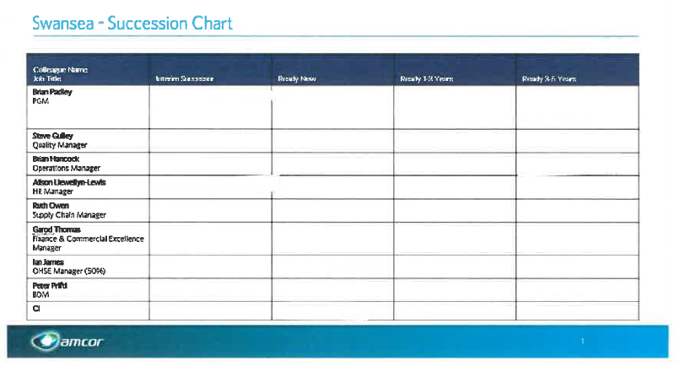
(Amcor, 2022b)
Annual performance reviews are key to this process. They help identify talent pools, opportunity for feedback, highlight employees’ aspirations, assessment of current abilities and skills levels to fill the gaps. And action any development plans required to fulfil their full potential. Includes formal training programmes, coaching, mentoring, shadowing and covering higher positions. (Taylor and Woodhams, 2016e, pp.59)
Amcor try to balance out the succession planning with need for new talent sourced externally to bring new innovation, fresh ideas and experiences. (Taylor and Woodhams, 2016f, pp.60)
Production departments have different skills requirements based upon the job specifications for each role. And are set up on the training matrix to monitor and measure their progression against the set targets.
This matrix helps identify if they have the required number of employees with the ability, knowledge and experience to move into roles at the next level should someone leave. It also helps identify if employees are on track with their training plan or any underperformers or overperformers.
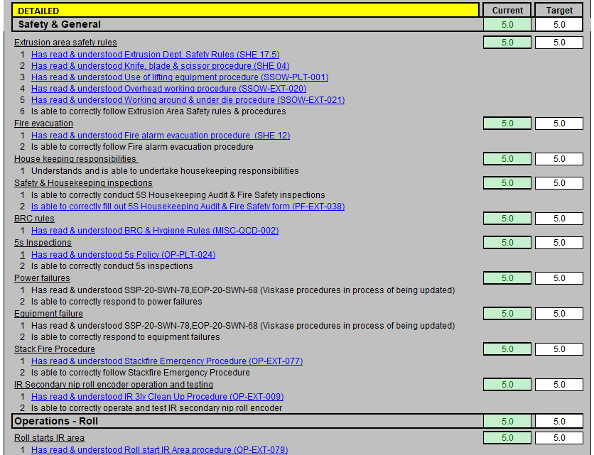
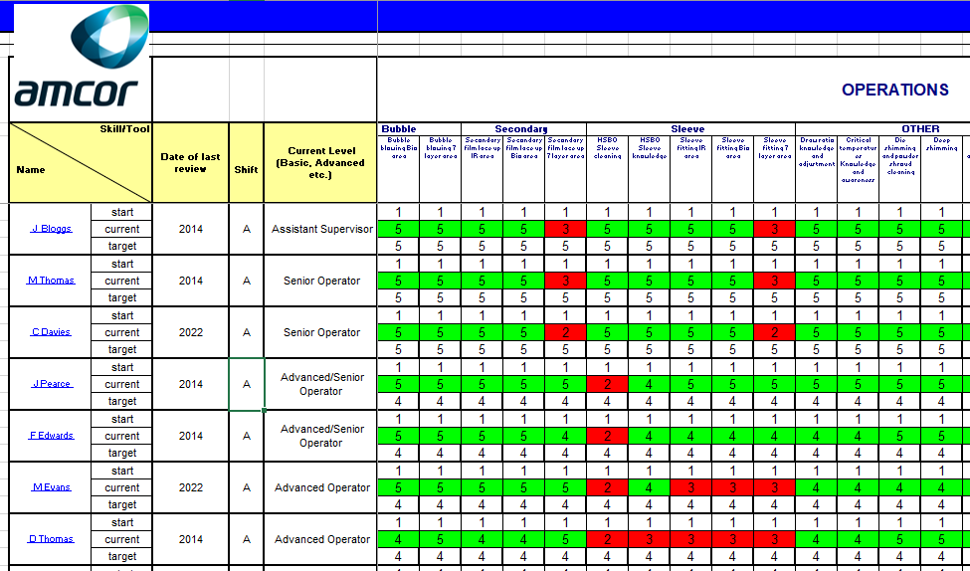
(Amcor, 2022c)
Recent Example

The training matrix has proved beneficial with the recent announcement that the Swansea site has been granted an 8 million euro investment to expand the Extrusion department. This requires additional resources therefore the training matrix has been used to help determine the current status of existing resources and identify skills gaps and those with the potential to be trained up and fully competent in time for the new production line to be installed.

2.4 Assess the strengths and weaknesses of different methods of recruitment and selection to build effective workforces.
Recruitment is the process of actively searching, finding and hiring candidates for a specific job (Sage, 2018). The process has changed significantly over the past decade due to advancements in technology. Technology has helped HR find top talent and streamline the process with automation, internet based recruitment, candidate assessments and video based interviews, transforming the way jobs are advertised, applications tracked and how we communicate and interview applicants. Mobile technology has changed how we can connect with the rest of the world and reach a wider audience. It also saves time and money (Atkinson, 2019).
The recent pandemic has had a profound effect on the recruitment process, forcing HR to use alternative methods using mobile technology. Conducting virtual interviews rather than face to face, means location is nolonger a deciding factor now that organisations now offer flexible working polices, meaning more applicants can apply. These changes have benefited the recruitment process making it quicker, more effective and efficient (ec.europa.eu, 2021).
The pandemic made people reassess their priorities and make changes due to struggles to balance life’s obligations. Women and people from ethnic minority backgrounds where among the most affected, some losing their jobs or having to give them up (Fell, 2020). As a result Amcor have had to reaffirm diversity and inclusion in their hiring efforts to improve their capacity to innovate and enhance its reputation, as it is believed diverse and inclusive teams will actively drive the recovery. Making adjustments to working structures and focusing on employee’s wellbeing in a bid to attract and take on new talent, as demonstrated by Tim Moss from the IPO government body (Moss, 2021).
Internal Recruitment methods applied by Amcor.

 | Strengths | Weakness
Intranet | A cost effective method and an efficient way of communicating the.  Provides the reader with direct links to the job description and person specifications  Enables candidate to apply online making it a simpler process. | Organisations have to have an intranet system to be able to advertise the vacancy.  Only effective if employees are actively looking at the intranet system.
Noticeboards | Low cost method, easy to maintain and enables all employees who read the notices access to open vacancies.  Good if employees don’t have access to computers. | Can be time consuming.  Need to be checked regularly to ensure the notices aren’t removed and are intact.
Email Notifications | Quick and easy method. | Only effective if all employees have an email account.
(Waite, 2021a, pp.107-108)
External Recruitment methods applied by Amcor.

 | Strength | Weakness
Employment agencies | Can draw on their existing talent pool, with the required experience, making it a quicker process.  Can advertise the vacancies to help source top-calibre candidates.  Offer a variety of services including advertising, shortlisting and selection. | Can be costly.  May miss out on candidates that aren’t registered with them.  Or may put forward candidates who would not fit into the culture of the organisation.
Professional and social networking sites | Many professionals use networking sites (LinkedIn) to source and target passive candidates.  Receive more applications from a wider audience. Even from those who aren’t actively looking for a new role but are attracted to the vacancy.  Method is inexpensive. | Can be time consuming and may not reach many individuals.
Word of mouth and referral schemes. | No cost to this unless the employers pays a financial incentive to the employee who referred the individual and are successfully appointed  Raises employee engagement | Can limit the talent pool and may have a negative impact on the referrer if it doesn’t work out as planned.
Organisation’s website | Powerful recruitment tool.  Low in cost and is open to a larger audience at the same time showcasing the company. | Must be kept current.
(Waite, 2021b, pp.109)

Selection methods applied by Amcor.

 | Strengths | Weakness
Sifting and Shortlisting | Identify potential candidates that may be more suitable for a different role.  Able to review applications more than once. | Can be a manual process and time consuming.  Open to human error and bias.
Face to Face interviews. One on one or Panel | Enables the interviewer to personally meet the applicant whilst giving the applicant the opportunity to visit the workplace.  Helps build rapport between both parties.  Panel interviewer’s, notes taken and questions asked can be shared between them.  Panel interviews reduce the personal biases. | Employers must ensure they offer reasonable adjustments to enable full access to selection.  One to one interview’s means interviewer has to ask questions and make notes.
Video Link | More people have access to the internet due to the developments in technology i.e. Skype, Microsoft teams, Zoom etc. | Connection issues i.e. lagging or problems with the camera and microphone can have an effect on the effectiveness of communication.
Aptitude Tests/ ability and personality testing. | Can be completed online and help shortlist applicants at a faster rate to speed up the shortlisting process. | Not everyone has a computer or aren’t computer literate.
(Waite, 2021c, pp.116-117)

Here’s Amcor’s Recruitment and Selection process flow for the hiring of Managers.
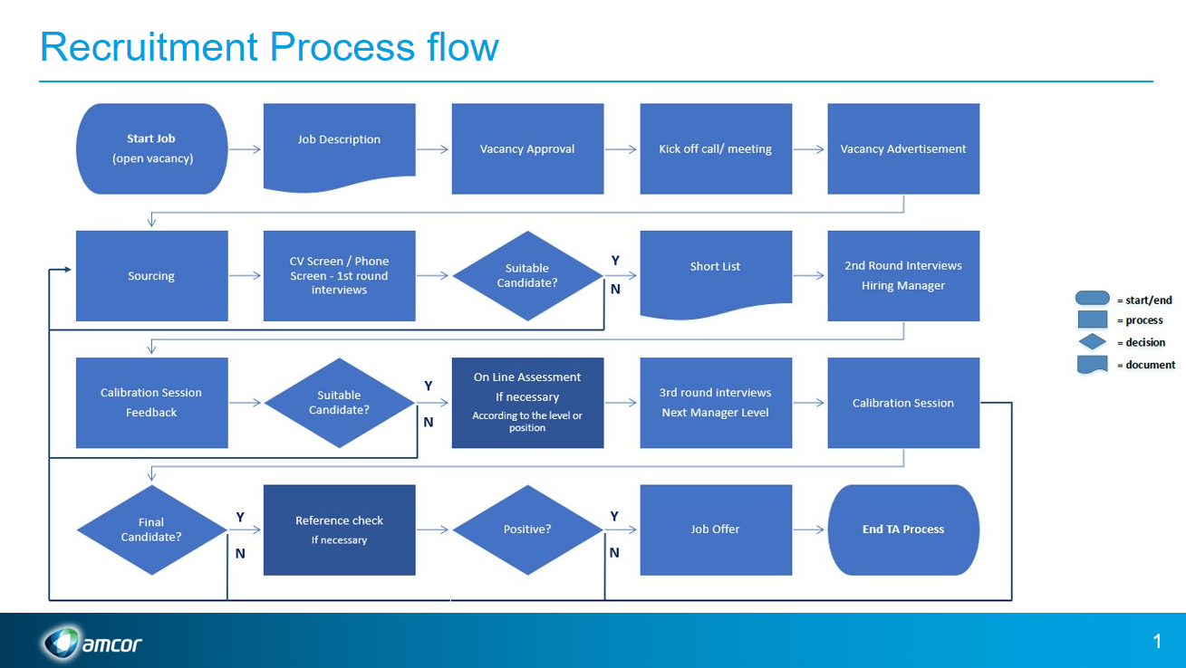
(Amcor, 2022d)
Amcor ensures their selection methods treat candidates fairly, without discrimination and are based on candidate’s ability to perform the role, contribute to the organisation to help achieve organisational performance and have potential for development (CIPD, 2021e).

3.1 Examine turnover and retention trends and the factors that influence why people choose to leave or remain.
Amcor focuses on employee turnover to try and identify the reasons and reduce the costs associated with recruitment, selection and development of lost talent. And to improve retention levels inorder to retain the skills and knowledge of valuable workers (Waite, 2021d, p.101).
Calculating Staff Turnover

Turnover rates are calculated based on the proportion of employees that leave the organisation over a set period of time.

Number of leavers in a period x (FTE) x 100
Number of employees in a period (FTE)

If there were 90 leavers in an organisation with a headcount of 1,600 employees the calculation would be

90 x 100 = 5.625%
1600

(Waite, 2021e, p.102).

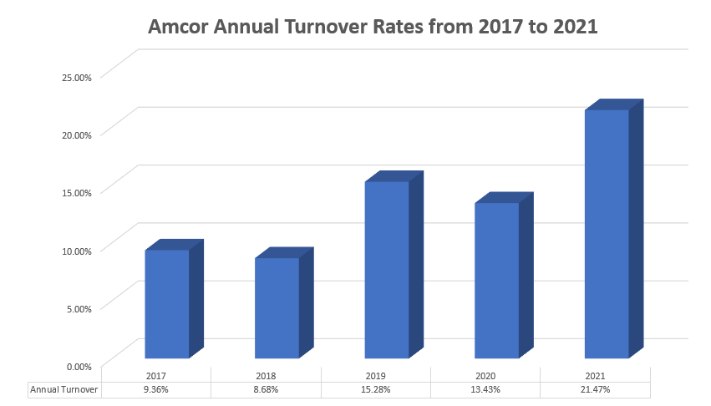
Internal and external factors influencing employee retention can differ between occupation, industries and from region to region.
Factors influencing Amcor’s employee turnover.
Internal reasons -
- 2019, Bemis was taken over by Amcor, causing employees unrest and fear job security.
- 2021, working hours were changed for some employees resulting in a 22% pay reduction. Many of which left for higher paid roles.
- 2021 many employees left after reassessing their work-life balance due to the Covid pandemic, nolonger wanting to work 12hr night shifts.
- Every year some employees voluntarily left of their own accord due to being dissatisfied with the pay they received.
External reasons -
- 2017, Bemis lost production orders after a pricing battle with competitors. Resulting in involuntary turnover where the company terminated some employee contracts due to redundancy after a restructuring exercise was conducted . (Waite, 2021e, p.102).
- 2021, labour market was tight labour, with low unemployment giving people a greater choice of roles, offering better rates of pay and more development opportunities.
Why employees stay -
Factors that encourage employees to stay include feeling valued, appreciated, reward and recognition, job security and growth opportunities increasing satisfaction and motivation levels. (Ravichandran, 2019)
Amcor - Understanding employee opinions

Amcor recently conducted an online engagement survey with a section focusing on engagement. With the aim of gathering employees’ opinions to identify possible trends that they could then address in the hope of improving employee retention.
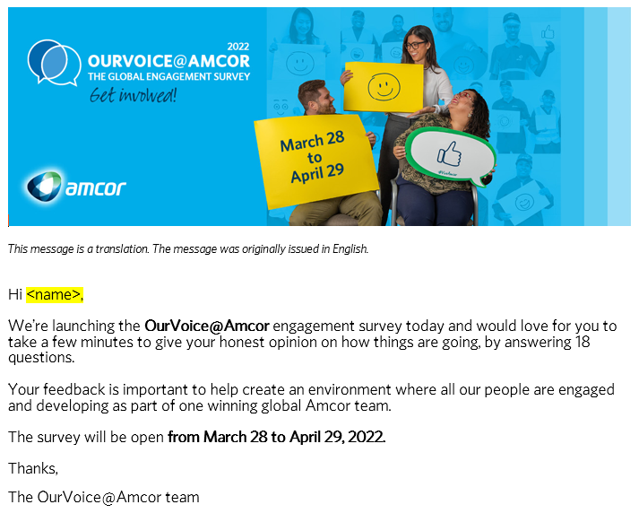

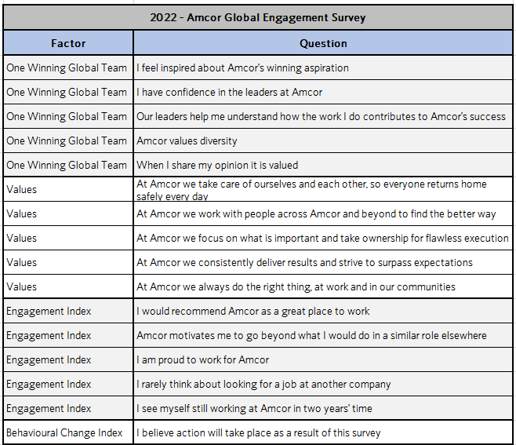

(Amcor, 2022e)

3.2 Compare different approaches to developing and retaining talent on an individual and group level.
According to CIPD (2021f) talent refers to individuals who make a significant difference to organisational performance. Either through their immediate contribution or, in a longer term, by reaching their highest levels of potential. Talent management is the systematic attraction, identification, development, engagement, retention, and deployment of those individuals who are of particular value to an organisation. Through their high potential or because they fulfil critical roles.
Amcor has adopted different approaches to developing and retaining talent for both individuals and groups of employees. Including continuous learning and development programs which are essential for developing and enhancing current employees’ talent through skilling and reskilling to meet future organisational needs and as part of talent strategy.
Approaches applied:
- Appraisals - Feed into talent management, identifying employee’s strengths and weaknesses, helps support talent development and deployment of the individual. Assessing performance, documenting future aspirations and identifying training requirements.
- Training Matrix - Helps manage, plan and monitor existing skills and highlights skills gaps to be addressed.
- Training and development – Talent management programmes including formal and informal leadership training i.e. coaching and mentoring.
- Lateral moves - Transferring employees to different departments to build experience and knowledge throughout the organisation.
- Flexibles working and work life balance – Granting employees flexibles working where possible i.e. hybrid working.
- Fair and equitable reward - Higher the position the more benefits they receive. Managers receive an annual bonus, medical cover, Senior Managers also receive additional benefits i.e. company car etc whilst all other staff receive a plant based bonus.
Amcor have recently developed a Talent Management Strategy to focus on critical jobs, workforce groups and individuals that present the most significant future resourcing risks. This is as a result of increased employee turnover and aging workforce.
(Amcor, 2022)

3.3 Evaluate approaches that an organisation can take to build and support different talent pools.

A talent pool is a collection of high performing and high potential employees that embody the organisations culture and values and are ready to take on greater responsibility within the organisation. This forms the basis for organisational succession planning. (Hibob, 2022)

Amcor have in place a talent management strategy that defines what they want to achieve and initiatives on how they are going to create and support an effective talent pool. Methods applied:

- Identifying talent -
A continual assessment process which analyses current talent and forecasts future organisational needs including identifying business critical roles which helps support the succession plan.
An internal talent pool is formulated based on the outcome of employee performance reviews and manager’s feedback. Where past performance and future potential is discussed. The data is transferred onto the “nine box exercise” placing employees in the relevant section highlighting high performers.

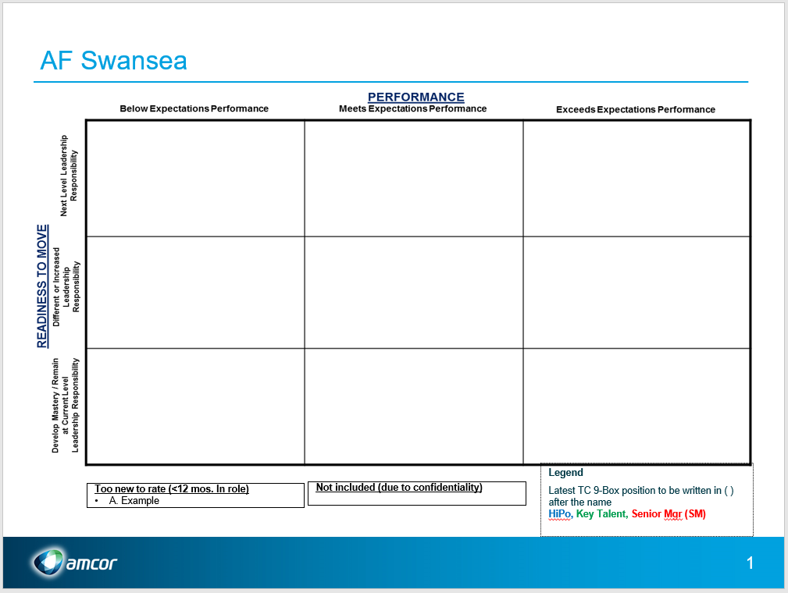

- Developing and retaining talent,
Amcor believe in applying learning and development initiatives that reflect the business objectives. Includes coaching and mentoring of employees on a talent management programme. Providing valuable career development opportunities that help them become more agile and flexible by enhancing knowledge, skills and capabilities throughout the organisation. This process helps with the acquisition and retention of high performing employee’s
- Emerging Talent
Focusing and maintaining a high level of employee engagement with open communication and collaboration between the organisation and its employees. Using technology i.e. talent management systems to build effective talent pools and retain records of talented external candidates that could potentially benefit the organisation.
(CIPD, 2022g)

3.4 Evaluate the benefits of diversity in building and supporting talent pools.

Creating a diverse workforce is essential to establish a diverse talent pool within the organisation. By adopting an inclusive approach from the outset, implementing a diversity and inclusion strategy to form a culture where everyone is valued as an individual and treated fairly.

Amcor understand the benefits of having diverse talent pools.
- Gaining competitive advantage - Bringing together different outlooks, perspectives, characteristics, experiences and knowledge can enhance organisational performance and offerings with more fresh, new ideas and opens doors to innovation. These factors can increase creativity within the workforce, improve decision making, employee turnover and have a positive impact on company branding. This is hugely important in attracting potential candidates from diverse backgrounds who perceive the organisation and establish if they feel represented or not (Wessinger, 2017).
  - Instant access to the internet and websites i.e. ‘Glassdoor’ provide inside information on companies from former and current employees anonymous reviews (HR Magazine, 2021).
- Attracting diverse talent - A recent study conducted by Glassdoor, stated 67% of job seekers thought a diverse workforce was an important factor when evaluating companies and job offers, making them more desirable place to work. Enhances the ability to attract top talent on a larger scale, improve language barriers and develop positive corporate reputation (Wessinger, 2017).
  - Since the pandemic companies have turned to the global workforce to hire more diverse teams whilst enabling remote working (Amcor, 2022)
- Diversity helps drive employee engagement - By demonstrating diversity and inclusivity creates trust in employees which motivates them to achieve their potential and enhance creativity. Whilst contributing to the success of the organisation by improving productivity, performance, reducing risk of discrimination and improving staff retention (Wessinger, 2017).

Amcor’s policy on “Talent through Diversity” was implemented to try and promote and uphold diversity in the workplace.
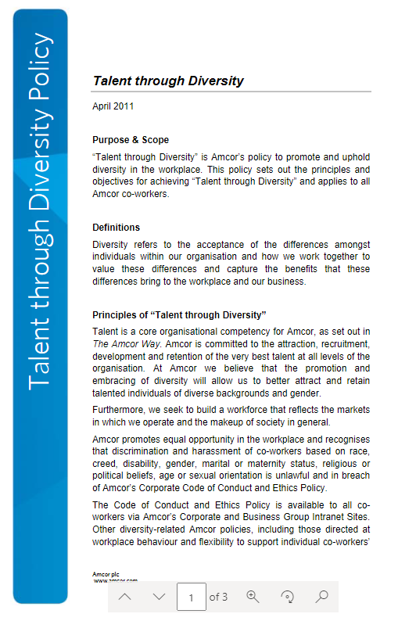

Information available on Amcor’s SharePoint System.
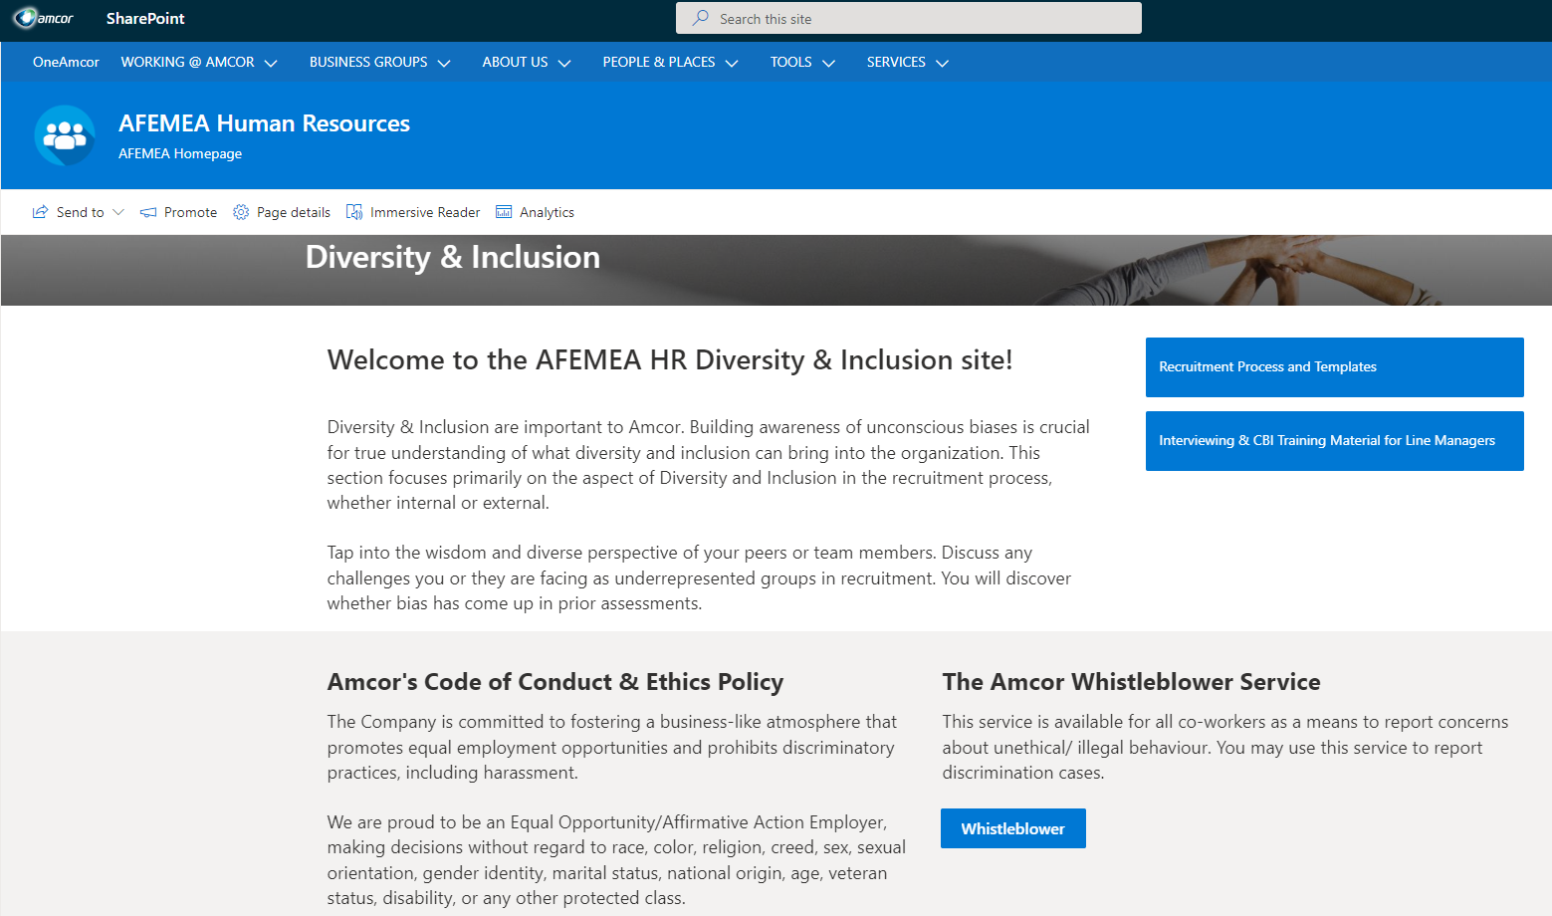
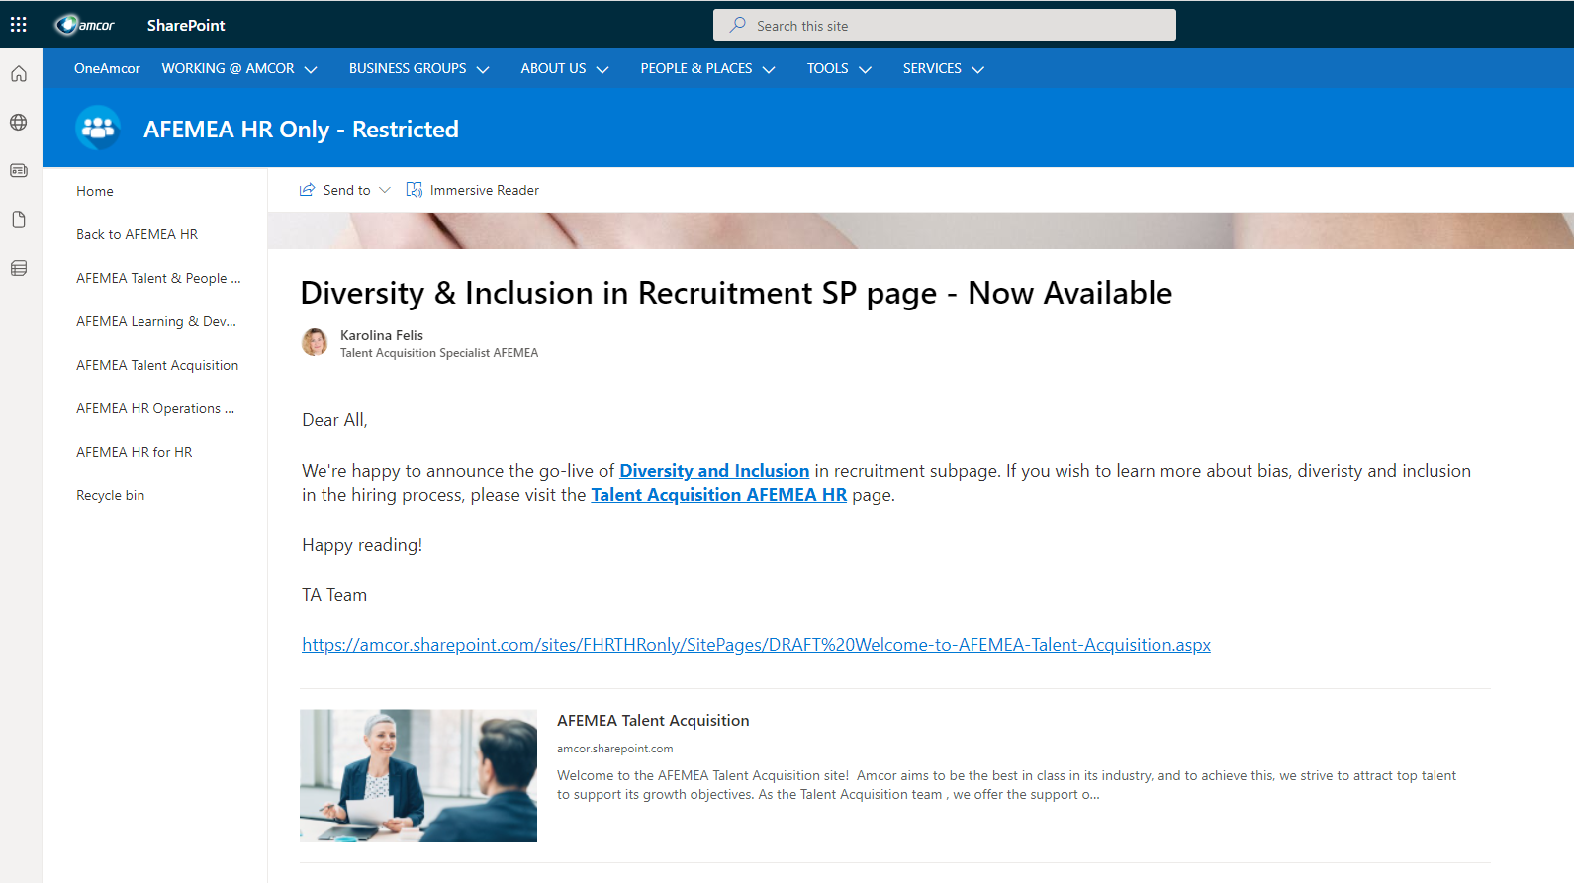
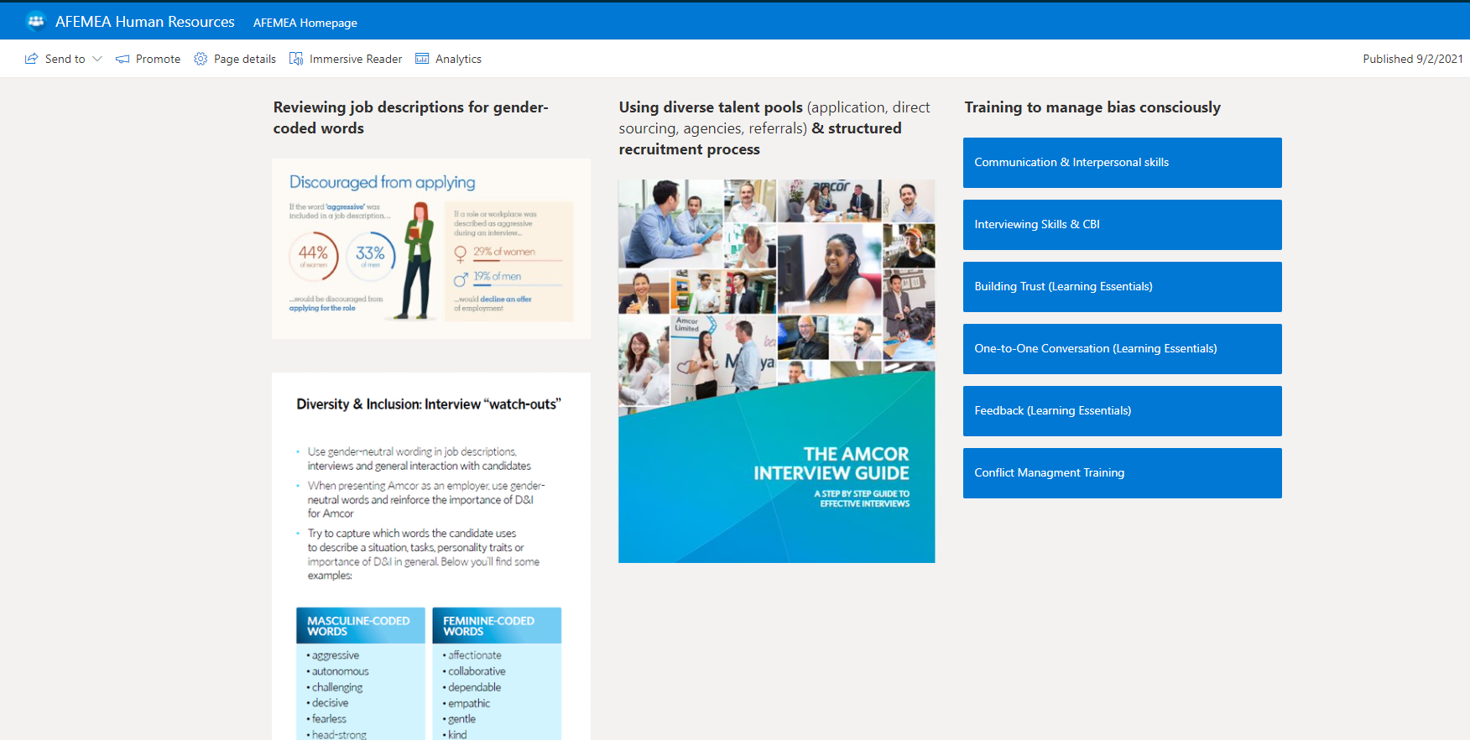
(Amcor. SharePoint, 2022)
  - Explain the impact associated with dysfunctional employee turnover.
Dysfunctional turnover is based upon when positive employees voluntarily leave at a higher rate than the weaker ones. This impacts the organisation financially and can be disruptive and destructive (Workify, 2022)
Dysfunction turnover impacts organisations by:
- Drop In Innovation – by losing high performers and innovators who are often the most productive employees.
- Loss of Experience – losing experienced and skilled workers who take with them vital knowledge that has inherent value to competitors that will benefit from their experience instead.
- Cultural Dissonance – causing cultural issues within the remaining workforce due to after effect of high performing employees leaving. Disrupting and unsettling the workforce (Workify, 2022).

The costs include:

- Direct Costs – HR administration time for leaver, the recruitment and selection process, advertising costs, cost of covering vacant role, new starter costs and employee induction and training costs.

- Indirect Costs – Leavers can be less productive in final weeks, so are new starter. Loss of morale, damage to client relationships. Company data could be leaked and potential damage to the company reputation if leave on bad terms (Taylor and Woodhams, 2016g, pp.69–70)
Amcor like many other organisations don’t currently calculate dysfunctional costs because of the difficultly in gathering all indirect costs that aren’t quantified. However HR practitioners should try to calculate these costs to gain a better understanding of the problem and gain backing from senior management for any proposed retention initiatives and strategic workforce plans that need applying.
The easiest way to calculate the dysfunctional costs is to estimate the cost of turnover for a ‘typical post’ within the company and multiply this by the number of dysfunctional leavers for the year. Or alternatively add all the costs together of HR/management time to the costs incurred related to employee resignation, recruitment, selection and induction throughout the year quantified (Taylor and Woodhams, 2016g, pp.69–70).

4.1 Assess suitable types of contractual arrangements dependent on specific workforce need.
In 2018 the government published the “Good work plan” which focused on improving the clarity of the employment status to help tackle the issue of employers trying to mislead their staff (Johnstone, 2022).
Under the UK Employment Act there are different types of employment contracts and employment status that are deemed acceptable.
  - Employment contracts
    - Permanent
    - Temporary,
    - Fixed Term,
    - Casual or zero hour,
    - Self employed

  - Employment status
    - Employee,
    - Self Employed
    - Workers.

It is important employers establish the nature of the employment relationship to determine the employment rights to which an individual is entitled and the type of employment contract that is applied i.e. permanent, fixed term, casual or zero hour (Johnstone, 2022).
All Amcor’s workforce based at Swansea are employed as employees which under the employment rights act 1996 means an individual who has entered into or works under a contract of employment” This is a legally binding agreement between the employer and employee and is indefinite in nature or until either side nolonger wants to continue with the contract.
The majority of contracts issued are on a full time permanent basis, under these contractual agreements the employees are entitled to all statutory employment rights and benefits as stipulated in the Employment rights Act. (Johnstone, 2022).
When production demand increases Amcor employs temporary staff to fill the positions and plug the gaps. They are issued with temporary contracts which aren’t expected to be indefinite but means they have the same protection and employment rights as permanent workers. At the end of their temporary contract, depending on the levels of production or their performance their contract could just expire, extended or issued with a permanent contract of employment.

4.2 Differentiate between the main types of contractual terms in contracts.

Contracts of employment form the basis of the relationship between the employee and employer and how they have agreed to work together. The terms specified in the contract are defined as expressed or implied terms (Johnstone, 2019b).

- Express terms – are terms contained within the contact, that are specifically mentioned and agreed upon by the employer and employee at the negotiation stage and remain within the common law and statue. They can be in writing or agreed upon verbally.
  - When employing a new worker, the contract will include expressed terms regarding their pay, working hours, holiday entitlements etc all covered by law (Johnstone, 2019b).
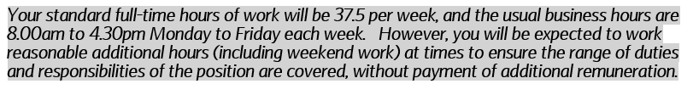
(Amcor, 2022f)
Compared to:
- Implied terms – are a set of default terms in contracts that are mandatory which operate in the background but doesn’t mean they aren’t enforceable. It means that some obligations exist between the parties irrespective of the express terms of the contract.
  - These come from a variety of sources i.e. duty of care, duty to pay, employee health and safety and collective agreements (Johnstone, 2019b).
The main differences between these two are
Express Terms | Implied Terms
The terms and conditions are spelled out in the contract, verbally or in writing | Are based on actions of these involved and can be unwritten.
Are agreed by both employer and employee when contract is drafted. | Is a term that have not been expressly agreed by either party
Is easier to enforce than an implied term because it is spelled out and more legally binding. | Are based on trust and confidence between the two parties.
Must comply with minimum legal standards. | Implied terms are legally binding but are as important as expressed terms.
(Johnstone, 2019b).

Other contractual terms
- Incorporated terms - are made up by the provision of other documents that are incorporated into the contract. If one document is referred to in another it is incorporated i.e. making reference to a scheme or policy (pension or sick pay), collective agreement or handbook (Johnstone, 2019f).

Here’s an example taken from an Amcor contract.
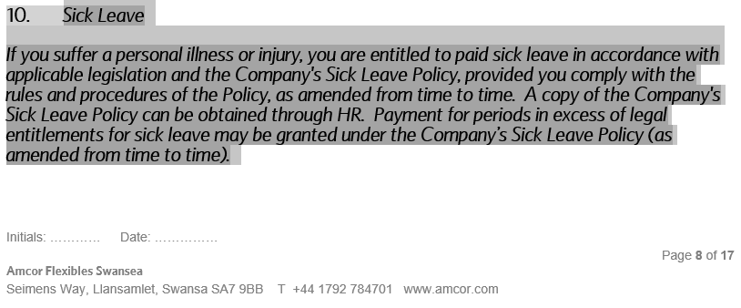

(Amcor, 2022f)

- Statutory terms – are terms in a contract that must follow law and cannot be signed away. E.g. statutory maternity leave and pay, statutory annual leave. Employers can enhance these rights but aren’t able to take any away. (Waite, 2021f, pp.134)

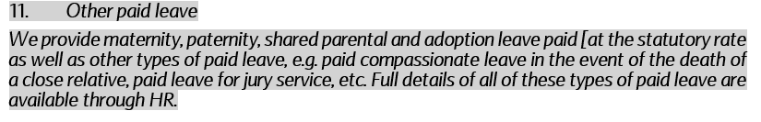
(Amcor, 2022f)

4.3 Explain the components and benefits of effective onboarding.

Onboarding is a comprehensive process of integrating new hires into the organisation and can be dealt with differently from one employer to another. It involves new employees completing an initial new hire orientation process where they learn about the companies’ structure, vision and mission. The benefit of an effective onboarding process can help lay down the foundation for long term success, improve their productivity, build loyalty and improve engagement, which helps the employees to become more successful earlier on in their employment, improving retention and reducing turnover (SHRM, 2021).

Amcor want to achieve a “Best-in-class” onboarding experience for all new starters and have recently relaunched a new On Boarding process to all its UK sites.



(Amcor, 2022g)
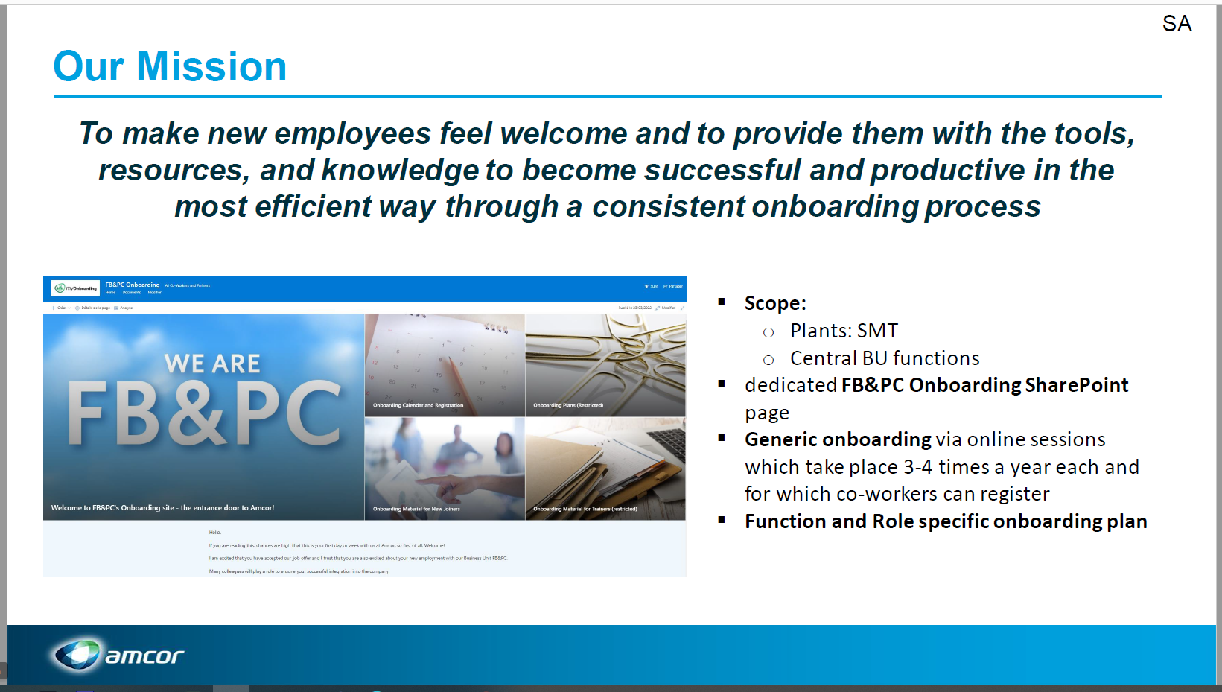

Effective onboarding plans offer an ideal opportunity to enhance employee engagement by creating a supportive relationship between the new employee and management, emphasizing the organisations commitment to helping new employees. This starts before their first day, with communications including correspondence of their contract of employment, offer letter and new starter documentation. It’s at this point the psychological contract is formed developing unwritten expectations between the employee and employer (Waite, 2021g, p.98)

The success of onboarding can be related to the quality of the induction provided by the organisation. Inductions help new starters learn more about the organisation and where they fit into it. It gives them the opportunity to be introduced to their colleagues, provide a knowledge of the health and safety requirements and other information required to perform their job (Waite, 2021g, p.98)

Example – Amcor New Start Induction Schedule.
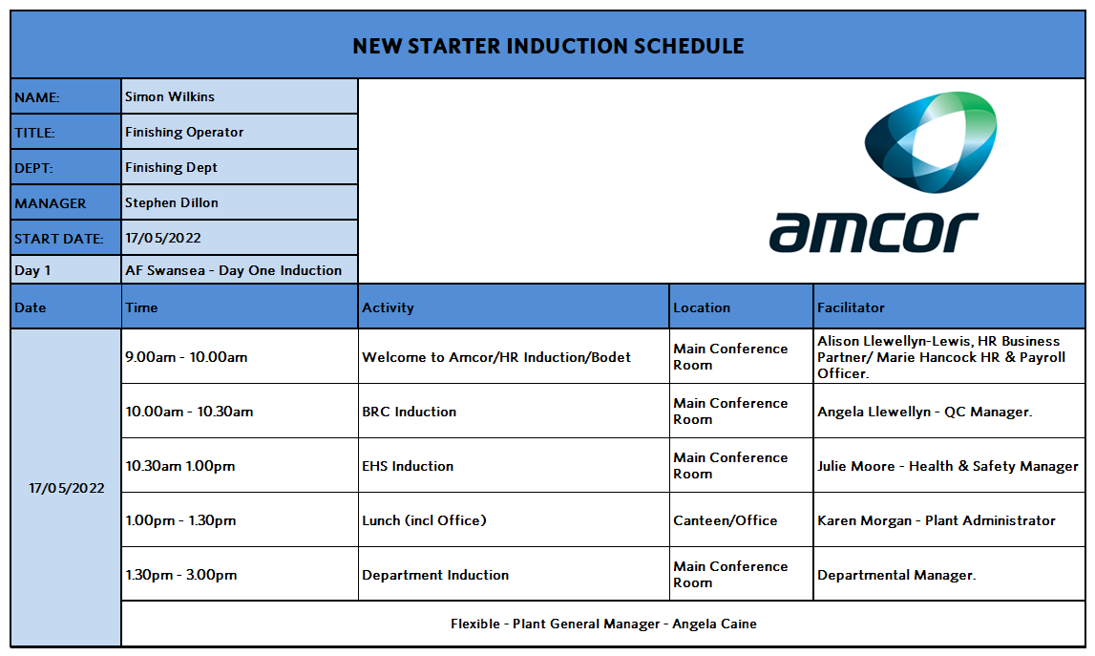

(Amcor, 2022h)

BIBLIOGRAPHY
- Acas (2019). What an employment contract is | Acas. [online] Acas.org.uk. Available at: https://www.acas.org.uk/what-an-employment-contract-is [Accessed 10 Jun. 2022].
- Amcor, (2022a), Code of Business Conduct and Ethics Policy.
- Amcor, (2022b), Succession Chart.
- Amcor, (2022c), Training Matrix.
- Amcor, (2022d), Recruitment Process Flow.
- Amcor, (2022e), Employee Engagement.
- Amcor, (2022f), Contract of employment.
- Amcor, (2022g), FB & PC Onboarding Presentation.
- Amcor, (2022h), Induction Schedule.
- Amcor. SharePoint, (2022), Diversity and Inclusion.
- Amcor.com. (2022). Amcor - Work with us. [online] Available at: https://www.amcor.com/work-with-us [Accessed 10 Jun. 2022].
- Atkinson, R. (2019). 5 Ways Technology Has Changed Recruitment. [online] www.linkedin.com. Available at: https://www.linkedin.com/pulse/5-ways-technology-has-changed-recruitment-ryan-atkinson/ [Accessed 11 Jun. 2022].
- CIPD (2020a). Employee Turnover & Retention | Factsheets. [online] CIPD. Available at: https://www.cipd.co.uk/knowledge/strategy/resourcing/turnover-retention-factsheet#gref [Accessed 22 May 2022].
- CIPD (2020c). Succession Planning | Factsheets. [online] CIPD. Available at: https://www.cipd.co.uk/knowledge/strategy/resourcing/succession-planning-factsheet#gref [Accessed 10 Jun. 2022].
- CIPD. (2021e). Selection Methods | Factsheets. [online] Available at: https://www.cipd.co.uk/knowledge/fundamentals/people/recruitment/selection-factsheet#7275 [Accessed 26 May 2022].
- CIPD (2021f). Talent Management Overview | Factsheets. [online] CIPD. Available at: https://www.cipd.co.uk/knowledge/strategy/resourcing/talent-factsheet#gref [Accessed 28 May 2022].
- CIPD. (2021b). Workforce Planning | Factsheets. [online] Available at: https://www.cipd.co.uk/knowledge/strategy/organisational-development/workforce-planning-factsheet#8043 [Accessed 27 May 2022].
- CIPD (2021d). Understanding Economy & Labour Market | Factsheets | CIPD. [online] CIPD. Available at: https://www.cipd.co.uk/knowledge/work/trends/economy-labour-market-factsheet [Accessed 10 Jun. 2022].
- CIPD. (2021g). Talent Management Overview | Factsheets. [online] Available at: https://www.cipd.co.uk/knowledge/strategy/resourcing/talent-factsheet#7241 [Accessed 8 Jun. 2022].
- Dondi, M., Klier, J., Panier, F. and Schubert, J. (2021). Future-citizen skills | McKinsey. [online] www.mckinsey.com. Available at: https://www.mckinsey.com/Industries/Public-and-Social-Sector/Our-Insights/Defining-the-skills-citizens-will-need-in-the-future-world-of-work [Accessed 10 Jun. 2022].
- ec.europa.eu. (2021). How COVID-19 has fundamentally changed recruitment. [online] Available at: https://ec.europa.eu/eures/public/how-covid-19-has-fundamentally-changed-recruitment-2021-10-13_en [Accessed 11 Jun. 2022].
- Fell, M. (2020). Diversity and inclusion in a post-COVID world. [online] CBI. Available at: https://www.cbi.org.uk/articles/diversity-and-inclusion-in-a-post-covid-world-1/ [Accessed 12 Jun. 2022].
- Fortune, D. (2019). Amcor Ltd Business Strategy | Free Management Resources. [online] Free Management Resources. Available at: https://freemanagementresources.com/amcor-ltd-business-strategy/ [Accessed 5 Jun. 2022].
- GOV.UK. (2021). Pioneering reforms to boost skills and jobs. [online] Available at: https://www.gov.uk/government/news/pioneering-reforms-to-boost-skills-and-jobs#:~:text=Boosting%20the%20quality%20and%20uptake [Accessed 10 Jun. 2022].
- Hibob. (2022). What is a talent pool? [online] Available at: https://www.hibob.com/hr-glossary/talent-pool/ [Accessed 28 May 2022].
- HR Magazine. (2021). HR Magazine - Diversity and inclusion: stretching both ends of the talent pipeline. [online] Available at: https://www.hrmagazine.co.uk/content/other/diversity-and-inclusion-stretching-both-ends-of-the-talent-pipeline [Accessed 28 May 2022].
- Johnstone, S. (2022). Determining employment status | Contracts of employment | Employment law manual | Tools | XpertHR.co.uk. [online] www.xperthr.co.uk. Available at: https://www.xperthr.co.uk/employment-law-manual/determining-employment-status/112417/?keywords=types+of+employment+status&searchrank=1 [Accessed 29 May 2022].
- Johnstone, S. (2022). Types of contract | Contracts of employment | Employment law manual | Tools | XpertHR.co.uk. [online] www.xperthr.co.uk. Available at: https://www.xperthr.co.uk/employment-law-manual/types-of-contract/20386/?keywords=types+of+contracts&searchrank=1 [Accessed 10 Jun. 2022].
- Johnstone, S. (2019b). Express and implied contract terms | Contracts of employment | Employment law manual | Tools | XpertHR.co.uk. [online] www.xperthr.co.uk. Available at: https://www.xperthr.co.uk/employment-law-manual/express-and-implied-contract-terms/20384/?keywords=express+implied+contract+terms&searchrank=1 [Accessed 4 Jun. 2022].
- www.mecpd.co.uk. (2022). Online CPD management system. [online] Available at: https://www.mecpd.co.uk/ [Accessed 12 Jun. 2022].
- Moss, T. (2021). Inclusion and diversity Report for 2020-2021. [online] Gov.uk. Available at: https://www.gov.uk/government/publications.
- National Apprenticeship and Education Event | Millennium Point Birmingham. (2022). The positive effect apprentices have on businesses ⋆ National Apprenticeship and Education Event | Millennium Point Birmingham. [online] Available at: https://nationalapprenticeshipevents.co.uk/questions-answered/the-positive-effect-apprentices-have-on-businesses/ [Accessed 13 Jun. 2022].
- Onoufriou, D. (2021). How to be an employer of choice in increasingly competitive labour markets. [online] www.linkedin.com. Available at: https://www.linkedin.com/pulse/how-employer-choice-increasingly-competitive-labour-demetra/ [Accessed 7 Jun. 2022].
- Ravichandran, S. (2019). 10 Reasons why employees want to stay in an organization. [online] www.linkedin.com. Available at: https://www.linkedin.com/pulse/10-reasons-why-employees-want-stay-organization-swathi-ravichandran/ [Accessed 10 Jun. 2022].
- Rigden, M. (2019). The Amcor Way - Talent. [online] Amcor. Available at: https://amcor.sharepoint.com/ [Accessed 10 Jun. 2022].
- Sage (2018). What is Recruitment? | Definition, Meaning, and Process | Sage Advice US. [online] Sage Advice US. Available at: https://www.sage.com/en-us/blog/glossary/what-is-recruitment/ [Accessed 10 Jun. 2022].
- SHRM (2021). Understanding Employee Onboarding. [online] SHRM. Available at: https://www.shrm.org/resourcesandtools/tools-and-samples/toolkits/pages/understanding-employee-onboarding.aspx [Accessed 4 Jun. 2022].
- skillsplatform (2021). The Benefits of Employer Branding – Examples and Strategies | Skills Platform Blog. [online] Skills Platform Blog | Learn Something New. Available at: https://www.skillsplatform.org/blog/the-benefits-of-employer-branding-examples-and-strategies/ [Accessed 10 Jun. 2022].
- Taylor, S. and Woodhams, C. (2016c). HUMAN RESOURCE MANAGEMENT : people and organisations. 2nd Edition ed. S.L.: Kogan Page, pp.53.
- Taylor, S. and Woodhams, C. (2016a). HUMAN RESOURCE MANAGEMENT : people and organisations. 2nd Edition ed. S.L.: Kogan Page, pp.54–55.
- Taylor, S. and Woodhams, C. (2016e). HUMAN RESOURCE MANAGEMENT : people and organisations. 2nd Edition ed. S.L.: Kogan Page, pp.59.
- Taylor, S. and Woodhams, C. (2016c). HUMAN RESOURCE MANAGEMENT : people and organisations. 2nd Edition ed. S.L.: Kogan Page, pp.58–59.
- Taylor, S. and Woodhams, C. (2016f). HUMAN RESOURCE MANAGEMENT : people and organisations. 2nd Edition ed. S.L.: Kogan Page, pp.60.
- Taylor, S. and Woodhams, C. (2016h). HUMAN RESOURCE MANAGEMENT : people and organisations. 2nd Edition ed. S.L.: Kogan Page, pp.60-61.
- Taylor, S. and Woodhams, C. (2016g). HUMAN RESOURCE MANAGEMENT : people and organisations. 2nd Edition ed. S.L.: Kogan Page, pp.69-70.
- Taylor, S. and Woodhams, C. (2016b). HUMAN RESOURCE MANAGEMENT : people and organisations. 2nd Edition ed. S.L.: Kogan Page, pp.110.
- TUC (2018). Learning and skills. [online] TUC. Available at: https://www.tuc.org.uk/resource/learning-and-skills [Accessed 12 Jun. 2022].
- Van Vulpen, E. (2018). 5 Essential Workforce Planning Tools for any HR professional. [online] AIHR. Available at: https://www.aihr.com/blog/strategic-workforce-planning-tools/ [Accessed 5 Jun. 2022].
- Waite, K. (2021a). People practice : a complete guide. London, United Kingdom ; New York, Ny: Kogan Page, p.107-108.
- Waite, K. (2021b). People practice : a complete guide. London, United Kingdom ; New York, Ny: Kogan Page, p.109.
- Waite, K. (2021c). People practice : a complete guide. London, United Kingdom ; New York, Ny: Kogan Page, pp.116-117.
- Waite, K. (2021d). People practice : a complete guide. London, United Kingdom ; New York, Ny: Kogan Page, p.101.
- Waite, K. (2021e). People practice : a complete guide. London, United Kingdom ; New York, Ny: Kogan Page, pp.102.
- Waite, K. (2021f). People practice : a complete guide. London, United Kingdom ; New York, Ny: Kogan Page, pp.134.
- Waite, K. (2021g). People practice : a complete guide. London, United Kingdom ; New York, Ny: Kogan Page, pp.98.
- Wessinger, M. (2017). Three benefits of a diverse talent pool. [online] www.linkedin.com. Available at: https://www.linkedin.com/pulse/three-benefits-diverse-talent-pool-mike-wessinger/ [Accessed 28 May 2022].
- Workify (2022). Dysfunctional Turnover: What it is, and How to Avoid it. [online] Workify. Available at: https://www.getworkify.com/blog/dysfunctional-turnover-what-it-is-how-to-avoid/ [Accessed 28 May 2022].

