

NAME: YEDUKONDALU VADLAMUDI
STUDENT ID : 2127061
MODULE: LCMB7001
PROFESSOR: TUSHARA BALENDRAN
COURSE: MASTERS IN BUSINESS ADMINISTRATION
SUBMISSION DATE: 08.09.2022
TITLE: MARKETING MANAGEMENT -1 (75%)
FILE NAME: 2127061-YEDUKONDALU VADLAMUDI-MM-1- LCMB7001

LCMB7001 MARKETING MANAGEMENT
ASSESSMENT-1
(BRITISH AMERICAN TOBACCO)


Executive summary
The report is based on improving he marketing communication and customer experience of British American Tobacco (BAT) for improving the brand equity. The Integrated Marketing Communication (IMC) model has been used for identifying the weakness in BAT’s communication strategy that relies on traditional channels mainly. The brand equity of BAT is analysed with the model proposed by Keller which suggests that brand equity of BAT is quite good. Analysis of the IMC strategy shows that manly traditional channel is used. Thus, recommendations for improving social media market from a social marketing principle is proposed along with connecting digital and physical touchpoints of the customer journey to improve the customer experience of BAT leading to an increase in brand loyalty.
Table of contents
Introduction 4
Background on BAT 4
Integrated Marketing communication 5
Current practices of BAT 7
Introduction of improved digital marketing communication 8
Social media 8
Website marketing 8
Direct marketing 8
Keller’s Brand Equity Model 9
Salience 10
Performance 10
Imagery 11
Judgements 11
Feelings 11
Resonance 12
Customer journey, experience, and touchpoints 12
Conclusion 15
Appendix 1: Positioning of BAT 19

Introduction
The marketing strategy of a brand plays a crucial role in determining the competitiveness in a market. Companies such as British American Tobacco (BAT) have a vast number of brands that are competing for a leadership position in the market. The presence of strong competitors in the British markets, the rising awareness of the consumers in the market, changes in the business environment and increasing expectations from the market are causes of significant challenges emerging in BAT. BAT was established in the year 1902 in London, the capital of the United Kingdom (Bat.com, 2022). The key competitors of the company are Imperial Brands, Japan Tobacco International, and Philip Morris International (Seekingalpha.com, 2022). The tobacco sector has been facing a significant number of challenges of late due to the increase in the regulations and policies set out by the British government to create the smoke-free UK by 2030 (Smokefreeaction.org.uk, 2022). Due to these external threats, tobacco companies must take the initiative of changing their marketing strategy and adopting a more ethical route to marketing. New product development, especially for reduced-risk products, also must increase since traditional tobacco products are both harmful to the health and the environment.

Background on BAT
The establishment of the British American Tobacco company was completed or the purpose of the marketing British tobacco products in the United States and alternatively, marketing American tobacco products in the United Kingdom (Bat.com, 2022). The company itself was formed due to the joint venture between the American Tobacco Company (US tobacco product manufacturer) and Imperial Tobacco Company (British tobacco products manufacturer). Mission statement of the company is focused on development of consumer’s experiences as well as reducing the health effect of their products.
BAT has acquired several important tobacco companies to expand their trade and export business. In 1905, BAT acquired the Egyptian tobacco products manufacturer based in Cairo named Maspero Freres Company. The American Tobacco Company divested the shares in BAT in the year 1912 and since then BAT has bene listed in the London Stock Exchange. The rapid growth and expansion of BAT saw it become the latest company in the UK by the year 1927 (Bat.com, 2022). Evidently the company saw a stellar rise in the profitability. Through the second world war and the great depression, the company’s profitability remained static at £ 5.5 million and even declined to £ 3 million. However, it was not long before the profitability of BAT exceeded £5.55 million 100 million by the year 1965 (Bat.com, 2022). The diversification into the food, cosmetics and the paper industry were also completed in four years leading up to 1965. By 1981, the tobacco operations itself drew profits of £ 463 million (Bat.com, 2022). Several important brands that were acquired by BAT during this time such as Allied Dunbar, Farmers Group, Eagle Star, and Hungary’s Pecsi Dohanygyar, Acquisition of Tekel, a global merger with Rothmans, acquisitions of Protabaco, UK’s CN-Creative, joint venture with the China National Tobacco Corporation and the complete acquisition of Reynolds American Incorporated are among the most important acquisitions that the company has made in the last three decades (Bat.com, 2022).

Integrated Marketing communication
The fundamental modes of communication involve a sender, a receiver, and a communication channel. The Shannon & Weaver model of communication proposes that there are five elements that are critical to any communication system apart from the ones that have been mentioned, the transmitter and the reception are added to show that the transmitting device is an artificial piece of equipment (Kubota, 2019). Obviously, the Shannion & Waever model is relevant to communication in the modern digitalised world where organisations are extremely adept at communicating to their customers through the digital medium (Kubota, 2019). In this case, the servers that host the webpages might be referred to as the transmitters and the access point or the personal computer of the customer might be referred to as the receiver.
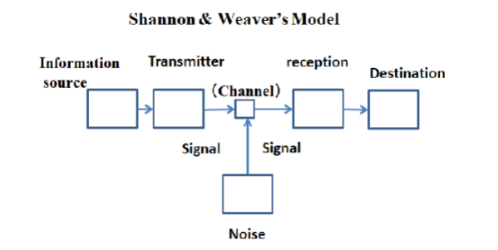
Figure 1: Shannon & Weaver model of communication
(Source: Kubota, 2019)
The communication media evolves as human beings evolve from an infant to an adult. The development of communication media model shown below proposes that the use of communication media evolve from expressions, postures, voice to gestures, and then to sign language however, these communication types are based on the anthropological features in the human body. Further revolution has led to the use of code such as morse and computer to communicate. Thus, as the human beings have evolved, the communication medium also changed.
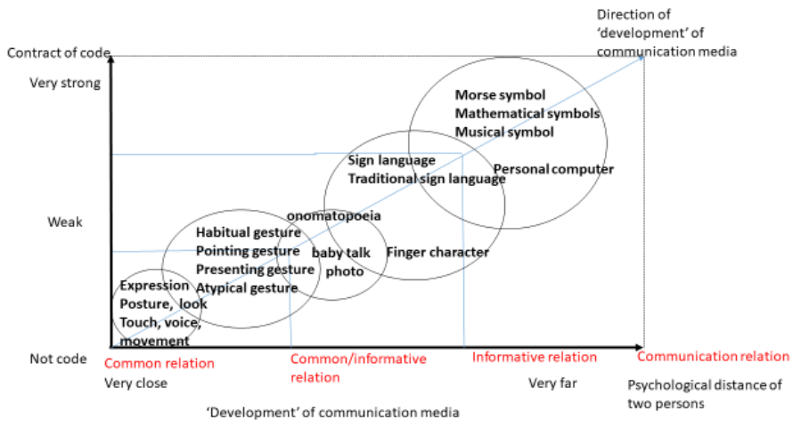
Figure 2: Evolution of communication media
(Source: Kubota, 2019)
Kushwaha et al. (2020) define IMC or Integrated Marketing Communication as "a strategic process to choose, develop, execute, evaluate, and coordinate with all the stakeholders of an organisation for a given period of time." IMC is used by marketers for increasing the value of a product, increasing the market share, the competitiveness of the brand and brand equity. IMC has gained immense popularity among markets because of the use of the tool to satisfy a varying number of objectives such as event marketing, targeting mass consumers, payment methods, accountability of media, social networking, and direct email (Kushwaha et al. 2020). The advancement of technology is greatly accelerating the popularity of the IMC channels. Presently, the channels that are most widely used in IMC are sales promotion, advertising, public relations, and direct marketing (Kushwaha et al. 2020). The introduction of new channels such as social media and digital media marketing forms the modern IMC. The digital marketing channel helps to both communicate helpful information to the customers and analyse the behaviour of the customer segments. On the other hand, social media channels help to improve customer engagement and share information with the customer through a shared community of users (Kushwaha et al. 2020). With the popularity of traditional marketing communication channels diminishing over the last few years, digital media and social media channels have become more prevalent in this respect. It is thought that social media might occupy as much as 26.9% of all marketing communication activity in 2020 (Kushwaha et al. 2020). IMC is specifically useful for increasing long-term healthy relationships with the customer. IMC can therefore help BAT to overcome the enormous competition, advertising cost, flattening demand, and efficiency of marketing overheads.

Figure 3: Integrated Marketing communication Model
(Source: Influenced by Kushwaha et al. 2020)

Current practices of BAT
The current practices of BAT in implementing the IMC can be observed to be significantly reliant on the traditional marketing channels. Through traditional marketing communication channels such as television, newspaper, billboards and in-store promotions, BAT has maintained their competitiveness in the market (Bat.com, 2022). The company uses digital media channels, social media, and direct marketing sparsely. This means that BAT has a significant amount of potential for improving the activities of the brands in the digital media marketing channels. Although digital marketing channels have significant potential for improving brand awareness and brand equity, BAT continues to rely mainly on traditional marketing channels. However, the option of purchasing online remains completely shut for buyers in the UK because the legislation in the UK prohibits both the promotion and selling of tobacco products online (Forestonlinee.org, 2022). This also extends to e-cigarettes which have a considerably lower potential for causing harm to the human body.

Introduction of improved digital marketing communication

Social media
The application of the modern IMC to BAT will see the use of digital media channels to a much greater extent. To improve brand awareness and brand equity, BAT must enhance the presence of the brands on digital media platforms (Tan and Bigman, 2020). The company must specifically use social media platforms to improve brand awareness. Social marketing is a kind of marketing that tobacco companies must practise in the coming years because it is related to increasing consumer awareness of the brand's social and environmental initiatives. With the uncertainty looming over the future of the tobacco industry, it is necessary for tobacco companies to ensure that the customers on social media can receive news and updates regarding the sustainability of the brand (Tan and Bigman, 2020). The innovations taking place in the company and information on new category products are evidently high on the list of priorities for BAT. However, British regulations and laws ban the advertising of any kind of tobacco products, and therefore it is not advisable to share content that is directly related to the product element of the marketing mix (Forestonline.org, 2022). Through social media, BAT must try to enhance the company's brand equity by engaging more consumers and increasing their awareness of the reduced-risk products that BAT have launched in the market.

Website marketing
BAT can also explore the strategy of communicating brand-related communication through their website. Although BAT brands are not legally allowed to sell their products through the website, BAT can share all kinds of information with the customer related to the activities of their brands on the website (Forestonline.org, 2022). BAT also has the legal right to publish product-related information on the website, which makes it possible for the brand to make the most of the opportunity.

Direct marketing
As the website is not the ideal place for BAT to sell products, the company can use the direct marketing strategy to suggest to target users based on the user's browsing history or a quick online survey to find out the interests of the user or the frequency of smoking. BAT's strategy is to redirect traditional smokers toward reduced-risk products (Fang et al. 2020). However, the people who are daily addicts and smoke over a pack of regular cigarettes are the ones whom BAT must target at the beginning. BAT can use the direct marketing strategy to message or email the customer through the contact information that they have provided to suggest alternative products. In this way, BAT can also act as the counsellors of the customers. BAT will increase brand awareness not only this way but also brand salience, which is another crucial element of brand equity.

Keller’s Brand Equity Model
The brand is a reputational asset, that has developed with time to embody certain value and/or a set of attributes, resulting in a set of beliefs that are powerfully held by a range of stakeholders including the customer. A brand is not simply a logo, a name, or a corporate identify (Britishbrandsgroup.org, 2022). Instead, a brand is a mark of quality, trust and consistency that makes it one of the most valuable yet intangible assets possessed by a company. A brand might develop sub consciously with the development of the customer’s knowledge and feelings about a product. Recognisability, familiarity, uniqueness, reassurance, and inspirational are some of the feelings that a brand can evoke (Britishbrandsgroup.org, 2022). Brands are also not static and they have to change with time, with the needs of the customer. Thus, continuous innovation is a necessity for developing and maintaining brands (Britishbrandsgroup.org, 2022). The accountability, responsibility and social practices of the brand are developed for the purpose of building brand equity.
The brand equity model proposed by Keller describes brand equity in terms of four elements; identity, meaning, response, and relationships (Kushwaha et al. 2020). In Keller's brand equity theory, there are six sections on the pyramid. The meaning and response are divided into two sections. Meaning is divided into performance and imagery. Response is divided into judgements and feelings. Although Keller’s model is widely used for determining the brand equity, there are other models such as the one proposed by Aaker that suggest that brand equity is determined by brand awareness, perceived quality, brand association and brand loyalty (Quan et al. 2020). Or an online business, the factors of e-satisfaction, e-loyalty and e-brand experience also plays a certain role in influencing customer’s purchase intention (Quan et al. 2020).

Figure 4: Keller's Brand equity model
(Source: Influenceed by Kushwaha et al. 2020)

Salience
Salience is a quality that determines the identity of the brand and the awareness that customers possess about the brand (Kushwaha et al. 2020). The reduced-risk products of BAT and the marketing principles of BAT have a positive influence on brand salience. BAT's marketing strategy is dependent on responsible, transparent, accurate, compliant, and targeted messages that are meant to convince the customers to recognise the importance of shifting from combustible cigarette consumption to reduced-risk products (Bat.com, 2022). BAT's websites contain information on the features of the reduced-risk branded products and thus help to further the brand salience. Additionally, the social media pages of BAT contain information on the sustainability initiatives taken by the brands, further promoting the brand's efforts to the millions of customers that are present on social media sites.

Performance
The performance of BAT has been the best in North America, where the company collected over US$ 16.09 billion in 2021 within the total revenue collections of US$ 35.34 billion from the global operations of BAT (Statista.com, 2022). BAT is the world's largest tobacco company based on the net sales
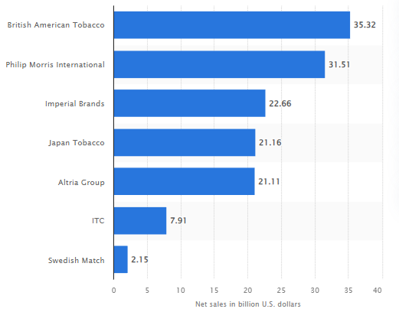
Figure 5: Largest tobacco companies in the world based on net sales
(Source: Statista.com, 2022)

Imagery
The imagery used by BAT brands does not use representations of people and is made in an ethical manner so that customers are not tricked into buying the product thinking that it is something that it is not (Bat.com, 2022). The use of imagery is therefore restricted, and mainly text is used as the brand logo and the imagery used on the websites.

Judgements
BAT is one of the largest tobacco companies in the world. The company has been at the forefront of innovation in the industry and provides reduced-risk products through three different brands. BAT is also committed to becoming net zero by 2040, and the company has numerous initiatives for protecting labour rights and practices of the suppliers to ensure the sustainability of the company (Bat.com, 2022). The judgments of consumers about the brand are therefore expected to be positive as the company does take numerous initiatives to satisfy the stakeholders of the organisation.

Feelings
The feelings that customers possess about the brands of BAT are influenced by their marketing and product quality. BAT takes extensive measures for ethically promoting the brands and ensures that customers are rewarded with new flavours through their innovative activities and research. BAT also takes the initiative of using data-driven technologies for decision-making and improving the customer centricity of the business (Bat.com, 2022). Therefore, the initiatives taken by the company to meet the ever-increasing demand of the customers in the various markets are formidable. Although BAT also has certain limitations in their new categories compared to traditional brands, the company is working on increasing the number of brands in the new categories.

Resonance
The BAT brands resonate with the consumer's feelings, as described before, and the data-driven insights that inform decision-making make it easier for BAT to improve the resonance of the brand with the customer. BAT has also been one of the first companies to introduce brands that are dedicated to reduced-risk products into the market (Bat.com, 2022). Hence, it is evident that BAT has a good egress of brand resonance with the customer.

Customer journey, experience, and touchpoints
The role of the customer journey in the tobacco industry is not well studied. The customer journey and experience have been found by researchers to have a significant influence on customer loyalty. The term customer journey itself has had several different interpretations, such as "interconnected contact points, "user interaction with service, "experience service interfaces along the time axis", and more (Mulyono and Situmorang, 2018). The customer journey can be defined as "customer interactions with one or more service providers to achieve a particular goal." The analysis of a customer journey provides the researcher with information on how customers might interact with a sequence of touchpoints. The goal of analysing a customer journey is to understand the choices that customers have for any number of touchpoints present in multiple phases of the customer journey (Mulyono and Situmorang, 2018). The customer experience derives from the fact that customers get involved and participate in the interactions during the touchpoints. It is this interaction and engagement that results in customers experiencing trust or feelings. According to Mulyono and Situmorang (2018), a customer experience can be composed of sensory, affective, cognitive, spiritual, social and physical elements.
Stage | Awareness | Consideration | Purchase | Onboarding | Advocacy
Customer goals | Gather information on the brands and the products of BAT | Evaluate the products of BAT with others that are available in the market | Buying can only take place through physical retailers | Customers went for additional information on how to best use the product | Sharing the experience with the other members of the community
Benefits | Customers might be looking for traditional or new category products | Price, reduced harm, accessibility of the site of sales | Retailer suggests the most suitable product after surveying the customer | Customers want to use the product in a way that was intended for it | Contribute to the growing community of reduced-risk product uses
Success factor | The customer received sufficient information regarding the product characteristics and also the company's initiatives. | All information is found relatively quickly without the customer having to spend an enormous amount of time searching the internet. | After going to the location where the chosen product is likely to be available customer receives the product with a small discount. | Customer receives support and additional information on the website of BAT brands. | A group that has a large number of members who have had similar experiences
Pain points | Customers might not know where to look or may not find any relevant information. | High prices, lack of options, lack of reduced risk alternatives, lack of accessible locations | Unavailable product, location is too far. | No usage characteristics and information on increasing the life of the product are available. | Inability to communicate due to barriers of language or other cultural differences
Emotions | Positive | Neutral | Negative | Neutral | Positive
Data | Brands, product types, a technology used in the products, key characteristics | Pricing information, product features | Address of the retail location where the product is sold | Reviews of previous customers | Personal experiences of the customers
Channel | Website | Website BAT brands and competitors | Physical channels | Social media | Social media
Table 1: Customer journey map of BAT
The customer journey map shows that BAT can use different communication channels for promoting and engaging customers. The website of BAT that uses SEO has a good scope for promoting the brands (Bat.com, 2022). The websites contain the links to brand websites that intern contain the functionalities of store locators. On the other hand, social media channels can be used to engage the customers and provide a forum where customers can share their experiences of using the products of BAT. The idea that BAT can use the website to point toward physical store locations has been explored by BAT previously also. BAT's marketing campaign in Poland and Belgium at an earlier time involved indirectly pointing towards physical stores or sites where the products from their various brands are sold (Tobaccocontrol.bmj.com, 2022). Tobacco companies have in the past been known for bending the rules on some occasions and taking advantage of loopholes in the law to market their products. BAT is no different. According to a particular report, BAT has been known to secretly market their tobacco products to teenagers by promoting sites where the products manufactured by BAT branded products are sold (Tobaccocontrol.bmj.com, 2022). The laws in the UK are much too strong and have been changed numerous times to prevent tobacco marketers from marketing products to children. However, the strategy can also be used to target adult smokers who are looking to switch toward reduced-risk products.
The total engagement model has proposed that customers and employees both must be engaged for the organisation to delver the customer value proposition. The organisation influenced the employees through the organisational culture and the customers through the advertising practices of the brand. BAT’s organisational culture is built on strong values of ethics, compliance, responsibility, accountability, and transparency. Thus, based on these principles, BAT’s workforce will develop products and sell them in ethical and compliant manner to ensure that the customers receive a unique customer experience. The ethical marketing principles of BAT will ensure that marketing activities cater to the demands of the customers.
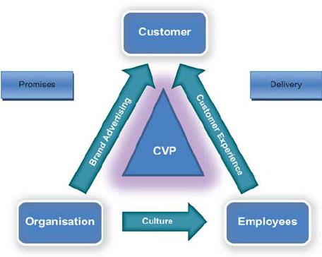
Figure 6: Total customer engagement
(Source: Roberts and Alpert, 2010)

Conclusion
The report is successful in identifying the limitations in the communication strategy of BAT and highlights some of the areas where the brand needs to take some form of initiative to improve the communication with the customer. BAT engaged customers through the social media channel but only in a limited way. To ensure better customer engagement, BAT must explore a wide range of options when it comes to gaining information on the behaviour of the consumer. Determining consumer behaviour can improve the decision-making and innovation activities of BAT, thus improving brand resonance and responses. BAT needs to provide information to consumers on the websites of the brands so that they can make purchase decisions. The physical retail stores are a crucial part of BAT's customer journey, and therefore, stores of vuse and vape have to be organised to ensure that all customer records are adequately maintained, and it is possible to ensure that customer experiences are solid. The external environment analysis shows that there are numerous challenges faced by BAT, such as the legislation that bans commercials and advertisements of tobacco products on any form of media. Environmental concerns and political pressures are also huge. Within the industry, consumer demands and competitive rivalry are vital forces that are causing BAT to change their marketing strategy.
Reference List
Bat.com, (2022). History. Available at https://www.bat.com/history, [Accessed 25.08.2022].
Bat.com, (2022). How digital is driving our transformation. Available at https://www.bat.com/group/sites/UK__9D9KCY.nsf/vwPagesWebLive/DOBUVKYJ, [Accessed 21.08.2022].
Bat.com, (2022). Marketing our products responsibly. Available at https://www.bat.com/imp, [Accessed 21.08.2022].
Bat.com, (2022). Our portfolio. Available at https://www.bat.com/group/sites/UK__9D9KCY.nsf/vwPagesWebLive/DOAWUGEB, [Accessed 21.08.2022].
Fang, J., Yang, G. and Wan, X., (2020). ‘Pro-tobacco propaganda’: a case study of tobacco industry-sponsored elementary schools in China. Tobacco control, 29(4), pp.447-451.
Forestonline.org, (2022). Internet cigarettes. Available at https://www.forestonline.org/info-bank/internet-cigarettes/, [Accessed 21.08.2022].
Kubota, M., (2019). What is “Communication”?―Beyond the Shannon & Weaver’s Model―. International Journal, 13(1), pp.54-65.
Kushwaha, B.P., Singh, R.K., Varghese, N. and Singh, V.N., (2020). Integrating social media and digital media as new elements of integrated marketing communication for creating brand equity. Journal of Content, Community & Communication, 11(6), pp.52-64.
Laki, M., (2015). Restructuring and re-regulation of the Hungarian tobacco market. Corvinus Journal of Sociology and Social Policy, 6(2), pp.39-71.
Legislation.gov.uk, (2022). The Tobacco and Relate Products regulations 2016. Available at https://www.legislation.gov.uk/uksi/2016/507/contents/made, [Accessed 21.08.2022].
Mulyono, H. and Situmorang, S.H., (2018). E-CRM and loyalty: A mediation Effect of Customer Experience and satisfaction in online transportation of Indonesia. Academic journal of Economic studies, 4(3), pp.96-105.
Politics.co.uk, (2022). Tobacco advertising. Available at https://www.politics.co.uk/reference/tobacco-advertising/, [Accessed 21.08.2022].
Quan, N., Chi, N.T.K.C., Nhung, D., Ngan, N. and Phong, L., (2020). The influence of website brand equity, e-brand experience on e-loyalty: The mediating role of e-satisfaction. Management Science Letters, 10(1), pp.63-76.
Roberts, C. and Alpert, F., (2010). Total customer engagement: designing and aligning key strategic elements to achieve growth. Journal of Product & Brand Management, 19(3), pp.1-12.
Seekingalpha.com, (2022). British American Tobacco: Batting for a lucky strike. Available at https://seekingalpha.com/article/4443084-british-american-tobacco-batting-for-a-lucky-strike, [Accessed 21.08.2022].
Smokefreeaction.org.uk, (2022). Together we can achieve a Smokefree 2030. Available at https://smokefreeaction.org.uk/smokefree2030/, [Accessed 21.08.2022].
Statista.com, (2022). British American Tobacco – Statistics & facts. Available at https://www.statista.com/topics/7144/british-american-tobacco/#dossierContents__outerWrapper, [Accessed 21.08.2022].
Statista.com, (2022). Leading tobacco companies worldwide in 2021 based on net sales. Available at https://www.statista.com/statistics/259204/leading-10-tobacco-companies-worldwide-based-on-net-sales/, [Accessed 21.08.2022].
Stukalina, Y. and Pavlyuk, D., (2021). Using customer-based brand equity model in the higher education context: simulating the current university’s brand. Business, Management and Economics Engineering, 19(2), pp.272-288.
Tan, A.S. and Bigman, C.A., (2020). Misinformation about commercial tobacco products on social media—Implications and research opportunities for reducing tobacco-related health disparities. American journal of public health, 110(S3), pp.S281-S283.
Tobaccocontrol.bmj.com, (2022). BAT’s internet marketing plan. Available at https://tobaccocontrol.bmj.com/content/tobaccocontrol/10/2/91.2.full.pdf, [Accessed 21.08.2022].

Appendices

Appendix 1: Positioning of BAT
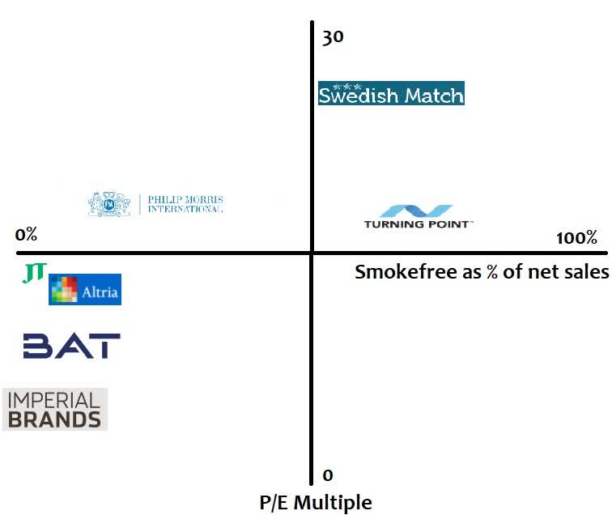
(Source: https://static.seekingalpha.com/uploads/2021/7/29/saupload_gc44vVDOBne3GwNEl4Qe7QnxLoETeUmojCU2QxysRvA6PMLk72dQMB0jjJhzS-O06tyrZi4sLLC4m81T0k9Qzpel_dys9nyCER8MzFftvR28T0qicKZMRHI5SvywLdcmZMrkuFaF.jpeg)

