Personal Development Plan
What do I know already / What have I learnt so far?
I have achieved grades being between B and D in my GCSE’s. I have fulfilled my level 3 apprenticeship and gained a great knowledge of children’s development. I have completed numeral courses with work such as safeguarding level 2, fire warden training, well coms and attention autism and many more.
What do I want to develop?
I want to develop my safeguarding and complete my level 3 safeguarding so I can make sure every child is safeguarded in the correct way. I want to continue developing my understand to a Childs development to help me in the future. My last thing I want to develop is my digital skills by the end of my year one in university.
Objective | Actions (How will I achieve this objective/ what needs to be done?) | Resources (What support and resources are needed to achieve this objective?) | Target Date for achieving objective. | Success criteria (How will I know I have achieved this goal; how will I review this?)
I want to complete my level 3 safeguarding unit. | I will need to look for a level 3 safeguarding course to be able to join and sign up to complete the course. I would like to complete this by January 2024. | In work my management will support me with my learning, and I may need my laptop to help me complete any units. Also, I will need a notebook and paper to write any notes down. | By January 2024. | I will have a certificate to show I have completed the course.
I want to complete my degree in early years childcare. | I will turn up to all of my lectures to be able to pass all the assignments, if I need some help, I will find the help. I would like to complete the degree by July 2025. | My managers and staff will support me through my time in university and I will need a notebook and pens to write notes down for my assignments and I will need my laptop to do anything digital for the assignments. | By July 2025. | I will have a certificate and I would officially graduate.
I want to gain more confidence within my work practice. | I will ask my staff members to give me feedback within my role and ask my management team to support me in different ways to achieve my role. | My managers will give me regular feedback and support me with my own confidence development, and I will need to attend different training to ensure I am up to date with the children’s development. | By January 2024. | My staff and parent feedback and advisory teachers will give me feedback for my staff file.
460
Reflection and Reflective Practice
Reflection:  As suggested by Nottingham (no date), reflection involves learning from experience, considering action and recognising an event from a new perspective. According to HCPC (2021) thinking critically about any part of your professional practice during the reflection phase may help you develop insight to it. Similarly, Brock (2015) demonstrates professionals hold reflection and reflective practice in Hugh regard and they play a major part in professional development.  Reflective practice  According to Cambridge (no date) learning via and from experience in order to obtain fresh perspectives on yourself and your work is recognised as reflective practice. | Importance of reflective practice to an early year's practitioner:  According to the Gunning.C (2022) it is critical to reflect on our practice as a means of developing and bettering ourselves. When we collect insights and learn from our ideas, we can become more proficient practitioners. Similarly, Birth to five matters (no date) suggests a reflective practitioner will reflect on their work, analysing what performed well and what didn’t in terms of planning, activities and the learning environment.
The theory of reflective practise:
Schon (2016) believes the reflective practitioner gives themselves permission to feel shocked, perplexed or confused in an unfamiliar or unique scenario. They will take into account the occurrence in view oof them as well as the past knowledge that has guided their actions directly. They conduct an experiment which results in an alteration of the circumstances as well as an entirely newer perspective of the occurrence. Schon has 2 theories of reflective practice, these being reflecting in action meaning reflecting as something happens and reflecting on action meaning reflecting after something happens.
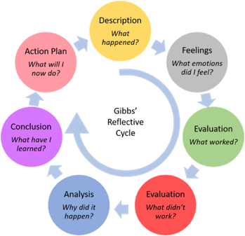  Graham Gibbs (1988) | 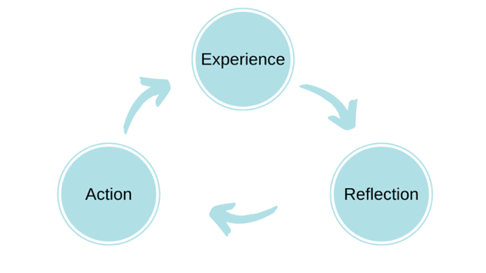  ERA cycle
Compare
Both Gibbs and the ERA cycles both reflect on their practice however Gibbs is more in depth. Gibbs (1988) reflective cycle is similar to Kobl’s learning cycle and provides a structure for a reflective essay. An essay or a learning log entry with a reflective writing style may be divided into six section or paragraphs this being in the first box above. The Open university (2014) suggests that since this approach makes absence of critical thinking, analysis or reflection. Also, The open university (2014) say that it doesn’t explicitly suggest that the learning will lead to a change in assumptions, viewpoints or practice. It additionally doesn’t address any preconceptions you may have about the experience or the necessity of looking objectivity at many points of views. However, ERA (2013) experience, reflection and action comprise the acronym ERA. Developed by Jasper (2013), this is a straightforward approach and is predictive on constructing knowledge through experience. Action is crucial because it transfers learning from introspection to subsequent encounters.
Conclusion
In conclusion, the three pillars of the ERA approach are experience, reflection and action. The reflective cycle Gibbs (1988), on the other hand, consists of six unique stages that go from describing the experience or event to come to a conclusion and making plans for the subsequent ones. 495

Introduction:

Values
Communication and relationship
Multi agency workers
Observation
Planning
UNCRC

Conclusion

Reference list:
Birth to five matters (no date) Learning and development observation, assessment and planning. Available at: https://birthto5matters.org.uk/wp-content/uploads/2021/03/PDF-20-Professional-Reflective-Practice-1-1.pdf (Accessed: 22nd October 2023).
Brock, A. (2015) the early years reflective practice handbook. London: Routledge.
Cambridge (no date) Getting started with reflective practice. Available at: https://www.cambridge-community.org.uk/professional-development/gswrp/index.html (Accessed: 22nd October 2023).
Gunning. C (2022) Why reflective practice important. Available at: https://early-education.org.uk/reflective-practice/#:~:text=Why%20reflective%20is%20practice%20important,built%20through%20processing%20and%20reflecting. (Accessed: 22nd October 2023).
HCPC (2021) What is reflection? Available at: https://www.hcpc-uk.org/standards/meeting-our-standards/reflective-practice/what-is-reflection/ (Accessed: 22nd October 2023).
Nottingham (no date) Reflection: Summary. Available at: https://www.nottingham.ac.uk/nmp/sonet/rlos/placs/critical_reflection/origins/reflection_summary.html (Accessed: 21st October 2023).
Schon, D. (2016) The reflective practitioner: how professionals thin in action. England: Routledge.
University of Hull (2023) Reflective writing: Gibbs. Available at: https://libguides.hull.ac.uk/reflectivewriting/gibbs (Accessed: 29th October 2023)
University of Hull (2023) Reflective writing: ERA. Available at: https://libguides.hull.ac.uk/reflectivewriting/era (Accessed: 29th October 2023)

