

Undergraduate Dissertation coversheet & feedback form

PLEASE COMPLETE THE TOP SECTION OF THIS FORM AND SUBMIT ONE COPY WITH YOUR DISSERTATION
For completion by student: Hannah Thompson
Student Name: Hannah Thompson

Student University Email: 1500884@student.uwtsd.ac.uk

Module code:  AHSK6002 | Student ID number:  1500884 |  |  |  | Educational support needs:  Yes
Dissertation title:
Are We What We Eat: The Paradox Of Relating While Consuming The Self
Supervisor: Emma-Jayne Abbots |  |  | Word count:  11580
I confirm that this is my original work and that I have adhered to the University policy on plagiarism.
Signed …………………………………………………………
For completion by the first marker:
Comments:

First Marker’s Mark:  Signature: |  |  |  | Date:
For completion by the second marker (if appropriate):

Comments:

Second Marker’s Mark:  Signature: |  | Date:
NB. All marks are provisional until confirmed by the final examination board.

For completion by the External Examiner:

Comments:

Proposed Mark:

Signature of External Examiner:

Final Agreed Mark:

Are We What We Eat: The Paradox Of Relating While Consuming The Self

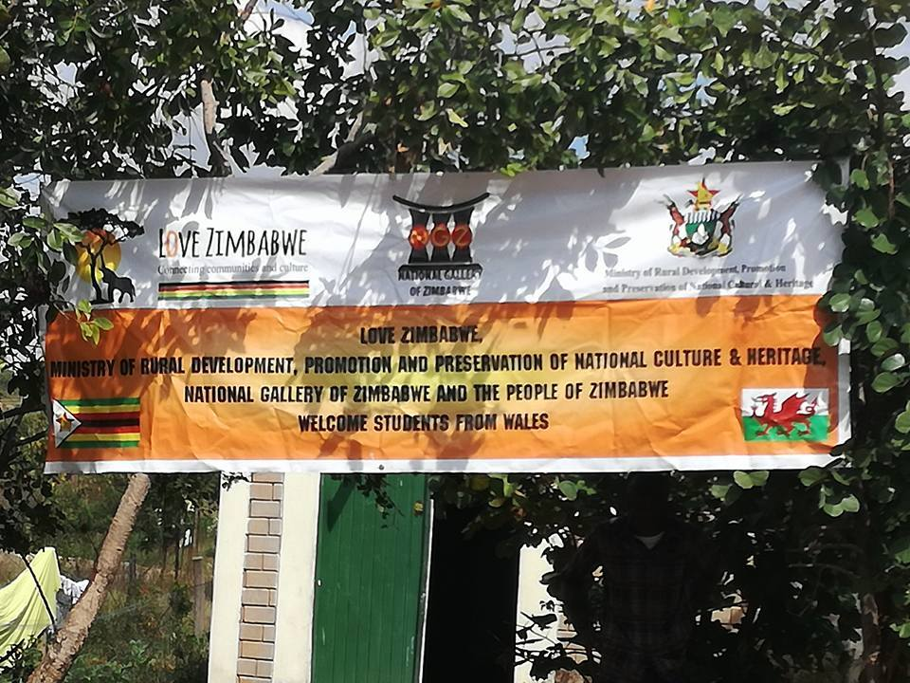
Figure 1

Hannah Thompson
Dissertation submitted in partial fulfillment of a B.A. (Hons.) in Applied Anthropology
University of Wales Trinity Saint David May 2018

Abstract

Food is an amazing element in every culture and like a diamond possess many different facets that have not all been outlined in this dissertation. Food in anthropology can never simply be understood as food. This dissertation will be focusing on a paradox of how food can be used to create bonds with the people you are with by both making and preparing food or by eating food together. However, food is also very important in ones constructed ideas about themselves and their culture. Therefore the aim of this dissertation is to examine this paradox of food and evaluate how it can simultaneously create bonds whilst also creating your identity.

Table of Contents

Undergraduate Dissertation coversheet & feedback form 1
PLEASE COMPLETE THE TOP SECTION OF THIS FORM AND SUBMIT ONE COPY WITH YOUR DISSERTATION 1
Are We What We Eat: The Paradox Of Relating While Consuming The Self 4
Abstract 5
Table of Contents 6
List of Figures 7
Acknowledgments 8
Introduction 9
Introduction to the study community 10
Methodology 12
Chapter One: The Fruit Of Knowledge 17
Chapter Two: Two Peas In A Pod 25
Chapter Three: Food For Thought 32
Conclusion 39
References 43

List of Figures

Figure | Reference | Page
1 | Thompson, H. 2017.  Banner at community center open day  [photograph] (Chinamhora, Zimbabwe: Author’s own private dissertation collection)
2 | Thompson, H. 2017.  View over Chinamhora, [photograph] (Chinamhora, Zimbabwe: Author’s own private dissertation collection)
3 | Thompson, H. 2017.  Goat slaughter [photograph] (Chinamhora, Zimbabwe: Author’s own private dissertation collection)
4 | Thompson, H. 2017.  Chicken slaughter [photograph] (Chinamhora, Zimbabwe: Author’s own private dissertation collection)
5 | Thompson, H. 2017.  Making sadza in traditional hut [photograph] (Chinamhora, Zimbabwe: Author’s own private dissertation collection)

Acknowledgments

Many various people have extensively supported me emotionally throughout the process of writing my dissertation, such as my friends and family who have always been there for me during my most doubting moments and have encouraged me to pursue the till the very end.
I would like to formally show my thanks to my dissertation supervisor, Dr Emma-Jayne Abbots, Lecturer in Social Anthropology as well as many of my other lecturers, such as Luci Attala, Senior Lecturer in Social Anthropology and Eloise Govier, Lecturer in Anthropology, who have all offered me support and guidance throughout the writing process. Moreover, the help from both of my support workers Annwen Williams and Kim Eames has been essential to me. They have given me emotional and academic support throughout my time at university and especially during my dissertation. Helping me to learn more about myself and to conquer some of my learning difficulties.
Moreover, I can not express my eternal thanks to the University of Wales Trinity Saint David along with the founders of the Love Zimbabwe Charity who gave me the opportunity to visit Zimbabwe on two separate occasions. I would also like to give thanks to the community in Zimbabwe who have allowed me to experience so much and who have facilitated my research and guided me through it. This project would not have been completed without out them and I can not express how deeply I was affected by their generosity and kindness during my time there, as well as their continuous help after I left through electronic messages. I hope to see them all again soon, maita basa (thank you) to all.

Introduction

Over the course of this dissertation I will be outlining and exploring a paradox entailing how food can be used in the creation of social bonds by participating in activities surrounding food and by the consumption of food, however, food can at the same time create distance and separation between people if used in that manner. Furthermore, when considering food from an anthropological standpoint, it must be recognised that it has the power to create bonds, exile people, and influence the identities of the people consuming them.
In the discussions throughout part one, The Fruit Of Knowledge, I will be showing how my participation in cooking and preparing food with participants affected my relationship with them, and additionally my own relationship with food and myself.
The second part, Two Peas In A Pod, will be assessing how eating together can create bonds. For this, we will be looking at Janet Carsten’s notions surrounding relatedness, followed by Marcel Mauss’s gift exchange theory and hospitality along with African philosophies of ubuntu/hunhu. By looking at these I will be demonstrating how each of these qualities surrounding food cultures is brought, through the action of eating, a sense of closeness with the people around you. Conversely, final part will be examining the opposite, how with the creation and consumption of different types of food one can find a distance between individuals on a class basis, referencing ideas from Jack Goody and Sidney W. Mintz.
In the last and final section, Food For Thought, I will be looking at how food can create identity and culture. By examining primarily women’s relationships with food as well as the formation of status and identity through the quality of food along with my experience of it. Following this, I will be investigating why we have this connection with cultural food, how it makes us feel, and why we are so attached to it that looking at examples from the internet become a habit/ memory.

Introduction to the study community

Location
My fieldwork took place in a village called Chinamhora, in the Mashonaland East district of Zimbabwe. While there I was working with the Love Zimbabwe charity and help carry out many different projects such as building a library for the community center and constructing keyhole gardens. I chose this location after an initial visit in April which led me to return in August of that same year.
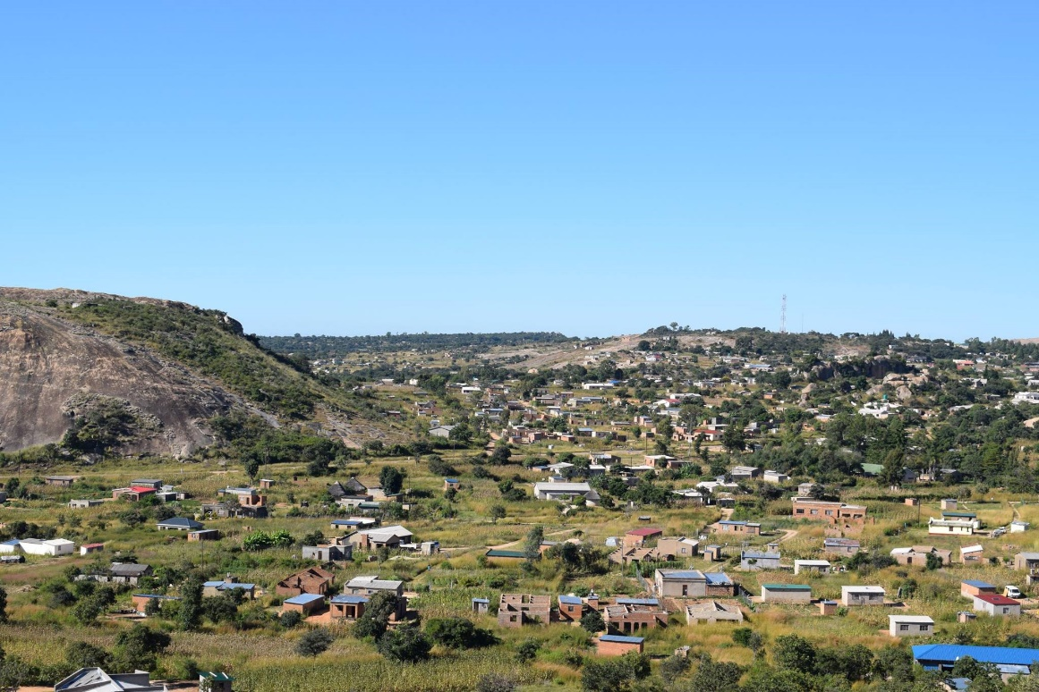
Figure 2
Participant information
My interviews and observations are predominantly the result of working very closely with the people who come to the community center on a daily basis. I have also performed observation in the bigger cities, especially at local supermarkets and restaurants. Luckily for me a year prior to me, a previous student had done her dissertation within Chinamhora. Moreover, another student on the trip with me in August was also doing her dissertation. This made it easier to explain my research to the locals as they already had gotten somewhat used to being constantly asked questions and understood my intentions with the information. This was further confirmed as during our first meeting we were both asked to outline and explain what our dissertations were on and politely explained that if anyone wanted to help us with it that was what the information would be used for. Though they were acutely aware of this I did not feel comfortable using direct pictures except one who gave me permission. Furthermore, I did not want to evoke direct names as I was unsure if they were comfortable with it.

Ethnographic information about the Shona
The most known book on the Shona is by Michael Bourdillon, The Shona Peoples, written in 1982. In his opening chapter, he gives a brief introduction to the history of the Shona. Though no written documents have been found, archaeologists and historians believe the Shona originate from a Bantu tribe who had migrated from modern-day Sudan. They formed the early-iron age culture of Zimbabwe which lasted around a thousand years. Though nowadays all of the old clans identify as Zimbabwean I did note that there still exists among the older generation a certain distinction between the five clans, though there is no prejudice against them, they were simply performing a mark of respect toward the subtlety of cultural differences.

Methodology

In terms of methodology, from my previous modules “In The Field” I felt comfortable that my tried and true method of participant observation, open-ended questions and narrative interviews would be the most logical way forward for me. The methodologies I used in researching this dissertation are outlined below.

- Open-Ended Questions
Primarily, I used open-ended questions, this is because as Martyn Denscombe (2001) stated in their book The Good Research Guide, “the questions tend to be short and the answers tend to be long.” I found that using this method meant I was prevented from interpreting too much from the participants responses and additionally that it provided my participants with more opportunities to give a detailed and true account of their opinion. I chose not to structure my questions excessively as the close interpersonal setting of the fieldwork lent itself to more open-ended and casual questioning which would fit within the community and could be carried out directly during Participant Observation (see below).

- Participant Observation
In my experience, participant observation is essential to avoid becoming an armchair anthropologist and quintessential to any fieldwork. Participating in community activities allows me to collect more accurate data and to understand that data to a much further extent whilst helping with the formulation of new ideas, Kathleen M Dewalt and Billie R. Dewalt (1992). However, participation may not always be pleasant and presents many of its own unique challenges. A section from Judith Okely’s (2012) book Anthropology Practice Fieldwork and the Ethnographic Method recounts a tale about Levi-Strauss’s experience with participant observation when he had to prove to the people he wanted to participate for them to show and explain to him. She then further elucidates,
“Participant observation can require to eat worms; the unfamiliar or that which once seemed repellent. Lévi-Strauss made sense of this in terms of other familiar food. In the event, the experience is rendered less strange and intelligible through bodily tasting. That is what participants observation entails. The example reveals how even the most vulnerable and isolated individual will not give way to pressure to give away secrets unless the interlocutors indicates a desire to participate fully and share.” (Judith Okely 2012)

This quote had a very profound effect on me as I knew it would be necessary to use participant observation in order to learn as much as I could about food in Zimbabwe. I found some correlations between the experiences of Lévi-Strauss and my own research in Chinhamora, where participant observation played an instrumental role in establishing trust and respect with community members. My experiences demonstrated, much like Lévi-Strauss, that it can often be the unpleasant experiences that further strengthen these bonds through demonstrating a willingness to engage with the community despite the possible personal discomfort, allowing in tangent personal growth.

- Autoethnography/Reflexive Journal
After revisiting ideas about participant observation, especially after reading the above quote, I also decided that it would be essential to consider autoethnography as a part of my methodology. Autoethnography conveys ideas about self-reflection and associates them with the wider picture of politics and culture.
Coming from an extremely different culture from the one in which my fieldwork was taking place, it would be essential for me to self-reflect on my ideas about food and how my culture has influenced them, as well as how it affects me in my day to day life so I could better understand how individual experience and cultural influence and how it can impact other people and their relationships to food. My autoethnographic methodology was influenced by Denzin and Lihcoln as shown in this excerpt from their 2005 work The Sage Handbook Of Qualitative Research Third Edition
“Autoethnography thus engages ethnographical analyses of personally lived experiences. The evidence act of showing in autoethnography is less about reflecting on the self in a public space than about using the public space and performance as an act of critically reflecting culture, an act of seeing the self, see the self through and the other. Thus as a form of performance ethnography, it is designed to engage a locus of embodied reflexivity using lived experience as a specific cultural site that offers social commentary and cultural critique” Norman K. Denzin, Yvonna S. Lihcoln (2005)

To accompany this method I also maintained a reflexive journal throughout my time in Zimbabwe to ensure that any ideas and thoughts I had conveyed in my autoethnography were the best representation of what I had experienced as well as allowing me to be reflexive when revisiting concepts at a later time.

- Cooking as Inquiry
Additionally, during further research, I discovered a theory that was new to me called ‘Cooking As Inquiry.’ These ideas have been mainly explored by Jennifer Brady (2001) in her book Cooking as Inquiry: A Method to Stir Up Prevailing Ways of Knowing Food, Body, and Identity, this method attempts to understand what happens to the body and identity through the everyday mundane practice of making food. ‘Cooking as Inquiry’ looks at food and bodies as sites of knowledge in an attempt to get researchers and their participants to engage in reflexive, cooperative effort to explore ways in which food and the preparation of food promotes the self.
Jennifer Brady introduced to me the idea that by making food, we can observe the cultural differences experienced by diverse people. By cooking with the local Zimbabwean women, and with the other members of the Love Zimbabwe charity, this research attempts to capture the moment identity is created through the constant performance of the necessary task of food making. The physical act of making food within the framework of ‘Cooking as Inquiry’ brings to life the way food establishes identity and makes this evidence clearer to the researcher, who can better understand all the symbolic links such as the social, historical, and cultural aspects of food and how they are incorporated in embodied performances.

e) Limitation
Every anthropologist with limited time in the field may feel as if things are uncompleted. This certainly applies to me. Moreover, I wished I had had more time to learn the local language to be better able to understand what people were saying to me in more depth. As most of my interviews were very informal, the default language was English, but upon reflection, I wish I had asked them to talk to me in their native language and made use of a translator. I believe the participants would have been more comfortable, as well as more capable of giving nuanced and thorough answers had the language barrier been removed. I am conscious upon self-reflection that the possibility of misinterpretations that could have been mitigated by having knowledge of the indigenous language of the people I was interacting with. I have attempted to amend this by keeping in contact via electronic messages with some of the people from the community center, but there is still a concern about not being able to communicate points clearly. Indeed, one of my most common reservations about using open-ended questions lies with the fact that I was attempting to ask questions that were free from theory that would necessitate explanation and possibly influence the responses by introducing them to where I was approaching the subject from. This was most evident to me when trying to explore ideas about hospitality (see part 2). Paradoxically, in attempting to remove theory from the questions I found that I was attempting to analyse their responses based on the theories and can not help but keep reflecting on this when writing this dissertation, rather than focusing on the participants sentiments and statements. Eventually, this practice will help to make me a better anthropologist

f) Conclusions
A complete anthropological study requires many kinds of methodology in order to attempt a thorough view of the group or individuals one is learning from. I found that autoethnographic methodologies allowed me to assess my possible biases and be aware of potential external factors which may have affected participants answers. Reflexive journaling aided the recording and review of the information gained during fieldwork experiences. Open-ended questioning methods and participant observation allowed me to have a conversational and honest experience with the people I spoke with in Zimbabwe and was I believe a major factor in allowing me to better understand the complexities of ways in which they prepared their food.

Chapter One: The Fruit Of Knowledge

As a warning to any readers, this chapter contains two images that some may view as disturbing.
The first section of this dissertation will be dedicated to ideas regarding how preparing and cooking food is an integral part of both the creation and solidification of social relations. This section will be heavily focused on my own experience using autoethnography to assess how personal experiences relating to food affected my eating habits and my sense of taste, food preferences, and ultimately how these experiences influenced both my relationship with food and how I view food as a necessary and inescapable paradox in the development of human relationships and individuality. I will be considering multiple examples and case studies from my time in Zimbabwe in hopes of illustrating my thesis, and further support the existence of this. Throughout my life, I have always been drawn to food studies, as it is the most mundane and cross-cultural event that takes place daily. Yet, how we eat, what we eat and our relation to food can change dramatically from culture to culture. It is at this point that I would like to state that my account from time in the field is undoubtedly, in my mind, unfinished or only partial. My time there was limited and my line of questioning at the time unclear. I would have wished for nothing other than to be able to spend a year there knowing exactly what I was doing and what direction I was taking. Though, I take refuge in Janet Carsten’s (1995) words “Of course, my account is incomplete, but I do not take completeness to be a proper aim for an anthropologist.”
My first visit to Zimbabwe was in April 2017 for a three week duration and my additional visit was in August of the same year for three more weeks. On self-reflection, each trip instigated very different feelings and gave me different ideas to work with. However, the one thing which was a constant throughout each trip was our never ending questions: who is making food and what is there to eat? It seemed to be the question we asked at the start of every day. As if no one really wanted to begin with heaving labor until we knew that there would be food when we came home. In the words of Robin Fox:
“We have to eat; we like to eat; eating makes us feel good; it is more important than sex. To ensure genetic survival the sex urge need only be satisfied a few times in a lifetime; the hunger urge must be satisfied every day.” (Robin Fox)

Let us now put this into my fieldwork site context. As described above making food is an extremely mundane activity. Every day I would have a new opportunity to talk to people about making food and how it made them feel. This also provided an opportunity to see if I, as an outsider, could feel more connected to the people I was staying with by making food with them.

Preparing Food: A Dance Of Relations
During a conversation with a man I met at the Welsh Assembly, promoting the Love Zimbabwe charity, gave me a very insightful understanding about food making. He said that making food with people can express your relationship with them. To elucidate, if you get on well with the person with whom you are cooking then the process of making the food will go smoothly, or not, depending on that interpersonal relationship. It is as if the food can somehow reflect the relationship between those people.
I felt that his words rang true, as when cooking in Zimbabwe it was not only with the local women but also with the people who were on the trip I noticed that cooking together seemed to amplify the qualities of the chefs relationship. On my first visit, I only knew one person and found that making food with them was much more relaxed and enjoyable, as opposed to being a learning experience that was somewhat hindered by a lack of familiarity when I cooked with the other volunteers. I had never previously interacted with the other students but found that the experience of cooking with them changed between my first and second stays in Chinamora, we had formed bonds through the preparation and consumption of food, and this led to our interpersonal relationships losing much of their awkwardness. However, I found that the better you knew the person the easier it was to make food and to have a good time doing it. I also felt that it consolidated the relationship with that person in a “trial by fire” kind of way, as the rest of the volunteers were depending on us for their dinner. I also observed several instances where the people cooking together had previous tensions that they brought to the kitchen, and this made preparing the food an extremely arduous activity.
Furthermore, in my opinion, making food is an activity that should not be done alone. In everyday life I have always found cooking to be considered a chore, however, when I participate in communal cooking there is a feeling of accomplishment, and it is almost as if the atmosphere from the room had soaked into the food because it represented the combining of a group effort to make something essential to us all.
One of the most notable examples of food preparation happened during a visit to one of the charity founder’s friends who owned cows. We wanted to get some manure for the new gardens we were building and he had said we were welcome to take some. Walking back from the cow paddock with my shoes covered in cows dropping I noticed a group of ladies plucking chickens together. They explained that they had come together to help each other to prepare them as a group. It was a sign of solidarity, a promise that they could rely on each other if times became hard.

The Truth Of Where Food Comes From: Wake Up And Smell The Coffee
From seeing the camaraderie expressed by these women I decided that it was time to face my initial fears of participating in killing and preparing chickens. This train of thought had come about several days before when my first experience in difference in “taste” in food had come to light.
Despite all my attempts to be similar and to copy others to get a better understanding of their tastes, there were times when the food they prepared and what I preferred clashed. For example, when eating chicken, every time the women would try to give us the legs or the wings of the bird as for them it is the best part because most meat is on the bone and represents the fattiest and most flavourful part of the animal, in their opinion. This is why the women always looked confused when explained that most of us would rather the breast or white meat. Many people at the community center asked me why this was. Their confusion prompted me to question as to why I wanted only a small part of the chicken; if I had a whole chicken to myself would I then only eat that part and waste the rest? These questions initiated self-reflection and it was only after several days was I able to come back with a formulated answer. I tried to explain to them that, in my opinion, it was because we don’t eat with our fingers, and it makes eating items like chicken bones or wings harder to eat whereas the breast meat, for example, is much easier to eat with knife and fork. Moreover, as we are not accustomed to slaughtering our own animals, meat is generally made to look less like an actual animal to divorce us from that process.
Seeing the women, at the friend’s house, working together made me want to help the women at the community center and to see if it would create a feeling of closeness. They told me that an open day at the community center, where local people from Chinamora could come and join in with dancing and a meal, would be happening soon and that they would greatly appreciate my help in any food preparation. It did take some consideration, but I ultimately felt it would be important for me to participate in the preparation of this meal, especially as it would take place during a particularly important open day where the village was invited to come to the community center, along with the Chief and Headman. This was a very special occasion and we had a lot of food to prepare, and the pièce de resistance would be a goat, slaughtered as there were so many people to feed. During that day one goat and several chickens were killed, to accompany the rest of the food which included vegetables and sadza, caterpillars, and salad. Though I decided that I could not actively kill the goat myself, I went to witness it to try to better understand the process.
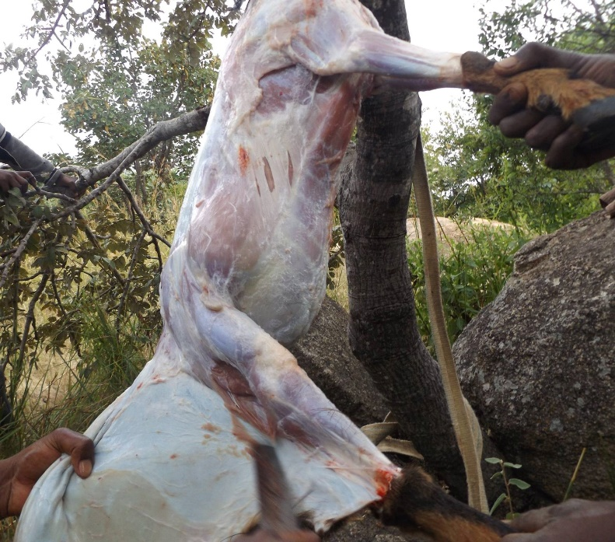
Figure 3
Although, I found this experience to be quite difficult and could not think of any questions I wanted to ask the men as they were doing it, failing in participating with the preparation of the goat. I later decided that I would help with the preparation of the chickens, and I felt I would need to participate more actively. The women showed me how and where to cut but again, I was not able to. I did, however, manage to help with the plucking and gutting.
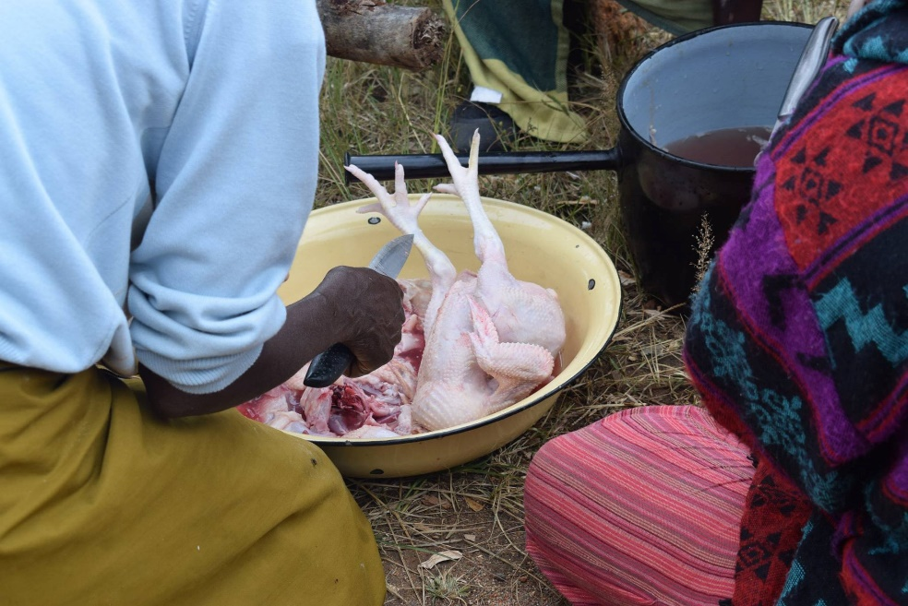
Figure 4

This experience felt like it was assisting me in feeling closer to the women, as they were very happy to have the help since I had not completely backed out. There was an element to the laughter and conversation that made the unpleasant experience much better, and perhaps this is why they choose to do it as a group.
However, I would argue that this experience had a negative effect on me. This is because we gutted the chickens and goat near the place where the plates were washed. The reason the slaughtering and washing were done in such close proximity to each other is because it is where the most reliable source of water is kept and both things require consistent water supplies. However, the smell from cleaning the chickens with my bare hands really affected me, and all I could do when I walked past that location, which was necessary to get a plate on which to eat, was to associate the faint smell with the action of gutting. I felt as if the smell had plastered itself on all the clean plates we used and even the new ones that had just been washed. The smell was so strongly associated with the act of preparing the chickens that for days I felt unable to eat off the plates because I felt as if they had been lightly covered with the insides of animals. It was a truly difficult experience that took me several days to reason with myself that the plates were clean and that the smell was actually mainly psychosomatic. I found this to be a profound moment for me as I felt a complete disgust for food for a few days which really put me behind in my work as I found it difficult to talk about food when I myself felt such a strong aversion to it. I felt so hungry, so weak and so ill that it made me realise even more how important food is to keep us going and how my own relationship to meat was profoundly different to theirs.
Though in conclusion to this event, I found that their relationship with food, especially meat, was a much truer one than my own. They understood the meat as being an animal and not just food, and in order to have meat in your diet, there is unpleasantness involved. Due to this experience this I have resolved to be vegetarian until I am able to face that unpleasantness with the animal myself so I can avoid taking it for granted and having, in my opinion, a somewhat unhealthy or false relationship with what I am eating. This situation furthermore created a problem with the way I was eating food.
Eating With Hands: Finger Liking Good
Every Zimbabwean I met always ate with their hands. Sadza is the staple dish in Zimbabwe, has a paste like consistency and is generally rolled in the hand along with vegetables or made into flat like surface used to pick up the vegetables with. The experience of eating with my hand was completely new to me, but I was adamant to try it. A previous investigation performed in Amsterdam by Anna Mann, Annemarie Mol, Priya Satalkar, Amalinda Savirani, Nasima Selim, Malini Sur and Emily Yates-Doerr (2011) about eating with hands gave some basis for ideas. In a discussion with a friend called Malini, it was proposed that eating with one's fingers was a form of tasting the food. That it was possible to begin to taste the food before it reaches the tongue.
Though the people I talked to didn’t express this exact idea, nor did I find this to be true to myself either, they did, however, say that they preferred it over cutlery but that this was just what was normal and more comfortable to them. After spending a few days eating only with my hands I concluded that it was much more pleasurable as sadza is harder to eat with cutlery if you want to mix it with the vegetables. Furthermore, you don’t want to eat sadza on its own as it has little to no flavour and feels quite dry in the mouth.
“Well. Let me tell you: I liked it. I enjoyed this substantive contact of fingers and food. Feeling the warmth of what I was about to eat, no, what I was eating.” Anna Mann, Annemarie Mol, Priya Satalkar, Amalinda Savirani, Nasima Selim, Malini Sur and Emily Yates-Doerr (2011).

Though I am not personally convinced about being able to taste food through the fingers from my experience of it, I would say that being able to feel the food and the texture of it in your hand and in your mouth creates a much closer relationship with the food you are eating. You can feel the consistency, the grease, the dryness and moisture, and from these things can get a better sense of what you are putting into your body. Though I was certainly not as masterful as the locals at eating with my hands I reveled in the sense of belonging. The act of partaking in what was normal to the people around me I felt as if I was more connected and similar to them, not the odd one out. Moreover, the lingering smell that can remains on my fingers once the food is gone. I have found that even to this day that the memories of Zimbabwe vividly come back to me when I make sadza back home, as I can smell it on my hands after eating. This concept of scent being tied to memory led me to make the connection between my positive memories brought on by pleasant associations with food, and the negative experience I had where the plates seemed to absorb the scent of chicken offal, and was transferred into my body through the process of eating off of them, exacerbating my ill feeling. (Ideas of memory will be further explored in the third part)

Chapter Two: Two Peas In A Pod

We will now be moving on to the second part of my dissertation, dedicated to exploring how not only can preparing and making food together help build social relations, but also how eating food together, more particularly the same food, can help to bring people together. We will be exploring ideas from Janet Carsten about how relatedness could be applied and how they can create a sense of sameness. Along these same lines, we will be exploring ideas about hospitality and how African philosophies might disprove current theories surrounding hospitality. The last section will be dedicated to exploring Jack Goody’s ideas about class and food as well as attempting to show how by eating together we can help heal some of the wounds from Zimbabwe’s past.

Connecting Societies: Eat Drink And Be Merry
My first real instance of fascination with how food can create bonds between different people happened during a meeting for the love Zimbabwe charity at the Welsh assembly. A questioner asked if the Love Zimbabwe Charity was, in fact, a benefit to the poor communities it operated within, and challenged the usefulness of sending “privileged white people” to work in Chinhamora rather than employing local people to perform the work. The spokesperson for the charity retorted that the work we performed was indeed essential, and was there to help the community. They added that we worked closely with the community and take active part in ideas and projects directly benefiting the community. However, they felt that these trips were truly about cultural exchange and attempting to help heal the wounds of racism and stereotypes in Zimbabwe. They believed that it could only be by living, eating and sharing our day to day lives together that we would be able to create a sense of friendship and community. I found their ideas to correlate to Janet Carsten’s fieldwork on the island of Langkawi. Carsten challenges many modern ideas about kinship in anthropology. Most anthropologists would describe kinship in simple terms, as being related to the people around you that share your blood or have a genetic link. However, Carsten attempts to demonstrate kinship, or what she calls relatedness, as being fluid and not something that we are simply born with. It is in constant development and change throughout their entire lives. In the case of the Malays, foods, especially breast milk and rice, are seen as blood and they are viewed as what will tie the people together. People are in a constant state of becoming by eating and living together.
“My argument may be placed in the general context of an analysis of kinship that begins from native categories. I take for granted that the meaning of "kinship" cannot be assumed a priori. I use the term "relatedness" to indicate indigenous ways of acting out and conceptualizing relations between people, as distinct from notions derived from anthropological theory. Ways of living and thinking about relatedness in Langkawi lead me to stress a processual view of personhood and kinship. It is through living and consuming together in houses that people become complete persons-that is, kin. The core substance of kinship in local perceptions is blood, and the major contribution to blood is food. Blood is always mutable and fluid-as is kinship itself.” Janet Carsten, (1995)

Though it is hard to determine whether Carsten’s theory is transmutable to the people in Zimbabwe I would, however, infer from what was said at the Welsh Assembly and further confirm from our time in Chinamora that the spokesperson hoped that this “relatedness” could be something obtainable across multiple cultures. That through simple mundane activities like living and eating together we would become united through our experiences. When talking to people in Zimbabwe about this it was hard to get a straight answer that I would feel comfortable expressing here.

Stranger Danger: Bad Egg Or Good Egg?
Continuing with themes of likeness I will now be moving on to my second section on hospitality. I found that Mauss’s theory on gift giving particularly in regards to how it links people in a constant tie of exchanging possess some similarities with theories of hospitality as it creates a link that person also.
Hospitality can be found across many different cultures with Zimbabwe being no exception. During my time there I constantly felt touched by how generous people were and how they always wanted to share whatever they had with others. However, according to Matei Candea and Giovanni da Col (2012) theories surrounding hospitality have been blindsided by theories of gifts and exchange.
“Searching through the past century's anthropological literature for discussions of hospitality, one is struck by the fact that hospitality is both everywhere and (nearly) nowhere. On the one hand, hospitality emerges over and over again entangled with the gift as an implicit or passing reference-point. On the other hand, there is a surprising paucity of attempts to foreground hospitality as a theoretically important concept in its own rights.” (Matei Candea and Giovanni da Col 2012)

As anthropologists I believe that this study should be more deeply investigated as we are usually guests of the people we are staying with and I would argue that having a better understanding of these relationships would help us to further understand our relationships with the people who are helping us and how they relate to each other within their communities as well.
In a general sense, rituals surrounding hospitality generally entail the sharing of food and drink with guests or visitors. However, hospitality, someone coming into your home could be a dangerous situation. Its original etymology reveals the potential hazards in inviting someone into your home or refusing them hospitality. “Hostis” the root of hospitality in Latin translates as “foreigner” or “enemy” Matei Candea and Giovanni da Col (2012). What then does one do to avoid being seen as an enemy? The presupposition is that these individuals will come into contact with people that are “other” to them. To help create a sense of normality and safety the ritual of food and water sharing provides both parties the opportunity to feel more secure. The term hospitality acknowledges the initial problems of distrust and hesitation people can face when meeting and helps to mediate a theoretically threatening situation. Therefore, the ritual of hospitality including sharing food and drink is essential in creating a sense of “same-ness”. This connection provides both parties with a sense of security by having both individuals consuming the same substances at the same time in the same manner hospitality rituals creates the opportunity to be seen no longer a foes but as friends. This logic implies that through sharing food the other is made ‘the same’. It is as if one was consuming some of the identity of the host.
“Hospitality are (in each other's eyes at any rate) not the same after the event as they were before. Hospitality converts: strangers into familiars, enemies into friends, friends into better friends, outsiders into insiders, non-kin into kin” (Conrad Lashley, Alison Morrison, 2000.)

So, what can, at first glance look like generosity can be viewed as a system put in place to diffuse potential animosity. However, let us put this back into my field site context. When talking to people about hospitality I felt nervous in expressing these ideas to them as I didn’t want to seem ungrateful to them. As if the act of offering me food when they had so little of would fall under these categories made me feel uncomfortable to talk about it. Perhaps this is why there has been so little done on hospitality by previous anthropologists.
Throughout Africa, there is a still to this day a very strong feeling of Ubuntu also known more commonly in Zimbabwe as Hunhu. Ubuntu or Hunhu are African philosophies which express in my opinion a very beautiful idea. Despite the prevalence of Christianity in Zimbabwe I would argue that roots of Hunhu are still very strong and as Oswell Hapanyengwi-Chemhuru and Ngoni Makuvaza, have argued in their work Hunhu: In Search of an Indigenous Philosophy for the Zimbabwean Education System published in 2014, that there was a need in Zimbabwean education system for re-evaluation, as many of the teachings and ways of teaching did not fit with most people’s primary philosophies which still celebrate hunhu as an important part of Zimbabwean culture.
“We argue that for the education system at any level to be relevant, it must have its foundations in the philosophy of hunhu. It is not being argued that the philosophy of hunhu be one of the philosophical foundations, but that it be the foundation of Zimbabwean education.” (Oswell Hapanyengwi-Chemhuru, Ngoni Makuvaza, 2014)

But what is hunhu/ubuntu? In its essence it expresses the idea that ‘I am because we are, how can I be happy, when another is sad?’ It is the primal essence of being human. I can not be human without other humans around me. A person can only be a person through others
(https://www.youtube.com/watch?v=z_aDmjBr-aA&t=14s).
I observed many instances in Zimbabwe that I believed demonstrated the above definition of hunhu/ubuntu.
During my first visit, I was very interested in what community was and why it was important. I was told that because money was not always available it was important to know one could rely on their neighbours. Having the knowledge that people were willing to help you in times of need and that you can be supported by your community offers us insights into how hunhu is performed. This is a very strong idea in Zimbabwe and truly brings a tear to my eye as people are so willing to share the little that they have. Though, I would argue that though hunhu is a very important concept I would not want to rule out every theory about gift exchange. As of the ladies from the community center told me:
“You come here and do good. Because of you, I have a garden with food I can feed my family with. You bring clothes for my children and give them a safe place to play and learn. You are like my sister. You can come to me and I can come to you for help.”
Though I am not comfortable with the idea of people from the community center feeling indebted to me in any way. I can see certain elements of Mauss’s (1966) theories of gift exchange being in play here. By building the keyhole gardens, the women at the community center would want to share the food they had grown in those gardens with us. Through the volunteers giving them a gift the women felt it must be returned to the original giver, which seems to be in agreement with theories about gift exchange, according to which everything given possesses an invisible thread that links us together.
Overall I would like to state that by eating with the locals and by being let into their world I did feel a sense of closeness with them. This could be simply because eating together is a social act, or that by adopting social cues on proper ways of eating, as well as eating the same food as my host was viewed as it was intended, as a symbol of respect to their culture and to themselves. Interestingly, I would say people definitely showed more interest in me and seemed more open once I had said that I had eaten their local food, sadza. It would either be because when mentioned that I had eaten it and they would generally reply “Oh sadza?! What do you think of it?”, or they would ask me directly “Have you tried sadza?” They explained to me that some people, especially people from the older generation who had lived under colonial times, had never heard of white people eating sadza.

Social class and food: Let them eat cake.
Here Goody’s (1982) theories about class and food could be applied. In creating food that some classes eat and others do not, a distinction is generated that and makes us more separate. Through other readings, I have found several other instances where people use food, ways of cooking food, and ways of eating food as a distinction between social classes. As expressed before, food is never simply food, along with it are attached many different ideas. “Food is a prism that absorbs and reflects a host of cultural phenomena” Carole M. Counihan, (1999). The way people cook and what they cook can mark the boundary between one culture and another and create a sense of discrimination between the two. For example, the Ainu consider their neighbours the Japanese and the Gilyaks to be barbaric as they consume raw food whereas they eat cooked food (Emiko Ohnuki-Tierney 1993). However, from talking to and seeing various people from different social classes in Zimbabwe, I gleaned that there was not one person I met in Zimbabwe that would not eat sadza (This excludes any white people still living in Zimbabwe as I never got the chance to meet any). Though it is cheap and basic it is not considered food for only the rich or poor. This was exemplified by the fact that we would have the same food if we were visiting the Chief, a middle class person from the town, or enjoying a meal prepared at the community center by the Chinamoran women. It was unfailingly sadza followed by condiments of vegetables and meat. In many ways, I suppose it is similar to our western relationship with bread or potatoes, or the eastern tradition with rice. From visiting the bigger cities I saw that it was possible to get many different international foods and that fast food restaurants had made their way as the new form of colonisation by introducing cheap food that was different from the indigenous culture. However, there were also places you would be able to buy sadza, meat, and vegetables at typically a very good price. I was told that people working in the big cities would use sadza similarly to how we would buy a sandwich from a supermarket. People would on occasion if we were out have something different like pizza, but even when fast food was available some people would choose to have takeaway sadza instead. As one person told me when we were waiting in line to get sadza “If you have sadza in your stomach then you will not go hungry”. It brought me great joy to see that unlike some other colonized societies they had not changed their sense of taste to try and fit better into a higher class. As Mintz (1985) explains that sugar was once for rich people only but it became popular as the lower classes tried to emulate the rich. This translates the enormous social and economic power food can have, that it is possible for someone to be seen as different simply by consuming differently.
To conclude this chapter, I would most definitely argue that by eating sadza and living with the community was very important for the process of healing the wounds of colonialism and creating a sense of likeness with the people we were living with.

Chapter Three: Food For Thought

Here I will be discussing the final part of my paradox. As explored in previous sections we have talked about how food can help create and affect our social bonds, how it can separate us by having certain foods being exclusive to different social classes and finally we explored how it can help create a same-ness and link us with an ‘invisible thread’. In this final section, we will be exploring ideas about food and identity. How food is intimately linked to ideas about ourselves and our culture. To begin with, I will be showing how sadza can be seen as essential to Zimbabwean women’s identity through exploring some of Tye’s ideas about womens status through the perpetuation of the same recipes. Adding to this I will be exploring my own limitation in the making of sadza. This section will additionally include the cooking as inquiry method to see the moment culture is made and how we can physically feel the difference. Finally, we will be investigating why people want to eat food items that represent their culture when they are outside of it by looking at ideas about how food can be very strongly linked to memory.

Creation Of Women’s Identity Through Making Sadza: Piece Of Cake
The first section I would like to concentrate on the one occasion which gave me the most noticeable insights into the making of food and creation of, particularly womens’ identity. The event occurred when we were making a keyhole garden located several hours walk away from the community center. After a discussion, the group decided that one of our founded keyhole gardens by Hub Cymru Africa should go to this location. We spent the morning walking there with our supplies and occupied the rest of our afternoon by digging and planting the new keyhole garden. While we were building the keyhole garden, two women from the community center agreed to come with us to make food while we were working. In-between a break from digging, I decided to go take a closer look at how they were making the food. At the community center it is never uncommon to have the opportunity to observe the making of sadza, for it is made every day without exception for lunch, dinner and sometimes breakfast too. However, apart from the traditional African huts where we would sleep, there is not a traditional hut where they could make food. Either they use the gas cooker in the community center or made it on a fire outside with a tin roof for protection. The case of making it at the location was my very first opportunity to see sadza being made the truly traditional way in a traditional thatched roof hut. My research and interest in food led me to be drawn to experiment myself in active participation to truly understand how it was made and the effort that must go into it. By observing the authentic preparation of the sadza, I hoped to understand the relationship these women had with making sadza and themselves.
One of the first observations I made was of the overpowering smell of wood smoke. It was everywhere and there was no escaping it. Moreover, though the hut was very nice and cool compared to the blazing sun outside, it was quite dark apart from the light coming from the door and a few very small windows. The space was also relatively small, especially when about eight people want to see what is happening. However, the most important remark to be made about the experience is the extensive amount of work and determination that goes into making sadza. It starts off as a flour-like composition of ground up maize and water is added. The combination makes a very thick paste, which is put over the open wood fire on a purpose made metal sheet. Once the heat is added the stirring must begin this is not to be taken lightly. The paste is thick hard and will go lumpy if it is not vigorously stirred with two hands to create the smooth consistency. Observing this sadza preparation led me to consider how different the strength of our arms must be and how by simply cooking could create such a physical difference in our bodies.
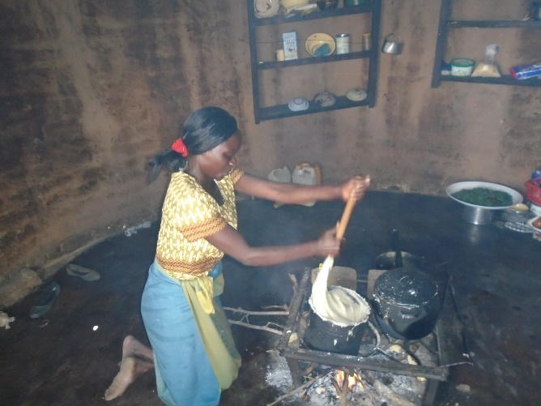
Figure 5
Moreover, cooking over the fire adds extensive work as the wood must be collected lit and maintained whilst cooking. As expressed before, the smoke is unavoidable and most of my time stirring was spent with tears streaming down my face from it. It truly does feel like blood, sweat and tears go into making sadza, that through it the person eating it is benefitting from my efforts in a direct way. I found this feeling was echoed on my return home while preparing meals with friends.
Carsten (1995) observed among the Malay people of the island of Langkawi there is a special word for the main living space of the house, ‘dapur’. This area is used to describe the kitchen space and the living space. This is where most women would spend their time cooking and leisuring with other women. In Zimbabwe the local language is Shona and it uses the word ‘choto’ to describe a fireplace. From my time in Zimbabwe, I observed that most of the time women would be the ones who would spend time around the choto doing chores like cleaning, cooking and childminding. I am aware that this observation could be skewed from the status quo in Zimbabwe by the fact that most of the women we spent time with were widows, and at the community center we would spend time with the men around the fire near our huts, separate from where the food preparation took place.
Moreover, whilst I was attempting to cook the sadza, the ladies started giggling and explained that no man would want to marry me as I was showing signs of a “bad housewife”. This statement came from the fact that as I was stirring the pot a lot of sadza had accumulated around the edges, thus wasting it. They explained to me that is was very important for a woman to know how to make good sadza for her family to eat and to never waste any.
I found this to be similar to Tye’s (2010) work in his book Baking As Biography, in which he explains it can not only be through eating food that we can understand identity but through the continuous pattern of making food from a recipe passed down to us, that one can establish their social relationship and status within a family:
“Making tasty food–some of which was once my mother's food- has become part of how my family sees me and how I see myself. This piece of my gender performance as daughter, sister, wife, and mother is part of my mother's legacy. Reproducing her baking reinforces my position as the family's eldest female, and it is a partial claim of her authority and a display of competency that everyone in the family recognizes. (Tye’s 2010)

Sadza is a meal that every Zimbabwean has eaten and will eat in the future. Every day, mothers, sisters, grandmothers, aunts, children… will make it for breakfast lunch and dinner. Other items of food will be used to complement the sadza and these will be subject to availability. The sadza is always the staple. Being able to make it well is important to every Zimbabwean women as a sign of herself identity and her lineage. In failing to perform well, I felt initially ashamed and worried about what the women would think of me. I had felt such passion and pride in their voices about being able to cook well that I felt I had disappointed them. After expressing my sorrows on this matter, one explained to me that she felt more humbled that a “white girl” wanted to participate and that through this act she felt closer to me. Yes, for Zimbabwean women it was important, but for an outsider to express that regret, promoted understanding and a closer connection that has long been diminished in Zimbabwe and the outside world. Moreover, it became evident to me that this was indeed a more gendered role and creation of female identity when my partner James wanted to have a go, they all fell about laughing that James wanted to try and make sadza. Though men do know how to make sadza and will make it on occasion it is traditionally cooked by women. Cooking has often been associated with women across many cultures as they have been seen as the ones who provision and prepare the food for the family. We could also discuss ideas about entitlement as some food could be more associated as masculine and others as feminine.
“This is particularly notable in the case of meat, which in the west is widely linked to masculinity. Real men are thought to need meat, particularly red meat.” (Pat Caplan, 1997)

I would argue that this is partially true to Zimbabwe as well but is not always exclusive. As with men making sadza, women do cook meat but more in stews and men would cook it over a barbeque. I find it intriguing that this does appear to be a universal trait, for example, my father who would never do any cooking in the house (mainly because my mother says it tastes horrible) but, he would pick up the tongs and spatula if we were having a barbeque, and prepare all of the meat. The same could be said of my mother’s experience of living in Australia, where the barbeque is almost exclusively a male activity.

A Taste Of Home: The Best Thing Since Sliced Bread
The next two sources I will be using are not academic though in my opinion they are still of value to this dissertation, and will give the reader an opportunity to see sadza, with the recipes used and the way of eating it with one's hands.
Sadza has been migrating to other parts of the world as the people of Zimbabwe immigrate to many different countries. For example, in an episode of Master Chef, a woman from Zimbabwe makes a traditional meal of sadza meat and vegetables. In the video, she explains why they sometimes put peanut butter with the vegetables as sometimes people do not have enough money for meat so they use it for the protein. This is something that I came across regularly in Zimbabwe but never thought to ask why until I saw this clip. Moreover, she explains that every Zimbabwean woman is expected to cook, that it is part of her. The main comment on her dish was that it was

“...a complete mirror image of you. I see you in the palate I see your ethnicity, I see your personality.”
(https://www.youtube.com/watch?v=BlNtPUNIB1Q&index=0&list=PL5DMs1MDbeNPLVWmA_brxElHLkrdH0jJw)
I found this clip to be very interesting even though it is not from an academic source I believe that this is something we know and understand instinctively. Food can represent us, it can be a symbol of our culture and of who we are and when we eat it we feel closer to both of those aspects of ourselves. Following along these lines a women traveled around Kent visiting many different people from different cultures to see what they cook traditionally. At the beginning, she says she wants to see the staple meals that their mothers would have taught them that have been passed down for generations. She visits a Zimbabwean dancer and singer in the UK. He explains that it is not always easy to get a hold of the right food, so he goes to London where it is easier to find. He says that he has to because if he goes a long time without eating this kind of food he doesn’t feel well, he feels something is missing. He explains it would be like not having a strong cup of tea. If you don’t have it you get a bit of a headache.
(https://www.youtube.com/watch?v=C9rMDL1B0LY&list=PL5DMs1MDbeNPLVWmA_brxElHLkrdH0jJw&index=3)
Again this ties into women’s identity and pride if we compare it to Tye‘s (2010) ideas once again. The perpetuation of the same recipe creates identity for the members of the family. As I might have mentioned throughout this dissertation, people in Zimbabwe eat sadza every day. Though my first impression of it was that it was not very nice, in my opinion, the people there do not only eat it because it is cheap. They often chose it over other food available and when asking people at the community center how they would feel about not eating sadza ever again they would respond with “I do not know, I can not imagine it. I’ve never gone long without, it would be like not having water, not having a place to live. It is what I do every day what else would I do?” In this case, I would argue that this feeling of loss from not being able to obtain sadza is in part linked to routine/habit and memory. In many ways, we are creatures of habit when sitting down for meals we like to sit in the same space as we did the first time. The men explained to me that they could not remember a time when there was no sadza, it was always there and available to them the idea of not having any seems ridiculous to them. One man even said to me “It is like the sun, we know it goes away for some time but it always comes back in the morning to make our lives easier.”
Taste and smell are both very strong senses that bring us back to a certain place at a certain time, sometimes maybe with people. My support worker once told me that for her the smell and taste of clementines brought her straight back to school because during any after school activities her grandmother would bring her one to have as a snack. She said that it was so strong that even just from the smell of them she could picture the room where she was sitting and the memory of eating them.
“Inquiries address how tasting and smelling relate to other aspects of cultural life, how they evoke memories, help to frame collective identities and foster feelings of belonging” (Anna Mann, Annemarie Mol, Priya Satalkar, Amalinda Savirani, Nasima Selim, Malini Sur and Emily Yates-Doerr 2011).

During several of my travels have I truly become aware of my own relationship with food and identity. The most striking example I can think of happened during my time in Thailand. Throughout my travels, in Thailand, I found that one day I simply could not bear to eat another stir-fry. All I truly wanted was to have a cup of tea and jam and toast. Still, to this day, I am not certain it was purely because I felt I wanted to enact the food related aspects of my culture. However, after many days of reflecting and diving into myself about it, I found that the reason I wanted tea was to almost normalise myself as if I was trying to make myself and the situation I was in more real. “Many people on holiday deliberately seek out food which is nostalgic.” (Pat Caplan 1997)

Conclusion

To conclude this dissertation, I have attempted to investigate how complex and diverse food can be. Though I have come across issues I have done my best to give a detailed and honest account of my experience and the people of Zimbabwe’s experience of food. By exploring a wide variety of literature, theories, and ideas. I have presented the bonding properties of food through various activities. By exploring my own relationship to food has given me more knowledge about myself and my connection with people especially being close to the slaughtering, and preparing of food. This has an effect on my current relationship with food in an emotionally even physically draining experience. I have also attempted to explain how it has influenced how I related to the people in Zimbabwe, experiencing those same things.
By comparing and contrasting the differences and similarities of hospitality, preparation, and consumption of food, and how individuals must navigate these sometimes complex insinuations that food implies through the entire process of food. Class can furthermore create a dynamic between people by presenting and classifying people as “other”.
Finally, I have attempted to display the paradox that food creates by further exploring how it can be a creation of identity. Food ties us to ourselves though place and memory when certain foods that we might consider part of us are unavailable we feel a loss an almost physical pain within ourselves.

Appendices

Because most of the interviews at the community were a continuous process it seemed simpler to make the participants sign once. As they were very aware of what fieldwork and dissertation work involved I did not feel this was misleading.

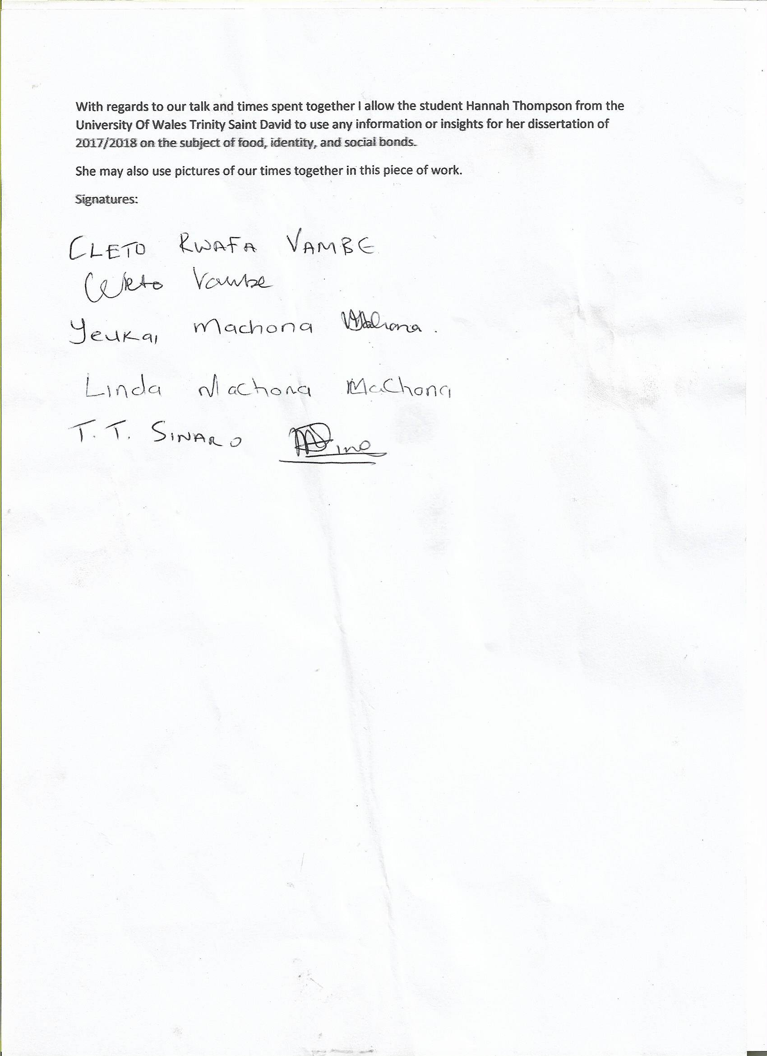

However, if interviewing someone who was not regularly at the community center I asked if they would sign after I had been writing notes form the interview. I found that because they had not participated in previous dissertation works that though explaining being able to show the writings they could see what I had written and would make a sense of trust and leave me with the knowledge that it is consensual and fully informed.
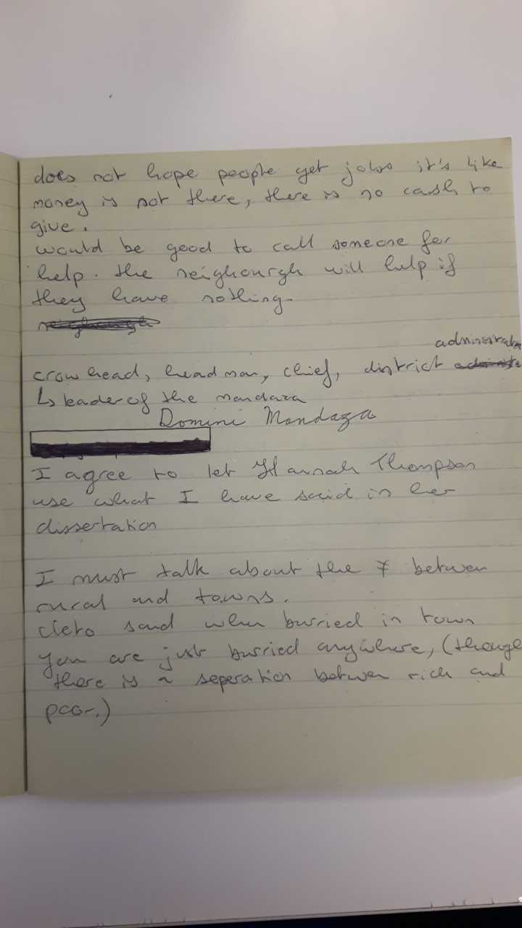

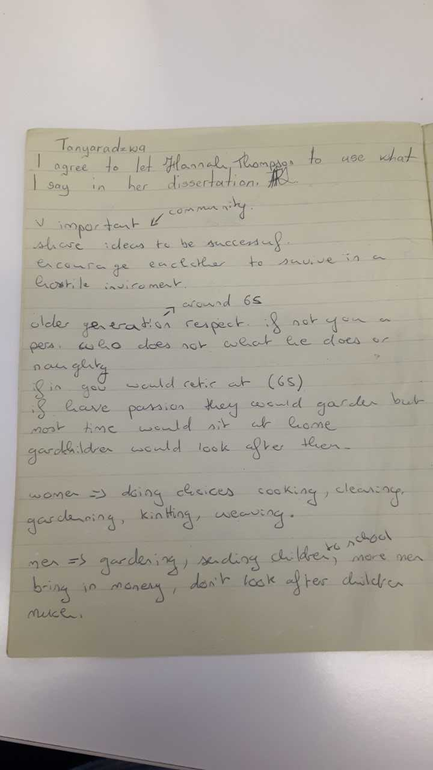

References

Books and journals:
Carole M. Counihan, 1999, The Anthropology Of Food And Body Gender, Meaning And Power, Routledge New York London.
Claude Lévi-Strauss, 1969, Le Cru Et Le Cuit, translated by Jonathan cape, 1970, The Raw and the Cooked, Random House UK Ltd reg. 954009.
David Bell, Gill Valentine, 1997, Consuming Geographies We Are Where We Eat, London Routledge.
Ed. Carole Counihan Penny Van Esterik, 2008, Food And Culture A Reader Second Edition, Routledge.
Ed. Chris Tilley, Webb Keane, Susanne Kuchler, Mike Rowlands, Partricia Spyer, 2006, Handbook Of Material Culture, Sage Publications.
Chapter 9 Judith Farquhar, Food Eating And The Good Life.
Ed. Pat Caplan, 1997, Food Health and Identity, Routledge 11 New Fetter Lane, London EC2P 4EE.
Emiko Ohnuki-Tierney, 1993, Rice As Self Japanese Identities Through Time, Princeton University Press.
Emma-Jayne Abbots, 2017, The Agency Of Eating Mediation, Food And The Body, Blomsburry Academic.
Helen Macbeth, 1997, Food Preferences And Taste, Community And Change, Berghahn Books.
Jack Goody, 1982, Cooking Cuisine and Class a Study in Comparative Sociology, Cambridge University Press.
Judith Okely, 2012, Anthropology Practice Fieldwork And The Ethnographic Method, Berg London New York.
Kathleen M Dewalt and Billie R. Dewalt, 1992, Participant Observation a Guide for Fieldworkers, AltaMira press Rowman & Littlefield Publishers, Inc.
Martyn Denscombe, 2001, The Good Research Guide for Small-Scale Social Research Projects, Open University Press Buckingham Philadelphia.
Michael Bourdillon, 1982, The Shona Peoples, Revisited Edition, Mambo Press.
Norman K. Denzin, Yvonna S. Lihcoln (2005) The Sage Handbook Of Qualitative Research Third Edition, Sage Publication.
Sidney W. Mintz, 1985, Sweetness and Power the Place of Sugar in Modern History, Penguin Books.
Sidney W. Mintz, 1996, Tasting Food Tasting freedom, Beacon Press, Boston.

Online books and journals:
Anna Mann,University, Annemarie Mol, Priya Satalkar, Amalinda Savirani, Nasima Selim, Malini Sur, Emily Yates-Doerr, 2011, Mixing methods, tasting fingers Notes on an ethnographic experiment, HAU: Journal of Ethnographic Theory 1 (1): 221–243 file:///C:/Users/1500884/Downloads/Eating%20with%20Fingers%20(1).pdf
Autoethnography: Revealing Your Self From The Inside And Outside English, 121 Sansburn – LE1 Assignment Sheet https://people.emich.edu/cgallaghe1/Autoethnography_Instructions_2014.pdf
Conrad Lashley And Alison Morrison, 2000, In Search Of Hospitality Theoretical Perspectives And Debates, Butterworth-Heinemann https://www-dawsonera-com.ezproxy.uwtsd.ac.uk/readonline/9780080508566
Ed Deane W. Curtin, Lisa Maree Heldke, 1992, Cooking, Eating, Thinking: Transformative Philosophies Of Food, Indiana University Press https://books.google.co.uk/books?id=Hq9dT_iH8xsC&printsec=frontcover&source=gbs_ge_summary_r&cad=0#v=onepage&q&f=false
Ed. Emma-Jayne Abbots, Anna Lavis, 2013, Why We Eat, How We Eat Contemporary Encounters between Foods and Bodies, Ashgate https://moodle.uwtsd.ac.uk/pluginfile.php/76782/mod_resource/content/1/Abbots_second%20layout%20proof_11-3.03.13.pdf
Ed. Emma-Jayne Abbots, Anna Lavis, Luci Attala, 2015, Careful Eating: Bodies, Food And Care, Ashgate https://moodle.uwtsd.ac.uk/pluginfile.php/76783/mod_resource/content/1/Abbotts_20May.pdf
Janet Carsten, 1995, The Substance Of Kinship And The Heat Of The Hearth: Feeding, Personhood, And Relatedness Among Malays In Pulau Langkawi, American Ethnologist, Vol. 22, No. 2, pp. 223-241, Blackwell Publishing on behalf of the American Anthropological Association http://www.jstor.org/stable/646700?origin=JSTOR-pdf&seq=1#page_scan_tab_contents

Jennifer Brady, 2011, Cooking As Inquiry: A Method To Stir Up Prevailing Ways Of Knowing Food, Body, And Identity, International Journal of Qualitative Methods University of Alberta International Institute of Qualitative Methodology http://journals.sagepub.com/doi/citedby/10.1177/160940691101000402
Jon D. Holtzman, 2006, Food and Memory, Annual Review of Anthropology, Vol. 35 (2006), pp. 361-378, https://moodle.uwtsd.ac.uk/pluginfile.php/76804/mod_resource/content/1/Holtzman%2C%20Food%20and%20Memory.pdf
Marcel Mauss, Translated By Ian Gunnison, 1966, The Gift Forms And Functions Of Exchange In Archaic Societies, Cohen & West Ltd https://monoskop.org/images/a/ae/Mauss_Marcel_The_Gift_The_Form_and_Functions_of_Exchange_in_Archaic_Societies_1966.pdf
Maria Antoniou, My Cypriot Cookbook: Re-imagining My Ethnicity, University of Brighton, UK https://autobiography.stanford.clockss.org/aub_2004_12_2/10.1191_0967550704ab009oa.pdf
Matei Candea and Giovanni da Col, 2012, The Return To Hospitality: Strangers, Guests, And Ambiguous Encounters, pp. S1-S19 the Journal of the Royal Anthropological Institute, Vol. 18, Royal Anthropological Institute of Great Britain and Ireland https://www.jstor.org/stable/i40073937
Oswell Hapanyengwi-Chemhuru, Ngoni Makuvaza, 2014, Hunhu: In Search Of An Indigenous Philosophy For The Zimbabwean Education System Practice Without Thought Is Blind: Thought Without Practice Is Empty, Journal of Indigenous Social Development Volume 3, Issue 1 pp. 1-15 https://scholarspace.manoa.hawaii.edu/bitstream/handle/10125/33334/v3i1-01hapanyengwi-chemhuru.pdf?sequence=1
Robin Fox, Food and Eating: An Anthropological Perspective, Social Issues Research Centre, http://www.sirc.org/publik/foxfood.pdf
Tye, D., (2010), Baking As Biography: A Life Story In Recipes, Kingston, ON: McGill-Queen's University Press. Google Scholar https://books.google.co.uk/books?hl=en&lr=&id=j1M6mS9hTAEC&oi=fnd&pg=PR7&ots=lTP7cN1tCz&sig=0iaSljkgvv66aa6DdnpUIdnxy0Q&redir_esc=y#v=onepage&q&f=false

Online sources:
Cimbarashe Jul 9, 2012, MasterChef sadza, https://www.youtube.com/watch?v=BlNtPUNIB1Q&index=0&list=PL5DMs1MDbeNPLVWmA_brxElHLkrdH0jJw
Global Oneness Project, Feb 27, 2009, Ubuntu, https://www.youtube.com/watch?v=Zf4hP3GkABI
Karen Boswall, Mar 30, 2013, Sadza - World in Kent, https://www.youtube.com/watch?v=C9rMDL1B0LY&list=PL5DMs1MDbeNPLVWmA_brxElHLkrdH0jJw&index=3
TempletonPrize, Nov 26, 2013, 2013 Templeton Prize Laureate Desmond Tutu -- on Ubuntu, https://www.youtube.com/watch?v=z_aDmjBr-aA&t=14s

