工作和地点
swyddi a lleoliadau
jobs and locations

Vocabulary

中文 | Pinyin | Cymraeg | English
老师 | lǎoshī | athro  athrawes | teacher
学生 | xuéshenɡ | myfyriwr  myfyrwraig | student
医生 | yīshēnɡ | meddyg | doctor
护士 | hùshi | nyrs | nurse
厨师 | chúshī | cogydd | cook
服务员 | fúwùyuán | gweinydd  gweinyddes | waiter  waitress
警察 | jǐnɡchá | plismon  plismones | policeman  policewoman
家 | jiā | cartref | home
学校 | xuéxiào | ysgol | school
医院 | yīyuàn | ysbyty | hospital
餐厅 | cāntīng | bwyty | restaurant
警察局 | jǐnɡchájú | gorsaf heddlu | police station

* colour code for tones: first tone (blue), second tone (yellow), third tone (green), fourth tone (red), neutral tone (grey）

sentence builder 1
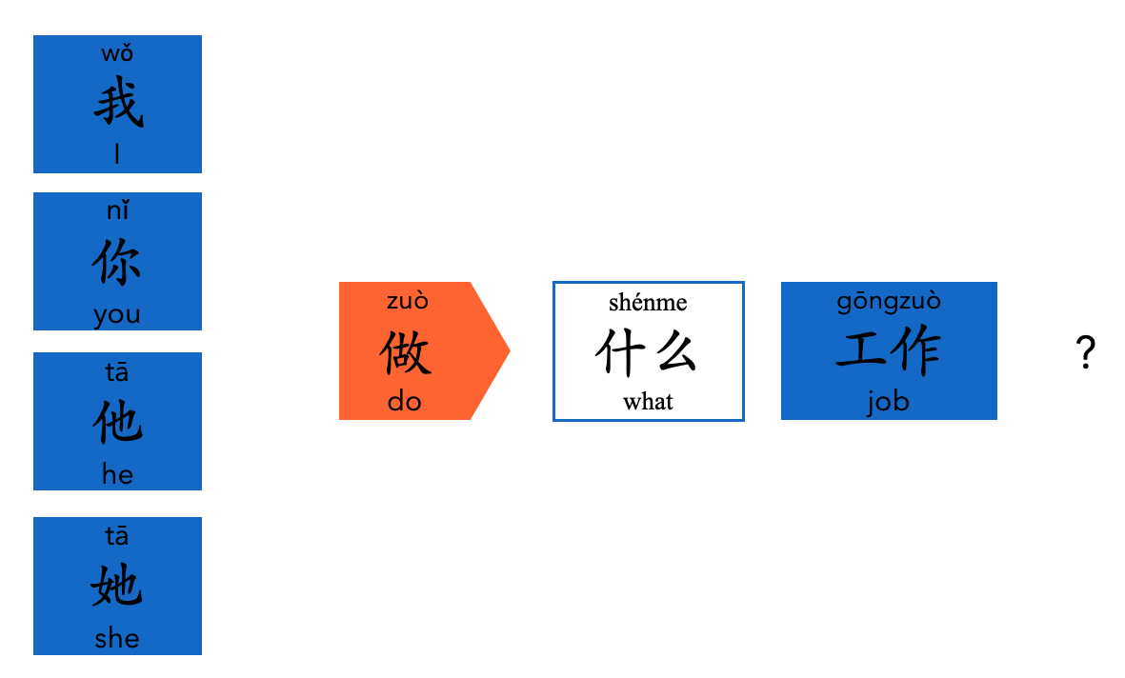

sentence builder 2

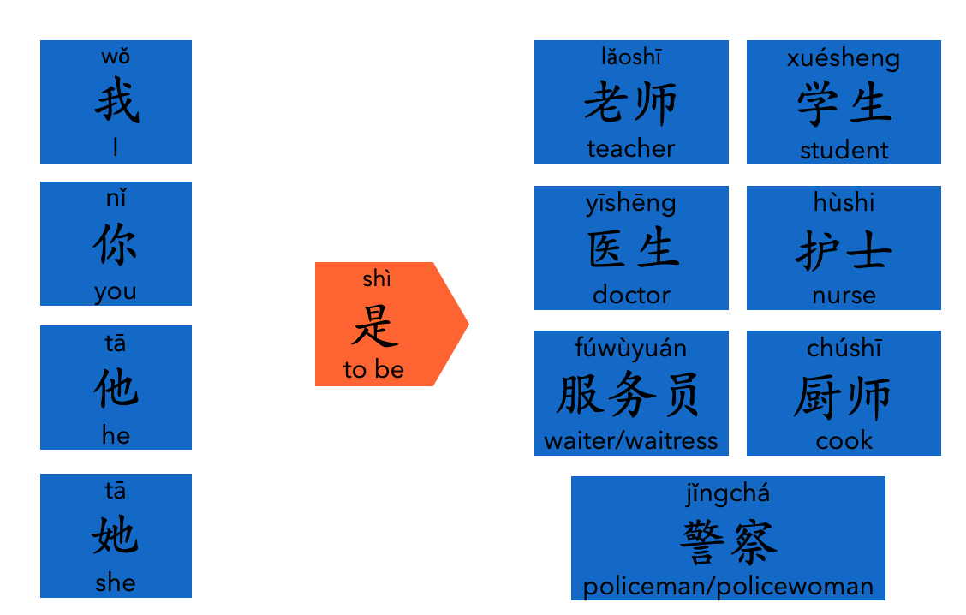

sentence builder 3a

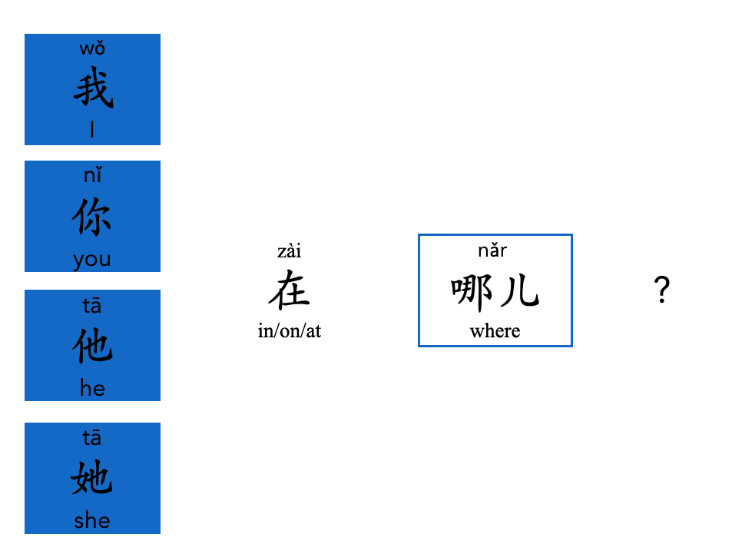

sentence builder 3b

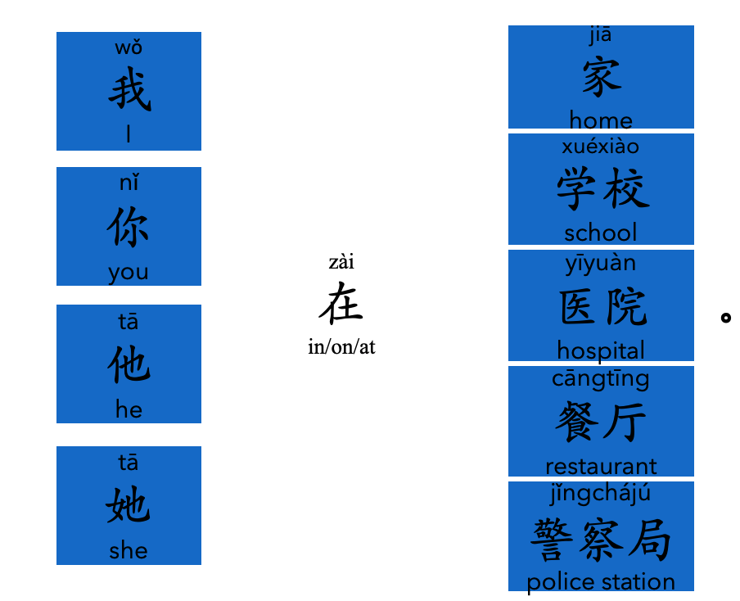

sentence builder 4a

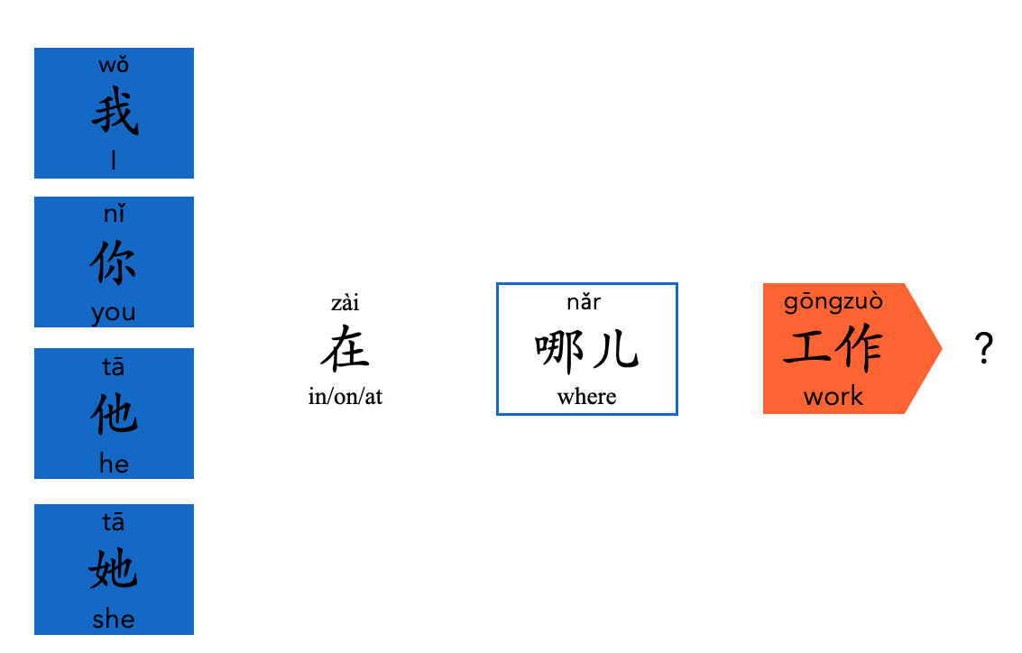

sentence builder 4b



