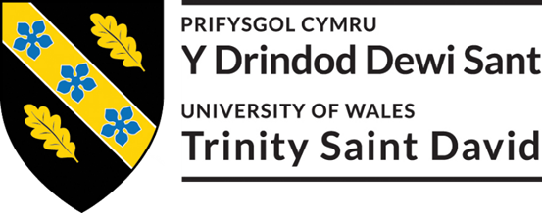

Five years on: an analysis of how social businesses are impacting on Wales
Master of Business Administration Dissertation
may 2018

By: Luminita Somicu Supervisor: Dr Louise Emanuel

DECLARATION

This work has not previously been accepted in substance for any degree and is not being concurrently submitted in candidature for any degree.

Signed: Luminita Somicu (candidate)
Date: 16/05/2018

STATEMENT 1
This work is the result of my own investigations, except where otherwise stated. Where correction services have been used, the extent and nature of the correction is clearly marked in a footnote(s).

Other sources are acknowledged by footnotes giving explicit references. A bibliography is appended.

Signed: Luminita Somicu (candidate)
Date: 16/05/2018

STATEMENT 2
I hereby give consent for my work, if accepted, to be available for photocopying and for inter-library loan, and for the title and summary to be made available to outside organisations.
Signed: Luminita Somicu (candidate)
Date: 16/05/2018

Acknowledgements

Special thanks are due to:
Dr Louise Emanuel, my dissertation supervisor – thank you for the encouragement and enthusiasm shown along the way! Your support has been truly invaluable and has guided me to accomplish my greatest academic success to date!

My family and close friends – thank you for putting up with me, for being there when I needed you the most! You are all amazing and I am so blessed to have you in my life!

My best friend K – thank you for the love and support, and for being such an inspiration at times when you are facing the toughest challenge of your life!

All participants that agreed to answer the interview questions, as well as those that kindly shared the weblink with young people for the online survey. I could have not done it without their assistance!

Abstract

As a progressive work from a research undertaken five years ago, this current piece of writing intended to boldly analyse how social businesses are impacting on Wales. For the purpose of this research, ‘social businesses’ (SBs) have been used as an umbrella term to include social entrepreneurship main hybrid models of SBs structures and activities.

At times of economic uncertainties due to Brexit, extreme funding cuts and rising levels of various inequalities, in Wales SBs are focusing on change and cultural planning to generate social change and address unmet societal needs, operating in areas of deprivation with the social mission to fight poverty.
More precisely, the literature review sought to establish the impact social businesses produce in Wales by looking at specific factors such as economic growth, unemployment and SBs education targeting the 18-24 age group, and a comprehensive PESTEL analysis amongst others. Furthermore, through an exploratory approach and employing a mixed method research more specifically online survey and interview, new quantitative and qualitative data has been gathered.

The overall findings have revealed that over the last five years SBs have shown positive growth contributing to Welsh economy and providing job opportunities, thus the alarming number of economically inactive people is a key indicator of a struggling economy that is not maximising on its assets.
Regarding SBs education, although efforts have been made towards improving the awareness and promotion of SBs, the findings clearly indicated a discrepancy between rhetoric about what was said on paper and what was actually found through new data when put in practice as only ONE out of 23 students was able to name some benefits of SBs in their local community. The main issue here being that in the near future, the Welsh youth would inherit the responsibility to find solutions to numerous deep-rooted economical, societal and environmental problems, yet they are not receiving the relevant education that could enable them to unlock the next generation of social entrepreneurs and nurture social innovation. Making provisions for the future must include today’s youth as this is perhaps the only one-time chance to secure a sustainable economic growth and seize forthcoming possibilities.
Nevertheless, the PESTEL analysis has identified several impending opportunities and challenges and these have been unanimously supported by the participants answering the interview questions; most notably Brexit was said to be both beneficial and damaging. Beneficial as it will force SBs to become more reliant in their own resources and harness from social innovation to capitalise on financial independence, and at the same time damaging due to the unknown and uncertainty that this may bring.

Conclusively, this research has minimised the knowledge gap and determined the importance of SBs to the Welsh economy and general well-being of people living here by producing a systematic analysis of how SBs impact on Wales.
As detailed in the very last chapter, several recommendations have been made with the potential of addressing the inconsistencies found within the study.

Contents

List of Figures and Tables 7
Figures 7
Tables 7
List of Abbreviations 8
Chapter 1: INTRODUCTION 9
Background to Subject Area 9
Research Question Aims and Objective 10
Conclusion 11
Chapter 2: LITERATURE REVIEW 12
Introduction 12
Definitions: Revision and Update 12
Entrepreneurship and Social Entrepreneurship 12
Social Businesses and Social Entrepreneurs 14
Social Businesses: Five Years On Measuring the Impact 15
Growth of Social Businesses 15
Young People and Unemployment 17
Social Business Education 18
The Impact 21
PESTEL Analysis of Wales 24
Political trends 24
Economic trends 25
Social trends 26
Technological trends 27
Environmental trends 27
Legal trends 28
Social Businesses: The Future within PESTEL Framework 28
Opportunities 29
Challenges 30
Conclusion 31
Chapter 3: METHODOLOGY 32
Introduction 32
Research Rationale 32
Research Design 33
Sampling Framework Selection and Size 35
Data Analysis and Technique 36
Ethics, Reliability, Validity and Limitations 37
Conclusion 39
Chapter 4: ANALYSIS OF RESULTS 40
Introduction 40
Presentation of Findings 40
Online Survey 40
Interviews 46
Conclusion 61
Chapter 5: CONCLUSIONS AND RECOMMENDATIONS 62
Introduction 62
Conclusions 62
Recommendations 64
REFERENCES 65
APPENDIXES 86
Appendix 1 Online Survey Questions 86
Appendix 2 Interview Questions for Academics 88
Appendix 3 Interview Questions for Social Businesses 89
Appendix 4 Online Survey Q7 Answers 90
Appendix 5 Interview Transcripts 91

List of Figures and Tables

Figures
Figure 1 Mapping Social Businesses 15
Figure 2 Participant 18+ age consent 40
Figure 3 Participant Location 41
Figure 4 Participant Age 42
Figure 5 Gender Identity 42
Figure 6 Participant occupation status 43
Figure 7 Awareness of local social businesses 43
Figure 8 Benefits of social businesses within local community 44
Figure 9 Willingness to know more about social businesses 45

Tables
Table 1 Skills Certificate Challenge 19
Table 2 Q7 Further analysis 44
Table 3 SBs main benefits to local community 45
Table 4 Social Businesses and their employees 48
Table 5 SBs Strategies for recruitment and retention 48
Table 6 Tools and Methods for Social Impact Measurement 49
Table 7 PESTEL Opportunities 50
Table 8 PESTEL Challenges 52
Table 9 Achieving better social impact (1) 53
Table 10 Achieving better social impact (2) 54
Table 11 Achieving better social impact (3) 54
Table 12 Achieving better impact (4) 54
Table 13 Question 7 original answers 91

List of Abbreviations

AE | Academic Education
AI | Artificial Intelligence
AM | Assembly Member
AS | Academic Support
DT | Department for Transport
EU | European Union
GCC | Global Citizenship Challenge
GDP | Gross Domestic Product
GDPR | General Data Protection Regulation
HEFCE | Higher Education Funding for England
MMR | Mixed Method Research
MP | Member of Parliament
NAO | National Audit Office
NAW | National Assembly for Wales
NHS | National Health Service
PESTEL | Political Economic Social Technological Environmental Legal
PPIW | Public Policy Institute for Wales
QAA | The Quality Assurance Agency
SBs | Social Businesses
SCC | Skills Challenge Certificate
SE | Social Entrepreneurship
UK | United Kingdom
VUCA | Volatile Uncertainty Complexity Ambiguity
WCVA | Wales Council for Voluntary Action
Welsh Bacc | Welsh Baccalaureate
WG | Welsh Government
YP | Young People

Chapter 1: INTRODUCTION

A term that best describes the external business environment is VUCA standing for volatility, uncertainty, complexity and ambiguity (Whiteman, 1998:15) is suggesting that change is not only the new normal but also indicating the speed at which this happens, the prospect of the unexpected and its multiple of issues that are becoming increasingly challenging (Harries, 2016:8; Casey, 2017:2). The main headlines news of today’s world is full of articles about poverty, crime, terrorist threats, environmental pollution, natural disasters, economic crises, diseases and many more (Tran and Von Korflesch, 2016) a reality that is creating one uneven field for economic growth.
At present, the landscape of the Welsh economy is roughly shaped by the inequalities deeply rooted in areas such as education, economic development, health, housing and social care (Gwilym, 2015; Jones, 2016).
To tackle these inequalities, in 2015 National Assembly for Wales (NAW) has introduced a new ground-breaking piece of legislation called ‘The Well-being of Future Generations (Wales) Act 2015’ which requires public bodies in Wales to form feasible long-standing partnerships with each other, others (private and third sectors) and communities so that the decisions they make, will have a positive impact on existing and future generations.
The Act is a legal obligation inclusive of everyone to pursue sustainable development and to improve social, cultural, environmental and cultural well-being of Wales by eradicating inequality (adapted from NAW, 2015).
Part of this partnership, social businesses are playing a significant role and as the title implies, this piece of research intends to analyse the impact they have on Wales.

Background to Subject Area
Past research of five years ago looked into examining how young people (YP) in Wales perceived social entrepreneurship (SE) in the light of socio-economic environment back then which was marked by high rates of youth unemployment and its negative social costs such as financial hardship, poverty and debt in the rural Wales.
The main aims and objectives of previous research were to determine how the awareness of SE could be promoted and increased so that YP were mindful of their existence and based on their views, understand the positive difference social businesses would have made at such difficult times.
Through the contribution of academic and non-academic writers, the literature review had addressed topics such as the origins and definitions of entrepreneurship (traditional and social), types of SE and their aims and objectives, barriers preventing them from growth and how SE generally benefited areas of social exclusion and the tackling of youth unemployment in Wales. The research also revealed gaps in the literature regarding the popularity of SE, their contribution to the Welsh economy and an overall lack of evidence of the actual social impact SE had in Wales.
To make the matter worse, the weight of evidence from primary data findings and their analysis, unveiled that efforts to teach SE education were not visible as this was not a topic included in the teaching curriculum with only a small number of business studies students at college level had the opportunity to be familiarised with the topic and this was by the choice of one lecturer’s enthusiasm and motivation to provide the students with alternative career options to benefit them and the wider community.
The implications from the theory and practice findings clearly indicated that a greater deal of work needed doing in the area as, although the literature review provided evidence that there were efforts made to promote SBs, in practice and specific to the targeted geographical area, YP knew very little about the topic and its benefits (Cone, 2009; Nga and Shamuganathan, 2010; Beer, 2012; Herbert, 2012; Walters, 2012).
Consequently, it has been suggested that ‘future work should examine other important factors in relation to the actual impact SE is having Wales’ (Somicu, 2012 in Somicu, 2018).

Research Question Aims and Objective
The title ‘Five years on: an analysis of how social businesses are impacting on Wales’ puts five years as timescale on this progressive piece of work, time in which it is hoped that social businesses have increased profile and overall contribution to the Welsh economy, which is exactly what this research will attempt to analyse.

Therefore, based on previous and current findings, this research has the following aims:
Aim One: To establish the benefit of social businesses for the Welsh economy five years on since past research.
Aim Two: To examine the social impact social businesses achieve in Wales.

The main objectives are inclusive of:
Objective One: To revise how much do the young people of North / Mid Wales presently perceive and use social businesses.
Objective Two: To investigate how social businesses in Wales achieve social change.
Objective Three: To establish how social businesses in Wales measure their social impact.
Objective Four: To forecast opportunities and challenges that social businesses in rural North and Mid Wales may face in the next five years based on the current findings.

The strategy in place to fulfil the above aims and objectives, is straightforward and systematic, and it will enquire informed research from both secondary data in Chapter 2. Literature Review as well as raw primary data findings from Chapter. 4 Analysis of Results, whilst the detailed procedure of how the whole research will be carried out is described step-by-step in Chapter 3. Methodology. Lastly, Chapter 5. Conclusions and Recommendations will inform the reader if the research’s aims and objectives have been fulfilled, what has been decided and what several potential references for future research might be.

Conclusion
The scene for this research has been set within this chapter, predicting an interesting journey in the world of Welsh social businesses, having past research as a starting point. The following chapter will determine how far social businesses have got in terms of growth, attempting to deal with unemployment and promote enterprise education amongst YP within 18-24 age group as well as identifying opportunities and challenges social businesses will encounter in the future.

Chapter 2: LITERATURE REVIEW

Introduction
This chapter brings together an exciting array of secondary research resources to firstly revise and update terms such as ‘entrepreneurship’, ‘social entrepreneurship’, ‘social businesses’ (SBs) and ‘social entrepreneurs’. Secondly, the research is looking into identifying how SBs have achieved growth at times of high unemployment rates and poverty, as well as tracking the progress made within entrepreneurship education, more specifically SBs education.
Thirdly a PESTEL (political, economic, social, technological, environmental and legal) analysis is carried out to classify main current and future trends within the external environment.
Lastly, findings from within PESTEL will lead the secondary research to identify the main opportunities and challenges that SBs should be aware of and prepare for to continue in their race to achieving the desired social impact.
Subsequently, the secondary findings will inform the research of what is happening from a theoretical point of view, with the hope that primary data findings will determine the reality of things when theory is applied to practicality.

Definitions: Revision and Update
It has been argued that the lack of one accepted definition that could exclusively represent entrepreneurship (Chell et al., 1991; Kirby, 2003; Rauch et. al., 2009) and a conceptual framework, has made entrepreneurship according to Shane and Venkataraman (2000:217), a ‘broad label under which a hodgepodge of research is housed’. Therefore, a comparison between previous research undertaken five years ago and current, more up-to-date definitions will be drawn in the first part of the literature review chapter to show of any improvements in the field.

Entrepreneurship and Social Entrepreneurship
A summary of the research undertaken previously (Somicu, 2012), has identified entrepreneurship as the process of revitalising economies worldwide by converting new ideas into profitable and sustainable new economic entities, having a positive impact on job creation, a process that societies and governments encourage and promote (Birley, 1986; Curran and Stanworth, 1989; Zahra, 2005; Burns, 2008). Having a transient advantage, entrepreneurship integrates key features such as vision, innovation, risk taking, and an implementation of a required knowledge, practicality and spot-on perception of the needs catered for to generate profit and personal wealth (Eckhardt and Shane 2003; Martin and Osberg, 2007; Boschee, 2012; Kauffman Foundation, 2012).
Moreover, the belief that entrepreneurship is becoming a crucial factor in the development, well-being of societies and economic growth, is embraced by most economists and academics (Reynolds et. al, 1994; Katz, 2003; Abu-Saifan, 2012; Carlsson et. al, 2013) yet, finding a recent academic definition of entrepreneurship is proving difficult. While entrepreneurship is still young in the academia world, it has been advanced for decades in many subfields within many disciplines such as economics, management and business administration beside business history, sociology and psychology to name just a few (Carlsson et. al, 2013), consequently the concept of entrepreneurship is ‘ill-defined but still as multi-dimensional as ever’ (Somicu, 2015). Associated with the ‘the identification, evaluation, and exploitation of opportunities’ (Shane and Venkataraman, 2000), entrepreneurship could be described as ‘the pursuit of opportunity beyond the resources you currently control’ (Stevenson, 2004:3). In their turn and building on this, Carlsson et al. (2013) define entrepreneurship as:
“an economic function that is carried out by individuals, entrepreneurs, acting independently or within organisations, to perceive and create new opportunities and to introduce their ideas into the market, under uncertainty”.
Although the above newer definition gives a more punitive approach to the understanding of entrepreneurship as the process that creates economic value, yet still supportive and adding credence to past research.
In the same vein, due to its visible and tested impact on the economic and social development (Peredo and McLean, 2006) SE, an important sub-field of entrepreneurship (Austin et al., 2006; Steyaert, 2006), is no longer simply a fad, or a vague idea as argued by Leadbeater (2007) and in the last five years it has been increasingly researched and mainstreamed (Rey-Martí et al., 2016).

Having said that, researching for a unified definition is futile. Focusing on change and cultural planning to create social value, SE differentiates from traditional entrepreneurship in the value proposition itself and purpose (Nicholls and Young, 2008; Briggs, 2009; Grassl, 2012). Referred to as the process that makes use of innovation and combinations of resources to chase opportunities, SE generates social change and address unmet individual and societal needs (Carraher and Welsh, 2015).
Employing social innovation and with prime strategic focus on social impact (Nicholls, 2008; Choi and Majumder, 2014) currently, SE has become so inclusive that is blurring the traditional borders between the other sectors (public, private and non-profit) to accentuate main hybrid models of social activities (Martin and Osberg, 2007; Tran and Von Korflesch, 2016).

To avoid confusion, the term ‘Social Business’ is going to be used as an umbrella term (Allies and Irving, 2017) that includes SE’s main hybrid models of social business structures and activities (Perrini, 2006).

Social Businesses and Social Entrepreneurs
Regardless of its registered status i.e. social enterprise, community owned business, co-operative, credit unions, trading charities, housing associations, development trusts, mutual and employee owned businesses etc., and although different in structure – generally, a social business has a social purpose, is financially sustainable, generates social impact and reinvest all profits back into organisation (Young, 2007; Yunus, 2010; Social Business Wales, 2018).

A social business is one with a conscious and community orientated with the mission to create social good for people living in that community, investing in social inclusion and opportunities to better our world, whilst simultaneously pursuing economic, social and environmental goals
tackling market failures (Nicholls, 2006; Haugh, 2007:743; Borestein and Davis, 2010; European Commission, 2011; Social Business Wales, 2018). Similarly, Roberts and Woods (2005:49) have defined SE as:
“the construction, evaluation and pursuit of opportunities for transformative social change carried out by visionary, passionately dedicated individuals”.
In this context, social businesses (SBs) are the creation of the adequately able social entrepreneurs, the prime agents of change attempting to generate and sustain a social value whilst filling gaps or basic needs of a society that does not have the necessary means to achieve positive social change on its own (Schumpeter, 1949; Dees, 1998; Bornstein, 2004; Martin and Osberg, 2007; Briggs, 2009; Durieux and Stebbins, 2010:10).

According to Certo and Miller (2008:267) the social value is not about profit making but driven by the prerequisite to fulfil elementary needs: provision of food and water, shelter, education and medical facilities. For this to happen, there is a great requirement for solution providers, socially responsible social entrepreneurs that own talent, skills, innovative thinking and a can-do attitude to address some of coarsest problems that society faces nowadays (Glancey and McQuaid, 2000; Nicholls, 2008).

Social Businesses: Five Years On Measuring the Impact
Bridging an imperative gap between business and social action and developing in one of the most current business model, SBs resolve social problems in a sustainable way (Roberts and Woods, 2005; Briggs, 2009; Douglas, 2018).

Growth of Social Businesses
Research undertaken five years ago determined main areas where challenging social problems were commonly found: health care, unemployment, poverty lessening through empowerment, education and training, community regeneration, welfare projects, advocacy and campaigning, and environmental preservation (Borstein, 2004 cited in Somicu, 2012). Present research slightly increases the above list by adding the protection of vulnerable people (including children and YP), addressing social and financial exclusion, supporting other SBs and providing affordable housing (Allies and Irving, 2017).
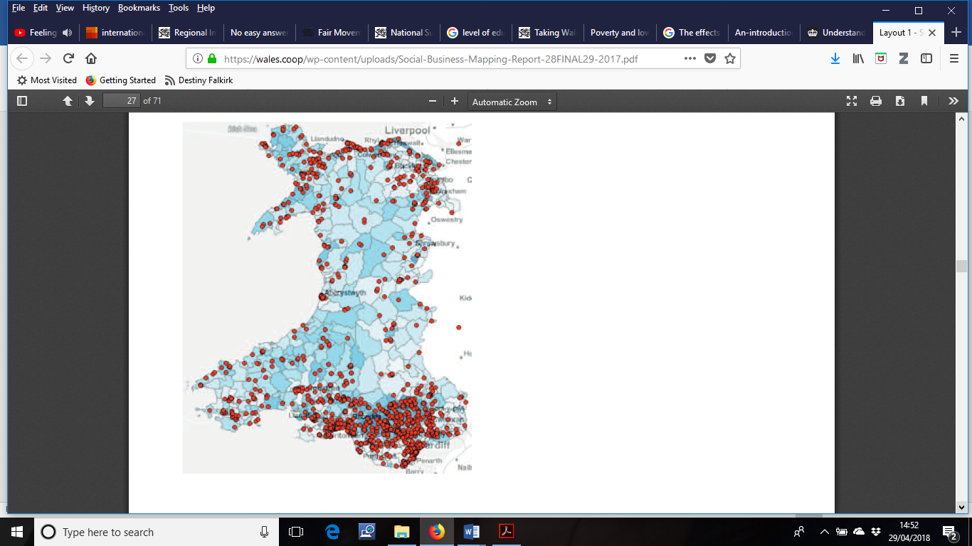
Commissioned by Social Business Wales, the report ‘Mapping the Social Business Sector in Wales’ undertaken in 2017 by Oliver Allies and Jessica Irving is the only most comprehensive and up-to-date study on the Welsh SBs. They have found that in Wales, SBs mostly operate in areas of deprivation with the social mission to fight poverty. The map in Figure 1 (Allies and Irving, 2017) is not only highlighting where SBs are located but also their propensity and presence in areas with high level of deprivation.
Moreover, the world we currently live in, is imposed upon by a multitude of complex social and environmental issues, hence SBs play a major part within any country’s economy and the social change they achieve is incremental to the support and development of existing and future generations (Braunerhjelm and Hamilton, 2012).
Additionally, their findings show that in some of the geographical areas, the number of SBs have exceeded the number of businesses in the private sector, playing a major part in the Welsh economy creating an unprecedented social impact (Allies and Irving, 2017).
Figure 1 Mapping Social Businesses
An older study mapping the social business sector in 2008 had highlighted the following: SBs were contributing by 2.6% (of £2.2 billion brought by all enterprises in Wales) to Welsh economy, employing 29, 000 full-time and 20,000 part-time staff accounting for 3.6% of jobs in Wales as well as offering volunteering opportunities to 105,000 people (NAW, 2010).
In 2015, another study by Welsh Co-operative Wales emphasised the growth of SBs in Wales: £1.7 billion value of social business; 38,000 number of employees; 19% of them were founded within the last three years; 40% are in rural areas; 19% said that a quarter of their employees are disadvantaged in the labour market.
The latest study by Allies and Irving (2017) has revealed that there are 1,698 SBs in Wales, worth £2.37 billion to the economy, providing 40,800 jobs and between 48,000 and 58,000 volunteering opportunities.

Covering a broad range of services, local authorities are extremely stretched due to limited funding with most deprived areas having already seen the worst of the cuts, impacting even on the protected services namely education and social care, making 2018 a ‘watershed’ year for the Welsh finances; yet, in 2019/20 the Welsh government will have £1.1 billion less for public spending (Wales Public Services 2025, 2017; Winckler, 2017).

Standing the test of time, SBs continue to emerge and succeed mainly due to the public sector’s inability to meet the needs of its residents (Spear, 2001; Mair and Marti, 2006; Sharir and Lerner, 2006), leading to the number of SBs start-ups targeting social market failures to surpass those of more traditional businesses (Alvord et. al, 2004; Harding and Cowling, 2004; Allies and Irving, 2017).

Young People and Unemployment
Despite great efforts to reduce unemployment and improving adult skills, but showing little improvement, the benefits cut, rising levels of deprivation and living costs - as a country within the UK, Wales is the most ‘poverty-stricken’ (Bulman, 2018). Unemployment, especially concerning the youth in a society is a key indicator of a struggling economy that is not maximising on its assets (Politics Online, 2012).

Research five years ago noticed that 16-24 age group were hardest hit by unemployment as statistics of 2011 showed that in Wales: 50,500 young people were unemployed, another 140,200 economically inactive; additionally scoring the highest upsurge of youth that were not in education or training, making youth unemployment one of the biggest challenges that Welsh government needs addressing as this is generally associated to social costs such as poverty, debt and financial hardship (McClelland and Macdonald, 1998; Office for National Statistics cited in Jennings, 2011; West, 2012; ACEVO, 2012).
Recent statistics have shown that between December 2017 to February 2018 - 700,000 people were unemployed and 430,000 people were economically inactive; additionally, for the year ending 31 December 2017 an estimated number of 28,700 people aged 16-24 in Wales were unemployed (Gov.Wales, 2018). Analysing the findings from 2011 and 2017-18, the number of unemployed young people has decreased, yet it is difficult not to remark the staggering difference of people that are economically inactive.

In a world where competitiveness and productivity are critical to achieving economic growth, a new poverty that is associated with low self-esteem, poor education, low skills, job insecurity and health issues, has already taking over aiding social exclusion in Wales. The new poverty encompasses both of money and income, as well as other characteristics of exclusion (Grieco, 2015).
In 2018 an investigation by Joseph Rowntree Foundation has revealed that 710,000 people of which 185,000 are children, 405,000 working-age adults and 120,000 pensioners live in poverty in Wales. Unemployment has a multitude of negative effects firstly on the individual and secondly on the society as it facilitates the changeover of poverty on future generations, encourage illegal activities and disruptive behaviour to earn money (Jennings, 2011).
And although SBs in Wales have already proven to make an incredible positive difference (based on their money value contribution and job creation) year on year, there is still more to do to challenging youth unemployment. One feasible solution would be to give YP the opportunity to learn about SE and the social change SBs continue to achieve.

Social Business Education
It has been well documented that education in general is crucial to shaping attitudes with the impact of determining future success, a ‘milestone’ of a country’s economic development, equipping individuals with self-esteem and confidence (Ross and Wu, 1996; Birdthisle, 2008; Idris et al., 2012) and concerning YP, it has the main purpose to aid them gain certain qualifications, improving their chances for entering higher education or securing better employment prospects (Payne, 2003).
In a world where change is the only constant, education content should alter context to complement the demands imposed by the changes in social, economic and environmental varieties; education levels will indicate how capable individuals are of managing quality of life; a deficit in educated people will have a major impact on future progress (Ross and Wu,1996; Idris et.al, 2012).
Particularly, enterprise education as identified by The Quality Assurance Agency for Higher Education {QAA (2018)} develops proficiencies such as enquiry, critical thinking and future orientated thinking equipping individual with the ability to face any career challenges with gained awareness for community and social responsibility.

In theory, SBs education is beneficial for a variety of reasons: could increase awareness among YP, promotes the social responsibility that everyone should have towards society, emphasises a new business structure that is dynamic, ethical and sustainable that already has well-established reputation to positively impacting when tackling wider social, economic and environmental concerns (Cone, 2009; Rae, 2010).
In practice, past research revealed that SBs education was non-existent with Coleg Ceredigion being the only educational institution in the region to incorporate some SE teaching by one lecturer’s choice to inspire and nurture social change. Furthermore, the findings clearly exposed that 54% of the college and university business students taking part in the research knew nothing or very little of SBs; 77% did not know of any social businesses operating in the area; 92% were aware of some negative effects that unemployment had overall; and 77% of them were never involved in SBs type of projects. When asked to suggest ways of increasing SBs awareness, 73% of them gave varied answers including: through schools and colleges; involvement in activities with social purpose; a general inclusion of SE courses and a better profiling in the media of successful SBs as role models (Somicu, 2012).

These findings advocated for a better liaison amongst Welsh Government, education providers, Edexcel and BTEC courses to integrate SBs learning as part of the teaching curriculum in Wales to give YP the opportunity to understand the importance of SE and the opportunity to be part of it if they choose so. In agreement with this, Wilson (2011) has acknowledged the need for a strong infrastructure to support and enhance the development of enterprise in general, across the teaching curriculum.

Five years on - in theory a significant progress has been made towards enterprise and SBs education. Perhaps the most notable one is the introduction in 2015, of Skill Challenge Certificate (SCC) within the Welsh Baccalaureate (Welsh Bacc) in Wales. Welsh Bacc is a qualification for 14 to 19 years old students in Wales and it is said to provide engagement opportunities for learners as part of a continuum meant to bridge education from school to further education frameworks and in preparation for employability, further study, societal responsibility and contribution to benefit both: community and economy (Mason et al.2006:2; Blackmore et al. 2016:10; Qualifications Wales, 2017, WJEC, 2018).

Table 1 Skills Certificate Challenge
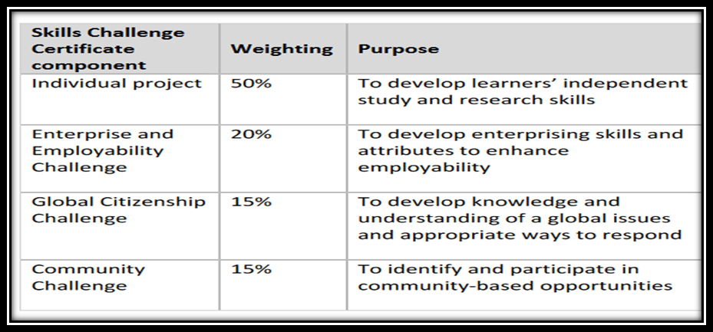
SCC has been introduced with the purpose to encourage real world learning, ensuring that students would develop seven essential employability skills such as ‘numeracy, literacy, digital literacy, critical thinking, problem solving, creativity and innovation, personal effectiveness, planning and organisation’ (Engeli and Daly, 2018:11). Additionally, 50% of the SCC is enterprise education including global citizenship and community challenge, as it can be seen in Table 1 (Engeli and Daly, 2018).

Such effort is designed to work in partnership with other governing bodies in Wales: Big Ideas Wales offers invaluable full support and advice for enterprises in general, whereas UnLtd and Social Business Wales are tailored specifically to provide for all needs SBs may have, from business support, industry awards, small cash awards support, coaching and networks to stimulate social entrepreneurship for all aged 16 and over. Furthermore, competitions such as Global Citizenship Challenge (GCC) taking place every year, is not just a requirement for passing the Welsh Bacc qualification, but it is also intended to allow students to demonstrate knowledge and understanding of global issues including PESTEL factors (Engeli and Daly, 2018).

At university level, as a recommendation made by Lord Young in ‘Enterprise for All’ report (2014), UK universities have added optional modules to their already existing courses so that all students could have access to entrepreneurship education, thus the problems arising from here are threefold. Firstly, Matt Clifford (cited in Elmes, 2016) co-founder at ‘Entrepreneur First’, argued that integrating entrepreneurship in a traditional business school is a painful task as it looks like ‘grafting’ on other curriculums. Secondly, delivering entrepreneurship education within traditional academia does not fully work, unless successful entrepreneurs do it in a non-traditional way as they got first-hand experience. Lastly, Henry Jinman (cited in Elmes, 2016) the Co-founder at ‘Crowdfund Campus’, claimed that using traditional business plan as a method of assessment should not be allowed as this is deterring entrepreneurship education. He asserts that traditional business plans do not allow for failure and, to support this Vendel and Brown (2012) maintains that traditional business plans are made to meet the needs of a variety of stakeholders whereas an entrepreneur will decide what planning tool will be used based on factors such as the identified opportunity or problem, the resources constraints, skills and experience at hand.

Overall, investigation by Higher Education Funding for England (HEFCE) revealed that entrepreneurship is becoming better known as a career pathway in the UK – between 2014 and 2015 there were 4,160 new graduate start-ups (QAA, 2018). In Wales, Ken Skates the Cabinet Secretary for Economy and Transport through Prosperity for All: Economic Action Plan (2017) report, is calling for more entrepreneurship and innovation driven enterprises at all levels of education.

Five years on in theory look promising, however it will be interesting to see what the new primary data of this research is going to reveal in Chapter 4. For now, it can be concluded that in Wales, there has been a positive approach and progress towards the promotion of enterprise and SBs education with qualifications and support to ensure that YP take the advantage of learning about a career direction that could be more rewarding whilst making a difference and achieve social impact.

The Impact
Research undertaken five years ago has established that SBs could be the answer to enhancing growth, reducing poverty and improving social development on a large scale with far reaching economic impact (Yunus and Weber, 2008; Zahra et. al, 2009; James, 2011; McMullen, 2011). Current research among other enquiries, is looking at the nature of social impact through the lenses of social value and social change that is achieved by SBs activities within a society, as well as ways of measuring it with both quantitative and qualitative scales.
Defined by Dietz and Porter (2012) as ‘something of value for society’, social value is difficult to quantify as this is part of a conscious objective had by single minded social entrepreneurs with unique ethical make-up, a drive and strong commitment to social justice mirrored in their main SBs objectives (Bochee, 1995; Bornstein,1998; Catford; 1998) and positioned at the ‘heart of their vision’ (Briggs, 2009) in the pursue to relentlessly achieve social change. Changes happening in human interaction and relations altering cultural and social institutions, are defined by sociologists as changes that often have deep and longstanding costs for society (Dunfey, 2017).
To combat social constraints generated by change, SBs make use of resources in an innovative way to explore and exploit opportunities in a sustainable manner, having a clear strategy in place to deal with social change (Sud et al., 2009:203; Branzei, 2012). Social change too, cannot easily be quantified. Value is fundamentally subjective, and people see it as the benefits social SBs generate through social changes (Kirkland, 2012).

Social impact provides a balance between ‘teaching people and raising awareness of a particular issue, as well as contributing back to a community or location to support them in overcoming what they have identified to be their biggest challenges’ (DeSimone, cited in Schwartz, 2017). Usually, the consequences of an action taken is going to create change in something or someone else, impacting either positively or negatively. Adding the social in the mix, the impact is the value of an action taken to address a social need identified in a society (Meldrum et al., 2017). Paradoxically perhaps, there are ways of measuring social impact and the next section is going to elaborate on how it could be done.

When measuring social impact, a wide array of key indicators should be considered and as suggested by Bagnoli and Megali (2011) these should include Inputs, Outputs, Outcomes and Impacts: the resources requested and allocated to undertake activities; the revenue in terms of completed actions to achieve the mission, including countable goods or services provided; the results in terms of benefits or impact for the targeted recipients; and the overall consequence for the wider society (Kendall and Knapp, 2000; UK Voluntary Sector Research Group, 2003).

A survey undertaken in 2015 by the Welsh Co-operative Centre revealed that most SBs in Wales taking part, were aware of the importance of measuring own social impact with only 8% of them not performing social impact measurement; some used a variety of tools for measurement, 25% said they were relying on received informal feedback, yet interestingly 63% of SBs have developed own bespoke tools to measure their social impact. Generating qualitative data mainly to measure the ‘soft outcomes’, it is common for SBs to use feedback questionnaires or diaries for recipients to fill in, providing SBs with recorded evidence of a comparative importance that social value generated by the changes their experience (SEEAhead, 2015; Social Value UK, 2018).

Given the significance of measuring social impact and to quantify outputs, a more complex social reporting could be employed to assign monetary value to it (Meldrum et al., 2017) and to achieve this, one method that is widely used out is Social Return On Investments (SROI).
In brief, SROI is a method that is generally accepted within and outside of the UK, used for outcomes identification and valuation by taking into consideration and depended on the findings from all inputs, outputs, outcomes and impacts that SBs create (SROI Network, 2012; Social Value Lab, 2018), however to quantify the value an accounting formula is used:
SROI = Impact Value / Input with the result showing how much social return is achieved from every pound spend to generate impact value. The method works and is employed widely, however SBs should be careful not to exaggerate values as aforementioned, social value is not easily quantified (Dietz and Porter, 2012; SEEAhead, 2015).

Research has shown that measuring social impact is essential as a proof of whether the change SBs aim to achieve is taken place and that social value is created, ultimately helping them to put a better system in place to attain sustainable change in the future (Meldrum et al., 2017; Pierce, 2018).
More importantly, past research has suggested that further work should be carried out to examine other important factors that determine the social impact generated by SBs in Wales, together with their benefits for the Welsh economy. And to identify those, as part of the literature review, a PESTEL analysis and SBs’ areas of impact within this framework would be included in the following sub-chapter.

PESTEL Analysis of Wales

Aguilar (1967), originally used the aide-mémoire ETPS for Economic / Technical (Technological) / Political / Social, however the acronym PESTEL which include Environmental and Legal factors is widely recognised as a tool (trends analysis) for scanning the external business environment and its complexity (Hooley et.al, 2008:59).
To counterattack and minimise future negative consequences posed by the emergence of new needs and growing demand for new services (Grieco, 2015) as well as identifying opportunities, an analysis of PESTEL would be undertaken in the attempt to predict and explore key drivers for change concerning SBs in Wales.

Political trends
Under a shaky Conservative leadership the overall political scenery in the United Kingdom (UK) displays a great degree of ambiguity where change is the new normal (Somicu, 2017). The banking crisis of 2008 still reverberates continuing to expose underlying discrepancies within political and economic spectrums (Erk, 2017).
To add to this, ‘Brexit’ referendum in 2016 to leave the European Union (EU) is impacting on the increased price for imports and the fall of the UK pound, reducing trade (Elliot, 2017) and, as part of the UK, Wales is experiencing similar political worrying signs. With devolved powers and responsibilities since 1999, vested in the NAW and the Welsh Government, Wales is divided into 22 elected councils known as local authorities that oversee all local government services i.e. economic development, education and training, health, housing, highways and transport, environment, food, agriculture and rural development, fire and rescue services, culture and Welsh language, social welfare, tourism and several others (Gov.UK, 2013; EURYDICE, 2018).

Vital to Welsh communities, EU funding has been incremental to traditional and social businesses (Pay, 2016) hence, Brexit is posing a great deal of uncertainty and could be the most disruptive factor having the potential to slowdown economic growth, promote de-globalisation and increase protectionism (Welsh Government, 2017).

Economic trends
Like a domino effect, any changes happening in the political environment can have a ripple effect in the economic spectrum and considering the above information it not only applies to the UK economic situation but is also relevant to the Welsh economy.

Main trends in 2017 indicated slow economic growth, consumer price inflation has risen to 2.9%, Brexit referendum has caused the fall to a 31 year-low of the British Pound value against the US dollar, reduction in disposable income, cuts regarding pay and downward living standards (Office for National Statistics, 2017; Wallace, 2016; Giles, 2017).
Last year, 3,170,000 people counted as Wales’ population (Population UK, 2017) with 1.4 million people in employment. According to StatsWales (2016), 176,600 non-UK individuals were residing in Wales of which 79,100 originally from EU countries, most of them in employment covering economic, public and education sectors, significant contributors to Welsh economy; the uncertainty of Brexit’s final outcomes would have a negative impact on migrant workers. A survey undertaken by the CIDP in 2017 unveiled that due to Brexit, the UK economy has already started to experience both skills and labour deficiencies (CIPD, 2017; Rodionova, 2017).

With a Gross Domestic Product (GDP) growth of around 1.2%; a lowest UK average Gross Value Added (GVA) per head of £18,002 when measuring productivity achieved by goods made and services provided; deindustrialisation; youth unemployment of 13.1%; poor infrastructure and transport links; a 2.9% inflation that is said to match or even outpace earnings increase; a potential rise of 3.9% for social housing rental; an increase of 5% in Council Tax; and a poverty rate of 23% (child poverty predicted to increase to 40% in the next two years) - Wales’ overall economic picture looks grim (Department for Transport, 2017; Hood and Waters, 2017; Gooberman, 2017; Bevan Foundation, 2018; Wales.Gov, 2018).

Henceforth, unemployment continues to be one negative trend that is having a direct impact on living standards, implicitly worsening poverty and hardship for many.
As per above, the brief outline of the economic trends would give anyone a good insight of the Welsh government leadership and the deficiency of clear, positive economic policies and viable frameworks.

Social trends
In considering what is happening in the political and economic spectrums, some important social trends could be anticipated. A less positive performance of GVA echoes a higher depended population when we consider demographic structures (income, poverty and age distribution), employment rates and lack of ‘economic mass’ due to low skills; future cuts in higher education will only emphasise the widening of retention gap between children from low-income families and others. Population in 2018 is forecasted to have a net increase of 9,500 people and it will be mainly in people aged 65+, signifying an ageing population rise, whereas the next 20 years might see a 5% increase overall.

In terms of health and social care, a mixture of bigger service demand, specialised staff shortages and gap in funding, is already creating a lot of pressure on the Welsh National Health Services (NHS) concerning health and wellness in general, but especially lifestyle type illnesses and mental health. In line with this, an ageing population could show an increase in dementia sufferers as it is predicted that by 2025 - 50,000 people aged 65+ may be living with this illness in Wales (McKinsey & Company, 2010:2; Ritson, 2011:31; Price, 2016; Slawson, 2017; Welsh Government, 2017; Bevan Foundation, 2018).

Crucially, the social trends depend somewhat not only on the economic conditions, but also on the wider VUCA environment in which some people live, the changes it brings and the creation of new needs.

Technological trends
The research is showing that in the future, technology such as artificial intelligence (AI) and automation could have a major impact on any economy’ structure due to the possibility of job losses estimating that 66% of current jobs are at risk (Lawrence, 2016; PWC, 2018). Moreover, greater productivity is achieved by machine intelligence where 3D printers are used for aircraft and high-performance racing cars components (PWC, 2017); new communications and navigation capabilities are available because of the satellite technologies; health and resources technologies and breakthrough for treating deadly illnesses, autonomous electric cars and robotic technologies are just several examples of future trends within this spectrum.
Meantime, a slow economic growth in Wales, the impact of Brexit and cuts in funding could mean that there will be scarce investments in the research and development of new technologies. The accelerating advancement in technology is already shaping the way we work, shop, consume and communicate with Internet playing an important part in this development (Government Office for Science, 2017; Welsh Government, 2017). However, with a poor infrastructure, a rural Wales is far from becoming a digital nation.

Environmental trends
One of the most controversial trend within this spectrum is climate change and the observed impacts that this is having on ‘physical, biological and human / managed systems’ (Stevenson, 2017) especially in terms of ecosystems and natural resources decline such flooding and Welsh coastal changes.
Flooding is a long-term risk to the country’s infrastructure with great negative implications for communities and businesses (Clark, 2013), hence the Welsh Government made this a priority and last year £32 million capital funding was made available to reduce the flood risk to over 2,100 homes and businesses across Wales (Welsh Government, 2017). Climate change future trends regarding the mitigation of carbon emissions in energy costs, are going to hit the poorest in the society as the prices for fuel, travel, housing and lifestyle in general, will upsurge (WCVA, 2017).

Legal trends
Ironically, most of the future trends to do with Welsh legislation are unknown and unpredictable since Brexit. There were serious concerned raised about the EU Withdrawal Bill which would have allowed the UK’s government to take control over the already Welsh devolved policy areas, once the separation of UK from EU has been completed. After long arguments and parties’ divides, the Welsh Assembly Members have passed the Continuity Bill as an emergency bill in the effort of transferring EU law into Welsh law in areas already devolved to provide Welsh businesses with certainty and stability from a legal point of view to continue their activities without unnecessary interrupted access to the EU market (BBC News, 2018; Welsh Government, 2018). Others argue this Bill, will in fact be a risky decision as it will create serious legislation uncertainty. Ultimately, the decision for the Continuity Bill to become a law, stands with the UK Supreme Court (BBC News, 2018).
Another much talked about piece of legislation, is the Europe’s new data protection law GDPR (General Data Protection Regulation) which comes into force on 25th of May 2018. GDPR will replace the 1995 data protection law and it will be adopted in the UK despite this leaving the EU. Beside substituting the old legislation, GDPR is putting consumers and citizens first regarding both personal and sensitive data, giving power to regulators to fine businesses that will not comply with the law (Information Commissioner’s Office, 2018; Local Government Association, 2018).

Social Businesses: The Future within PESTEL Framework

The identification of current and future PESTEL trends, creates a generous array of opportunities for SBs regarding longstanding and new-fangled needs, however challenges and the adoption of innovation, both open and social, are required for sustainable social impact generation.
Commonly, innovation is essential to business entities to produce and withstand competitive advantage (Cassiman and Valentini, 2013). Within PESTEL analysis, open innovation is the ‘use of purposive inflows and outflows of knowledge’ (Chesbrough, 2006a:1) that is engaging with external ‘actors and sources’ to help organisations ‘achieve and sustain innovation’ (Laursen and Salter, 2006:131). Besides, innovation is the most important feature in entrepreneurship, it reinvents ‘the pattern of value generation by exploiting inventions’ (Piccarozzi, 2017).
Moreover, social innovation translates ideas into action by bringing together problem-solving awareness and fresh creativity to build alliances and relationships (Echoing Green, 2018) and generate pecuniary revenues through positive social change. Social needs are usually triggered by new events, new data and research and as soon as a problem is acknowledged - ‘visibility creates ideas’ leading to social innovation taking control to find solutions (Murray et al., 2010).
Based on the PESTEL analysis findings five major themes could be put together to assess opportunities and challenges: Brexit, (youth) unemployment, health and social care, infrastructure and environmental preservation.

Opportunities
In terms of future opportunities, due to scarce donations and grants to fund their activities, SBs are creating services (and goods) to become more autonomous financially (Perrini, 2006); in doing so, they are engaged in the fight against poverty, how to improve people’s health and reduce carbon footprint, areas that they will continue to make a difference (Murray et al., 2010).

More specifically, considering youth unemployment and low skill base SBs could use their adaptive resilience to customise education and training programs to fulfil current labour shortages and make provisions for the future i.e. specialised / qualified staff to deliver services for the increase in number of dementia sufferers within the ageing population segment.
Similarly and to promote employment, collaboration and partnership with others (Echoing Green, 2018), could see SBs involved more in improving the infrastructure regarding transport links within rural Wales to increase job prospects i.e. unsociable hours shift work.

To preserve the environment, SBs will keep being a great advocate for adoption of greener lifestyles and sustainable green growth (Moncada-Paternò-Castello et al. 2017) to combat climate change. With great unexploited potential for renewable sources to produce energy, SBs will have a bigger role in renewable energy projects that have a proposed target of meeting country’s 70% electricity demand by 2020 (Regen, 2016; WCVA, 2017). Additionally, SBs will make use of Welsh eco-friendly policies to secure Wales’ place as the second in the world for best household waste recycler and will help towards achieving zero waste target by 2050 (Laville, 2017).

As innovation and technology continue to modify the world’s landscape, SBs could prepare the next work generation ready for industries and jobs of the future where a higher degree of skills will be required. In partnership with Welsh government SBs will have the opportunity to best tap in new technologies (AI and automation) as this will not only enable long-term economic growth and productivity but will also improve services delivery with great potential of enriching the lives of Welsh people (Government Office for Science, 2017; Welsh Government, 2017).
The future belongs to those that are prepared to be disrupted by technology and this is likely to affect all the other spectrums of PESTEL framework, therefore Wales must be technologically agile and prepared to deal with opportunities and risks that future may bring.

Challenges
As already discussed in previous sections, unemployment is a consequence of lack of education and skills and that its negative effects could be seen in the widespread of poverty and social exclusion throughout Wales. Fighting to recover from the joblessness when nearly a quarter (430,000) of working-age Welsh adults are economically inactive is proving to be an incredibly difficult task. With a flatline economy and rising poverty, it is clear that Welsh government is failing to positively impact on its people’s daily life.

Main challenges SBs have to contend with (currently and in the future), are found in all PESTEL areas but mostly in connection with Brexit, funding, low skill base, infrastructure and legislation.

Although the full outcome of Brexit and its consequences for Wales are not known yet - funding, public services, trade and investment will be hit hard as EU structural funding and farming subsidies will be stopped (Jones, 2016). In one way or another, all SBs are dependent of funding i.e. money coming in from either grant, donations and / or from providing services (goods) to their customers. Lack of money to fund sustainable business activities will lead to the difficulty to future proof revenue and disastrous no exit strategy in case things go wrong (Gardner et al., 2005).

Continued deindustrialisation and pressure on SBs to increase GVA input (Gooberman, 2017) coupled with a low skill base, are hindering SBs in sustaining economic growth, hence business support, tax relief and financial incentives should be available for training and personal development (Miller et al., 2016).
Meagreness of digital infrastructure both broadband and mobile networks, transport links equally public and roads inadequacy, impose a lot of pressure on SBs whose operational activities are online or within the tourism industry.

The unknown concerning Continuity Bill melds with all the above challenges to add to the long list of obstacles encountered on day-to-day running business activities. SBs require legislation that is simple, transparent, fair and lawful (Fisher, 2017).
Therefore, to be able to make a difference and continuous societal impact, SBs must receive the necessary backing to overcome the challenges imposed by the external environment.

Conclusion
From the evidence gathered here is obvious that there is so much more to be done to increase economic growth and fight youth unemployment especial in rural areas within North and Mid Wales where the infrastructure in terms of transport links and connectivity (broadband and mobile signal) is inadequate for the 21st century. Welsh government must prioritise and support SBs to prosper for economic success, increase their social impact and tackle the growing inequality within our society that will continue to exist for many years to come as there is no quick fix to this endless curse.

Chapter 3: METHODOLOGY

Introduction
This chapter will give a detailed broken-down account of how the research has been carried out in terms of primary data gathering methods and justify why these methods and their design were the most appropriate to fulfilling research’s aims and objectives.
It will include the sampling framework and the reasons for choosing to conduct both quantitative and qualitative research, respectively online survey and interviews. It will also look into qualifying the techniques employed to interpret and analyse data generated by the research.
The ethicality of how the research has been conducted, the reliability of the findings, their validity and limitation have also been given careful consideration towards the end of this chapter.

Research Rationale
To not duplicate the information, as it has already been detailed in Chapter 1 under the ‘Background to Subject Area’, the rationale for this current investigation is a progressive work from previous research and at the same time attempting to fulfil new aims and objectives.
Based on past and current findings the main aims are to establish the benefit of SBs for the Welsh economy five years on since last research and examine their social impact.
The main objectives are inclusive of: revision of how much YP within 18-24 age group presently perceive (are aware of) and use SBs (in terms of employment opportunities); to investigate how SBs achieve social change in Wales; to establish how SBs measure their social impact (tools / methods employed); and based on the current findings (from PESTEL analysis) to forecast opportunities and challenges that SBs in North/Mid Wales may face in the next five years.

Secondary research subjects covered in the current literature review chapter are broad and by no means all-inclusive, thus they are making a substantial qualitative contribution towards the analysis of how SBs are impacting on Wales, five years on since previous research. It is believed that it offers a fresh view on past findings and builds on certain features to discuss and evaluate several keywords that were given insufficient consideration beforehand. To establish the overall benefit of SBs for the Welsh economy, the clarification of new keywords such as: Brexit, social impact, social value, social change, social innovation and PESTEL analysis (to name a few) - was necessary to form the basis for this work in the pursue of achieving research’s aims and objectives and also allowing for the examination within secondary research of SBs social impact.
That being said, and despite extensive research, the literature review has not produce any findings supporting the effectiveness of Welsh Bacc and its efforts to promote and increase SBs awareness among young people; or how many people from the 18-24 age group SBs have in their employment; or if there is one main tool/method that SBs are using to measure impact, therefore the lack of information is providing a great platform and potential for the primary research to unveil what the reality is when in practice.

Research Design
According to Adams et al. (2014) the research design is ‘the blueprint for fulfilling research objectives and answering research questions’, the negotiator between the research question and findings in the empirical data (Yin 2009:24).
Research Method
There are two types of designs: explorative and conclusive and for this work both of them will be used for the following reasons: explorative research is usually adopted to gather qualitative data when insufficient or no previous research has been carried out (Brown, 2006:43) and as this is a progressive work from previous research this design fits the purpose and at the same time, creates the foundation for conclusive research which will provide a way to verify quantitative findings of explorative data (Singh, 2007:64; Nargundkar, 2008:39) hereby, creating two areas of research: qualitative and quantitative.

Data collection
To collect both qualitative and quantitative kinds of data (Creswell, 2003) a Mixed Method Research (MMR) must be employed to maximise on data strengths and minimise their weaknesses (Creswell and Plano Clark, 2011). In this instance, MMR will be used as a part of a continuum and due to the importance of data that need collecting, it will deliver a more comprehensive evidence as it involves both words and numbers with potential to explore and obtain depth understanding (adapted from: Newman and Benz, 1998; Teddlie & Tashakkori, 2003, Woodruff, 2003; Creswell, 2006, in Somicu, 2012/2018). From an MMR generous offering (i.e. observation, case study, interview, focus groups and survey) based on their combined potential, interview and survey have been chosen here for primary data gathering.

Surveys in general are suitable for collecting descriptive, explanatory and factual data, technique that require answering a set of questions in a predetermined order so that will lead to comparability and measurements of desired parameters for a selected larger target to decrease sampling error but provide adequate validity power (DeVaus, 2002; Creswell and Plano Clark, 2007:11).

Interviews used widely to gather qualitative information and uncover ways in which people ‘think, feel and act’ are making this method one of the most truthful and reliable when primary data is needed from a small number of interviewees (Waddington, 1994; Warren, 2001). Although, it can be used by itself, it has been suggested that additional research methods could be used to achieve greater outcome (Webb et al., 1991) and as asserted by Lincoln and Guba (1985, cited in Somicu, 2012) will fulfil the criteria for methodological accuracy of internal validity and external validity, as well as reliability and objectivity.

The philosophy behind the research methodology
The paradigm through which shared views, beliefs and values of those involved in the SBs will be gathered, is the Interpretivist / Constructivist (I/C) approaches due to their intent to understand the world of human experience; as the researcher will trust the participants and their personal views expressed through own experiences and in this way, fulfilling the research’s epistemology to rationalise how the knowledge is studied (adapted from Cohen and Manion, 1994:36; Schwandt, 2001; Creswell, 2003:8; Murphy, 2017 in Somicu, 2018).

Sampling Framework Selection and Size

As defined by National Audit Office (2001) sampling is the ‘mean of gaining information about the population without the need to examine the population in its entirety’ to provide a framework that comprises characteristics of the broader population (Fink, 2003).
Sampling can be decided to be performed through either probability or non-probability sampling depending on what needs to be researched and the chosen research methods, in this case MMR.
Sample Selection
Probability sampling is used when a random selection is required to include different units within a given population to ensure they have equal chances to be selected (Gunter, 2002). Non-probability sampling is more target orientated and the units included in the sample are purposefully (purposive) chosen for convenience reasons to be studied according to specific criteria (Henry, 1990; Battaglia, 2008), therefore, due to its properties, non-probability sampling has been used for this research. More specifically for the survey, a non-probability purposive quota sampling has allowed YP to non-randomly self-select themselves within fix quota parameters: firstly, to be over 18 of age (18-24 group) able to give consent and best representing the population); and secondly from within an intended geographical area (North and Mid Wales). The survey has been set up online and the link has been shared with professionals working in the education establishments, youth community clubs and young mum’s networks.
For the interviews, non-probability purposive expert sampling has been sought to gather qualitative data from people that have acknowledged experience and expertise within the SBs field including in the sample people such as politicians and academics and from the social industry have been purposely sampled based on their expertise and relevant credentials that would make a rich qualitative contribution to this research (Patton, 2002; Creswell and Plano Clark, 2011; Social Research Methods, 2018). For both research methods, the availability and willingness to participate has been key to the research (Spradley, 1979; Bernard, 2002).
Consequently, for this research and given its exploratory nature, the chosen MMR methods were considered to have most appropriate practicability based on the available resources and sampling size.

Sample Size
After considering the sample selection and its exploratory proclivity where numbers do not have to be large, but produce meaningful results (Saunders et al., 2012) it has been agreed that for the purpose of this research fulfilling its aims and objectives and generating reliable and valid findings, the sample should include a minimum qualitative participation of: two politicians, two academics, six social businesses and to add sufficient quantitative supportive weight, fifty surveys to be successfully completed.
To achieve the sample size agreed in terms of interview participation, the questions have been sent to seven politicians, nine academics (education and SBs supporting bodies) and twenty-one social businesses; the choice selection was made based on the accessibility and geographical spread.
To attain the number of survey answers and relating to the 18-24 age group, the survey was inclusive of a wider sample targeting not only business students as it was the case five years ago in previous research, but also to those studying other disciplines as well from outside the education mainstream.

Data Analysis and Technique
By definition, data analysis is the classification, examination and recombining the evidence of findings to address the initial proposal of a research, the process of ‘bringing order, structure and meaning’ to data findings (Marshall and Rossman, 1999:150; Yin, 1994). To effectively manage the flow of new information collected through the employed MMR methods, appropriate techniques need to be selected for analysis purposes (Gorard, 2004:7). For the interview mainly, template analysis will be used to mine and evaluate the findings (the survey has only one question that require template analysis).
As interviews are one of the most popular methods for collecting qualitative data (King and Horrocks, 2010), template analysis has been selected for analysing the findings as it offers clear multiple levels of coding and flexibility when handling textual data, identifying general statements among the groups of data (Braun and Clark, 2006; Schwandt, 2007:6).
Regarding the quantitative data generated from the survey, Survey Monkey online tool has been used not only for collection but also for presentation (visual graphs) which was done easily, with no required technical software knowledge. Other statistical analysis alternatives such as IBM SPSS was considered, thus there was a charge whereas Survey Monkey basic plan is free and offers the same quality service. Moreover, users have reviewed both and Survey Monkey comes well above IBM SPSS (g2crowd, 2018).

Ethics, Reliability, Validity and Limitations
Ethics
In academic writing, ethics are prerequisite to following the correct behaviour in the research process when dealing with others, conducting the research and analysing the findings (Blumberg et al., 2005), prerequisite that guides the researcher to differentiate between what is acceptable and unacceptable behaviour (Shah, 2011; Resnik, 2015) and to see the work to completion with integrity and honesty (Adams et a., 2014). This research has aimed to fulfil the ethics requirements in all aspects of the work undertaken, from being professional when communicating with the participants, to ensuring confidentiality, appropriate protection and storage of data by following the University’s ethics and integrity code of practice (Somicu, 2018).

In research, anonymity and confidentiality are a crucial continuum: the anonymity assures a participant’s personal details would be kept private whereas a confidentiality promise will protect the answers provided; the researcher have made anonymity and confidentiality a priority whereby the questions were structured so that no participant personal sensitive data was requested, the link was a shared weblink with no requirements for email addresses; moreover the IP address function was disabled on Survey Monkey. These measures were necessary to balance participant identity whilst preserving the value and veracity of data (Scott, 2005:249).

Lastly, careful consideration and great efforts have been placed into acknowledging and referencing others’ work to avoid plagiarism and this could be seen in the extensive reference list.

Reliability and Validity
In research, reliability and validity are the most important evaluation features whereby reliability refers to the consistency and the potential to replicate a measurement over time and validity represent the ability of a device to measure what is exactly desired (Mora, 2011; Mohajan, 2017). This is indicating that reliability and validity overlaps each other and therefore a balance need to be reached and maintained between them to contribute, support and evaluate the accuracy of interpretations (Messick, 1989).
To initially test the reliability and validity of this research, the interview and survey questions were sent out prior the official launch to business associates and other acquaintances (not part of the final sample) to gain feedback regarding the clarity, flow of the questions and any potential bias. A dummy run has taken place to see how long it will take to answer the questions and also to determine how Survey Monkey works generally as online surveying has never been performed before. The feedback was positive and encouraging and Survey Monkey as a research tool is easy to navigate through.
It is believed that the employed MMR methods to research the chosen sample and by using the template analysis technique to interpret the data would be reflected in the consistency and accuracy of the conclusion drawn from the findings (Joppe, 2000; Ryan et al., 2002 in Somicu, 2018).

Limitations
There are few limitations that could have potentially affected the results of the research.
One limitation has been identified shortly after the interview questions were sent out, the timing was poor due to Easter holidays i.e. most individuals sampled within the ‘academics’ category had an automatic email reply to say that they were out of office and the date when they were due back. For the ‘social businesses’ category, being school holiday, they were busier than usual hence some positive results were achieved at a later date after a second round of polite reminder emails were sent out.

Second limitation comes from the lack of participation from the ‘politicians’ despite various attempts to contact most of the Assembly Members (AMs) and Members of Parliament (MPs) within North and Mid Wales (seven in total). Beside couple of automated replies, several answers came in very slowly with one offering an appointment weeks later and another one to say that beside a very busy schedule, due to the ‘specialised’ nature of the enquiry, there will be no opportunity to answer the questions. One would think that politicians should be ‘specialised’ in PESTEL analysis in order to plan the country’s future and deal with current issues. Consequently, the research findings are poorer with lost potential of invaluable insights.

Third limitation could be linked to interview delivery method, perhaps a face-to-face approach instead of electronic means would have yield better results. However due to the covered geographical area, timing, full time employment and cost involved to attend in person, would have made this task very difficult and unfeasible.

Fourth limitation has occurred when collecting primary data and preparing it for analysis, a missed opportunity in not including in the research communities perhaps couple of focus groups could have taken place to generate quality data and uncover how local people felt about what this research was aiming to finding out.

Fifth limitation concerns the failure to secure the participation of the key informants that took part in previous research five years ago. The interview questions have been sent out, but no answers received. One of them is a college lecturer teaching Welsh Bacc at A levels; a knowledgeable view and expertise on this matter have been unexploited.

Final limitation is related to the online survey method of collecting data where, the researcher had little control over who did actually take the survey or if the answers given were honest. It was hoped that sharing the weblink with professionals in charge of teaching or supporting young people would minimise the reliability risk.

Conclusion
Choosing the appropriate methodology for this research has proved to be challenging but also hopeful to know that no research method choice is perfect, but it is certain to generate desired outcomes despite its limitations as it will be seen in Chapter 4. Analysis of Results.

Chapter 4: ANALYSIS OF RESULTS

Introduction
This chapter presents and analyse the findings from collecting primary data. Briefly, as mentioned in the previous section, it was intended that the agreed sample size for the interviews will include two politicians, two academics, six SBs and fifty online survey participants to support the research further and enhance the results.
Due to lack of participation, the politicians were left out of the research and it is trusted that the remaining participants have generously contributed towards attaining the research’s aims and objectives.
First part of the chapter includes the online survey and interview data in terms of findings and presentation, whilst the analysis for both is presented in the second part.
The conclusion section will establish if the overall aims and objectives have been accomplished.

Presentation of Findings

Online Survey
The link of the survey has been sent to professionals from within education establishments, youth clubs and youth services. The following data has been gathered through questions (Q) posed on Survey Monkey online tool.
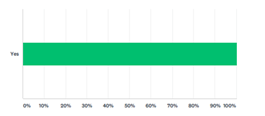
Q1 To take part in this survey, please confirm that you are 18 years of age or over.
Figure 2 Participant 18+ age consent

This question was asking the participants to confirm that they are 18 years of age or over to deter those under this age from taking part in the survey, ensuring that only those competent to give consent would progress to the next page where participant information together with withdrawal, anonymity and confidentiality measures were clearly stated to comply with the ethical requirements regarding informed consent (UK Data Service, 2018). Following the process through, fifty-three of them self- selected themselves to support this research.

Q2 What is your location? Please write the name of the town you live in or the nearest main town.
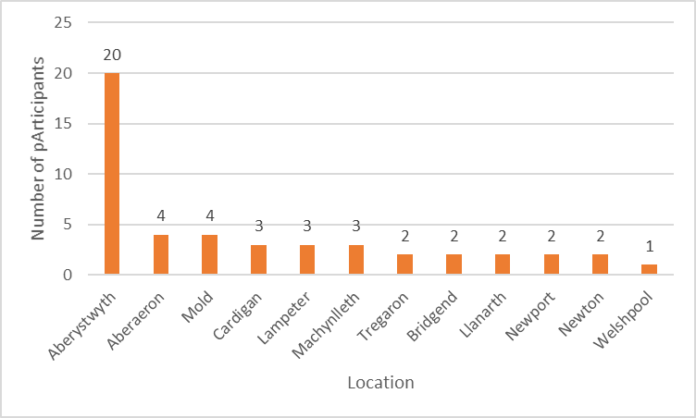
Figure 3 Participant Location

This research method was aimed to target YP from within North and Mid Wales. All efforts have been made to ensure that the sampling frame included participants best representing the population. To cover the proposed geographical areas, key informants working in different institutions have been selected for link web-sharing as following: Coleg Ceredigion Aberystwyth and Cardigan campuses; Youth Services Lampeter and Aberaeron and Flying Start in Ceredigion; Boys and Girls Club Llandudno (Conwy); Flintshire Youth Services; and Coleg Cambria Wrexham.
Overwhelmingly, Aberystwyth has shown the most participation with (twenty YP) and overall Ceredigion has the highest contribution with thirty-four of them taking part. Counties such Powys (six) and Flintshire (four) have brought little by significant input too.

Q3 What is your age?

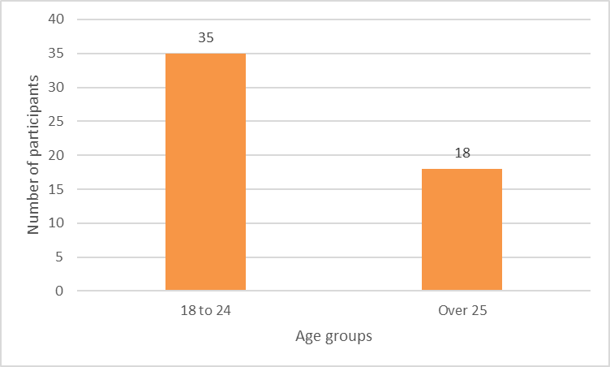
Figure 4 Participant Age

The 18-24 age group has been the main target for this research to review and compare the findings with data of five years ago regarding enterprise education especially their awareness towards SBs and it is important to note that 66% of total participants are from the targeted group.

Q4 What is your gender identity?
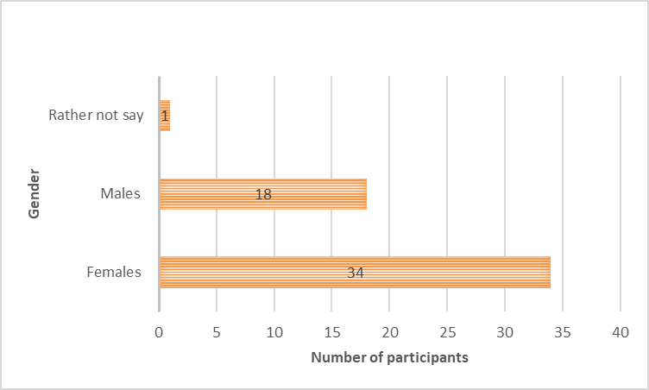
Figure 5 Gender Identity
Findings for this question indicate that female participation (66%) in this research is the dominant one as its number is almost double in comparison with males’ contribution.

Q5 Which one of the following best describe your current status?

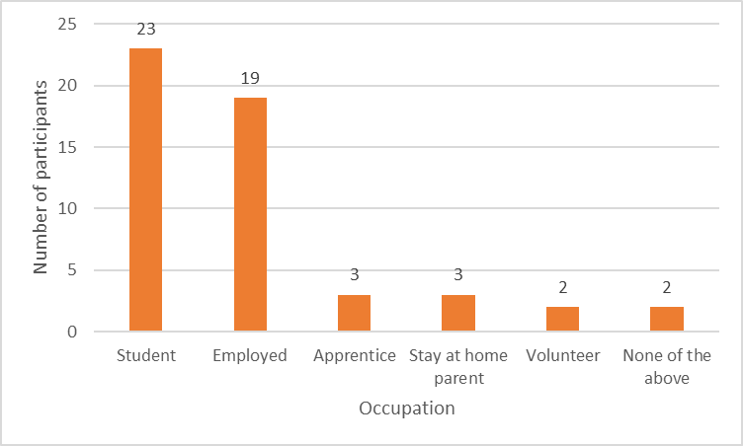
Figure 6 Participant occupation status

This figure highlights the trends concerning current occupation status and two that really stand out are the student (44%) and employment (37%) following closely. It is also interesting to see apprenticeship and stay at home parents taking part as well.
Q6 Are you aware of any goods or services provide by local social businesses?

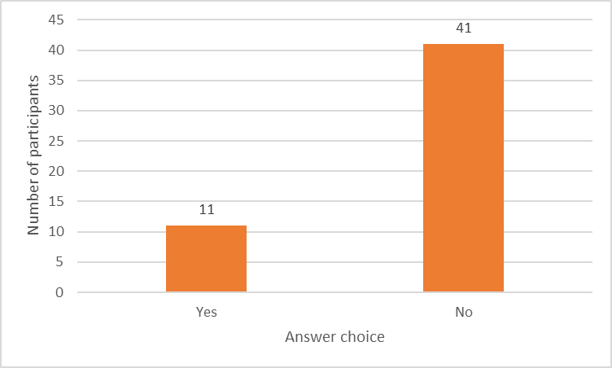
Figure 7 Awareness of local social businesses

This finding shows a staggering difference between YP and their awareness related to SBs where 79% of the respondents claim they are not aware of any local social businesses.
Q7 If you answered with ‘Yes’ to the previous question, what do you believe are some of the benefits social businesses generate in your local community?
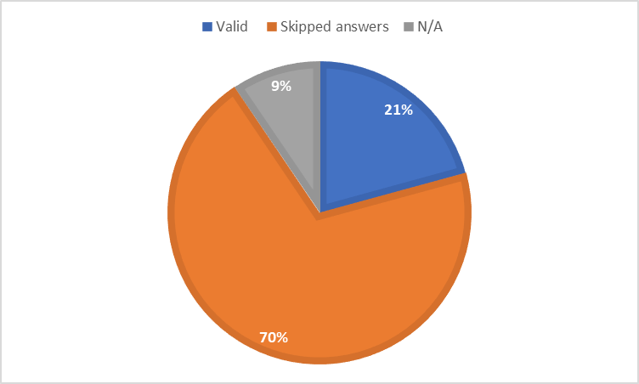
Figure 8 Benefits of social businesses within local community
As a follow up from previous question, it was expected that findings here will show a small positive number as well. Only eleven respondents gave valid, useful information, with thirty-seven skipping the question and five with not relevant (not applicable) data.
Table 2 Q7 Further analysis
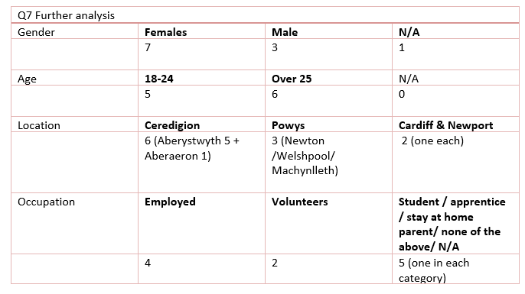
The above table provides the research with more in-depth findings to Q7 and classifying its answers by gender, age, location and occupation.
Several main template trends for analysis could be established from the original answers (please see Appendix 4) in the table below. Additionally, in most of the answers could be seen clearly that the examples of benefits provided were correctly associated with characteristics of SBs with only couple of vague answers given.
Table 3 SBs main benefits to local community
Template trends | SBs main benefits
Community | Regeneration; Caring for; Give back to; Engaging the; SBs are part of.
Well-being | Youth social inclusion; Raising quality of life.
Environment | SBs can enhance this; SBs are aware of.
Economy | SBs generate money; Increase employment; Affordable housing; Cost effective as a start-up.

Q8 If given the opportunity, would you be interested to know more, get involved and make a positive difference too?

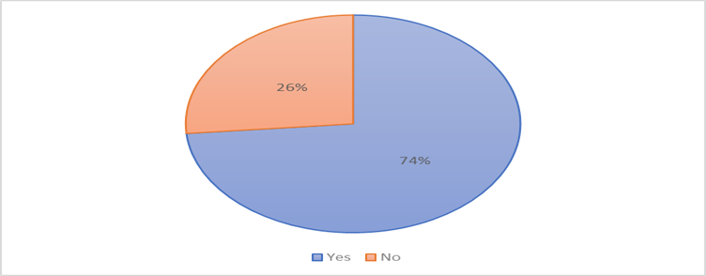
Figure 9 Willingness to know more about social businesses

Last question of the survey indicates that thirty-nine of the participants have a compelling willingness to want to know more about SBs, whereas fourteen of them have answered with ‘no’.
Next section will be looking at the findings from the interview questions.

Interviews
Although there were two different set of interviews sent out, one for the academics and one for the SBs, for better presentation and then discussion and analysis the following structure compilation has been chosen as last three questions are the same for both groups.
Specific questions for Academics (A)
The ‘Academics’ sample selection envisioned to target professionals not only from within education sector, but also those that hold high positions in institutions that support youth social entrepreneurship and social business education.
Emails containing cover letter, participant agreement form and the interview questions were sent out to nine ‘Academics’ covering North and Mid Wales boundaries and included five lecturers at college and university levels and four support institutions.
As mentioned in the methodology chapter, the timing for sending out the emails was not great due to Easter holidays and most of the lecturers were on annual leave, hence couple of weeks later a polite reminder email was sent out. In the end, only two professionals have agreed to take part and contributed enormously to this research; one Academic Support which will be abbreviated as ‘AS’ and one Academic Education (university level) which will be referred to as ‘AE’. As there is just one specific question for this category, a brief description of the findings is given opposed to try discovering template trends for analysis.

How do you feel social businesses are currently promoted and taught within the Welsh education in comparison with five years ago?
Although the AS did not have full knowledge about how this subject was taught five years ago to compare, both participants agreed that SBs are better recognised and that as a subject has entered the classroom at university level (AE) and also covered at secondary and higher education levels (AS).
However, it is believed that despite working with local SBs, the students may not have a clear understanding of ‘criteria’ for this type of business; the teaching in itself is behind whatever is happening in the economy and that SBs as subject needs to be ‘discussed more specifically in the classroom’ (AE).

Specific questions for Social Businesses (SBs)
Again, emails containing cover letter, participant agreement and interview questions were sent out to twenty-one SBs. They were selected due to their location (to cover North and Mid Wales) and some of them based on their popularity and media coverage in terms of national awards and local success; Social Business Wales Directory has been used to select some of them. Only six of them have agreed to participate, bringing invaluable contribution to this research. They will be referred to as SB1 up to SB6 for abbreviation and anonymity reasons.

There were five specific questions for this category with the aim of establishing: SBs location, the total number of employees, the total number of employees aged 18-24, existing strategies to recruit and retain YP and what tools/methods SBs use to measure SBs social impact. A brief description of the answers is given below.

What is your location? Please write the name of the town (or the nearest town) your business operates from.
The SBs locations have been identified to be from counties such as Ceredigion, Gwynedd, Denbighshire and Powys. More specific SBs are located in Caernarfon; Lampeter (Headquarters) with other offices in Aberystwyth and Cardigan; Aberystwyth and Cardigan; Ruthin; Aberystwyth; and Llandrindod Wells. Ceredigion is leading with three SBs out of six participating.

What is the total number of people you as a social business have in your employment?
Between them, findings show the researched SBs are providing jobs for 232 individuals, full-time and part-time.

From the total number, what is the number of employees aged 18-24?
Concerning the employees within the 18-24 age group, SBs employ a total of 21 YP on full-time and part-time basis.
Table 4 Social Businesses and their employees

Do you have any strategy in place to recruit and retain young people within the 18-24 age group?
Table 5 SBs Strategies for recruitment and retention

SBs | Strategy for recruitment and retention of 18-24 age group
SB1 | No.
SB2 | No – ‘we need experience to be foremost’.
SB3 | Yes – a new team of staff has been created with this age group in mind and some have already promoted to managerial positions. Living wage and the range of duties are the main incentives.
SB4 | No specific strategy other than commitment to apprenticeships in trades; also, some office-based role.
SB5 | No, but developing an apprentice scheme.
SB6 | Not currently. Previously, there was an apprenticeship scheme to encourage the 18-24 demographic into work.

The table above has encapsulated main strategies that SBs adopts in order to cater for the 18-24 age demographic; template trend is associated with the ‘apprenticeship’ word. Also, currently, four of SBs do not have a strategy in place to attract YP.

What tools / methods do you use to measure the social impact you generate as a social business?
There is an array of methods SBs use to measure their social impact as it can be seen in the table provided.
Table 6 Tools and Methods for Social Impact Measurement
SBs | Tools / Methods for social impact measurement
SB1 | Questionnaires, feedback, chips and chat nights, social media and quotes.
SB2 | Feedback forms / currently working on a social value report.
SB3 | As a SBs is impossible to measure social impact; years ago, consulting company was commissioned to measure economic and social impact; would like to do it more often but there is high cost involved. The SB measures its social impact in terms of ‘success’ i.e. building let in town; staff / employment figures; customers data; quality of performances etc.
SB4 | Supply chain monitoring. Tender evaluation criteria other than cost. Tender Scoring Matrix Procurement policy. Community Benefit toolkit returns to Welsh Government.
SB5 | Sociological methodologies to evaluate impact (developed with Cardiff University).
SB6 | Collate monitoring of all services provided; have key performance indicators and social outcomes. Case studies from service users. Conduct service user engagement.

Yet, a template trend of most popular tools/methods was not easy to establish as SBs use what suits their type of business; one even developed its own.
Identical Questions for Academic and Social Businesses
The purpose behind asking both the Academics and Social Businesses these last three questions, was for the researcher to gather different views on the same topics with the potential of establishing several template trends for analysis.
Bearing in mind the current political, economic, social, technological, environmental and legal factors what do you think the main opportunities social businesses may have over the next five years?

Table 7 PESTEL Opportunities
PESTEL Opportunities Template Trends Analysis
Political | Brexit: ‘a chance to do things differently, explore new markets (AS); ‘what BREXIT will actually mean to business and customers; potential recession may be a good thing’; the government may re-evaluate their priorities and austerity measures/policies and investing in infrastructure/future projects (SB3).
Economic | Social Businesses: ‘viable option in the future’ (AS); will find greater support over the coming years’ (AE); ‘will be supporting the statutory services to deliver services to our community’ (SB1); SB3 is a unique company in terms of business model; ‘have tried to “future-proof” as much as possible our business model and focus’ (SB3).  Diversification and growth in to new areas’; ‘re-investment back into the business’ (SB4).  Innovation: ‘social innovators as one of the key drivers for young entrepreneurs in Wales’ and Brexit may ‘force innovation’ (AS); changes in funding streams for most organisation ‘will inevitably mean that organisations will have to be innovative in delivering services for people’ (SB6).
Social | Young People: ‘very concerned about the future of society and current social issues’; (AS).  Inequalities: ‘strong movements happening, and more and more people realise the growing inequality in our society and that this must end’ (AE).  Employment, Training and Education: ‘Job creation and training in the communities where people reside which are relevant to their interests, experience and aspirations’ (AS);’ job creation’ (SB4); ‘as creative learning pioneers we are looking to digital to develop both our work and audiences’ (SB5).  Community: ‘giving the community that sense of empowerment and ownership in everything we do’ (SB3).  Ageing Population ‘Helping people in later life live independent lives, avoiding entering hospital or residential care’ (AS).  Collaboration and co-operation: services delivery especially in rural areas (AS); ‘greater partnership and collaboration’ (SB4).
Technological | I.T. & Technological ‘advances together with increased use of social media platforms could provide an opportunity to increase engagement with social business’ (SB6).
Environmental | Natural resources: tourism ‘maximising our beautiful Welsh landscape and heritage’ (AS).
Legal | ‘Well-being of the Future Generations Act (Wales) 2015, make it a legal requirement to look after the well-being of Wales’ (AE).  ‘always an opportunity to lobby politicians at a local regional and national level and create change’(SB6).

The table above highlights numerous opportunities within PESTLE that SBs could have in the future. Key trends include: Brexit, diversification, innovation, YP, inequality, collaboration and co-operation, information technology (IT), natural resources and legislature.

Again, bearing in mind the current political, economic, social, technological, environmental and legal factors what do you think the main challenges social businesses may have over the next five years?

Next table includes many of the challenges SBs are dealing with currently, and for years to come. The most notable template trends are related to Brexit and what possible consequences it is going to have on everyone; the second main trend concerns money / funding together with the difficulty of securing constant and sustainable cashflow.
Table 8 PESTEL Challenges

PESTEL Challenges Template Trends Analysis
Political | Brexit: ‘austerity, squeeze on public sector expenditure (AS); underdeveloped economy due to Brexit could have a negative impact on social businesses’; ‘government funding / subsidies’ (AE); ‘possibly funding’, earlier on reliance on EU funding’ (SB2); ’funding constraints / uncertainty’ (SB4), (SB5); ‘social businesses are susceptible to the ‘political winds of change’ (SB6).
Economic | Money / funding: ‘earning a living is a very important consideration and often difficult to achieve at the outset of starting a new social business’; ‘accessing start up grant funding is now more challenging than 5 years ago’ (AS); ‘funding (revenue / capital / cashflow) is the main challenge; SBs within the “service” market depend on some form of public funding/support’ (SB3); ‘to sustain our core costs’ (SB1); SBs ‘being asked to take on more business areas once provided by the statutory sector’ (SB4); continuity and sustainable funding, a constant threat to all SBs (SB5) and (SB6).  Infrastructure: ‘poor transport links in this area’ (SB4).  Innovation: ‘places/forums to generate ideas about this especially in rural areas’ (AS).
Social | Employment: ‘recruitment and retention of good quality staff’ (SB4).  Community: ‘Internet companies are detached from people and the local community’; low income earners could mean little support for SBs (AE).
Technological | I.T. & Technological: ‘limited broadband and mobile phone coverage’ (AS); ‘the growing dominance of internet business as a threat to social enterprises’ (AE); ‘data sharing / ownership is currently a hot-topic’ (SB3); ‘slow broadband in this area’ (SB4).
Environmental | Plastic: ‘huge shift now also in the use of plastic’; the key for companies here is to promote their policies – whether this is banning plastic, recycling, sourcing locally, investing in renewable energy (SB3).
Legal | GDPR – ‘new GDPR has been set-up to protect consumers – so it is essential that all businesses (of all types/sizes) comply with the new legislation’ (SB3).
Considering young people and social businesses, in your opinion, how could they work together to achieve better social impact?

Template trends analysis, as it could be seen in the next tables, has identified six ways through which better social impact can be achieved.

Table 9 Achieving better social impact (1)

Template trends Description
Education  Training  Employment | Clarification of what social impact is (AS and AE); Better definition for SBs - currently a broad terminology (AE); greater knowledge of the social business sector (SB4).  ‘School based intervention to encourage and promote entrepreneurship and social entrepreneurship’ (SB4); National Curriculum and Welsh Bacc (AS); ‘setting up a county wide project which will include a social enterprise training academy and facilities for the 18-24 age demographic’ (SB6); ‘inspiring case studies for students’ (AS); ‘a different teaching of economics in schools and University is also necessary to teach the working of society’ (AE).  Empowerment /ownership is key to the success of any company (SB3); ‘young people as well as social enterprises need to recognise each other’s value’ (AE);  ‘going back to the basics and showing that equality can be achieved’ (AE); ‘young people are often a “forgotten” group’ (SB3).  ‘Involving / recruiting young people to governance roles is extremely beneficial to social businesses (SB5); volunteering / work placement opportunities’ (SB4); ‘inter-generational work can be beneficial’ (SB2).

Table 10 Achieving better social impact (2)
Template trends: Social Businesses Supporting Bodies

Big Ideas Wales - extending its role already promotes youth entrepreneurship in schools (AS).
UnLtd, the Foundation for Social Entrepreneurs – ‘already offer small cash awards plus support, coaching and networks to stimulate social entrepreneurship for all aged 16 and over’ (AS).

Table 11 Achieving better social impact (3)
Templates trends: Promotion
Mainstream great stories about social business and young people in social media, TV (AS).
‘We regularly attend school events ‘to discuss our work’, ‘need for entrepreneurial approach in day-to-day personal life’ and also ‘how vital young people are to growing their town/area and the economy’ (SB3).
Maximising online resources and forums to create supportive networks (AS).
‘Young people could bring enthusiasm energy and a new and fresh perspective’ (SB6).
‘Whole purpose of our social enterprise – for the people, by the people – for ALL ages’ (SB3).

Table 12 Achieving better impact (4)

Template trends: Collaboration
‘Ensure existing support organisations in Wales work together to advance this subject, and also work with communities’ (AS).
‘Co designing services with young people can ensure services are relevant to the 18-24 demographic and improve engagement’ (SB6).

This rich compilation of template trends shows that education, training, employment, SBs supporting bodies, promotion and collaboration are great engines through which social impact can be generated, attained and harvested from when SBs work together with YP.

Discussion and Analysis of Findings

As presented in the first part, it is noteworthy to mention that the results generated by primary data are invaluable and contributing greatly towards determining the accomplishment of this research aims:
Aim One: To establish the benefit of social businesses for the Welsh economy five years on since past research.
Aim Two: To examine the social impact social businesses achieve in Wales.

For a complete analysis and to support this, previous research of five years ago and the core of secondary data resulted from Chapter 2, will be used to place current research findings within the framework of existing literature and to qualify the prevailing objectives hereafter.

Objective One: To revise how much do the young people of North and Mid Wales presently perceive and use social businesses.
Looking at the surveys generated data and to put it all in perspective to acquire an exploratory overview, a research undertaken five years ago and aimed at YP 16-24 years old was attempting to examine how YP perceived SE; how the awareness of SE could be promoted and increased; and how YP’s views could make a difference at times of socio-economic hardship in Wales targeting youth unemployment and its negative effects (Somicu, 2012).
Five years on, current research amongst other objectives, is trying to revise how much YP understand and use SBs in terms of employment, training, services or goods purchasing from this type of business. The questions, whilst fewer and simpler, were trying to achieve similar data for comparison reasons. When analysing this, it is important to remain mindful of the fact that current research had double number of participants, included a larger area and it was open to many others as opposed to only business students as previously.
A summary of both findings is as shown below:
Five years ago, in Ceredigion, 26 business students (college and university level), from which 59% were female; 88% were from within the targeted sample 16-24. Furthermore, 77% of them had no idea of SBs operating in the area and 54% of them mentioned several benefits of SBs in terms of job creation, training and skills development.
Five years on, the research has been extended to North and Mid Wales to capture a bigger geographical area, 53 participants from all backgrounds (students, employed, in apprenticeships and so on). A 66% of them were from within the targeted age group 18 – 24 years old; there were 64% females taking part; 44% of the total were students followed closely by the employed ones (37%); a large majority of 79% were not aware of any goods and services provide by local SBs with only 21% knowing of any benefits that SBs deliver to their local communities, however a total of 74% said they would like to know more and be involved to make a positive difference.
Further elaborating on new data, unveiled that 21% of those giving examples of SBs benefits, 7 of them were females and 3 male (plus one unidentified gender); there were 5 from within 18-24 age group and 6 from the over 25s years old. Location wise 6 were from Ceredigion, 3 from Powys and 2 from the South.
Most surprising result of all concerned the occupation of participants: 4 were employed, 2 volunteers and one each from the remaining categories, meaning that from all 11 answers only ONE came from a student! Even more worrying, the number of those that have no awareness regarding the presence of SBs in their local communities is more or less the same with five years ago (77% vs. 79%). And one cannot disregard the issues raised here.

Cumulating data from the literature review and interview answers, the findings suggest that the introduction of the Welsh Bacc is contributing to SBs to be better recognised and as a subject this is covered at secondary and higher education levels (AE; AS) and that the SCC (within the Welsh Bacc) is said to prepare YP towards having societal responsibility and contribution to benefit community and economy (Mason et al.2006:2; Blackmore et al. 2016:10; Qualifications Wales, 2017, WJEC, 2018). Sense-making of this, is puzzling. Thus, at a closer examination, in theory SCC should be beneficial to those in education, however despite collaborative partnerships such working with local SBs either through employment or apprenticeship schemes (SB3; SB4), the students may still not have a clear understanding of the ‘criteria’ for this type of business (Beer, 2012; AE).
More specifically, it has been argued that there needs to be a better definition for SBs (Beer, 2102) as currently it is a broad terminology (AE), so inclusive, it is blurring the traditional borders between the other sectors to accentuate main hybrid models of social activities (Martin and Osberg, 2007; Tran and Von Korflesch, 2016), hence a greater knowledge of the SBs is required (SB4). As a result and as exposed five years ago, there is still the case that efforts to teach SBs are still not visible (Somicu, 2012). Besides, AE implies that SBs teaching ‘is behind the current developments in the economy and it needs to be discussed more specifically in the classroom’.
To a considerable degree, education is crucial, a milestone of a country’s economic development thus if this fails to shape attitudes to determine future success (Ross and Wu, 1996; Birdthisle, 2008; Idris et al., 2012) how are the YP supposedly to increase awareness of SBs so that they could work together to achieve better social impact? YP have ideas and social conscience (Walters, 2012) they could ‘bring enthusiasm, energy and new fresh perspective’ (SB6), so it is vital to offer them hope and incentive to work and progress (Herbert, 2012). Moreover, SB6 is looking into ‘the feasibility of setting up a county wide project which will include a social enterprise training academy and facilities for the 18-24 age demographic’.
For now, one thing is certain: based on new findings (see Table 5) the six SBs taking part in this research have 232 employees of which 21 are from within the 18-24 age group and it is all about ‘empowerment / ownership’ to ‘encourage loyalty’ and with a ‘positive impact on social and economic factors’ (Smallbone et al., 2001; DTI, 2002; Ocampo, 2007; Beer, 2012; SB3).

Concerning the current study and elaborating from the template trends found within the answers given by all taking part in the interview and supported by the literature review, it has been established that a working relationship between YP the ‘forgotten’ group (SB3) and SBs can be achieved through the following: education, training and employment (Cone, 2009; Rae, 2010; Engeli and Daly, 2018; AS; SB2; SB4; SB5); SBs supporting bodies (AS); promotion (Somicu, 2012; AS; SB3; SB6); and collaboration (Wilson, 2011; AS; SB6) (see Tables 10 to 13).
As so aptly AE points out, there is a need for both YP and SBs to ‘recognise each other’s value’ and by ‘going back to the basics will show that equality can be achieved’; and together will generate a bigger impact (Beer and Herbert, 2012).

The new data used in this section, is consistent with past findings and literature review and could suggest that although the awareness is still low, there is a small number of YP (21% in comparison with 54% five years ago) that understand the importance of SBs within their local communities and put them to use accordingly; it should be added that 74% of them want to know more, get involved and make a positive difference.
In sum, it could therefore be concluded that objective one has been accomplished.

Objective Two: To investigate how social businesses in Wales achieve social change.
In coherence with the literature review, past and current findings, it is abundantly clear that SBs exist mainly to produce social value with a prerequisite to fulfil elementary needs (Certo and Miller 2008:267). SBs can be found working to achieve social change in areas where challenging social problems are commonly found and as rightly identified in the online survey by the YP as the community, well-being, environment and economy, and within this, it is reassuring to see words such ‘community regeneration’; ‘youth social inclusion’; ‘caring for community’; ‘raising quality of life’; ‘increase employment’; ‘affordable housing’, etc. and found in the literature review as well (Appendix 4; Nicholls, 2006; Haugh, 2007:743; Borestein and Davis, 2010; European Commission, 2011; Social Business Wales, 2018).

The consequence impact of the actions taken by SBs to address the social needs (Meldrum et al., 2017) within Welsh local communities, could be seen in the social change they persistently try to realise at times when Wales is experiencing a great deal of austerity and inadequate funding, leading to local authorities to be stretched to their limits (Wales Public Services 2025, 2017; Winckler, 2017). In turn, this is creating a multitude of complex social and environmental issues, leading SBs to continually emerge and succeed mainly due to the public sector’s inability to meet the needs of its residents (Spear, 2001; Mair and Marti, 2006; Sharir and Lerner, 2006), and seconding this, SB4 states that SBs sector is ‘asked to take on more business areas once provided by the statutory sector’.

Based on the new findings, it can be said that YP play an important part in the race for social change, they are ‘very concerned about the future of society and current issues’ and identified as social innovators, they are key drivers for youth entrepreneurship in Wales (AS). In particular, SB2 says that inter-generational work in this case, YP and older people (including those with dementia) is beneficial; but generally, SBs purpose is to be there ‘for the people, by the people for ALL ages’ (SB3).

As found in the literature review, social change is not easily quantified however it is visible. Having a major share of Welsh economy i.e. money value contribution and job creation (£2.37 billion / 40,800 jobs) SBs generate the type of social change that is incremental to the support and development of existing and future generations (Sud et al., 2009:203; Branzei, 2012; Braunerhjelm and Hamilton, 2012; Allies and Irving, 2017).

Summarising, the social change that SBs in Wales produce can be seen in their actions and successes when tackling societal issues such as: health care, unemployment, poverty, inequalities, protecting the vulnerable, addressing social and financial exclusion, promoting education and protecting the environment (Borstein, 2004; Allies and Irving, 2017). All the information gathered in this section, confirm that objective two has been achieved.

Objective Three: To establish how social businesses in Wales measure their social impact.
Measuring social impact could prove difficult, mostly due its complexity and the lack of a recognised effective tool or method. According to the literature review, SBs are enhancing growth, reduce poverty and improve social development on a large scale with far reaching economic impact (Yunus and Weber, 2008; Zahra et. al, 2009; James, 2011; McMullen, 2011). Yet, how is this measured?
When asked the question ‘what tools / methods you use to measure the social impact you generate as a social business?’ most of the SBs answers were varied, suitable for their industry and claiming to use more than one tool / method (see Table 7), a list that is similar with the findings in literature review (SEEAhead, 2015; Social Value UK, 2018).

Most interestingly and not found in the secondary research, one of the SBs have employed a consulting company to evaluate their economic and social impact (SB3) whilst a second one is working on a social value report (SB2); even though invaluable, this way of measuring is very costly (SB3). In terms of SROI (SROI Network, 2012; Social Value Lab, 2018), no one of the SBs taking part in the research have said that they use this.

Although the findings have emphasised how SBs in Wales measure their social impact, leading to this objective to be achieved also, there was no opportunity to establish if there was one tool or method (beside the feedback) that could generally be employed by all as different industries have different requirements for measurement.
Objective Four: To forecast opportunities and challenges that social businesses in rural North and Mid Wales may face in the next five years based on the current findings.
Evaluating the findings from PESTEL analysis of Wales and as rightly acknowledged by all participants answering the interview questions, current and future trends within PESTEL pose a variety of serious challenges but also exciting opportunities for SBs in the next five years.
It is needless to say how satisfactory it is to see a long list translating as opportunities for SBs in Wales (see Table 8), and actually including more than those listed in the literature review. From seeing Brexit as a great opportunity to drive innovation and do things differently (AS) to collaborate and co-operate for better delivery of services in much needed local communities (AS; SB6); to providing solution for the ageing population (AS) and all its consequences (McKinsey & Company, 2010:2; Ritson, 2011:31; Price, 2016; Slawson, 2017; Welsh Government, 2017; Bevan Foundation, 2018) and the general requirement to look after the well-being of Wales to reduce inequality (AE) in terms of unemployment and poverty; to planning to ‘future-proof’ both business and focus (SB3) by creating services (and goods) that will allow for financial independence (Perrini, 2006) - all these activities contributing to doing more good and making a difference (Murray et al., 2010).

The challenges list mirrors the opportunities one to highlight how these could be steamed from the same source. Of note, and as found through PESTEL analysis as well, Brexit and funding are the main themes that keeps coming up in most of the answers here (see Table 9). By using the informal ‘the elephant is in the room’, SB3 refers to Brexit as the ‘unknown’ to emphasise that the future is difficult to predict due to its uncertainty (SB4) and that ‘continuity and sustainable funding’ is a real threat to all businesses (SB6). The lack of support from the EU and own resources to fund business activities effectively, could only lead to difficulty to future proof income (Gardner et al., 2005; Jones, 2016; Gooberman, 2017).
In addition, SB3 drawn attention onto the GDPR, underlining the need for all businesses to comply with the new legislation.

Without reservation it can be said that SBs would have enough areas to work with in the future. Together, these findings qualify the last objective of this research to become accomplishable.

Conclusion
The consistency of the findings from past research, literature review and new primary data and as shown by the achievement of this research objectives, clearly indicate that both aims have also been fulfilled. That being said, it is believed that more qualitative weight could have been added if participants such as politicians and college lecturers were to have their say in this research.

Chapter 5: CONCLUSIONS AND RECOMMENDATIONS

Introduction
This study aimed to establish the benefit of social businesses for the Welsh economy five years on since past research and to examine the social impact they achieve in Wales. As a progressive research building on findings of five years ago, it can be said that at present, SBs are increasing momentum particularly in areas of deprivation and that in some instances their number have exceeded the more traditional businesses.

Conclusions
Currently, and to recognise the overall SBs benefit, the literature review has looked at different aspects that could determine this. More precisely, it evaluated the available data reporting on SBs economic performance and their contribution to the Welsh economy and in terms of growth, the findings are reassuring.
It has also considered trends in youth unemployment and the findings show that in comparison with five years ago, this has decreased slightly and that more YP within the 18-24 age group are in employment nowadays, thus the increased number of economically inactive people in Wales is worrying. Historically, the much larger effects of unemployment in general could be associated with social costs such as poverty, debt and financial hardship and seen in the high percentage of Welsh people living in poverty. Nevertheless, this does not necessarily mean that SBs are not as effective as initially thought and commended for, but it actually exposes how concerning the situation in Wales is and that SBs by themselves in confinement cannot offer all the answers and solutions to present and future Welsh societal problems.

Furthermore, there has been an emphasis on determining how imperative SBs education to YP is, yet this has proved to be one of the main challenges. Past research led to the conclusion that five years ago SBs education was not visible; five years on, the introduction of SCC within the Welsh Bacc was expected to have addressed this. In addition, background knowledge together with new data suggest that there has been a positive approach in introducing the SCC to inspire the young generation to become more aware of the current social and environmental issues and work together with SBs to alleviate them. However, in the absence of views and expertise of a teacher / lecturer teaching at this level (14 to 19 years old) and the fact that from 23 students taking part in the survey, only one knew of any SBs in the locality and was able to give an example of SBs benefits, the question raised here is to whether or not SCC is as useful as it initially was designed to be.
SBs are extremely beneficial to the Welsh economy, yet the lack of investment and adequate resources in SBs education to increase community awareness and social responsibility amongst the YP, is hindering their progression and greater potential for better social impact.

As outlined in the literature review and by the new primary data, the social impact SBs are generating is remarkable. The social change that SBs in Wales produce can be seen in their actions and successes when tackling societal issues such as: health care, unemployment, protecting the vulnerable, addressing social and financial exclusion, promoting education and protecting the environment. Ultimately, for SBs in Wales the main challenge is to generate the much-needed growth to reduce unemployment rates, poverty and other social inequalities.
Thus, based on the success had so far, SBs need all the available support to facilitate a greater operational scale at times when Welsh government’ silos are ill-equipped and not suited to tackle society’s complex problems. SBs exist to push boundaries, working with people and for people offering solutions to social and environmental problems that government, traditional business and charities have failed.
Concluding, UK’s intent to exit from the EU (Brexit) is impacting on all areas of PESTEL and poses several opportunities and challenges for SBs. Stringent funding cuts followed by EU funding withdrawal in the near future, as a country, Wales is forced to step up and reinvent itself.
With a well-established integral part of Welsh economy, SBs’ influence and impact keep growing year on year, in the future they will play an even greater role to make Wales a better place for everyone. From identifying needs and finding solutions to satisfy these, SBs will keep ‘doing good’ and in the process, will create more jobs and social impact.

Recommendations

Recommendation one regards the SBs education of YP, the idea of a physical ‘Social Enterprise Training Academy’ should be launched and promoted as a one-off project in first instance to see its feasibility and be done in partnership with schools and colleges that teach SCC, as well as all the supporting bodies such as UnLtd Wales and Social Business Wales.
The main SBs infrastructure appears to be in place, thus maximisation and smart use of available resources are required to target the 18-24 age demographic.
Recommendation two follows on from the above and involves the identification of inspiring social entrepreneurs as ‘teachers’ within the Academy as the findings have signalised that delivering entrepreneurship education within traditional academia does not fully work, hence the prerequisite for successful SBs entrepreneurs to enter the education mainstream.

Recommendation three calls for better networking, collaboration, openness and transparency amongst SBs and other service providers including, education establishments, supporting bodies, local government and private sector. In doing so, will aid increasing awareness and achieving greater social impact towards the well-being of all Welsh people in a joint effort to tackle inequality.
Recommendation four streams from the new findings that no one of the six SBs taken part in this research have identified SROI as tool / method of measuring social impact. To better quantify the social value SBs generate, SROI should benefit from more promotion together with its advantages and disadvantages as a way of measuring success. Further research may consider to trial SROI method with several SBs to determine its effectiveness.
Recommendation five urges the Welsh government to encourage and support social innovators and social innovation to attain sustainable development especially at times when Brexit is more than likely to create further disruptions and divisions. There is an imperative need for SBs to create cohesive communities with resilient functioning ecosystems that could provide some sort of stability especially in the rural Wales over the coming years.

REFERENCES

- Abu-Saifan, S. (2012) Social Entrepreneurship: Definition and Boundaries. Technology Innovation Management Review. February 2012: 22-27
- ACEVO (2012) Youth unemployment: the crisis we cannot afford. Available at: http://dn56eaq5gsh5n.cloudfront.net/ACEVO%20Youth%20Unemplyment_lo_res.pdf. Accessed on: 26/02/2012
- Adams, J., Khan, H.T.A. and Raeside, R. (2014) Research methods for business and social science students. New Delhi: SAGE
- Aguilar, F. J. (1967) Scanning the Business Environment. New York: MacMillan
- Allies, O. and Irving, J. (2017) Mapping the Social Business Sector in Wales. Available at: https://wales.coop/wp-content/uploads/Social-Business-Mapping-Report-28FINAL29-2017.pdfM. Accessed on 28 /12/2017
- Alvord, S., Brown, L. and Letts, C. (2004) Social Entrepreneurship and Societal Transformations: an Exploratory Study. Journal of Applied Behavioural Science, 40.3, pp. 260_83
- Austin, J., Stevenson, H. and Wei-Skillern, J. (2006) Social and commercial entrepreneurship: same, different, or both? Entrepreneurship Theory and Practice, Vol. 30 No. 1, pp. 1-22
- Bagnoli, L. and Megali, C. (2011) Measuring Performance in Social Enterprise. Non-profit and Voluntary Sector Quarterly 40(1) 149 –165
- Battaglia, M. P. (2008) Non-Probability Sampling. Encyclopaedia of Survey Research Methods. 2008. SAGE Publications, 1-4
- BBC News (2018) Brexit: Wales EU Continuity Bill passed by AMs. Available at: http://www.bbc.co.uk/news/uk-wales-politics-43477470. Accessed on: 23/03/2018
- BBC News (2018) Brexit: Welsh Government continuity bill referred to Supreme Court. Available at: http://www.bbc.co.uk/news/uk-wales-politics-43795158. Accessed on: 23/03/2018
- Beer, A. (2012) Primary research interview for ‘Social entrepreneurship: an examination of how young people in Wales perceive this in the light of the current socio-economic environment’ – UWTSD undergraduate dissertation
- Bernard, H. R. (2002). Research methods in anthropology: Qualitative and quantitative approaches, 3rd edition. Walnut Creek, CA: Alta Mira Press.
- Bevan Foundation (2018) tough time ahead? What 2018 might hold for Wales. Available at: https://41ydvd1cuyvlonsm03mpf21pub-wpengine.netdna-ssl.com/wp-content/uploads/2017/12/Tough-Times-Ahead-Report-Final.pdf. Accessed 23/04/2018
- Birdthistle, N. (2008) An examination of tertiary students’ desire to fund an enterprise. Education and Training, Vol. 50 Issue: 7, pp.552 – 567
- Birley, S. (1986) The role of new firms: births, deaths and job generation; Strategic Management Journal, 7: 361-376
- Blackmore, P., Bulaitis, Z.H, Jackman, A.H and Tan, E. (2016) Employability in Higher Education: A review of practice and strategies around the world. Available at: https://www.pearson.com/content/dam/one-dot-com/one-dot-com/uk/documents/about/news-and-policy/employability-models-synthesis.pdf. Accessed on: 26/04/2018
- Blumberg, B, Cooper D.R, and Schindler P.S. (2005) Business Research Methods. Berkshire: Mc Graw Hill
- Bochee, J. (1995) Social Entrepreneurship Across the Board, 32 (3):20-5
- Borenstein, D. and Davis, S., (2010) Social Entrepreneurship: What Everyone Needs to Know. Kindle Edition: Oxford University Press
- Bornstein, D. (1998) ‘Changing the World on a Shoestring’ Atlantic Monthly, 281 (1):34-9
- Bornstein, D. (2004) How To Change The World: Social Entrepreneurs and the Power of New Ideas. Oxford: Oxford University Press
- Boschee, J. (2012) Institute for Social Entrepreneurs. Available at: http://www.socialent.org/Social_Enterprise_Terminology.htm. Accessed 06/04/2012
- Branzei, O. (2012) Social change agency under adversity: How relational processes (re)produce hope in hopeless settings. In K. Golden-Biddle & J. Dutton (Eds.), Using a positive lens to explore social change in organizations: Building a theoretical and research foundation (pp. 21–47). London: Routledge
- Braun, V. and Clarke, V. (2006) Using thematic analysis in psychology. Qualitative Research in Psychology, 3:77–101
- Braunerhjelm, P. (2010) Entrepreneurship, Innovation and Economic Growth. Past experiences, current knowledge and policy implications. Available at: http://entreprenorskapsforum.se/wp-content/uploads/2013/03/WP_02.pdf. Accessed 28/12/2017
- Briggs, M. (2009) The business of change: Introducing the social entrepreneurship mindset to students (Master's thesis). Prescott College in Education. Prescott, Arizona
- Brown, R.B. (2006) Doing Your Dissertation in Business and Management: The Reality of Research and Writing. Sage Publications
- Bulman, M (2018) Almost a quarter of people in Wales trapped in poverty amid rising living costs and cuts to benefits. Available at: https://www.independent.co.uk/news/uk/home-news/wales-poverty-rates-rising-living-costs-benefits-cut-people-trapped-government-a8241926.html. Accessed on 24/04/2018
- Burns P (2008) Corporate Entrepreneurship: Building the Entrepreneurial Organisation (2nd edition). Hampshire: Palgrave Macmillan
- Carlsson, B., Braunerhjelm, P., McKelvey, M., Olofsson, C., Persson, L., and Ylinenpaa, H. (2013) The Evolving Domain of Entrepreneurship Research. Small Business Economics, 913-930.
- Carraher, S.M., and Welsh, D.H.B. (2015) Global entrepreneurship (2nd edition). Dubuque: Iowa
- Casey, G. W. (2017) Leading in a VUCA world. Available at: https://www.johnson.cornell.edu/Portals/32/PDFs/execed/Cornell%20Executive%20Education%20-%20VUCA%20Leadership%20-%20February%202017.pdf. Accessed on: 21/07/2017
- Cassiman, B. and Giovani, V. (2013) What is open innovation, really? Available at: http://mackinstitute.wharton.upenn.edu/wp-content/uploads/2013/04/Cassiman-Bruno-Valentini-Giovanni_What-Is-Open-Innovation-Really_v2.pdf. Accessed on 15/04/2018
- Catford, J. (1998) Social Entrepreneurs Are Vital for Health Promotion-But They Need Supportive Environments Too. Health Promotion International, 13 (2):95-7
- Catherall, R. and Richardson, M. (2013) What will Social Enterprise look like in Europe by2020? Available at: https://www.britishcouncil.org/sites/default/files/what_will_social_enterprise_look_like_in_europe_by_2020_0.pdf. Accessed on: 15/03/2018
- Certo, S.T. and Miller, T., (2008) Social entrepreneurship: Key issues and concepts. Business Horizons, 51(4), pp.267–271
- Chell, E., Haworth, J. and Brearley, S. (1991) The entrepreneurial personality: Concepts, cases, and categories. London/New York: Routledge
- Chesbrough, H. 2006a. Open innovation: A new paradigm for understanding industrial innovation. In: Chesbrough, H., Vanhaverbeke, W., West, J. (Eds). Open innovation: Researching a new paradigm, 1-12. Oxford: Oxford University Press
- Choi, N. and Majumdar, S. (2014) Social entrepreneurship as an essentially contested concept: Opening a new avenue for systematic future research. Journal of Business Venturing, 29(3), 363-376
- CIPD (2017) Brexit impact on workforce trends. Available at: https://www.cipd.co.uk/news-views/brexit-hub/workforce-trends. Accessed on: 23/04/2018
- Clark, D. (2013) What are the potential impacts of climate change for the UK? Available at: https://www.theguardian.com/environment/2013/oct/08/potential-impacts-climate-change-uk. Accessed on 23/03/2018
- Collins, P. (1998) Negotiating Selves: Reflections on “Unstructured” Interviewing. Sociological Research Online, 3 (3).
- Collins, P., 1998. Negotiating Selves: Reflections on “Unstructured” Interviewing. Sociological Research Online, 3 (3).
- Cone, J. (2012) Teaching entrepreneurship in colleges and universities: How (and why) a new academic field is being built. Available at: http://www.kauffman.org/entrepreneurship/teaching-entrepreneurship-incolleges. Accessed on: 14/03/2012
- Cresswell, J. W. and Plano Clark V.L. (2007) Designing and conducting mixed methods research. Thousand Oaks, California, London, Sage
- Cresswell, J.W. (2003) Research design: Qualitative, quantitative, and mixed methods approach, 2nd edition. Thousand Oaks: Sage
- Cresswell, J.W. and Plano Clark V.L. (2011) Designing and conducting mixed method research (2nd edition). Thousand Oaks, CA: Sage
- Creswell, J. W. (2006) Qualitative Inquiry and Research Design: Choosing Among Five Approaches, 2nd edition, Thousand Oaks: SAGE Publications
- Curran, J. and Stanworth, J. (1989) Education and training for enterprise: some problems of classification, evaluation, policy and research. International Small Business Journal, Vol. 7 No. 2, pp. 11-23
- De Vaus, D. A. (2002) Surveys in Social Research 5th edition. London: Routledge
- Dees, J. G. (1998) Social Enterprise: Private Initiatives for Common Good, Harvard MA: Harvard Business School Press
- Department for Transport (2017) Understanding and Valuing the Impacts of Transport Investment. Available at: https://assets.publishing.service.gov.uk/government/uploads/system/uploads/attachment_data/file/662777/understanding-and-valuing-impacts-transport-investment-progress.pdf. Accessed on: 23/03/2018
- Dietz, A.S. and Porter, C. (2012) Making sense of social value creation: three organizational case studies, Emergence: Complexity and Organization, Vol. 14 No. 3, pp. 23-43.
- Douglas, S. (2018) Top challenges facing social entrepreneurs. Available at: https://yourbusiness.azcentral.com/top-challenges-facing-social-entrepreneurs-11115.html. Accessed 24/04/2018
- Dunfey, T. S. (2017) What is Social Change and Why Should We Care? Available at: https://www.snhu.edu/about-us/news-and-events/2017/11/what-is-social-change. Accessed on 30/04/2018
- Durieux, M.B. and Stebbins, R.A. (2010) Social Entrepreneurship for Dummies Hoboken, NJ: Wiley
- Echoing Green (2018) Social Change in 2018. Available at: https://www.echoinggreen.org/ideas/how-create-positive-social-change-2018. Accessed on: 23/04/2018
- Eckhardt, J. T., and Shane, S. A. (2003) Opportunities and entrepreneurship. Journal of Management, 29(3), 333–349
- Elliot, L. (2017) Brexit economy: sterling fall hits public finances and fails to boost trade. Available at: https://www.theguardian.com/politics/2017/jul/24/brexit-economy-sterling-fall-hits-public-finances-and-fails-to-boost-trade. Accessed on: 21/08/2017
- Elmes, J. (2016) Enterprise courses in HE ‘reluctant’ to give real-world scenarios. Available at: https://www.timeshighereducation.com/news/enterprise-courses-in-higher-education-reluctant-to-give-real-world-scenarios. Accessed on: 23/04/2018
- Engeli, A. and Daly, C. (2018) A review of the design and assessment model of the Skills Challenge Certificate, and its place within the Welsh Baccalaureate. Available at: http://qualificationswales.org/media/3311/review-of-scc-final-report-e.pdf. Accessed on: 28/04/2018
- Erk, J. (2017) Is Age the New Class? Economic Crisis and Demographics in European Politics Critical Sociology Vol.43 (1), pp.59-71
- European Commission (2011) Social Business Initiative – Frequently Asked Questions. Available at: http://europa.eu/rapid/press-release_MEMO-11-735_en.htm. Accessed 28/12/2017
- EURYDICE (2018) United Kingdom – Wales: Political, Social and Economic Background and Trends Available at: https://eacea.ec.europa.eu/national-policies/eurydice/content/political-social-and-economic-background-and-trends-96_fr. Accessed 24/04/2018
- Fink, A. (2003) How to Sample in Surveys 2nd edition. Thousand Oaks: Sage
- Fisher, L. (2017) Businesses need a strong legal framework. Available at: http://www.accaglobal.com/uk/en/member/member/accounting-business/2017/05/insights/legal-framework.html. Accessed on 15/03/2018
- G2crowd (2018) Compare SPSS Statistics vs SurveyMonkey. Available at: www.g2crowd.com/compare/ibm-spss-statistics-vs-surveymonkey. Accessed on: 23/04/2018
- Gardner, A., Greenblott, K. and Joubert, E. (2005) What We Know About Exit Strategies Practical Guidance For Developing Exit Strategies in the Field. Available at: https://reliefweb.int/sites/reliefweb.int/files/resources/A02C7B78FB2B408B852570AB006EC7BA-What%20We%20Know%20About%20Exit%20Strategies%20-%20Sept%202005.pdf. Accessed on: 15/03/2018
- Giles, C. (2017) The UK economy since the Brexit vote — in 5 charts. Available at: https://www.ft.com/content/cf51e840-7147-11e7-93ff-99f383b09ff9. Accessed on: 14/08/2017
- Glancey, K. S. and McQuaid, R. W. (2000) Entrepreneurial Economics, London: Macmillan Press Ltd
- Gooberman, L. (2017) No easy answers on the Welsh economy. Available at: http://www.iwa.wales/click/2017/02/no-easy-answers-welsh-economy/. Accessed on: 23/03/2018
- Gorard, G. (2004) Combining methods in educational and social research. Berkshire: Open University Press
- GOV.UK (2013) Devolution settlement: Wales. Available at: https://www.gov.uk/guidance/devolution-settlement-wales. Accessed 24/04/2018
- Gov.Wales (2018) Key Economic Statistics – April 2018. Available at: http://gov.wales/docs/statistics/2018/180419-key-economic-statistics-april-2018-en.pdf. Accessed on 27/04/2018
- Government Office for Science (2017) Technology and innovation futures. Available at: https://assets.publishing.service.gov.uk/government/uploads/system/uploads/attachment_data/file/584219/technology-innovation-futures-2017.pdf. Accessed on: 23/04/2018
- Grassl, W. (2012) Business Models of Social Enterprise: A Design Approach to Hybridity, ACRN Journal of Entrepreneurship Perspectives Vol. 1, Issue 1, p. 37 – 60
- Grieco, C. (2015) Assessing Social Impact of Social Enterprises, SpringerBriefs in Business, DOI 10.1007/978-3-319-15314-8_2. Accessed 24/04/2018
- Gunter, B. (2002) The quantitative research process Handbook of Media and Communication Research, K. Jensen. London: Routledge
- Gwilym, R.A. (2015) The competing narratives on Welsh economic performance. Available at: http://ppiw.org.uk/files/2016/10/PPIW-Summary-of-Expert-Workshop-Improving-the-Economic-Performance-of-Wales.pdf. Accessed on: 15/03/2018
- Harding, R. and Cowling, M. (2004) Social Entrepreneurship Monitor: United Kingdom 2004 London: Global Entrepreneurship Monitor
- Harries, R. (2016) Leadership development in the Third sector: Facing the future. Available at: http://www.cloresocialleadership.org.uk/userfiles/documents/Research%20reports/2016/Clore%20Social%20reports/CloreS-Facing%20the%20future-(paper%202)-FINAL.pdf. Accessed on: 21/07/2017
- Helen M. Haugh, H. M. and Talwar, A. (2014) Linking Social Entrepreneurship and Social Change: The Mediating Role of Empowerment. Available at: https://link.springer.com/content/pdf/10.1007%2Fs10551-014-2449-4.pdf. Accessed on: 29/03/2018
- Henry, G. T. (1990) Practical Sampling. Vol. 21. London: Sage Publications
- Herbert, J. (2012) Primary research interview for ‘Social entrepreneurship: an examination of how young people in Wales perceive this in the light of the current socio-economic environment’ – UWTSD undergraduate dissertation
- Hood, A. and Waters, T. (2017) Living standards, poverty and inequality in the UK: 2017–18 to 2021–22. Available at: https://www.ifs.org.uk/uploads/publications/comms/R136.pdf. Accessed on 23/04/2018
- Hooley, G., Piercy, N.F. and Nicoulaud, B (2008) Marketing Strategy and competitive Positioning 4th edition Harlow: FT Prentice Hall
- Idris, F., Hassan, Z., Ya’acob, Z., Gill, S. K. and Awal, N. A. M. (2012) The role of education in shaping youth’s national identity. Available at: https://ac.els-cdn.com/S1877042812037470/1-s2.0-S1877042812037470-main.pdf?_tid=825082d6-1f38-4856-834d-a881679a2c01&acdnat=1525082231_6a46ecb85bb8a5f72dc026f9da98ecc4. Accessed on: 30/04/2018
- Information Commissioner’s Office (2018) GDPR – key definitions Available at: https://ico.org.uk/for-organisations/guide-to-the-general-data-protection-regulation-gdpr/key-definitions/. Accessed on 27/04/2018
- James, H. (2011) Social enterprises -- they could be the answer | Children & Young People Now. Available at: http://www.cypnow.co.uk/news/1048459/Social-enterprises---answer/. Accessed 10/11/2011
- Jennings, M. (2011) Key Issues for the Fourth Assembly. Available at: http://www.assemblywales.org/ki-009.pdf. Accessed on 26/02/2012
- Jones, I. (2016) What will Brexit mean for Wales? Available at: http://ppiw.org.uk/what-will-brexit-mean-for-wales/. Accessed 23/04/2018
- Joppe, M. (2000) The Research Process, The Quantitative Report Journal, vol.8, no.4, pp.597-607
- Joseph Rowntree Foundation (2018) Poverty in Wales. Available at: https://www.jrf.org.uk/report/poverty-wales-2018. Accessed on 24/04/2018
- Katz, J. A. (2003) The chronology and intellectual trajectory of American entrepreneurship education 1876 -1999. Journal of Business Venturing, 283-300
- Kauffman Foundation (2012) Entrepreneurship in American higher education Available at: http://www.kauffman.org/uploadedfiles/entrep_high_ed_report.pdf. Accessed 14/03/2012
- Kendall, J., & Knapp, M. (2000) The third sector and welfare state modernisation: Inputs, activities and comparative performance (Civil Society Working Paper). London: Centre for Civil Society—LSE
- King, N. and Horrocks, C (2010) Interviews in qualitative research. London: Sage
- Kirby, D. A. (2003) Entrepreneurship. Maidenhead: McGraw Hill
- Kirkland, K. (2012) What's the best way to measure social value so that it's relevant to everyone? Available at: https://www.theguardian.com/voluntary-sector-network/2012/sep/17/best-measure-social-value. Accessed on: 23/04/2018
- Laursen, K., Salter, A., (2006) Open for innovation: the role of openness in explaining innovation performance among U.K. manufacturing firms. Strategic Management Journal 27 (2), 131–150
- Laville, S. (2017) Wales is second best household waste recycler in the world. Available at: https://www.theguardian.com/environment/2017/dec/11/wales-household-waste-recycling-england. Accessed on 23/03/2018
- Lawrence, M. (2016) Future proof Britain in the 2020’s Available at: https://www.ippr.org/files/publications/pdf/future-proof_Dec2016.pdf. Accessed on 23/04/2018
- Leadbeater, C. (2007) Mainstreaming of the mavericks: The social entrepreneurship movement has come of age Available at: http://www.guardian.co.uk/society/2007/mar/25/voluntarysector.business. Accessed 24/04/2018
- Lincoln, Y. S. and Guba, E. (1985) Naturalistic Inquiry. Newbury Park, CA: Sage Publications Inc
- Local Government Association (2018) General Data Protection Regulation (GDPR). Available at: https://www.local.gov.uk/our-support/general-data-protection-regulation-gdpr. Accessed on 27/04/2018
- Lord Young (2014) Enterprise for All. Available at: https://assets.publishing.service.gov.uk/government/uploads/system/uploads/attachment_data/file/338749/EnterpriseforAll-lowres-200614.pdf. Accessed on: 28/04/2018
- Mair, J., & Martí, I. (2006) Social entrepreneurship research: A source of explanation, prediction, and delight. Journal of World Business, 41(1), 36-44
- Mandram, S.S. and Bindlish, P.V. (2017) Managing VUCA Through Integrative Self-Management: How to Cope with Volatility, Uncertainty, Complexity and Ambiguity in Organizational Behaviour. Cham: Springer International Publishing
- Marshall, C. and Rossman, G. B. (1999) Designing qualitative research, 3rd edition. London: Sage Publications
- Martin, R. L., & Osberg, S. (2007) Social entrepreneurship: The case for definition. Stanford Social Innovation Review, Spring 28-39
- Mason, G., Williams, G and Cranmer, S. (2006) Employability Skills Initiatives in Higher Education: What Effects Do They Have On Graduate Labour Market Outcomes? Available at: http://www.niesr.ac.uk/pubs/DPS/dp280.pdf. Accessed 23/04/2018
- McClelland, A. and Macdonald, F. (1998) The social consequences of unemployment. Available at: http://library.bsl.org.au/jspui/bitstream/1/5912/1/social.pdf. Accessed on 10/04/2012
- McKinsey (2010) Trends that will shape the future of Consumer Goods Industry Available at: www.mckinsey.com/.../consumer%20packaged%20goods/.../trends%20that%20will%...Accessed on: 15/07/2017
- McMullen, J. S. (2011) Delineating the domain of development entrepreneurship: A market-based Approach to facilitating inclusive economic growth. Entrepreneurship Theory and Practice, 35 (1), 185-193
- Meldrum, B., Read, P. and Harrison, C. (2017) A guide to Measuring Social Impact. Available at: https://www.learningandwork.org.uk/wp-content/uploads/2017/01/A-guide-to-Measuring-Social-Impact-v2.pdf. Accessed on: 24/04/2018
- Messick, S. (1989) Validity. In R. L. Linn (Ed.). Educational Measurement (3rd Ed.). New York: American Council on Education and Macmillan
- Mohan, H. (2017) Two Criteria for Good Measurements in Research: Validity and Reliability. Available at: https://mpra.ub.uni-muenchen.de/83458/1/MPRA_paper_83458.pdf. Accessed on: 23/04/2018
- Moncada-Paternò-Castello P., Grassano N. and Vezzani A. (2017) Innovation and Industry: Policy for the next decade’, Industrial R and D - JRC Policy Insights. Available at: https://ec.europa.eu/jrc/sites/jrcsh/files/jrc109610.pdf. Accessed on:28/04/2018
- Mora, M. (2011) Validity and Reliability in Surveys. Available at: https://www.relevantinsights.com/validity-and-reliability/. Accessed on 22/01/2018
- Murphy, P. (2017) Design Research: Aesthetic Epistemology and Explanatory Knowledge Available at: https://ac.els-cdn.com/S2405872617300655/1-s2.0-S2405872617300655-main.pdf?_tid=65e20c0c-ff6b-11e7-9926-00000aacb35e&acdnat=1516622419_68dd76419d25f4382badac2df974b963. Accessed on: 22/01/2018
- Nargundkar, R. (2008) Marketing Research: Text and Cases. Tata McGraw-Hill Educational
- National Assembly for Wales (201) Enterprise and Learning Committee: The role of social enterprises in the Welsh economy. Available at: http://www.assembly.wales/en/bus-home/bus-third-assembly/3-committees/Pages/CommitteeItem.aspx?category=els&itemid=1674. Accessed on: 23/03/2018
- National Assembly for Wales (2015) Well-being of Future Generations (Wales) Act 2015. Available at: http://www.legislation.gov.uk/anaw/2015/2/pdfs/anaw_20150002_en.pdf. Accessed on: 15/03/2018
- National Audit Office (2001) A Practical Guide to Sampling. Available at: https://www.nao.org.uk/wp-content/uploads/2001/06/SamplingGuide.pdf. Accessed on 23/03/2018
- Newman, I. and Benz, C. R. (1998) Qualitative-Quantitative Research Methodology: Exploring the Interactive Continuum, Carbondale: University of Illinois Press
- Nga, J. K. H. and Shamuganathan, G. (2010) The influence of personality traits and demographic factors on social entrepreneurship start up intentions. Journal of Business Ethics, Vol. 95 No.2, pp.259-82
- Nicholls, A. (2006) Social Entrepreneurship: New Models of Sustainable Social Change. New York: Oxford University Press
- Nicholls, A. (2008) Social Entrepreneurship New Models of Sustainable Social Change, Oxford: Oxford University Press
- Nicholls, A. and Young, R. (2008) Preface to the Paperback Edition in Nicholls A, Social Entrepreneurship New Models of Sustainable Social Change, Oxford: Oxford University Press
- Office for National Statistics: Inflation and price indices (2017). Available at: https://www.ons.gov.uk/economy/inflationandpriceindices. Accessed on: 14/08/2017
- Patton, M. Q. (2002) Qualitative research and evaluation methods, 3rd edition. Thousand Oaks, CA: Sage.
- Pay, A. (2016) What does Brexit mean for business funding in Wales? Available at: https://www.theguardian.com/small-business-network/2016/nov/11/what-brexit-mean-business-funding-wales. Accessed 23/04/2018
- Payne, J. (2003) Choice at the end of compulsory schooling: A research review. Available at: www.education.gov.uk/publications/eOrderingDownload/RR414.doc. Accessed 30/04/2018
- Peredo, A.M., and McLean, M. (2006) Social entrepreneurship: A critical review of the concept. Journal of World Business, 41, 56–65
- Perrini, F. (2006) The New Social Entrepreneurship. What awaits social entrepreneurial venture? Cheltenham: Edward Elgar
- Piccarozzi, M (2017) Does Social Innovation Contribute to Sustainability? The Case of Italian Innovative Start-Ups. Available at: www.mdpi.com/2071-1050/9/12/2376/pdf. Accessed on: 15/04/2018
- Pierce, A. (2018) Why Measure Social Impact? Six Reasons For All Changemakers. Available at: https://www.sopact.com/perspectives/social-impact/why-measure-impact-six-reasons-for-all-changemakers. Accessed on: 28/04/2018
- Population UK (2017) Wales Population 2018 Available at: https://www.ukpopulation.org/wales-population/. Accessed 27/04/2018
- Price, J (2016) Welsh Economic Performance: A Challenge, not a Mystery. Available at: https://orca.cf.ac.uk/92104/1/Price%20Welsh%20economic%20performance.pdf. Accessed on 28/04/2018
- PWC (2018) Will robots really steal our jobs? An international analysis of the potential long-term impact of automation. Available at: https://www.pwc.co.uk/economic-services/assets/international-impact-of-automation-feb-2018.pdf. Accessed on: 20/04/2018
- QAA (2018) Enterprise and Entrepreneurship Education Guidance for UK higher education providers. Available at: http://www.qaa.ac.uk/en/Publications/Documents/Enterprise-and-entrpreneurship-education-2018.pdf. Accessed on: 28/04/2018
- Qualifications Wales (2017) Requirements for setting specified levels of attainment for the Skills Challenge Certificate qualifications (Welsh Baccalaureate). Available at: http://qualificationswales.org/media/2566/setting-specified-levels-of-attainment-for-the-skills-challenge-certificate-wbq.pdf. Accessed on: 28/04/2018
- Rae, D. (2010) Universities and enterprise education: responding to the challenges of the new era. Journal of Small Business and Enterprise Development, Vol. 17 Issue: 4, pp.591 – 606
- Rauch, A., Wiklund, J., Lumpkin, G., and Frese, M. (2009) Entrepreneurial orientation and business performance: An assessment of past research and suggestions for the future. Entrepreneurship Theory and Practice, 761-787
- Regen (2016) Energy Generation in Wales. Available at: https://www.regensw.co.uk/energy-generation-in-wales. Accessed on 23/03/2018
- Rey-Martí, A., Ribeiro-Soriano, D. and Palacio-Marqués, D. (2016) A bibliometric analysis of social entrepreneurship. Journal of Business Research 69, 1651-1655
- Reynolds, P. D., Storey, D., and Westhead, P. (1994) Cross-national comparisons of the variation in new firm formation rates. Regional Studies: The Journal of the Regional Studies Association, 28(4), 443—456
- Ritson, N. (2011) Strategic Management. Available at: www.kau.edu.sa/Files/0057862/Subjects/Strategic%20Management%20Book.pdf. Accessed on: 21/07/2017
- Roberts, D. and Woods, C. (2005) Changing the world on a shoestring: The concept of social entrepreneurship. University of Auckland Business Review. 7, 45–51
- Robin Murray, R., Caulier-Grice, J. and Mulgan, G. (2010) The open book of social innovation. Available at: http://www.nesta.org.uk/sites/default/files/the_open_book_of_social_innovation.pdf. Accessed on: 15/04/2018
- Rodionova, Z. (2017) Brexit: Drop in EU workers contributes to labour shortage in UK, CIPD says. Available at: https://www.independent.co.uk/news/business/news/brexit-latest-news-eu-workers-nationals-labour-shortage-contribute-uk-cipd-europe-quit-2017-a7576991.html. Accessed on: 23/03/2018
- Ross, C. & Wu, C.L. (1996) Education, age, and the Cumulative advantage in health. Journal of Health and Social Behaviour, 37:104-120
- Ryan, B., Scapens, R.W. and Theobald, M. (2002) Research Method & Methodology in Finance & Accounting, 2nd edition. Thomson: London
- Saunders, M., Lewis, P. & Thornhill, A. (2012) Research Methods for Business Students, 6th edition. Harlow: Pearson Education Limited
- Saunders, M., Lewis, P. and Thornhill, A. (2012) Research Methods for Business Students 6th edition. Pearson Education Limited
- Schumpeter, J. A., (1949) Theory of Economic Development. Cambridge, Massachusetts: Harvard University Press
- Schwandt, T. A. (2001) Dictionary of qualitative inquiry, 2nd edition. Thousand Oaks: Sage
- Schwartz, A. (2017) What Is Social Impact Anyway? Available at: http://socialimpactstrategy.org/what-is-social-impact-anyway/. Accessed 02/05/2018
- Scott C. (2005) Anonymity in applied communication research: tensions between IRBs, researchers, and human subjects. Journal of Applied Communication Research 33(3): 242–25
- SEEAhead (2015) Measuring social impact for Social Enterprises. Available at: http://seeahead.co.uk/wp-content/uploads/2015/01/Measuring-social-impact.pdf. Accessed on: 23/04/2018
- Shah, N. (2011) Ethical Issues in biomedical Research publication. Journal of Conservative Dentistry, 14(3), 205-207
- Shane, S. A., and Venkataraman, S. (2000) The promise of entrepreneurship as a field of research. Academy of Management Review, 25(1), 217–226
- Sharir, M., and Lerner, M. (2006). Gauging the success of social ventures initiated by individual social entrepreneurs. Journal of World Business, 41(1), 6-20
- Singh, K. (2007) Quantitative Social Research Methods. SAGE Publications Available at: http://methods.sagepub.com.ezproxy.uwtsd.ac.uk/book/quantitative-social-research-methods/n1.xml. Accessed on: 15/03/2018
- Slawson, N. (2017) UK social care sector in crisis due to staff shortages. Available at: https://www.theguardian.com/society/2017/mar/08/uk-social-care-crisis-staff-shortages. Accessed on: 23/04/2018
- Social Business Wales (2018) So what exactly is a social business? Available at: https://businesswales.gov.wales/socialbusinesswales/. Accessed 10/01/2018
- Social Research Methods (2018) Available at: https://socialresearchmethods.net/kb/sampnon.php. Accessed on: 23/03/2018
- Social Value Lab (2018) SROI Consultancy. Available at: http://www.socialvaluelab.org.uk/sroi-consultancy/. Accessed on: 23/04/2018
- Social Value UK (2018) What is social value? Available at: http://www.socialvalueuk.org/what-is-social-value/. Accessed on: 23/04/2018
- Somicu, L. (2012) Social entrepreneurship: an examination of how young people in Wales perceive this in the light of the current socio-economic environment – UWTSD undergraduate dissertation
- Somicu, L. (2015) SBMA711D: Entrepreneurship - UWTSD Assignment 1
- Somicu, L. (2016) SBMA711D: Entrepreneurship - UWTSD Assignment 2
- Somicu, L. (2018) SBMA7123D Research Proposal for MBA Dissertation
- Spear, R. (2001) ‘A Wide Range of Social Enterprises’, in Borzaga, C. and Defourny, J. (eds) The Emergence of Social Enterprise, London: Routledge
- Spradley, J. P. (1979). The ethnographic interview. New York: Holt, Rinehart & Winston
- SROI Network (2012) A guide to Social Return on Investment. Available at: http://socialvalueint.org/wp-content/uploads/2016/12/The-SROI-Guide-2012.pdf. Accessed on: 23/04/2018
- StatsWales (2016) National Survey for Wales. Available at: https://statswales.gov.wales/Catalogue/National-Survey-for-Wales. Accessed on: 23/03/2018
- Stevenson, H. (2004) Intellectual foundations of entrepreneurship. In H.P. Welsch (Ed.), Entrepreneurship: The way ahead. New York: Routledge
- Stevenson, M. (2017) What is the future for the environment and natural resources in Wales? Available at: https://www.miller-research.co.uk/what-is-the-future-for-the-environment-and-natural-resources-in-wales/. Accessed on 23/03/2018
- Steyaert, C. (2006) “Introduction: what is social in social entrepreneurship?”, in Steyaert, C. and Hjorth, D. (Eds), Entrepreneurship as Social Change: A Third Movements in Entrepreneurship Book Edward Elgar Publishing, Cheltenham, pp. 1-18
- Sud, M., VanSandt, C. V., & Baugous, A. M. (2009) Social entrepreneurship: The role of institutions. Journal of Business Ethics, 85 (1), 201–216
- Teddlie, C. and Tashakkori, A. (2003) Major issues and controversies in the use of mixed methods in the social and behavioural sciences. In: Tashakkori A, Teddlie C, editors. Handbook of mixed methods in the social and behavioural sciences. Thousand Oaks, CA: Sage
- Tran, A.T.P. and Von Korflesch, H. (2016) A conceptual model of social entrepreneurial intention based on the social cognitive career theory, Asia Pacific Journal of Innovation and Entrepreneurship Vol. 10 Issue: 1, pp.17-38
- U. K. Voluntary Sector Research Group (2003) Measuring impact. London: NCVO
- UK Data Service (2018) Consent for data sharing. Available at: https://www.ukdataservice.ac.uk/manage-data/legal-ethical/consent-data-sharing/special-cases. Accessed on: 29/04/2018
- Vendel, M. and Brown, T. (2012) SERIAL ENTREPRENEURS – ALTERNATIVES TO TRADITIONAL BUSINESS PLANS? (Interactive Paper), Frontiers of Entrepreneurship Research: Vol. 32: Iss. 4, Article 24.
- Waddington, D. (1994) Participant Observation - In: Cassell, C and G. Symon (Ed.). Qualitative Methods in Organizational Research: A Practical Guide. London: Sage. Pp. 107-122
- Wales Co- operative Centre (2015) Social Businesses in Wales: The State of the Sector, Caerphilly. Available at: https://wales.coop/. Accessed on: 23/03/2018
- Wales Public Services 2025 (2017) Austerity and Local Government in Wales: an analysis of income and spending priorities, 2009-10 to 2016-17. Available at: http://www.walespublicservices2025.org.uk/files/2017/11/Local-Gvt-ReportFinal-221117.pdf. Accessed 24/04/2018
- Wales Public Services 2025 (2017) Welsh Government Budgetary Trade-offs: Looking Forward to 2021-22. Available at: http://www.walespublicservices2025.org.uk/files/2017/09/Looking-Forward-Report Final-Updated.pdf. Accessed 24/04/2018
- Wallace, T. (2016) The pound hits a 31-year low - but how low can it go? Available at: http://www.telegraph.co.uk/business/2016/10/04/sterling-is-at-a-31-year-low---can-it-fall-further/. Accessed on: 15/08/2017
- Walters, R. (2012) Primary research interview for ‘Social entrepreneurship: an examination of how young people in Wales perceive this in the light of the current socio-economic environment’ – UWTSD undergraduate dissertation
- Warren, K. (2001) Qualitative Interviewing - In: Gubrium, J.F and Holstein, J.A. (Ed.). Handbook of Interview Research: Context and Method. Pp 83 -101. Thousand Oaks, CA: Sage
- WCVA (2017) Future Trends report launches. Available at: https://www.wcva.org.uk/what-we-do/policy-latest/2017/05/future-trends-report-launches. Accessed on 23/03/2018
- Webb, E. J., Campbell, D. T., Schwartz, R. D., Sechrest, L. and Belew, J. (1991), Nonreactive Measures in the Social Sciences, Boston, MA: Houghton Mifflin
- Welsh Government (2017) £32m to reduce flood risk to over 2,000 homes. Available at: http://gov.wales/newsroom/environmentandcountryside/2017/170309-32million-to-reduce-flood-risk-to-over-2000-homes/?lang=en. Accessed 23.03/2018
- Welsh Government (2017) Future trends report Available at: http://gov.wales/docs/statistics/2017/170505-future-trends-report-2017-en.pdf. Accessed on 23/04/2018
- Welsh Government (2017) Prosperity for All: Economic action plan. Available at: http://gov.wales/docs/det/publications/171213-economic-action-plan-en.pdf. Accessed on 23/03/2018
- Welsh Government (2017) Prosperity for All: economic action plan. Available at: http://gov.wales/docs/det/publications/171213-economic-action-plan-en.pdf. Accessed on: 30/04/2018
- Welsh Government (2018) New law proposed to protect Welsh devolution. Available at: http://gov.wales/newsroom/firstminister/2018/180227-New-law-proposed-to-protect-Welsh-devolution/?lang=en. Accessed on: 23/03/2018
- Welsh Government (2018) Welsh economy: in numbers. Available at: http://gov.wales/statistics-and-research/economic-indicators/output?lang=en. Accessed on 23/04/2018
- West, D.P.W. (2012) Young people in jobs crisis - Rhyl - Local Welsh News - News - Wales Online Available at: http://www.walesonline.co.uk/news/local-news/rhyl/2012/02/07/young-people-in-jobs-crisis-91466-30279721/. Accessed on: 26/02/2012
- Whiteman, W. E. (1998) Training and educating army officers for the 21st century: implications for the United States Military Academy. Available at: http://www.dtic.mil/dtic/tr/fulltext/u2/a345812.pdf. Accessed on: 21/07/2017
- Wilson, T. (2011) The Wilson Review of University Business Collaboration. Available at: at: www.wilsonreview.co.uk. Accessed on:28/03/2018
- Winckler, V. (2017) Tough time ahead? What 2018 might hold for Wales. Available at: https://41ydvd1cuyvlonsm03mpf21pub-wpengine.netdna-ssl.com/wp-content/uploads/2017/12/Tough-Times-Ahead-Report-Final.pdf. Accessed on 24/04/2018
- WJEC (2018) Welsh Baccalaureate. Available at: http://www.wjec.co.uk/qualifications/levels/welsh-baccalaureate.html. Accessed on 23/03/2018
- Woodruff, R. B. (2003) Serving the marketing discipline through journal reviews. Journal of the Academy of Marketing Science, Vol. 31 No.3, pp.327-30
- Yin, R. K. (1994) Case study research: Design and Methods 2nd edition. Thousand Oaks, CA: Sage Publishing
- YIN, R.K. (2009) Case study research: design and methods, 4th edition. Thousand Oaks, CA: SAGE
- Young, D. R. (2007) A unified theory of social enterprise [Working Paper 07-01]. Andrew Young School of Policy Studies, Atlanta: Georgia State University
- Yunus, M. (2010) Building social business: The new kind of capitalism that serves humanity’s most pressing needs. Philadelphia: Public Affairs
- Yunus, M., and Weber, K. (2008) Creating a world without poverty: Social business and the future of capitalism. New York: Public Affairs.
- Zahra, S. A. (2005) Entrepreneurship and disciplinary scholarship: Return to be fountainhead, in Alvarez S A and Sorenson O (eds.) Handbook of entrepreneurship research: Disciplinary perspectives: 253-268 New York: Springer
- Zahra, S., Gedajlovic, E., Neubaum, D. O. and Shulman, J. M. (2009) A typology of social entrepreneurs: Motives, search processes and ethical challenges. Journal of Business Venturing, 24(5), 519-532

APPENDIXES

Appendix 1 Online Survey Questions


Participant Information

This research project is part of a dissertation for a Master degree in General Business Management at Trinity Saint David, Carmarthen. The aim of this research is to establish the benefits of Social Businesses for the Welsh economy and more specifically how aware of their existence young people within the 18 – 24 age group are and use the goods or services local social businesses provide. Studies and statistics have indicated that in our rural communities the young people are the most disadvantaged, especially when we think youth unemployment, social exclusion and the changeover of poverty from one generation to another. Social businesses can be mostly found in deprived areas, offering support, jobs and training opportunities, changing our communities for better, having the overall social mission to fighting poverty in Wales.

Withdrawal, Anonymity and Confidentiality

Please note that by completing this questionnaire, you are giving your consent for the information collected to be used within this study only. Your information will not be shared with any third parties, all data collected will remain completely anonymous. Once this questionnaire has been completed and returned, you will not be able to withdraw your responses.
If you have any further questions you could contact us at: 29000484@student.uwtsd.ac.uk
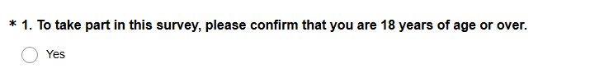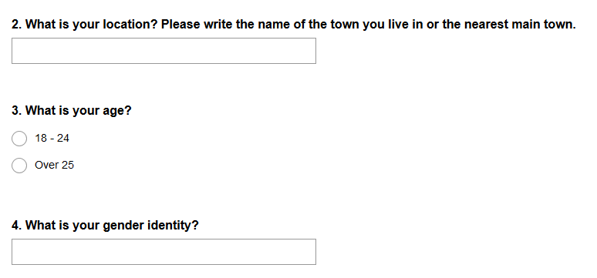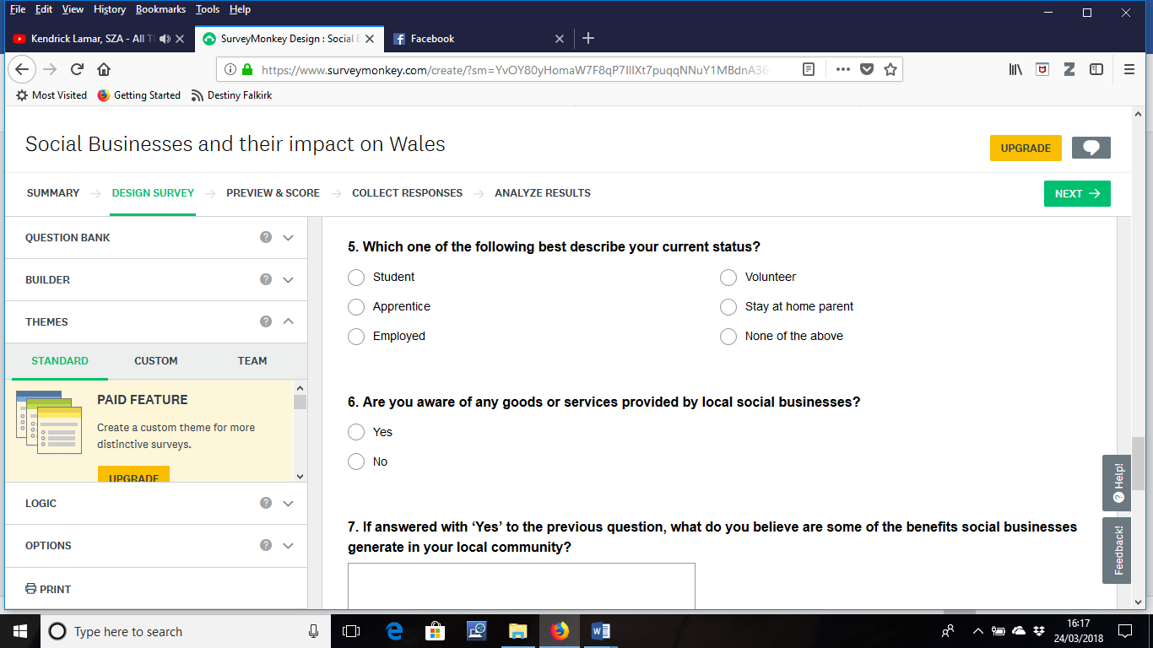
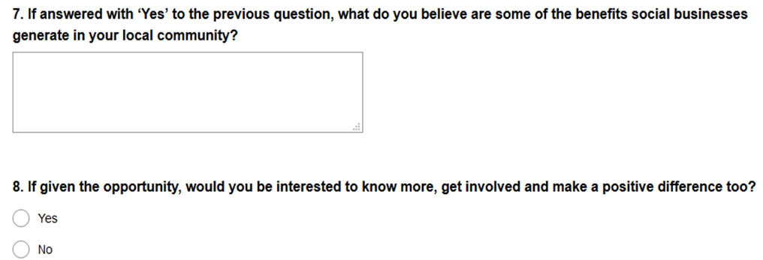

Appendix 2 Interview Questions for Academics

Interview Questions

- How do you feel social businesses are currently promoted and taught within the Welsh education in comparison with five years ago?

- Bearing in mind the current political, economic, social, technological, environmental and legal factors what do you think the main opportunities social businesses may have over the next five years?

- Again, bearing in mind the current political, economic, social, technological, environmental and legal factors what do you think the main challenges social businesses may have over the next five years?

- Considering young people and social businesses, in your opinion, how could they work together to achieve better social impact?

Appendix 3 Interview Questions for Social Businesses

Interview Questions

- What is your location? Please write the name of the town (or the nearest town) your business operates from.

- What is the total number of people you as a social business have in your employment?

- From the total number, what is the number of employees aged 18-24?

- Do you have any strategy in place to recruit and retain young people within the 18-24 age group?

- What tools / methods do you use to measure the social impact you generate as a social business?

- Bearing in mind the current political, economic, social, technological, environmental and legal factors what do you think the main opportunities social businesses may have over the next five years?

- Again, bearing in mind the current political, economic, social, technological, environmental and legal factors what do you think the main challenges social businesses may have over the next five years?

- Considering young people and social businesses, in your opinion, how could they work together to achieve better social impact?

Appendix 4 Online Survey Q7 Answers

Table 13 Question 7 original answers
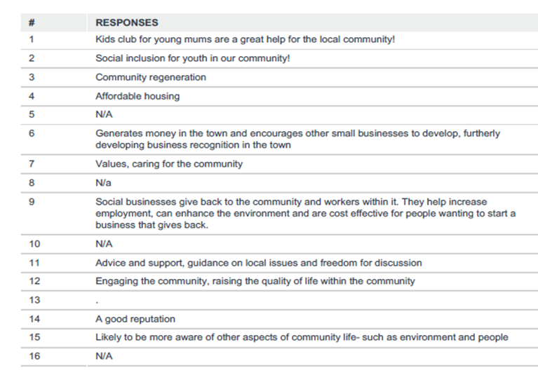

Appendix 5 Interview Transcripts

Specific questions for Academics (A)
- How do you feel social businesses are currently promoted and taught within the Welsh education in comparison with five years ago?
AS: I do not have detailed knowledge of what is taught between now and 5 years ago. However, I do understand this subject is covered at secondary education level and higher.
AE: Social enterprises are recognised more compared to five years ago. I have been to a research seminar on the social enterprises at *** University about three years ago. The research looked at the reasons why this has become such a popular type of organisation. It has also entered the lecture room in terms of teaching and we are working together with local social enterprises. I am however, not sure that students know or understand the criteria for this type of organisation. Overall, I think our teaching is behind the current developments in the economy and it needs to be discussed more specifically in the classroom.

Specific questions for Social Business (SB)

- What is your location? Please write the name of the town (or the nearest town) your business operates from.
Caernarfon, Gwynedd / Ceredigion and the borders - Headquarters in Lampeter, other offices in Aberystwyth and Cardigan / Aberystwyth & Cardigan / Ruthin / Aberystwyth / Llandrindod Wells.

- What is the total number of people you as a social business have in your employment?
SB1: 1 full time and 2 part time.
SB2: 1 full time member of staff, 2 part-time and a bank of sessional workers.
SB3: 45 full time equivalent (we also have freelance staff and casual staff as and when requested as well as 26 volunteers).
SB4: 147.
SB5: 4 core team members + a team of 12 freelance dance leaders.
SB6: 30.

- From the total number, what is the number of employees aged 18-24?
SB1: Zero.
SB2: None.
SB3: 6 (full/part time). We currently have another 3 on the casual pool of staff and 2 volunteers within that age bracket.
SB4: 13.
SB5: None.
SB6: 2

- Do you have any strategy in place to recruit and retain young people within the 18-24 age group?
SB1: No.
SB2: No – nothing specific as due to the nature of our business, we need experience to be foremost.
SB3: Quite recently we created a new team of staff – Customer Service Team. Whilst not exclusive for 18 to 24-year olds – these positions have been created with that age group in mind. Since the formation of that team in 2016 – a number of staff have been promoted to managerial/deputy manager positions. The main appeal to the position(s) are the salary (we offer a living wage) and the range of duties in the post (box office / café-bar / front of house / duty manager). The posts are generally created with the view/aim that these people move on either within the business to new jobs or elsewhere (we tend to have an unwritten rule that staff should stay in these posts for 2-3 years maximum). This also allows us to get new staff in as a “conveyor belt” if you like.
SB4: Have offered apprenticeships in trades and office-based roles. No specific targeted strategy other than a commitment to apprenticeships.
SB5: No, although we are developing an apprentice scheme.
SB6: Not currently – The *** has previously had an apprenticeship scheme with a view to encouraging people from the 18 – 24 demographic into work. I am currently working on the feasibility of setting up a county wide project which will include a social enterprise training academy and facilities for the 18-24 age demographic

- What tools / methods do you use to measure the social impact you generate as a social business?
SB1: questionnaires, feedback, chips and chat nights, social media and quotes.
SB2: We have feedback forms after every session group/training day and are currently working on a social value report.
SB3: It’s impossible to prove our social impact ourselves. In 2010, we commissioned *** Consulting to measure our economic and social impact. This provided us with a non-biased report. This is something we’d like to do more often, but there are considerable costs involved. The impact can also be measured in terms of ‘success’. For example: Buildings let in the town > Number occupied / empty (we generally have a high occupancy rate as our rates are affordable to ensure tenant turnover is low) > Staff/employment figures by our tenants Events/shows in *** > Number of tickets sold > New customers / returning customers > Customer data : do people travel (we have customers who come from a wide catchment – this has a further economic impact) *** (Arts project) > Number of members > Feedback > Waiting list numbers > Quality of the performances/shows Café-Bar > Daily use > Number of covers per day / week / month > Suppliers are local = social and economic implications *** / Conferencing > Number of bookings/conferences > New bookers > Multi-day conference has a wider impact on the community (hotels / restaurants / spend in the area).
SB4: Supply chain monitoring. Tender evaluation criteria other than cost. Tender Scoring Matrix Procurement policy Community Benefit toolkit returns to Welsh Government
SB5: We currently use sociological methodologies to evaluate impact, developed through a project with University of Cardiff.
SB6: We collate monitoring for all the services we provide and have key performance indicators and social outcomes which directly relate to the funding criteria of each project and the charitable aims and objectives of The ***. We collate both quantitative and qualitative data on a regular periodic basis. We use Case Studies from service users; conduct service user engagement through individual and team consultation programmes and events. For some of our projects we can measure levels of recidivism and subsequently estimate savings to the public purse.

Mutual Questions for Academic and Social Businesses

- Bearing in mind the current political, economic, social, technological, environmental and legal factors what do you think the main opportunities social businesses may have over the next five years?
AS: I genuinely think young people are very concerned about the future of society and current social issues and would consider social business as a viable option in the future. I am aware of some recent research which identified “social innovators” as one of the key drivers for young entrepreneurs in Wales. Key opportunities include Brexit – a chance to do things differently, explore new markets, force innovation. Collaboration and co-operation through the delivery of services especially in rural areas. Job creation and training in the communities where people reside which are relevant to their interests, experience and aspirations. Solutions for an aging society, helping people in later life live independent lives, avoiding entering hospital or residential care. Tourism, maximising our beautiful Welsh landscape and heritage. Natural resources, which benefit the communities surrounding them. Using online forums to promote best practice and mutual support, given the dispersed population. AE: There are many strong movements happening and more and more people realise the growing inequality in our society and that this most end. At the same time, legislation like the Well-being of the Future Generations Act (Wales) 2015, make it a legal requirement to look after the well-being of Wales. Therefore, I strongly believe that social businesses will find greater support over the coming years.
SB1: As a third sector social business we will be supporting the statutory services to deliver services to our community.
SB2: Not sure.
SB3: We are a truly unique company. There is no other company in the UK to our knowledge who work the way we do in terms of the business model. The main opportunities we see is that the town of *** is improving year-on-year in terms of the appearance, footfall and the mix of independent “niche” outlets. The town is community driven – so it’s about giving the community that sense of empowerment and ownership in everything we do. We have spent almost 8 years to draw-up plans, secure funding and are currently in construction phase (to open September 2018) a new dedicated 2 screen cinema on-site. This is one project of three large-scale projects now happening in the town. This shows our commitment to the town and will hopefully act as a catalyst to further investment potentially from the private sector. We must be optimistic – we have tried to “future-proof” as much as possible our business model and focus.
It is impossible to make assumptions/an optimistic case for future opportunities without knowing: * Who will be leading our country * What BREXIT will actually mean to us as a company and customers! A recession will only make the government re-evaluate their priorities and austerity measures/policies – this COULD be a good thing if it means investing in infrastructure/future projects.
SB4: Diversification / growth in to new areas. Greater partnership and collaboration. Flexibility. Job creation. Re-investment back into the business.
SB5: For us, as creative learning pioneers, the new curriculum presents opportunities. We are also looking to digital to develop both our work and audiences.
SB6: Changes to funding streams for most charitable organisations and social businesses will inevitably mean that organisations will have to be innovative in delivering services for people and this could prove a catalyst for organisations to co-design services with other organisations and service beneficiaries. I.T & Technological advances together with increased use of social media platforms could provide an opportunity to increase engagement with social business Legal factors will vary depending upon the legislation that pertains to each project delivered by an organisation or the particular sector in which the organisation operates. There is always an opportunity to lobby politicians at a local regional and national level and create change.

- Again, bearing in mind the current political, economic, social, technological, environmental and legal factors what do you think the main challenges social businesses may have over the next five years?
AS: Brexit, austerity, squeeze on public sector expenditure, limited broadband and mobile phone coverage, poor transport links around Wales, lack of business. Innovation and places/forums to generate ideas about this especially in rural areas. Earning a living is a very important consideration and often difficult to achieve at the outset of starting a new social business. Accessing start up grant funding is now more challenging than 5 years ago.
AE: If the economy is not developing due to Brexit, this could have a negative impact on social businesses. If individuals find it hard to earn enough money, the support of social enterprises from a consumer perspective could end. This might also apply to any government funding/ subsidies. Furthermore, I also consider the growing dominance of internet business as a threat to social enterprises. Normally, internet companies are detached from people and the local community and they can have a negative impact on social enterprises due to competitive advantage.
SB1: To sustain our core costs ...project costs are not a problem.
SB2: Possibly funding. Early on, we relied on European funding.
SB3: The elephant in the room is simply – what BREXIT will mean and who will be leading our country in the future. This causes a huge “unknown” to business owners and the general public – there is a risk and no understanding or knowledge of what is ahead of us or the timescale and/or short-medium-long term obligations. In terms of challenges to social business – I would suggest that funding (revenue / capital / cashflow) is the main challenge. A lot of social businesses within the “service” market depend on some form of public funding/support. It is almost impossible to plan, develop a business and/or look for funding without knowing that the existing business is “safe”. This is one reason why we as a company have been working on a contingency and investing in change over the past 3 years (in particular). We expect our revenue support to continue to reduce year-on-year, so we have adapted our business model to develop more ‘commercial’ avenues to bring in revenue (whilst being able to keep additional costs as low as possible). Depending on the type of business – data sharing / ownership is currently a hot-topic. The new GDPR has been set-up to protect consumers – so it is essential that all businesses (of all types/sizes) comply with the new legislation. Environmentally – there is a huge shift now also in the use of plastic. Most ethical businesses now reduce (or stop altogether where possible) using certain types of plastic. Consumers are becoming sensitive to such topics and this will inevitably be key to future decision making on their behalf – do they shop/support/use a service who promote “green and clean” policies or not? The key for companies here is to promote their policies – whether this is banning plastic, recycling, sourcing locally, investing in renewable energy etc. All of the above examples have a cost implication to go with it…
SB4: Brexit and funding constraints / uncertainty. Third sector in particular being asked to take on more business areas once provided by the statutory sector. Recruitment and retention of good quality staff. Poor transport links in this area. Slow broadband in this area.
SB5: Brexit and reduced public funding (austerity).
SB6: Continuity and sustainable funding is a constant threat to all social businesses. Within the current political climate (as with all businesses and public-sector organisations) the priorities placed by local authorities and political parties vary and consequently social businesses are susceptible to the ‘political winds of change’. Brexit may compound this situation.
- Considering young people and social businesses, in your opinion, how could they work together to achieve better social impact?
AS: Social business forms part of the National Curriculum, not sure if it does already? Is it part of the Welsh Bacc? Study visits for students to inspiring case studies. Extending the role of Big Ideas Wales which already promotes youth entrepreneurship in schools, to include even more role models representing social business (this is work in progress). Clarify what is social impact. Not just increased turnover and job creation. Mainstream great stories about social business and young people in social media, TV. Ensure existing support organisations in Wales work together to advance this subject, and also work with communities where there are currently limited opportunities. Maximising online resources and forums to create supportive networks. UnLtd, the Foundation for Social Entrepreneurs - already offer small cash awards plus support, coaching and networks to stimulate social entrepreneurship for all aged 16 and over.
AE: This question very much depends on how you define social impact. Do you mean stronger communities, integration, etc? Linked to what I have said in the previous question, young people as well as social enterprises need to recognise each other’s value. Only when they appreciate the existence of each other, the can benefit from each other and work together. Again, social business is quite a broad terminology and this question might depend on the industrial sector of the social business. Some social businesses are more suitable to work with young people than others. Overall, I think going back to the basics and showing that equality can be achieved, could be a starting point. A different teaching of economics in schools and University is also necessary to teach the working of society. At the moment, there is not enough… and we go back to your question one.
SB1: We could look at supporting our youth forum to be more of a social business.
SB2: We do train some students locally as Volunteer Reminiscence Friends as we feel strongly that inter-generational work can be beneficial for both the students themselves and, perhaps more importantly, for the clients they work with (older people and those living with dementia).
SB3: We regularly attend school events to discuss our work, how the company started and the need for entrepreneurial approach in day-to-day personal life and also how vital young people are to growing their town/area and the economy. Our business model/mix is quite fluid in terms of income generation: Rent (tenants) • Private hires (events/conferences) • ticket sales • café bar • Membership (arts project) • consultancy fees (for advice etc) Young people are often a “forgotten” group. Here in *** there has been a recent decision to close youth clubs (although bases on a consultation with young people) – this will offer an opportunity for us as a company to look into our offer for young people (specifically ages 12 – 25). This is a difficult group to target through the arts – but we believe through film/cinema we will manage to attract young people to use our new cinema screens and use us as a social space to meet with friends. This is the whole purpose of our social enterprise – for the people, by the people – for ALL ages! Our arts project is another prime example of our work with young people. *** is a project for ages 8 – 21. The members suggest ideas and topics for shows as well as workshops and ideas on how to develop the project. This gives the members empowerment on the activities. Empowerment/ownership is key to the success of any company. If a person feels “part of” a business – this will encourage loyalty and will have a positive impact on social and economic factors.
SB4: Greater knowledge of the social business sector. School based intervention to encourage and promote entrepreneurship and social entrepreneurship. Volunteering / work placement opportunities.
SB5: We hope our work increases aspiration in young people (particular our productions, which aim to engage young people with science). With our next production, we are considering ways in which young people can have a voice throughout the creative process which we hope will help us further engage young audiences with dance and science. In considering the bigger picture, I’m not I have an opinion, other than to say that involving / recruiting young people to governance roles is extremely beneficial to social businesses.
SB6: Young people could bring enthusiasm energy and a new and fresh perspective. Co designing services with young people can ensure services are relevant to the 18-24 demographic and improve engagement.

