

Module Code and Title:
BMSW5007 Building a Sustainable Marketing Relationship
Report

Student Name: MARIANA-ADELA SUGAR
Student id:2244011
Date:29/11/2024

Executive Summary
This paper looks at the sustainable relationship marketing strategies used by Tesco and how they influence organisational performance. In this analysis, key aspects like segmentation, pricing, differentiation, ethical practises and sustainability, Tesco’s data collection and evaluation methods are analysed. This study attempts to examine how these strategies contribute to customer centrality and long-term customer loyalty.
The findings show that Tesco uses data driven insight through its Clubcard programme to facilitate personalised marketing and improve customer engagement. The fact that it is customer-centric; providing competitive pricing, product differentiation, and commitment to sustainability strengthens its place in the market. Yet problems such as improving competition with discount retailers and balancing the need for affordability with sustainability remain unresolved.
On the whole, Tesco’s relationship marketing strategies have been successful, but further integration of cost-effective sustainability practises and digital personalization will keep Tesco growing and customers loyal.

Table of Contents
Executive Summary i
Introduction 1
Findings 1
Historical Profile of Tesco 1
Historical Development 1
Current Status 2
Mission Statement 2
Data Collection, Analysis, Evaluation 2
Data Collection 2
Analysis and Evaluation 3
Sustainability Impact 3
Critical Analysis 4
Marketing Relationship Strategies 4
Segmentation 4
Pricing Strategies 4
Differentiation 5
Ethical and Sustainable Practises 5
Achieving Customer Centrality 6
Integration of Strategies 6
Critical Discussion 6
Evidence and Examples 6
Conclusion 7
References 8
Appendix 10

Introduction
This report aims to explore Tesco’s sustainable relationship marketing policies and practises and their impact on organisational performance. The Marketing Executive Officer of Marketing Focus, an online journal published by Tesco, has asked me to contribute to research on the importance of customer centrality and how it affects sustainable marketing relationships.
The report is put together through the use of secondary research methods including data from academic textbooks, peer reviewed journal articles, reputable business websites, and Tesco’s own reports. They are credible and up to date sources that give you insight into Tesco’s strategies and performance metrics.
Tesco, one of the leading multinational retail companies, is best known for its customer relationship-oriented strategies through loyalty programmes and innovative marketing. Tesco’s operations depend on sustainable relationship marketing, which helps the organisation to keep customer loyalty, respond to changing consumer needs and sustain competitive advantage in the dynamic retail environment.

Findings

Historical Profile of Tesco

Historical Development
Tesco was founded in 1919 by Jack Cohen, who started out selling fruit and vegetables from a market stall in East London, before becoming one of the world’s largest retailers (Tesco PLC, 2024). The name 'Tesco' was first used in 1924, when Cohen's supplier was T.E Stockwell and the first two letters of his surname.
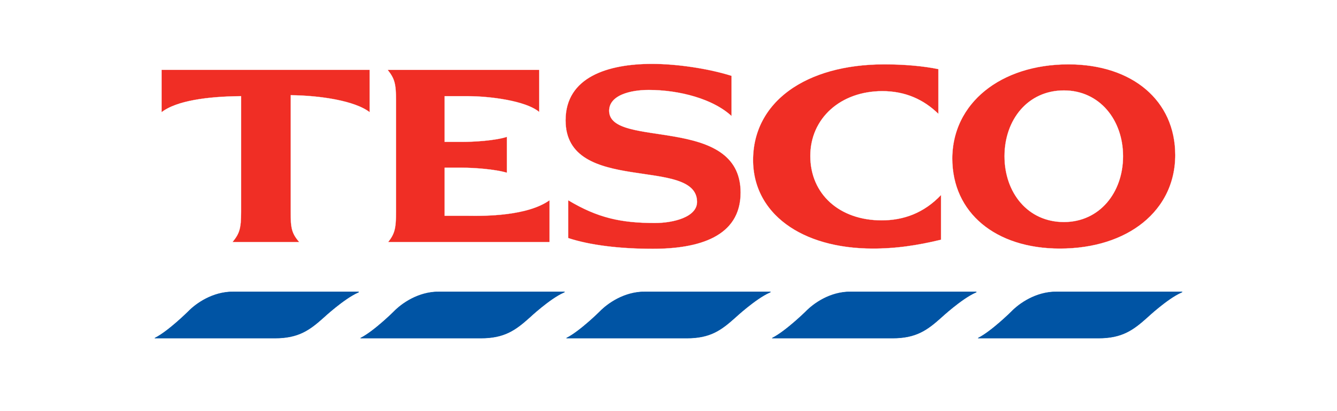
Figure 1 Tesco (Tesco PLC, 2024)
In the mid twentieth century, Tesco grew rapidly by opening its first supermarket in 1947 and introducing self-service retailing. Among its key milestones were the introduction of Clubcard in 1995, a loyalty programme that changed the game in customer relationship management, and its international expansion into Europe and Asia (Arefin et al., 2024). Over the past decade or so, Tesco has been shifting its focus towards digital and sustainability practises in order to keep up with modern expectations.

Current Status
In the UK grocery market, Tesco currently has a market share of about 27% in 2024, a position of dominance that has been eroded by the entry of discount retailers Aldi and Lidl (Doğan et al., 2018). In its latest financial year, the company reported a pre-tax profit of £2 billion, suggesting steady growth despite challenges including last year's 2014 accounting scandal. With the strategic investments in digital transformation and sustainability, Tesco has continued to adapt.

Mission Statement
Tesco's mission is "Serving shoppers a little better every day," which reflects the importance the company attaches to understanding and serving customers. This mission is very much aligned with the relationship marketing, which focuses on customer loyalty, customer satisfaction and long-term engagement (Doğan et al., 2018). Personalisation and community participation are important to the company's focus on trust and sustainable growth through strong customer connections.

Data Collection, Analysis, Evaluation

Data Collection
An acceptable method is the Tesco Clubcard scheme that started in 1995 is the main source through which Tesco gets consumer data. They may also also use this programme to monitor consumption patterns and habits of the consumer and offer them specific promotions or discounts (Griva et al., 2018). Information is gathered from internet, online, Tesco’s customers’ questionnaires, Clubcard, and through website and mobile application. These data sources offer purchasing behaviour, products, and users whom purchase information is being collected from. Tesco is able to build lasting customer relationship using the data to offer value added products and services.

Analysis and Evaluation
These tools capture information, analysed big data and CRM systems can then review it. Demographic and behaviours help Tesco’s marketer to design and develop specific promotional techniques (Jones et al., 2020). Specifically, Clubcard data hold are employed to provide promotions relevant to a member’s interests in purchasing items and make product suggestions. Apart from marketing, Tesco uses this data in other fields; forecasting, inventory management, and developing supply chain procedures to satisfy the customers.

Sustainability Impact
Sustaining long term customer relationships requires effective data collection and analysis (Tesco PLC, 2024). Tesco is able to personalise the shopping experience, build trust and increase customer loyalty by leveraging data. Insights from customer data help Tesco design promotions that speak to particular segments and engage.
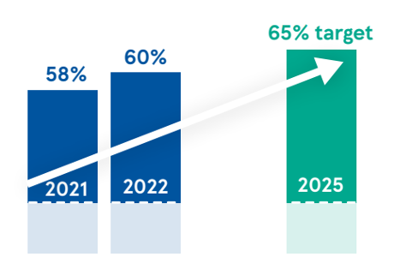
Figure 2 Sales of Healthy Products as a Proportion of Total Sales (Tesco PLC, 2024)
Additionally, data enables Tesco to not only identify but also implement sustainable practises like decreasing food waste by studying demand patterns or suggesting ecofriendly product to environmentally conscious consumers (Aiello et al., 2020).

Critical Analysis
When combined with Tesco’s data driven approach, a lot is to be gained, including increased customer loyalty, more effective operation and closer alignment to consumer preference (Naidoo and Gasparatos, 2018). But as you know, there are challenges like ensuring privacy of data and staying compliant with regulations such as GDPR. Also, the need for data analytics requires continuous investment in technology and staff. The other concern is alienating customers when the feel overly monitored or left out of promotions (Osburg et al., 2021). Although these challenges exist, Tesco is able to harness data effectively to help it lead sustainable relationship marketing.

Marketing Relationship Strategies

Segmentation
Segmentation is the process of splitting a market into distinct groups of consumers who share similar needs, preferences, or behaviours, allowing businesses to deliver their product or service in a way that best meets the needs of each of those groups. Segmentation is important in relationship marketing to personalise the interaction and build customer loyalty (Patel and Swamy, 2023). Tesco uses demographic, psychographic and behavioural segmentation strategies. For example, Tesco markets value products to the families and high end products through their Finest range to attract the high end customers. Tesco uses its Clubcard programme to analyse customer data to identify unique customer segments and sends targeted marketing campaigns targeting them (Seyfang and Gilbert-Squires, 2019). This approach enables Tesco to serve a specific customer base by meeting specific needs, reinforcing customer centrality by ensuring that each shopper feels valued and understood creating loyalty and trust.

Pricing Strategies
Tesco uses pricing strategies to meet customer needs of affordability and profitability simultaneously. The company uses competitive pricing to attract cost conscious customers and provides discounts and promotions to keep old customers (Ruiz-Real et al., 2018). For example, Tesco’s Price Match programme compares its prices with those of rivals like Aldi and guarantees that it is at the leading edge of pricing in the main product categories. In addition, the Clubcard programme offered by Tesco provides loyalty based discounts that are offered to repeat customers (Aiello et al., 2020). However, these strategies also play a role in customer loyalty by reinforcing customer loyalty on account of value for money and the transparency in pricing. The affordable pricing helps customers to adopt Tesco as a fair and trustworthy retailer which will lead to long term relationships with customers and premium pricing for exclusive products appeal to higher income customers who are willing to pay a premium for quality to keep relationships within different customer segments.

Differentiation
The differentiation aspect of relationship marketing involves creating unique products or experiences to set a business apart. Tesco stands out for its product selection, loyalty programs, and customer service (Doğan et al., 2018). Its Finest and Everyday Value product lines meet premium and budget customer needs, respectively. Clubcard also offers tailored promos and discounts to differentiate the loyalty programme (Ruiz-Real et al., 2018). To differentiate the shopping experience, Tesco uses technology like its Scan & Shop system to simplify in-store purchases. These tactics ensure that Tesco delivers value beyond pricing, develops customer connections, and improves loyalty by meeting a variety of consumer demands and preferences.

Ethical and Sustainable Practises
Tesco, in its relationship marketing strategy, is using its ethical policies and sustainability initiatives to show its commitment to responsible business practises. Through supply chain transparency the company sources product ethically and practises fair trade (Aiello et al., 2020). For example, Tesco does support local farmers and promotes certified sustainable. With its commitment to cut carbon emissions and cut food waste, sustainability initiatives like that resonate with environmentally conscious consumers. In addition to using surplus food donations, Tesco’s also reuses its packaging (Tesco PLC, 2024). By practising these, customer centricity is improved as they embody the consumer values, build trust and build loyalty among the ethically and environmentally conscious shoppers. Tesco’s ethical and sustainable efforts are a major driver of the long-term relationship with customers who increasingly prefer brands that are responsible.

Achieving Customer Centrality

Integration of Strategies
Through segment, price, differentiate, and sustainability, Tesco’s marketing strategies are integrated to pursue customer centrality, the main of its relationship marketing. Segmentation allows Tesco to understand and respond to different needs of its customers delivering specific solutions (Griva et al., 2018). Pricing strategies emphasise affordability and value, and differentiation emphasises Tesco’s distinct product lines, including the Finest and Everyday Value. Tesco supports both sustainability and ethical practises which are aligned with modern consumers' values of trust and emotional connexion (Ruiz-Real et al., 2018). Through the integration of such strategies, Tesco develops a comprehensive marketing method that satisfies customer requirements, fosters loyalty and gives it a competitive edge. Examples of this include Tesco’s sustainability practises which encourages long term engagement and personalised offers created through segmentation and loyalty programmes which all reinforce customer satisfaction.

Critical Discussion
Overall, Tesco’s attempt to achieve customer centrality is very effective, evidenced by its strong market position and excellent customer retention. Tesco’s relation marketing cornerstone programme, Clubcard, is the backbone of keeping Tesco aware of consumer preferences through robust data collection and analysis (Ruiz-Real et al., 2018). Nevertheless, competition from discounter Aldi and Lidl, with its aggressive pricing strategy, is keeping challenges alive. In addition, while Tesco's ethical and sustainability practises attract environmentally conscious consumers, it may be that some segments will pay less for sustainability (Doğan et al., 2018). To address these gaps Tesco has to improve the accessibility of sustainable options at no compromise to affordability. In general, Tesco’s ability in balancing the customer centric strategies and operational efficiency shows that it has strong position on relationship marketing.

Evidence and Examples
Tesco’s customer centric success is visible through high customer satisfaction and strong loyalty programme engagement (Naidoo and Gasparatos, 2018). In the UK, for example, the Clubcard programme has over 20 million active users, giving Tesco a treasure trove of data to personalise offers and boost the shopping experience. Moreover, Tesco’s measures to cut food waste and carbon emissions have been well received by the public, for example through surplus food donations that resonate with eco friendly consumers (Naidoo and Gasparatos, 2018). These examples show how Tesco’s integrated marketing approach helps the company to win a loyal and divers customers and stay competitive in the ever changing retail market.

Conclusion
As a result, Tesco’s relationship marketing strategies have been very effective in achieving customer centrality and building customer loyalty. Tesco has segmented their customer base through robust segmentation, data driven personalisation (through their Clubcard programme), competitive pricing and differentiated offerings. This is all part of Tesco’s commitment to ethical and sustainable practises that resonate with consumer values and build long term loyalty.
Tesco is struggling to reduce its costs even as it looks to increase its sustainability quotient. As new competitors Aldi and Lidl are entering their markets, Tesco has to find out how to set the prices on its items, being competitively low, while not compromising product quality as well as customer appeal. Data privacy is also traces important to ensure the client’ trust especially when undertaking business online.
Currently, there is the need for Tesco to implement the sustainable, low-cost strategies that will increase its ability to personalise products and pursue customers. With Tesco’s honesty to emerge on price and ethics the organisation’s image and integrated customer-oriented vision will be enhanced.

References
Aiello, L.M., Quercia, D., Schifanella, R. and Del Prete, L. (2020) 'Tesco Grocery 1.0, a large-scale dataset of grocery purchases in London', Scientific data, 7, p.57.
Arefin, S. et al. (2024) 'Retail Industry Analytics: Unraveling Consumer Behavior through RFM Segmentation and Machine Learning.' 2024 IEEE International Conference on Electro Information Technology (eIT)., pp.545–51.
Doğan, O., Ayçin, E. and Bulut, Z. (2018) 'Customer segmentation by using RFM model and clustering methods: a case study in retail industry', International Journal of Contemporary Economics and Administrative Sciences, 8.
Griva, A., Bardaki, C., Pramatari, K. and Papakiriakopoulos, D. (2018) 'Retail business analytics: Customer visit segmentation using market basket data', Expert Systems with Applications, 100, pp.1–16.
Jones, P., Wynn, M. and Comfort, D. (2020) 'SDG 12, Sustainable consumption and the UK’s leading retailers', RESPONSIBLE CONSUMPTION AND PRODUCTION p.7.
Makos, J. (2024) Tesco SWOT Analysis: 39 Factors Affecting the Retailer. Available at: https://pestleanalysis.com/tesco-swot-analysis/ (Accessed: 15 November 2024).
Naidoo, M. and Gasparatos, A. (2018) 'Corporate environmental sustainability in the retail sector: Drivers, strategies and performance measurement', Journal of Cleaner Production, 203, pp.125–42.
Osburg, V.-S., Davies, I., Yoganathan, V. and McLeay, F. (2021) 'Perspectives, opportunities and tensions in ethical and sustainable luxury: Introduction to the thematic symposium', Journal of Business Ethics, 169, pp.201–10.
Patel, K.S. and Swamy, D. (2023) 'Customer Role in Relationship Marketing in Acquisition and Retention of Customers: TESCO', Modern Research in Consumer Behaviour and Marketing Research p.87.
Ruiz-Real, J.L., Uribe-Toril, J., Gázquez-Abad, J.C. and de Pablo Valenciano, J. (2018) 'Sustainability and retail: Analysis of global research', Sustainability, 11, p.14.
Seyfang, G. and Gilbert-Squires, A. (2019) 'Move your money? Sustainability transitions in regimes and practices in the UK retail banking sector', Ecological Economics, 156, pp.224–35.
Tesco PLC (2024) Tesco. Available at: tesco.com (Accessed: 15 November 2024).
Vadakkepatt, G.G. et al. (2021) 'Sustainable retailing', Journal of Retailing, 97, pp.62–80.
Yawson, D.E. and Yamoah, F.A., (2022) 'The TESCO Club Card Loyalty Programme: The Gold Standard.' in Contemporary Retail Marketing in Emerging Economies: The Case of Ghana’s Supermarket Chains. Springer., pp.77–87.

Appendix
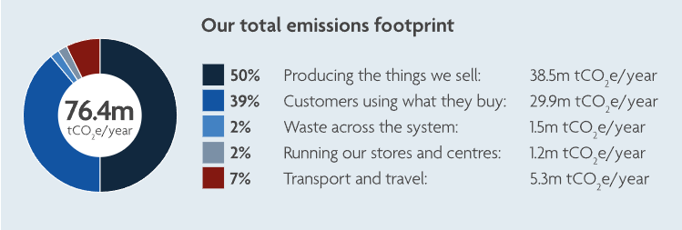
Figure 3 Tesco Carbon Emission Footprint (Tesco PLC, 2024)
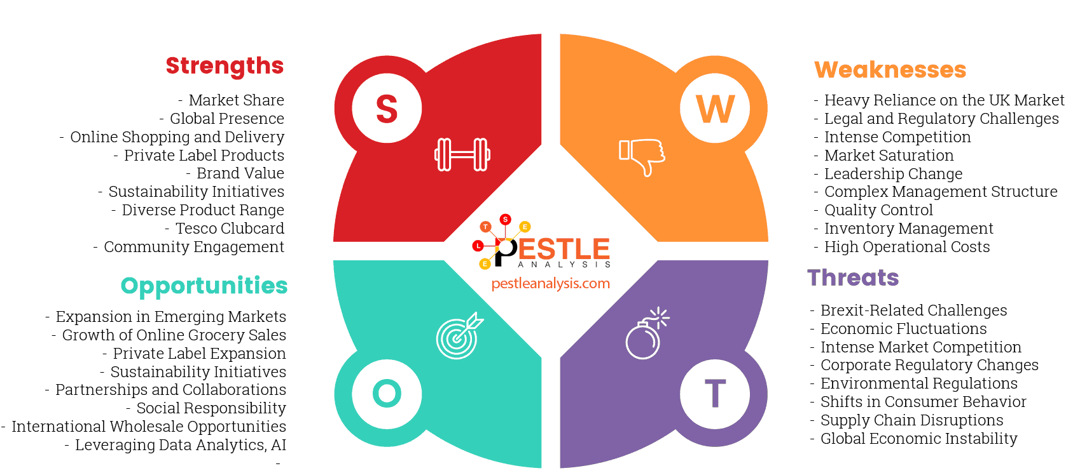
Figure 4 Tesco SWOT Analysis (Makos, 2024)

