Data security, governance & compliance

Name: Jonathan Davies
Student Number: 1707239
Module Code: ACCA7028
Lecturer: Dr. Carlene Campbell

Word Count: 3112
Table of Contents
Table of Figures 3
Abstract 4
Introduction 5
1. Literature Review 5
1.1 What is a Cybersecurity Framework? 5
1.2 Frameworks and Models 5
1.2.1 ISO 27000 5
1.2.2 NIST Cybersecurity Framework (NIST CSF) 6
1.2.3 PCI DSS Framework 6
1.3 ISMS Comparison 7
1.3.1 Application 7
1.3.2 Structure 7
1.3.3 Global/Organisational Standing 8
2. ISMS Design 8
2.1 Explore 9
2.1.1 Review 9
2.1.2 Risk Assessment 9
2.1.3 Risk Management 9
2.1.4 Employee Needs 9
2.2 Engage 9
2.2.1 Network 9
2.2.2 Software 10
2.2.3 Data 10
2.2.4 Cloud 10
2.2.5 Bring Your Own Device (BYOD) 10
2.3 Evaluate 10
2.3.1 System Review 11
2.3.2 Exploratory Review 11
2.3.3 Engagement Review 11
3. Conclusion 11
References 12
Appendices 15
Appendix A1 – NIST History and Creation 15
Appendix A2 – NIST Core Functions 15
Appendix A3 – NIST Implementation Tiers 15
Appendix B1 – ISO 27000 Family Outline 16
Appendix C1 – ISO 27001 & NIST CSF Similarities (Clauses) 16
Appendix C2 – ISO 27001 & NIST CSF Similarities (Controls) 17
Appendix D1 – ISO 27001 Requirements 18
Appendix E1 – NIST Function Breakdown 19
Appendix F1 – PCI DSS Requirements 20

Table of Figures

Figure 1 - Custom ISMS Design Overview 6
Figure 2 - Similarities between framework clauses (ISO 27001 & NIST CSF) [20] 14
Figure 3 - Similarities between framework controls (ISO 27001 & NIST CSF) [20] 15
Figure 4 - NIST CSF Functions & Categories 17

Abstract
The purpose of this report is twofold. Firstly, an understanding is to be gained and documented in regard to Information Security Management Systems and how they are created or migrated into organisations around the globe. The advantages and disadvantages shall be studied and used to form a basis for a newly created ISMS for a fictitious company. The new ISMS shall be a blend of the frameworks investigated in section one.

Introduction

Literature Review

What is a Cybersecurity Framework?
The number of users that are connected to the Internet in the year 2020 has been predicted to be anywhere from 4.3 billion [1] to 4.9 billion [2]. In either case, what is clear is that the global number of connected devices is rising quickly. Whilst this volume of internet usage provides a rate of data exchange unlike anything experienced in the history of humanity, it also widens the net cast by malicious individuals, organisations, and states that endeavour to capture sensitive information be it financial, personal, or governmental.
Each year, businesses and organisations are presented with an increasing threat from various types of malware that pose a financial threat not only in the way of theft but also downtime and loss of reputation [3], [4]. The threat became so commonplace that in 2007 Microsoft announced a new plan that would embed an antivirus package inside Windows completely free of charge to Windows users and this replaced a subscription based service that the company were already offering [5]. Current estimates show that in 2016, the average monetary cost of cybercrime among business and organisations in the United States was $665,000 per year [6], the US economy as a whole $60 billion per year [7] and the global economy $500 billion per year [8].
To mitigate this, companies with a reliance on cyber activities searched for ways in which to not just apply a reactionary response towards threats, but take an aggressive, proactive stance. The need for the ability to manage cyber threats reliably and continuously was met with the idea of an Information Security Management System (ISMS). These are frameworks that can be migrated into a company’s security policy to enhance what already exists or can be a central pillar of the organisation from the very start.

Frameworks and Models

ISO 27000
The ISO 27000 series provide a multitude of standards relating to the optimal setup of an ISMS. This model is currently the most popular of its kind currently in use today with not only companies and organisations adopting its specifications, but also government agencies and facilities [9]. The basic principle of the standard is to protect aspects of the user’s data; Confidentiality (ensures that only authorised persons have access to the data), Integrity (ensures that data is not compromised by unauthorised parties) and Availability (ensures that data is accessible whenever required) (CIA) [10].
Whilst the ISO 27000 itself deals with terminology and an overview of the series, the ISO 27001 is the standard that companies can use to develop their own ISMS and can receive a certification to state that they have met the standards requirements. An outline has been provided in Appendix B1 – ISO 27000 Family Outline that depicts the role of the most prominent of the standards [11]. ISO 27001 is the section that envelopes all requirements and implementation procedures that an organisation must comply with to be considered for certification. The requirements stipulated by ISO 27001 have been showcased in Appendix D1 – ISO 27001 Requirements [12], however, requirements 1-3 have been omitted due to them being general information.

NIST Cybersecurity Framework (NIST CSF)
The National Institute of Standards and Technology (NIST) developed an industry-agnostic framework that allowed for the planning and employment of an extensive cybersecurity policy. The framework was modelled in such a way that not only could it be applied to virtually any business regardless of the field that it resided in, but each element of it could be understood by everyone in the organisation, from executive board members down to employees responsible for implementation.

NIST Core
The core section of the framework is the one that allows organisations to formulate a strategy that will aid in the protection of assets in the case of a cyber-attack. It consists of a set of five functions, each one complimenting the last. Each function name serves as a high-level overview of the suggested action and is coupled with a set of categories and subcategories that provide further information and avenues. Each category/subcategory also has its own informative references that provide even greater detail on its particular topic. The design of this approach allows for general understanding to be gained at the higher levels of the structure when read by executive officers and upper management, but also provide clear direction and specific instructions for those tasked with the adoption and implementation process. The five functions have been outlined in Appendix A2 – NIST Core Functions with descriptions of their specific coverage [13]. Appendix E1 – NIST Function Breakdown showcases an example of tracing the ‘Identify’ function from its highest level through to its informative material.

NIST Implementation Tiers
The Implementation tiers provided by NIST grant organisations the ability to evaluate their levels of cybersecurity readiness in a levelled tier system. There are four possible tiers: Tier 1 – Partial, Tier 2 – Risk Informed, Tier 3 – Repeatable and Tier 4 – Adaptive. Each level also incorporates three categories: Risk Management Process, Integrated Risk Management Program and External Participation. This tier system has not been designed as a ‘test’ from which a certain score must be attained, but rather as an aid that can show possible areas of improvement. Due to the use of non-technical terminology and generalisation, the system can be adopted and understood between many different types of industries [14].
It should be noted that organisations are not placed under stress to increase their standing in the tier system as not every firm requires the security that higher tiers offer. Organisation size plays a major role in determining what is an acceptable level of cybersecurity readiness. It is generally accepted that smaller businesses consisting of a small number of employees would see the greatest cost-to-benefit results at either tier 1 or 2, whilst large organisations are expected to be at tier levels 3 or 4 [15]. With that said, all firms are encouraged to attain a tier 2 status due to its relatively simple requirements [13]. Appendix A3 – NIST Implementation Tiers outlines the tier systems and the measures needed to achieve each one.

NIST Profile
NIST provided a mechanism from which organisations could analyse their current cybersecurity capabilities and compare these results against a target level that they wished to achieve. This is called the Framework Profile and is a purely voluntary scheme so there is no backlash from discovery of sub-standard methods, and instead offers a reflective medium that organisations can learn from.

PCI DSS Framework
The Payment Card Industry Data Security Standard (PCI DSS) was formulated in 2006 by five of the largest credit card administers (American Express, Discover, JCB, Mastercard and Visa) to provide a standard for the lowest level of cybersecurity that could be considered safe by organisations that use, store or transmit credit card information [16]. Online and in-store payment trends reveal that card payment transactions have been the primary mode of payment since at least 2003 [17] and the total monetary value of these sales in 2019 was $3.5 trillion, with estimates of $4.9 trillion in 2021 [18].
This has resulted in a surge in credit card fraud that cost businesses worldwide roughly $22 billion in 2015 [19] and the purpose of the aforementioned PCI DSS was to lessen the number of cases of credit card fraud. The standard holds twelve key requirements that have been generalised into six overarching goals that organisations must comply with to be deemed as PCI DSS certified. These goals/requirements have been listed in Appendix F1 – PCI DSS Requirements.

ISMS Comparison

Application
In terms of using or integrating any of the aforementioned Information Security Management Systems, NIST CSF allows for the greatest range of application as it is a very open-ended framework, allowing organisations to submerge themselves only as deep as they deem necessary and this would appeal to many as it is can be far more lightweight and customisable. It also focuses efforts on the operational aspects of integration because it assumes some level of managerial practices are already in place[20].
Both NIST CSF and ISO 27001 share some striking similarities that may initially cast confusion when selecting a model, however it should be noted that both frameworks offer technological neutrality (allowing an adoptee to select specific technologies to meet their needs) and industrial neutrality (allowing all organisations to use the frameworks) [20]. Appendix C1 – ISO 27001 & NIST CSF Similarities (Clauses) and Appendix C2 – ISO 27001 & NIST CSF Similarities (Controls) depict how clauses and controls from each framework correlate.
When performing an analysis of the effectiveness of PCI DSS with either NIST CSF or ISO 27001, it should first be noted that the scope of PCI DSS is far tighter, focusing solely on the protection of credit card information compared to a general information that the business engages with. With that said, a general evaluation of the architecture of the framework can be undertaken by examining the features that each hold, rather than the effectiveness of the security that they provide.

Structure
The first major similarity is that both frameworks adhere to the CIA (Confidentiality, Integrity, Availability) infrastructure. By using this foundation and ensuring that the core elements of the triad are covered, each framework is working towards the same aim. The next comparable feature is that both NIST CSF and ISO 27001 allow the integration of external frameworks/framework-controls into the policy under their respective ‘control implementation’ section. This would allow organisations that incorporate either NIST or ISO to use aspects of PCI DSS or HIPAA if they held particular control measures that related to their industry [21].
The structure of each ISMS also holds related methodologies. The essence of the NIST Framework Core provides five functions from which a guide can be compiled. These areas are broken down into 22 categories, (much like ISO 27001 Annex A’s sections), 98 sub-categories (akin to ISO 27001 Annex A’s controls), and finally into reference material that signposts directions to other frameworks such as COBIT or HIPAA [21].

Global/Organisational Standing
Both PCI DSS and ISO 27001 award a certification (this is something that NIST CSF does not do), which helps to reassure business partners and other third-party officials that the security of both their information, and those handling it, is of a high standard. The ISO 27001 controls are also written to a higher level than that of PCI DSS, thus making the ISO a more flexible framework to work with, whilst PCI DSS is very rigid in its implementation practices. NIST CSF is even more flexible than ISO 27001, allowing for even greater implementational freedom, but as previously mentioned, does not provide any certification for adopting the framework, therefore not guaranteeing the organisation’s informational security reputation to potential clients/partners [22].
A major benefit of the NIST CSF when compared to ISO 27000 and PCI DSS is the cost to implement has the chance of being far smaller as companies can just use the sections that apply to them without the overarching need to complete every requirement for fear of not attaining a certification.

ISMS Design
Although security management systems such as NIST CSF and ISO 27001 aim to be applicable to nearly all organisations, they can be quite cumbersome if the target of the ISMS is quite specific. In the case of CaribbeanCoffee, they require a system that focuses on the protection of cloud-based activities as well as BYOD security. For that reason, this custom ISMS has been presented.
Figure 1 - Custom ISMS Design Overview
The idea behind the design above is that each activity flows neatly into the next, and that each level cannot be accessed until the previous has been completed. Only three main activities have been created v Each portion of the framework is responsible for a set of actions; these actions have been listed below.

Explore
This section covers the organisation’s approach to the concepts of implementing a cybersecurity framework. It specifically allows the managerial tier to map out the needs of the company and calculate, manage, and prepare for potential risk. The ‘Explore’ area has been broken down into five stages that must be navigated.

Review
Very much like the approach that the NIST Profiles take, the review process encourages the organisation to take a snapshot of their current security system and investigate its strengths, weaknesses, and appropriateness. Once the current snapshot has been processed, the company can propose their preferred future model and calculate a roadmap of how best to get there.

Risk Assessment
The next stage is to compile a list of risks that are a threat to the company. Considering that much of CaribbeanCoffee’s services are offered via the cloud, 95% of the network is wireless and there is a push to allow employees the right both to use their devices at work and use their devices for work, much of the risk assessment will be pointed in that direction. Risks specific to this company will be the choice of cloud provider (it will need to be investigated to ensure that CaribbeanCoffee management know exactly which responsibilities belong to them which belong to their cloud provider), how users will interact with CaribbeanCoffee’s services when on their own devices, and what are the most prevalent wireless based attacks.

Risk Management
The Risk Assessment stage will provide a thorough list of risks that can now undergo a mitigation process to determine the likelihood and severity of each. This mitigation process will end with a plan of how best to handle each risk and outline the risks that need the greatest level of monitoring. This process correlates closely to ISO 27001 6.1.3 requirement.

Employee Needs
Due to the demand by staff for a BYOD work environment, CaribbeanCoffee needs to forge a security solution that satisfies both the employer and the employee. Decisions need to be made on the amount of control CaribbeanCoffee has over employee’s personal devices and which services employees can access when using them.

Engage
The Engage area is only entered once the entirety of the Explore section has been completed. It focuses its aim solely on the operational side of system by splitting down the topics related to CaribbeanCoffee’s key activities. It has been styled in a manner similar to that of PCI DSS. The reasoning for this is that the PCI DSS requirements provide strict, permissive set of instructions that potential users can follow and that is the exact approach needed here. By having access to a set of rules concerning the physical and digital security of their infrastructure, CaribbeanCoffee can spend less time constructing their own rules and more time implementing the ones listed.

Network
Perhaps the most important, and arguably most vulnerable, element to protect is the network infrastructure of the organisation. To ensure that the threat of a breach is as low as it can be a set of requirements have been laid out.
- The system must be protected by a firewall.
- All passwords must be changed from default and it is recommended that password policy within the organisations ensures the regular changing of passwords and that they are of suitable strength.
- All access to and from the system must be logged and monitored for unusual activity.
- Use a VPN to access local systems remotely.

Software
The security of software used within the company must also be monitored to prevent data breaches or leaking of information.
- Anti-virus software must be used and kept up to date.
- All software used on company systems must first be vetted and then kept up to date.
- Software updates must be patched immediately [23].

Data
Data is the target most data breaches making it an extremely vulnerable resource; however, actions can be placed in motion to protect it.
- Data that is either at rest or in transit must be encrypted [24].
- Access to data must only be granted to individuals that need it for their work.

Cloud
Although most cloud service providers provide their own protection to user data whilst both at rest and in transit (therefore alleviating much of the risk from the user’s perspective), the selection of a suitable cloud service provider is still something that is the sole responsibility of the organisation. This might seem like a trivial task, but it should be noted that a poor choice of provider could have disastrous consequences.
- Ensure that the potential cloud service provider hold relevant certifications that guarantee the level of protection that the user requires (for example ISO 27000 or PCI DSS).
- Ensure that the cloud provider as a migration plan and technical support available for it.
- Request the cloud provers Service Level Agreement (SLA) to determine their reliability and performance levels.

Bring Your Own Device (BYOD)
Whilst the benefits of employing a BYOD system cannot be disputed [25], there is an added risk that follows suit [26]. This section is dedicated to the safe operation of a BYOD infrastructure within the organisation.
- Referring to the policies agreed between the employee and the employer discussed in 2.1.4, implement a Mobile Device Management system that allows the containerisation of work-related applications on remote devices [27] [28].
- The use of Multi-Factor Authentication must be adopted [29].
- Only allow devices that are connected remotely a limited (preferably minimum) number of accessible services [30].
- Incorporate a risk-based authentication process to reduce the likelihood of unauthorised access [31].

Evaluate
This process involves planning of a full system evaluation and determining the scope of such an event. An audit mechanism should be conceived with the goal of checking the areas of the system at different time intervals which are determined by their level of importance. The audit should be undertaken by impartial employees and reported to multiple persons within the upper management tier.
The evaluation stage should not just evaluate the operational side of the system, but also the exploration stage as new technologies emerge very quickly and may either pose a threat or an opportunity to the company. This audit system should heavily reflect that of ISO 27001’s section 9 entitled ‘Performance Evaluation’.

System Review
Due to the ever-changing technological landscape, it is advised that a full system review take place annually. This will aid in efforts to keep threats at bay by adopting new elements (both managerial and operational) into the ISMS.

Exploratory Review
A full Exploratory review should take place bi-annually and will consist of a reiteration of both the risk assessment and risk management processes. This ensures that new risks are allowed to be investigated and managed in a timely manner.

Engagement Review
An Engagement review should occur monthly as the infrastructure will be the prime target of attackers.

Conclusion
This report firstly researched different Information Security Frameworks and how they can be applied to organisations from all different industries. The benefits and shortcomings of each were analysed and compared to produce a solid platform from which to tackle task 2’s scenario of custom designing an ISMS to fit the described company. The created ISMS covered areas that closely relate to ones found in task 1, with particular attention paid to ISO 27000 and NIST CSF.

References

[1] International Telecommunication Union, “Measuring Digital Development,” Geneva, 2019.
[2] Cisco, “Cisco Annual Internet Report (2018-2023),” 2018.
[3] MalwareBytes Labs, “2020 State of Malware Report,” 2020.
[4] S. Sen, E. Aydogan, and A. I. Aysan, “Coevolution of Mobile Malware and Anti-Malware,” IEEE Trans. Inf. Forensics Secur., vol. 13, no. 10, pp. 2563–2574, Oct. 2018.
[5] B. Ryon, “Microsoft Announces Plans for No-Cost Consumer Security Offering - Stories,” 18-Nov-2008. [Online]. Available: https://news.microsoft.com/2008/11/18/microsoft-announces-plans-for-no-cost-consumer-security-offering/. [Accessed: 07-Oct-2020].
[6] M. Xu, K. M. Schweitzer, R. M. Bateman, and S. Xu, “Modeling and Predicting Cyber Hacking Breaches,” IEEE Trans. Inf. Forensics Secur., vol. 13, no. 11, pp. 2856–2871, Nov. 2018.
[7] J. W. McCormick and P. C. Chapin, Building high integrity applications with spark. Cambridge University Press, 2015.
[8] A. Kovacevic, N. Putnik, and O. Toskovic, “Factors Related to Cyber Security Behavior,” IEEE Access, vol. 8, pp. 125140–125148, 2020.
[9] Z. Hamdi, A. Anir Norman, N. Nuha Abdul Molok, and F. Hassandoust, “A Comparative Review of ISMS Implementation Based on ISO 27000 Series in Organizations of Different Business Sectors,” in Journal of Physics: Conference Series, 2019, vol. 1339, no. 1, p. 12103.
[10] M. E. Whitman and H. J. Mattord, “The Value of Information and the C.I.A Triad,” in Management of Information Security, 6th ed., Cengage, 2018, pp. 7–10.
[11] D. J. Tjirare and F. B. Shava, “A gap analysis of the ISO/IEC 27000 standard implementation in Namibia,” in 2017 IST-Africa Week Conference, IST-Africa 2017, 2017.
[12] ISO, “NEN-ISO/IEC 27001,” 2013.
[13] M. Barrett, “Framework for improving critical infrastructure cybersecurity,” in Proceedings of the Annual ISA Analysis Division Symposium, 2018, vol. 535, pp. 9–25.
[14] J. Beasley, “A Guide to Successfully Implementing the NIST Cybersecurity Framework,” 2015.
[15] L. A. Gordon, M. P. Loeb, and L. Zhou, “Integrating cost–benefit analysis into the NIST Cybersecurity Framework via the Gordon–Loeb Model,” J. Cybersecurity, vol. 6, no. 1, Jan. 2020.
[16] HCPro, “Bringing together information security and finance with PCI DSS,” Briefings on HIPAA, vol. 16, no. 12, pp. 6–8, 2016.
[17] J. Liu, Y. Xiao, H. Chen, S. Ozdemir, S. Dodle, and V. Singh, “A survey of payment card industry data security standard,” IEEE Commun. Surv. Tutorials, vol. 12, no. 3, pp. 287–303, Sep. 2010.
[18] O. Tounekti, A. Ruiz-Martinez, and A. F. Skarmeta Gomez, “Users Supporting Multiple (Mobile) Electronic Payment Systems in Online Purchases: An Empirical Study of Their Payment Transaction Preferences,” IEEE Access, vol. 8, pp. 735–766, 2020.
[19] K. Randhawa, C. K. Loo, M. Seera, C. P. Lim, and A. K. Nandi, “Credit Card Fraud Detection Using AdaBoost and Majority Voting,” IEEE Access, vol. 6, pp. 14277–14284, Feb. 2018.
[20] Dejan Kosutic, “How to implement NIST Cybersecurity Framework using ISO 27001,” 2017.
[21] P. P. Roy, “A High-Level Comparison between the NIST Cyber Security Framework and the ISO 27001 Information Security Standard,” in 2020 National Conference on Emerging Trends on Sustainable Technology and Engineering Applications, NCETSTEA 2020, 2020.
[22] T. Mataracioglu, “Comparison of PCI DSS and ISO / IEC 27001 Standards,” ISACA J., vol. 1, no. October 2010, pp. 1–5, 2016.
[23] K. Bauer, V. Dedhia, R. Skowyra, W. Streilein, and H. Okhravi, “Multi-variant execution to protect unpatched software,” in Proceedings - 2015 Resilience Week, RSW 2015, 2015, pp. 108–113.
[24] A. Chopra and M. Chaudhary, “Annex A.10: Cryptographic Control,” in Implementing an Information Security Management System, APRESS, 2020, pp. 63–64.
[25] K. Timms, “BYOD must be met with a wider appreciation of the cyber-security threat,” Comput. Fraud Secur., vol. 2017, no. 7, pp. 5–8, Jul. 2017.
[26] M. S. Doargajudhur and P. Dell, “Impact of BYOD on organizational commitment: an empirical investigation,” Inf. Technol. People, vol. 32, no. 2, pp. 246–268, Apr. 2019.
[27] Z. Mitrovic, I. Veljkovic, G. Whyte, and K. Thompson, “Introducing BYOD in an Organisation : The Risk and Customer Services Viewpoints,” in CSM Africa Conference 2014, 2015.
[28] NCSC, “BYOD: Executive Summary - NCSC.GOV.UK,” 2016. [Online]. Available: https://www.ncsc.gov.uk/guidance/byod-executive-summary. [Accessed: 08-Jan-2021].
[29] M. Olalere, M. T. Abdullah, R. Mahmod, and A. Abdullah, “Bring Your Own Device: Security Challenges and A Theoretical Framework for Two-Factor Authentication,” Int. J. Comput. Networks Commun. Secur., vol. 4, no. 1, pp. 21–32, 2016.
[30] NCSC, “Mobile Device Guidance.” [Online]. Available: https://www.ncsc.gov.uk/collection/mobile-device-guidance/bring-your-own-device#section_3. [Accessed: 08-Jan-2021].
[31] L. Dostalek, “Multi-Factor Authentication Modeling,” in 2019 9th International Conference on Advanced Computer Information Technologies, ACIT 2019 - Proceedings, 2019, pp. 443–446.
[32] J. Webb and D. Hume, “Campus IoT collaboration and governance using the NIST cybersecurity framework,” in IET Conference Publications, 2018, vol. 2018, no. CP740, pp. 25 (7 pp.)-25 (7 pp.).
[33] NIST, “History and Creation of the Framework,” NIST, 2018. [Online]. Available: https://www.nist.gov/cyberframework/online-learning/history-and-creation-framework. [Accessed: 09-Oct-2020].
[34] M. Hinchey and L. Coyle, “Evolving Critical Systems: a Research Agenda for Computer-Based Systems,” 2010.

Appendices

Appendix A1 – NIST History and Creation
The cybersecurity framework was developed by NIST (National Institute of Standards and Technology) and was originally intended as a means of safeguarding United States critical infrastructure from cyber threats. The scheme was conceived in 2013 when President Obama enacted executive order 13636, effectively calling for a new cybersecurity framework to be created that offered the flexibility of allowing many different organisations and agencies to adopt it [13], [32], [33]. The framework encourages users to regard threats to their cyberspace and digital information as part of the organisations general risk policy.
As previously mentioned, the original recipients of this framework were to be those involved with the operation of critical systems within the United States. These systems have been categorised by Hinchey & Coyle [34] into four distinct areas (Safety, Mission, Business and Security critical) and a cyber intrusion into any of them could result in a situation whereby human lives, national security or social balance are put at risk.

Appendix A2 – NIST Core Functions
- Identify – This function prompts organisations to assess their current level of cybersecurity awareness and analyse areas of weakness and strength. The end goal of this action is for management to have a clear outline of the association’s stance on cybersecurity, the readiness and current ability to mitigate an attack and present key areas of improvement needed.
- Protect – The ‘Protect’ function serves as a way of ensuring that all data used by the company/organisation is not unnecessarily exposed and is also responsible for the application of safeguards should the data need added protection.
- Detect – This function provides guidance for the continual monitoring of internal systems to expose potential threats and attacks. This can be done by watching for anomalies in data management, access control and other unusual activity.
- Respond – The manner in which an organisation responds to a cybersecurity attack is critical. This function promotes the rapid and aggressive reaction to any potential breaches or attacks made from both internal and external sources.
- Recover – The ‘Recover’ function outlines means by which data, communications and financial loss can be restored. This can be achieved via data backups, encrypted communication, and insurance.

Appendix A3 – NIST Implementation Tiers
- Tier 1 (Partial) – Organisations operating at this level have little to no formulated cybersecurity plans and tend to perform sporadic risk assessments if at all. Any threats received are dealt with reactively and on a case-by-case basis.
- Tier 2 (Risk Informed) – Organisations are aware of general cybersecurity threats and may enforce best practices, however a structured policy is not yet in place. Cybersecurity information may be generated by the company, but it is not usually shared externally and is only shared internally on an informal basis.
- Tier 3 (Repeatable) – At this level, a cybersecurity risk policy is properly implemented in the organisation and are regularly amended to reflect a dynamic threat environment. Staff are made aware of their importance in deterring potential situations and the company will continually monitor company resources and assets.
- Tier 4 (Adaptive) – Organisations will have a well-established information security policy in place that is kept updated on a very regular basis in response to emerging threats in the technological environment. Information is not only generated by the company and shared both internally and externally, but they will also take a proactive role in the investigation and detection of threats that may not have been initially targeted at them.

Appendix B1 – ISO 27000 Family Outline
- ISO 27000 – Synopsis of the framework
- ISO 27001 – Requirements and implementation details
- ISO 27002 – Code of practice
- ISO 27003 – Application instruction
- ISO 27004 – Measurement practices

Appendix C1 – ISO 27001 & NIST CSF Similarities (Clauses)

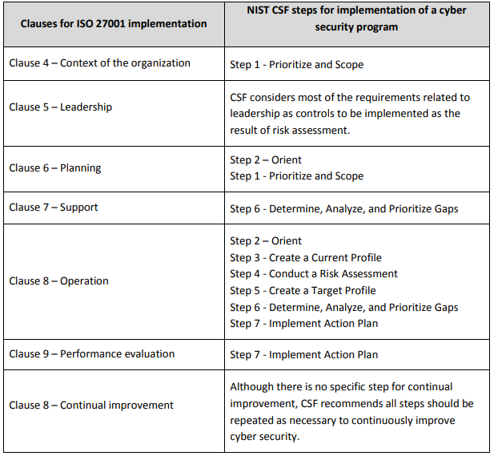
Figure 2 - Similarities between framework clauses (ISO 27001 & NIST CSF) [20]

Appendix C2 – ISO 27001 & NIST CSF Similarities (Controls)

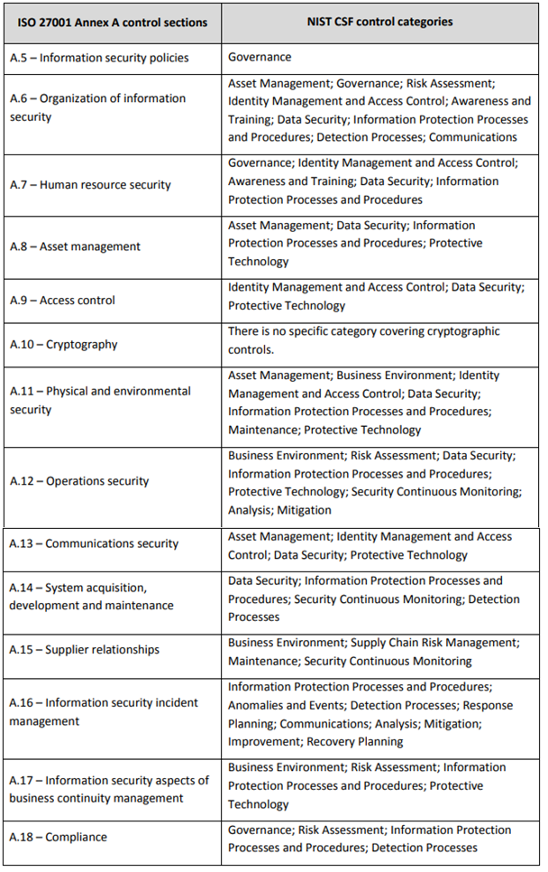
Figure 3 - Similarities between framework controls (ISO 27001 & NIST CSF) [20]

Appendix D1 – ISO 27001 Requirements
4. Context of the Organisation –
This section focuses on the considerations, needs and aspirations of both the organisation that is implementing the ISMS and any third-party affiliates. It is responsible for managing the expectations of what the framework can offer whilst also highlighting the areas in which the organisation identifies as a weakness in terms of cybersecurity.
5. Leadership –
This branch targets the leaders and managers of an organisation and emphasises how these members are involved with the ISMS and their particular roles in ensuring its operation.
6. Planning –
The focal point of the planning stage is to ideate any potential risks and opportunities that may be present in relation to the cyberspace of the organisation. Not only are risks found during this stage, but also any remedies and treatments to them. The list should be as inclusive as possible to ensure maximum benefit effectiveness for the rest of the ISMS operation.
7. Support –
The target of the Support section is to establish the criteria needed for persons operating under the regulations posed by the ISMS. It specifically incorporates a need for employee competence (is each person adequately trained/qualified in security measures), awareness (are they aware of the ISMS, what it means, how it affects them and the organisation and the consequences of not adhering to it) and communication (what can be communicated and to whom it may be sent).
8. Operation –
This category covers the control process of meeting the requirement standards as a whole. It outlines the organisations need to document all results that return from information security risk assessments and treatments. It also ensures the monitoring of outsourced projects.
9. Performance Management –
The organisation is advised to constantly evaluate the successes and failures of their system and section 9 provides details on how to achieve this. It suggests that the organisation be aware of not only what metrics are being evaluated, but also who is performing them.
10. Improvement –
Should the organisation find itself operating outside of the guidelines stipulated by ISO 27001, it should begin a corrective process in order to continue to receive accreditation by ISO.

Appendix E1 – NIST Function Breakdown
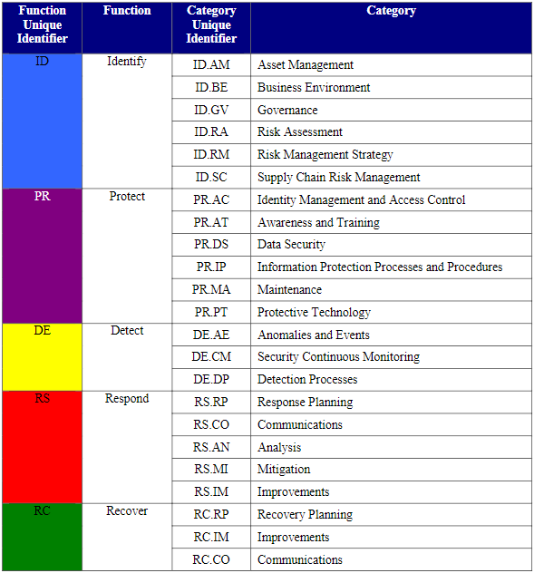
Figure 4 - NIST CSF Functions & Categories

Appendix F1 – PCI DSS Requirements
- Secure Network
  - Functional firewall.
  - Changing all default passwords.
- Cardholder Data Protection
- Protection of data when stored.
- Employing encryption when sending data across public networks.
- Vulnerability Management Program Maintenance
- Use of up-to-date antivirus software.
- Use of secure systems and ensuring that they are updated frequently.
- Strong Access Control Measure Implementation
- Sensitive data should only be accessed on a need-to-know basis.
- Formalised access controls
- Secure access for the physical storage of the data
- Network Monitoring and Testing
- All network resources should be monitored, tracked, and audited.
- All security systems should be tested periodically.
- Information Security Policy Maintenance
- Suitable ISMS in place in organisation

