BMTP5022

Research Methods and Field Study

Assessment 2

Table of Contents
1. Introduction 1
2. Research Methodology 2
2.1 Research Philosophy 2
2.2 Research Approach 2
2.3 Research Strategy 3
2.4 Data Collection and Analysis Method 4
2.5 Ethical Considerations 4
3. Findings and Discussion 5
3.1 Internal Environment Analysis 5
3.1.1 Customer service and products 5
3.1.2 Location 5
3.1.3 Mission and Value 5
3.1.4 Employees 6
3.2 Competitive Advantages 6
3.3 Customer Review 6
3.4 SWOT Analysis 7
4. Conclusion 8
Reference 9
Appendix 11
Competitor of Chill Factore 11
Customer Reviews of Chill Factore 12

1. Introduction
The travel and tourism industry is a growing industry in the UK. The country has a very effective, growing, mature and advanced travel and tourism industry including different service sectors such as travel agencies, airlines, tour operators, accommodation and lodging services, ground transport, entertainment, and theme parks/attraction providers (Adamovich et al., 2021). Based on the market trends and perspective, the travel, hospitality and tourism industry has been contributing to the UK’s GDP. The GDP has been increased by 40% from 2020 to 2023. But, the sector is also dealing with higher competition and challenges in the global market, changing the behaviour of customers and changing trends in markets and society (Entina et al., 2021). The aim of the study is to investigate customer review of Chill Factore and the customer service management, and how the company is improving and can improve its performance in the tourism sector.

2. Research Methodology

2.1 Research Philosophy
In order to select the research tools and methods to conduct the study, research onion has been followed. This has helped in making decision for structure and research method relevant to the research type. Secondary research has been selected for mostly detailed information. To apply research’s knowledge, judgement, value and thinking, interpretivism research philosophy has been applied. Interpretivism research philosophy states that reality is subjective in nature and is also socially constructed (Saunders et al., 2016). Under the research philosophy, the researcher tends to understand reality through their experience which can be different among others based on their understanding and perspective. The observation and participation of the researcher have been managed for the collection and analysis of data and utilisation of the relevant tools. The researcher has not selected the positivism research philosophy for applying the knowledge and judgement in the study. This research philosophy focuses on social data collection without the participation of the researcher with the assumption of reality in an objective manner (Pandey and Pandey, 2021). Hence, interpretivism research philosophy has been utilised in the paper.

2.2 Research Approach
Following the research philosophy in the study, the broader assumptions, systems and planning are required for the data collection, analysis and interpretation which is considered the research approach (Hair et al., 2019). For the selection of research tools and methods, the inductive research approach has been adopted. The inductive research approach contributes to the assessment and addressing of research questions with the development of a general conclusion from the specific conclusion (Bell et al., 2022). The transition of the discussion and specific conclusion has helped the researcher to explore the findings and develop a new theory. Compared to the deductive research approach, inductive allows the involvement and participation of the researcher in using research tools and data collection method.
For the decision-making and framework exploratory research design has been applied. Exploratory research design allows researchers to select and uitlise research tools and methods which contribute to the detailed investigation (Blumberg et al., 2014). The exploratory research design helps in assessing the research questions which have not been explored previously. Relevant research tools and methods have been applied in the exploratory research design of the study.

2.3 Research Strategy
To conduct exploratory research design and relevant research tools, the desk research strategy has been chosen. Desk research strategy is known as secondary research which contributes to the selection of secondary sources and collection of secondary and detailed data. Desk research strategy is a cost-effective method for the study that values in collecting vast amount of data from different sources (Bell et al., 2022). Under the desk research strategy, relevant and reliable sources such as articles, journals, reports, case studies, websites and online sources published after 2013 have been selected. The sources representing tourism and travel industries, data sources related to Chill Factore and customer review and service management have been included under the inclusion criteria. Other research strategies have not been selected as these strategies could not be effective in nature for conducting the study.
For the research strategy, case studies could be adopted but has not been applied. Case research strategy is a qualitative design to explore in depth a program, process, event and situation where the cases are bound by time ad activities (Pandey and Pandey, 2021). But, this research strategy needed variety of data collection procedures over a period and it could lead to more time and costs for conducting the study. On the other hand, triangulation is another qualitative research design for the use of multiple methods to develop a comprehensive understanding of phenomena. But, expense and challenges applying triangulation could be higher compared to desk research strategy.
Finally, the new addition of qualitative research design is netnography which is a specific type of qualitative social media research, adapting the method of ethnography, to understand and assess social interaction in digital communication process. Within this study, only previous documents and information from data sources selected where in some cases, some information has been collected from the website and social media page of the organisation. Netnography is approached in the study as the form of research to investigate online consumer culture. Also, the researcher can assess to deconstruct the cultural norms that impact consumption decisions within the groups. In some areas, netnography has been reflected where the online customer culture has been showed in the findings.

2.4 Data Collection and Analysis Method
To conduct the study and collect information, the secondary data collection method has been applied in the paper. The secondary data collection method uses tools to collect mod ified and available research data from the available sources which were previously used and modified for different reasons (Pandey and Pandey, 2021). The secondary sources can be easily collected due to available sources. To conduct a data analysis tool and process, content data analysis tool has been selected. Content data analysis tool has been applied with focus on the content related to the company such as internal environment, customer service etc. The analysed data has been used for assessing the case study and achieving the aim of the paper.

2.5 Ethical Considerations
In order to conduct the study with the right tools and practice, ethical principles have been followed. Data Protection Act has been followed in order to select and utilise research tools and design for the study. The research error, bias of the researcher, manipulation and alternation have been reduced. The plagiarism of the data has been reduced. Citation will be provided for the acknowledgement of the sources.

3. Findings and Discussion

3.1 Internal Environment Analysis
Travel and tourism sector has been working on its growth in business, sale volume, revenue and scopes of the businesses (Rodríguez-Díaz and Pulido-Fernández, 2021). The organisations in the tourism industry of the UK have seen the scopes for new business and organisations. Chill Factore is working under this sector. The company started its business in 2007 with the unique service for the UK’s longest indoor real snow slope (Chillfactore, 2023).

3.1.1 Customer service and products
Customers and tourists are focusing in art, entertainment and attraction services in the tourism sector (Khan et al., 2020). Chill Factore has been working on the service and tourism products to target different types of market segmentation. Chill Factore has welcomed more than 3 million visitors and customers in their attraction (Chillfactore, 2023). Chill Factore has built different types of services for the tourists such as Ski and Snowboard Lessons, Downhill Donuts, Ice Slide and Snow for every individual, considering age, abilities and preferences (Chillfactore, 2023). After two years of the operation of the organisation, Chill Factor launched its longest indoor real snow slope (180 metres) in the UK. Since opening, the organisation has been able to welcome more than 3 million visitors. This has created the market position as the leading UK visitor attraction.

3.1.2 Location
Based on the market demands, Chill Factore is considered a leading UK visitor attraction. The location of the organisation is on Stretford, Manchester, UK. This place has been attractive destination for the customers and tourists. The location of Chill Factore has made the location an easily accessible, famous, and fun leisure destination for every individual, from tourists and customers.

3.1.3 Mission and Value
The mission and vision of Chill Factore are to be the number 1 visitor attraction. The organisation has been consistently educating and inspiring the guests and customers. Chill Factore has the preference to invest in research and development, the development of a unique environment and team for delivering and managing fun and safe activities. This has helped Chill Factore to work on its mission and image development in the market.

3.1.4 Employees
The organisation has been employing 144 Employees and the employment grew their employee by 17% last year (Growjo, 2022). This also represents the business performance and growth of Chill Factore in the tourism sector.

3.2 Competitive Advantages
Chill Factore has focused on customer service while thinking of different preferences and choices of different market segmentation. Customer service in the tourism and travel industry needs to be on point to target customers (Alisa and Ridho, 2020). Also, the uniqueness and quality of service and tourism products can help the travel and tourism sector to acquire new customers, develop sale and revenue of business, and improve brand value (Park and Jeong, 2019).
Chill Factore has been working on a customer service strategy to fulfil the demands of every targeted customer. The organisation caters for the needs of every people, without disability and with disabilities. Chill Factore has two ski lifts to make sure the guests don’t miss any moment of snow fun. The company also ensures to maintain less obstruction on the slope for the customer. Two ‘travellators’ are managed in Chill Factore leading to the top of the beginner slope. Each facility of Chill Factore is managed with the facilities, proper resource, technologies and monitoring, risk assessment and management. In the case of managing tourism and travel service, the organisation needs to maintain proper human resource planning and management. Talented and skilled employees can influence the quality of service and service delivery to the tourists and customers (Sugathan and Ranjan, 2019). Based on the allocation of employees and management of services, Chill Factore has ensured to keep the employees and talented professionals.

3.3 Customer Review
Customer reviews say a lot about the performance and activities of the organisation (Dedeoğlu et al., 2020). A review of one customer can help other customers to make decisions. Based on the Social Capital Theory, social media users build relationships, communication and networks in order to have their advantage. The company has been using social media platform and website to get reviews and feedback from customers and assess their performance and ability in the business markets. The customer review of Chill Factore is represented below:
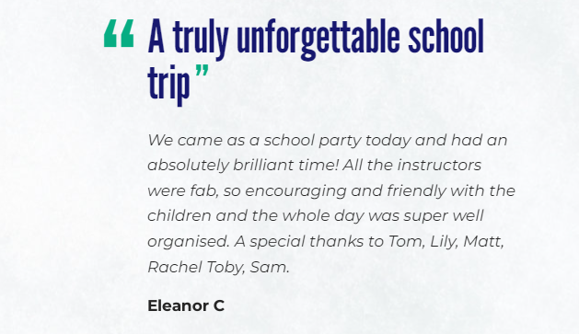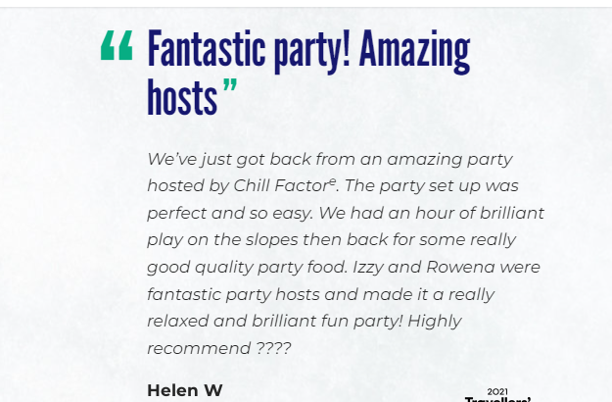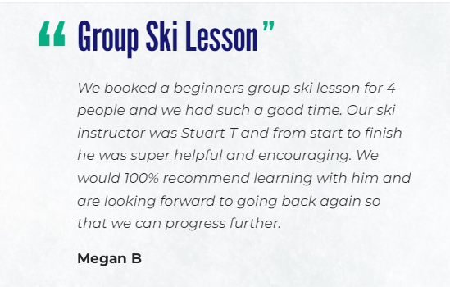
Chill Factore has been able to get customer reviews and feedback from social media platform which are used as the source of feedback. This has helped Chill Factore to work on customer service development, communication, marketing and promotional activities and customer relationship management in social media platform.

3.4 SWOT Analysis
In this era of social media platform, the organisations need to pay attention to maintaining the quality of products and services and to manage customer service in order to get positive reviews and recommendation (Bazargani and Kiliç, 2021). To create a great image and quality products, Chill Factore has worked on the strengths. The SWOT analysis of the organisation is as follows:
Strengths: To create the image and reputation in the destination, Chill Factore brings different services and products to customers such as the wealth of bars, cafes and restaurants. Chill Factore has also developed the UK’s leading outdoor clothing shops for targeting different market segmentations and customers. This has contributed to higher income and revenue for the organisation. The estimated annual revenue of Chill Factore is currently $40.1M per year and revenue per employee is $278,300 (Growjo, 2022).
Weaknesses: Chill Factore has weaknesses related to effective social media marketing strategy, website design, and proper communication system with the customers and tourists. These have already created challenges for Chill Factore to address customer complaints and issues in the workplace.
Opportunities: Diversified industries and services are managed and operated under the tourism industry which are targeting millions of tourists and customers. The UK has seen how tourist arrival has been increasing with the growth of sale volume and revenue (Bănescu et al., 2021). The sector is highly growing with its reputation, business scopes and opportunities in markets.
Threats: The tourism and travel industry has seen how organisations are bringing diversified services and products to customers. This can be challenging for Chill Factore for the company. Also, globalisation, competition and changing behaviour of customers can affect performance of Chill Factore.

4. Conclusion
The key findings of the study have stated that Chill Factore has been able to work on its business performance and productivity through product development, diversified service strategy, customer service strategy, social media marketing strategy, customer recommendation and engagement strategy and employee management strategy. These have helped Chill Factore to work on its performance and success in the tourism and travel sector. In the future, the investigation areas can be related to the assessment of the market environment, and impacts of business strategy on Chill Factore on performance and so on. Based on the selected research tools and methods, the study has accomplished the research aim. The detailed data has been collected from secondary sources where analysed data has critically assessed the data. However, the survey research strategy could be selected for the numerical data collection which could result in using MS Excel or SPSS for better quantitative data analysis.

Reference
Adamovich, V., Nadda, V., Kot, M. and ul HAQUE, A., 2021. Camping vs. Glamping Tourism: Providers' Perspective in the United Kingdom. Journal of Environmental Management & Tourism, 12(6 (54)), pp.1431-1441.
Alisa, F. and Ridho, Z., 2020. Sustainable cultural tourism development: A strategic for revenue generation in local communities.
Bănescu, C., Boboc, C., Ghiță, S. and Vasile, V., 2021, June. Tourism in digital era. In Proceedings of the 7th BASIQ International Conference on New Trends in Sustainable Business and Consumption, Foggia, Italy (pp. 3-5).
Bazargani, R.H.Z. and Kiliç, H., 2021. Tourism competitiveness and tourism sector performance: Empirical insights from new data. Journal of Hospitality and Tourism Management, 46, pp.73-82.
Bell, E., Bryman, A. and Harley, B., 2022. Business research methods. Oxford university press.
Bhatia, A., Roy, B. and Kumar, A., 2022. A review of tourism sustainability in the era of Covid-19. Journal of Statistics and Management Systems, 25(8), pp.1871-1888.
Blumberg, B., Cooper, D. and Schindler, P., 2014. EBOOK: Business research methods. McGraw Hill.
Chillfactore, 2023. About Us [WWW Document]. Chillfactore. URL https://www.chillfactore.com/about-us (accessed 11.12.23).
Dedeoğlu, B.B., Taheri, B., Okumus, F. and Gannon, M., 2020. Understanding the importance that consumers attach to social media sharing (ISMS): Scale development and validation. Tourism Management, 76, p.103954.
Entina, T., Karabulatova, I., Kormishova, A., Ekaterinovskaya, M. and Troyanskaya, M., 2021. Tourism industry management in the global transformation: Meeting the needs of generation Z. Polish Journal of Management Studies, 23.
Growjo, 2022. Chill Factore revenue and competitors [WWW Document]. Chill Factore: Revenue, Competitors, Alternatives. URL https://growjo.com/company/Chill_Factore (accessed 11.12.23).
Hair Jr, J., Page, M. and Brunsveld, N., 2019. Essentials of business research methods. Routledge.
Khan, A., Bibi, S., Lorenzo, A., Lyu, J. and Babar, Z.U., 2020. Tourism and development in developing economies: A policy implication perspective. Sustainability, 12(4), p.1618.
Lew, A.A., Cheer, J.M., Haywood, M., Brouder, P. and Salazar, N.B., 2020. Visions of travel and tourism after the global COVID-19 transformation of 2020. Tourism Geographies, 22(3), pp.455-466.
Pandey, P. and Pandey, M.M., 2021. Research methodology tools and techniques. Bridge Center.
Park, J. and Jeong, E., 2019. Service quality in tourism: A systematic literature review and keyword network analysis. Sustainability, 11(13), p.3665.
Rodríguez-Díaz, B. and Pulido-Fernández, J.I., 2021. Analysis of the Worth of the Weights in a new Travel and Tourism Competitiveness Index. Journal of Travel Research, 60(2), pp.267-280.
Saunders, M., Lewis. P., and Thornhill, A., 2016. Research Methods for Business Students. (7th Ed). UK: Pearson
Sreejesh, S., Mohapatra, S. and Anusree, M.R., 2014. Business research methods: An applied orientation. Springer.
Sugathan, P. and Ranjan, K.R., 2019. Co-creating the tourism experience. Journal of Business Research, 100, pp.207-217.

Appendix

Competitor of Chill Factore
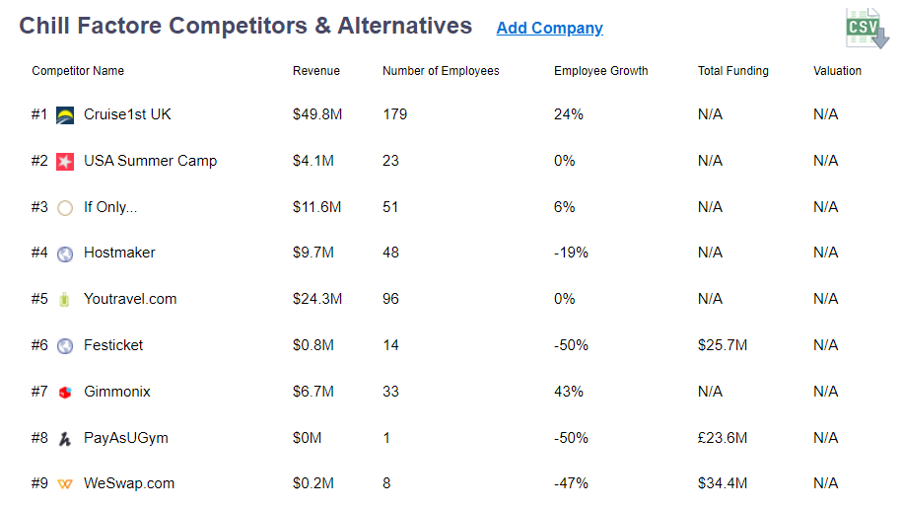

Customer Reviews of Chill Factore

