Dissertation Research Proposal
A Local Economic Impact Study of A Mega Event: A case study of Swansea Air Show.

Roisin Hannon
University Of Wales Trinity Saint David
BA Events Management

Table of Contents
1. Introduction 3
1.2 Background & Rationale 3
1.3 Literature Review 4
2. Aims & Objectives 4
2.1 Aim 4
2.2 Objectives 4
3.Research Design 4
3.1 Methodology 5
3.2 Approach & Strategy 5
3.3 Philosophy 6
3. Strategies 6
3.1 Analysis 6
4.2 Interviews 7
4.3 Sampling Framework 8
5. Resources 8
6. Ethics & Risks 9
7. Limitations 9
7.1 Resources Limitations 9
7.2 Ethical Considerations 9
8. References 10
9. Appendix 11
9.1 Gantt Chart 11

Introduction

The purpose of this dissertation is to analyse how an annual event held in Swansea is economically impacting the local area. The case study that will be investigated will be Swansea Air show which creates 200,000 attendees each year and continues to grow Harding (2017). Tourists/visitors coming to a visit a destination means that their expenditures are recycled through the local economy making many events beneficial to local communities and businesses (Zima K, 2011). This dissertation will be investigating what scale of economic impact this major event is having on the local area.

1.2 Background & Rationale

Swansea Air Show is a free two-day annual event which has seen attendance figures grow each year Williams (2019). The event draws in visitors from all over the UK to watch the air displays which feature the Battle of Britain Memorial Flight and The Red Arrows, the event also provides a range of ground displays/activities. The event continues to develop each year, adding an ‘After Dark’ element to 2019’s display which helped to draw in more tourists and local attendees than previous years.
Chalip & McGuirty (2004) argue that an event is a part of a tourists over all experience and it becomes more attractive to the attendee once they can incorporate an array of tourism experiences. Swansea Air show continues to draw in more tourists each year Williams (2019). There has been an increasing interest in event attendee spending patterns of tourists (Laesser and Crouch, 2006) and the purpose of this study is to investigate local business perceptions of costs and benefits in order to determine if local businesses/organisations within the local economy are benefiting from this event. The event’s marketing/advertising, along with media coverage, will help to benefit and enhance the destination’s image, thus helping to build visitation at other times of the year (Chalip, Green, & Hill, 2003, p. 214). Creating attendees or tourists to visit at other times in the year can create additional visitor spend for Swansea. Preuss (2005) argues that event attendees can have both a positive and negative effect which could create a problem for Swansea Air Show. Tourists can bring in new money from outside into the hosting region directly into the economy therefore creating a positive impact, however, money can also leak out of the local economy therefore producing a negative impact for local businesses. However there remains a paucity in academic literature that identifies specific spending around events such as Swansea Air Show.

1.3 Literature Review

For this dissertation the researcher will be using main authors such as Chalip, L., and Getz. The researcher will have to base some literature on economic sporting events as there is currently little wealth of research and knowledge on air display events.

Aims & Objectives

Aim

The overall aim of this study is to investigate the local economic impacts of Swansea Air Show and evaluate how local businesses are affected.

Objectives

In order to fully meet the aim of this dissertation will look to meet the following objectives:
- To establish whether local businesses see a benefit to their profits whilst Swansea Air Show is displayed.
- To critically analyse previous academic literature on how destinations/local areas can economically benefit from staging events.
- To investigate local business perceptions of costs and benefit.

3.Research Design

Methodology

Research can be defined as an enquiry process which is both highly organised and explore a proposed question or test hypothesis (Punch, 2016). An effective research strategy has been created by Saunders et al (2009), The Research Onion, which is made up of layers that relate to certain stages of research. The researcher will use ‘The Research Onion’ to help them establish the correct research methodology.
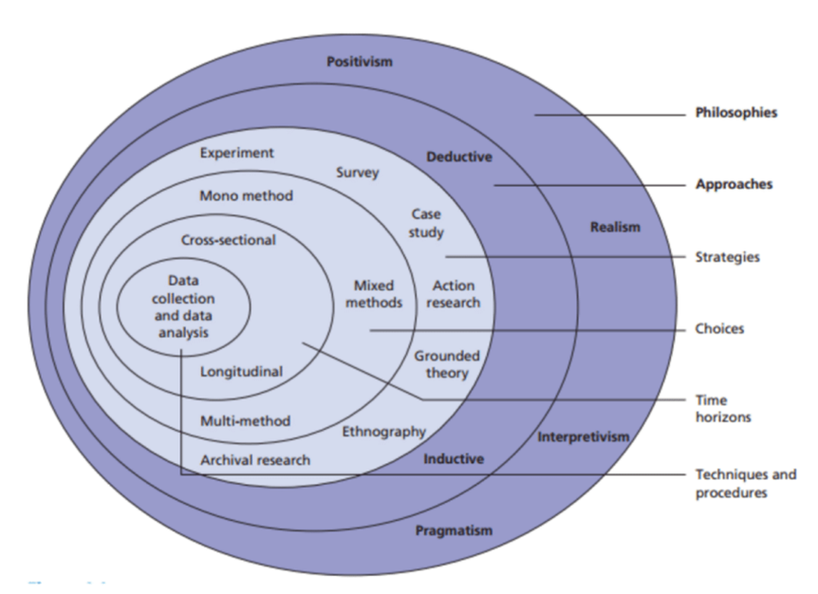
Understanding the many different types of research is extremely important to the researcher as they need to choose the appropriate/correct method for their research. Understanding the different methods also enables the researcher to establish good practise for implementing their methods correctly Bryman & Bell (2007).

Figure 1.1 – ‘Research Onion’ (Saunders et al, 2007)

Approach & Strategy

The researcher will be using the deductive approach. The deductive approach helps to develop a hypothesis upon a pre-existing theory and then formulates the research approach to test it (Silverman, 2013). Research conducted during this dissertation will follow this approach where pre-existing theories based on the economic impacts of events will be tested and advanced and a hypothesis will be made based on the researcher’s findings. To conduct this dissertation the researcher will be using a mixed method approach, Tashakkori and Teddlie (2003) state that multiple methods of research are useful if they are able to provide the researcher with better opportunities to answer the questions they need to.
The researcher will use online surveys (not survey monkey) and interviews. Any information/data gained will be used to provide a framework for a hypothesis and the research conducted will have the purpose of linking with this dissertation’s objectives.

Philosophy

The Philosophy taken for this research will be both positivism and interpretivism. Williamson (2002) states that the interpretivism form of research philosophy allows data to be distorted by perceptions of the participants chosen and this allows for different views to the same problem to be analysed. Interpretivism also applies to this study as the researcher will be using the questionnaire and interviews to gather quantitative data, this research method usually requires large samples Saunders et al (2012).

Strategies

Analysis

All data will be analysed with the researchers aims and objectives in mind, which will help to analyse the data appropriately. The study proposes to use a mixed method triangulation design where a questionnaire, interviews and previous literature will provide a range of information and data to help analyse the economic impacts of Swansea Air Show. Secondary data will also be used to analyse this study as no resources get wasted during the collection of information and there is already a large amount of data around the subject (Bajpal, 2011). The researcher will be using all data collected to cross examine and analyse the scale of economic impact this mega event has on local businesses.

4.2 Interviews

To provide a qualitive element to this dissertation and in order to gather as much information from business owners as well as attendees as possible, the researcher will conduct a series of interviews. According to (Gillham, 2004, p2) the research interview is to obtain information and understanding of issues relevant to the general aims and specific questions of the research project and this can be conducted in different ways, over the phone, over social media, face-to-face. For the purpose of this dissertation semi-structured face-to-face interviews will take place with open and closed questions for the researcher to gather as much information as possible. Also, semi structured interviews do not require as much experience as unstructured interviews in order to gain the appropriate data (Altinay & Paraskevas, 2008).
The interviews will be conducted as a triangulated method of research which is a way of assuring the validity of research using a variety of methods to collect data on the same topic. Due to this being a triangulated method the researcher will only be conducting five to six interviews with the relevant people. The questions will be open ended allowing room for the interviewee to give an in-depth response. All questions will need to be piloted in order to test the researcher’s questions and minimise the chances of interviewees having any troubles with the questions (Robson, 1993). Questionnaires will also make up a part of this triangulated method along with previous literature.

4.3 Sampling Framework
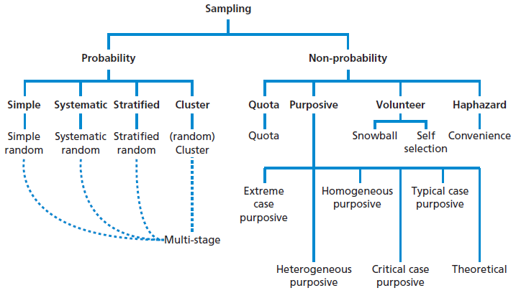
Figure 4.1 – Sampling Framework (Saunders et al, 2016 pg.276)
As shown in figure 4.1 there are many forms on sampling frameworks. Brown (2006) states there are five advantages to sampling, cost savings, makes research of any size easier to manage, can result in more accurate research findings, opportunity to process information in a more efficient way and it can also accelerate the speed of primary data collection. Nonprobability sampling best applies to this dissertation paper as the researcher will choose participants in a non-random manner. The researcher will mainly be choosing specific individuals and will be focusing upon interviews and questionnaires, meaning they will be focusing mainly on purposive sampling. The researcher will focus on business owners in the local area within a one-mile radius to aid the researcher in understanding the local economic activity.

5. Resources

Secondary data including those of theoretical resources will be used so the researcher can gain more knowledge and understanding in their topic area. Primary data that will be collected through online surveys and interviews and university IT software will be used to help the researcher analyse all data collected. The UWTSD library service will also be used to gain access to academic textbooks, articles and journals.

6. Ethics & Risks

This dissertation will be of minimal risk as the topic chosen should not offend any participants or pose as a risk to the researcher or the university. A completed ethics form will be completed alongside this research proposal to ensure all considerations have been thought of before the research begins.
One problem that could arise is if the researcher has no responses from the interviewees however this has been taken into consideration and the researcher will factor additional time should any changes need to be made to the research method.

7. Limitations

7.1 Resources Limitations

The time frame could be a limitation for the researcher, so they will attempt to lessen these limitations by creating a Gantt chart (see appendix) to help keep on track and ensure time is used effectively. Due to lack of statistics on Swansea Air Show this research could become hindered to some degree. All resources and literature provided by the university will be used to help benefit research.

7.2 Ethical Considerations

All participants of this study will be over the age of 18 and will complete their interview/survey voluntarily. Confidentiality will be taken with the utmost importance during this study and all data collected will be held securely on a password protected server. All participants will be kept confidential and remain anonymous unless they have stated otherwise.

8. References

Altinay, L. & Paraskevas, A. (2008), Planning research in hospitality and tourism, Oxford: Butterworth-Heinemann.
Bajpai. N, (2011), Business Research Methods, Dorling Kindersley, India.
Brown, R, B., (2006), Doing your dissertation in business management: The reality of research and writing. Oxford: SAGE Publications.
Bryman, A. & Bell, E., (2007), Business Research Methods. 2nd Ed. Oxford: Oxford University Press. London: Continnum.
Chalip, L., & Green, B.C., & Hill, B., (2003), Effects of sport event media on destination image and intention to visit, Journal of Sport Management, 17 (3), pp. 214 -234.
Chalip, L. & McGuirty, J. (2004), ‘‘Bundling sport events with the host destination’’, Journal of Sport Tourism, Vol. 9 No. 3, pp. 267-282.
Harding, (2017), ‘Wales National Air show: Full Flying Display Times & What To See’ [Online], UK Aviation. Available: https://uwtsd.ac.uk/media/uwtsd-website/content-assets/documents/library-and-learning-resources/infoskills/Harvard-eng_v.1.2.pdf, 22, November, 2019.
Gillham, B., (2004), The Research Interview. London: Continuum.
Laesser, C. & Crouch, G.I. (2006), ‘‘Segmenting markets by travel expenditure patterns: the case of international visitors to Australia’’, Journal of Travel Research, Vol. 44 No. 4, pp. 397-406.
Punch, K, F., (2016). Developing effective research proposals. 3rd Ed. London: SAGE Publications.
Preuss, H., Seguin, B. and O’Reilly, N. (2007), ‘‘Profiling major sport event visitors: the 2002 Commonwealth Games’’, Journal of Sport and Tourism, Vol.12 No. 1, pp. 5-23.
Robson, C. (1993), Real World Research, Blackwell:Oxford. In Saunders, M., Lewis, P. & Thornhill, A. (2000) Research Methods for Business Students, 2nd Ed, Prentice Hall: Harlow.
Saunders, M., Lewis, P. & Thornhill, A,. (2007), ‘Research Methods For Business Students’, 7th Ed, Pearson: Essex.
Silverman, D. (2013), Doing Qualitive Research: A practical handbook, London: SAGE Publications.
Tashakkori, A., & Teddlie, C. (2003). Handbook of Mixed Methods in Social & Behavioral research. Thousand Oaks: Sage.
Williams, C. (2019), ‘Amazing Weekend for 2019 Wales Air Show’ [Online], Wales Airshow. Available: http://www.walesnationalairshow.com/uncategorized/amazing-weekend-for-2019-wales-airshow/, 22, November, 2019.
Williamson, K. (2002). Research Methods for Students, Academics and Professionals. Wagga Wagga: Centre for Information Studies.
Zima, K. (2011). Event Tourism Economical and tourstic impacts on regional economy: A study of Polish regions preparations for UEFA EURO 2012.

9. Appendix

9.1 Gantt Chart


