Assessment of a Digital Media Organisation

Christion Breeze (P-1503300) Masters of Business Administration -2018-19

University of Wales Trinity Saint David

Module Code: BMMB7002/D

Programme: Digital Entrepreneurship Date: 25.04.19

Contents

Executive Summary

Introduction

Primary Activities
Support Activities

Conclusion

Bibliography

Executive Summary

For the purpose of this report a Porters Value Chain has been used to record a systematic analysis of the record company the Universal Music Group. The main focus is targeted towards the Primary and Supporting activities, which in turn, describe the attributes that create value for the company.

The UMG (2019) believes that they are the world’s number one music company, and in everything they do they are committed to the artist, welcoming innovation with open arms. Subsequently, they acknowledge the digital age by saying that they have many channels, platforms, to project their music, with dedicated devotion to new technologies and pioneering developments.

Introduction

This report (part b) is additional support to the previous presentation (part a) to finalise a full systematic investigation of the company Universal Music Group (UMG). It will analyse the Internal examination of the main company structure, and how it operates as a whole business.

The Universal Music Group was previously a sister company for the American owned Universal Studios company. In 2015, the French media company Vivendi decided to acquire another business to add to their list of companies and purchased UMG. This was precise decision that elevated Vivendi to a wider global base and company monopoly. Whitfield (2017).

The main body analysis will explore the internal company value at present. Highlighting where the Universal Music group (UMG) is positioned in the market, and how and what UMG are doing to encapsulate the ever-changing music industry of present.
There are two parts that divide this report, which are the Primary and Supporting Activities, which make up the full internal network within the UMG company.

As the music industry moves towards a technological era, it is imperative to understand the companies current infrastructure first, through the use of Porters Value Chain.
Later, analysis will display what new digital technology is being used to maintain UMG at the top of the market share of music publishers in the world.

Buckley (2007) states that the famous musician Elton John once said great quote, that in essence encompasses, music, consumers, the digital era of music and the company UMG in a big way:

“Music has healing power. It has the ability to take people out of themselves for a few hours.”
-Elton John

Primary Activities

Inbound Logistics
Artists are signed to record and promote their music, and later to tour with concerts and shows around the world. Different licenses are attached to the artists signed contracts and then licensed to the media sources such as - movies, television, radio, gaming companies. Royalties from these above activities then provide the revenue for UMG.
The digital technology used for these activities involve:
- Joining Streaming companies, and physical companies like iTunes, Amazon, GooglePlay.
- Social media advertising and sharing from consumers.
- YouTube, Vimeo and similar sites are also licensed to display videos and music.
- UMG also have a College Marketing department that analyses the students customers profiles via software analytics programmes.
- Shopping analytic software that examines consumers research methods and content.

Operations
Vivendi is parent company of UMG and has access to many media channels. UMG is a Global company, that currently has 47 offices in 45 countries, with the biggest consumer base in the USA. Subsidiary companies offer other distribution platforms, as they are all online and have separate websites for promotional or viewing uses.
There are three major record publishers at the moment, but UMG is the leading company, (also see Appendices 1 and 2).
Each UMG department in various countries has they own infrastructure which is the same as the original USA Head Office. Vivendi (2019).
The operating costs for UMG in are listed as $6.1B, and sales of streaming music sales are recorded at a 3.2% increase. Christman (2019).
As the record publisher industry is operated around the artists and their music, they are the main product for revenues. When music is released to a streaming music company, or movie company, etc, then they must have a certain license. If this music is projected or used digitally in any format, then the royalties are set at mandatory price rate for this, and later the revenues are generated from this. Passman (2015).

Outbound logistics
The only main digital presence of the outbound logistics are listed below:
- Artists and Bands - promoted, concerts and touring, sold tickets to big companies like TicketMaster. Ticket companies then create a digital ticket for consumers, which is sent to their smart device (mobile phone), to prevent piracy of tickets.
- Media license - movies, television, radio, gaming. - royalties and revenue from these.
- Promotion teams - concerts, other events - festivals, food, charitable, etc - using social media sites like Instagram, Facebook.
- Customer focus - Remaining high street shops - Morrissons, Asda, Sainsburys, Independent shops - consumers can order digitally online for the physical products also.
- Media - licensed music to other companies - tv, film, radio, gaming, etc - consumers can purchase products physically through Apple iTunes or stream the music or videos from companies such as Spotify and Amazon Prime.
- UMG has no direct contact for sales to the consumers, all done via externals companies. UMPG (2019).

Marketing & Sales
The Marketing for UMG works through the external suppliers of the company. This all depends on the publishing or copyright contracts for licensing, etc. that have been settled at point of purchase from the distributing companies.
Sales for UMG are displayed below:
- the large French company Vivendi bought UMG in 2015.
- Revenues recorded in 2018 by Christman (2019) at a figure of $7.1B as streaming sales rise to 31%. As a percentage of revenue, North America accounted for 46.1 percent, Europe 32.7 percent. Asia 12.8 percent, Latin America 3.2 percent and the rest of the world 5.2 percent in 2018.
- Meanwhile, physical fell 17.9 percent to $1.126 billion. Looking at recorded music by format, digital grew 15.8 percent to $3.65 billion. Whitfield (2017)
- Also see Appendices 1 and 2 for further data.

Service
This section explains the service and how UMG maintains their current and new data for the public via their websites. As UMG have many subsidiary companies, networking, customers enquiries and other data transfer is operated with ease, quickly and efficiently.
For example, the udiscover.com site is where UMG digitally display all of their artist news, and has links to one of their subsidiary companies called Abbey Road Studios.
The other service digital details are listed as follows:
- Customer Enquiries - This is done directly through the countries website, with email details or phone number data.
- Accurate and up-to-date data is available through their main website for each country.
- udiscover.com displays large current data.
- Supplier contact is done via admin department, and new suppliers through email.
- To provide the best service, innovations and welcome the customers with enthusiasm.

Support Activities

Firm Infrastructure
One of UMGs main significant mission statements is that they welcome Artists, Innovators and entrepreneurs, this can be seen on all of their global websites.
UMG (2019).
The companies structured network contains many departments ranging from the A&R Business Strategy and Planning, Quality management, Finance, Human Resources, Administration, College Lifestyle Marketing, and Commercial Services. All of these departments are operated with professional attitude, and of a networking character.
They have adapted to the technological age with precise accuracy with the numerous technological departments and roles in operation on a daily basis, from software programming, technological analysts, and Social media analytic positions. UMPG (2019).

Human Resource Management
As the company is global, the opportunities for the public to apply for a variety of different jobs are diverse. The additional opportunities are for students to work in an Internship, and UMG offer an Equal Opportunity policy.
UMG take their Human Resources department very seriously, and with an optimum professional training schemes, catering for all needs, and different legislative policies. Also, the presence of Human Resource managers are always present and on hand to deal with employees issues, disabilities, and requests such as payroll, or taxation concerns. In the careers and job opportunities pages on UMGs website these roles are exhibited within the application details. UMG (2019).

One employee said:
“Wonderful colleagues and creative environment! The culture there is inclusive, collaborative and friendly.
Generous company holidays such as being closed from Christmas to New Years.”
Indeed (2019).

Technology Development
The two main current technological developments UMG has made are:

-(displayed on the UMG website) you can see that if you are a client or stakeholder you have access to streaming any of their music, direct.
-Analytics recording for customer profiling to record sales styles and so on.
-licensing to streaming companies.

Conclusion

With the present evolution of the music industry, this report looks into the main operations of how a large music publisher maintains their status as one of the three major record labels.
The industry is changing from a physical product base to a streaming base, and independent record publishers, bands, and other artists have adapted to the new structure. For such a large record publisher, their main tasks of today are- to sign an artist, publish them, contract them for a year, promote them and extract as much revenue as possible from them. Passman (2015).
On the other hand, as the music industry has evolved, the major record labels now have many other jobs, such as licensing streaming companies, selling their music to companies like Amazon and iTunes, and selling lyrics of songs, and so on. Agrawal (2019).

This proves that at a time when many people thought the music industry was going into extinction, it was actually re-inventing itself to become a better and modern consumer orientated industry.

Appendices

Appendix 1 - Biggest Record Companies, Globally, Market Shares
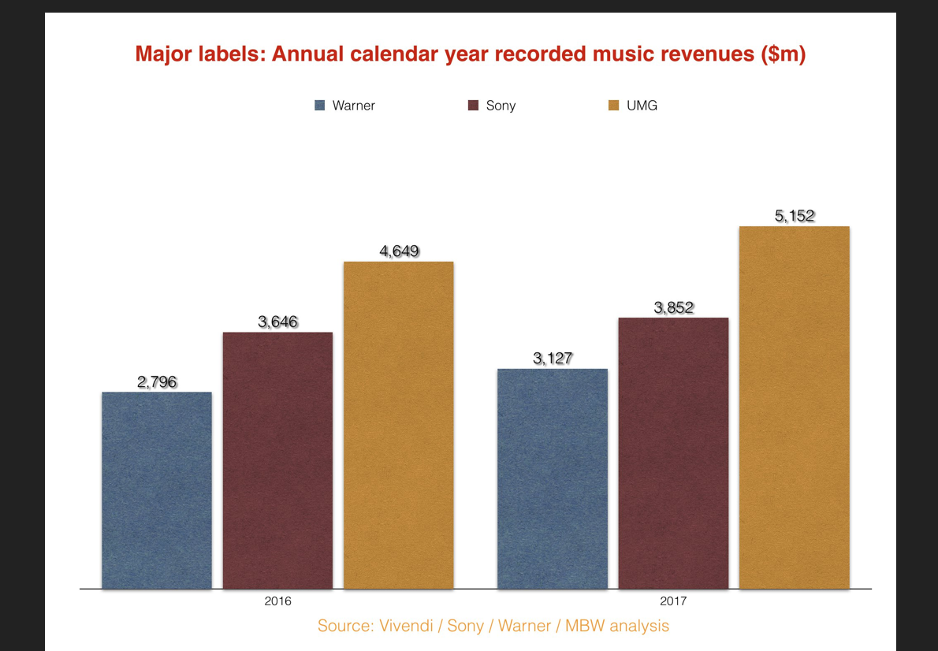

(Source - Ingham 2018).

Appendix 2 - Universal Music group revenues -2007-2018
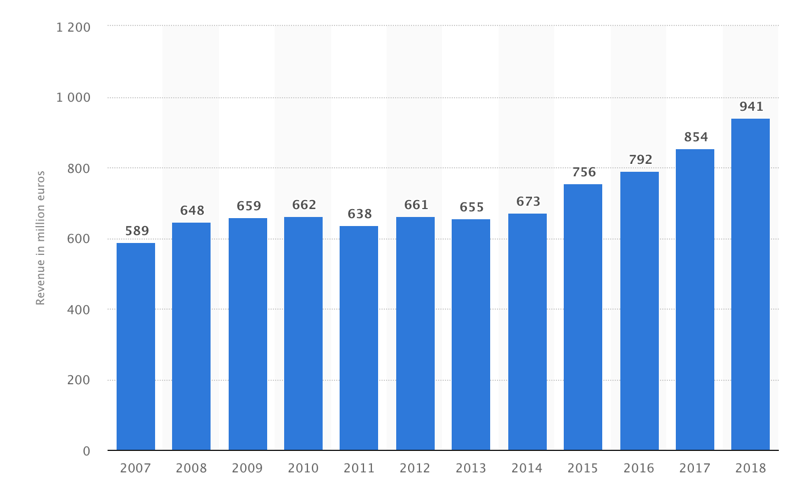

(Source - Statistica 2019)

Bibliography

Adegoke, Y. (2018). The worlds biggest music company is setting its sight on Africa.
[online] Available at: https://qz.com/africa/1328454/universal-music-group-the-worlds-biggest-music-company-sets-its-sights-on-africa/
[Accessed: 11.04.19].

Agrawal, A. (2019). How Digital Marketing Is Changing the Music Industry.
[online] Available at: https://www.inc.com/aj-agrawal/how-digital-marketing-is-changing-the-music-industry.html
[Accessed: 11.04.19].

Aswad, J. (2019). Driven by Streaming, Global Recorded-Music Revenues Soar to $19.1 Billion.
[online] Available at: https://variety.com/2019/biz/news/driven-by-streaming-global-recorded-music-revenues-soar-to-19-1-billion-1203178318/
[Accessed: 10.04.19].

Blewitt, J. (2019). IFPI Global Music Report 2017.
[online] Available at: https://www.ifpi.org/news/IFPI-GLOBAL-MUSIC-REPORT-2017
[Accessed: 10.04.19].

Bruin, S. (2017). More About: Music - A Digital Disruption in the Music Industry.
[online]. Available at: https://medium.com/the-innovation-station/more-about-a-digital-disruption-in-the-music-industry-d28d97d1ff31
[Accessed: 12.04.19].

Buckley, D. (2007). Elton: The Biography. Chicago Review Press: Chicago, USA.

Christman, E. (2019). Universal Music Group 2018 Earnings: Revenue Tops $7.1B as Streaming Spikes 31 Percent.
[online] Available at: https://www.billboard.com/articles/business/8498460/universal-music-group-2018-earnings-revenue-streaming-physical.
[Accessed: 13.04.19].

Davis, S., and Laing, D. (2006). The Guerilla Guide to the Music Business. The Continuum International Publishing Group: London, UK.

Indeed. (2019). Universal Music Group Employee Reviews.
[online] Available at: https://www.indeed.com/cmp/Universal-Music-Group/reviews
[Accessed: 20.04.19].

Ingham, T. (2018). THE MAJOR LABELS’ REVENUES GREW BY $1BN IN 2017. BUT WHO HAD THE BIGGEST YEAR?
[online] Available at: https://www.musicbusinessworldwide.com/major-labels-revenues-grew-1bn-2017-biggest-year/
[Accessed: 10.04.19].

King, A. (2019). Apple Music Doubles Down on Data-Driven ‘For You’ Recommendations — Sound Familiar?
[online] Available at: https://www.digitalmusicnews.com/2019/04/17/apple-music-new-music-for-you-section/
[Accessed: 10.04.19].

Passman, R. (2015). All You Need to Know About the Music Business - Ninth Edition. Simon & Schuster Inc: New York, USA.

Rudsenske, J. (2005). Start an Independent Record Label. Music Sales Limited: London, UK.

Sanchez, D. (2019). Global Recorded Music Revenues Expected to Hit $18.9 Billion This Year — But Growth Is Slowing.
[online] Available at: https://www.digitalmusicnews.com/2018/12/19/midia-research-global-recorded-music-revenue-2018/
[Accessed: 10.04.19].

Sisario, B. (2012). U.S. and European Regulators Approve Universal’s Purchase of EMI.
[online] Available at: https://www.nytimes.com/2012/09/22/business/global/universal-takeover-of-emi-music-is-approved.html
[Accessed: 09.04.19].

Statistica. (2019). Music publishing revenue of the Universal Music Group from 2007 to 2018 (in million euros).
[online] Available at: https://www.statista.com/statistics/314363/universal-music-group-music-publishing-revenue/
[Accessed: 19.04.19].

Szalai, G. (2012). Universal Music Completes $1.9 Billion EMI Recorded Music Acquisition.
[online] Available at: https://www.hollywoodreporter.com/news/universal-music-completes-19-billion-374965.
[Accessed: 09.04.19].

Udiscovermusic. (2019). Browse Artists.
[online] Available at: https://www.udiscovermusic.com/browse-artists/
[Accessed: 12.04.19].

UMPG. (2019). Film, TV and Media.
[online] Available at: https://www.umusicpub.com/uk/FilmAndTv.aspx
[Accessed: 09.04.19].

Universal Music. (2019). EMI-UMG.
[online] Available at: https://www.universalmusic.com/label/emi/
[Accessed: 20.04.19].

UMG. (2019). Overview.
[online]. Available at: https://www.universalmusic.com/company/
[Accessed: 20.04.19]

Vivendi. (2019). Corporate Social Responsibility.
[online]. Available at: https://www.vivendi.com/en/social-responsibility/
[Accessed: 02.04.19]

Whitfield, P. (2017). Universal Music Parent Company Vivendi Defends $4.6 Billion Havas Acquisition.
[online]. Available at: https://www.thestreet.com/story/14292566/1/universal-music-parent-company-vivendi-defends-4-6-billion-havas-acquisition.html
[Accessed: 02.04.19]

