
University of Wales Trinity Saint David

Topic: Blog about SAMSUNG

Module Name: Marketing Fundamentals
Module Code: LCBB4004

Student Name: Pavlinka Todorova Veleva
Student Number: 2028165

Lecturer Name: Tushara Balendran
Date: 23.12.2021

TABLE OF CONTENTS:

Title page………………………………………………………………………………………….1
Background/ History of the company…………………………………………………………..…3
Product………………………………………………………………………………………….....4
Price……………………………………………………………………………………………….9
Place……………………………………………………………………………………………...10
Promotion………………………………………………………………………………………...13
References……………………………………………………………………………………..…17

BACKGROUND/HISTORY OF THE COMPANY:

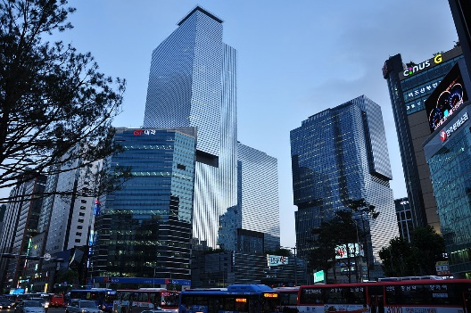
Samsung group is a South Korean group established in 1938. On the world market is known as a producer of high-quality products, electronics, home appliances, and audio and video devices. The main office of the company is placed in Seoul.
The entrepreneur and trader Byung-Chull Lee, who lives in Daegu, decided to expand his business together with Chinese partners for marketing with rice. The sellings were going well, the company covered new areas for working, the staff grew and in 1948 the new name of the company ‘Samsung Trading Co’ came out.
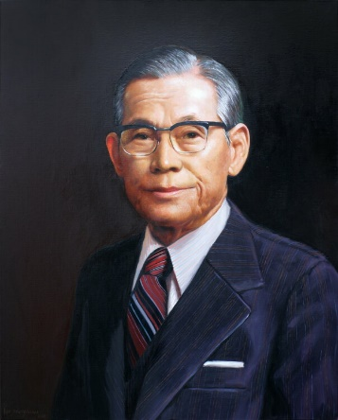
The real breakthrough in history went in 1969 when our company opened a workplace for assembling black-and-white TVs with Sanyo (a Japanese company) in South Korea. Suvon started fully large-scale producing of wide range of electronics for everyday uses and the whole managing of the business through under the control of Samsung Trading Co and became in corporation Samsung Electronics Corporation. Starting our activities from the bottom on the everyday appliances’ market now Samsung electronics is on an important place in it. After we accepted Sanyo’s technology, which is concentrated on producing mow our company is one of the biggest and most famous electronics manufacturers in the world.
Nowadays is difficult to be found an industry where Samsung doesn’t take a part. Our brand produces everything: from microwaves and toasters to cameras and stereo systems through cars and ships and planes. In the internal market in South Korea, Samsung group also manages financial operations, insurances, and guards’ activities in a result we are forming over 50% of the total budget in our country. Almost half a million employees work in corporate offices in the whole world. Suvon, where is the center of Samsung Electronics is called Samsung City.
It has a lot of different theories for the meaning of the word ‘Samsung’, but the most popular version is ‘Samsung’ means three stars. We can link this with Byung-Chull has three sons – one of them is Lee Kun-hee, who is leading the industrial group at the moment. We can see three stars on Samsung’s logo at the beginning.

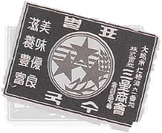 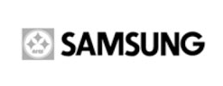 
1938-1969 1969-1979 1979-1993

In 1993 Samsung had seen these logos didn’t content looking of the international corporation, so we decided to change it. Then our well-known modern emblem felt changes – dynamically inclined blue ellipse with the written name of our company.
 
1993-2005 2005-present
The Brilliant design and the enormous promoting campaign made a good job – our logo became one of most recognizable in the world
The process of developing a new logo hadn’t been a reality without eastern philosophy. According to our marketing strategy of Samsung ‘inclined blue ellipse’ show the global moving in the cosmos to express the idea for constantly refreshing and developing. (EstrellaSuecia, 2021)
Our mission:
- To support people to give the world the best of them – we have the aim to help for the human resources development and to increase the process of a synergy of all managing systems with human resources and technologies.
- Our inside goals – to develop good products and services, which will provide the best satisfaction for the clients; to save the first place in the world in the same business.
- Over Samsung – to follow our mission as a part of the community and to help for our interests and good quality of life.
‘52 years later we continue to be innovators as we create technologies, which skip the old and new borders of possibility and we help people to reach higher levels. Our aim continues to inspire us and for that reason, we place people and their needs in the basis of everything, what we make.’
Our vision:
The brand’s vision is to be in the global top 5 by 2022 and it believes that value creation and innovation will lead it to the top.
PRODUCT:
Samsung consists of around 80 companies whose activities are so various. They cover different areas like construction, electronics, financial services, shipbuilding, and medical services. Let’s look at examples of each are:
ELECTRONICS:
- Phones – Samsung offers a big variety of mobile phones. We produce new models every year. We have different series like Samsung Galaxy S-line, Z-line, A-line, Note line.
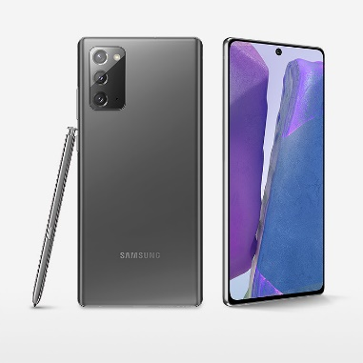 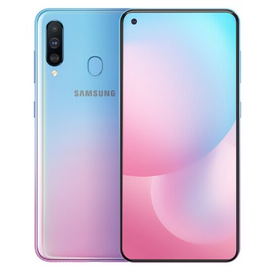
Note-line A-line
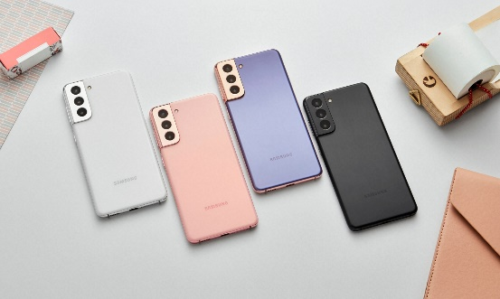 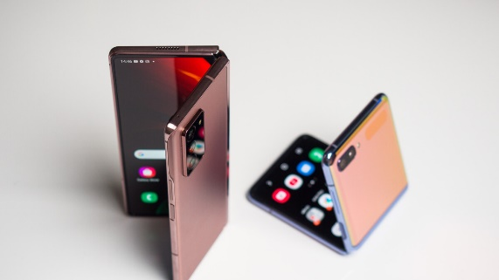
S-line Z-line
- Accessories – Our accessories are like the final step to finishing your style. Every client can match his phone with additional devices like:
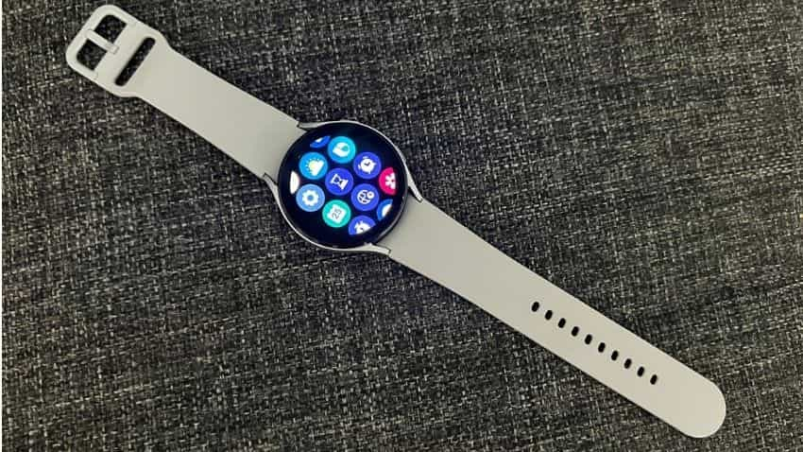 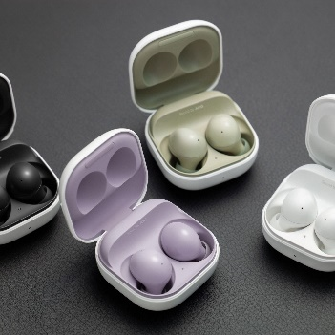
Samsung Watch 4 Galaxy Buds 2
- Laptops and monitors – To full comfort, our team develops wide gamma of devices that can help you in your everyday life uses or professional gaming.
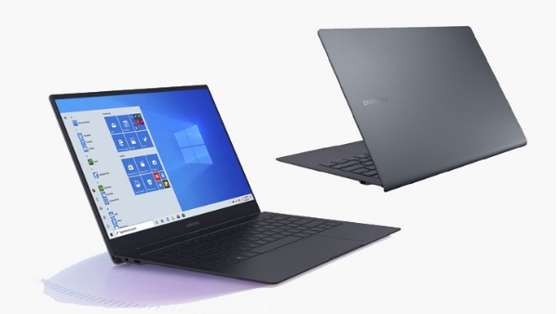 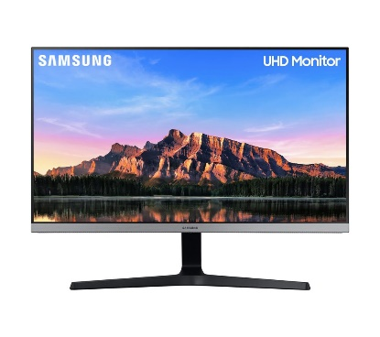
Samsung Galaxy Book S Laptop LU28R550UQUXEN 4K Ultra HD
28” LED Monitor - Dark Grey
- TV and audio systems – Turn your home into a cinema with the perfect size TV and brilliant sound system.
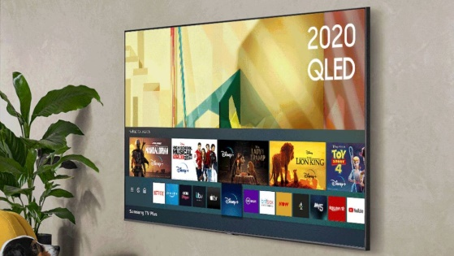 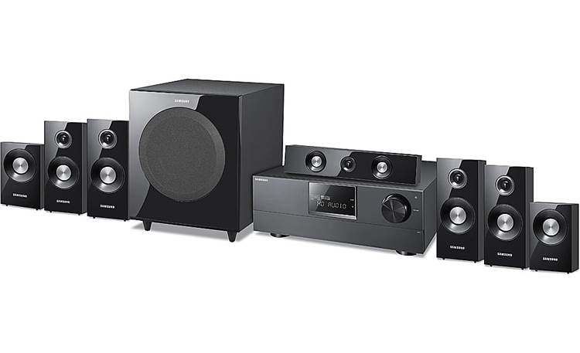
75” QN900A Neo QLED 8K HDR Smart TV Samsung HW-C770BS
- Home appliances – What is one home with the best choice of home appliances? Our brand present last innovations of the fridges, cookers, washers, dryers, etc.:
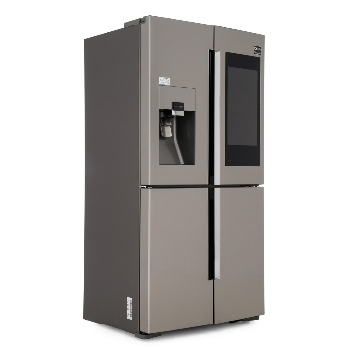 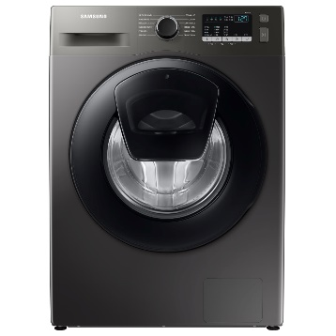 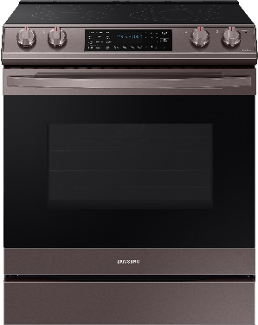
Samsung Fridge Family Samsung WW90T4540AX Samsung
Hub American Freezer 9kg Add Wash NE63T8511ST
- Additional suppliers – here is something for the lovers of big space. You can add additional memory to your laptop or computer.

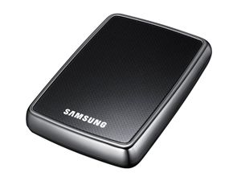 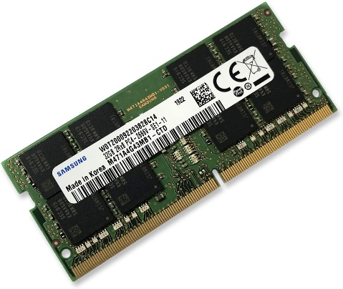Samsung S2 Ultra-Portable Hard Disk Drive Samsung 32GB DDR4 2666MHz RAM
Memory Module for Laptop

FEATURES AND BENEFITS OF ONE OF THE OUR NEWEST PHONES:
The newest luxurious phone produced by Samsung is Galaxy Z flip. Samsung Galaxy Z Flip presents a big & vibrant screen, It supports Foldable Dynamic AMOLED capacitive touchscreen, 16M colors, It has a size of 6.7 inches, 101.6 cm2 (~82.5% screen-to-body ratio) that is very suitable for watching videos, browsing the internet & playing games, It has a resolution of 1080 x 2636 pixels. It has HDR10+ and it offers a Cover display: 1.1″, Super AMOLED, 112 x 300 pixels.
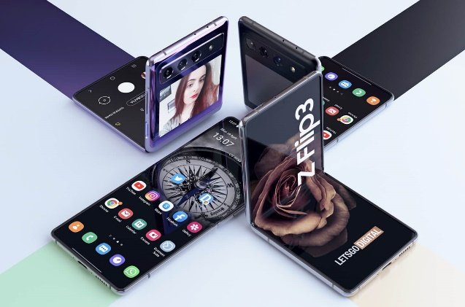
The innovative design of this phone presents the past and the future in one. The phone could be folded like the older phones from the past but at the same time content the newest technologies and brilliant outside looking connected with the future. The highest resolution makes the picture crystal clear. It has a double camera which can transfer your memories in pictures of great experience. The curved corners allow the image to be seen from every angle. Fast processor allow easy and fast jobs with the phone in the workplace or in the everyday life. The big memory makes it possible to save countless documents, pictures, music, so you shouldn’t replace your data for other devices. The battery lasts long so you can use the phone the whole day without charging it and the device will be with you everywhere in every time. Galaxy Z Flip is a small luxurious treasure for Samsung’s lovers. (Soffar, 2020)

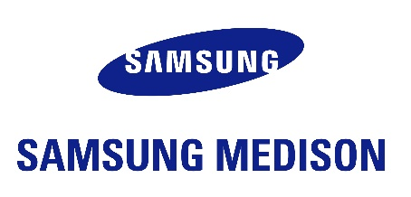
MEDICAL SERVICES:
Samsung Medison CO., LTD is a producer of ultrasonic systems of diagnostic. The company is established and acquired by Samsung in 2010. In 2010 we sold our medical products in 110 countries. Then we accumulated up to 85% of our total sales. (Ost316, 2021)

CONSTRUCTIONS:
Samsung Heavy Industries is one of the biggest shipbuilders in the world and one of the ‘Biggest three’ shipbuilders in South Korea. The main focus of the SHI fall into the engineering, construction, the input of producing and delivering of: transport ships for trade industry, modules for an upgrade, drilling and floating parts for petrol and gas sector, gantry cranes for producing companies, devices for managing the ships and other construction and engineering services. (Krillzyk, 2021)

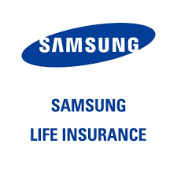
LIFE INSURANCE:
Samsung Life Insurance is a South Korean multicultural insurance company with center in Seoul, South Korea, and a subsidiary of Samsung Group. This is one of the biggest companies in South Korea. The main products of Samsung Life Insurance are life insurance and health insurance. To the period of 1957 Samsung Life was a private company, but in 2010 became public. The IPO was the largest in South Korean history and made Samsung Life one of the country's most valuable companies measured by market capitalization. (Wbm1058, 2021)

PACKAGING:
To update the package of Samsung’s products we are forming workgroups that are making projects for development, buying, marketing, and control of the quality for the innovative ideas for packaging.
For tablets and phones, Samsung is going to exchange the plastic with cellulose molds and accessories for packaging with eco-friendly materials. We are working also on the change of design of the charger – we want to replace the shiny outside part with a matt cover and to delete plastic protective films.
Samsung is going to use only fibrous material.
Until 2030 we have the plan to use 500 000 tones recycled plastic and to collect 7,5 million tons threw rubbishes. (Korea, 2019)
PRICE:

The price is one of the most important things when we look at when we are on way to purchase something especially electronics. Samsung launches new models of phones every year. As everybody knows when a new phone arrives, the old one gets cheaper. Here I will compare the last three phones of the series Galaxy S-line:

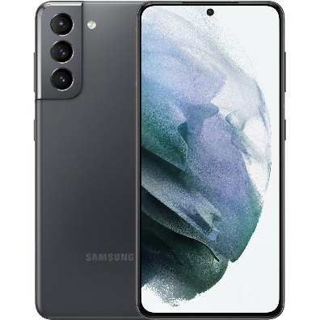 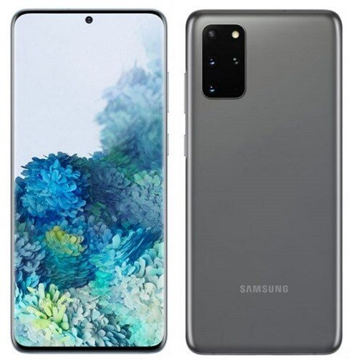 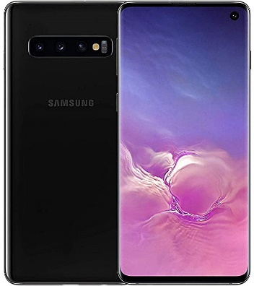 a Samsung galaxy S21 Samsung galaxy S20 Samsung galaxy S10
719£ 473£ 319£
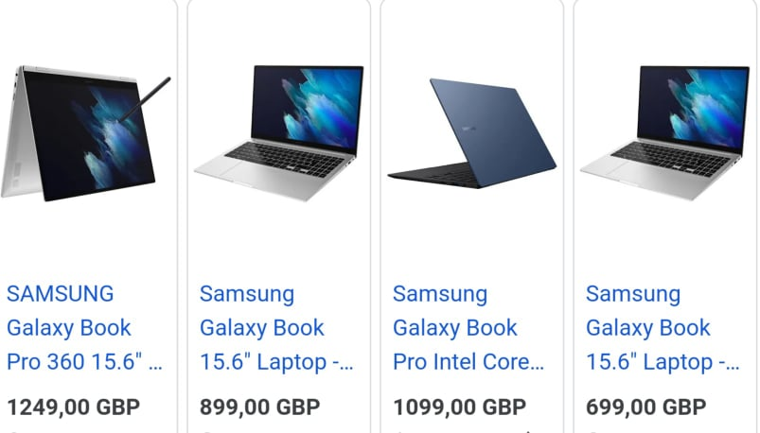
Our ultra-thin laptops and tablets in one have the best characteristics – a lot of power – long-last battery, speed, touch screen, plenty of space for all of your needs, compact can be everywhere with you. You can use it in the office, on the way or just at home. These are the last innovations of technology and are the best choice for people who travel a lot.

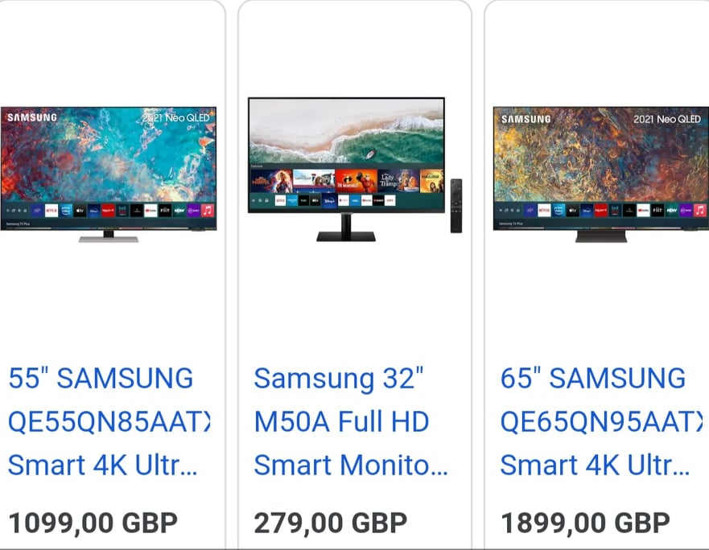

As everybody knows Samsung produces TV as well. The newest TV allows us to enter on Internet, review pictures, connect it with our phone and access a lot of Tv channels, games, and apps like Netflix, Disney Plus, and Amazon Prime.

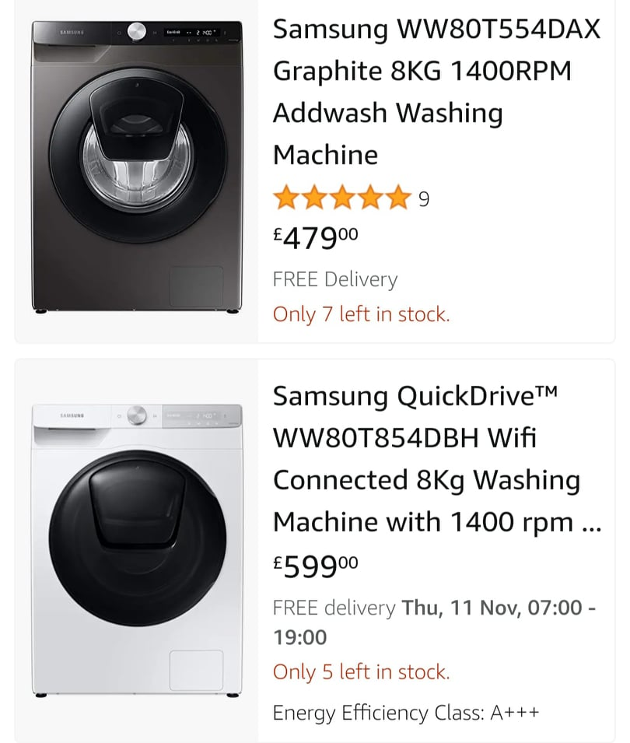
One of our last offers is a combination of a washing-up machine and dryer, which can be controlled from the mobile app. Another advantage is easier and faster wash and also if you had forgotten to put something inside you can easy to stop it, to put it inside and to started it again.

We are trying to create new stuff which can make people’s life easier and more comfortable. We are trying to reach out of our frame and to create innovations that can be appreciated by the people. We aim to inspire us, and we place people and their needs based on what we are creating.

PLACE:
Samsung products are available worldwide. To make that we use different channels for distribution. The channels of distribution are the different ways how we deliver our products to arrive at our customers. We use direct channels of distribution which means we use our website and our shops. (TREVZSAAGA, 2016)
- Website - https://www.samsung.com/uk/, there we have all the information of our company – history, progress, process step by step, new arrivals, deliveries, terms and conditions, and many others.
- Our shops – Samsung shops are the place, where you can make the best choice easily and pleasing. There you can find the latest models smartphones, watches, and stylish accessories. Our shops rely on customer service with experience and skills, who can describe the features and benefits of every device. With their help, you will find the best for you. In our place, customers can test and explore everything. Our specialist will explain everything, give you answer to every question and make a true one easy and fast purchase. Here I will leave a few locations around London:
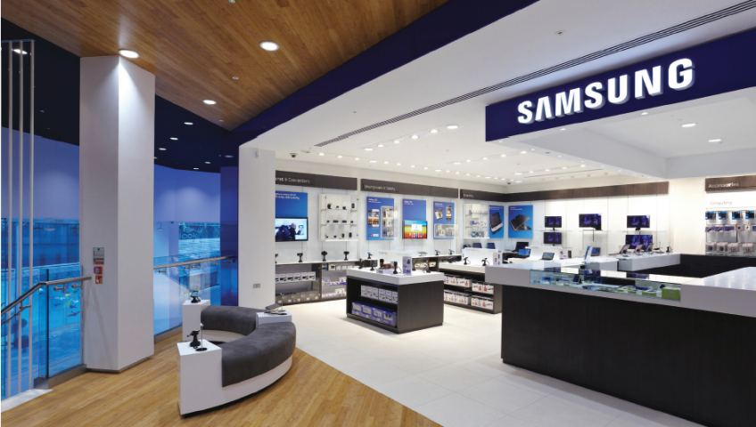
Samsung store in Westfield Stratford City, Unit 2038 & 2039, First Floor, The Gallery, London E20 1EQ
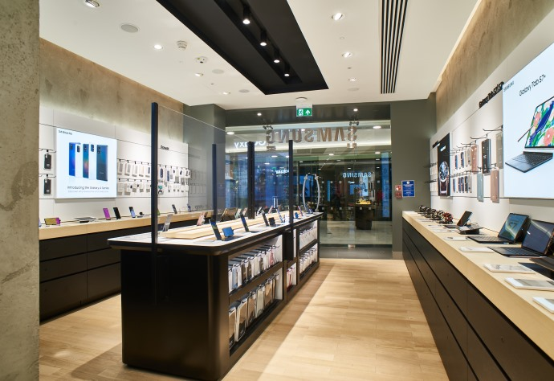
Samsung store in Canary Wharf Address: Unit 3A Canada Pl, London E14 5AB

If you want to find the nearest store around, you can click on this link: https://www.samsung.com/uk/storelocator/
Samsung Electronics has assembly plants and sales networks in 74 countries and employs around 290,000 people. It is majority-owned by foreign investors. It is the world's largest manufacturer of consumer electronics by revenue.
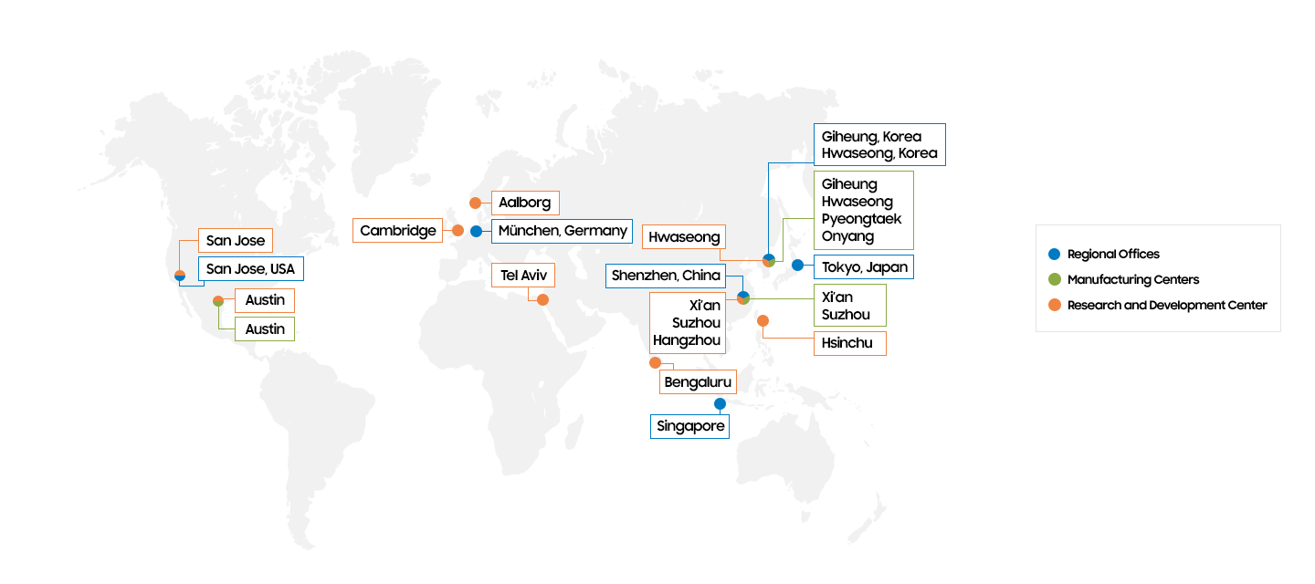The map shows the information on where Samsung has offices and centers all around the world.
- We use one more channel of distribution – indirect or middleman - we used to sell our products on websites and shops which are not our own. Our brad sells our product in many stores like Curry’s, Amazon, Argos and many others. Because of the good reputation of each of these shops, they help us to make a lot of sales and increase our incomes.
Scheme of Samsung’s channels of distribution:
Manufacturer | Manufacturer
↓
Retailer
↓
Consumers | Consumers

PROMOTION:
Promotion is a strong pillar in the marketing mix of the company. Samsung believes that advertising is the best form of promotion to engage potential consumers and to maintain a good level in a marketing environment.
Samsung promotes new products using newspapers and digital media.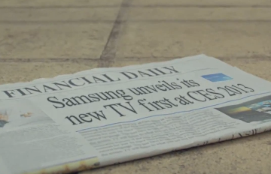
Examples of digital media – The brand has a strong presence online via social media channels, digital marketing, and online ads. Samsung has official pages on Facebook, Instagram, and Twitter. There we post a lot of news around our newest devices, interesting facts about them and make challenges with customers (with their answers we understand their preferences and choices). Here are their links to them and covers pages.

- Facebook - https://www.facebook.com/SamsungUK/

- Twitter - https://twitter.com/samsungmobile?lang=bg

- Instagram - https://www.instagram.com/samsungmobile/?hl=bg
Facebook
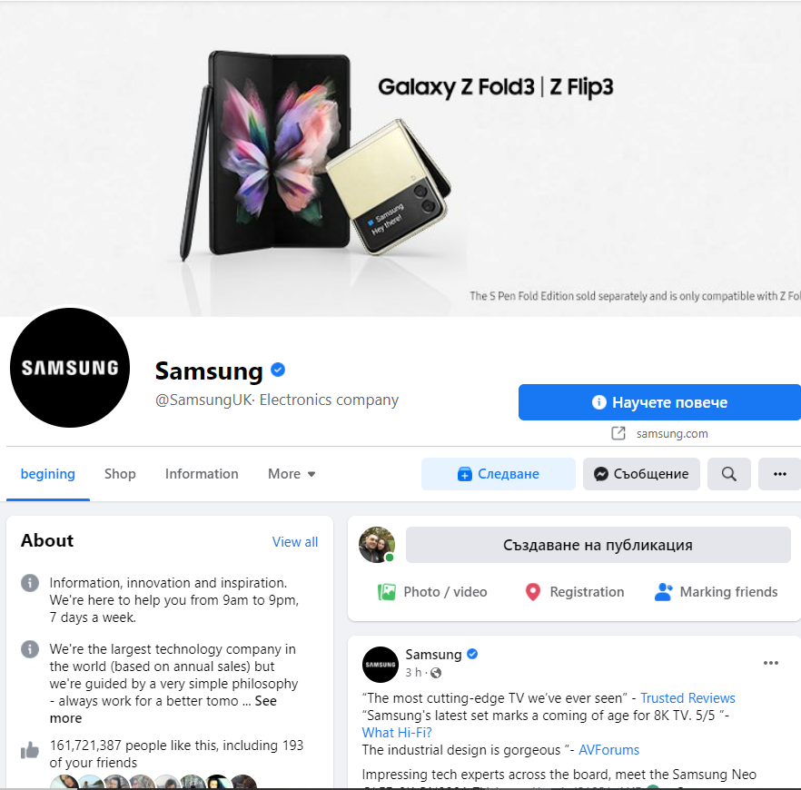
Twitter
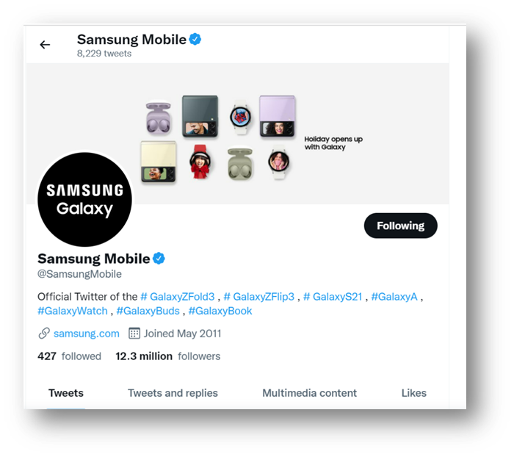
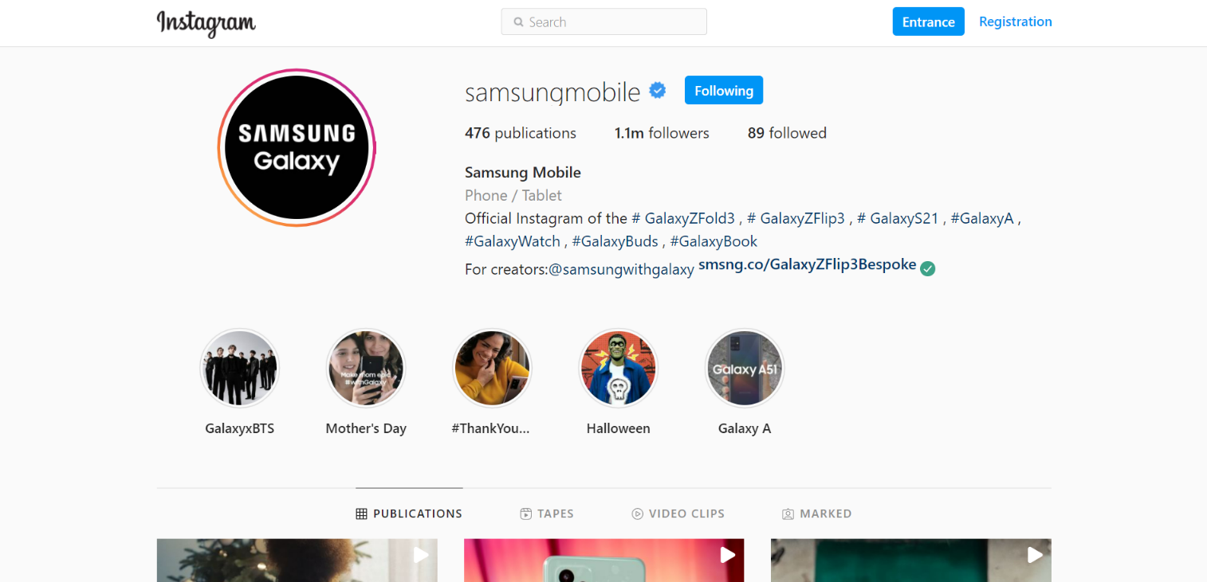
Instagram

To take the advantage of the huge number of followers of celebrities, the brand has invited many celebrities to be the brand ambassadors and promote the product.
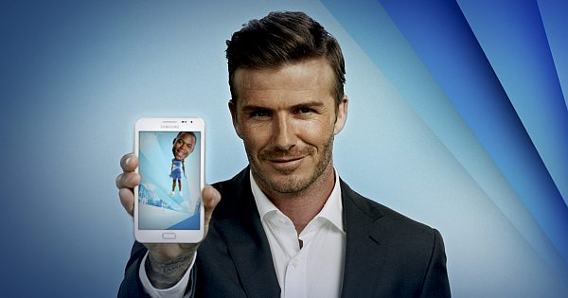

Big hoardings and posters are put up on highways.
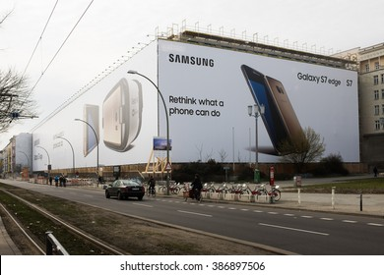
Besides advertising, Samsung also uses different promotional tactics to make customers buy the product. Samsung is mostly famous for its product quality and user experience, but Samsung is also known for being a giant in sponsoring events.
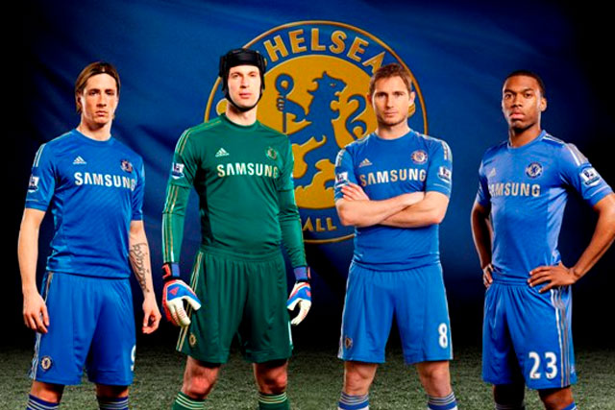
Samsung also sponsors major events. Samsung offers heavy discounts during national festivals. This concludes the Samsung marketing strategy and marketing mix analysis. (Team, 2021)
REFERENCES:

Badi, K. S. (2018, 10 21). Business and Management. The Impact of Marketing Mix on the Competitive Advantage of the SME Sector, 8(3), 10.
Baines, P., Fill, C., Rosengren, S., & Antonetti, P. (2014). Marketing (2ND ed.). United Kingdom: Oxford, Oxford University Press.
Blythe, J. (2013). Principles and Practice of Marketing (3th ed.). United Kingdom: SAGE Publications Ltd.
Housden, M. (2010). Marketing Information and Research. Butterworth-Heinemann Coursebooks.
Jepma, W. (2020, 12 11). 10 of the Best Marketing Strategy Books Worth Reading. Retrieved from Marketing Automation: https://solutionsreview.com/marketing-automation/best-marketing-strategy-books/
Korea. (2019, 01 27). Samsung Electronics to Replace Plastic Packaging with Sustainable Materials. Retrieved from Samsung Newsroom: https://news.samsung.com/global/samsung-electronics-to-replace-plastic-packaging-with-sustainable-materials
Schmitz, A. (2019). An Introduction to Business. In A. Schmitz, The Marketing Mix. Schmitz, Andy.
Soffar, H. (2020, 3 5). Samsung Galaxy Z flip,review, advantages, disadvantages and specification. Retrieved from Online Sciences: https://www.online-sciences.com/mobile/samsung-galaxy-z-flip-2020-review-advantages-disadvantages-specifications/
Team, M. S. (2021, 09 29). Samsung Marketing Strategy & Marketing Mix (4Ps). Retrieved from MBA SKOOL: https://www.mbaskool.com/marketing-mix/products/16860-samsung.html
TREVZSAAGA. (2016, 05 16). Channels of Distribution Crucial to Success? SAMSUNG ELECTRONICS. Retrieved from Marketing Management: https://mpk732t12016clustera.wordpress.com/2016/05/16/channels-of-distribution-crucial-to-success-samsung-electronics/

