“Good leadership is by definition all about taking the venture forward and finding viable new avenues where the business can evolve and prosper. Poor leadership, on the other hands, typically tends to be static, much more about protecting the status quo and, if there are any around, resting on laurels.”  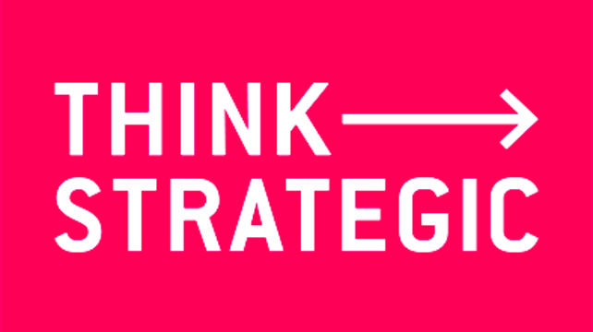  (Virgin.co.uk)  Fantastic leadership development training  We have two types of leadership theory models to choose from. The first, the GROW model, and the second is the Adaptive Leadership model by Ronald Heifetz. These models have been tried and tested by great leaders such as Richard Branson. | CAJ Consultancy  Spring Garden  ___  Meidrim  ___  SA33 5QQ  ___  Phone: 01994 690 022  ___  Email: c-jones93@outlook.com  ___ | A leadership development program to help grow your business  CAJ Consultancy  - Leadership Development Program
(The Professional Learning Hub @NIST, 2018) |  | - Phone: 01994 690 022  - Contact: c-jones93@outlook.com  - Website: caj-consultancy.com

The Grow Model uses a framework of 4 factors. G-Goal, R-Reality, O-Options and W-What, Who & When. The first factor of a Goal, looks into what the aim is, and can be either short term or long term. The second which is Reality, focuses on the reality of the tasks, the size, the delivery of a task and if the individual is prepared for the tasks ahead and what it will take to complete them. The Options factor concentrates on giving your subordinates decision choices whilst making them feel that they are an important part of the team. Using this method can also help introverts feel confident in their decisions and work efficiently. The final factor in this framework is the What, When and Who factors. This focuses on the details of who is doing the tasks that have been assigned to them, what the task involves and what timescale they have in which to do it. The benefits to this model is that you can plan tasks for either short term or long term and that everybody is aware of their responsibilities and the task that they must do and within the timescale set. It is also great for subordinates who are introverts as this helps to build their confidence and maximize their working efficiency.  The GROW Model | The Adaptive Leadership Model  The Adaptive Leadership model by Ronald Heifetz focuses on the ability to be able to adapt to different situations and different people. Some subordinates need a leader to take a different approach with them as they might not understand the task in the way it has been set out, and need their leader to take a different learning or leaded approach to help them understand. This model can also help introverts to become more comfortable which will inevitably help to make their work more efficient. The benefits of this model is that it develops the way you think about a situation and makes you adapt to any forthcoming changes. This could be changes in tasks or possibly the changes that need to be made to lead subordinates. Various techniques could be applied to a situation to change the outcome effectively. | Why Choose us???  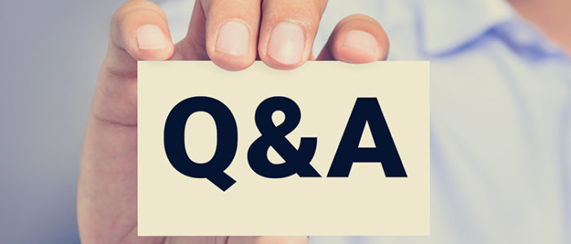  We work with a dedicated team of coaches that have a vast knowledge in the model frameworks and will be on hand to help as and when needed. We have fantastic coaching methods on how to lead introverts and extroverts and how to inspire subordinates to work efficiently for your business. We also undertake a reviews at the 3 month and 6 month stage following this program to monitor progress and to help with any questions you may have.

